
Jak to rozchodit s tasmota?
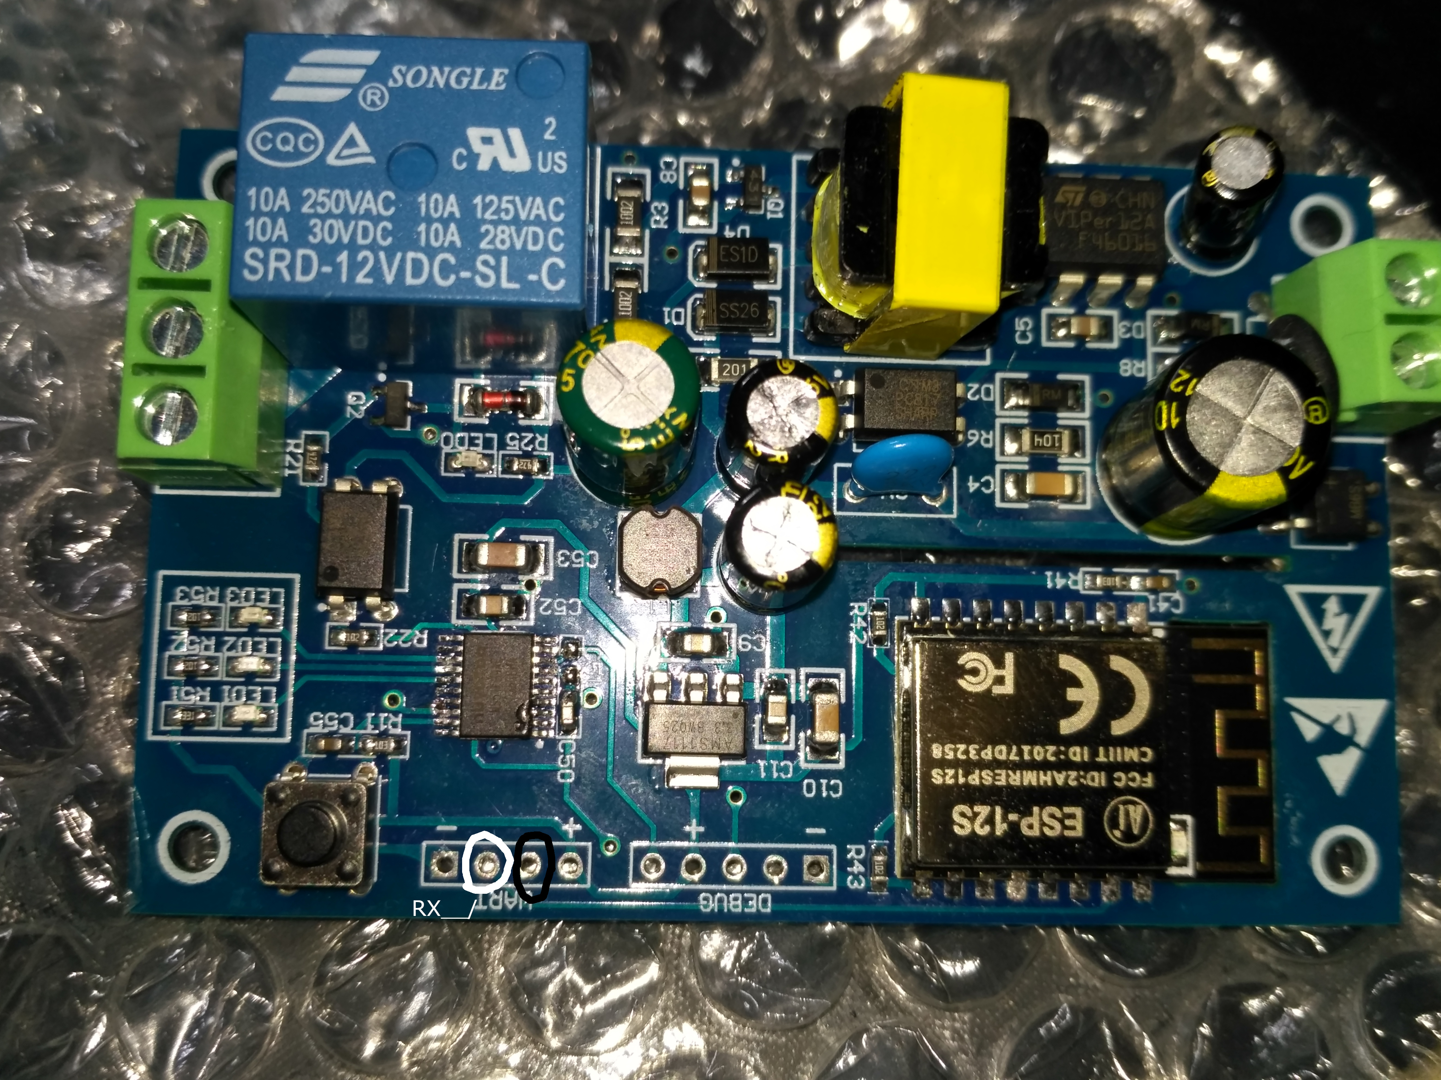
1) Pripojit UART – 3.3V.
2) Deska obsahuje Nuvoton svab, ktery komunikuje s relatkem a ESP. S ESP komunikuje pomoci serioveho spojeni (TX/RX piny). Dle fotky je treba Nuvoton ostavit tim, ze jej uvedeme permanentne do RST stavu. Dle datasheetu je to pin 4 a je treba ho uzemnit. Pin 4 je vyvedeny do debug header.
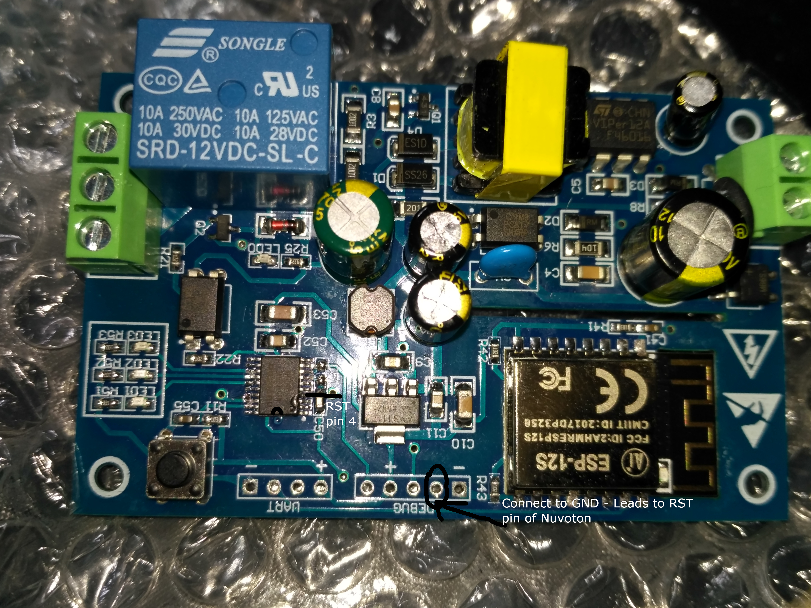

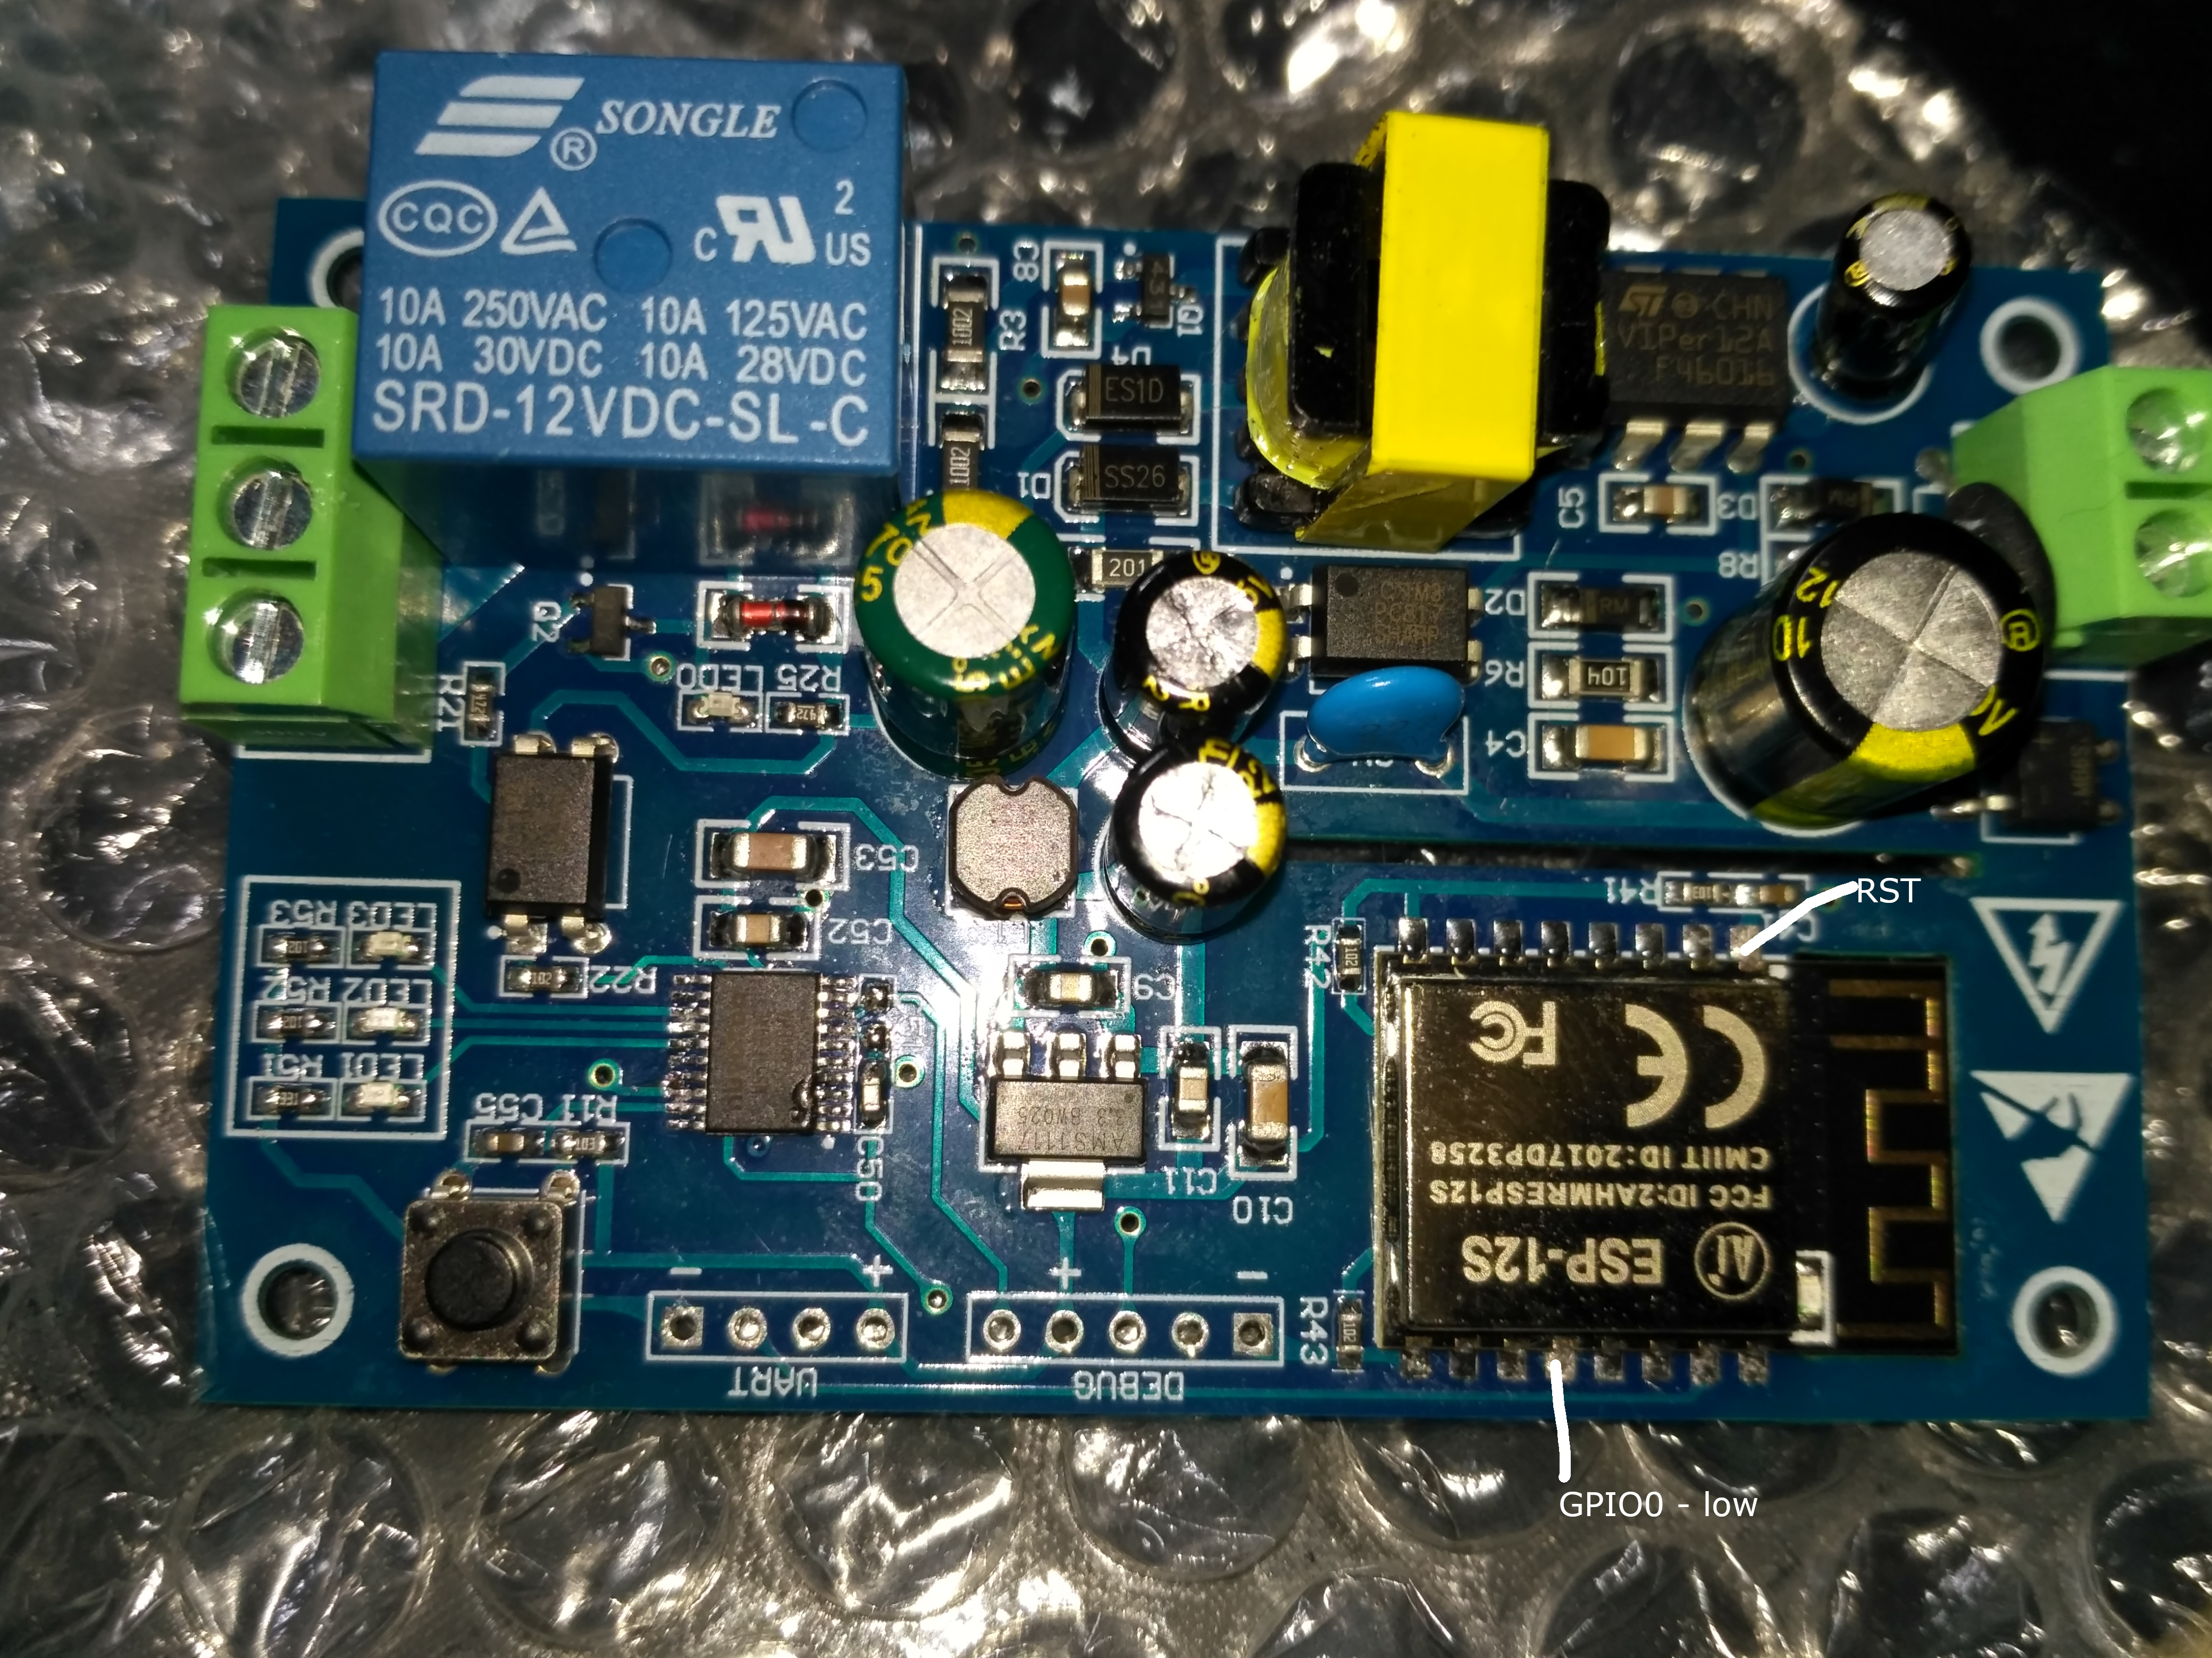
3) Flash ESP – je treba uzemnit GPIO0 na ESP pri privedeni energie. Nasledne je nutne mit GPIO0 stale uzemneny a soucasne uzemnit RST.

4) URL, ktere slouzilo jako odrazovy mustek pro nastaveni Tasmota firmware:
https://tasmota.github.io/docs/devices/LC-Technology-WiFi-Relay/
tasmota – jedno relay:
Template:
{"NAME":"LC-ESP12S-1R-5V","GPIO":[0,3200,0,3232,0,0,0,0,224,0,0,0,0,0],"FLAG":0,"BASE":18}
Rule do console:
Vypnout serial log, ktery jinak jde do nuv cipu
seriallog 0

TODO: Bude treba upravit jen pro jedno relay

Rule1 on System#Boot do Backlog Baudrate 115200 endon on SerialReceived#Data=41542B5253540D0A do SerialSend5 5749464920434f4e4e45435445440a5749464920474f542049500a41542b4349504d55583d310a41542b4349505345525645523d312c383038300a41542b43495053544f3d333630 endon on Power1#State=1 do SerialSend5 A00101A2 endon on Power1#State=0 do SerialSend5 A00100A1 endon on Power2#State=1 do SerialSend5 A00201A3 endon on Power2#State=0 do SerialSend5 A00200A2 endon on Power3#State=1 do SerialSend5 A00301A4 endon on Power3#State=0 do SerialSend5 A00300A3 endon on Power4#State=1 do SerialSend5 A00401A5 endon on Power4#State=0 do SerialSend5 A00400A4 endon Rule1 1

Alternativni firmware pro nuvoton:
https://github.com/nekromant/lctech-relay-altfw
Programator: nu-link (zadat na ali).

