Workshop in algorithms and data structures
Specification document

Nimrod Reiss
Mor Gazith
September 2008

- Introduction:
  - The following document specifies our work on implementing, testing and measuring performance of the Push-Relabel algorithm for the max flow problem, based on the article: "On Implementing Push-Relabel Method for the Maximum Flow Problem" by B. V. Cherkassky and A. V. Goldberg.
  - Our work is also be supported by the following articles:
"Network Flow Algorithms" by R.E. Tarjan, E. Tardos and A. V. Goldberg. And
"A New Approach To The Maximum Flow Problem" by B. V. Cherkassky and A. V. Goldberg.
  - The next pages describe our implementation of the algorithm, the testing plan and type of graphs on which we've tested the project, the tests results, and some explanation of running and using the source code.
  - Project's purpose:
    - We noticed that many times, a maximum flow is limited due to "bottlenecks" in the flow (meaning specific saturated edges with low capacities), in order to elaborate the tests done in the article we plan to implement a "flow-fix" mechanism, meaning that we allow an increase in the capacity of one saturated edge after the maximum flow has been computed, thus testing how the push-relabel method behaves with these changes.
Push Relabel had been tested only as a stand-alone max-flow algorithm; in our workshop we will test the efficiency of the algorithm when a capacity changed after algorithm ends. By this we will mimic a simple "real-time" environment test. Unlike the static version of the original article, our benchmark results contain some interesting conclusions.
    - We've compared two optimization methods, the HL method and the FIFO method, which selects nodes in different orders, we've checked if the selection made by the original article really is the best choice.
    - We test different family graphs and tried to "tweak" the graphs to be as similar to the practical problem as possible. Some practical, real-life problems include roads traffic load, airline scheduling, image processing, communication network reliability, etc.
    - The original paper was published in 1994, and therefore all the benchmarks are on hardware that is now obsolete, A SUN sparc-10 workstation model 41 with 40MHZ processor running SUN Unix version 4.1.3 with 160 megabytes of memory, we plan to run our code on a computer much more modern PC, with higher capabilities in order to check whether the conclusions hold up to the test of time.
  - Environment:
    - We've implemented our project in the C++ programming language. Our IDE is Microsoft Visual Studio.
We chose this programming language in order to work in an object oriented environment which is more suitable for benchmarking but without sacrificing much of the performance (as in Java).

- Push-Relabel:
  - Algorithm in a nutshell:
    - Basically, the algorithm is built upon two main stages, preflow and flow.
The preflow stage calculates an "almost legal" flow, in which nodes in the network can have excess; meaning can send less flow out than the flow in.
The flow stage makes the preflow calculated in the previous stage a legal flow (no excess in the nodes, except, of course, the sink node).
    - The calculations are done using two main methods: push and relabel, as defined more thoroughly below.
Push pushes flow from a node a neighboring lower label nodes.
Relabel relabels a node.
  - Push-Relabel explained:
    - The push-relabel algorithm is one of the most efficient algorithms to compute a maximum flow. The general algorithm has O(V²E) time complexity, while the implementation with FIFO vertex selection rule has O(V³) running time, the highest active vertex selection rule provides 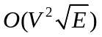 complexity.
Given a flow network G(V,E) with capacity from node u to node v given as c(u,v), and source s and sink t, we want to find the maximum amount of flow you can send from s to t through the network.
Two types of operations are performed on nodes, push and relabel.
We use the following definitions:
      - f(u,v) - the flow from u to v.
      - c(u,v) – the capacity of the arc (u,v).
      - Available capacity is c(u,v) − f(u,v).
      - height(u) – An auxiliary variable used to measure the "height" of each node, in this algorithm, flow can only go from a higher node to a lower one.
      - 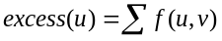 - The sum of the flow to and from u.
    - After each step of the algorithm, the flow is a preflow, satisfying:
      - 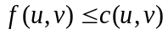, meaning that the flow between u and v does not exceed the capacity.
      - 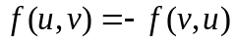 meaning that we maintain the net flow.
      - 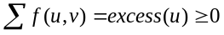 for all nodes 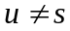meaning that only the source may produce flow.
    - We observe that the longest possible path from s to t is | V | nodes long. Therefore it must be possible to assign height to the nodes such that for any legal flow, height(s) = | V | and height(t) = 0, and if there is a positive flow from u to v, height(u) > height(v). As we adjust the height of the nodes, the flow goes through the network as water through a landscape. Differing from algorithms such as Ford-Fulkerson, the flow through the network is not necessarily a legal flow throughout the execution of the algorithm.
    - In short words, the heights of nodes (except s and t) is adjusted, and flow is sent between nodes, until all possible flow has reached t. Then we continue increasing the height of internal nodes until all the flow that went into the network, but did not reach t, has flowed back into s. A node can reach the height 2 | V | − 1 before this is complete, as the longest possible path back to s excluding t is | V | − 1 long, and height(s) = | V | . The height of t is kept at 0.
    - Definition: A push from u to v means sending a part of the excess flow into u on to v. Three conditions must be met for a push to take place:
1. excess(u) > 0 - More flow into the node than out of it so far.
2. c(u,v) − f(u,v) > 0 - Available capacity from u to v.
3. height(u) = height(v) + 1. Can only send to lower node.
We send an amount of flow equal to min(excess(u),c(u,v) − f(u,v)).
    - Definition: Doing a relabel on a node u is increasing its height until it is higher than at least one of the nodes it has available capacity to. Conditions for a relabel:
1. excess(u) > 0 - There must be a point in relabelling.
2. 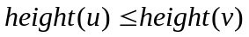for all v such that c(u,v) − f(u,v) > 0 - The only nodes we have available capacity to are higher.
    - When relabelling u, we set height(u) to be the lowest value such that height(u) > height(v) for some v where c(u,v) − f(u,v) > 0.
    - Push-relabel algorithms in general have the following layout:
As long as there is legal push or relabel operation:
Perform a legal push, or a legal relabel.
    - Definition: a discharge on a node u is the following:
As long as excess(u) > 0:
If not all neighbours have been tried since last relabel Try to push flow to an untried neighbour, Else Relabel u.
This requires that for each node, it is known which nodes have been tried since last relabel.
- Implementation of the algorithm and used data structures:
  - Brief:
    - Our implementation is based on the Push-Relabel maximum flow algorithm with highest label node selection and FIFO node selection variations, meaning the order in which we select the next node to discharge can be either by FIFO (the first node that was queued), or by the highest labeled node in the queue.
    - We've used API function to call all the data structures methods so the implementation could change without making modifications to the code.
    - Data structures include priority queue (for the highest label method) and FIFO queue (for the FIFO selection method).
  - Main classes:
    - PushRelabel – a static class containing the push-relabel algorithm methods.
Methods include: calc, recalc, push, relabel.
Used by main.
    - Graph – represents the entire graph. Contains parsing and printing methods. Holds the DS for the nodes and edges.
Methods include: readGraph, printGraph, incEdgeCapacity
    - Node – represents a node in the graph. Contains a list of edges.
Methods for setting and getting label, edges list, excess, etc.
    - EdgeEntry – represents an edge in the graph. Contains pointers to next and previous edges. Pointer to the reversed edge.
Methods for setting and getting capacity, flow, end-node, etc.
    - NodePool – Abstract class to be implemented by FifoQueue, HighLabelQueue and PriorityQueue.
    - FifoQueue – DS for maintaining the queued nodes in the algorithm. Obtains a FIFO order.
    - HighLabelQueue – DS for maintaining the queued node in the algorithm. Obtains a Highest label first order – using an Ad hoc implementation of a priority queue.
    - PriorityQueue – DS for maintaining the queued node in the algorithm. Obtains a Highest label first order – a generic STD priority queue was tried out, but gave poor performance.
    - Utils – contains some defines and special functions, used by the entire project.
- Usage:
  - Each graph is generated by one of the generators listed in section graph families, and saved in a .grp format:
a predefined header, explaining the type of generated graph, the source and sink nodes, and other info, followed by an info line per node, e.g.:
"a" <from> <to> <arc capacity>
a 1 2 300
a 2 6 11
a 2 5 58
a 2 7 34
  - Program parameters:
    - The program's usage is as follows:
pushrelabel FILE [-c INC NEW-OUT] [-s] [-o OUT] [-m HL/FIFO]
      - FILE – graph file in the above format.
      - -c – specifies that the max flow need to be recalculated after a capacity change.
Where INC is the capacity to increase - must be a positive integer.
The new max flow is saved in file NEW-OUT.
      - -s – print statistic data to screen.
      - -m – use the HL or FIFO queue method
      - -o – save calculated flow to file: OUT.
Graph families:
  - We've used a number of generators in order to test different types of graphs, using many different parameters such as height, width, density, node's degree, etc.
  - The generators are of-the-shelf implemented generators, used by DIMACS challenges.
  - We've used the following graph families (using the generators: Washington, AC, and genrmf, Acyclic-dense):
    - Washington graphs have <width> layers, each layer containing <height> nodes, each node is randomly connected to three nodes in the next layer. The source is connected to all nodes of the first layer, and the last layer's nodes all connected to the sink.
      - Washington wide – width >> height.
      - Washington long – height >> width.
      - Washington medium – height ~ width.
    - Acyclic-Dense – a full graph with random capacities between nodes.
    - Genrmf graph family has b (depth) pieces of frames of size (a x a) (a – frame size).
In each frame all the vertices are connected with their neighbours. (forth and back). In addition the vertices of a frame are connected one to one with the vertices of next frame using a random permutation of those vertices.
- Benchmarks:
  - The main aspects of the calculation that were good benchmarks were:
    - Time of calculation.
    - Number of pushes and relables
  - Those aspects were compared using the following states:
    - Type of graph.
    - Normal calculation vs. re-calculation (after a capacity change).
    - Node selection method: FIFO vs. Highest Label.
  - The results shown are the average results of several runs, to prevent compromising results by background tasks (e.g. OS processes).
  - Tests were run on PC with Quad 2.4MHz cores running Windows Vista with 2GB of memory. Our code was written and compiled with Visual C++ 2008 express edition
  - Results:
In order to compare results we counted the number of pushes and relabels that are done per run, we also used the standard <ctime> library in order to check the system clocks.
Note – At first we thought we will test the STD priority queue implementation in our benchmarks but after running a few tests we found it was far too slow so it was not included in our benchmarks.
    - Normal Calculations:
After running the tests on three different graph families the results are:
      - Washington Graphs:
Washington generated graphs provides the fastest solutions using the push relabel algorithm, as seen on figure 5.1. Trying wide, long and medium graphs (in height-width ratio) had little effect on computation efficiency. FIFO selection method provided better results than the HL method, the pattern shown in figure 5.2 might suggest greater differences as number of nodes increases.
      - AC Graphs:
These graphs are slightly less "Push-Relabel friendly" showing worse times than Washington generated graphs with similar number of nodes.
We can see a slight advantage to the HL method in terms of pushes and relabels (figure 5.3), and in the clocks/nodes we can see the same slight advantage to the HL (figure 5.4).
      - Genrmf Graphs:
In our tests we used a constant amount of blocks (10) and changed their size, under these conditions we found that the HL method became much more efficient (clock-wise) as the number of nodes grew, doing the calculation in half the time and even less (figure 5.5). The total number of pushes and relabels, however, did not differ as much, although it was always lower on the HL method (figure 5.6).
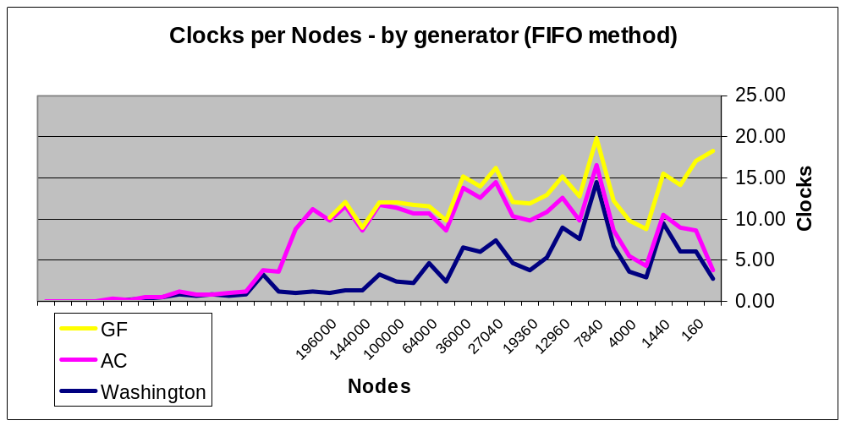
Figure 5.1 – comparison between the different graph generators.
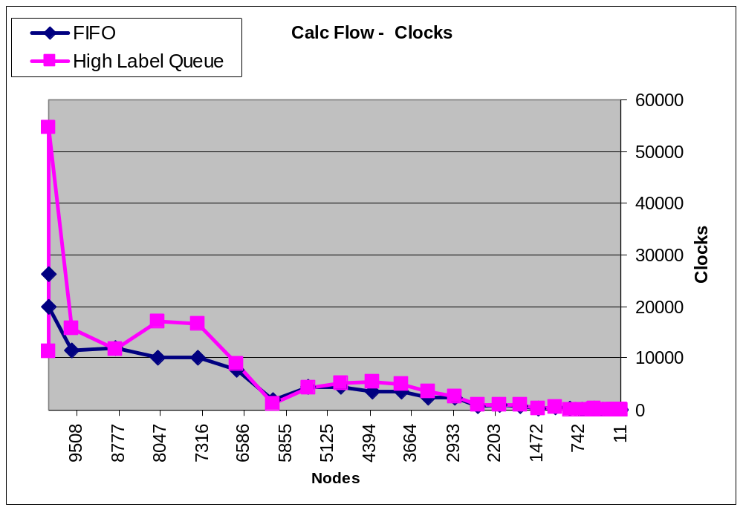Figure 5.2 – FIFO and HL selection in Washington graphs
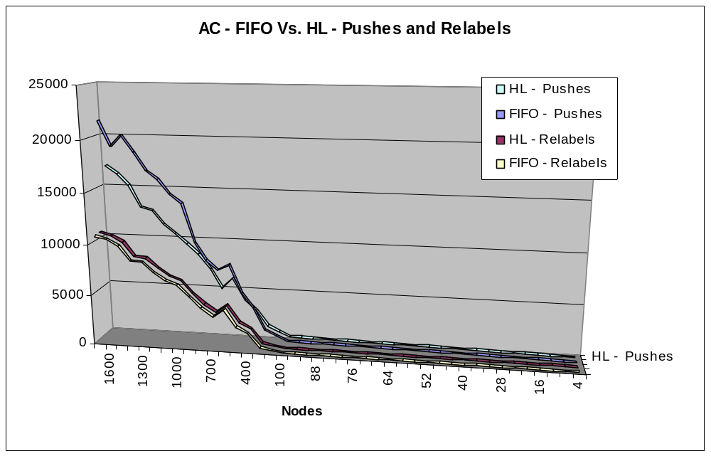Figure 5.3 – Number of operations in FIFO and HL in AC graphs
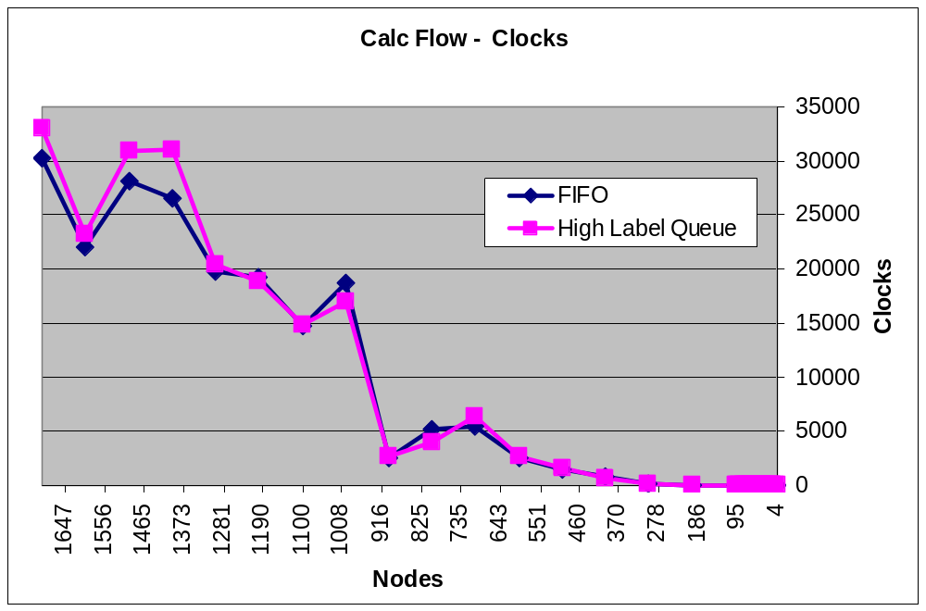Figure 5.4 – FIFO and HL times in AC graphs
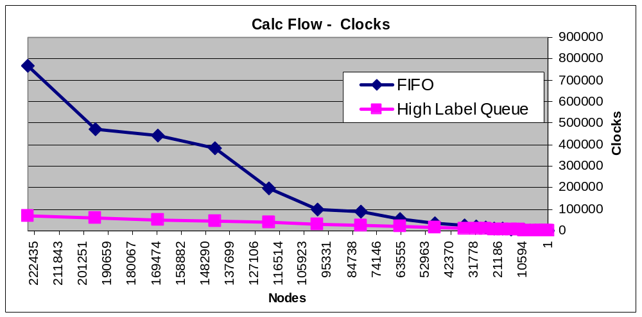
Figure 5.5 – FIFO and HL times in Genrmf graphs
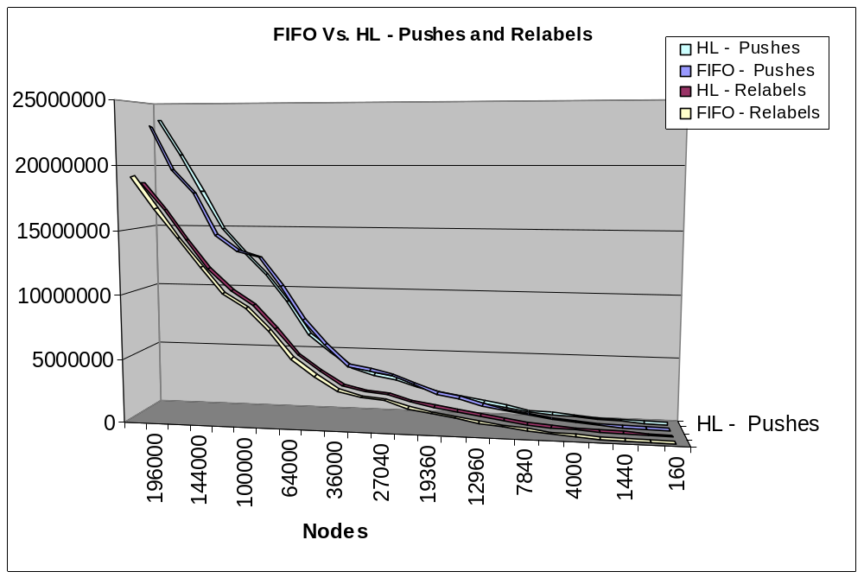
Figure 5.6 – Number of operations in FIFO and HL in Genrmf graphs

    - Recalculations:
When approaching the recalc problem, we assumed that a "bottleneck" in the graph was "stretched" thus allowing more flow to flow from the source to the target.
Obviously that required us to find that bottleneck and increase the capacity. At first we tried to implement Dijkstra's algorithm on the residual graph from the source and from the sink, testing the distance labels and finding two nodes which are reachable (one from the source and one from the sink) and have an edge between them. This method was implemented but the problem was that the bottlenecks don't necessarily consist of only one edge.
So we decided to take a different approach, as we know, if there is a path in the residual graph between the source and the sink, it is possible to increase the flow by saturating that path, so we found a path (in the normal graph) between the source and the sink using a BFS algorithm and increased the capacity of all edges along the path, thus assuring we can increase the total flow.
Now that we know that the graph can increase its total flow it was time to decide on a recalculation method.
At first the PushRelabel method was tested, running the same algorithm on the residual graph. This gave us better times then the first calculation, but then we realized that the problem that we were testing did not require a full calculation and that only one path exists between the source and the target, so we used our Dijkstra implementation in order to find a path in the residual graph thus saturating the path.
So our benchmarks compare several things:
1. Time in system clocks: FIFO method vs. HL method vs. Dijkstra method
2. Number of pushes and relabels needed in the recalculation compared to the original calculation.
Parameters 1 and 2 are tested on the three different graph families (described above).
      - In this section we have found very interesting results.
In graph generators Washington and AC there hasn't been much improvement in the time took to recalculate the max flow (figures 5.7 – 5.10). However, as seen in figure 5.11, and figure 5.12 the Genrmf generated graphs shows great improvement using our recalculation technique both in HL and in FIFO queues. Genrmf graphs are made of highly connected, fixed size clusters (, interconnected between them by a limited number of arcs. This type of topology is used in real life networks such as intranet in big office buildings (where each office represent such a cluster) etc.
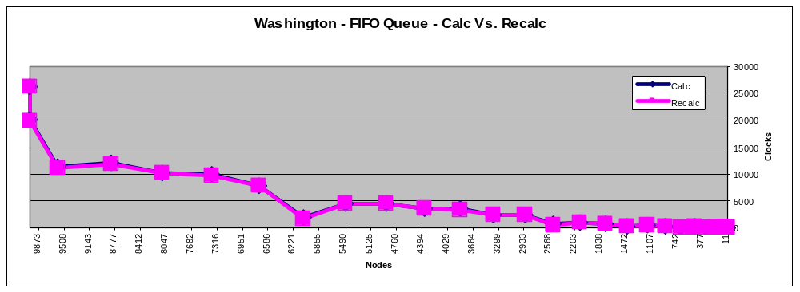Figure 5.7
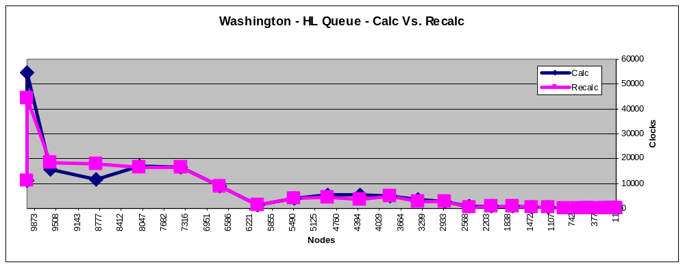Figure 5.8
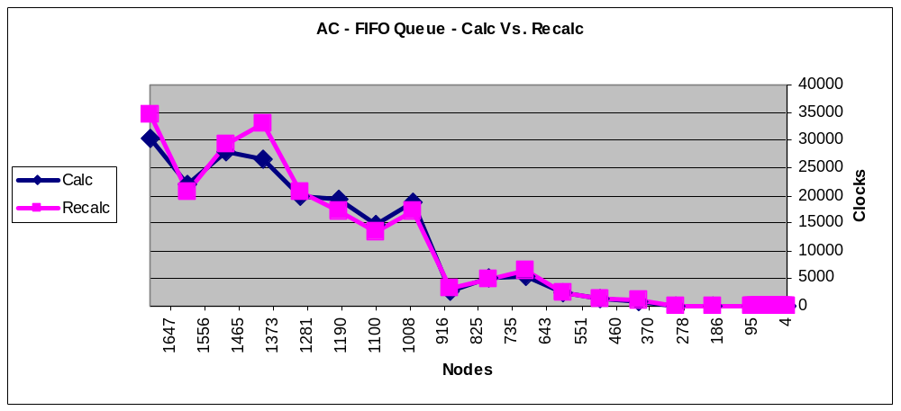
Figure 5.9
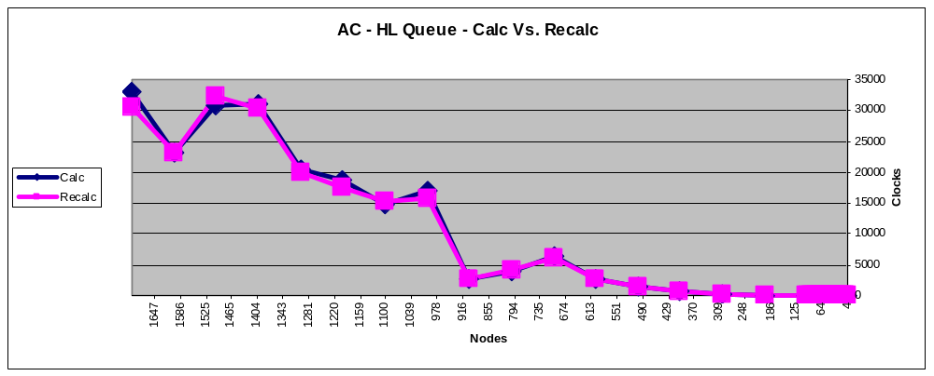
Figure 5.10
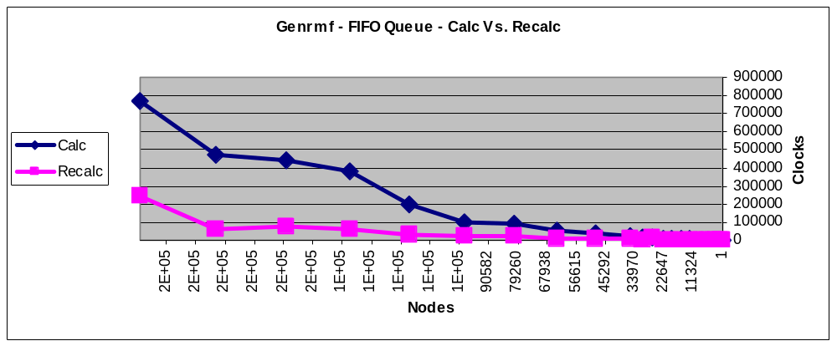
Figure 5.11
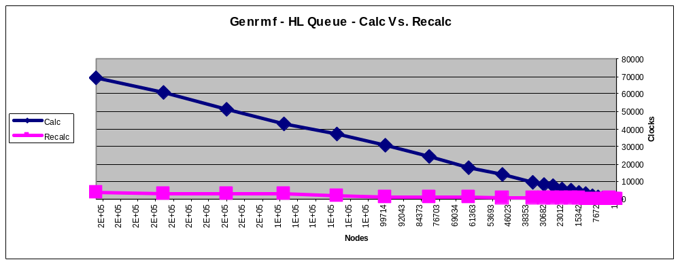
Figure 5.12
    - In conclusion, we can come to the following:
      - The push relabel algorithm is suitable to certain graph types more than others, as in our tested graph families the Washington graphs were best suitable.
      - The recalc technique suggested in this work is very much suitable to some graph types, as in our tests the Genrmf graphs showed incredible results.
      - The recalc technique, therefore, should be considered when a max flow needs to be calculated on a real-time clustered network.
      - Most of the figures above show relatively linear characteristics, showing good scalability by the push relabel algorithm.
      - The above is in contrast to the findings of Cherkassy and Goldberg in their article "On implementing push-relabel method for the maximum flow problem", which shows logscaled linear graphs, suggesting that perhaps modern compilers and/or hardware design can better coupe with specific algorithms making outdated findings re-examinable.

