**PDF MERGER**

**USER MANUAL**

Version 1.0

27-09-2023

## Introduction

The pdf-merger is a visualization tool to import pdf files and swap, insert or delete pages. This manual provides an overview of the program use and available functions.

Executing the program opens the GUI from figure 1.

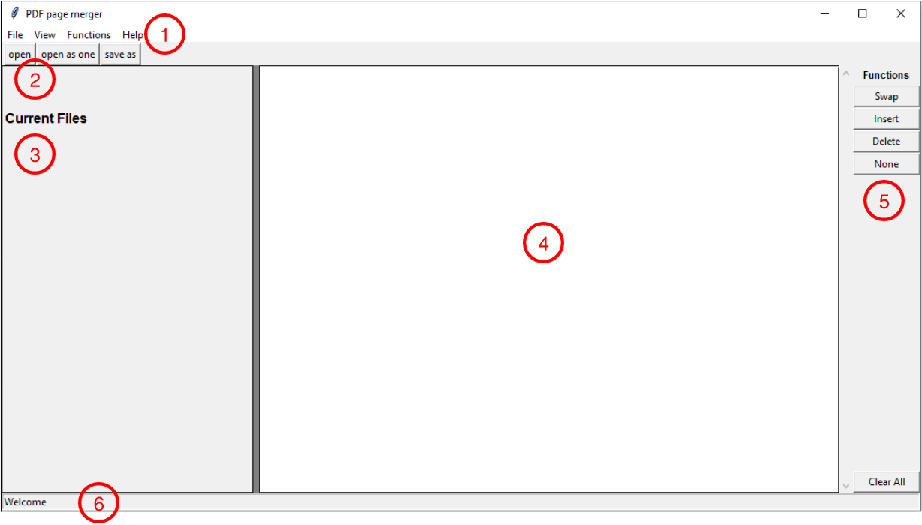

Figure 1: GUI overview

The GUI contains the following 6 panels:

1 – Menu bar

2 – Top menu

3 – Current pdf files

4 – Page visualization frame

5 – Function panel

6 – Status bar

All functions and options are accessible through the menu bar(1) options. The following chapter holds an overview of all these functions.

The top menu(2) and function panel(5) have buttons to address the same functions as the menu bar.

The imported pdf files are listed in the current pdf file section(3). Their numbering corresponds to the first number in the page details on the page visualization frame.

All pages of the imported pdf’s are shown in the page visualization frame(4), except for pdf’s opened as one. In this case only the first page is imported with an ‘A’ mark at its left top corner.

The status bar(6) corresponds to the user by giving updates on the current or finished process.

## Menu bar

### File

The open pdf and save functions can be addressed via the file menu. The *Open pdf* function imports all pdf pages to the visualization frame. The *Open pdf as one* function will only show the first page of the document. Both opening functions allow for multiple pdf’s to open at once.

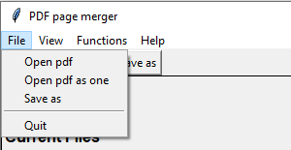

Figure 2: Expand the file menu

The example below has all the blue pages imported via *Open pdf*. For the green page only the first page in imported with an additional letter A at the right top corner (*Open pdf as one*).

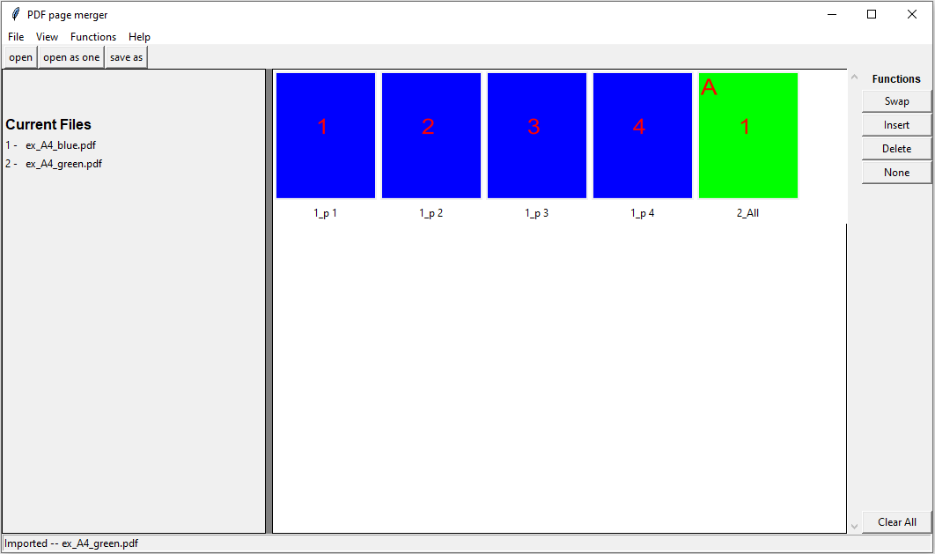

Figure 3: Visualization blue pdf and green pdf as one

### View

The view menu allows the user to change the page size in the visualization frame, as well as adding page details.

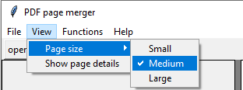

Figure 4: Expand the view menu

In the example below the page size has been set to Large and the page details are presented. The first number of the page details corresponds to the current file numbering.

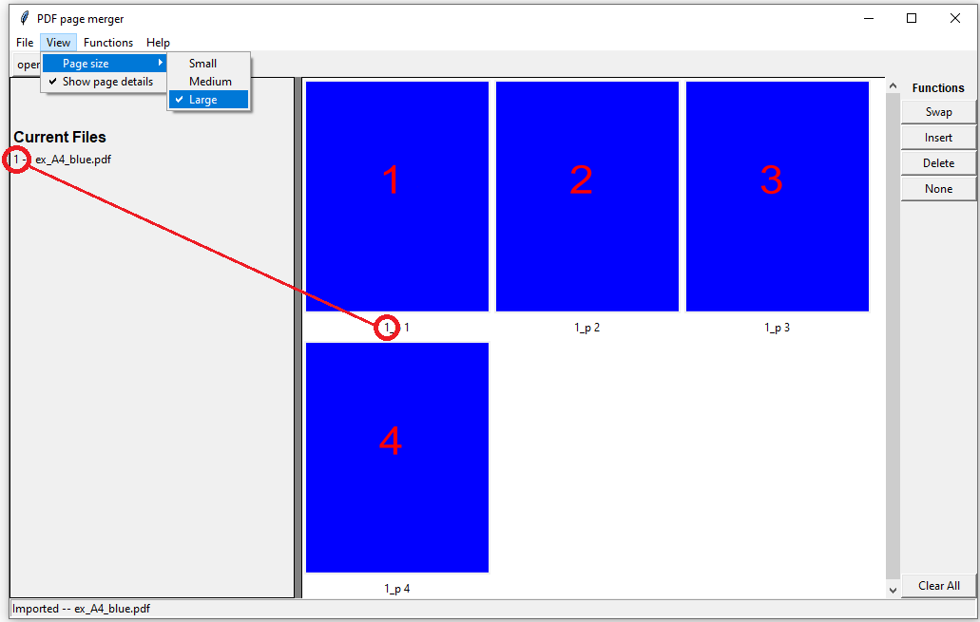

Figure 5: Example with large page size and page details activated

### Functions

All page manipulation tools can be used via the *Functions* menu. A detailed description of these function is presented in the following chapter.

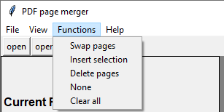

Figure 6: Expand the functions menu

### Help

This user manual can be found under the *Help* menu.

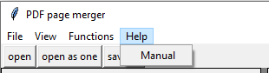

Figure 7: Expand the help menu

## Functions

### Swap pages

Activating the swap functions allows the user to swap the selected pages one by one.

In the example below the place of page three is swapped with page one.

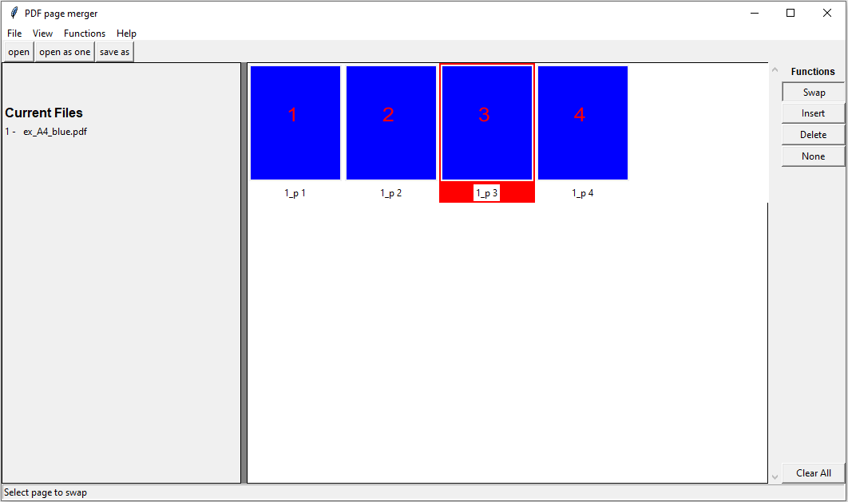

Figure 8: Select page 3 by clicking with the mouse

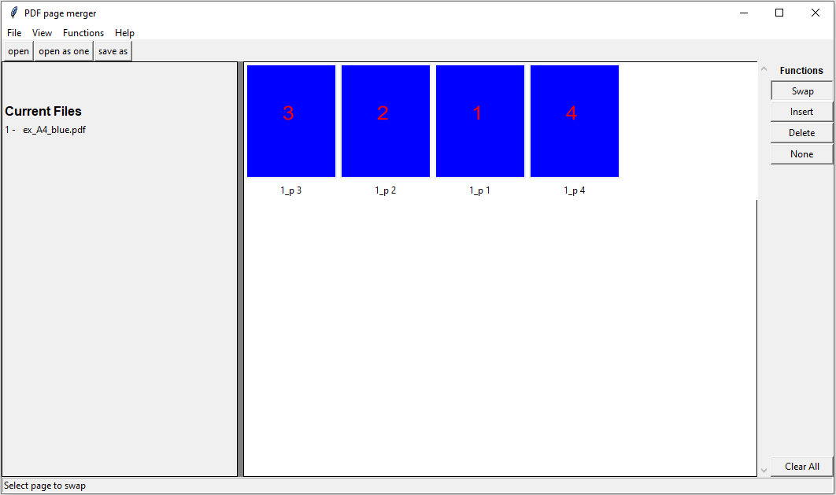

Figure 9: Swap by clicking on page 1

### Insert pages

Activating the Insert functions allows the user to insert multiple pages at a new location.

In the example below the pages 4 of the blue and green documents are inserted at the front.

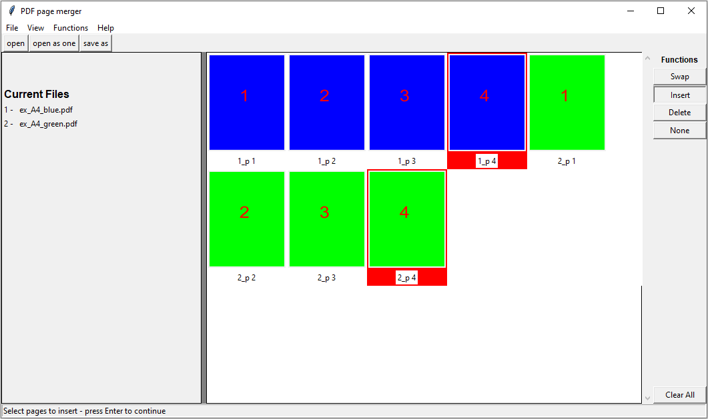

Figure 10: Select multiple pages by holding the shift-key, press Enter to finish selection

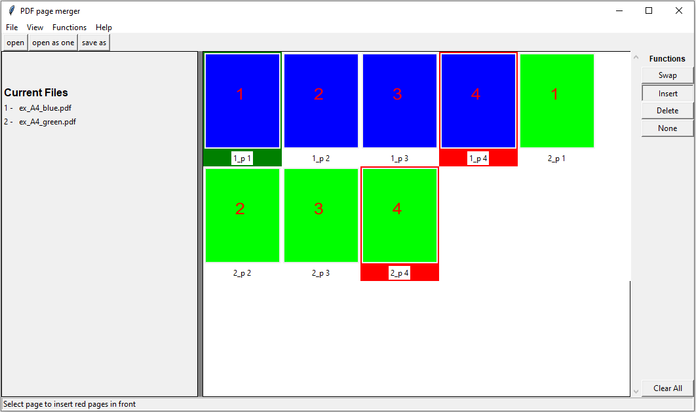

Figure 11: Select the location (green) to insert the red selected pages, press Enter to continue

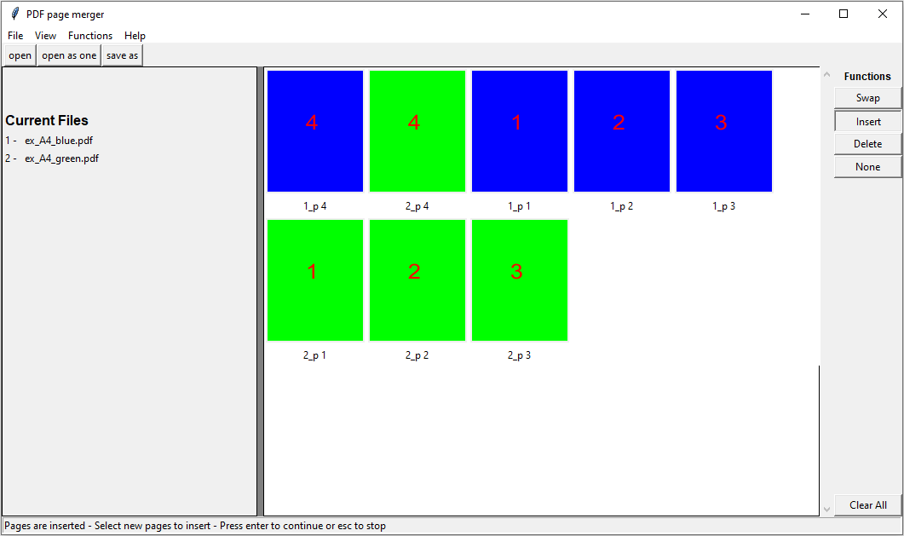

Figure 12: The selected pages are inserted with their original order, in this case blue before green

### Delete pages

Activating the delete function allows the user to delete multiple pages.

In the example below all even numbered pages will be deleted.

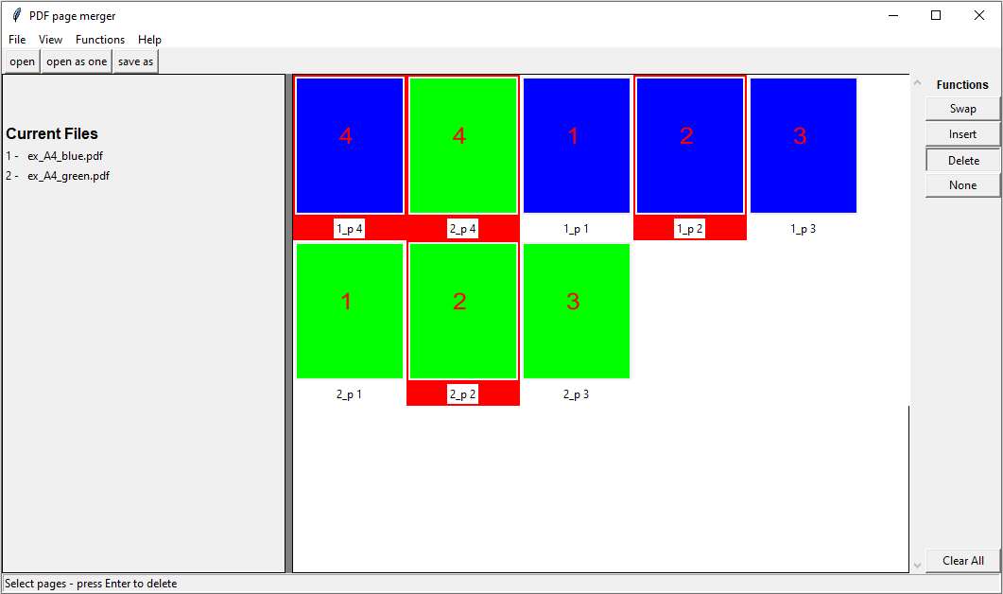

Figure 13: Multiple pages are selected by holding the shift-key

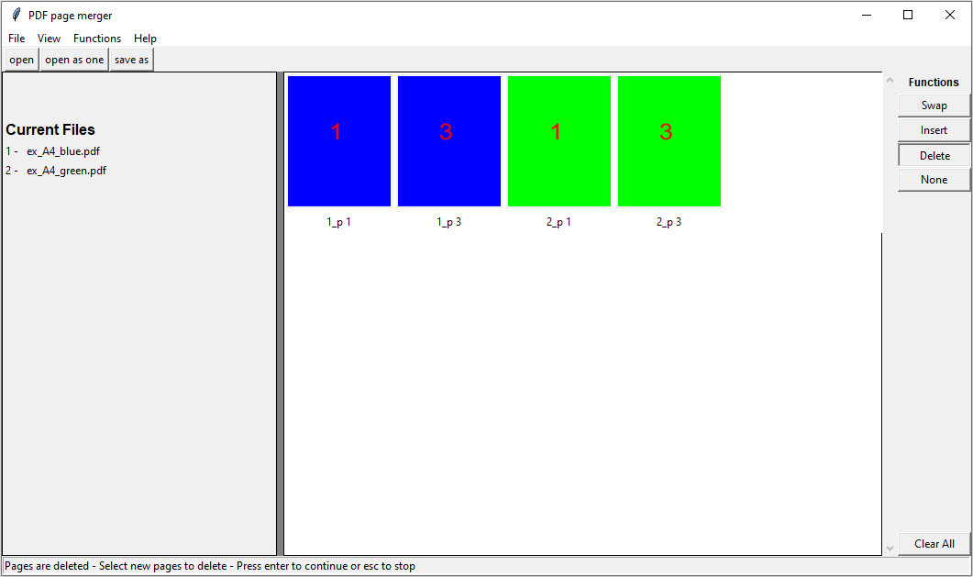

Figure 14: Press enter to delete the selected pages

### None

Deactivate any active function.

### Clear All

Remove all pages from the visualization frame and clear the *Current Files* panel.

## Hotkeys

|  |  |
| --- | --- |
| **Key** | **Description** |
| 1 | Swap function |
| 2 | Insert function |
| 3 | Delete function |
| o | Open file |
| s | Save as |
| Mouse 2 | Enter |