Create Reports tab.
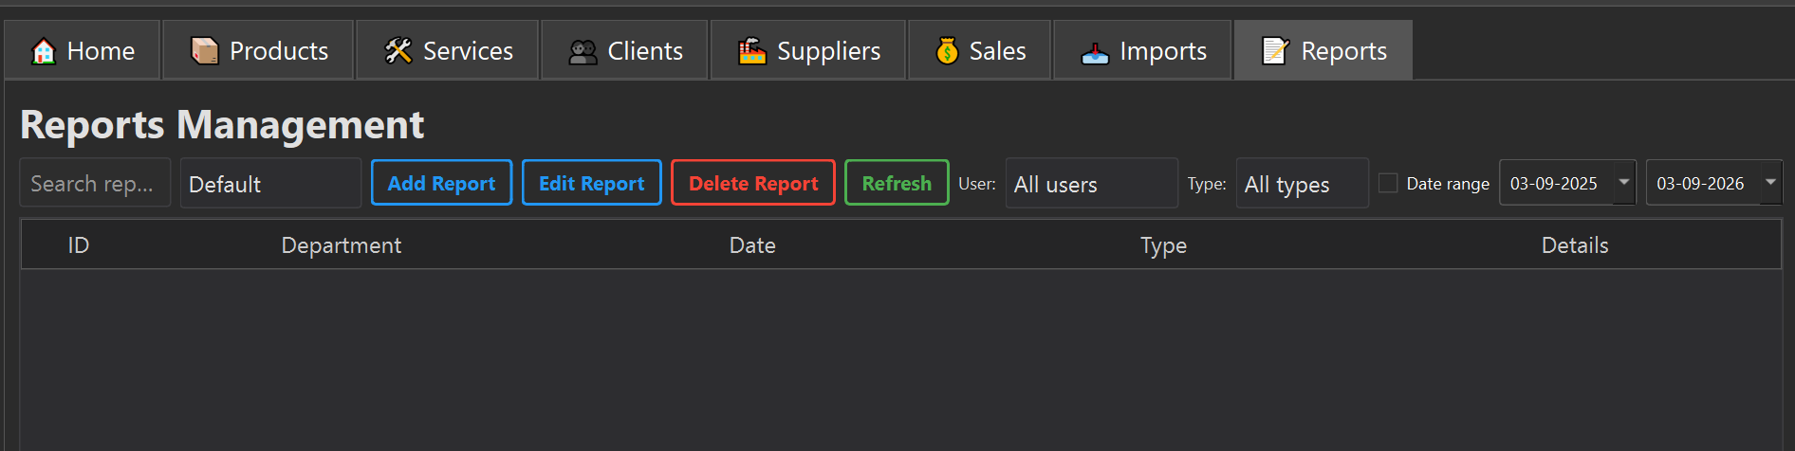
Add view details button in table
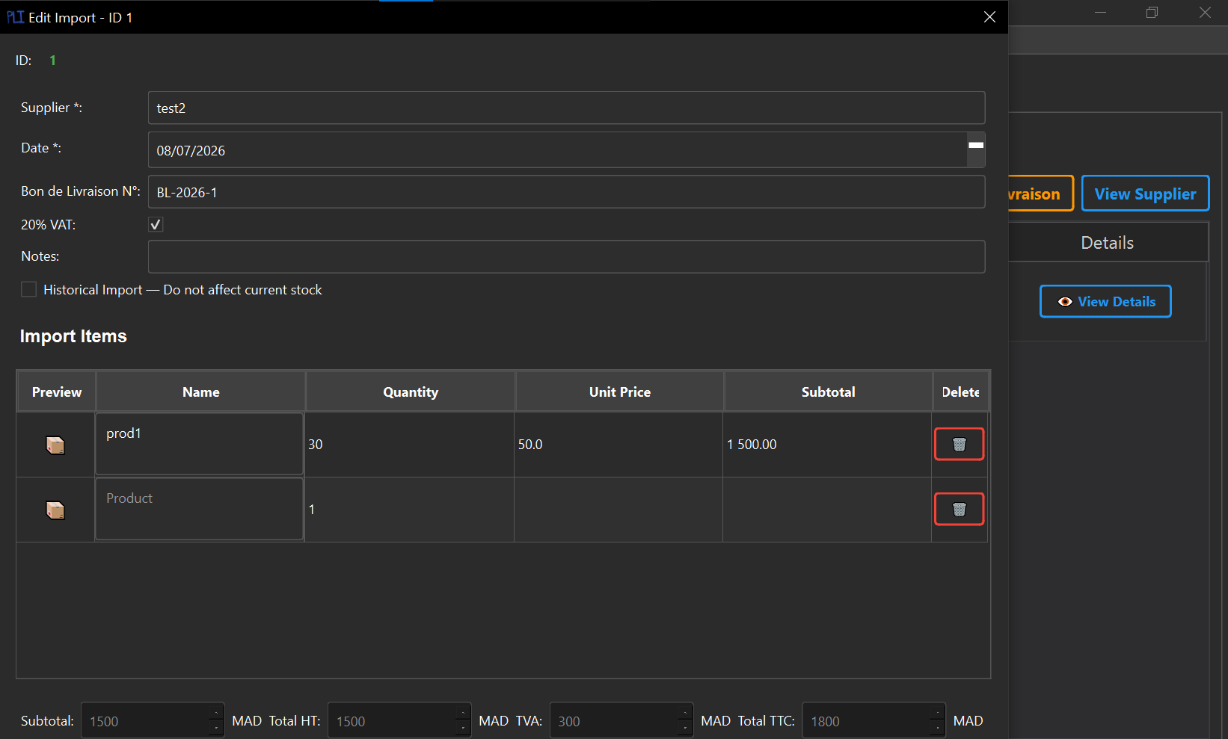
Create payment button in orders
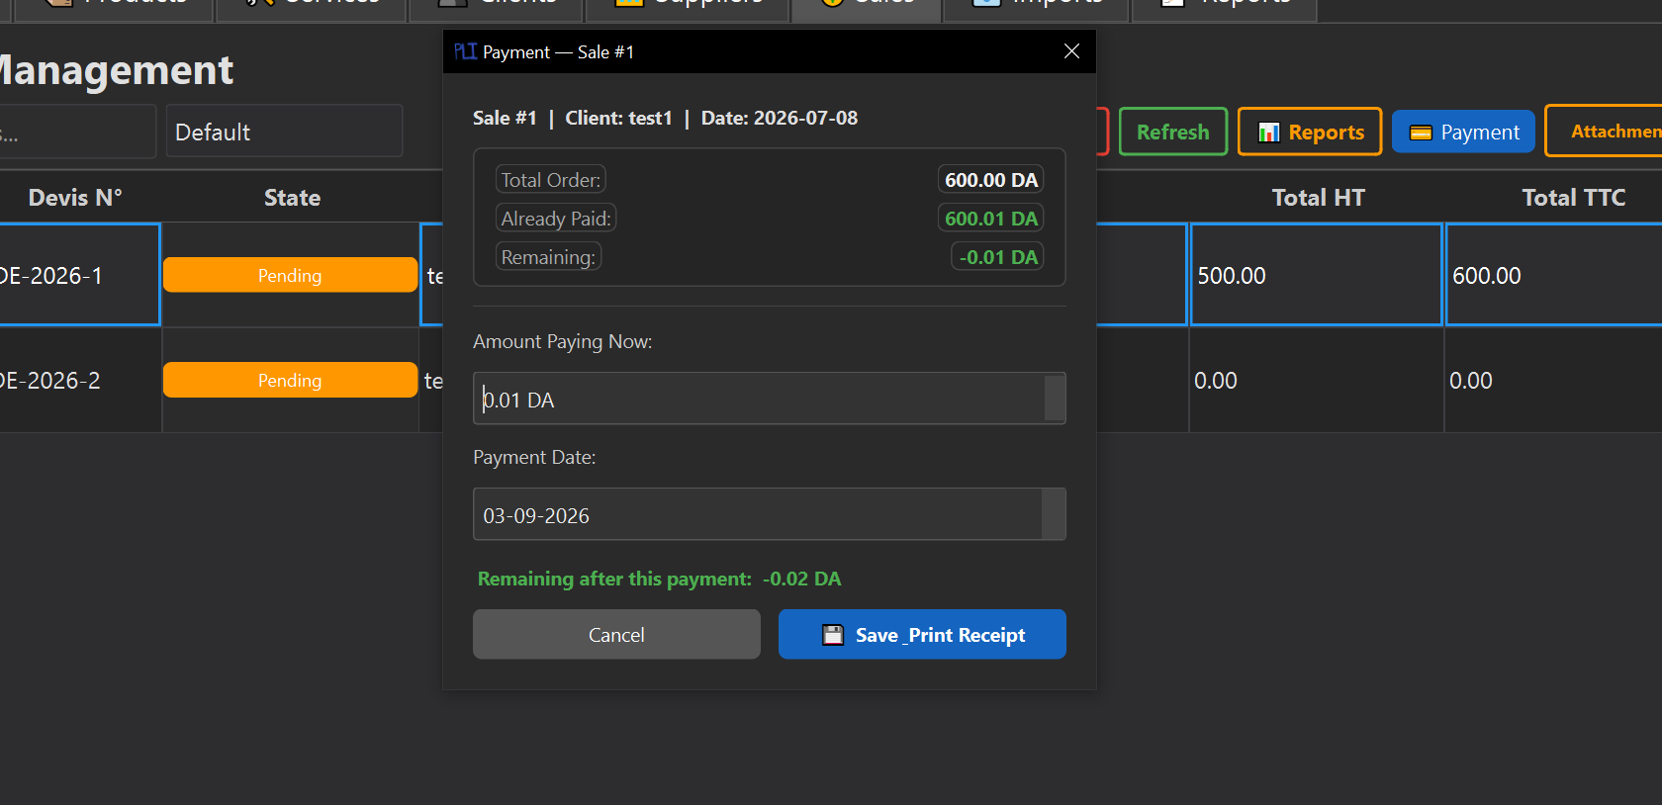
Set up network connection, users, roles, permission, and databass(PostgreSQL)
