Madison Rockwell

**history | cut -c 8- | cut –d” “ –f1 | sort | uniq -c | sort -nr | head**

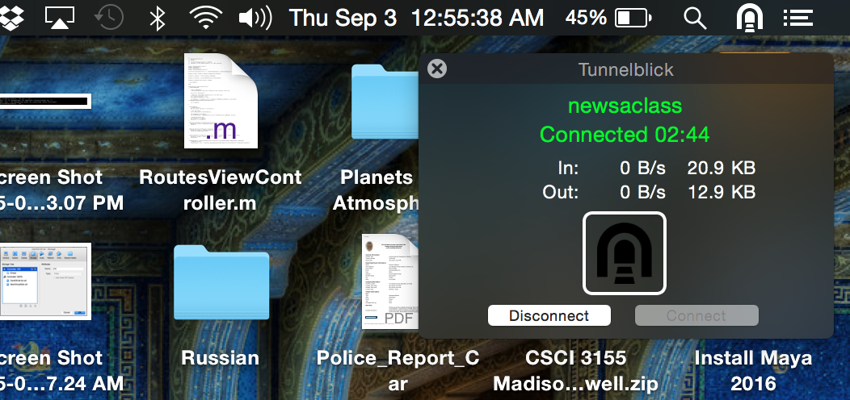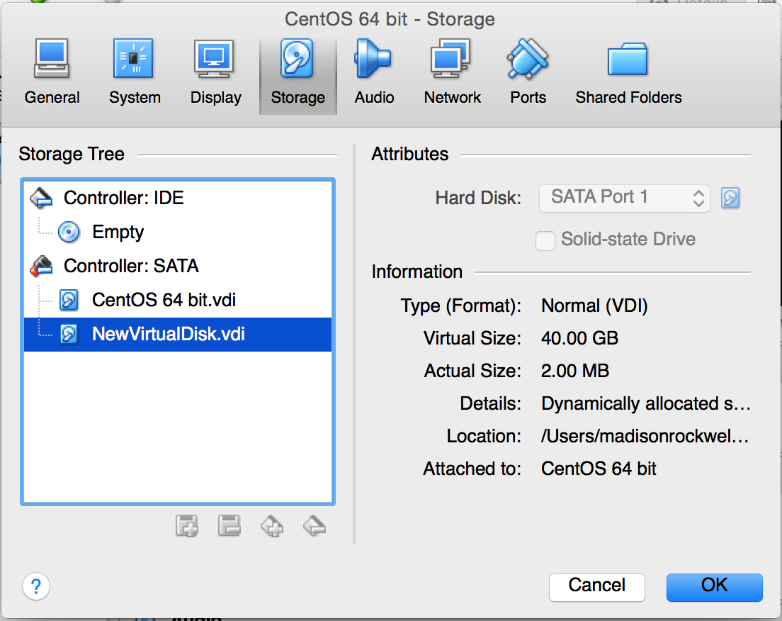

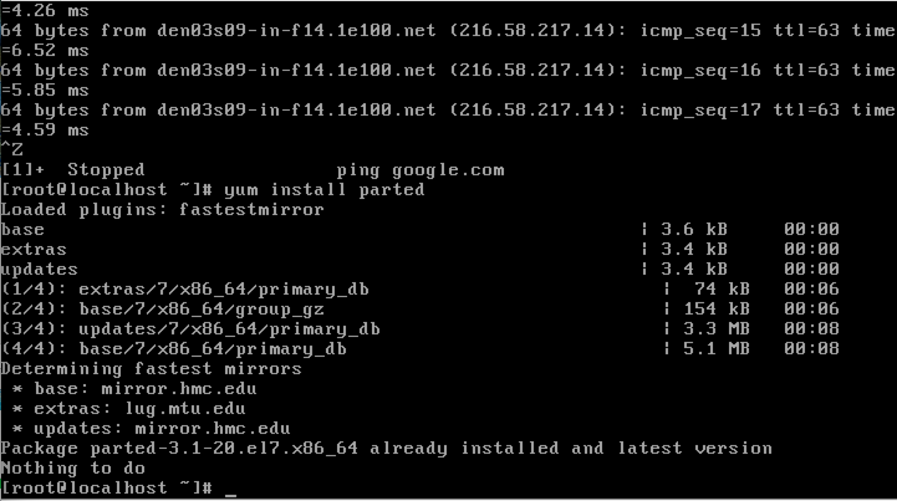

**When using cut –d –f_ I am confused as to whether the count starts at 0 or at 1. For the first value do you put –f0 or –f1?**

**Bash Shortcut:**

**Run “cd –“**

**This will take you to your last working directory and print out the file paths like with pwd.**