Madison Rockwell

**ps hax –o user | sort | uniq -c**

* 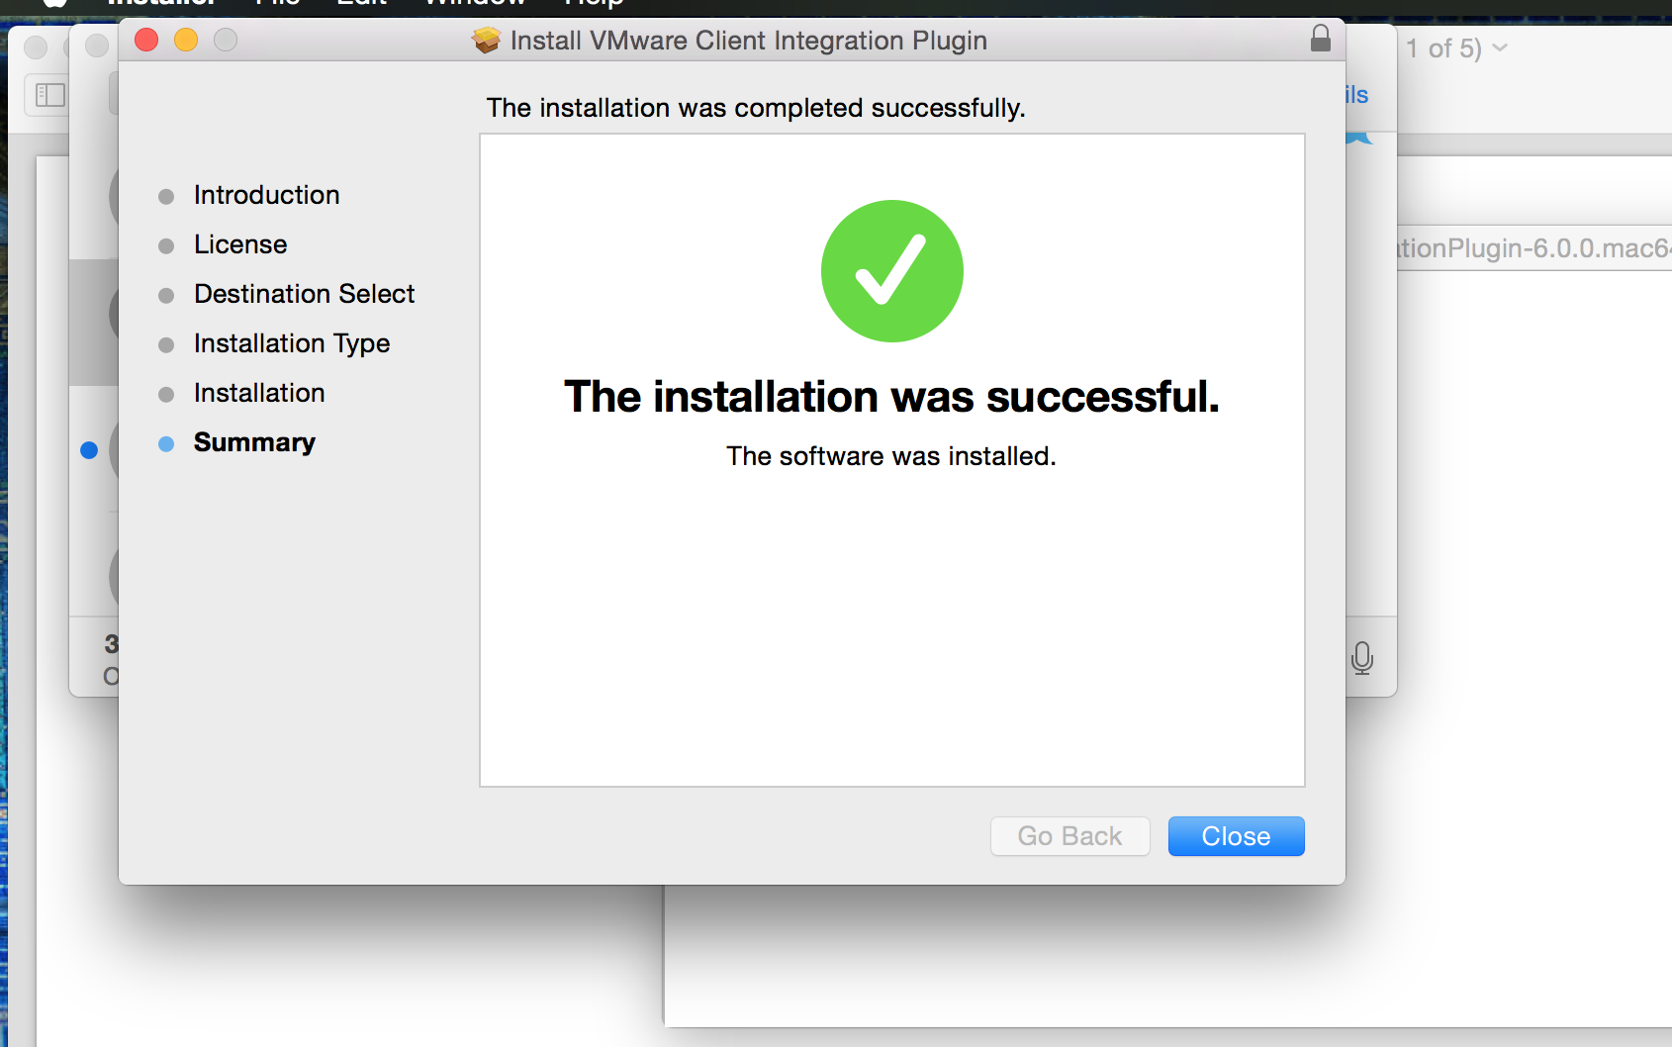
* I’m still confused about what a logical volume is and how it
* works.