Madison Rockwell

Basic Exercises

1.Once the virtual machine has finished booting, use the command pwd to print the current (or present) working directory.

2.How many files does the home directory contain?  A simple way to find out is to use the ls command.

**1 file.**

3.How many hidden files does the home directory contain?  With no arguments, the ls command doesn’t show hidden files.  Look at the man page for ls by running the command ‘man ls’.  You can navigate in the man page by using the up and down keys.

**6 hidden files**

**Found by calling “ls –a”**

4.In what directory would you expect to find the cp command?

**Locationg: /usr/bin/cp**

**Found by calling “which cp”**

5.Where is the command to make a directory (mkdir) located on the filesystem?  What command did you use to find mkdir?  Give an alternative to the command you initially used to find mkdir.

**Located in /user/local/bin**

**Found by calling “find / -name mkdir”**

6.Use the mkdir command to create a new directory under the root user’s home directory (i.e. /root/).  Name it anything you’d like.  Use the touch command to create a file under that new directory.  What does the new file contain?

**The file contains nothing, it is an empty file.**

7.By default, the rm command will not remove directories.  You can use the flag -r to tell the rm command to remove recursively; i.e., remove all files & directories under the target directory (and the target directory itself).  What happens when you run the command “rm” without -rf to remove the directory you created in #6?  What happens when you run the command “rm -rf” to remove the directory you created in #6?

**Running rm without –rf:**

**Rm: cannot remove ‘Madsion’ : Is a directory**

**Running rm with –rf:**

**The directory and it’s files are removed**

8.Print the contents of /etc/passwd, which contains the list of users on the system in a very specific format.  This format is:

        username:password_hash:user_id_number:group_id_number:full_name:home_directory:default_shell

**Printed contents by running cat /etc/passwd**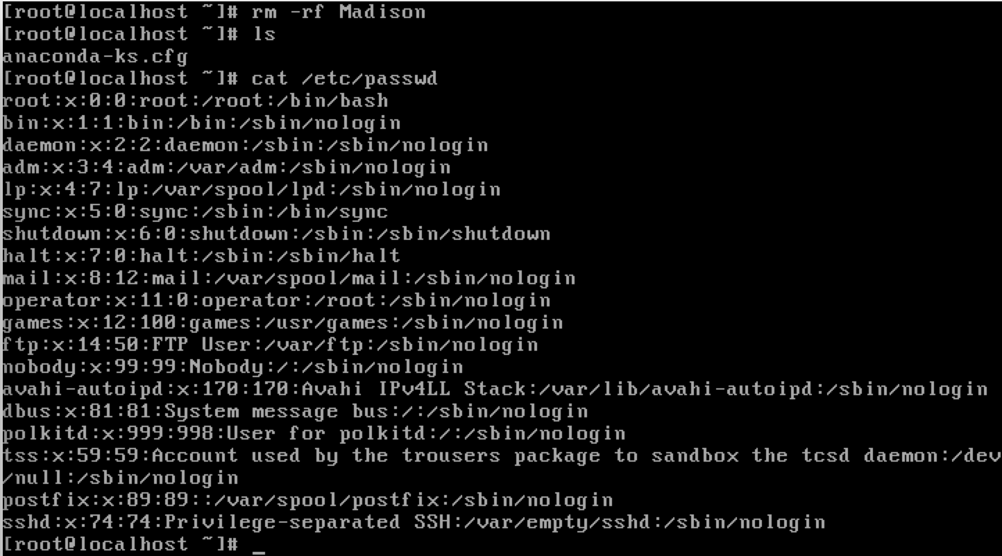

Write a command pipeline to print a list of just usernames here:

**cat /etc/passwd | cut –d: -f1**

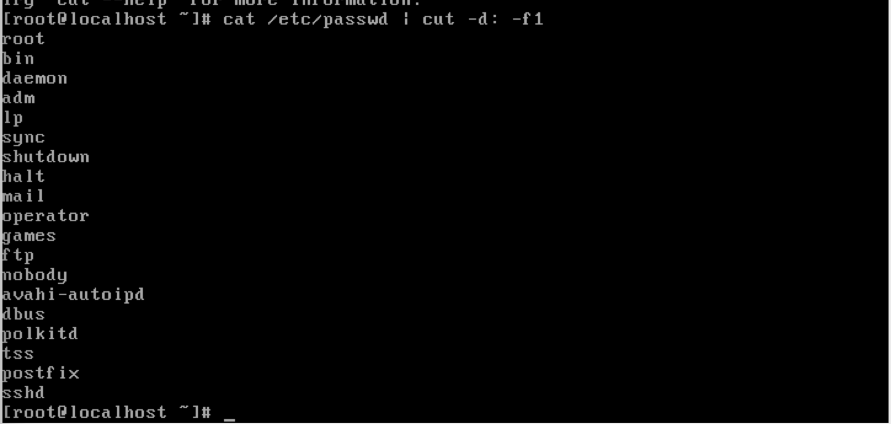

9.Write a command pipeline of the cat, cut, and tail commands to print only the username of the last user in /etc/passwd here:

**cat /etc/passwd | cut –d: -f1 | tail –n 1**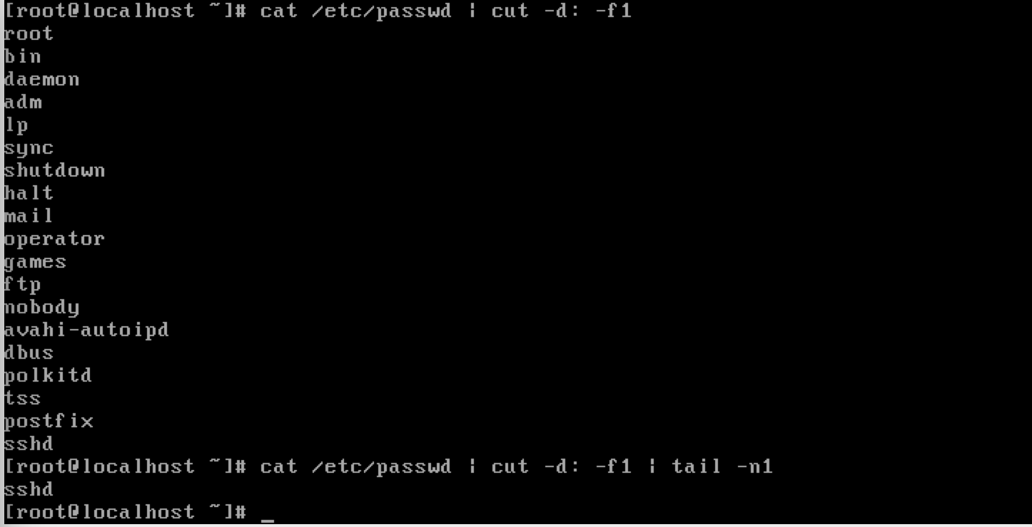

10.Combine the cat, cut, and sort commands to print only the usernames, sorted alphabetically, in descending order.  Write the command pipeline here:

**cat /etc/passwd | cut –d: -f1 | sort**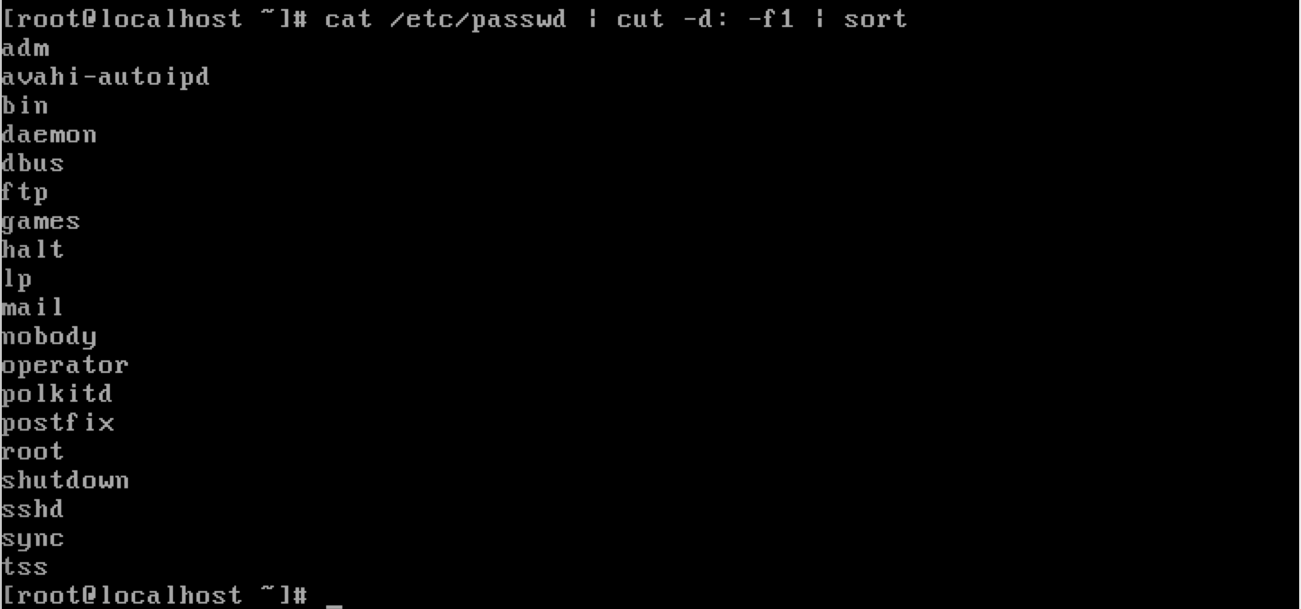

11.Is the Debian Almquist Shell (dash) available on this virtual machine?  Is the Fish shell (fish) available?  List two ways below to check the availability of a shell.

**which Fish or which Debian Almquist**

**This will tell you whether it is there or not**

**cat /etc/shells**

**This will give you a list of available shells**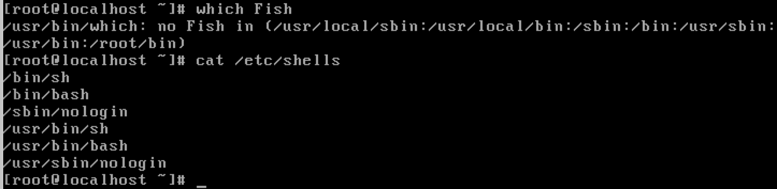

12.What is the current value of the $PATH environment variable?  How would you append the directory /usr/local/bin?

**Echo $PATH to find the current value which is:**

**/usr/local/sbin:/usr/local/bin:/sbin:/bin:/usr/sbin:/usr/bin:/root/bin**

**To append the directory /usr/local/bin you run the command PATH=$PATH:~/usr/local/bin**

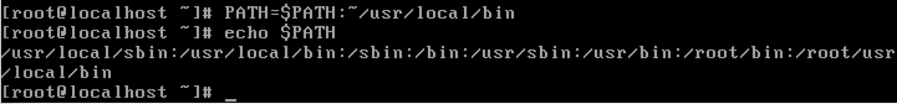

13.Issue this command and explain the result. “> time; date >> time; cat < time”

**An empty file called time is created, then the current date is being put into the file, then the file is printed out showing the date and time you created it.**



14.Take a snapshot of the virtual machine, then run the command “rm / -rf” on your virtual machine.  What happened?  Restart the virtual machine (you may have to click Machine, then Reset).  Does it boot?

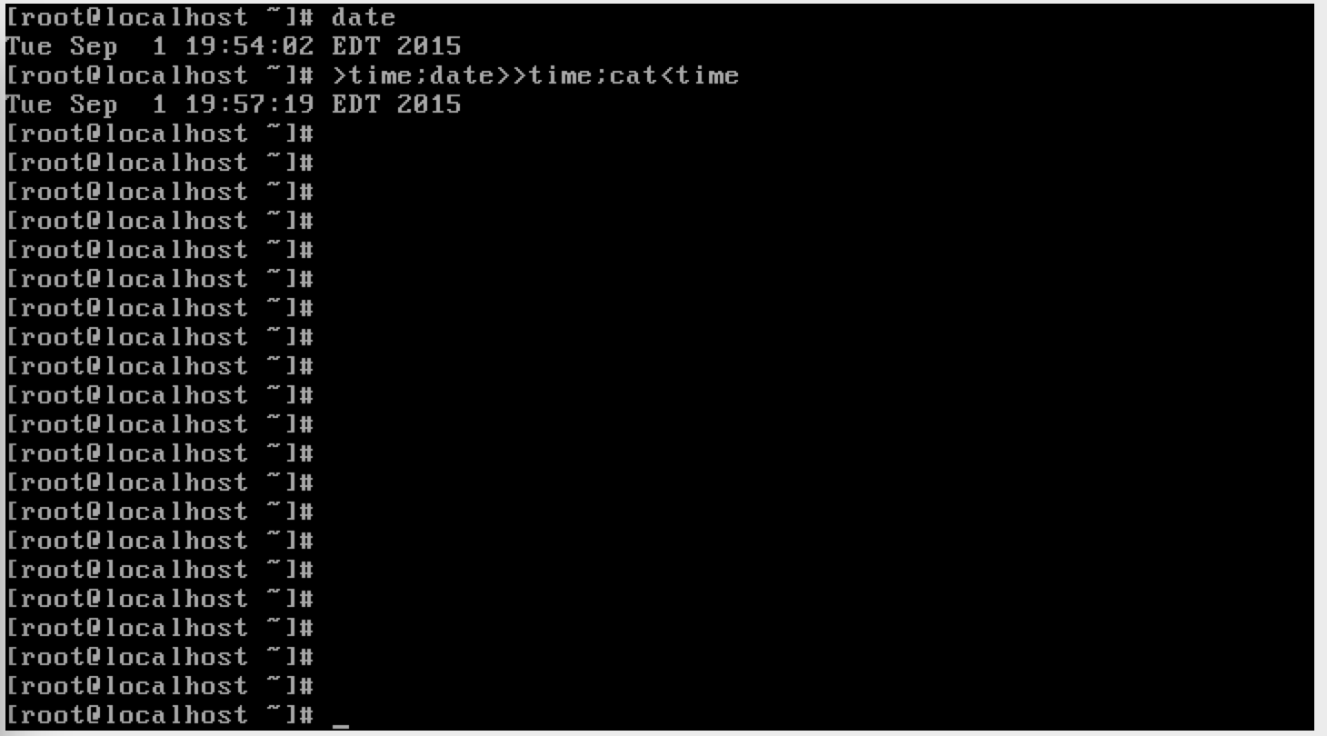

**This is what happens when rm / -rf is run**



**After adding the flag, the command recursively removes all the files in the system.**

**Restarting the virtual machine, it did not reboot. I had to restore with the saved snapshot.**