Empty box returns “You must specify a file to download”





Wrong name returns “server can open the backup file: return code”

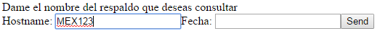



Name and date correctly “File successfully downloaded”



