**How to setup Corporate email on Android 4.2**

Settings > Accounts > + Add Account

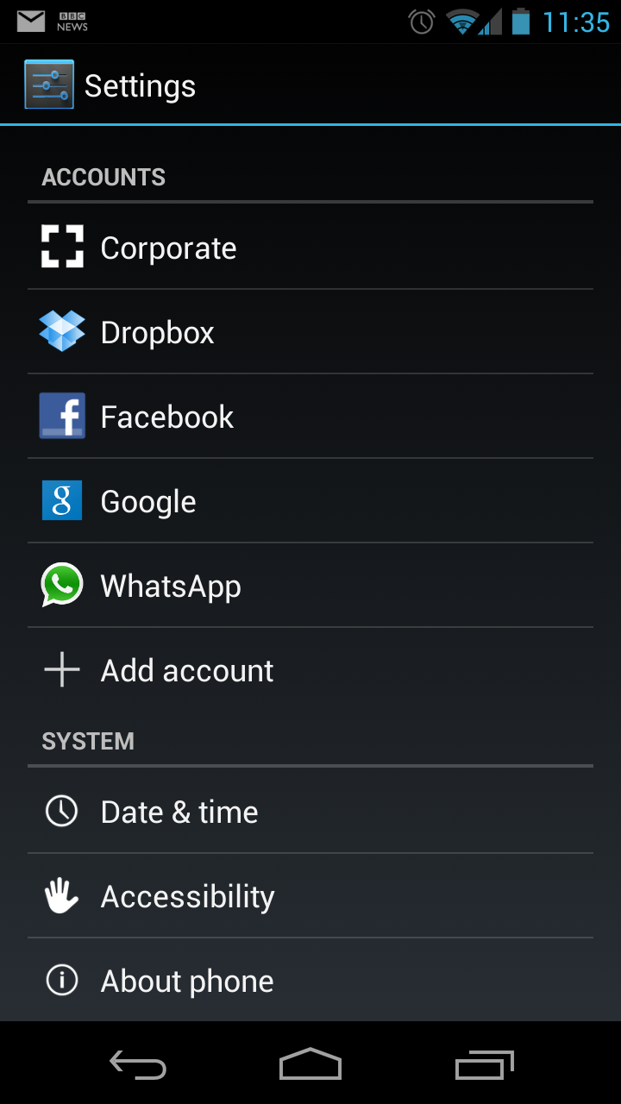

Choose Email or Corporate

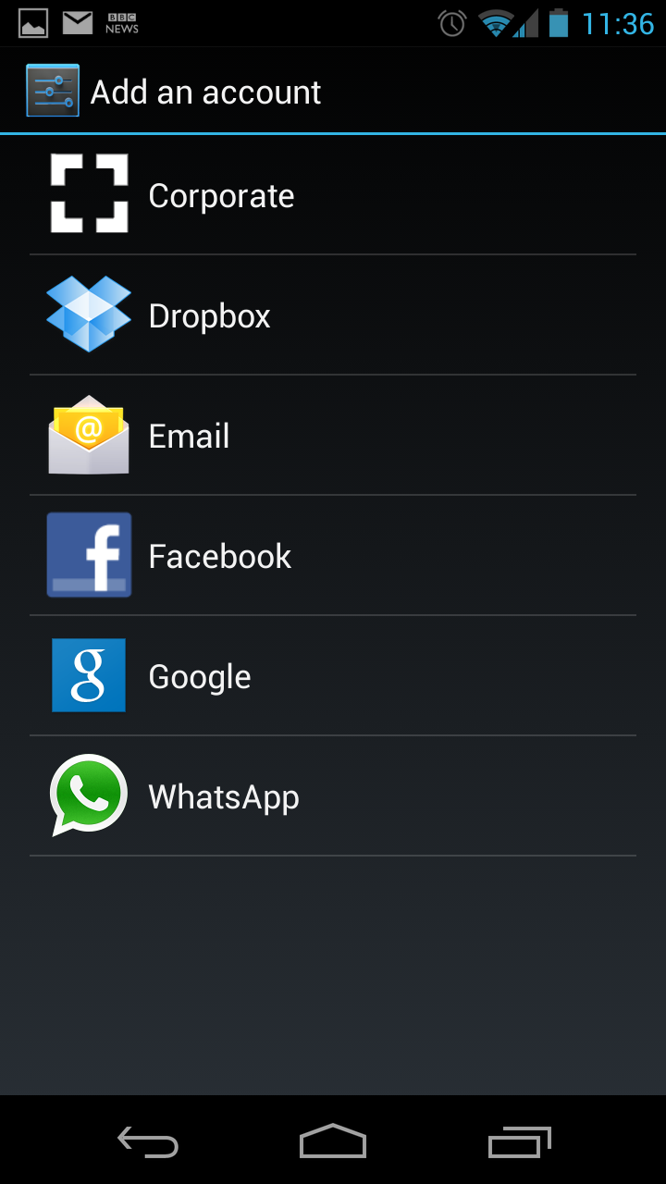

Enter your domain details in the foremat ‘tla@qliktech.com’ and the Password you use to access your laptop

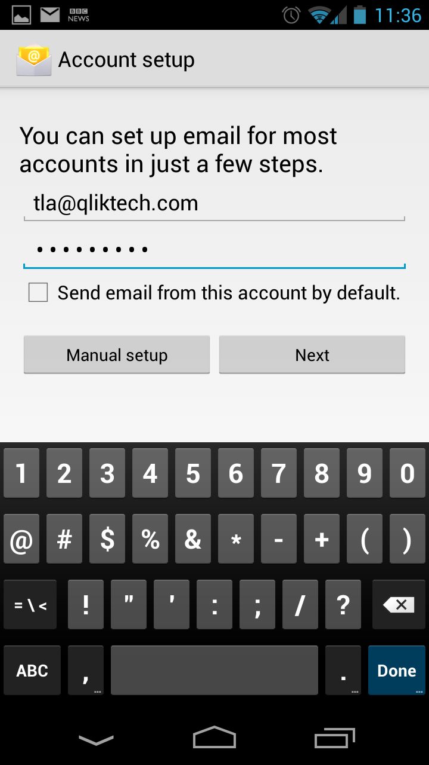

Select ‘Exchange’

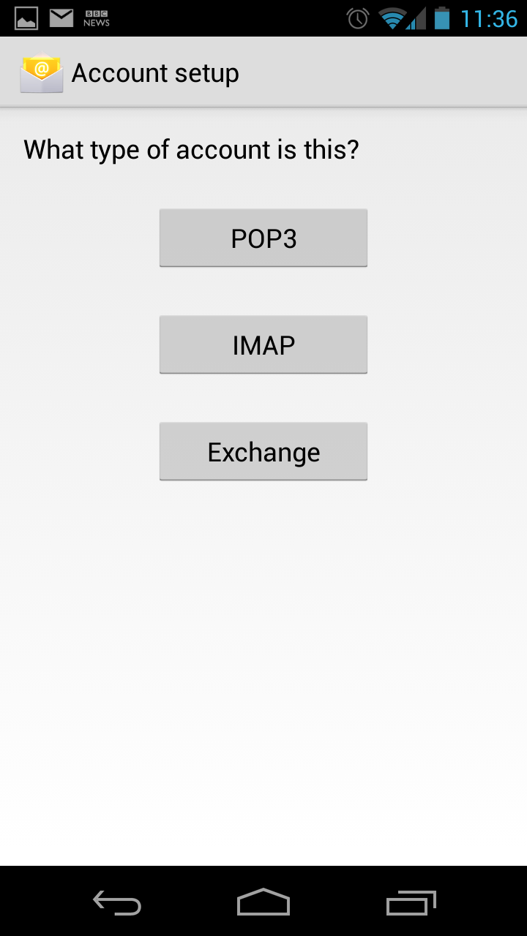

Check the setings are correct (Server is Region dependant and so could be **cas-us**) then select ‘Next’

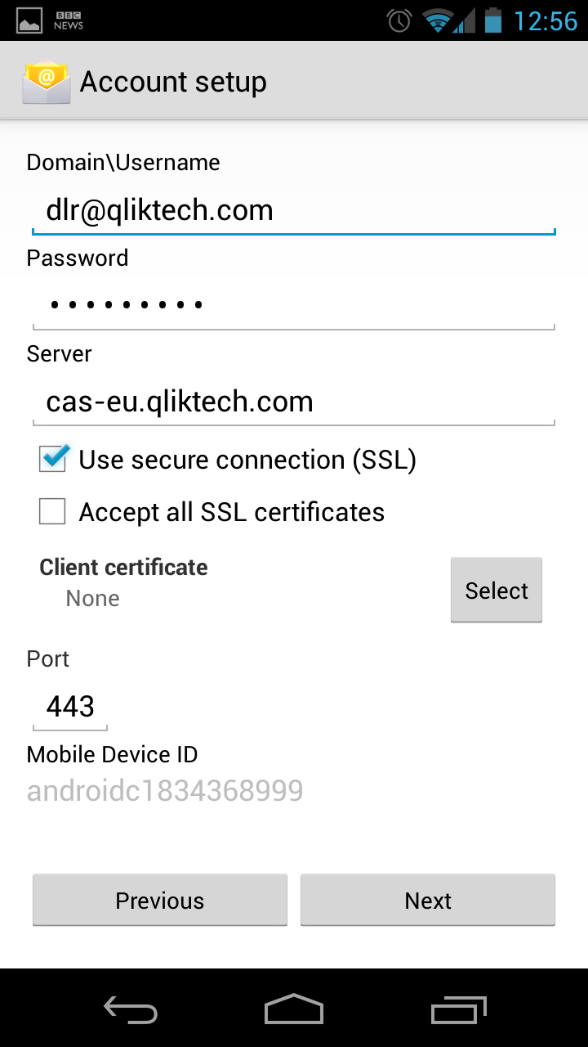

Click Ok

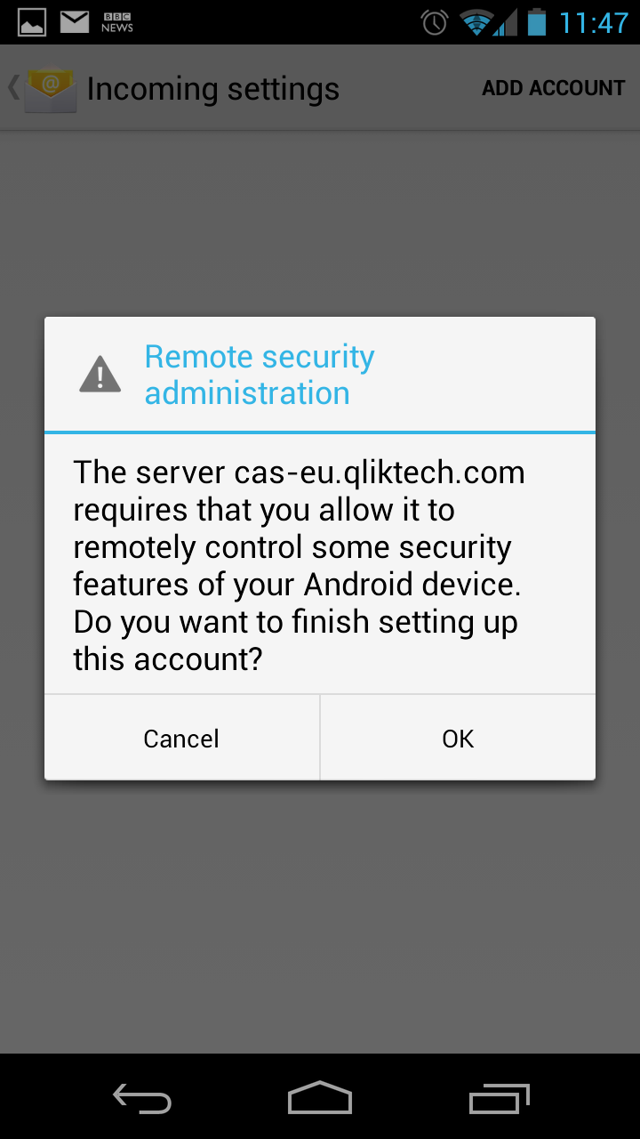

Complete Account settings (these are optional and the screen shot doesn’t reflect any ‘required’ options)

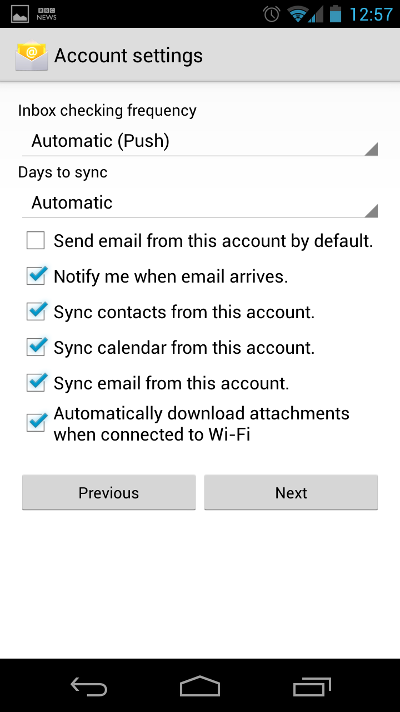

Activate the Device Administrator

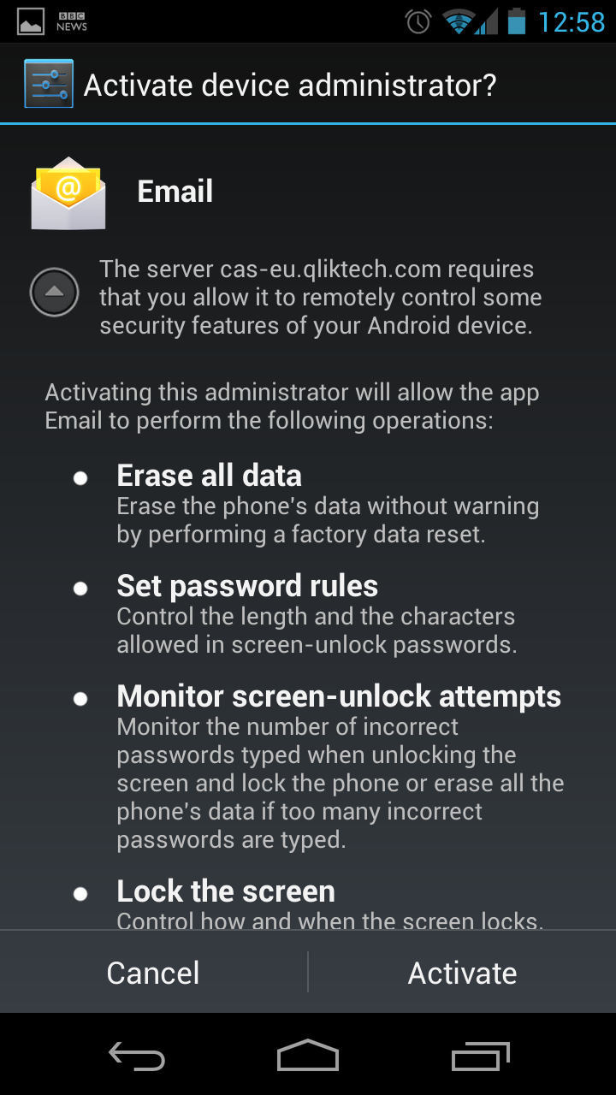

Setup is now complete and your corporate email will start arriving on your device, if there are any problems please raise a case through the helpdesk: <http://helpdesk.qliktech.com>