5 methods of the Activity Class:

1. onCreate(): is called when an activity is first created. This is where the static set up is done which includes: create views, bind to lists etc. This method also provides you with a Bundle containing the activity’s previously frozen state, if there was one. It is always followed by onStart().
2. onStart(): is called when the activity is becoming visible to the user. It is followed by onResume() if the activity comes to the foreground, or onStop() if it becomes hidden.
3. onStop(): is called when the activity is no longer visible to the user because another activity has been resumed and is covering this one. This may happen either because a new activity is being started, an existing one is being brought in front of this one, or this one is being destroyed. This is followed by either onRestart() if this activity is coming back to interact with the user, or onDestroy() if this activity is going away.
4. onRestart(): is called after your activity has been stopped, prior to it being started again. It is always followed by onStart()
5. onDestroy(): is the final call you receive before your activity is destroyed. This can happen either because the activity is finishing (someone called finish ) on it, or because the system is temporarily destroying this instance of the activity to save space. You can distinguish between these two scenarios with the isFinishing() method.

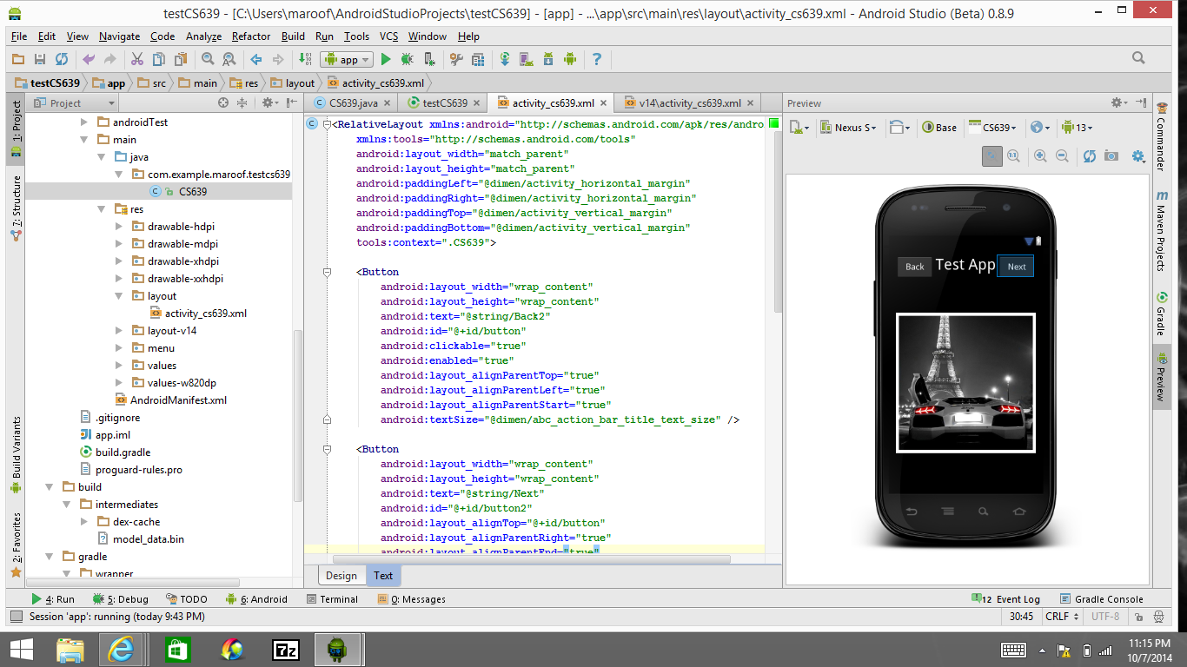

For some reason my app always seemed to have a “stopped execution”. Is there a reason why?