**LAB – 2**

**NAME – TUSHAR MAROO**

**SECTION – A**

**REGISTRATION NUMBER – 190905238**

**ROLL NUMBER – 40**

**ALGORITHM:**

Euclid’s algorithm for computing gcd(m, n)

Step 1 If n = 0, return the value of m as the answer and stop; otherwise,

proceed to Step 2.

Step 2 Divide m by n and assign the value of the remainder to r.

Step 3 Assign the value of n to m and the value of r to n. Go to Step 1

Consecutive integer checking algorithm for computing gcd(m, n)

Step 1 Assign the value of min{m, n} to t.

Step 2 Divide m by t. If the remainder of this division is 0, go to Step 3;

otherwise, go to Step 4.

Step 3 Divide n by t. If the remainder of this division is 0, return the value of

t as the answer and stop; otherwise, proceed to Step 4.

Step 4 Decrease the value of t by 1. Go to Step 2

Middle-school procedure for computing gcd(m, n)

Step 1 Find the prime factors of m.

Step 2 Find the prime factors of n.

Step 3 Identify all the common factors in the two prime expansions found in

Step 1 and Step 2. (If p is a common factor occurring pm and pn times

in m and n, respectively, it should be repeated min{pm, pn} times.)

Step 4 Compute the product of all the common factors and return it as the

greatest common divisor of the numbers given

**CODE:**

#include <stdio.h>

#include <stdlib.h>

#include <math.h>

int opcount1, opcount2, opcount3;

int euclidGCD(int n, int m)

{

unsigned int r;

int opcount = 0;

while (n != 0)

{

opcount++;

r = m % n;

m = n;

n = r;

}

printf("Operation count of Euclid's GCD method = % d\n", opcount);

return m;

}

int consecutiveInt(int n, int m)

{

int t = m > n ? n : m;

int opcount = 0;

while (t > 0)

{

if (m % t == 0)

if (n % t == 0)

{

printf("Operation count of Consecutive Integer method = %d\n", opcount);

return t;

}

t--;

opcount++;

}

}

int *Sieve(int n)

{

int p, j, *A, *L;

opcount1 = 0;

A = (int *)malloc(sizeof(int) * (n+1));

L = (int *)malloc(sizeof(int) * 200);

for(int i=0; i<200; i++)L[i]=0;

for (p = 2; p <= n; p++)

{

A[p] = p;

}

for (int p = 2; p < sqrt(n); p++)

{

opcount1++;

if (A[p] != 0)

{

j = p * p;

while (j <= n)

{

A[j] = 0;

j += p;

}

}

}

int i = 0;

for (p = 2; p <= n; p++)

{

if (A[p] != 0)

{

L[i] = A[p];

i++;

}

}

return L;

}

int *Divide(int m, int *Prime)

{

int *PrimeFactor, i;

PrimeFactor = (int *)malloc(sizeof(int) * 200);

for(int i=0; i<200; i++)PrimeFactor[i]=0;

opcount2 = 0;

i = 0;

int j = 0;

while (m > 0 && j <= 9 && Prime[j]!=0)

{

opcount2++;

while (m % Prime[j] == 0 && Prime[j]!=0)

{

PrimeFactor[i] = Prime[j];

i++;

m /= Prime[j];

}

j++;

}

return PrimeFactor;

}

int middleSchool(int m, int n)

{

int *PrimesM, *PrimesN, *PrimeFactorsM, *PrimeFactorsN, *CommonFactors;

PrimesM = (int *)malloc(sizeof(int) * 200);

PrimesN = (int *)malloc(sizeof(int) * 200);

PrimeFactorsM = (int *)malloc(sizeof(int) * 200);

PrimeFactorsN = (int *)malloc(sizeof(int) * 200);

CommonFactors = (int *)malloc(sizeof(int) * 200);

for(int i=0; i<200; i++)CommonFactors[i]=0;

PrimesM = Sieve(m);

for (int i = 0; i < 200 && PrimesM[i]!=0; i++)

printf("Prime Number = %d\n", PrimesM[i]);

PrimeFactorsM = Divide(m, PrimesM);

for (int i = 0; i < 200 && PrimeFactorsM[i]!=0; i++)

printf("Prime Factor of M = %d\n", PrimeFactorsM[i]);

PrimeFactorsN = Divide(n, PrimesM);

for (int i = 0; i < 200 && PrimeFactorsN[i]!=0; i++)

printf("Prime Factor of N = %d\n", PrimeFactorsN[i]);

int k = 0;

opcount3 = 0;

for (int i = 0, j = 0; (i < 200 && PrimeFactorsM[i]!=0) || (j < 200 && PrimeFactorsN[i]!=0);)

{

opcount3++;

if (PrimeFactorsM[i] > PrimeFactorsN[j])

j++;

else if (PrimeFactorsM[i] < PrimeFactorsN[j])

i++;

else if (PrimeFactorsM[i] == PrimeFactorsN[j])

{

CommonFactors[k] = PrimeFactorsM[i];

k++;

i++;

j++;

}

}

for (int i = 0; i < 200 && CommonFactors[i]!=0; i++)

{

printf("Common Factor = %d\n", CommonFactors[i]);

}

int gcd = 1;

for (int i = 0; i<k; i++)

{

gcd *= CommonFactors[i];

}

if (opcount3 > opcount2 && opcount3 > opcount1)

printf("OPCOUNT3 = %d\n", opcount3);

else if (opcount2 > opcount3 && opcount2 > opcount1)

printf("OPCOUNT2 = %d\n", opcount2);

else

printf("OPCOUNT1 = %d\n", opcount1);

return gcd;

}

int main()

{

int m, n;

printf("Enter the numbers whose GCD needs to be calculated : \n");

printf("Number 1 : ");

scanf("%d", &n);

printf("Number 2 : ");

scanf("%d", &m);

printf("GCD using Euclid's GCD method = %d\n", euclidGCD(n, m));

printf("GCD using Consecutive Integer method = %d\n", consecutiveInt(n, m));

printf("GCD using Middle School method = %d\n", middleSchool(n, m));

}

**OUTPUT:**

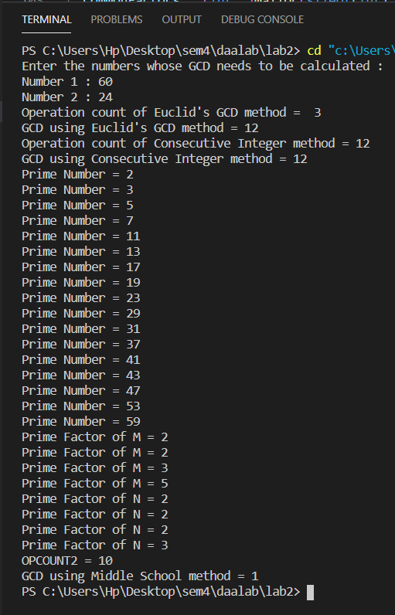

**GRAPHS:**