Scale-Dependent Controls on Plume Dispersion in Stable Boundary Layers
Benjamin Marosites

Introduction
Initially, this research set out to relate plume behavior, in the form of plume metrics, to the scales of motion as observed through a multi-resolution decomposition (MRD). Challenges and limitations in the dataset made these processes less robust, and identifying that relationship was challenging. This research was a little overly optimistic given the timeframe; however, the findings do support the existence of an observable linkage between the vertical heat flux and the ratio of turbulent to submesoscale motion and plume behavior. Additionally, the experimentation process and the fine-scale analysis of this dataset have been consequential for the researcher. The final information and analysis reported here explain the attempt to describe observed scales of motion and simplified plume metrics.

Background
Using atmospheric lidar to observe near-surface plume behavior is a relatively uncommon practice. However, most research focuses on extracting plume metrics based on an area of maximum backscatter and a related threshold to identify the plume's edges (A. L. Hiscox et al., 2006; Strawbridge, 2006). From this data, dispersion (σx, σy, σz) and plume location can be extracted. Running this over a series of scans can provide a time series of these metrics and provide insight into the evolution of plume behavior. Most work on this style of research has focused on plume description and ratios of spread from the source, as well as on dispersion in different stability regimes. Very little attention has been given to how different scales of motion influence plume behavior.
Due to the atmosphere’s non-wavelike pattern at high frequencies, several methods of decomposition have been used in atmospheric science research (Torrence & Compo, 1998). By using a multi-resolution decomposition, Vickers and Mahrt found a larger cospectral gap in SBLs. This gap suggests that submesoscale motions and intermittent turbulence under stable conditions play an important role in atmospheric motion that is not accounted for in typical averaging methods or similarity theories.
This research attempts to connect these two bodies of research to understand plume behavior. Existing literature suggests that plume motion, as measured by the overall location, should be governed by motions larger than the plume itself (submesoscale). The smaller-scale turbulence should govern the internal dispersion of the plume.

Data
This research will use data from the 2018 Stable Air Variability ANd Transport (SAVANT) campaign, conducted in the fall of 2018 near Mahomet, Illinois. The overarching goal of the experiment was to extensively collect data and further explain the evolution, characteristics, and processes of stable atmospheric boundary layers (A. L. Hiscox et al., 2023). From 15 September to 27 November, data were collected using a dense array of instruments deployed across an agricultural field. This research will focus on data from one of the three atmospheric lidars deployed during intensive observational periods (IOPs) and from one of the four meteorological towers installed for the campaign. Towers were identified and located to represent distinct zones in the anticipated drainage regime. This research will use only data from a select set of instruments providing high-frequency (20 Hz) data on the ‘UCONV’ tower. This tower was located at the confluence of two drainage gullies and is the expected location of converging cold-air drainage in stable conditions.This tower is also the closest to the center of the lidar scans and should serve as the best analog to atmospheric conditions in the plume. All data listed above, along with additional project details, are available on the EOL website at https://www.eol.ucar.edu/field_projects/savant.

Methods
The most ambitious part of this research is processing the lidar data. During IOPs, an artificial fogger was deployed to simulate a continuous, non-buoyant, point-source plume. Raw lidar data were processed from the four IOPs available. One IOP, the night of November 2nd, was selected based on a combination of selection criteria, mainly related to the quality and quantity of lidar scans from that night. Raw lidar data files are in text format, including metadata on the instrument's position and angles, as well as the raw analog and photon-counting signals. Using Python, the location and intensity of a backscatter value are measured from the analog signal, along with the angle and distance at which the signal was received. The analog signal must be corrected by removing background signals. Due to the inverse square law of light, background-corrected signals must then be range-corrected. Combining several consecutive files creates a vertical cross-section of the plume. The existing literature suggests further reducing background noise by setting a threshold equal to 10-20% of the maximum backscatter value in the slice. All data from the selected night were processed and transformed from the polar coordinate system to an interpolated coordinate grid; from this grid, plume metrics, including the area and location of the maximum backscatter, were extracted.
To understand the scales of motion, 20 Hz data from a 3-D sonic anemometer and temperature sensor located at 4.5 meters above the ground at the upper convergence zone were explored. Using Vickers and Marht’s Cospectral Gap and Turbulent Flux Calculations, Python code was updated and created to run a multiresolution decomposition of the heat flux, w’T’ (2003). This MRD uses the turbulent fluxuations of vertical wind (w’) and temperature (T’) to model the turbulent flux (w’T’) averaged over 1 hour. Heat flux was used because it is a good descriptor of where the energy is stored.

Results
The time frame from 04:00 to 08:00 UTC on November 3rd was selected due to the quality of lidar data and availability of wind and temperature data at 4.5 meters. The MRD, compared the four 1-hour periods to show what scales influenced the heat flux that we are using as a proxy for energy transfer. The MRD does not show a clearly defined cospectral gap between the submesoscale motions and turbulence as expected considering the stable conditions, however there were several interesting segments. The first hour, marked in pink in Figure 2, was inactive, and this is represented in the limited plume area in Figure 2b. The following three segments indicate a broader range of energy fluxes and increased motion. The period that stands out the most is between 05:00 and 06:00. We see a sharp, strong negative peak, followed by a positive peak at slightly larger scales. With this vertical motion, we observe large changes in the plume over time.
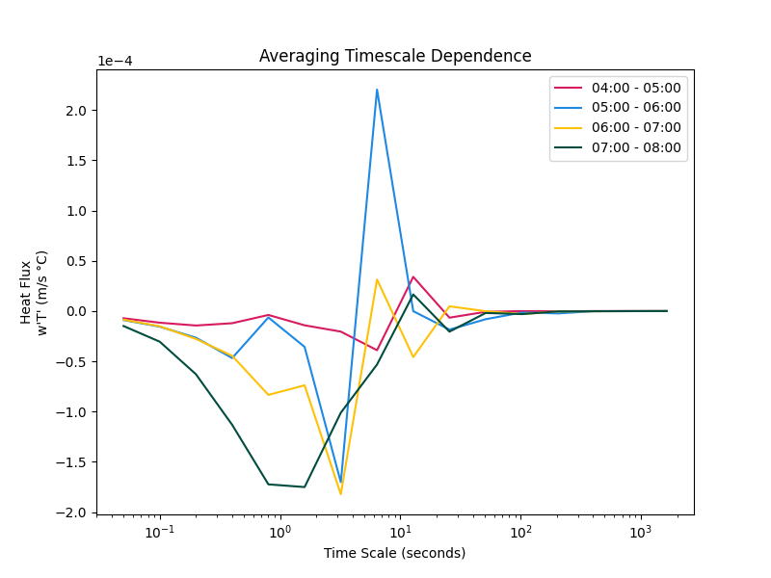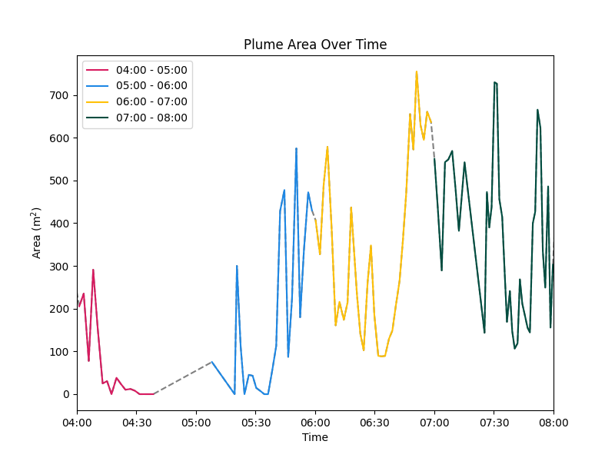
Figure 1 A) show the timescale dependence of Heat Flux for the four one-hour periods. B) Time series of plume area from 04:00 - 08:00. Matching colors line up to identical time segments.

Limitations
There are three major challenges with this dataset: its near-field and non-uniform scanning strategies, scans being so close to the surface, there is a lot of noise introduced into the signal, and finally, the location of the plume relative to the lidar. This led to a high amount of uncertainty surrounding the data that is captured. Often, the tracer smoke would hang close to the surface below the lowest scanning angle and then meander onto either side of the gully. This significantly decreases the confidence in the results. Future research will rely on using data from other angles of the tracer from the other lidar systems deployed during the campaign.
Future considerations will also be given to the time scales of the data sources. Sonic anemometers operate at 20 Hz; this can be downsampled to a rate of 60-120 seconds, which is the time required to complete a vertical slice. This could also present opportunities to decompose these signals into their principal components.

Future Directions
This project is a solid starting point for my dissertation research. This lidar dataset is underexplored and offers many opportunities, especially when combined with other instruments deployed during the campaign. Additional time must be dedicated to processing the lidar data. The signal-to-noise ratio in near-field, low-elevation scans imposes significant limitations. The volume of available data requires that this complex process be refined and automated to yield valuable data for several IOPs.

References
Hiscox, A. L., Bhimireddy, S., Wang, J., Kristovich, D. A. R., Sun, J., Patton, E. G., Oncley, S. P., & Brown, W. O. J. (2023). Exploring influences of shallow topography in stable boundary layers: The SAVANT field campaign. Bulletin of the American Meteorological Society, 104(2), E520–E541.
Hiscox, A. L., Nappo, C. J., & Miller, D. R. (2006). On the use of lidar images of smoke plumes to measure dispersion parameters in the stable boundary layer. Journal of Atmospheric and Oceanic Technology, 23(8), 1150–1154.
Strawbridge, K. (2006). Scanning lidar: a means of characterizing the Noranda-Hornesmelter plume. Geochemistry: Exploration, Environment, Analysis, 6, 121–129.
Torrence, C., & Compo, G. P. (1998). A practical guide to wavelet analysis. Bulletin of the American Meteorological Society, 79(1), 61–78.
Vickers, D., & Mahrt, L. (2003). The cospectral gap and turbulent flux calculations. Journal of Atmospheric and Oceanic Technology, 20(5), 660–672.

## Having an issue with formatting this picture in the document. Could be corrected on future revisions.
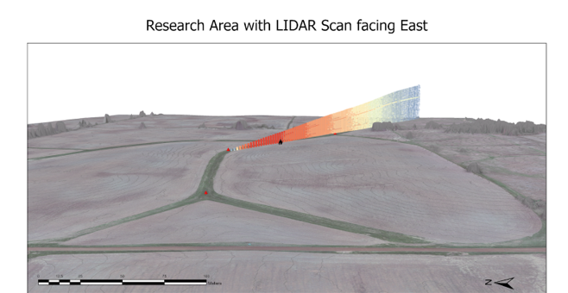
Figure 2. Image of field site, view looking east down slope. The USC lidar is pointed to the south-southeast down the gully towards where the plume tracer is released.

