Défaut 28/08

/home/marotant/dev/Expert_op4grid_recommender/data/bare_env_20240828T0100Z

ALBERL51RANDE

ALBERL61MALGO => CONTAL61MALGO (side 2)

ALBERL71COCHE (N-2)

ARENCL61SAUM6 => Overload ARENCL61SEPTE (side 2) =99.9 % (sur side 1).. !

ARGIAL71CANTE => Overload CANTEY761 (side 2) Very difficult to solve ! (ou avec PST?)

"FROGEL61ZMER7" =>

REALTL61SEPTE => REALTL63SEPTE (side 1) => two works now (after removing doubling - one works but is defined twice .. !)

VOGELY631 => MARCKL31RHINA (side 2)

GAUGLY731 => C.LO6L31SANCE (side 1)

Defauts 25/11

/home/marotant/dev/Expert_op4grid_recommender/data/bare_env_20241125T1400Z
ALBERL62ZRAN6, LONG6L62ZRAN6, RANDEL62ZRAN6 => ALBERL61LONG6 (side 2)

AMBONL31THEIX,GESVRL31ZGESV, GUERSL61ZPRIN, AMBONL31MARZA, BEZONL31MALE5, BLAINL31PTCHA, ORVAUL31SSHE8,SSJOSL61ZORVA,THEIXL61ZPRIN, ORVAUL61ZORVA => DONGEL31PTCHA (side one)

DONGEL31PTCHA => BLAINL31ZGESV (side 2)

AOSTEL61BISSY => CBERYL31ZMTME (side 2) => overloads, but need DC mode, and then prioritized actions are not converging. Tough to solve .. !

B.TOLL71GEN.P => GEN.PY761 (side 2) => Ok (but GEN.PY762 should not be reonnectable)
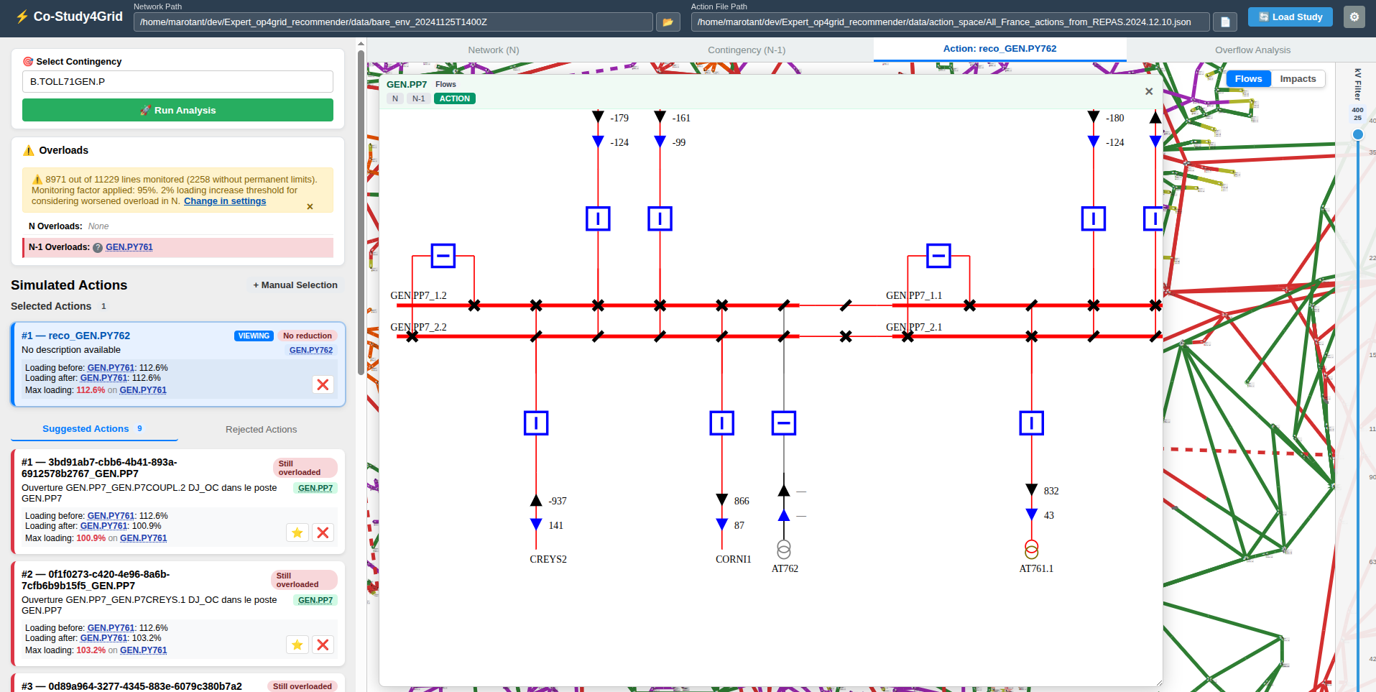

CHAN6L31L.BAR => L.BARL31ZT.BA (side 1) => KO, overload breaks the grid

CUBNEL61ZSS11, GREZIL31SSPEY, GREZIL31SSPEY => GUPIEL31SAUVE (side 1) Toulouse

LAVEYL61MTGRO => P.BORL31SALEL => KO breaks grid appart

PAILLL31TALEN=> BRUGEL31GLACI (side 2) Toulouse => KO breaks grid appart

SEINEL61SSOU5=> SEINEL62SSOU5 (side 1)

VALDIY761 => VALDIY762 (side 2)

GUERSY631 => GUERSY631 (side 2)

