JDBC (Java Database connectivity)

- JDBC stands for java database connectivity. It is the technology , the standard API in java which is used to connect java application with any database application.

What is data?
It is a collection of values or raw facts, which convey information any specific entity, its properties, facts, quantity, quality and other information.

What is Data Storage?
It is the process of storing the data, considering how and where to store it digitally.
It can be stored in :-
- File System
- DataBase
  - RDBMS
  - No SQL DataBases

Q. What is the difference between File System and DataBase?
File System | Database
A way to store and organize files on storage devices like HDD or SSD. | An organized collection of data managed by a Database Management System (DBMS)
Stores data in plain files (e.g., .txt, .csv). | Stores data in structured tables (rows and columns).
No Efficient Query Processing (Manual Access) | Efficient Query Processing (Using SQL)
Provides Less Security (Basics) | Provides More Security (Roles, authentication, encryption)
File System | DataBase
Redundant data can be present. Less Consistent | Redundant data can be avoided. More data consistency
Concurrency is less flexible. Difficult to manage – no built-in control. | Built-in concurrency control (multiple users can access safely)
Backup & Recovery is manual and time consuming | Backup & Recovery is Automated, with rollback, recovery, and backups.
Hard to manage large data efficiently, not suitable for complex transactions | Efficient for managing large data and complex queries
Less Complex to use | More Complex to use
Windows File Explorer, Linux File System | MySQL, Oracle, SQL Server, PostgreSQL

Q. What is Database?
- A database is a structured and organized collection of data or information, typically stored virtually in the computer system.

Types of Database
  - Relational Database:
Stores data in tables (rows and columns).
  - Object-Oriented Database:
Stores data as objects (like in OOP languages such as Java or C++)
  - Distributed Database
Data is stored across multiple physical locations, either on the same network or different geographic locations.
  - NoSQL database
Not Only SQL" – supports unstructured, semi-structured, or structured data without using traditional table format.
  - Graph database
Stores data in nodes and edges to represent entities and their relationships.
  - Data warehouse
A central repository of integrated data from multiple sources, optimized
for analytics and reporting.

  - Open Source database
Databases that are freely available, and their source code is open for customization and use.
  - Cloud database
Database hosted on a cloud platform and accessible over the internet
  - Multimodel database
Supports multiple data models (like relational, graph, etc) in one system.
  - Document/JSON database
Stores data in document format, usually JSON (name: value)

The need of connecting java application with the database application.
Within the java application it is not possible to store the data permanently, so that we will lose the processed data once the application is closed, in order to overcome this problem, the application data must be stored somewhere outside the application permanently so that the data can be accessed in the application whenever required in future.

API : API stands for Application Programming Interface.
An API is a set of rules or specifications which will help two different software communicate with each other which are incompatible to each other.

Real Time Examples:
1.Vyantkat knows: Tamil
Martin knows: Spanish
- So, the third person (some name ) which will know both Tamil and Spanish will help Vyankat and Martin to communicate with each other!
2. API is like a waiter in a restaurant
- Customer(End-User/Client)tell the waiter(API) what they want.
- The waiter(API) transfers the order(request) to the Kitchen(Back-end logic/Database)
- The kitchen takes the order(request),prepares the food(response) and the waiter(API) brings it back to the Customer(End-User/Client)

- JDBC is an API which will help java application to communicate with database application which are incompatible to each other.

Incompatibility between java application and database application
Since the java application understands java commands or instructions and the database application understands structured queries (SQL) which makes both the application incompatible to each other.
To overcome this incompatibility and to establish the connection between java application and database application we can make use of JDBC technology that's why JDBC is also called as API.

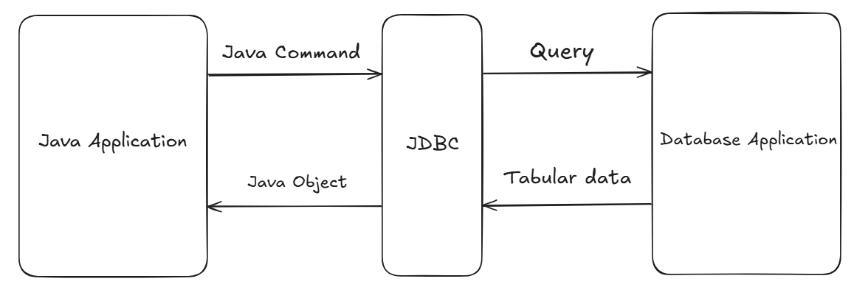

- JDBC sends SQL queries written by the developer to the database and converts database results into Java-accessible objects.
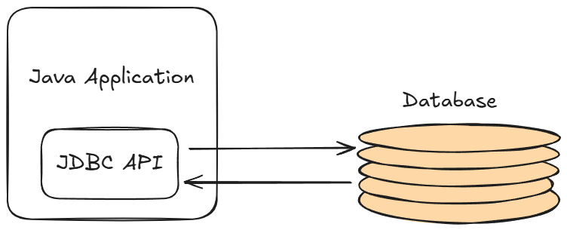

JDBC API

- Data stored in a relational database can be accessed with the help of JDBC API and respective Database Driver
- The API provides a mechanism for dynamically loading the correct java packages and registering them with the JDBC Driver Manager

JDBC with Database Driver

- Driver is a software which will help JDBC API to communicate with database application. Since JDBC API is a part of java application it will take the help of database driver to communicate with database application, each database application comes up with dedicated driver software. This software will be developed by the database application developers.

- Every Database has its own Driver Software! using which a JDBC API can communicate with database. So, Drivers are dependent on the Database Application!
- JDBC API is independent of any Driver Software/Database, but to communicate with database, a particular Driver must be integrated in the java application!.

- JDBC API has a built-in mechanism which loads the respective Driver classes into the memory if integrated.

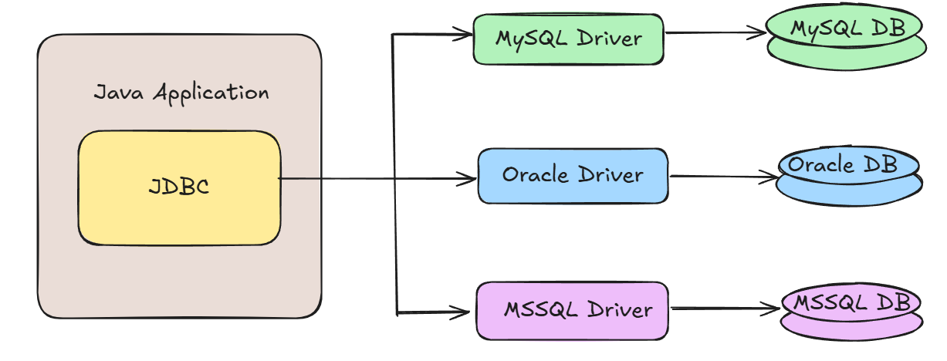

Steps to connect the Java application with the database application

- Step 1: Load or register the driver (Not required from JDBC 4+/Java 6, as it will automatically load and register the driver!)

- Step 2: Open/Create the connection between java application and the database application

- Step 3: Create or prepare the statement

- Step 4: Execute the statement/Query

- Step 5: Close the connection between java application and database application

- Step 6: Deregister the Driver if registered

- In java library we have a package called as java.sql package which represents JDBC API.

ResultSet
- ResultSet Interface is present in java.sql package.It is a table of data representing a database result set, which is usually generated by executing a statement that queries the database.

- Its object holds the data, which is returned from the database when select query is executed.

- We can get ResultSet Object by calling some built in methods like executeQuery(), getResultSet(), etc

- The ResultSet Object maintains the cursor that points to row of the result set fetched from the select query

- The next() method is used to move the cursor to the next position in a forward direction

- boolean next() throws SQLException;
Moves the cursor forward one row from its current position. A ResultSet cursor is initially positioned before the first row; the first call to the method next makes the first row the current row; the second call makes the second row the current row, and so on.
When a call to the next method returns false, the cursor is positioned after the last row

- We can get the data from the column by calling built in overloaded getter methods for e.g getInt(int columnIndex), getString(String columnLabel),etc. We can pass column name or column position to it!

- int getInt(String columnLabel) throws SQLException;
- int getInt(int columnIndex) throws SQLException;, etc

Connection
- Connection is an interface present in java in java.sql package
- We can get the connection object by calling getConnection() method
- getConnection() is a public static overloaded method present in DriverManager class
public static Connection
getConnection(formal arguments..) throws SQLException

- Connection object is created only when the URL, user and password are accurate!

Statement
- Statement is an interface present in java.sql package
- We can get the statement object by calling createStatement() method
public Statement createStatement() throws SQLException
- Statement objects are generally used to execute the static queries!
- Static queries is an SQL command which will not change during runtime i.e it will not include user input
e.g. Select queries, Creation queries with hardcoded values
- Insert, Update , delete is not recommended using statement objects!

PreparedStatement
- It is an interface present in java.sql package. It is the child of (sub-interface)of Statement.

- We use Prepared Statement Object to execute dynamic queries.
- Dynamic query: Query consisting input from User or Inputs constructed at Runtime

- To execute a dynamic query, we have to write it with Placeholders(?)
e.g. String query=”INSERT INTO products VALUES(?,?,?,?,?)”;

- We can create a prepared statement object by calling prepareStatement() method

public PreparedStatement prepareStatement(args) throws SQLException;

- We can set the data from the column by calling built in setter methods for e.g setInt(), setString(), etc.
e.g.: "INSERT INTO products VALUES(?,?,?,?)";
//number represents the position of placeholders!!!
preparedStatement.setInt(1, scanner.nextInt());

[refer jdbc.shop.PreparedStatements]
***Note: In JDBC, Auto-commit is enabled by default,!!!***

Statement | PreparedStatement
Used for executing a static SQL | Used for executing a dynamic SQL
Cannot accept parameters at Runtime | Can accept parameters at Runtime
Slower as compared to PreparedStatement | Faster than Statement if used repeatedly
Preferable for executing DDL commands  (CREATE, ALTER, DROP, TRUNCATE) | Preferable for executing DML commands  (INSERT, UPDATE, DELETE)
Cant be used for storing /retrieving image and file in database | Can be used for storing /retrieving image and file in database (CLOB/BLOB)
Same SQL query can’t be executed repeatedly for different values | Same SQL query can be executed repeatedly for different values
Less Secure(Prone to SQL injection) | More Secure

Methods used to execute statements

- boolean execute(String sql) throws SQLException

- It is used to execute both select as well as non-select queries i.e. any type of statements (DDL, DML, DCL, TCL, DQL) .
- This method returns a boolean value.
- Returns true if the result is a ResultSet object (i.e. if it contains tabular data); false if it is an update count or there are no results i.e It returns true if the statement to be executed is DQL otherwise it returns false.
- We cannot store the result of execute() directly in the ResultSet object!. We have to make use of getResultSet(), which returns the current result as a ResultSet object or null if the result is an update count or there are no more results.

- ResultSet executeQuery(String sql) throws SQLException;

- This method is used to execute only select queries i.e only DQL statements.

- This method returns the object of type ResultSet which will contain result returned form the query.

[refer jdbc.shop.SelectProducts]

- int executeUpdate(String sql) throws SQLException

- This method is used to execute only non-select queries i.e. only DML statements(INSERT, UPDATE, DELETE).

- This method returns int type value i.e. number of rows affected after execution of DML statement.

Batch Execution/Processing

- Batch Processing/Execution in JDBC is a Process/ mechanism that allows multiple SQL statements (usually of the same type, like INSERT, UPDATE, or DELETE) to be grouped together and executed once as a batch, instead of executing them one by one.

- It allows us to group related SQL statements into a batch and submit them with one executeBatch() call statement, which returns int[] where each index contains updated count.

- It is particularly useful for improving performance and efficiency, minimizing the overall execution time.

- Ideal approach when we want to manipulate bulk data.

- We can use executeBatch() to perform DML operations LIKE
INSERT, UPDATE, DELETE

- DDL (not recommended) and DQL, TCL and DCL are not allowed!

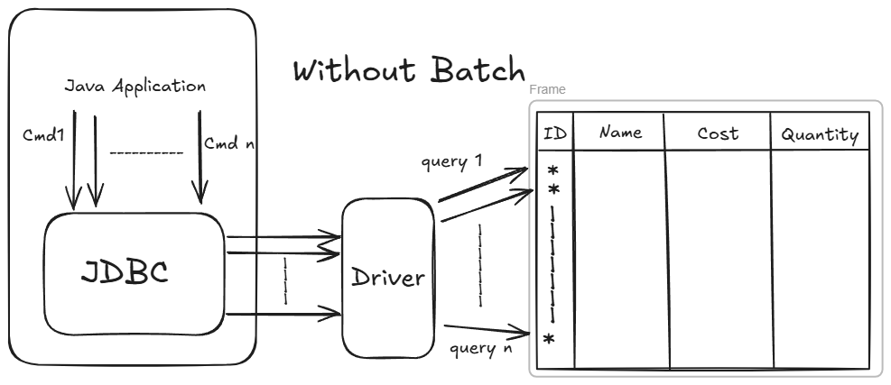

With Batch
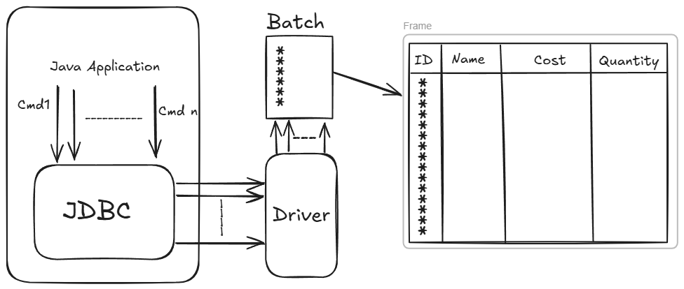

Closing the Connection
- If we don’t close the connection, it may lead to memory leakage.
- Connections are costly in terms of execution, so to manage the load overhead and to maintain efficiency, closing the connection is recommended and a good practice! [Calling a friend and not cutting it example]
- It is always recommended and a safe practice to close the connection in finally block to ensure the connection release.

finally {
//Step 5: Close the Connection/De-register driver
try {
if(stmt!=null)
stmt.close();
if(connection!=null)
connection.close();
//DriverManager.deregisterDriver(d);
}

catch (SQLException e) { e.printStackTrace();
}
}

- Closing the connection using try-resource

- After Java 8, it is recommended to use try - resource block , where
Compiler will close all the connections when we exit try block!

Stored procedures
- Stored procedures are the set of SQL statements (grouped together) to be executed to perform specific task on the database.
- These are beneficial when we are dealing with multiple tables with complex scenarios.
- It is similar to a method with void return type of java.
- Stored Procedures:
• Does not return a value (directly).
• Is called with CALL (not SELECT).
• Can have IN, OUT or both parameters.
• Can perform transaction control (COMMIT, ROLLBACK)(default in pgAdmin)
Syntax to create stored procedure
Step 1:
- Go to Procedures segment under Schema
- Provide Procedure name and Parameter information
- Write Code for that procedure
e.g.
BEGIN
INSERT INTO teacher
VALUES(tech_id, tech_name, tech_gender, tech_age, tech_email, tech_phone, tech_blood_group);
INSERT INTO id_card
VALUES( tech_id, tech_name, tech_phone, tech_blood_group );
END;
To call in the Procedure
Step 2:
call sp_create_teacher_records(1,'salunke','female',50,'sal@mail.com','9876898976','A+')

Functions
- A function is a named block of SQL/PLpgSQL code used to execute
SQL queries .

Function:
- Returns a value
- Can be called from a SELECT, WHERE, JOIN, or another function.
- Can be used inside SQL expressions.

Syntax to create functions
Step 1:
- Go to Functions segment under Schema
- Provide Function name and Parameter information
- Write Code for that function
e.g.:
DECLARE tech_count integer;
BEGIN
SELECT COUNT(*) INTO tech_count
FROM teacher
WHERE gender=tech_gender;
RETURN tech_count;
END;

To execute the function:
Step 2: select count_by_gender('female');

Advantages of Procedures & Functions Over Normal SQL Queries

1. Better Performance (Faster Execution)
- Stored procedures are compiled once and stored in the database.
- Execution plans are cached, so repeated calls are faster.
- Normal SQL queries must be parsed and planned every time.

2. Better Security
- We can restrict direct table access and allow only procedure execution.
- Sensitive logic stays inside the DB.
- Prevents SQL injection when parameters are used.

3. Code Reusability
- The logic written once can be reused in multiple applications.

4. Easier Maintenance
- Fix a bug or change logic in one stored procedure instead of hundreds of SQL lines in the application.
- Developers don’t have to modify the application code frequently.

Scenario | Use Procedure | Use Function
Return a value | ❌ | ✅
Perform CRUD operations | ✅ | ❌
Complex business logic | ✅ | ❌
Can be used inside SELECT | ❌ | ✅
Need transaction control | ✅ | ❌
Pure calculation logic | ❌ | ✅
Reusable business process | ✅ | ❌

CallableStatement

- It is an interface, which can be used to call or execute the stored procedures and functions
- prepareCall() method is used to get CallableStatement object

CallableStatement java.sql.Connection.prepareCall (String sql) throws SQLException

- Creates a CallableStatement object for calling database stored procedures and functions.

[refer jdbc.shop.CallingProcedure and jdbc.shop.CallingFunction]

Connection Pool
[In general, pool is the collection or group of entities]
- E.g. One company(c1) has pool of employees(resources), other companies will ask the resources from c1 for some project, after job is done, c2 will release the resources back to c1 and pool will get refilled!
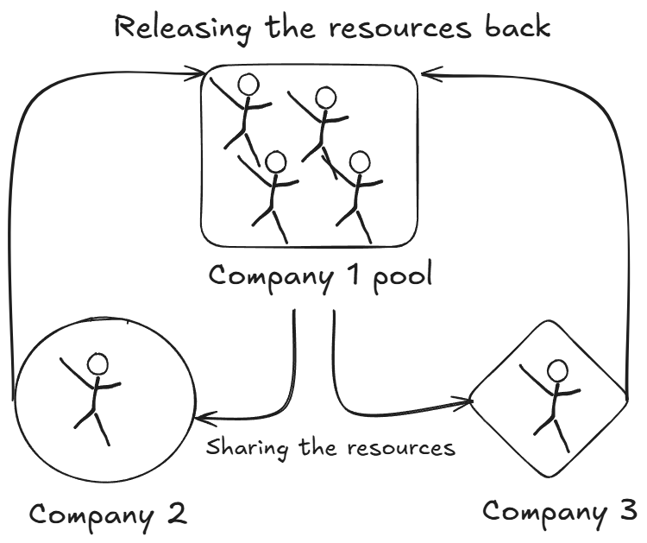

- If we do DriverManager.getConnection(URL,user,password):-
- Insert
- Update
- Delete ……

- For each and every task/ operation, Driver Manager have to verify all the details and then connection object is created!, which will consume more time!

[Customer wandering for different items in different shops example!!!!]

- So to optimize this, We can make us of Connection pool! ,which will contain collection of connection objects.
[Vending machine, Utility stores, Malls, etc ]

- Connection Pool is the collection of connection objects

- Connection object are utilized on request, and returned back to connection pool after the usage.

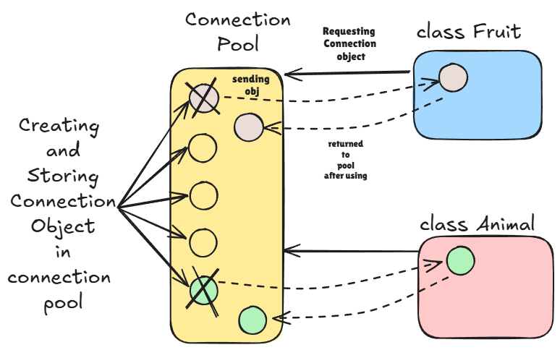

Transaction Management

- Multiple parts/units of actions grouped together are called as transactions.
e.g.--> select route, search flights, selecting one, providing more information, payment: -
- If successful, booking confirmed!(Transaction is complete)
- If failed, (Transaction is failed)

- So to handle this, we can manage it like:

- If all operations succeed, then it will be stored into the table as a single transaction! (COMMIT)
- If one of the operation fails, we will revert all the related information (ROLLBACK)

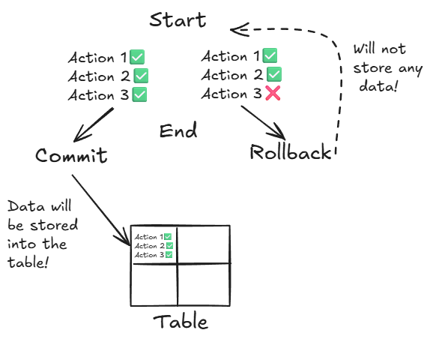
- It is used to prevent unnecessary data/junk data to be stored in the table

