Servlets and JSP's

Web Based Application / Web Application:
An application which runs inside a distant system called as server and which can be accessed using standard web browsers by clients is called as web application or web-based application.

Web resource:
Web resource is the Data or the information present on the web or internet. It can be classified in two types as static web resource and dynamic web resource.

1.Static web resource: If the data or the information associated with the web resource will not change based on some inputs or conditions then that web resource is called as static web resource.

2.Dynamic web resource: If the data or the information associated with the web resource will change based on some inputs or conditions is called as dynamic web resource.

Client-Server Interaction
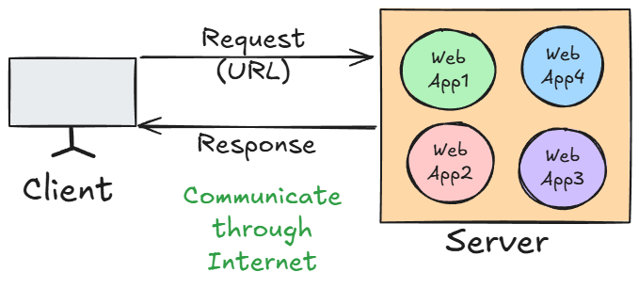
- Request Side Parameters
These parameters are sent from the client (browser or any testing tool) to the server.
1. URL (Uniform Resource Locator)
- The address used to access a particular resource on the server.
- Example:
https://flipkart.com/products?id=5
- Parts:
  - https → Protocol
  - flipkart.com → Domain name
  - /products → Path to the resource
  - ?id=5 → Query parameter (used to send data in GET request)

2. Method Type
- HTTP method used to send the request.
- Common Types:
  - GET → Fetch data
  - POST → Send new data
  - PUT → Update existing data
  - DELETE → Delete data

3. Data
- Data sent by the client to the server (mostly in POST, PUT).
- Can be sent as:
  - Query Parameters (e.g., ?id=1&name=John)
  - Form Data
  - JSON/XML payload in the request body
- Example
{
"username": "john",
"password": "abc123"
}

- Response Side Parameters
These parameters are sent from the server back to the client as a result of the request.
1. Status Code
- A 3-digit code representing the result of the request.
- Common Status Codes:
  - 200 OK → Request successful
  - 201 Created → Resource created
  - 400 Bad Request → Invalid input
  - 401 Unauthorized → Authentication required
  - 404 Not Found → Resource doesn’t exist
  - 500 Internal Server Error → Server crashed
  - 405 – Method Not Allowed → Invalid Method type

2. Content Type
- Tells the client the format of the response content.
- Common Values:
  - text/html → HTML page
  - application/json → JSON data
  - text/plain → Plain text
  - application/xml → XML data

3. Actual Content
- The real body/content of the response (data or HTML page).
- Examples:
  - HTML webpage
  - JSON data (API response)
  - Image, PDF, etc.

Servlet:

- It is an API generally used for developing web applications.

- All the classes and interfaces related to Servlet API are present in javax.servlet/jakarta.servlet package

- Servlet is an interface present in javax.servlet/ jakarta.servlet package

- It is the technology which is used to accept web request in the Java application and to generate web response from the java application.

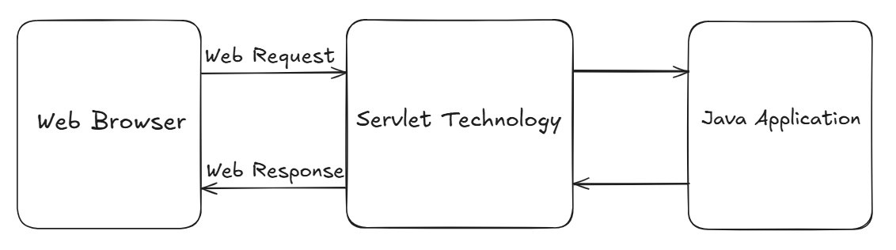

Servlet container/Web container

- It is the component of web server which is responsible to manage servlet life cycle.
When the request is sent to any specific servlet then the servlet container will create request and response objects internally.

Servlet life cycle

- Done by Servlet Container/Web Container

- Loading Servlet Class
- Instantiation of Servlet Class
- Initialization of members of Servlet Class by invoking init()
(All the above steps will be executed only once!!!)

- invoking service()
(service() method will get invoked N number of times for N number of requests!!!)

- Destroying the Servlet by invoking destroy() method

web.xml (Deployment Descriptor):

- web.xml acts as an instruction manual for the web server, telling it about information about servlets, components, their configurations etc.

- We have to provide a deployment descriptor (web.xml) to the web server so that the web server will refer deployment descriptor to forward the request to the application server to serve the request for web resource.

Servlet hierarchy:

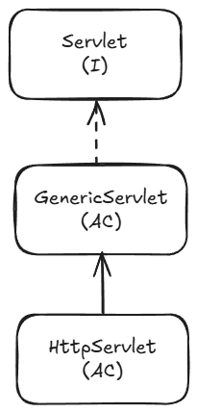

- Servlet is an interface present in javax.servlet package
- It has some methods used to implement the Servlet API. and perform some tasks when implemented further.
public void init(ServletConfig config) throws ServletException;
public ServletConfig getServletConfig();
public void service(ServletRequest req, ServletResponse res) throws ServletException, IOException;
public String getServletInfo();
public void destroy();

- GenericServlet is called as protocol independent servlet, since it allows any web request associated with any protocol.
- It is an abstract class which implements the Servlet interface.
- It will provide implementation to all the methods of servlet interface except service method(remains abstract).
- To create our servlet class, we must extend/inherit GenericServlet class.

Steps to Create Servlet Maven Project

Step 1: Create a new maven project( don’t click create simple maven project!)
Step 2: Search maven-archetype-web, select 1.5 and next

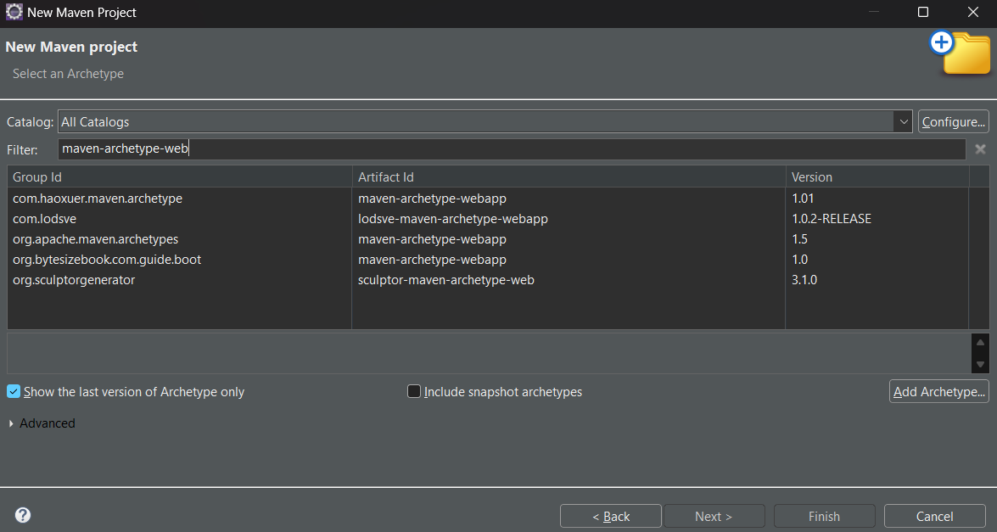
Step 3: Provide Group Id and Artifact Id and finish
Step 4: Press Y when asked on output console, wait for BUILD SUCCESS message.
Step 5: Visit mvnrepository.com and search for Java Servlet API, and select latest one.
Step 6: Add copied dependency into pom.xml dependencies tag.
Step 7: Right click on projectPropertiesJava build pathorder and export
check all the boxesapply and close
Step 8: Right click on projectmavenupdate projectselect force update checkboxok

Apache Server Configuration
Step 1: Go to ServersClick to create a new server
Step 2: Select ApacheSelect Tomcat v10.0 server
Step 3: Select Tomcat installation directory
- Create an new folder named Server in the system and select it.
Step 4: Download and install in same folder(See right bottom footer for downloading details) Finish after installation is completed.

Creating a Servlet Class
- Create a normal class in java resourcesrc/main/java
- Extend GenericServlet and implement the methods

- To register the Servlet

//Annotation used to declare a servlet.
//This annotation is processed by the container at deployment time,
//and the corresponding servlet made available at
//the specified URL patterns.

@WebServlet(value="/message")
public class MyServlet extends GenericServlet {

- Whenever the URL contain /message , MyServletClass service method will be invoked
- http://localhost:8080/servlets/message will execute the service method

Catalina Bootstrap ClassNotFoundException solution:

https://chatgpt.com/c/695bac55-018c-8324-8cc1-879addc02d07

- To Display the content on web page:
@Override
public void service(ServletRequest req, ServletResponse res) throws ServletException, IOException {
System.out.println("service method is called!");
PrintWriter printWriter=res.getWriter();
printWriter.print(
"<body>"
+"<h1>"
+ "Hello I am service method of MyServlet Class"
+"</h1>"
+ "</body>"
);
}

Running the Servlet Project on Server
Step 1:Right click on projectRun asRun on serverSelect server and finish
Step 2: Select windowweb browserChrome
Access the web page using:
http://localhost:8080/your_project _name/(url given in url-pattern tag)

Reading Form data using generic servlet
Step 1: srcwebappnewHTML File
Step 2: write a html code to create one form
- <form action="info" method="post">
- <label for="name">Name:</label><br>
- <input type="text" id="name" name="name" required><br><br>
- <label for="email">Email:</label><br>
- <input type="email" id="email" name="email" required><br><br>
- <label for="age">Age:</label><br>
- <input type="number" id="age" name="age" min="1" required><br><br>

- <input type="submit" value="Register">
- </form>

Step 3: Create one Servlet class extending GenericServlet and overriding service method

- Note: Values passed in getParameter() and name attribute of input tag must be same!!!

@Override
public void service(ServletRequest req, ServletResponse res) throws ServletException, IOException {
String name = req.getParameter("name");
String email=req.getParameter("email");
String age=req.getParameter("age");

System.out.println("Name: "+name);
System.out.println("Email: "+email);
System.out.println("Age: "+age);
}

Step 5: Run the tomcat server and access the following URL:
http://localhost:8080/servlets/info.html

Step 6: Enter the details In the form and click Register Button,
- Url will be looking like:
http://localhost:8080/servlets/info?name=Rakesh&email=Rakesh123%40gmail.com&age=45

- And the Entered values will be displayed on Output console
Name: Rakesh
Email: Rakesh123@gmail.com
Age: 45

HttpServlet

- It is an abstract class present in javax.servlet package without any abstract methods
- Its is the Child class of GenericServlet Class, which provides some implementation for service method
- HttpServlet is called as protocol dependent servlet, since it allows any web request associated with only http protocol.
- It is always recommended to create A Servlet Class by extending HttpServlet as it provides higher security to the web application

Reading Form data using HttpServlet

- Using doGet() method:

- The doGet() method is used in Java Servlets to handle HTTP GET requests from a client (usually a web browser).
- When a client sends a request to a servlet using the HTTP GET method (e.g., by entering a URL in the browser, clicking a link, or submitting a form without method="post"), the servlet container (like Tomcat) automatically calls the servlet’s doGet() method.

- Purpose:
- Receive data from the client (via query parameters in the URL).
- Process the request (e.g., fetch from a database, generate dynamic HTML, return a file).
- Send a response back to the client.

- Follow same steps as Reading form data using GenericServlet
- Different Steps:

Step 1: Create a Servlet class by extending HttpServlet class
Step 2: Create a form to take user data,
<!-- If we don’t mention the method type, by default it will be
method="get" inside the <form> tag-->
<form action="register" id="form">

Step 3: Override doGet() method of HttpServlet class

protected void doGet(HttpServletRequest req, HttpServletResponse resp) throws ServletException, IOException {
String name = req.getParameter("name");
String email=req.getParameter("email");
String age=req.getParameter("age");

PrintWriter printWriter=resp.getWriter();
printWriter.write(
"<body>"
+"<h1>User is Registered Successfully!!!</h1><br>"
+"<h2>Name: "+name+"</h2>"
+"<h2>Email: "+email+"</h2>"
+"<h2>Age: "+age+"</h2>"
+"<body>"
);
}

- Using doPost() method:

- The doPost() method is used in Java Servlets to handle HTTP POST requests from a client (usually a web browser).
- It is automatically called by the servlet container (like Tomcat) when it receives a POST request for any servlet.

- Purpose
- Process POST Requests
  - Handles requests where data is sent in the HTTP request body (not in the URL).
  - Commonly used for:
    - Form submissions with sensitive data (passwords, personal info)
    - File uploads
    - Sending large amounts of data
    - API calls where request body contains JSON/XML.

- Secure & Large Data Handling
  - POST requests are not cached and not stored in browser history.
  - Suitable for large payloads (unlike GET, which has a URL length limit).

Step 1: Make form tag as:
<form action="register" method="post" id="form">
(We have to specify method type as post explicitly!!!)

Step 2: Override doPost() method and provide implementation.

- Difference

Aspect | doGet() | doPost()
HTTP Method | Handles GET requests | Handles POST requests
Where Data is Sent | Appended to the URL as query string (e.g., ?name=John&age=25) | Sent in the request body, not visible in the URL
Data Size Limit | Limited (around 2 KB depending on browser/server) | Can handle much larger amounts of data (depends on server configuration)
Security | Less secure — data is visible in URL and stored in browser history/server logs | More secure — data is hidden from URL and not stored in history/logs
Use Cases | Fetching/displaying data, navigation, search queries | Submitting sensitive or large data, uploading files, API requests with JSON/XML
Performance | Faster for small requests because of URL-based data | Slightly slower due to sending data in the body
Default Method in HTML Forms | Yes — if no method attribute is given, default is GET | No — must explicitly set method="POST"

Query String
- It represents the data to be sent from the client side to the server in order to perform specific task at the server side.
- We can pass the data through url using Query String.
- Data can be sent in key-value pair, separated by &

- If we change the query string in url, changes will also get affected in the Page Content!
- getParameter() is for Client-to-Server communication. It retrieves data sent by the user (forms, URL query strings).

How Servlet Works?

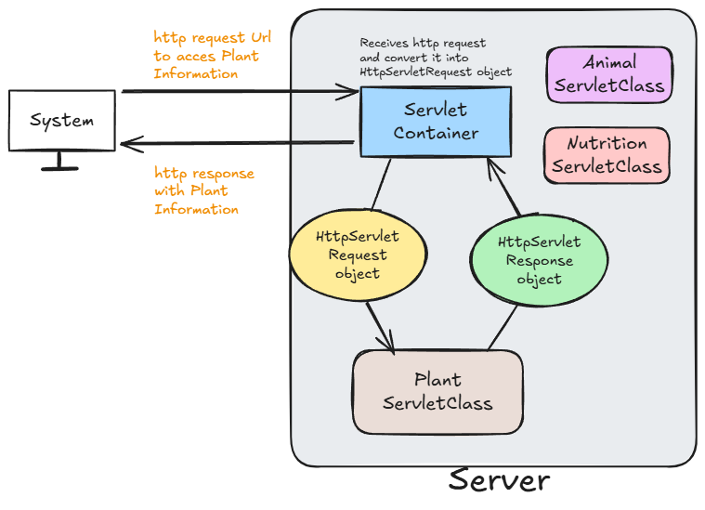

RequestDispatcher<<I>>
- It is an interface present in javax.servlet package.
- It is used
- to forward a request to another resource (like another servlet, JSP, or HTML file) on the server side, or
- to include the content of another resource in the response.

- It is used to dispatch the request from
- Servlet to Servlet
- Servlet to jsp/html
- Jsp to jsp
- Jsp to Servlet

- getRequestDispatcher() method is used to get the RequestDispatcher object with the help of Servlet request object
- Using RequestDispatcher object, we can use some methods like:

- forward (req, resp): forwards the request to another resource (no response sent yet)

- include(req,resp): Includes the content of another resource in the current response.
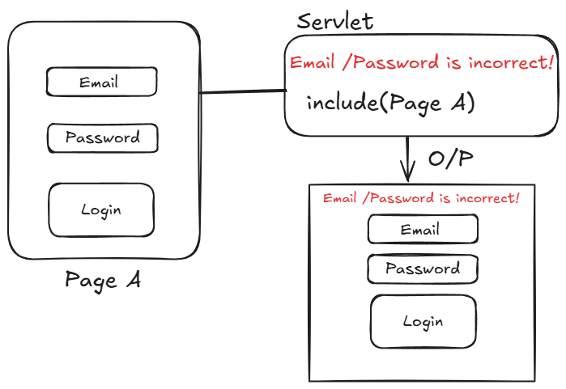

sendRedirect()

- It is used to redirect the client to a different resource (URL).
- This method is part of the HttpServletResponse interface.
e.g.: resp.sendRedirect("index.jsp");
//it will redirect user to index.jsp page!

Servlet Context

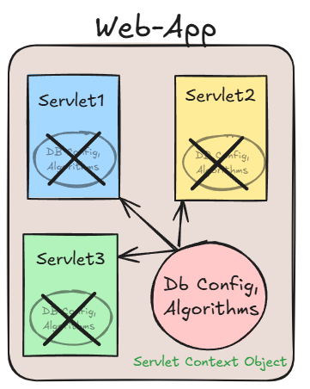
- ServletContext is an interface provided by the Servlet API that allows servlets to interact with their servlet container and share data across the entire web application.

- One ServletContext object per web application, created by ServletContainer/Web Container.
- ServletContext object is shared among all servlets in the application.
- Used for application-wide parameters and resources.
- Accessed via getServletContext() method from Servlet

- Storing and Getting Values in Servlet Context

- In web.xml, declare:
<context-param>
<!-- Data in key value pair -->
<param-name>user</param-name>
<param-value>postgres</param-value>
</context-param>
<context-param>
<param-name>password</param-name>
<param-value>root1234</param-value>
</context-param>
<context-param>
<param-name>url</param-name>
<param- value> jdbc:postgresql://localhost:5432/MyDB</param-value>
</context-param>

- These are shared/common for all the Servlet Class in the project.

- Using these parameters

//Creating a ServletContext Object

//Way 1(Easiest, direct, most common)
ServletContext servletContext = getServletContext();

//Fetching the context parameters from web.xml

String user= servletContext.getInitParameter("user"),
password= servletContext.getInitParameter("password"),
url= servletContext.getInitParameter("url");

System.out.println("--------------Servlet A--------------");
System.out.println("User: "+user);
System.out.println("Password: "+password);
System.out.println("URL: "+url);

Session Management
- http protocol is a stateless protocol i.e. Every request to the server is treated as new request bcz Server will not remember the client! In every next/new request.
- So, Client needs to introduce self for each new request
e.g. Providing username and password for every request in insta: login, then for accessing photos again and so on….

- So, to avoid this, we will make use of Session.
- Session is a state which will include the data of the client and store it for a particular time.

Why is Session Management Needed?
- HTTP is stateless: Each request is treated independently, and the server does not remember who made previous requests.
- For personalized experiences, such as:
  - Logging in users
  - Shopping carts
  - User preferences
  - Tracking user activity
We need a way to persist information across requests. That’s where session management comes in.
- So, Session management helps us maintain user state/data across multiple requests.

- Cookie

- Cookie is an object which can store a small piece of information.
- It is stored on the Client Side.(Client’s Browser)
- In Cookie, small piece of information is stored in Key-Value pair.(Only String data)
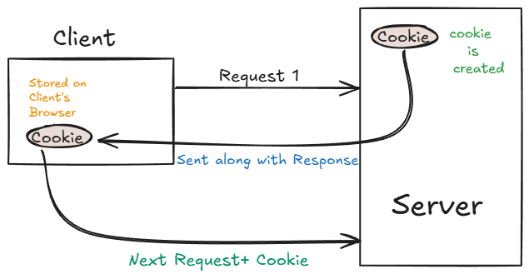

- In Java, Cookie is a class present in javax.servlet.http package
- We can create a Cookie object using:
- new Cookie()
- new Cookie(String key, String value)
Advantages:
- Simple Design
- Client Side Management

Dis-Advantages:
- Only Stores data in form of String
- Can be disabled from Client Side

Storing and Retrieving values from cookie object

- Create a Servlet Class and provide @WebServlet annotation and value/urlPatterns
- Override doGet():
//Creating cookie objects
- Cookie cookie=new Cookie("Username","Arpit"),
- cookie2=new Cookie("age","23");

- //Adding cookie objects to response object
- resp.addCookie(cookie);
- resp.addCookie(cookie2);

- PrintWriter printWriter= resp.getWriter();
- printWriter.print(
- "<h1>"
- + cookie.getName()+" : "+cookie.getValue()
- +"<br>"
- +cookie2.getName()+" : "+cookie2.getValue()
- + "</h1>"
- );

O/P:
Username : Arpit
age : 23

- Checking Cookie data on Browser:

SettingsPrivacy and SecurityCookiesSee all site data and permissions
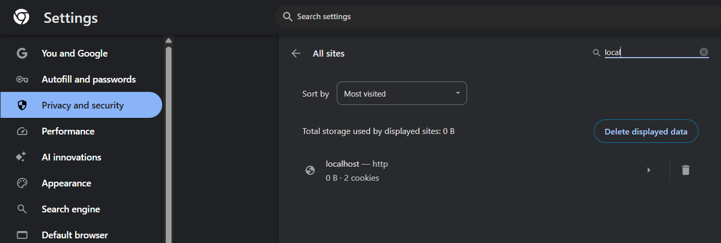

Managing Session using HttpSession

- It is an interface present in javax.servlet.http package.
- We can create HttpSession object by invoking:
- getSession(), which will return us the existing HttpSession object if present, else it will return new HttpSession object.
- getSession(boolean)
- if true is passed, it will return new HttpSession object even If it exists
- if false is passed, It will work similar to getSession()

HttpSession in login and logout Operation

- In web.xml, set Credentials:
- <!-- Session Management -->
- <context-param>
- <!-- Data in key value pair -->
- <param-name>Username</param-name>
- <param-value>admin</param-value>
- </context-param>
- <context-param>
- <param-name>Password</param-name>
- <param-value>admin@123</param-value>
- </context-param>

- Create one Login.html form
<form action="session-a" >
- Create 3 Servlet classes, and override doGet()
- SessionA
- PrintWriter writer = resp.getWriter();

- //Fetching login details
- String username=req.getParameter("user_name"),
- password=req.getParameter("password");

- //Fetching user and password from web.xml and comparing it with given credentials
- if(username.equals(getServletContext().getInitParameter("Username")) &&
- password.equals(getServletContext().getInitParameter("Password"))){

- //Creating HttpSession Object only when credentials match

- writer.print("<h1>Login Success!!</h1>"
- +"<a href=\"content-page-1\">View Content</a><br><br>"
- +"<a href=\"logout\">Logout</a>"
- );
- HttpSession session = req.getSession();
- session.setAttribute("username", username);
- }
- else {
- writer.print("<h1>Login Failed!!</h1>"
- +"<a href=\"SessionLogin.html\">Try Again</a>");
- }

- ContentPage1

- PrintWriter printWriter=resp.getWriter();

- String username=(String)req.getSession().getAttribute("username");

- if(username!=null) {
- printWriter.print("<h1>Welcome to Content Page 1</h1>");
- }else {
- printWriter.print("<h1>Please Login to view Content</h1>"
- + "<a href=\\\"SessionLogin.html\\\">Login</a>");
- }

- LogoutServlet

- HttpSession session = req.getSession();

- //Invalidates this session then unbinds any objects boundto it.
- session.invalidate();

- PrintWriter printWriter=resp.getWriter();
- printWriter.print(
- "<h1>Logged Out!!</h1>"
- );

JSP
- JSP stands for java server page.
- It allows developers to embed Java code directly into HTML pages using special tags.
- Servlets can be used if the focus is more on java logic and JSP's can be used if the focus is more on HTML logic.

- All the JSP files will be translated into servlets by jsp translator.

Creating a jsp file
- src/main/webappnew jsp file

- JSP Tags
1. Declaration tag <%! %>
- This tag is used to declare the variables or methods of a java.
- Anything inside this tag will be present outside the service() method!
- Variables declared here are global variables.

2. Scriptlet tag <% %>
- This tag is used to write java logic for dynamic response.
- Anything inside this tag will be returned within the service() method!.

3. Expression tag <%= %>
- This tag is used to print/display results on web browser.
- It is used to evaluate and output the result of an expression
- We cannot use void methods , as it don’t return anything!!
4. Directive tag <%@ %>
- This tag is used to import external resources in a JSP file.

- All the JSP files are capable of serving only HTTP requests because all the JSP files will be translated/converted into HttpServlet.

JSP life cycle:
JSP life cycle is very much similar to servlet life cycle.

Different phases of JSP life cycle
1. JSP file will be translated to the servlet by the component called as JSP translator, a part of Web Container and then compiled.
2. The translated servlet class will be loaded.
3. An instance will be created for the servlet class.
4. The servlet instance will be initialized by invoking jspInit() method.
5. The service will be provided for each request by invoking jspService() method, for n number of times, whenever the request is made!!!
6. Once the server stops, the jsp will get destroyed by invoking jspDestroy().

- Servlet container itself will manage the JSP life cycle.

