Spring MVC

Any application basically consists of three layers those are:
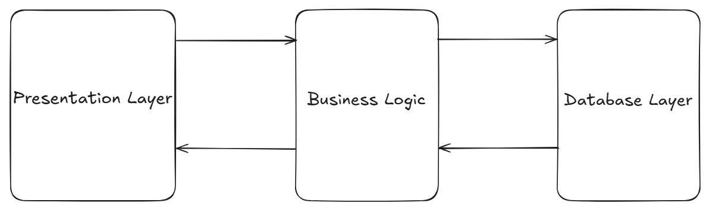

- Presentation layer:

This layer of an application deals with user interaction with the application.

- Business logic:

This layer of an application deals with data processing and database connectivity.

- Database layer:

This layer of an application deals with data management and data storage.

Monolithic application: If all the above layers of an application are present as a single application, then that application is called as monolithic application.

Spring MVC

- MVC stands for model, view, controller.
- Spring MVC is part of the Spring Framework and offers tools and conventions to create web applications (web pages, REST APIs, etc.).
- It is an architectural design pattern that divides an application into three parts/layers to make code cleaner and easier to maintain.

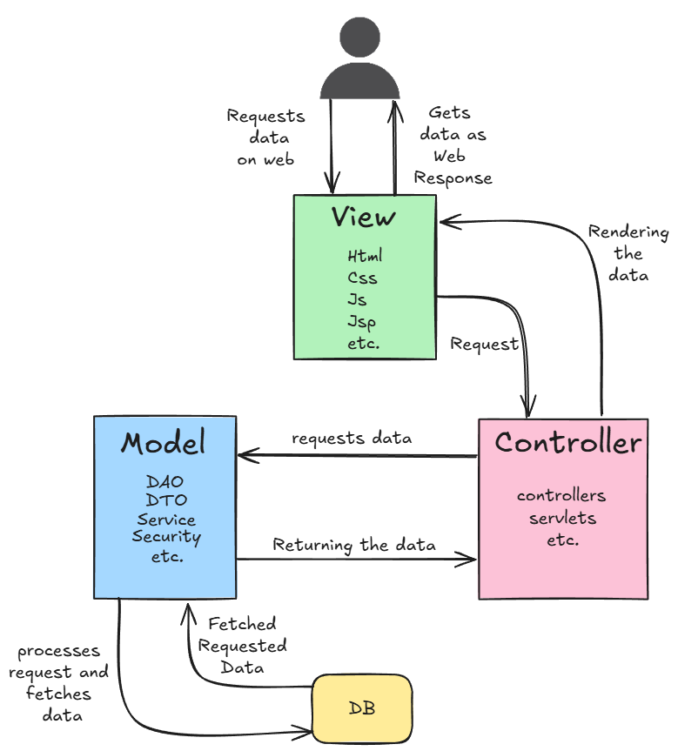
- Model:

- It represents business logic(backend) of an application, application data along with the database connectivity.
- It can have layers like Service, DAO, DTO, Security, Repository, etc.

- View:

- It represents presentation layer or user interface(frontend).
- It generally holds the HTML, CSS, JS, Thymeleaf , JSP ,etc codes.

- Controller:

- It acts like an interface between view and model.
- Controller controls all the requests and responses.

Real time example:
- Think of a restaurant:

- Controller is the waiter (takes your request)
- Model is the kitchen (the data and business logic)
- View is the plated food (what the user sees).

