**PharmEasy**

**First page**

**Navbar**

Logo, Location, Login, Offer, Cart

Medicine, Lab test, Heathcare surgeries, Health blog, Offer,

**Search Box**

Medicine, Lab test, Heathcare surgeries, Health blog, Offer, (with icon)

**Lab test by health concern**

Fool body check-up, vitamins, Diabetes, Thyroid, Women Care, Fever and infection, Covid care, Heart, Lifestyle, Bone health,

**Offer Just for you**

**Order with prescription**

**Details**

**Footer**

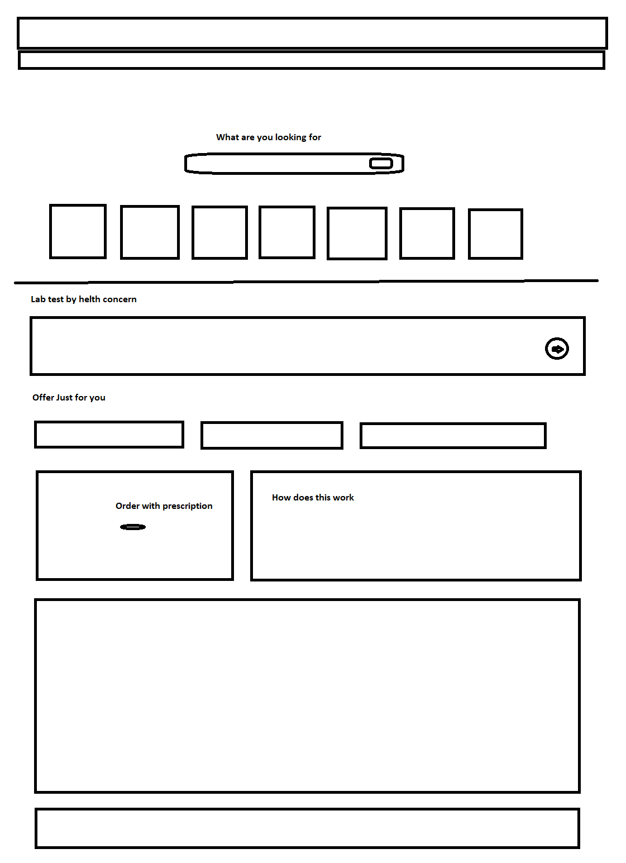

**Second page**

**Search box**

Order medicine online

Order via prescription

Don’t have prescription? Call

All offer

Details

Footer

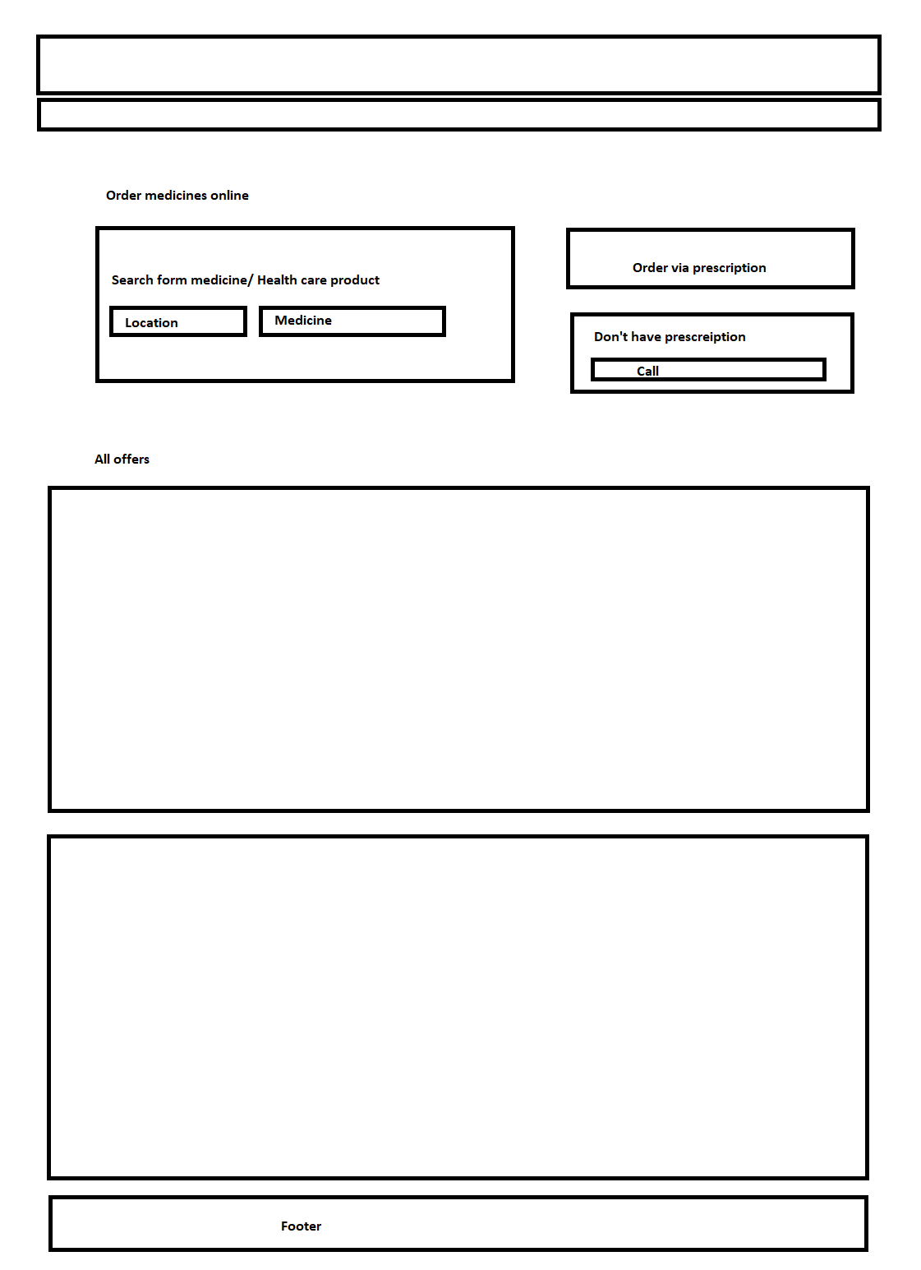

Third page

Product details:

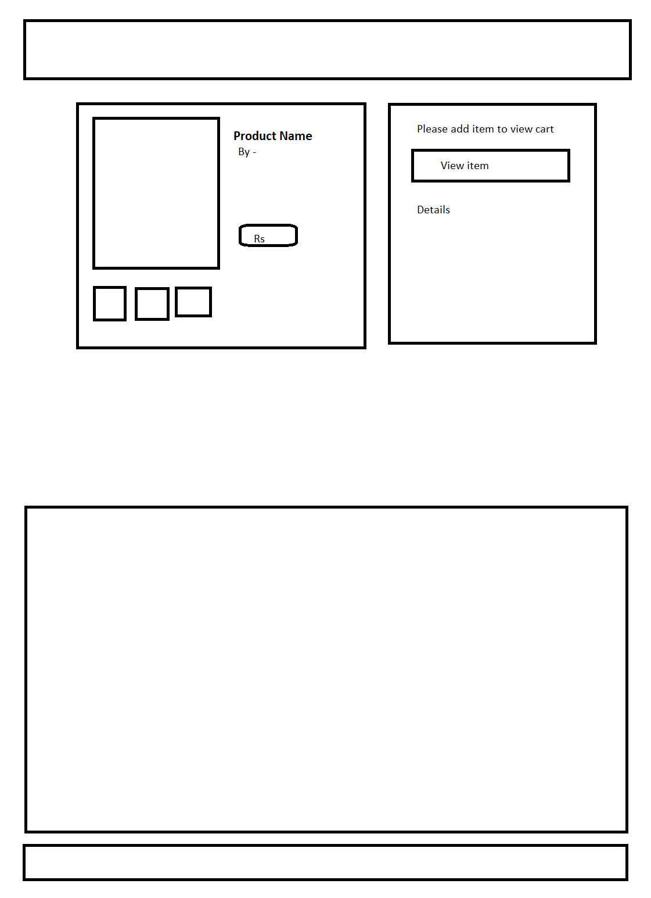

Fourth page

Bill details n summary

