## Exercise 1 – Northwind Queries (40 marks: 5 for each question)

* 1. Write a query that lists all Customers in either Paris or London. Include Customer ID, Company Name and all address fields.

SELECT CustomerID, CompanyName, Address + ' ' + City + ' ' + PostalCode + Country AS 'Full address' , Region

FROM Customers WHERE City = 'Paris' OR City = 'London';

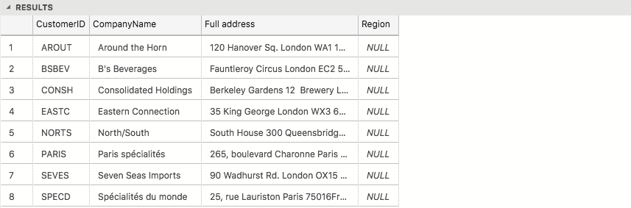

* 1. List all products stored in bottles.

SELECT ProductName AS 'Product name', QuantityPerUnit AS 'Unit type and qunatity' FROM Products WHERE QuantityPerUnit LIKE '%bottle%';

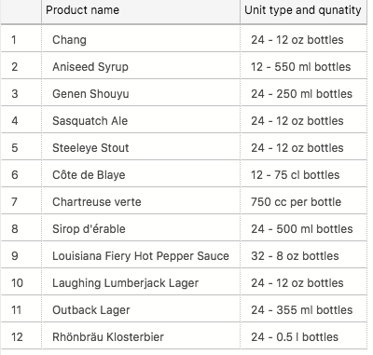

* 1. Repeat question above, but add in the Supplier Name and Country.

SELECT ProductName, Suppliers.CompanyName AS 'Suplier name', Suppliers.Country, QuantityPerUnit AS 'Unit type and qunatity' FROM Products

INNER JOIN Suppliers ON Products.SupplierID = Suppliers.SupplierID

WHERE QuantityPerUnit LIKE '%bottle%';

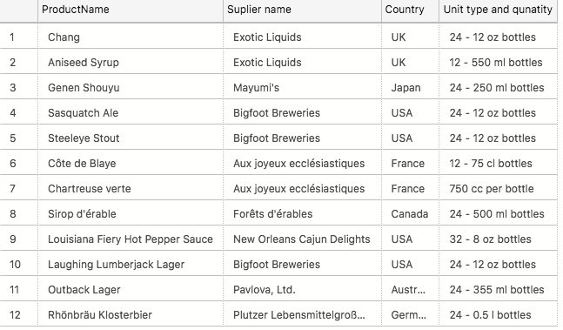

* 1. Write an SQL Statement that shows how many products there are in each category. Include Category Name in result set and list the highest number first.

SELECT Categories.CategoryName, Count(Products.CategoryID) AS 'Products per category' FROM Products

INNER JOIN Categories ON Categories.CategoryID = Products.CategoryID

GROUP BY Categories.CategoryID, Categories.CategoryName ORDER BY Count(Products.CategoryID) DESC;

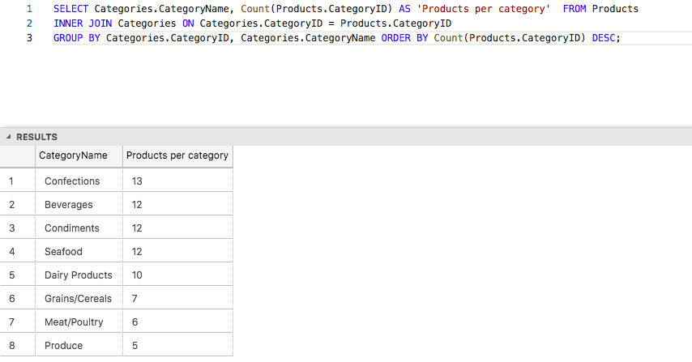

* 1. List all UK employees using concatenation to join their title of courtesy, first name and last name together. Also include their city of residence.

SELECT TitleOfCourtesy + ' ' + FirstName + ' ' + LastName AS 'Full Name' , City AS 'City of Residence' FROM Employees

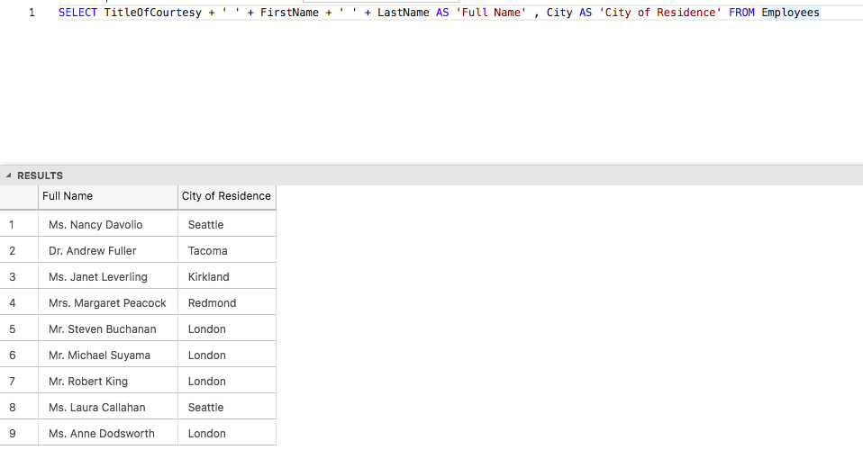

* 1. List Sales Totals for all Sales Regions (via the Territories table using 4 joins) with a Sales Total greater than 1,000,000. Use rounding or FORMAT to present the numbers.

SELECT DISTINCT Region.RegionDescription AS 'Regions', FORMAT((SUM([Order Details].UnitPrice*[Order Details].Quantity)), 'C','gb-GB') AS 'Sales Total'

FROM Territories

INNER JOIN Region

ON Region.RegionID = Territories.RegionID

INNER JOIN EmployeeTerritories

ON EmployeeTerritories.TerritoryID = Territories.TerritoryID

INNER JOIN Orders

ON EmployeeTerritories.EmployeeID = Orders.EmployeeID

INNER JOIN [Order Details]

ON Orders.OrderID = [Order Details].[OrderID]

GROUP BY Region.RegionDescription

HAVING SUM([Order Details].UnitPrice*[Order Details].Quantity) > 1000000;

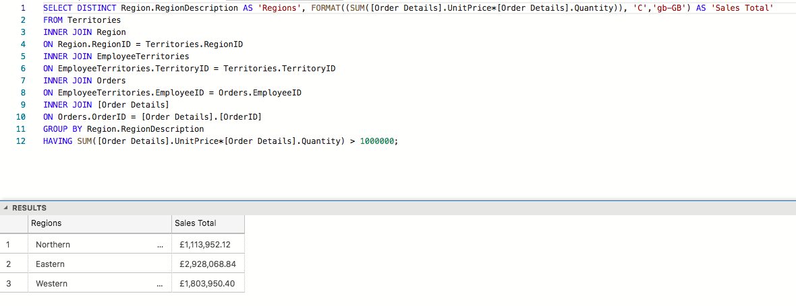

* 1. Count how many Orders have a Freight amount greater than 100.00 and either USA or UK as Ship Country.

SELECT COUNT(*) AS 'Orders with frieght Over 100' FROM Orders WHERE Freight > 100 AND (ShipCountry = 'USA' OR ShipCountry = 'UK');



* 1. Write an SQL Statement to identify the Order Number of the Order with the highest amount of discount applied to that order.

SELECT TOP 1 OrderID,

FORMAT(ROUND(SUM((Quantity*UnitPrice)-(Quantity*(UnitPrice*(1-Discount)))),0),'C','gb-GB') AS 'Total discounted amount'

FROM [Order Details]

GROUP BY OrderID

ORDER BY SUM((Quantity*UnitPrice)-(Quantity*(UnitPrice*(1-Discount)))) DESC;

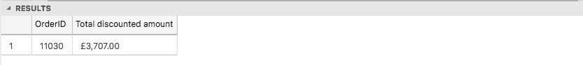

## Exercise 2 – Create Spartans Table (20 marks – 10 each)

2.1 Write the correct SQL statement to create the following table:

Spartans Table – include details about all the Spartans on this course. Separate Title, First Name and Last Name into separate columns, and include University attended, course taken and mark achieved. Add any other columns you feel would be appropriate.

IMPORTANT NOTE: For data protection reasons do NOT include date of birth in this exercise.

CREATE DATABASE sparta_database;

USE sparta_database;

DROP TABLE Spartans;

CREATE TABLE Spartans (

title VARCHAR(4),

firstName VARCHAR(20),

lastName VARCHAR(20),

universityAttended VARCHAR(40),

courseTaken VARCHAR(50),

markAchieved VARCHAR(10),

gameProject VARCHAR(40)

);

2.2 Write SQL statements to add the details of the Spartans in your course to the table you have created.

INSERT INTO Spartans (

title, firstName, lastName, universityAttended, courseTaken, markAchieved, gameProject

)

VALUES

('Mr', 'Seb', 'Woerkom','University of Kent', 'American and English lit and history of art', NULL, 'Maze runner'),

('Mr', 'James', 'Bachen','Bournemouth University', 'Music and audio technology', NULL, 'Black Jack'),

('Mr', 'Robert', 'Teall','University of West London', 'BMUS Popular music performance', NULL, 'A filament of your imagination'),

('Mr', 'Christopher', 'Baker','University College London', 'Digital humanities', 'Merit', 'Who wants to be a billionaire?'),

('Mr', 'Aaron', 'Leslie','Queen Mary University of London', 'Mathematics', NULL, 'Word wars'),

('Mr', 'Arthur', 'Hussey','University of Oxford', 'Materials science', 'First', 'Cravate'),

('Miss', 'Qamar', 'Aden','University of Portsmouth', 'Petroleum engineering', NULL, 'Connect 4'),

('Mr', 'Philip', 'Faboya','University of Surrey', 'Chemical engineering', NULL, 'Hunting Season'),

('Miss', 'Maroua', 'Akkari','Queen Mary University of London', 'Bioinformatics', 'Merit', 'MQ Trivia'),

('Mr', 'Benjamin', 'Owusu','London Southbank University', 'Business management with finance', NULL, 'Pig dice game'),

('Mr', 'Taher', 'Khan','London Southbank University', 'Informaticn technology', 'First', 'Disney characters memory game');

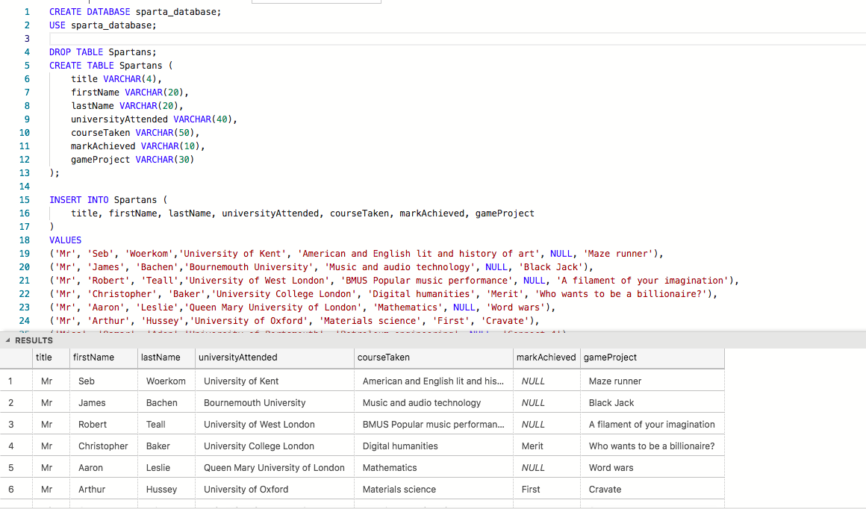

## Exercise 3 – Northwind Data Analysis linked to Excel (30 marks)

Write SQL statements to extract the data required for the following charts (create these in Excel):

3.1 List all Employees from the Employees table and who they report to. No Excel required. (5 Marks)

SELECT a.FirstName + ' ' + a.LastName AS 'Employer full name', b.FirstName + ' ' + b.LastName AS 'Employee full name'

FROM Employees a

INNER JOIN Employees b

ON a.EmployeeID = b.ReportsTO;

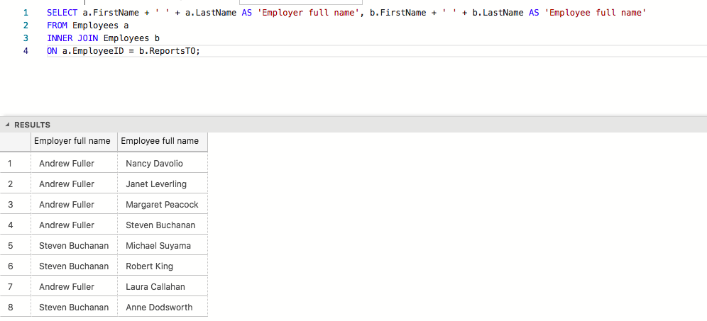

3.2 List all Suppliers with total sales over $10,000 in the Order Details table. Include the Company Name from the Suppliers Table and present as a bar chart as below: (5 Marks)

SELECT Suppliers.CompanyName, FORMAT(ROUND(SUM([Order Details].UnitPrice*[Order Details].Quantity-([Order Details].Quantity*([Order Details].UnitPrice*([Order Details].Discount)))),0),'C','us-US') AS 'Total sales' FROM [Order Details]

INNER JOIN Products

ON [Order Details].ProductID = Products.ProductID

INNER JOIN Suppliers

ON Products.SupplierID = Suppliers.SupplierID

GROUP BY Suppliers.CompanyName

HAVING SUM([Order Details].UnitPrice*[Order Details].Quantity) > 10000

ORDER BY SUM([Order Details].UnitPrice*[Order Details].Quantity) ASC;

3.3 List the Top 10 Customers YTD for the latest year in the Orders file. Based on total value of orders shipped. No Excel required. (10 Marks)

SELECT TOP 10 Customers.CompanyName AS 'Company Name', Customers.ContactName AS 'Customer Name',

FORMAT(SUM([Order Details].UnitPrice*[Order Details].Quantity),'C','us-US') AS 'Total Orders value' FROM Orders

INNER JOIN [Order Details]

ON Orders.OrderID = [Order Details].OrderID

INNER JOIN Customers

ON Orders.CustomerID = Customers.CustomerID

GROUP BY Customers.ContactName, Customers.CompanyName, Orders.ShippedDate

HAVING year(Orders.ShippedDate) = 1998

ORDER BY SUM([Order Details].UnitPrice*[Order Details].Quantity) DESC;

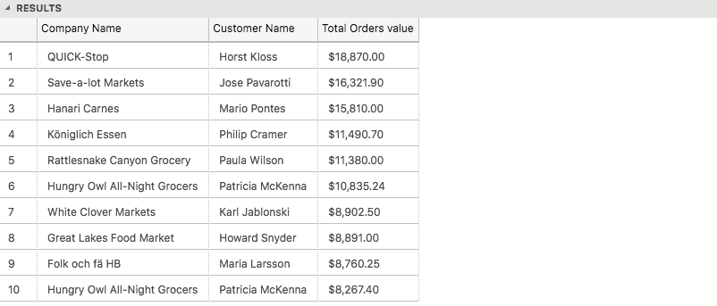

3.4 Plot the Average Ship Time by month for all data in the Orders Table using a line chart as below. (10 Marks)

SELECT CAST(DATENAME(MONTH,OrderDate) as char) + CAST(YEAR(OrderDate) as char) AS 'month of year',

AVG(DATEDIFF(day,OrderDate,ShippedDate)) AS 'Shipping time'

FROM Orders

GROUP BY MONTH(OrderDate), YEAR(OrderDate), DATENAME(MONTH,OrderDate)

ORDER BY MONTH(OrderDate), YEAR(OrderDate);