**Projects :**

* + [Flytopia]: [travel agency website that integrates with multiple travel websites to retrieve data and present it to users. This data might include flight, hotel, and rental car information, as well as other travel-related information.]

[Java, Javascript, Express (JavaScript), MongoDB,]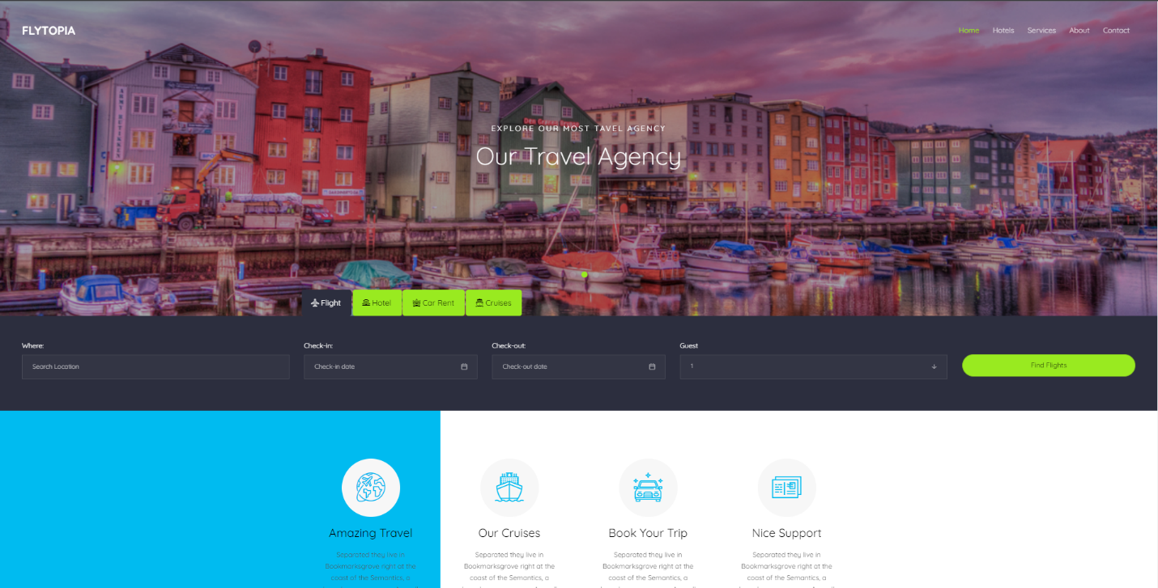

* + [desktop application to manage interns]: [designed to help businesses and organizations keep track of the interns that are currently working with them.]

[Programming languages: C#

XAML: for developing the user interface and layout

.NET Framework: for building the application's core functionality

Windows Presentation Foundation (WPF) : A framework for creating rich, interactive desktop applications.

Object-Relational Mapping (ORM) libraries: Entity Framework, NHibernate

Database management systems: sqlit3

Dependency Injection: Unity

UI controls and libraries : Material Design In XAML Toolkit, MahApps.Metro, Dragablz.

Version Control system: Git, SVN, Mercurial

software testing framework : MSTest, NUnit.]

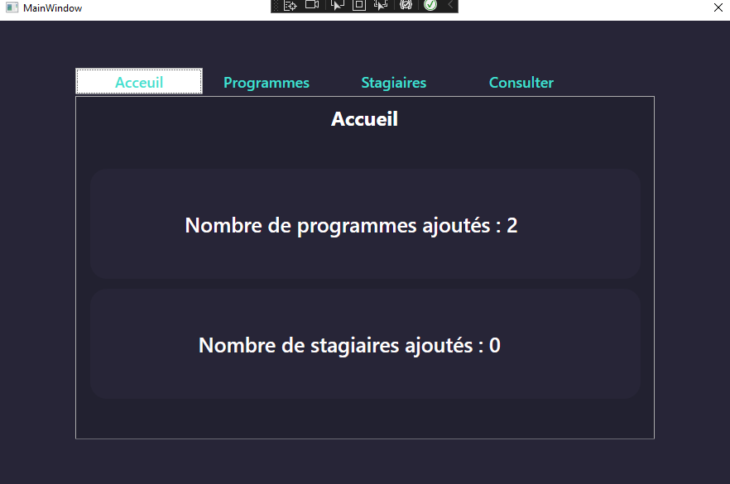

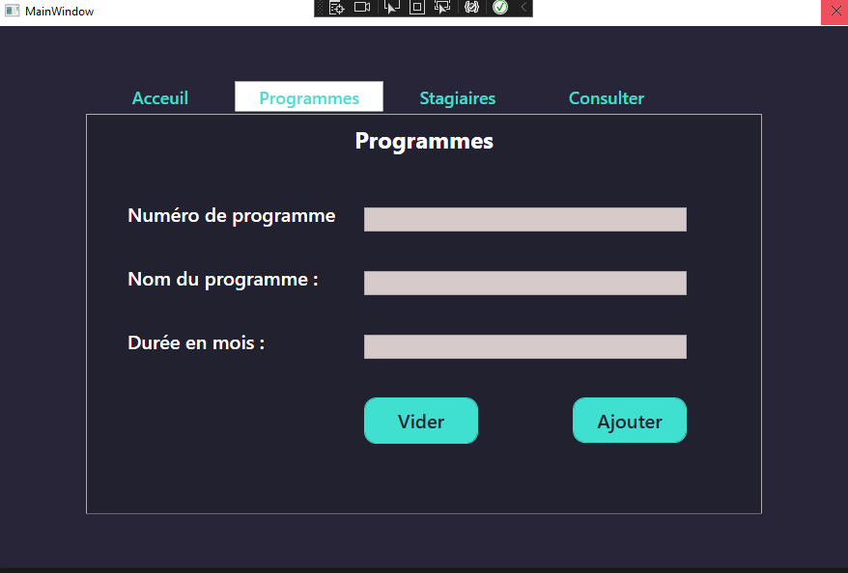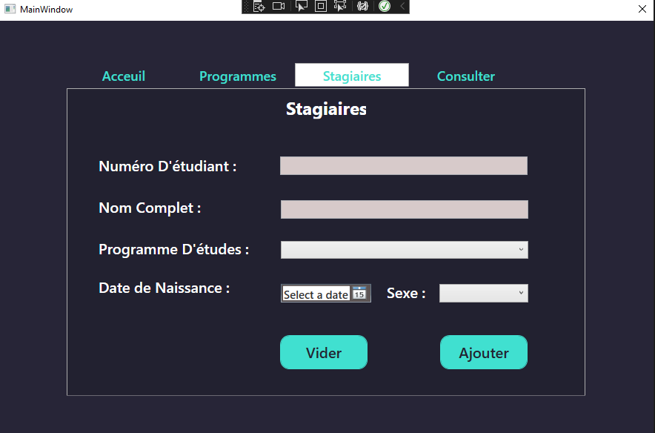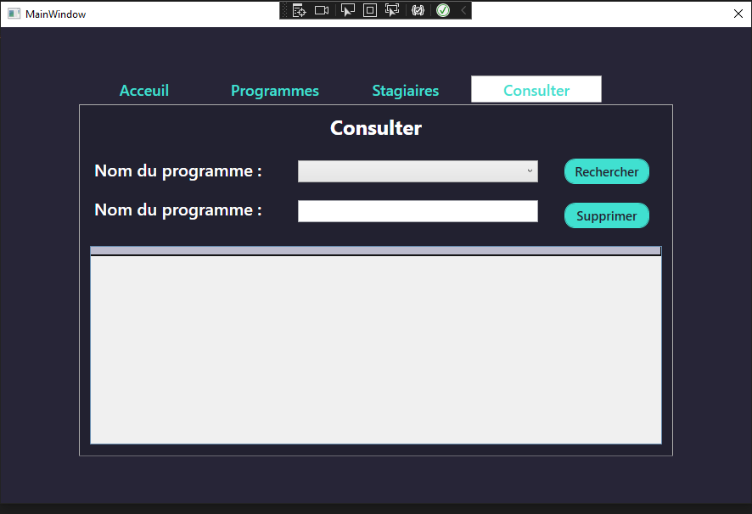

Design:

