Supporting Information for
Environmental Impacts of Lithium Supply Chains from Australia to China
Yan Feng¹, Danyi Feng^{2,} ∗, Wen Li³, Qian Zhang⁴, Wei-Qiang Chen^{1,5,6}, and Peng Wang^{1,5,6,} ∗
- Key Lab of Urban Environment and Health, Institute of Urban Environment, Chinese Academy of Sciences, Xiamen, Fujian 361021, China
- University of Wisconsin-Madison, Department of Civil and Environmental Engineering, 1415 Engineering Drive, Madison, WI, 53706, USA
- Department of Mechanical Engineering, University of Melbourne, Melbourne, VIC 3010, Australia
- Robert M. Buchan Department of Mining, Queen’s University, Kingston, K7L3N6, Canada
- Ganjiang Innovation Academy, Chinese Academy of Sciences, Ganzhou 341000, China
- University of Chinese Academy of Sciences, Beijing 100049, China

Contents
1. System boundary 3
2. Contribution of impact categories 4
3. Life cycle inventory datasets 5
4. Electricity generation mix 12
5. Provincial Li plants shipping information 13
6. LCA results 14

- System boundary
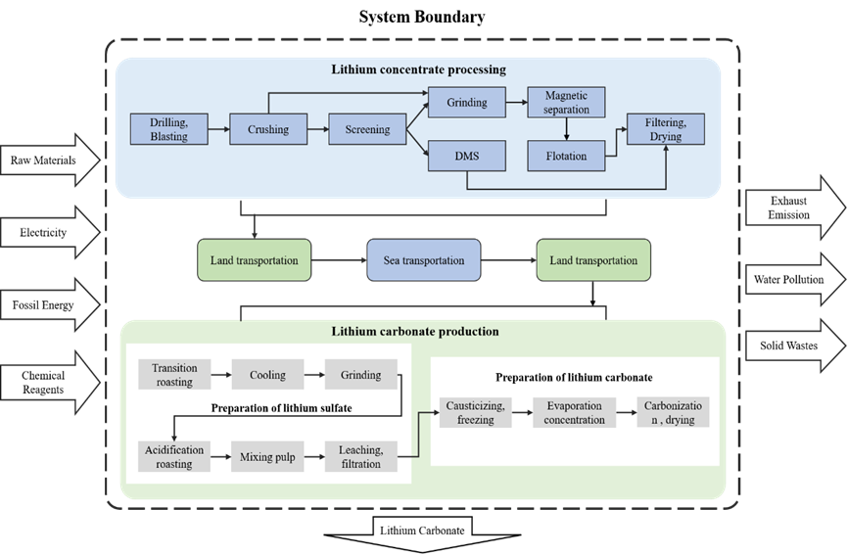
Figure S1 Flows and processes of lithium carbonate (LCE) production included in this life-cycle assessment model (1 t battery-grade LCE produced).

- Contribution of impact categories
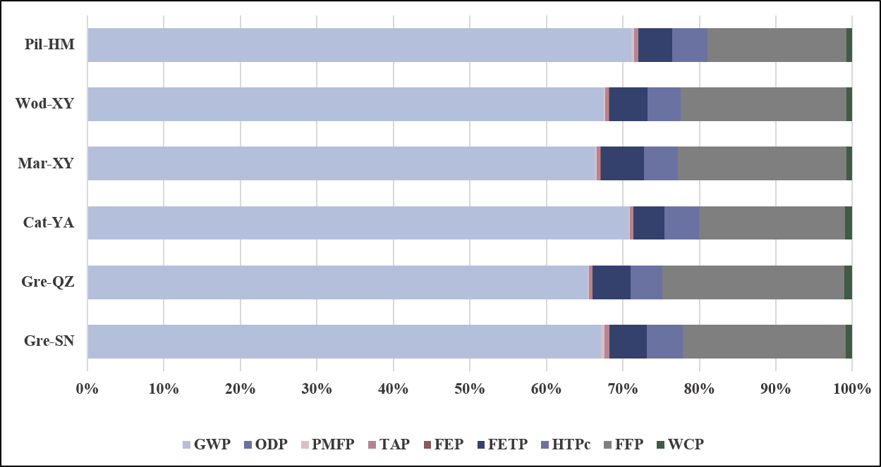
Figure S2 Contribution of environmental impact categories based on normalized results.

- Production capacity of Australian mines and China processing plants
Tabel S1 Comprehensive information on lithium (Li) extraction by Australian mines and processing plants in China.
Production routes | Raw ore grade  (Li₂O %) | Li extraction rate | production capacity  (t/years) | Concentrate demand (t) | Source
Gre-SN | 1.6 | Beneficiation: 75%  Refining: 82% | Concentrate: 1340000  LCE: 20000 | 164466 | http://www.tianqilithium.com/Upload/File/202304/20230429011029_0862.pdf
Gre-QZ | 1.6 | Beneficiation: 75%  Refining: 85% | Concentrate: 1340000  LCE: 3000 | 30142 | http://www.tianqilithium.com/Upload/File/202304/20230429011029_0862.pdf
Cat-YA | 1.2 | Beneficiation: 52%  Refining: 93% | Concentrate: 131000  LCE: 20000 | 152556 | https://www.datocms-assets.com/53992/1699424132-ake-fy23-sustainability-report-2023.pdf
Mar-XY | 1.37 | Beneficiation: 79%  Refining: 95% | Concentrate: 600000  LCE: 15000 | 106200 | https://s3.ap-southeast-2.amazonaws.com/assets.mineralresources.com.au/app/uploads/2022/10/13200621/MinRes-2022-Annual-Report-20220915.pdf
Wod-XY | 1.17 | Beneficiation: 68%  Refining: 95% | Concentrate: 750000  LCE: 15000 | 106200 | https://s3.ap-southeast-2.amazonaws.com/assets.mineralresources.com.au/app/uploads/2022/10/13200621/MinRes-2022-Annual-Report-20220915.pdf
Pil-HM | 1.1 | Beneficiation: 73%  Refining: 82% | Concentrate: 377902  LCE: 6000 | 48503 | https://1pls.irmau.com/site/pdf/84195c02-1519-47cb-8e0b-8ef4322bfa5b/2022-Annual-Report.pdf

- Life cycle inventory datasets
The process chains begin with a conventional open-pit mining process. Due to the lack of plant-specific inventory data (e.g., energy supply, explosives), the mining inventory is sourced from the EcoInvent database (Spodumene {AU}| spodumene production | Cut-off, S).
Table S2 presents material and energy inputs to produce concentrated spodumene from western Australia mines. The inventory data for Greenbushes, Marion, and Wodgina are based on data published by Kelly et al. and are converted according to the ore grade. For Cattlin, the beneficiation inventory data comes from Allkem' s “Sustainability Report 2022”, while Pilgangoora's data is sourced from Pilbara's “Annual Report 2022”.
The LCI details all inputs of material, energy, and water required to produce one metric ton of LCE. In this study, the LCI data for LCE produced in China was sourced from the project’s Environmental Impact Assessment Report (EIA). The upstream processes, including resource extraction, raw material production, energy generation, and transportation, are based on Ecoinvent 3.9. All LCIs are listed in Tables 3, described as follows.
Tabel S2 Life cycle inventory of spodumene concentrate per ton produced by Australian mines.
Input /t Concentrate | Greenbushes | Cattlin | Marion | Wodgina | Pilgangoora
Materials input
Spodumene ore [t] | 5 | 9.044 | 5.5 | 7.6 | 6.75
Fresh water [t] | 3.333 | 5.259 | 3.67 | 5.1 | 4.5
Otherª [t] | 0.017 | - | 0.018 | 0.025 | -
Energy input
Diesel [MJ] | 5000 | 2654.7 | 5500 | 7600 | 2271
Electricity [kWh] | - | 244.69 | - | - | 192.25
ª Includes sodium carbonate and a dispersant.

Tabel S3 Life cycle inventory of Li₂CO₃ per ton produced by Factories in China.
Input /t LCE | Gre-SN | Gre-QZ | Cat-YA | Mar-XY | Wod-XY | Pil-HM
Materials input
Concentrate | 8.223 | 10.047 | 7.628 | 10.838 | 10.874 | 8.084
Sulfuric acid | 2.68 | 1.903 | 1.115 | 2.501 | 2.501 | 2.082
Soda ash | 2.35 | - | - | 0.023 | 0.023 | 1.572
Sodium hydroxide | 0.48 | 2.076 | 0.659 | 0.144 | 0.144 | 0.005
Calcium carbonate | 0.7 | 1.278 | 0.274 | 0.665 | 0.665 | 0.539
Limestone | - | 0.010 |  |  | - | 0.539
Carbon dioxide | 0.3 | 0.646 | 0.176 | 0.700 | 0.700 | -
Hydrochloric acid | 0.17 | - | - | - | - | -
Oxygen, liquid | 0.035 | - | - | - | - | -
Fresh water | 29.68 | 20.473 | 18.405 | 0.496 | 0.496 | 18.6
Energy input
Electricity [kWh] | 2900 | - | 71.470 | - | - | 1900
Natural gas [m3] | 1414.5 | 1377 | - | - | - | 0.085
Steam | - | 0.999 | 7.004 | - | - | 9.340
Coal |  | - |  | 1.929 | 1.929 | -

Data source:
Gre-SN: https://maipdf.com/est/d17423523236@pdf
Gre-QZ: https://maipdf.com/est/d15527523549@pdf
Cat-YA: https://maipdf.com/est/d12526527214@pdf
Mar-XY: https://maipdf.com/est/d14089527598@pdf
Wod-XY: https://maipdf.com/est/d14089527598@pdf
Pil-HM: https://maipdf.com/est/d17389765945@pdf

- Electricity generation mix
Characterizing the electrical grids that will supply power to electricity-consuming processes remains crucial. Detailed information for both Australia and China is furnished in Table S.4-5. The most recent data available for Australian electricity from the International Energy Agency website is for 2022. For China, the latest information from the same source is for 2021.
Tabel S4 Electricity generation mix of electricity consumption for Li production in Australia.
 |  |  |  | Electricity mix
Grid | Coal | Oil | Natural gas | Biofuels | Hydro | Solar PV | Wind
Australia | 49.2% | 1.7% | 18.1% | 1.2% | 6.3% | 12.8% | 10.7%

Tabel S5 Electricity generation mix of electricity consumption for Li production in China.
 |  |  |  | Electricity mix
Grid | Coal | Nuclear | Hydro | Wind | Natural gas | Biofuels | Solar PV
China | 63.0% | 4.7% | 15.6% | 7.6% | 3.2% | 2.0% | 3.9%

- Provincial Li plants shipping information
For the assumed Australian mining facility, we assume that the spodumene concentrate is transported to the port by truck within inland Western Australia. Then we provide the assumed value for the transportation of spodumene concentrate to China's port by ship and its further movement by truck to the final processing location for refinement into Li₂CO_{3.}
Tabel S6 Transportation of spodumene concentrate from Australia to China (units: km)
Project | Distance | Transportation | Location
Greenbushes | 80.5 | Truck | Greenbushes—Bunbury
Greenbushes | 4980 | Ship | Bunbury—Haian (Jiangsu)
Greenbushes | 1435 | Truck | Haian (Jiangsu)—Suining (Sichuan)
Mt Marion | 347 | Truck | Mt Marion—Esperance
Mt Marion | 5029 | Ship | Esperance—Xiamen (Fujian)
Mt Marion | 484 | Truck | Xiamen(Fujian)—Fengcheng（Jiangxi）
Mt Cattlin | 196 | Truck | Mt Cattlin—Esperance
Mt Cattlin | 4709 | Ship | Esperance—Modern Terminals
Mt Cattlin | 1358 | Truck | Modern Terminals—Danling (Sichuan)
Wodgina | 116 | Truck | Mt Wodgina—Port of Hedland
Wodgina | 3488 | Ship | Port of Hedland —Xiamen (Fujian)
Wodgina | 484 | Truck | Xiamen(Fujian)—Fengcheng（Jiangxi）
Pilgangoora | 109 | Truck | Mt Pilgangoora——Port of Hedland
Pilgangoora | 3651 | Ship | Port of Hedland——Haian (Jiangsu)
Pilgangoora | 1149 | Truck | Haian (Jiangsu)——Haimen (Jiangsu)

- LCA results
Tabel S7 Cradle-to-gate life cycle results per ton of concentrate ore for the Australian mines
Indicators | Units | Greenbushes | Cattlin | Marion | Wodgina | Pilgangoora
GWP | kg CO2 eq | 7.50E+02 | 8.64E+02 | 8.25E+02 | 1.14E+03 | 6.80E+02
ODP | kgCFC11 eq | 6.65E-04 | 6.57E-04 | 7.31E-04 | 1.01E-03 | 5.19E-04
PMFP | kg PM2.5 eq | 3.16E+00 | 3.35E+00 | 3.48E+00 | 4.81E+00 | 2.62E+00
TAP | kg SO2 eq | 4.86E+00 | 4.83E+00 | 5.34E+00 | 7.38E+00 | 3.83E+00
FEP | kg P eq | 3.93E-01 | 7.77E-01 | 4.32E-01 | 5.97E-01 | 5.93E-01
FETP | kg 1,4-DCB | 2.80E+01 | 3.48E+01 | 3.08E+01 | 4.26E+01 | 2.73E+01
HTPc | kg 1,4-DCB | 4.38E+01 | 6.48E+01 | 4.81E+01 | 6.65E+01 | 5.03E+01
FFP | kg oil eq | 2.12E+02 | 2.28E+02 | 2.33E+02 | 3.22E+02 | 1.81E+02
WCP | m3 | 6.83E+00 | 1.06E+01 | 7.51E+00 | 1.04E+01 | 8.52E+00

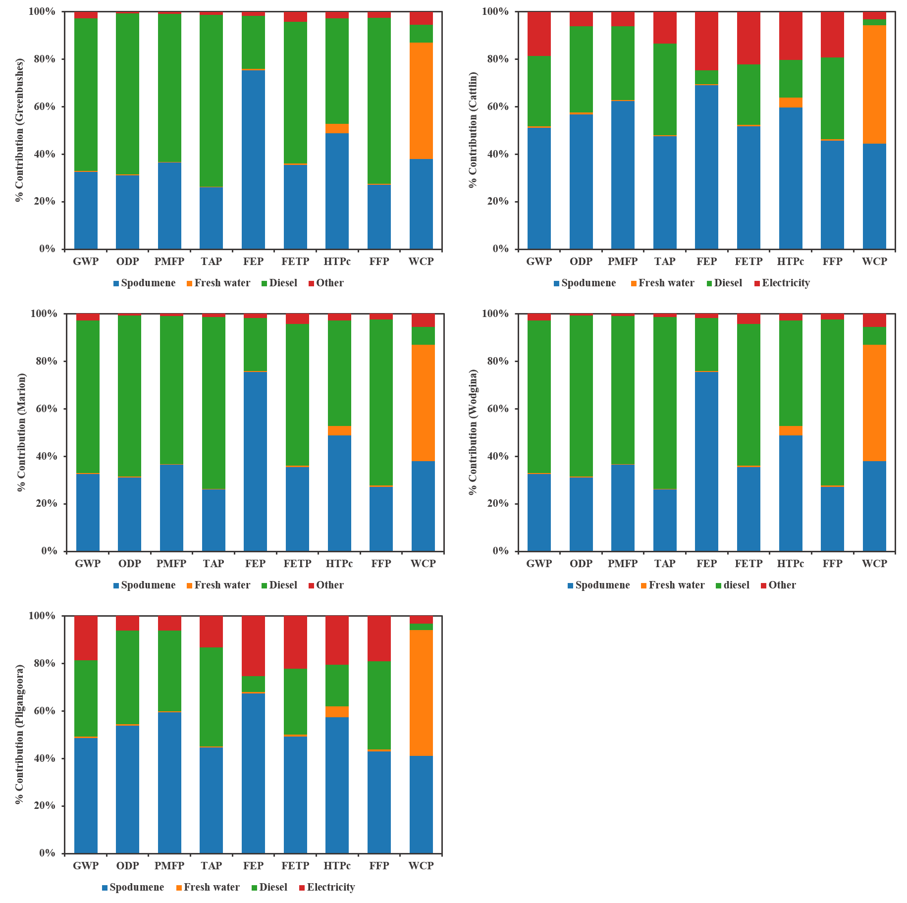
Figure S3 Percentage contributions of various energy and material inputs to the environmental and human health impacts based on the Australian concentrate process.

Tabel S8 Cradle-to-gate life cycle results per ton of Li₂CO₃ for the production routes. | Pil-HM | 1.45E+04 | 5.72E-03 | 8.17E+01 | 1.12E+02 | 7.58E+00 | 8.98E+02 | 9.34E+02 | 3.70E+03 | 1.58E+02
 | Wod-XY | 1.52E+04 | 1.18E-02 | 6.21E+01 | 1.05E+02 | 8.54E+00 | 1.13E+03 | 9.83E+02 | 4.89E+03 | 1.66E+02
 | Mar-XY | 1.17E+04 | 8.75E-03 | 4.75E+01 | 8.28E+01 | 6.73E+00 | 9.99E+02 | 7.81E+02 | 3.91E+03 | 1.34E+02
 | Cat-YA | 1.05E+04 | 6.60E-03 | 3.46E+01 | 5.73E+01 | 7.26E+00 | 6.02E+02 | 6.68E+02 | 2.82E+03 | 1.43E+02
 | Gre-QZ | 1.24E+04 | 1.05E-02 | 4.46E+01 | 7.93E+01 | 6.39E+00 | 9.43E+02 | 7.97E+02 | 4.53E+03 | 1.97E+02
 | Gre-SN | 1.64E+04 | 7.96E-03 | 1.15E+02 | 1.53E+02 | 7.00E+00 | 1.18E+03 | 1.15E+03 | 5.23E+03 | 2.01E+02
 | Units | kg CO2 eq | kg CFC11 eq | kg PM2.5 eq | kg SO2 eq | kg P eq | kg 1,4-DCB | kg 1,4-DCB | kg oil eq | m3
 | Indicators | GWP | ODP | PMFP | TAP | FEP | FETP | HTPc | FFP | WCP

∗ Corresponding author. E-mail address: dfeng26@wisc.edu (D.Y. Feng), pwang@iue.ac.cn (P. Wang).

