SUPPORTING INFORMATION FOR:

Degen, F., Mitterfellner, M. & Kampker, A. (2024) Comparative life cycle assessment of lithium-ion, sodium-ion and solid-state battery cells for electric vehicles. Journal of Industrial Ecology.
This supporting information provides information for battery cells of exiting LCA literature, additional material flows and additional environmental impact results.

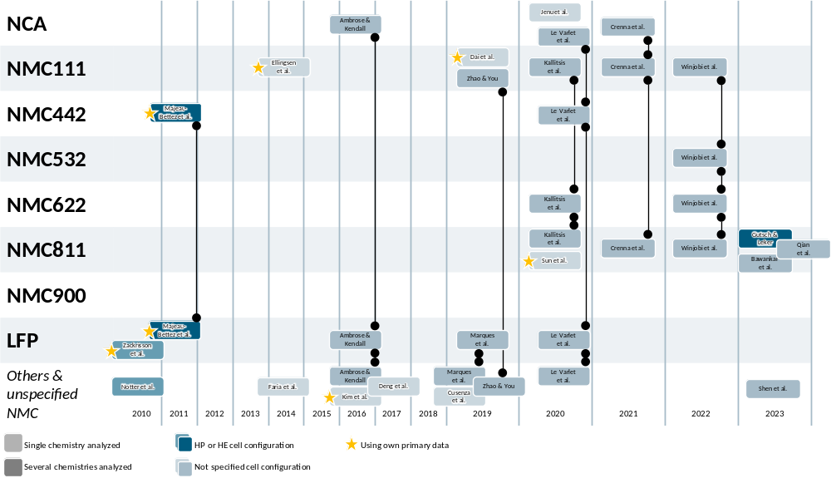
Figure 1. Overview of LCAs of lithium-ion batteries since 2010. Only LCAs are taken into account for Lithium-Ion Batteries (not Post Lithium-Ion Batteries etc.), which cover at least the “cradel to gate” part of the value chain. (Notter et al. 2010; Zackrisson et al. 2010; Majeau-Bettez et al. 2011; Ellingsen et al. 2014; Faria et al. 2014; Ambrose und Kendall 2016; Kim et al. 2016; Deng et al. 2017; Dai et al. 2019; Zhao und You 2019; Marques et al. 2019; Cusenza et al. 2019; Jenu et al. 2020; Le Varlet et al. 2020; Kallitsis et al. 2020; Sun et al. 2020; Crenna et al. 2021; Winjobi et al. 2022; Gutsch und Leker 2024; Qian et al. 2023; Bawankar et al. 2023; Shen et al. 2023)

Figure 2. Sensitivity analysis of global warming potential (GWP) for battery cells in high energy configuration. The values from Ecoinvent 3.10 of Li₂CO₃ (8.1 kgCO2-eq/kg → 6 kgCO2-eq/kg) (Rolinck et al. 2023), LiOH (15.6 kgCO2-eq/kg → 12 kgCO2-eq/kg) (Rolinck et al. 2023) and graphite (7.7 kgCO2-eq/kg → 9.6 kgCO2-eq/kg) (Engels et al. 2022)replaced by values from literature, to analyze the effect of the total GWP of the battery cells.
Figure 3. Material flow along the value chain, starting with the material input for precursor synthesis, to produce a battery cell of 1 kWh_{cell} energy storage capacity for NMC532, NMC622 and NMC900. The material flows shown here are for battery cells respectively electrode stacks in high energy (HE) configuration.

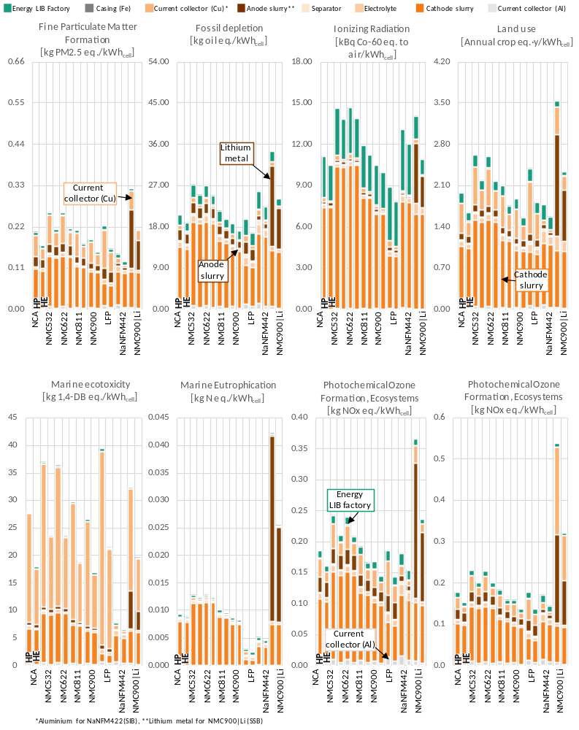
Figure 4. Environmental impact of different LIB chemistries, in different configurations for remaining impact categories of ReciPe2016 (Huijbregts et al. 2016).

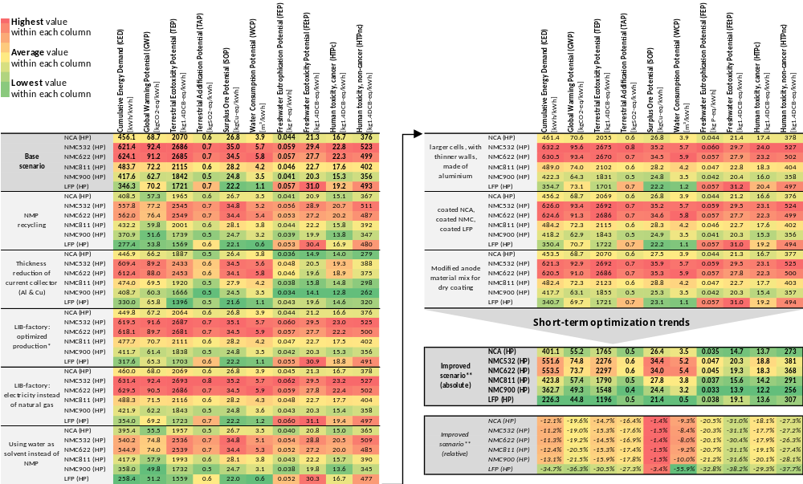
Figure 5. Effect of improvements in cell design and technology on the environmental impact of different LIB chemistries, in HP configuration. *Improvements in production technology are obtained from Degen et al. (Degen et al. 2023) **For NCA & NMC we assume NMP as solvent, for LFP we assume water as solvent. The underlying assumptions are given in the method section.

Literaturverzeichnis
Ambrose, Hanjiro; Kendall, Alissa (2016): Effects of battery chemistry and performance on the life cycle greenhouse gas intensity of electric mobility. In: Transportation Research Part D: Transport and Environment 47, S. 182–194. DOI: 10.1016/j.trd.2016.05.009.
Bawankar, Swapnil; Dwivedi, Gaurav; Nanda, Ipseeta; Daniel Jiménez Macedo, Víctor; Kesharvani, Sujeet; Meshram, Kundan et al. (2023): Environmental impact assessment of lithium ion battery employing cradle to grave. In: Sustainable Energy Technologies and Assessments 60, S. 103530. DOI: 10.1016/j.seta.2023.103530.
Crenna, Eleonora; Gauch, Marcel; Widmer, Rolf; Wäger, Patrick; Hischier, Roland (2021): Towards more flexibility and transparency in life cycle inventories for Lithium-ion batteries. In: Resources, Conservation and Recycling 170, S. 105619. DOI: 10.1016/j.resconrec.2021.105619.
Cusenza, Maria Anna; Bobba, Silvia; Ardente, Fulvio; Cellura, Maurizio; Di Persio, Franco (2019): Energy and environmental assessment of a traction lithium-ion battery pack for plug-in hybrid electric vehicles. In: Journal of Cleaner Production 215, S. 634–649. DOI: 10.1016/j.jclepro.2019.01.056.
Dai, Qiang; Kelly, Jarod C.; Gaines, Linda; Wang, Michael (2019): Life Cycle Analysis of Lithium-Ion Batteries for Automotive Applications. In: Batteries 5 (2), S. 48. DOI: 10.3390/batteries5020048.
Degen, F.; Winter, M.; Bendig, D.; Tübke, J. (2023): Energy consumption of current and future production of lithium-ion and post lithium-ion battery cells. In: Nat Energy. DOI: 10.1038/s41560-023-01355-z.
Deng, Yelin; Li, Jianyang; Li, Tonghui; Gao, Xianfeng; Yuan, Chris (2017): Life cycle assessment of lithium sulfur battery for electric vehicles. In: Journal of Power Sources 343, S. 284–295. DOI: 10.1016/j.jpowsour.2017.01.036.
Ellingsen, Linda Ager‐Wick; Majeau‐Bettez, Guillaume; Singh, Bhawna; Srivastava, Akhilesh Kumar; Valøen, Lars Ole; Strømman, Anders Hammer (2014): Life Cycle Assessment of a Lithium‐Ion Battery Vehicle Pack. In: J of Industrial Ecology 18 (1), S. 113–124. DOI: 10.1111/jiec.12072.
Engels, Philipp; Cerdas, Felipe; Dettmer, Tina; Frey, Christoph; Hentschel, Jan; Herrmann, Christoph et al. (2022): Life cycle assessment of natural graphite production for lithium-ion battery anodes based on industrial primary data. In: Journal of Cleaner Production 336, S. 130474. DOI: 10.1016/j.jclepro.2022.130474.
Faria, Ricardo; Marques, Pedro; Garcia, Rita; Moura, Pedro; Freire, Fausto; Delgado, Joaquim; Almeida, Aníbal T. de (2014): Primary and secondary use of electric mobility batteries from a life cycle perspective. In: Journal of Power Sources 262, S. 169–177. DOI: 10.1016/j.jpowsour.2014.03.092.
Gutsch, Moritz; Leker, Jens (2024): Costs, carbon footprint, and environmental impacts of lithium-ion batteries – From cathode active material synthesis to cell manufacturing and recycling. In: Applied Energy 353, S. 122132. DOI: 10.1016/j.apenergy.2023.122132.
Huijbregts, M.A.J.; Steinmann, Z.J.N.; Elshout, P.M.F.; Stam, G.; Verones, F.; Vieira, M.D.M. et al. (2016): ReCiPe 2016 v1.1. A harmonized life cycle impact assessment method at midpoint and endpoint level. Report I: Characterization. Hg. v. National Institute for Public Health and the Environment. Bilthoven (RIVM Report 2016-0104a). Online verfügbar unter https://pre-sustainability.com/legacy/download/Report_ReCiPe_2017.pdf, zuletzt geprüft am 17.11.2023.
Jenu, Samppa; Deviatkin, Ivan; Hentunen, Ari; Myllysilta, Marja; Viik, Saara; Pihlatie, Mikko (2020): Reducing the climate change impacts of lithium-ion batteries by their cautious management through integration of stress factors and life cycle assessment. In: Journal of Energy Storage 27, S. 101023. DOI: 10.1016/j.est.2019.101023.
Kallitsis, Evangelos; Korre, Anna; Kelsall, Geoff; Kupfersberger, Magdalena; Nie, Zhenggang (2020): Environmental life cycle assessment of the production in China of lithium-ion batteries with nickel-cobalt-manganese cathodes utilising novel electrode chemistries. In: Journal of Cleaner Production 254, S. 120067. DOI: 10.1016/j.jclepro.2020.120067.
Kim, Hyung Chul; Wallington, Timothy J.; Arsenault, Renata; Bae, Chulheung; Ahn, Suckwon; Lee, Jaeran (2016): Cradle-to-Gate Emissions from a Commercial Electric Vehicle Li-Ion Battery: A Comparative Analysis. In: Environmental science & technology 50 (14), S. 7715–7722. DOI: 10.1021/acs.est.6b00830.
Le Varlet, Thomas; Schmidt, Oliver; Gambhir, Ajay; Few, Sheridan; Staffell, Iain (2020): Comparative life cycle assessment of lithium-ion battery chemistries for residential storage. In: Journal of Energy Storage 28, S. 101230. DOI: 10.1016/j.est.2020.101230.
Majeau-Bettez, Guillaume; Hawkins, Troy R.; Strømman, Anders Hammer (2011): Life cycle environmental assessment of lithium-ion and nickel metal hydride batteries for plug-in hybrid and battery electric vehicles. In: Environmental science & technology 45 (10), S. 4548–4554. DOI: 10.1021/es103607c.
Marques, Pedro; Garcia, Rita; Kulay, Luiz; Freire, Fausto (2019): Comparative life cycle assessment of lithium-ion batteries for electric vehicles addressing capacity fade. In: Journal of Cleaner Production 229, S. 787–794. DOI: 10.1016/j.jclepro.2019.05.026.
Notter, Dominic A.; Gauch, Marcel; Widmer, Rolf; Wäger, Patrick; Stamp, Anna; Zah, Rainer; Althaus, Hans-Jörg (2010): Contribution of Li-ion batteries to the environmental impact of electric vehicles. In: Environmental science & technology 44 (17), S. 6550–6556. DOI: 10.1021/es903729a.
Qian, Lijun; Li, Tong; Dong, Xufeng; Li, Shuhua (2023): Life cycle assessment of high nickel ternary lithium (NCM811) power batteries. In: International Journal of Green Energy, S. 1–13. DOI: 10.1080/15435075.2023.2276162.
Rolinck, Maximilian; Khakmardan, Shayan; Cerdas, Felipe; Mennenga, Mark; Li, Wen; Herrmann, Christoph (2023): Completeness evaluation of LCI datasets for the environmental assessment of lithium compound production scenarios. In: Procedia CIRP 116, S. 726–731. DOI: 10.1016/j.procir.2023.02.122.
Shen, Kang; Zhai, Qiang; Gu, Yu; Wang, Weibo; Cao, Huajun; Hauschild, Michael; Yuan, Chris (2023): Life cycle assessment of lithium ion battery from water-based manufacturing for electric vehicles. In: Resources, Conservation and Recycling 198, S. 107152. DOI: 10.1016/j.resconrec.2023.107152.
Sun, Xin; Luo, Xiaoli; Zhang, Zhan; Meng, Fanran; Yang, Jianxin (2020): Life cycle assessment of lithium nickel cobalt manganese oxide (NCM) batteries for electric passenger vehicles. In: Journal of Cleaner Production 273, S. 123006. DOI: 10.1016/j.jclepro.2020.123006.
Winjobi, Olumide; Kelly, Jarod C.; Dai, Qiang (2022): Life-cycle analysis, by global region, of automotive lithium-ion nickel manganese cobalt batteries of varying nickel content. In: Sustainable Materials and Technologies 32, e00415. DOI: 10.1016/j.susmat.2022.e00415.
Zackrisson, Mats; Avellán, Lars; Orlenius, Jessica (2010): Life cycle assessment of lithium-ion batteries for plug-in hybrid electric vehicles – Critical issues. In: Journal of Cleaner Production 18 (15), S. 1519–1529. DOI: 10.1016/j.jclepro.2010.06.004.
Zhao, Shipu; You, Fengqi (2019): Comparative Life-Cycle Assessment of Li-Ion Batteries through Process-Based and Integrated Hybrid Approaches. In: ACS Sustainable Chem. Eng. 7 (5), S. 5082–5094. DOI: 10.1021/acssuschemeng.8b05902.

