Accessibility conformance test report
Page evaluated: 2025 Registration
Evaluator: Maimun Bin Masud

Summary of the conformance test

The conformance test using the WAVE Web Accessibility Evaluation Tool was performed on the "2025 Registration" page. The test found several accessibility issues that need attention. Seven errors were identified, all of which make it harder for people who use assistive technologies. These errors included missing form labels, an incorrect language setting, and empty buttons and links. The test also found 15 contrast issues, mainly due to low contrast between text and background, which can make reading difficult for people with visual impairments. One of the 21 additional flags was a missing label for a dropdown menu. These findings show that significant improvements are needed. The page received an accessibility score of 4.5 out of 10, underscoring the importance of addressing these issues to make the page usable for everyone, especially users with disabilities.

Results of the conformance test
Note that the information you will be reporting is in your own words, but is based on the ‘Details’ and ‘Reference’ sections in your WAVE conformance test results report.
Error type | Give one or two examples (images of the relevant part of the screen can be useful) | Why is this considered to be an issue? | What should be done? | What level of conformance does it break?
Missing form label | 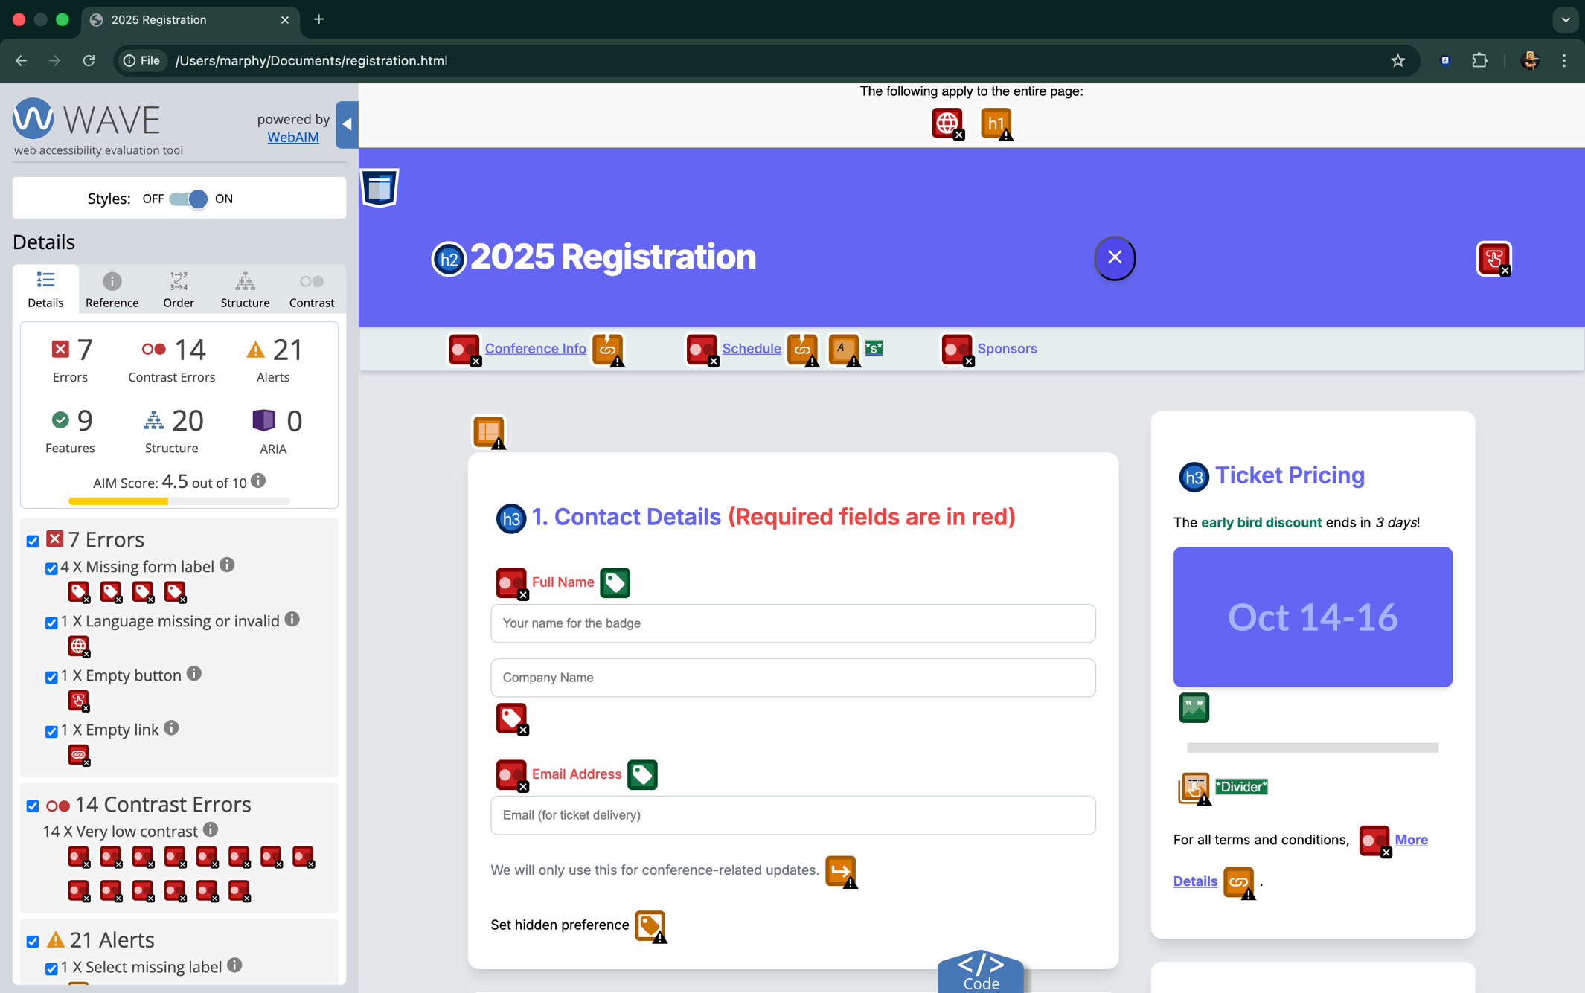 | - Inaccessible to Screen Reader Users  - Difficulty for Keyboard-Only Users  - Non-compliance with Accessibility Standards  - Poor Usability for All Users | - Add Descriptive Labels  - Use <label> Tag | This issue breaks compliance with accessibility standards and impacts usability for all users.
Language missing or invalid | 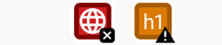 | - Screen Reader Accessibility  - Automatic Translation | - Identify the Document Language  - Ensure the lang attribute | The issue breaks WCAG 2.0 guidelines under 3.1.1 Language of Page (Level A), which ensures web content is accessible to screen readers and translation tools.
Empty Button | 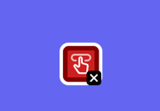 | - Screen Reader Accessibility  - User Navigation | - Add Descriptive Text  - For Icon-Only Buttons  - Ensure All Buttons Have a Clear Purpose | - Non-text Content (Level A)  2.4.4 Link Purpose (In Context) (Level A)
Empty Links | 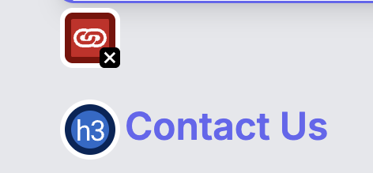 | - Inaccessible to Screen Reader Users  - Confusing for Keyboard and Mouse Users | - Provide Text or Descriptive Content  - Use aria-label for Icon-Only Links  - Ensure Clear Navigation | This issue breaks the WCAG 2.0 guideline 2.4.4 Link Purpose (In Context) (Level A), which requires that the purpose of each link must be clear to all users.
Very Low Contrast |  | Inadequate contrast makes text hard to read, especially for users with low vision. | Increase the contrast between text and background to meet accessibility standards. For normal text, the contrast ratio should be at least 4.5:1, and for large text, 3:1. | This issue breaks compliance with WCAG 2.0 1.4.3 Contrast (Minimum) (Level AA)

After fixing all the issues of the registration 2025 webpage, Level AA of the WCAG has passed.
