Lappeenrannan teknillinen yliopisto

School of Business and Management

Software Development Skills

Markku Pulli, x101105

LEARNING DIARY, Software Development Skills: Full-Stack 2020-21 MODULE

**LEARNING DIARY**

1.4.2021

2hours  
I went through general course information and setup the environment on my laptop. I watched the version control video and setup the Git on my laptop. Did some practice with bash editor. I created ‘Coursework’ and ‘Project’ directories. Run init, config, add, status, commit commands. This time I chose the VS as code editor. I started the NodeJS task by watching the ‘NodeJS (updated video)’video and writing the code while watching. My target is to finish this task by 2.4.21.

2.4.2021

2hours

Finish the NodeJS exercise creating web server. I had some problems with last changes done on video. Error I received in terminal window is following

[nodemon] restarting due to changes...

[nodemon] starting `node index index.js`

Server running on port: 5000

E:\AI ML\LUT\Coursework\index.js:49

let extname = path.extname(filePath);

^

ReferenceError: filePath is not defined

at Server.<anonymous> (E:\AI ML\LUT\Coursework\index.js:49:29)

at Server.emit (events.js:315:20)

at parserOnIncoming (_http_server.js:874:12)

at HTTPParser.parserOnHeadersComplete (_http_common.js:126:17)

[nodemon] app crashed - waiting for file changes before starting...

I was not able to figure out the problem as syntax on my editor looks identical. I need to investigate this more. All other scripts worked fine. Also setup HEROKU account.

3.4.2021

4hours

I was able to find the cause for the above error. There was a typo on ‘let filepath’ line. Once fixed server runs smoothly. No errors.

Heroku git push failed. See below error.

remote: Verifying deploy...

remote:

remote: ! Push rejected to intense-sea-53219.

remote:

To https://git.heroku.com/intense-sea-53219.git

! [remote rejected] master -> master (pre-receive hook declined)

error: failed to push some refs to 'https://git.heroku.com/intense-sea-53219.git'

From Heroku site build failed due to buildpack issue.

! No default language could be detected for this app.

HINT: This occurs when Heroku cannot detect the buildpack to use for this application automatically.

6.4.2021

2hours

Did setup the remote Git repository again as some folders did not open. Issue was subfolder had .git file too. Everything redone and works now ok. All the NodeJS module material is in Github. Including learning diary. Also was able to fix the Heroku issue following the links on error message.

Started MongoDB crash course. Installed MongoDB Compass on my laptop. Did all the video module with coding along using Mongo shell. Also created Mongo Atlas cluster. Created cloud database in sandbox. Db is called ‘acme’.

16.4.2021

3hours

There was almost two weeks break as I was busy with other activities. From now on I can speed up the course progress. 3 out 5 full stack tasks completed.

Watched the ‘Express JS Crash Course (new video)’ while coding along. Took about 3-4 hours as needed to go back and forward on the video. Also installed the packages including Postman. Was able to complete all the coding practice successfully without using the link to sourcecode.

17.4.2021

4hours

Started Angular Tour of Heroes project. Setup the environment by installing Angular and creating the workspace called ‘angular-tour-of-heros’. All the packages and dependencies are also installed. Took about 45 minutes. It could be because I created workspace on external hard drive. Launched the application from the workspace directory. Welcome app runs too. Everything looks great!

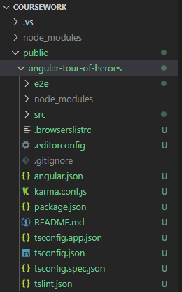

Started the coding practice. I finished coding the sections ‘1. The Hero Editor’ and ‘2. Display a List’. It was easy to follow step by step tutorial. Some details I need to go through again to understand better the interaction between the .ts and .html files.

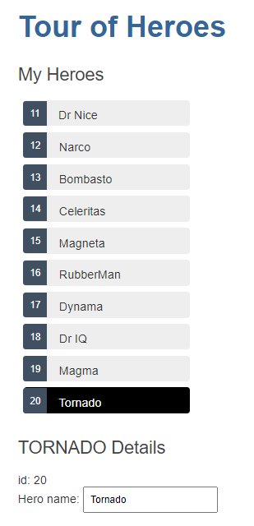

20.4.2021

2.5hours

Started to work on Angular module 3 ‘Create a Feature Component’. Got in great speed and was able to finish module 4 too. Module 4 ‘ Add Services’. No major issues. Few syntax related issues but everything works fine. But once again need to read more details about how the structure is built and how different components interact with each other. Component injection is one I need to go through. Feeling good about it.

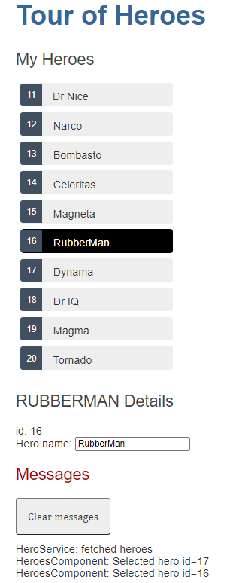

21.4.2021

3hours

Finished the modules 5. Add Navigation and 6. Get Data from a Server. Can navigate between pages. Can update, add and delete hero list. Everything works fine.

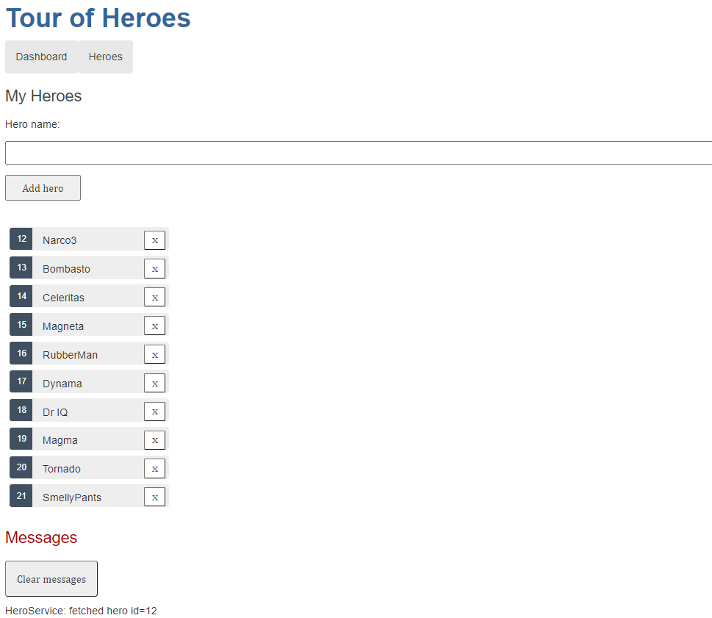

List of Heroes

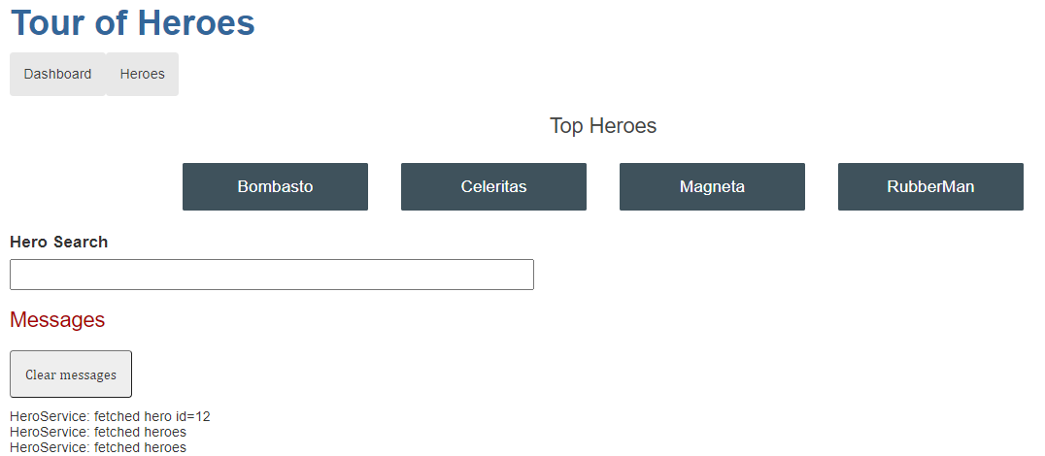

Dashboard

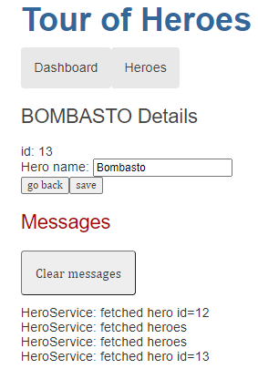 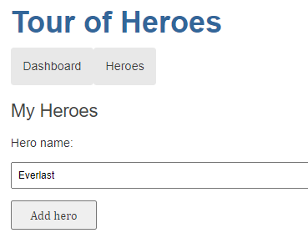 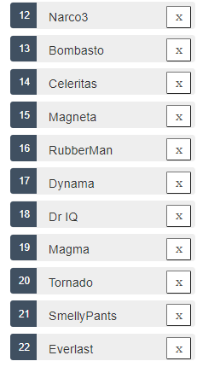

Database updates.

22.4.2021

Started the MEAN stack video lecture series. All the software packages already installed from previous sessions. Video ‘MEAN Stack Front To Back [Part 2] – Project Introduction’ completed.

23.4.2021

2hours

Completed video ‘MEAN Stack Front To Back [Part 2] - Express Setup & Routes’. Getting the code from the Github. Everything looks great. Learnt the basic setup steps.

27.4.2021

3hours

Completed videos 3 ‘MEAN Stack Front To Back [Part 3] - User Model & Register’ and 4 ‘MEAN Stack Front To Back [Part 4] - API Authentication and Token’ while coding along. I learnt the authentication process and JWT token at the back end. I played with code using Postman and MongodB. Started the video 5 ‘Angular 2 Components & Routes’

28.4.2021

2hours

Finished the remaining videos except the application deployment on Heroku. Something went wrong with the code as registration did not work. I had to replay the videos few times. I learn about authentication and validation and how to store data in local storage using token.

29.4.2021

3 hours

I found the error on my code. Some components I copied from GitHub and the code is actually for production use. The post database location was set wrong in authentication component. Currently I see one cosmetic issue as navigation bar is on top of the page covering some of the information. Flash message are behind navigation bar. I need to check if css file settings will do the trick.

I am planning to use this as template for the project delivery. Final application idea is to show air quality from different parts of the world. Either in plane text format or if feasible on the map location. If user is logged in more features are available. Need to also think some good idea how to use database. Maybe manual environment data entry.

30.4.2021

3 hours

Signed for two API key and public token. This is for IQAir and mapbox. Worked on API calls. Both text and graphical. Got some rough ideas how it works now. Need to create a new MEAN stack project.

4.5.2021

4 hours

Started to watch additional lecture videos and coursebooks. After seeing Materialize videos decided to make UI with ready made template at materialize web site.

6.5.2021

3hours

Second day working on UI design. Now the question is how to use materialize code inside Angular code. Can I use or do I need to use Angular-Material coding instead. Also I need figure out how to add city coordinates in Mongodb. About It is about 3000 rows of data. Only cities more than 200000 people included.

10.5.2021

3hours

Worked on mongodb mongoose data fetch. Using city name to get basic information of city. Data used for API call and showing on web page. Created Angular service. Back-end added route to catch the data and created mongoose schema for city data.

12.5.2021

4hours

Working on bootstrap themes as it is already used in mean stack example. Will enhance the looks of web pages. Created a new project folder now having problems with ‘npm install’. Installation takes too long time.

5/13/21

5/14/21

17.5.2021

4hours

Created new Angular service to retrieve data using API call. Got some challenges to read data in right format. I was missing the subscribe from my function call. Need to create search button to use for database city details retrieve.

18.5.2021

5hours

Got API working and now bringing data on the web page. Now I Need to figure out how to get two MongodB database connections active same time. Other is for users and other is to retrieve city coordinates for API call. Also the search button needs to get fixed for city search.

21.5.2021

6hours

I am not able to get data from database using angular. Works fine with Postman. Is this middleware related issue. Server goes down every time with Angular data get.

22.5.2021

4hours

Added bootstrap carousel in front page but photos are not rotating either automatically or with buttons. Several issues I am not able to understand. Is this SW combability related issue. I am using same Angular version as in MEAN stack video tutorial.

1. Angular data db get fails
2. Not able to show map on html page
3. Carousel not working

I have checked multiple online sites for help and support. All the tips I have tried are failing. Can it be related to one single issue?

24.5.2021

4hours

Worked on dashboard. Got the op ten city figures working every time user opens the page. Added more columns in city database. This is date to include in city details box.

25.5.2021

5hours

Worked on ‘about AQI’ page, built the path and import functions. Trying to get carousel working on home page but it seem very challenging. I also tried to put chart on dashboard page but nothing is visible. Included mouse hover text on two pages. Installing multiple packages but always some issues with node-modules. I can’t start the front end. Comes with errors.

27.5.2021

Had short discussion with Natasha about few issues I have experienced. Can’t read data from Mongodb database. Req.body is always empty. Any feature add ons like charts or maps do not show on angular html. If I install any SW packages there’s almost always errors related to node_module files. With MapBox comes error TypeError: Cannot read property 'length' of undefined with file ‘node_modules\typescript\lib\typescript.js’. I checked the common things like paths, system and environment files and could not figure out what can be the issue. Also checked online stackoverflow but none of the fixes did no good. Same .html and .js code works fine in non-angular environment.

28.5.2021

I got database search working. I use ‘headers’ to pass the search query, city name, and I am able to get the data back from server to front app. HOORAY!!!.

I am still tryin to get either map or charts working on my dashboard. If I get either working that would be great. I just need sisu and few days. I hope that will do. I just un-installed MapBox package and not able to start front end server. Still same node_module error. Most likely need to re-install npm to get it back to baseline.

29.5.2021

Top Ten city AQI fetch sometimes missing values. Could be API is not able to fetch everything. I tried async/await on function but got error.

ERROR in C:/Userdata/LUT/airapp/angulr-src/src/app/services/getdata.service.ts (14,3): Async functions are only available when targeting ECMAScript 2015 or higher.

ERROR in C:/Userdata/LUT/airapp/angulr-src/src/app/components/dashboard/dashboard.component.ts (75,44): Property 'subscribe' does not exist on type 'Promise<Observable<any>>'.

1.6.2021

4hours

Try to work on responsiveness of web site. It is responsive to certain point but when making web page very narrow on laptop screen everything gets slimmer but objects are not moving to next row when screen very narrow. I tried multiple different formatting options and screen size thresholds but results are same. I searched and tried bootstrap related tips from internet for hours.

3.6.2021

Started to build the app for Heroku. I need to check how I get existing Mongodb database to mLab for final trial and ready for publish. Target to submit project on 4.6.2021.

See below screenshots of created pages in the app.

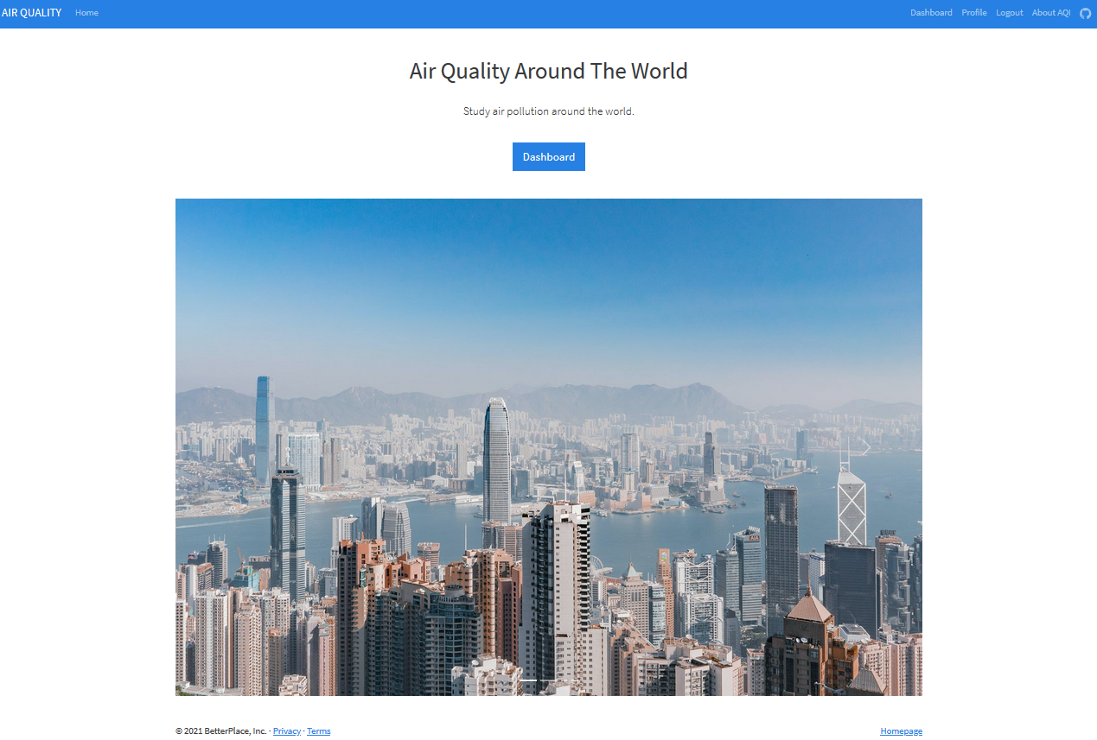

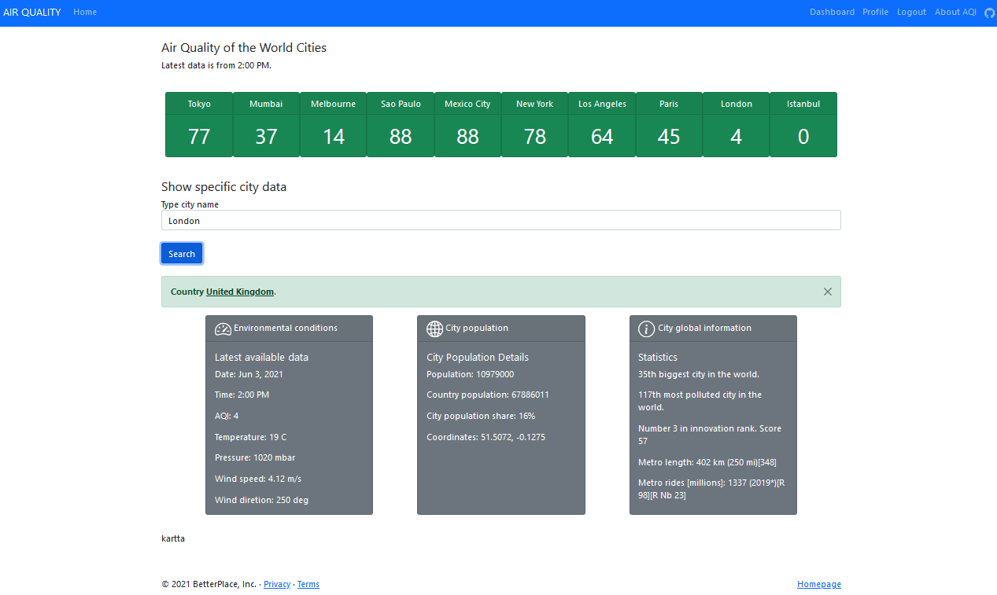

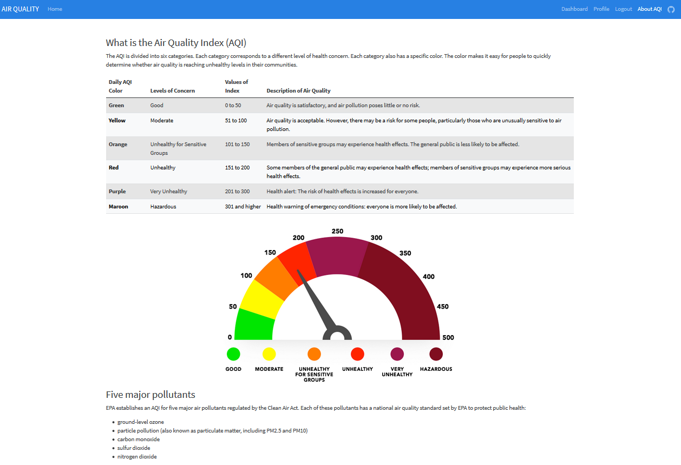

Following enhancements are required to be added as with used Angular version this was not working. Add

1. Map of the city
2. Chart for historical trending
3. Improve responsiveness for different screen sizes
4. Option to save new environmental data into database. Now most of the data shown is using API calls except city details.

I will update to latest Angular version as it seem to prevent many features not happening. All above test on plain html and javascript an it works. But this will be an other project.