# **WMO Codes Registry: Frequently Asked Questions**

(August 2013)

<http://codes.wmo.int/>

**Table of contents**:

Q1: Why does the WMO Codes Registry web application say “no description supplied” when I know that the Registry I am asking for exists? 3

Q2: Why does Common code-table C-6 reference entities from NASA’s “Quantities, Units, Dimensions and Data Types” ontology? 4

Q3: Why won’t the present weather code use in my METAR product validate? 6

Q4: Trying to determine TDCF encoding details for a BUFR element but I keep getting redirected to a related code-table. 8

Q5: What is the relationship between physical quantities from the proposed Common code-table C-15 and NASA’s “Quantities, Units, Dimensions and Data Types” ontology …? 10

This page is intentionally left blank.

## Q1: Why does the WMO Codes Registry web application say “no description supplied” when I know that the Registry I am asking for exists?

**Question**: I’m looking for code-table 0-20-086, from FM 94 BUFR (edition 4) Code- and Flag-tables. I have typed the URI [1] into the web-browser but the WMO Codes Registry states “no description supplied” [2]

[1] http://codes.wmo.int/bufr4/codeflag/0-20-086/

[2]

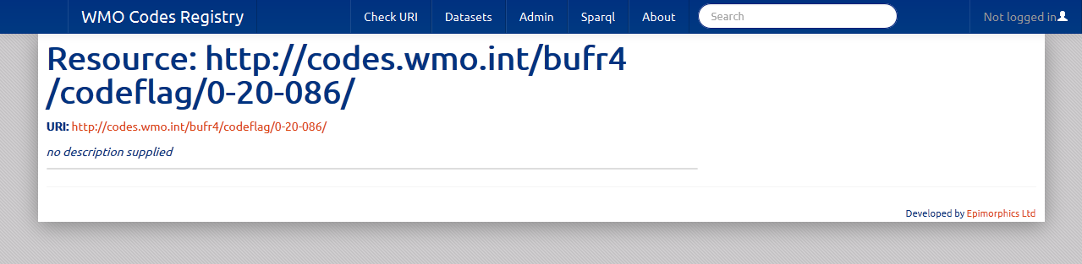

**Answer**: You have included a trailing forward slash “/” character at the end of the URI. URIs for Registers, Entities and Register Items do not end with a forward slash “/”. Remove the trailing forward slash.

Strictly speaking, the following to URIs might refer to different resources:

* http://codes.wmo.int/bufr4/codeflag/0-20-086
* http://codes.wmo.int/bufr4/codeflag/0-20-086/

## Q2: Why does Common code-table C-6 reference entities from NASA’s “Quantities, Units, Dimensions and Data Types” ontology?

**Question**: When reviewing Common code-table C-6 “List of units for TDCFs” I notice that the Entity referenced for term 005 (Kelvin) is <http://qudt.org/vocab/unit#Kelvin> from NASA’s “Quantities, Units, Dimensions and Data Types” ontology [1]. Why is this?

[1]

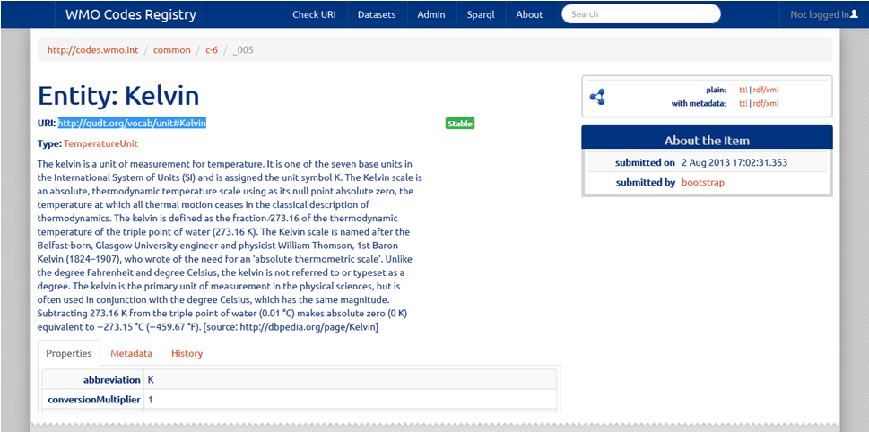

**Answer**: The purpose of Common code-table C-6 is to provide a list of the units of measurement that are permitted for use in WMO Table-Driven Code Forms. Rather than seeking to create and maintain its own set of definitions for units of measurement, WMO seeks to reuse authoritative resources provided elsewhere within the environmental science community.

Whilst there are a number of sources of information concerning units of measurement (including <http://unitsofmeasure.org/>), NASA’s QUDT is deemed to provide the best source available at present.

Also note that QUDT is used extensively in the proposed Common code-table C-15 “Physical quantities” where it provides a well structured hierarchy for organising physical quantities into meaningful groups.

Finally, note that as QUDT is an externally managed resource, we have no control over how that resource resolves when issuing an HTTP GET request. Here, we see that QUDT provides a large RDF/XML document within which the target resource should reside. This information “dump” is not particularly easy to work with and shows the value of the using the Registry to provide a consistent, well-behaved response that contains the set of properties deemed appropriate by the Register manager.

## Q3: Why won’t the present weather code use in my METAR product validate?

**Question**: My METAR product records present weather as “Heavy precipitation of freezing rain and drizzle”. The notation for this weather phenomenon is “**+FZRADZ**”. Given that the «CodeList» class for present weather as specified in IWXXM states “vocabulary” as <http://codes.wmo.int/49-2/AerodromePresentWeather> I have encoded this in my XML product as:

http://codes.wmo.int/49-2/AerodromePresentWeather/+FZRADZ

Yet when I attempt to validate this term, the WMO Codes Registry indicates that this URI is not found [1]. What is going wrong?

[1]

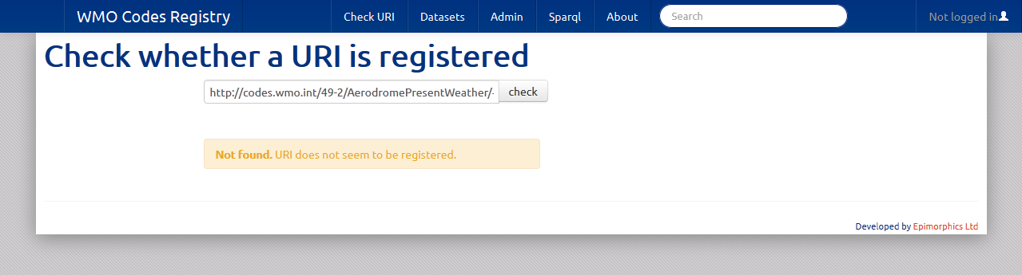

**Answer**: The problem here is that AerodromePresentWeather (plus AerodromeForecastWeather & AerodromeRecentWeather) Registers reuse definitions from code-table 4678 “Present weather” within WMO No. 306 – Manual on Codes, Volume I.1:

http://codes.wmo.int/306/4678

Whilst there is a Register Item for +FZRADZ in the AerodromePresentWeather Register denoted by use of the underscore “_” character:

http://codes.wmo.int/49-2/AerodromePresentWeather/_+FZRADZ

the Entity itself is specified as:

http://codes.wmo.int/306/4678/+FZRADZ

See screenshot below.

The URI you have used in your METAR data product is incorrect.

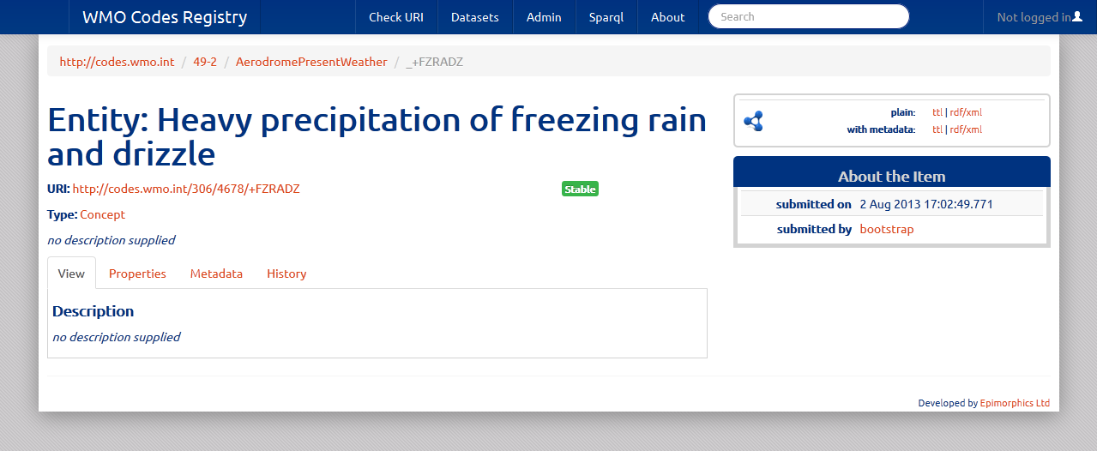

## Q4: Trying to determine TDCF encoding details for a BUFR element but I keep getting redirected to a related code-table.

**Question**: From the BUFR table B class 20 Register [1], I am trying to find determine the TDCF encoding details for “Runway deposits” (term 086), but I keep getting redirected to the code-table describing the valid entries for this term [2]. How can I find the TDCF encoding details?

[1] http://codes.wmo.int/bufr4/b/20

[2] http://codes.wmo.int/bufr4/codeflag/0-20-086

**Answer**: The issue here is that the Entity in question is a Sub-register, as shown in the screen shot below:

http://codes.wmo.int/bufr4/b/20/086

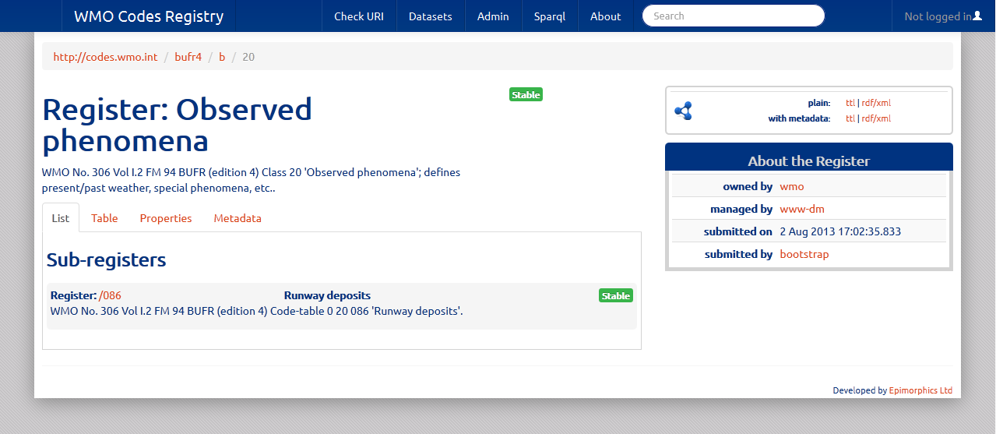

The standard behaviour of the web application is to automatically redirect users to the designated sub-register.

To override this behaviour, you must directly request the Register Item by typing the following URI into the browser address bar (note the use of underscore “_” character to designate Register Item):

http://codes.wmo.int/bufr4/b/20/_086

This will resolve to provide a page about the information you require; specifically see the “Metadata” tab for the TDCF encoding details:

* BUFR_DataWidth_Bits
* BUFR_ReferenceValue
* BUFR_Scale
* BUFR_Unit

See the screenshot below:

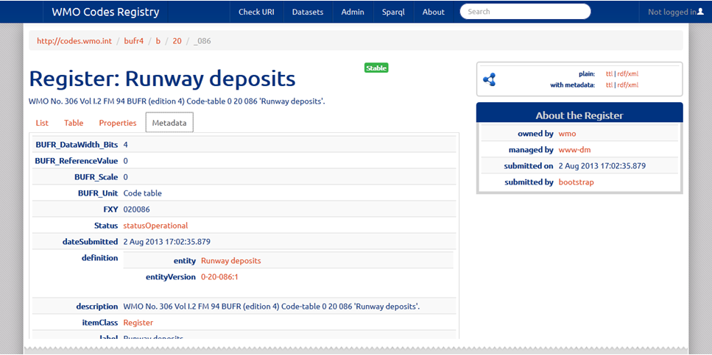

Also note that using the programmatic API you can retrieve the TDCF encoding details for all the elements in a given Register, including the sets of valid terms that may be used for elements marked with “BUFR_Unit” as “Code table”.

The example provided below is based on use of the [cURL](http://en.wikipedia.org/wiki/CURL) utility, but any software application capable of executing HTTP would suffice.

curl –i –H “Accept:text/turtle” http://codes.wmo.int/bufr4/b/20?_view=with_metadata

## Q5: What is the relationship between physical quantities from the proposed Common code-table C-15 and NASA’s “Quantities, Units, Dimensions and Data Types” ontology …?

**Question**: What is the relationship between physical quantities from the proposed Common code-table C-15 and NASA’s “Quantities, Units, Dimensions and Data Types” (QUDT) ontology? What is the relationship between those physical quantities and elements from BUFR table B? How can I verify that appropriate units of measurement are used for a given physical quantity?

**Answer**:

*Note: Please refer to* *previous question* *for more information about the use of QUDT within the WMO Codes Registry.*

1) Physical quantity dew-point temperature, defined in Common code-table c-15

http://codes.wmo.int/common/c-15/me/dewPointTemperature

This is specified as having Type [QuantityKind](http://qudt.org/schema/qudt#QuantityKind) (as defined in [QUDT](http://qudt.org/) – originally defined by NASA AMES) and provides the definition of the abstract concept of the physical quantity; it is not bound to a given unit of measure or precision.

Notice that this resource has reference "generalization" to the resource <http://qudt.org/1.1/vocab/quantity#ThermodynamicTemperature> which is defined within the QUDT vocabulary itself; this is a broad definition of all (thermodynamic) temperature properties. We'll use this later for figuring out the appropriate unit of measure.

2) Unit of measure kelvin, defined in QUDT

http://qudt.org/vocab/unit#Kelvin

This Entity is endorsed for usage based on its registration within Common code-table C-6; term 005. The associated Register Item is:

http://codes.wmo.int/common/c-6/_005

The Register Item is the glue that provides the registration context - relating the entity (Kelvin) to a given Register (Common code-table c-6). If you resolve the URI <http://codes.wmo.int/common/c-6/_005> in a browser you will see that even though the identifier for the Kelvin resource is defined outside the scope of the Registry, the Registry still knows some information about the resource (e.g. the properties that were provided when registering Kelvin). In particular, you will see properties describing the WMO abbreviations for the unit and those from UCUM plus some references to other resources purporting to be the same thing (e.g. at [dbpedia.org](http://dbpedia.org)).

The crucial things to note are:

a) Kelvin is of type "TemperatureUnit" - defined within the QUDT vocabulary; all units associated with temperature will be associated with this type (for example, see  Celsius at <http://codes.wmo.int/common/c-6/_060>). This means that it is trivial to determine if two units are commensurate (e.g. such as Kelvin and Celsius) as they must be of the same type.

b) QUDT provides the properties 'conversionOffset' and 'conversionMultiplier'; you can see these properties specified as 0.0 and 1.0 respectively for Kelvin - which is pretty boring, but not unexpected as Kelvin is the base temperature unit. By comparison, Celsius (at <http://codes.wmo.int/common/c-6/_060>) has offset and multiplier specified as 273.15 and 1.0. Neither Kelvin or Celsius are defined as a "canonical" unit (although with the offset and multiplier of 0.0 and 1.0 Kelvin can be inferred to be the canonical unit for temperature) - but this does not matter because one is always converting between *two* units; use of the conversion offset and multiplier from both units enables one to convert.

c) The property 'quantityKind' (from QUDT) indicates that this unit of measure can be used with the ThermodynamicTemperature QuantityKind (that we noted earlier) and, by inference, all specialisations of that QuantityKind - including the dewPointTemperature QuantityKind we defined in Common code-table c-15.

3) Dew-point temperature used within context of BUFR Table B

BUFR Table B Class 12 (see <http://codes.wmo.int/bufr4/b/12>) includes (at least) 3 references to dew-point temperature (003, 024 and 103). To accommodate this I have *registered* the physical quantity [dewPointTemperature](http://codes.wmo.int/common/c-15/me/dewPointTemperature) three times - each with the notation matching the appropriate code-figure from the BUFR Table B. Again, as outlined above for the unit of measure, it is the *Register Item* that maintains the glue between the entity and the Register:

- http://codes.wmo.int/bufr4/b/12/_003

- http://codes.wmo.int/bufr4/b/12/_024

- http://codes.wmo.int/bufr4/b/12/_103

Each of these Register Items express *different* information about the [dewPointTemperature](http://codes.wmo.int/common/c-15/me/dewPointTemperature) resource.

Now, here's the clever part. Because we consider the encoding properties (e.g. Data width, Scale, Reference value & Unit) to be part of the *registration context* rather than part of the physical quantity definition itself, these properties are defined within the Register Item. Therefore each Register Item shows different encoding properties. You can see this by looking at the "Metadata" tab for each of the register items. You'll also see that I linked the Unit to the term from QUDT that I registered earlier.

4) Dew-point temperature used within context of GRIB Code-table 4.2

For completeness, I included a reference from GRIB code-table 4.2 (see <http://codes.wmo.int/grib2/codeflag/4.2>) for dew-point temperature (discipline 0, category 0, parameter 6; using notation “0-0-6”):

http://codes.wmo.int/grib2/codeflag/4.2/_0-0-6

This page is intentionally left blank.