# **WMO Codes Registry: User Guide**

(August 2013)

<http://codes.wmo.int/>

**Table of contents**:

Overview of WMO Codes Registry service 3

WMO Codes Registry content scope 4

Service support arrangements and additional sources of information 5

Overview of concepts 6

Registers and Entities 6

Register Items 6

Status and lifecycle 7

History and versioning 8

WMO Codes Registry relationship with WMO technical regulation 10

Top-level Registers (WMO publications) 10

Leaf Registers (code-tables) 10

Codes and associated concepts 11

Externally managed Entities 12

WMO TDCF encoding details 13

Register content validation 14

WMO Codes Registry relationship to WMO AvXML data exchange standard 14

Validation mechanisms 16

WMO Codes Registry web application 18

General page overview 19

Register page 20

Entity page 25

User authentication 29

Programmatic read access to WMO Codes Registry 31

Content negotiation 31

Register retrieval 31

Entity and Register Item retrieval 33

Annex 1: WMO Codes Registry structure 35

This page is intentionally left blank.

## Overview of WMO Codes Registry service

The primary purpose of the WMO Codes Registry is to support the new data exchange standard developed by WMO in support of Amendment 76 to ICAO Annex 3 "Meteorological Services for International Air Navigation". This new data exchange standard ([WMO AvXML](http://wis.wmo.int/page=AvXML-1)) enables exchange of operational aeronautical meteorological (OPMET) in XML format. It depends on availability of authoritative terms from WMO technical regulation - most notably [WMO No. 306 Manual on Codes](http://www.wmo.int/pages/prog/www/WMOCodes.html) - as web-accessible resources that can be referenced from WMO AvXML-compliant data products.

The WMO Codes Registry is the mechanism through which the authoritative terms required for [WMO AvXML](http://wis.wmo.int/page=AvXML-1) are published as web-accessible resources.

The [Met Office](http://www.metoffice.gov.uk/) operates this Service on behalf of [WMO](http://www.wmo.int/) as an “Initial Operating Capability” for the period of two (2) years from September 2013.

## WMO Codes Registry content scope

The initial set of authoritative terms published within the WMO Codes Registry is deemed sufficient to support the [WMO AvXML data exchange standard](http://wis.wmo.int/page=AvXML-1).

The information provided within the WMO Codes Registry endeavours to be accurate, albeit sparse in comparison to the scope of the WMO Technical Regulation. Furthermore, please note that the Service does not (yet) provide a multi-lingual content, nor a change history of the authoritative terms pertaining to previous versions of the WMO Technical Regulation.

It is anticipated that the scope of content available through the WMO Codes Registry will expand during the Initial Operating Capability period; the content will be maintained by nominated members of WMO Expert Teams and the [WMO Secretariat](https://www.wmo.int/pages/prog/www/WDM/wdm.html).

To request the provision of additional content from WMO Technical Regulation to be published via this Service please post to the [WMO Codes List Registry group](http://www.google.com/url?q=https%3A%2F%2Fgroups.google.com%2Fa%2Fwmo.int%2Fforum%2F%3Fhl%3Den-GB%23!forum%2Fcbs-codes-registry).

## Service support arrangements and additional sources of information

The [Met Office](http://www.metoffice.gov.uk/) will endeavour that the Service is available, 24-hours per day, 7-days per week. In the event of a system fault, the Met Office will endeavour to restore the system to normal operation.

There is no provision of an alternative service should the Service be unavailable.

[WMO](http://www.wmo.int/) provides a Google Group ([WMO Codes List Registry](http://www.google.com/url?q=https%3A%2F%2Fgroups.google.com%2Fa%2Fwmo.int%2Fforum%2F%3Fhl%3Den-GB%23!forum%2Fcbs-codes-registry)) for discussion about the WMO Codes Registry and the content provided therein during the Initial Operating Capability period.

Limited end-user support is available via the [Met Office help desk](http://www.metoffice.gov.uk/about-us/contact) during UK business hours.

For technical information about the Registry software implementation and API, please refer to the documentation provided at the [UKGovLD Registry project wiki](https://github.com/der/ukl-registry-poc/wiki/). (note that the UKGovLD Registry software and API are open source and published under the [Apache 2 license](http://www.apache.org/licenses/LICENSE-2.0.html))

To notify the Service administrators of inappropriate or erroneous information, please post to the [WMO Codes List Registry group](http://www.google.com/url?q=https%3A%2F%2Fgroups.google.com%2Fa%2Fwmo.int%2Fforum%2F%3Fhl%3Den-GB%23!forum%2Fcbs-codes-registry) or contact the [Met Office help desk](http://www.metoffice.gov.uk/about-us/contact).

## Overview of concepts

### Registers and Entities

The essential concept is the notion of a **Register**.

A Register is a single controlled collection (e.g. a list). Each Register is operated on behalf of some owner organization which provides the authority for the collection.

Crucially, each Registry has a governance regime which defines what can be registered, the process to be followed and the types of changes that may be made following acceptance of entry into a register. A user of a Register is assured that the set of terms within that register is complete and definitive for the declared usage – any term which is missing is not approved.

The type things that can be entered in a Register is completely open. Examples of things that Registers may contain include: codes, concepts definitions, coordinate reference systems, units of measure, spatial objects, organizations, licenses etc.

We use the term **Entity** to describe these things.

Furthermore, a Register (e.g. a **Sub-register**) can itself be registered as an entry in another Register (e.g. a principal, or parent, Register), allowing one to create a hierarchy of Registers.

### Register Items

As well as simply enumerating the entities which have been registered, the Registry often records information such as the status of an entry, the category of the Entity in a classification scheme, aliases for the Entity and so forth. This *metadata* is not intrinsic to the Entity but is an aspect of how the organization governing the membership of the Registry regards the Entity.

In some cases, the same Entity might be entered in several Registers and have a different status and classification in each, even within the same Registry service. To achieve this, the Register maintains a set of metadata records called **Register Items** which describes each relationship between a Register and the Entities that are deemed members of that Register.

Each Register Item is assigned a unique *notation* within the scope of its containing Register.

For each Register Item, the Registry maintains a set of information about the associated Entity that is deemed appropriate in the context of the containing Register. This set of information is known as the ‘definition’. In the case that an Entity is registered in multiple Register (or multiple times within a single Register), there is no requirement for the definition to be identical in each instance; only the pertinent information in each context need be managed by the Registry.

The relationship between Register, Entity and Register Item is illustrated in Figure 1.

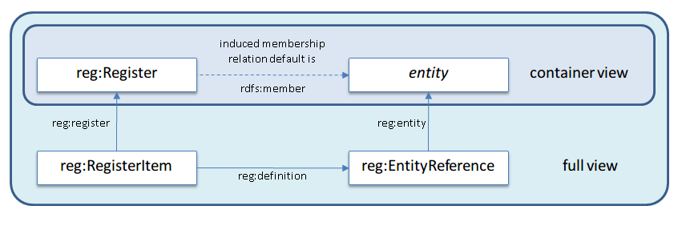

Figure : Relationship between Register, Entity and Register Item

### Status and lifecycle

A Register Item has an associated status within the register. This status is not an intrinsic attribute of the entity itself but rather a statement of how the entity is regarded by the Register’s authority (its owner).

Figure 2 illustrates the life cycle of a Register Item with regards to its status.

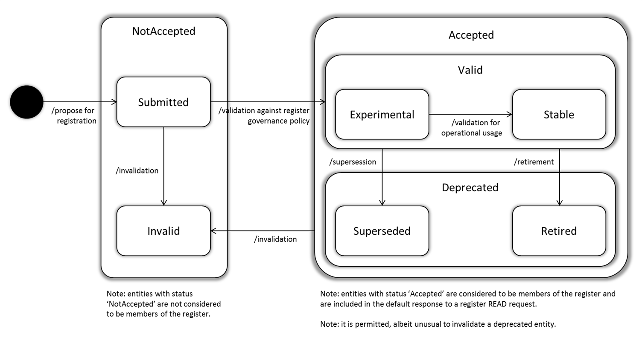

Figure : Register Item life cycle

Register Item status is arranged in the following hierarchy:

* not accepted
  + submitted
  + invalid
* accepted
  + valid
    - experimental
    - stable
  + deprecated
    - superseded
    - retired
* (reserved)

Register Items with status category “not accepted” are not included in the normal listing of the Register members. “not accepted” entries are either submitted but not yet approved (“submitted”) or have been deemed flawed (“invalid”).

Register Items with status category “accepted” are visible in the normal listing of Register members. These visible Register Items either have a status of “valid” (meaning they are suitable for use) or “deprecated” (meaning they should not be used for new applications though they may still be employed by existing applications). Only valid entries are used in response to a validation request – for more information on validation see section: User authentication.

A Register Item may become deprecated in one of two ways. It may be simply withdrawn (“retired”) or it may be replaced by an alternative (“superseded”).

A “valid” Register Item may also be marked as “experimental” to communicate the intention that the item is being trialled and might be withdrawn or replaced. Conversely a “valid” Register Item may optionally be marked as “stable” indicating that no change is currently anticipated.

In the normal lifecycle a new entry in a Register is given status submitted and thus is not shown in the list of register members. Once the entry is approved it becomes valid and normally remains in the list of register members permanently. If the entry is later deprecated (either by being withdrawn from use or being superseded) then it remains visible but is not used for validation.

Sometimes an entry is deemed too flawed to approve, or is approved and then a serious problem is discovered, and the item should be removed from the list of members – not even appearing as retired. This process is termed invalidation and is supported by the invalid status code.

The “reserved” status is treated as outside the lifecycle. A notation code may be reserved by registering a blank Register Item with status “reserved”. When the code is to be used the reserved entry is updated with a real entity definition with status submitted which initiates the above lifecycle.

### History and versioning

The Registry service maintains an accessible history of changes to Registers and Register Items.

Each time the state of a Register is changed (e.g. a new member is added or removed, or the Register properties are amended) a new version of the Register is created.

*Note: Changes to members or Sub-registers do not affect the version of the containing Register as this would lead to cascades of changes throughout the Register hierarchy. Only a direct change to the properties or membership of a Register will result in a version change.*

Furthermore, each time the Register Item properties are amended – including the definition of the associated Entity – a new version of the Register Item is created.

However, it is essential to note that the definition of a registered Entity will never affect the semantics of the Entity – the Entity’s identifier will always refer to the same concept. If a semantic change is required, the Entity should be deprecated and a new Entity with the appropriate semantics be registered in its place.

For more information on history and versioning please refer [here](https://github.com/der/ukl-registry-poc/wiki/Principles-and-concepts#history-and-versioning).

## WMO Codes Registry relationship with WMO technical regulation

### Top-level Registers (WMO publications)

The WMO Codes Registry currently publishes terms from:

* WMO No. 306 – Manual on Codes
* WMO No. 49 Volume II – Meteorological Services for Air Navigation

Each of these publications is aligned with a top-level Register.

Top-level registers are also provided for terms drawn from WMO No. 306 – Manual on Codes – International Codes, Volume I.2. These are organised under the following headings:

* FM 94 BUFR (edition 4)
* FM 92 GRIB (edition 2)
* Common Features

*Note: The WMO Codes Registry includes a top-level ‘system’ Register. The contents of this Register are used to control the Registry operation. Details of this Register are beyond the scope of this User Guide.*

Each Register is allocated a unique identifier – specifically, a HTTP URI. The URIs for top-level Registers are:

* WMO No. 306 http://codes.wmo.int/306
* WMO No. 49-2 http://codes.wmo.int/49-2
* FM 94 BUFR (edition 4) http://codes.wmo.int/bufr4
* FM 92 GRIB (edition 2) http://codes.wmo.int/grib2
* Common Features http://codes.wmo.int/common

### Leaf Registers (code-tables)

Below the top-level Registers, the Registry is further organised into Sub-registers. These sub-registers are, where possible, aligned with the organization of the WMO technical regulation.

The *leaf* Registers in the WMO Codes Registry represent the code-tables themselves. For example, the Sub-register for table 0 20 086 “Runway deposits” from FM 94 BUFR (edition 4) Code- and Flag-tables (see Figure 3) has identifier:

http://codes.wmo.int/bufr4/codeflag/0-20-086

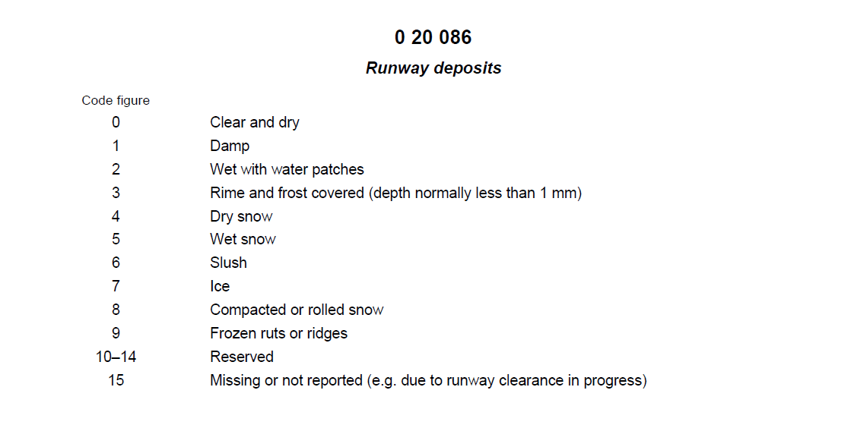

Figure : table 0 20 086 "Runway deposits" - excerpt from BUFR edition 4 Code- and Flag-tables

*Note: ‘Common Features’ Register contains a new code-table C-15 “Physical quantities” that is yet to be officially endorsed within the WMO No. 306 – Manual on Codes – International Codes, Volume I.2.*

*http://codes.wmo.int/common/c-15*

*This code-table is required to support the* [*WMO AvXML data exchange standard*](http://wis.wmo.int/page=AvXML-1)*. In contrast to the terms from FM 94 BUFR and FM 92 GRIB, the physical quantities defined therein are not explicitly mapped to specific units of measurement nor measurement precision. The table and its contents are marked as “Experimental” – for more information, please refer to section: .*

*Note: ‘FM 94 BUFR (edition 4)’, ‘FM 92 GRIB (edition 2)’ and ‘Common Features’ Registers each contain a ‘schema’ sub-register. The schemata provided therein are required to support detailed description of the BUFR, GRIB or Common terms elsewhere within the Register. General users can safely ignore these ‘schema’ Sub-registers.*

### Codes and associated concepts

The Entities within these leaf Registers are the *concepts* represented by the codes whilst the codes themselves are implemented as the Register Items.

Where available, the numeric identifiers from the WMO code-tables are used as the Register Item ‘notation’.

In the majority of cases, an identifier for the Entity is assigned by appending the ‘notation’ to the identifier of the containing Register – thus ensuring clash-free allocation of identifiers. For example, the concept “Slush” (term number 6 from BUFR edition 4 code-table 0-20-086 “Runway deposits”) has identifier:

http://codes.wmo.int/bufr4/codeflag/0-20-086/6

The Register Item identifier is distinguished from the Entity identifier by use of the underscore “_” syntax. Thus the code representing “Slush” in BUFR edition 4 code-table 0-20-086 “Runway deposits” has identifier:

http://codes.wmo.int/bufr4/codeflag/0-20-086/_6

### Externally managed Entities

In some cases, the Entity that is registered is defined elsewhere in the Registry – or perhaps defined by some external authoritative source.

In such cases the Register Item identifier is still allocated by appending the ‘notation’, prefixed with an underscore “_” character, to the identifier of the containing Register. However, the identifier of the Entity shall refer to the external definition.

For example, code-table 4678 “Present weather”, from WMO No. 306 – Manual on Codes, Volume I.1, provides an extensive set of concepts for describing the weather phenomena observed at an aerodrome. These phenomena are enumerated in the Register:

http://codes.wmo.int/306/4678

Specifically, the weather phenomena “Precipitation of freezing drizzle” is identified as:

http://codes.wmo.int/306/4678/FZDZ

According to WMO and ICAO regulation, a subset of these observed weather phenomena may be reported as “recent weather”. This subset of terms is enumerated in the Register:

http://codes.wmo.int/49-2/AerodromeRecentWeather

In accordance with WMO and ICAO technical regulation, the ‘notation’ used for recent weather prefixes the characters “RE” to the weather code, thus when reporting recent occurrence of freezing drizzle, one specifies “REFZDZ”.

Rather than creating a new concept for “recently observed precipitation of freezing drizzle”, the existing concept from Register /306/4678 is reused. In this case, the Register Item is identified as:

http://codes.wmo.int/49-2/AerodromeRecentWeather/_REFZDZ

yet the Entity referenced by this Register Item is defined elsewhere:

http://codes.wmo.int/306/4678/FZDZ

### WMO TDCF encoding details

The Register Item provides metadata about how an Entity is used in the context of a specific Register. In the WMO Codes Registry, the Register Item represents the *code* rather than the *concept* represented by that code.

For example, in FM 94 BUFR (edition 4) table B, the concept “dew-point temperature” is referenced three times – each with different units of measurement and precision implied by the combination of ‘data-width’, ‘reference value’ and ‘scale’.

In the WMO Codes Registry, the concept “dew-point temperature” is identified as:

http://codes.wmo.int/common/c-15/me/dewPointTemperature

The concept “dew-point temperature” is referenced three times within FM 94 BUFR (edition 4) table B, class 12 “Temperature”. The associated Register is identified as:

http://codes.wmo.int/bufr4/b/12

The specific codes, noting the underscore “_” syntax designating them as Register Items, are identified as:

http://codes.wmo.int/bufr4/b/12/_003

http://codes.wmo.int/bufr4/b/12/_024

http://codes.wmo.int/bufr4/b/12/_103

Each of these Register Items are configured with details about how the concept “dew-point temperature” is used in each context; e.g. the specific encoding information associated with each code. That is:

* BUFR_DataWidth_Bits
* BUFR_ReferenceValue
* BUFR_Scale
* BUFR_Unit

These properties are defined in the FM 94 BUFR ‘schema’ Sub-register:

http://codes.wmo.int/bufr4/schema/core /BUFR_DataWidth_Bits

http://codes.wmo.int/bufr4/schema/core/BUFR_ReferenceValue

http://codes.wmo.int/bufr4/schema/code/BUFR_Scale

http://codes.wmo.int/bufr4/schema/code/BUFR_Unit

A similar mechanism is provided for capturing WMO-specific metadata for codes within FM 92 GRIB (edition 2) and Common Features.

## Register content validation

### WMO Codes Registry relationship to WMO AvXML data exchange standard

The primary purpose of the WMO Codes Registry is to provide web-accessible resources that can be referenced from [WMO AvXML](http://wis.wmo.int/page=AvXML-1)-compliant data products.

Additionally, the WMO Codes Registry supports validation of those data products by assessing whether the terms used therein are members of the authoritative code-lists defined in the WMO and ICAO technical regulation.

*Note: During the period of Initial Operating Capability, the WMO Codes Registry is* ***not*** *intended to support operational validation of data products. It is anticipated that offline copies of the Registry content will be used for local validation in operational systems.*

The [WMO AvXML](http://wis.wmo.int/page=AvXML-1) data exchange standard is developed in line with community best practice using a model driven approach based on the ISO 19100-series of International Standards enables a semantic model to be encoded in a variety of formats – including GML.

Figure 4 provides a schematic of the model driven approach to the development of data exchange standards.

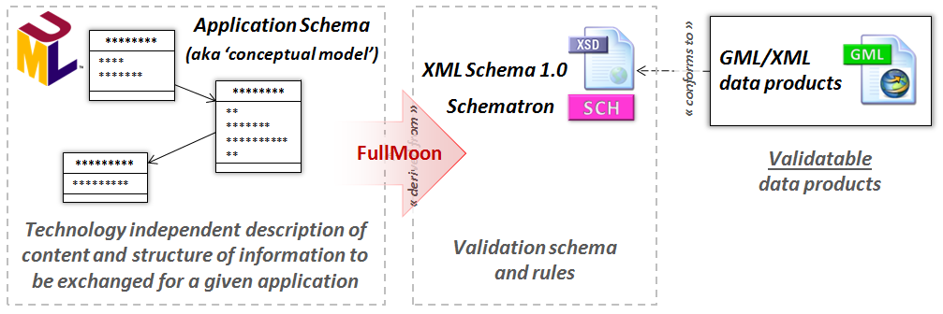

Figure : Schematic of model-driven approach to development of data exchange standards

A critical factor in the development of the [WMO AvXML](http://wis.wmo.int/page=AvXML-1) data exchange standard is the ability to bind the data model to the code-tables defined in existing WMO technical regulation. Figure 5 illustrates how this is achieved by using a «CodeList» class with tagged values that reference the appropriate controlled vocabulary, as published within the WMO Codes Register, and the validation regime that should be applied.

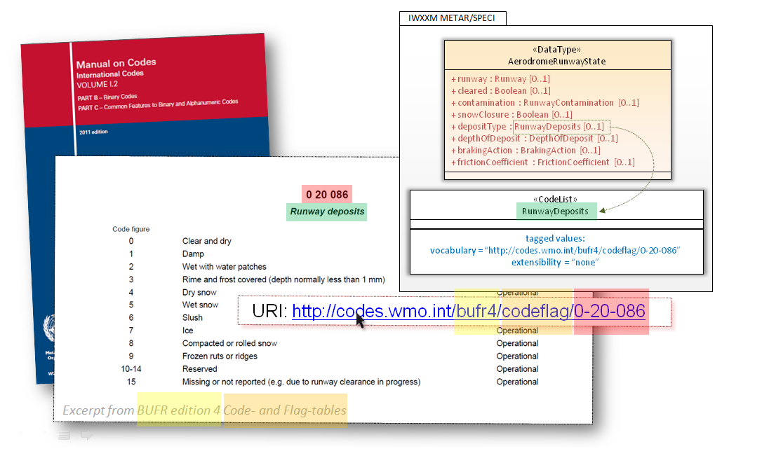

Figure : Binding data model to WMO code-tables

For reference, “extensibility” may be one of:

* "none": implies that **only** terms from the specified code list are permitted;
* "narrower": implies that terms with more refined definitions of the terms from the specified code list are permitted (e.g. narrower semantics); and
* "any": implies that anything goes and the specified code list is simply a recommendation.

Also note that the “vocabulary” and “extensibility” tagged values can be found in the XML Schema generated from the data model. Figure 6 provides a snippet from metarSpeci.xsd.

<complexType name="AerodromeRunwayStateType">  
 <sequence>  
 <element maxOccurs="1" minOccurs="0" name="runway" type="saf:RunwayDirectionPropertyType"/>  
 <element maxOccurs="1" minOccurs="0" name="depositType" type="iwxxm:RunwayDepositsType"/>  
 <element maxOccurs="1" minOccurs="0" name="contamination" type="gml:ScaleType"/>  
 <element maxOccurs="1" minOccurs="0" name="depthOfDeposit" type="gml:LengthType"/>  
 <element maxOccurs="1" minOccurs="0" name="estimatedSurfaceFriction" type="gml:ScaleType"/>  
 </sequence>  
 <attribute name="allRunways" type="boolean"/>  
 <attribute name="cleared" type="boolean"/>  
 <attribute name="estimatedSurfaceFrictionUnreliable" type="boolean"/>  
 <attribute name="snowClosure" type="boolean"/>  
 </complexType>  
   
 <complexType name="RunwayDepositsType">  
 <annotation>  
 <appinfo>  
 <vocabulary>http://codes.wmo.int/bufr4/codeflag/0-20-086</vocabulary>  
 <extensibility>none</extensibility>  
 </appinfo>  
 <documentation>Type of deposit on a runway. See WMO No. 306 Vol I.1 code table 0919 and WMO No.  
 306 Vol I.2 FM 94 BUFR code table 0 20 086 "Runway deposits".  
 </documentation>  
 </annotation>  
 <complexContent>  
 <extension base="gml:ReferenceType"/>  
 </complexContent>  
 </complexType>

Figure : XML Schema snippet from metarSpeci.xsd showing "vocabulary" and "extensibility" tagged values

The “vocabulary” and “extensibility” tagged values provide sufficient information for one to validate whether a data product asserting compliance with the WMO AvXML data exchange standard (see Figure 7 for an example fragment from a METAR) is using terms from the authoritative lists as specified in the WMO and ICAO technical regulation.

<iwxxm:runwayState>  
 <iwxxm:AerodromeRunwayState>  
 <iwxxm:depositType  
 xlink:href="http://codes.wmo.int/bufr4/codeflag/0-20-086/1"  
 xlink:title="Damp"/>  
 </iwxxm:AerodromeRunwayState>  
 </iwxxm:runwayState>

Figure : XML snippet from METAR data product

### Validation mechanisms

The WMO Codes Registry provides validation via both web application and programmatic API.

In the case of the web application, one simply enters the URI of the term to be validated in the form-field and selects “check”. The web application will then determine whether the URI refers to an Entity within the Registry, and provides information about where this Entity is registered – as illustrated in Figure 8.

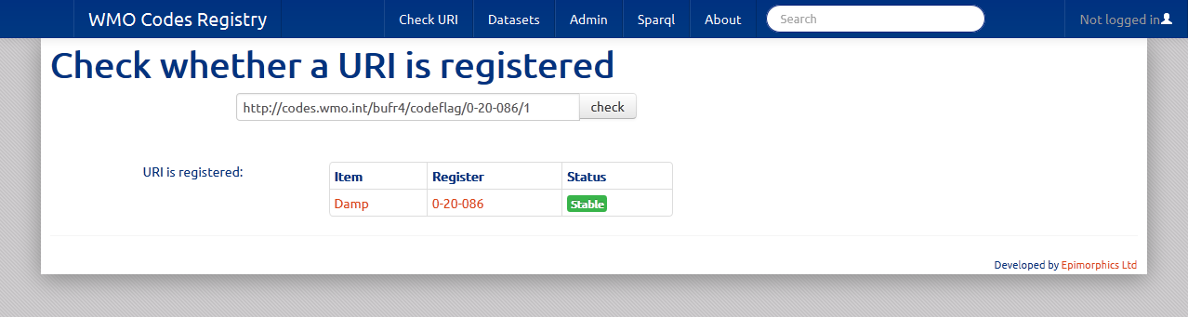

Figure : Entity validation via the web application

Alternatively, the programmatic API may be used to achieve the same result by way of a HTTP request. The example below is based on use of the [cURL](http://en.wikipedia.org/wiki/CURL) utility, but any software application capable of executing HTTP would suffice.

The following API request will validate whether a list of URIs are registered as entities within the specified Register and its Sub-registers.

POST http://registry/{register}?validate={uri1}&validate={uri2}&...

If successful, the Registry will provide a HTTP 200 “OK” response with body containing a list of Register Items associated with the given Entity or Entities. Else the Registry provides a HTTP 400 “Bad request” response with body indicating:

URI not found anywhere: [...]

Example: to determine with the Runway Deposit type “Damp” occurs within the code-tables of FM 94 BUFR (edition 4) …

curl –i –X POST http://codes.wmo.int/bufr4?validate=http://codes.wmo.int/bufr4/codeflag/0-20-086/1

response: HTTP 200 “OK”

http://codes.wmo.int/bufr4/codeflag/0-20-086/1 is http://codes.wmo.int/bufr4/codeflag/0-20-086/_1

*Note: For more information about validation using the programmatic API please refer* [*here*](https://github.com/der/ukl-registry-poc/wiki/Api#validation)*.*

## WMO Codes Registry web application

The WMO Codes Registry provides two forms of access:

1. Programmatic access via an API
2. Human readable access via a web application

An overview of navigation within the web application is provided below.

For details describing how to access the WMO Codes Registry via the API see section:

Programmatic read access to WMO Codes Registry.

### General page overview

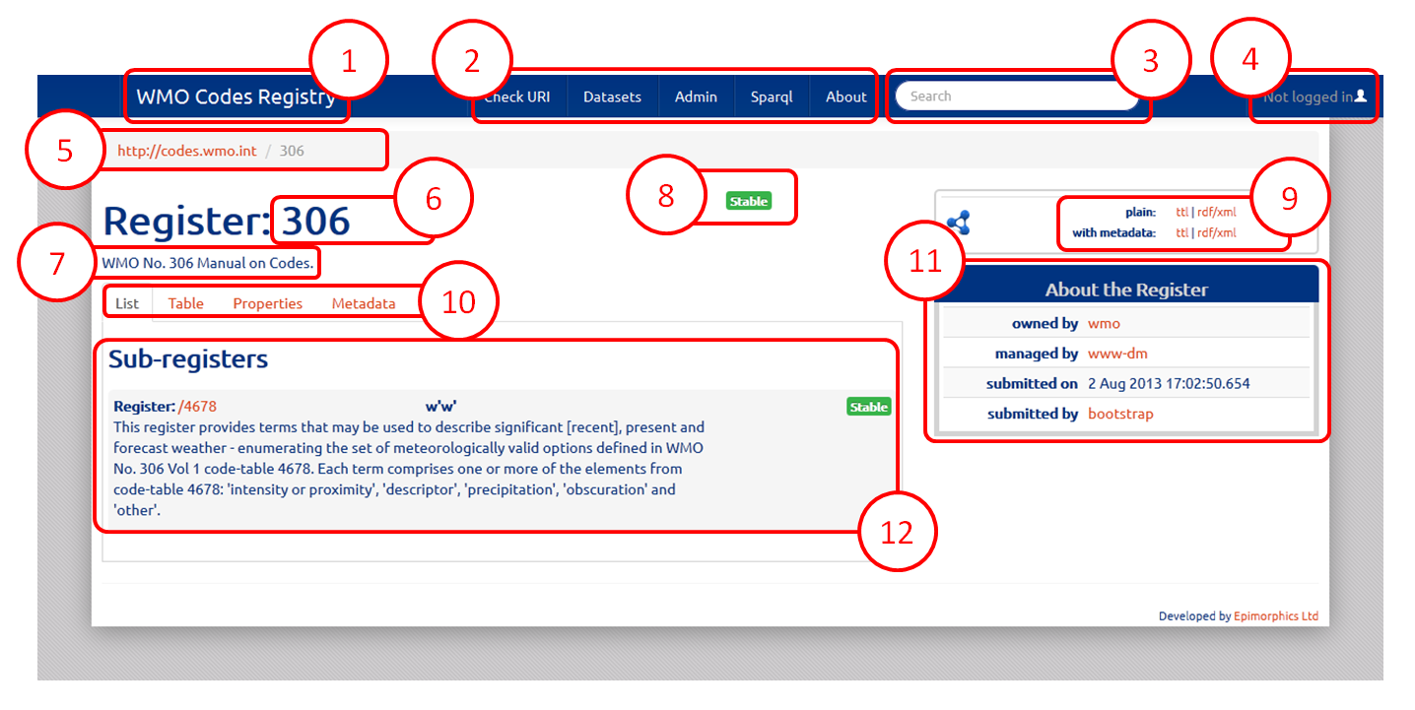

Figure : Page overview

Figure 9 provides an annotated example of a page produced by the WMO Codes Registry web application – in this case for WMO No. 306 – Manual on Codes - International Codes, Volume I.1: part A- Alphanumeric Codes.

http://codes.wmo.int/306

Details of each page element are provided below:

1. Link to root Register; provides quick access to top-level Registers.
2. Links to Registry functions:

* **Check URI**: Link to Register content validation page – see section: Validation mechanisms.
* **Datasets**: Link to page listing datasets available through this Registry; it is not anticipated that the WMO Codes Registry will be used to publish datasets at this time, thus this page will remain empty.
* **Admin**: Link to administration page for managing permissions to modify Registers and Register content. Users must be authenticated to access this page – see section: User authentication. Furthermore, note that administration and management of Registers / Register content is beyond the scope of this User Guide.
* **Sparql**: Link to page providing [SPARQL](http://www.w3.org/TR/rdf-sparql-query/) query facility against the underlying data store[1].
* **About**: Link to page providing overview of WMO Codes Registry service.

1. Search facility to find resources within the WMO Codes Registry; based on textual properties of resources (e.g. label, description).
2. Link to user authentication page – see section: User authentication.
3. “Breadcrumb” specifying the path to current Register; provides hyperlinks to parent Registers for quick access.
4. Register label.
5. Register description.
6. Register or Entity status – see section: Status and lifecycle.
7. Links providing data-download access for the current Register or Entity. Formats supported are [Turtle](http://www.w3.org/TR/turtle/) (“ttl”) and [RDF/XML](http://www.w3.org/TR/REC-rdf-syntax/) (“rdf/xml”). Selecting the “with metadata” option will include the Register Item resources associated with the Register or Entity.
8. Tabs providing information about the current Register or Entity. The tabs provided differ depending on whether a Register of Entity is selected; see section ‘Register page’ and ‘Entity page’ for more details.
9. Sidebar providing quick access to supplemental information for the current Register or Entity.
10. Information section; content varies depending on which tab is selected; see following sections for more details.

*Note: If available, the label and description provided will be provided in the locale of the requesting user-agent. However, please note that, at least in the interim, the majority of resources are provided only in English.*

### Register page

The Register page provides information about the current Register via the following tabs:

* List
* Table
* Properties
* Metadata

More information about the content of these tabs is provided below.

#### List tab

The ‘List’ tab provides a user-friendly overview of the members of the current Register.

The members are segregated according to Sub-registers and Members (see Figure 10 and Figure 11). Typically, a Register will contain either Sub-registers or Member Entities – but not both.

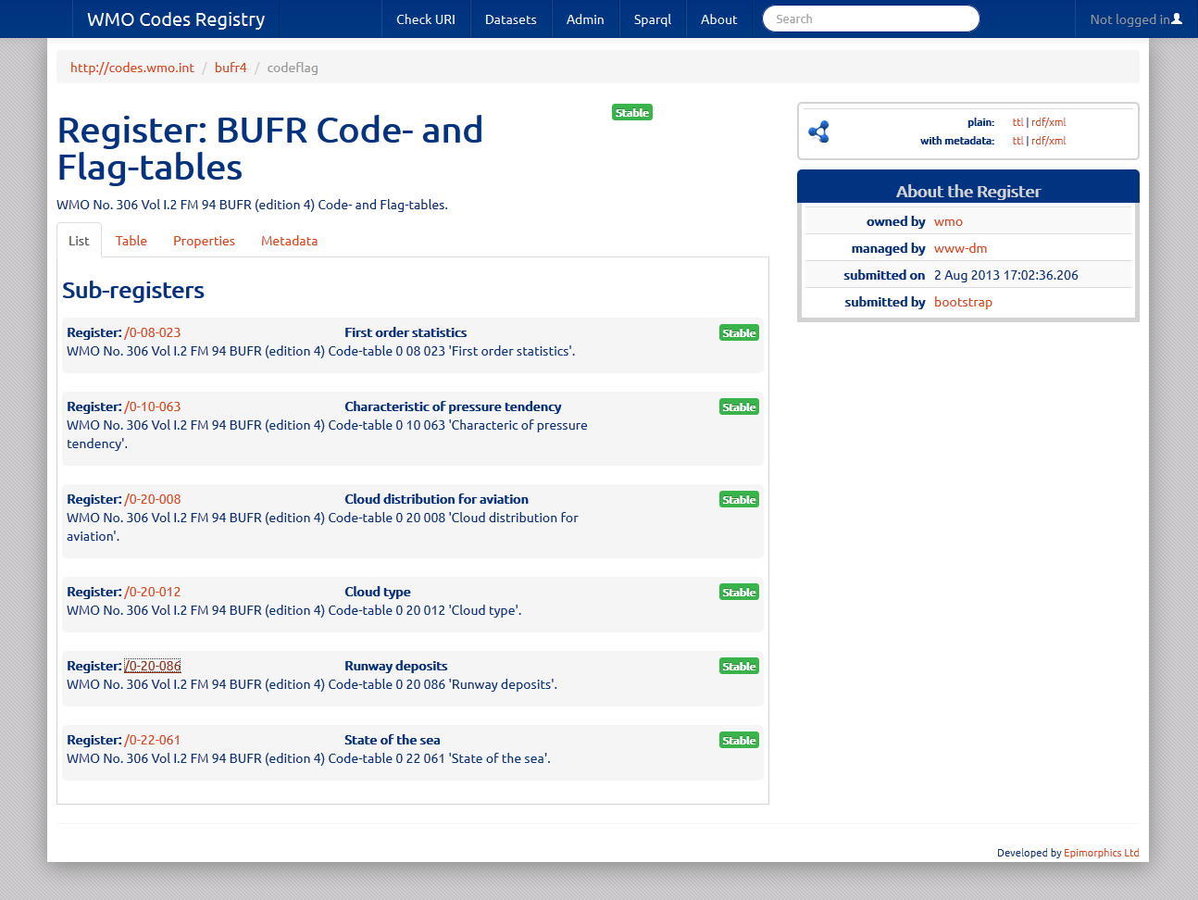

Figure : 'List' tab content for Sub-registers

Figure 10 illustrates the information provided for each Sub-register:

* Sub-register identifier (e.g. [/0-20-086](http://codes.wmo.int/bufr4/codeflag/0-20-086)); this is a hyperlink to the sub-register itself;
* Sub-register label (e.g. “Runway deposits”;
* (where provided) Sub-register description; and
* Sub-register status.

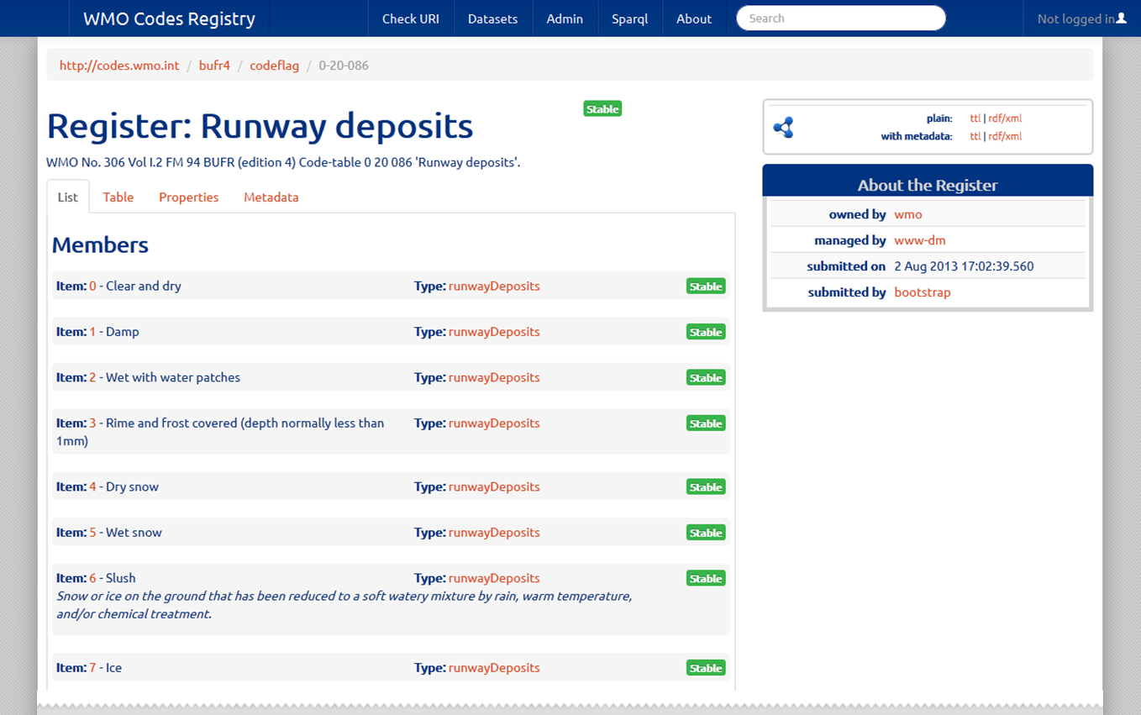

Figure : ‘List’ tab content for Members

Figure 11 illustrates the information provided for each Member:

* Item notation (e.g. [6](http://codes.wmo.int/bufr4/codeflag/0-20-086/6)); this is a hyperlink to the Member itself;
* Item label (e.g. “Slush”);
* Item type (e.g. “runwayDeposits”);
* (where provided) Item description (e.g. “Snow or ice on the ground […]”); and
* Item status.

*Note: in the case of terms from FM 94 BUFR code-tables, the Item type is typically specified as the appropriate term from BUFR table B or Common code-table. For example, the Item type in is specified as ‘runwayDeposits’ – a term from the proposed Common code-table C-15 “Physical quantities”:*

*http://codes.wmo.int/common/c-15/ae/runwayDeposits*

In cases where a Register contains a large number of Sub-registers or Members, the ‘List’ tab will be paginated.

*Note: the web application will only display Registers or Entities with ‘accepted’ status unless the user is either (a) authenticated, or (b) explicitly requests resources of ‘not accepted’ status – for more details see section: .*

#### Table tab

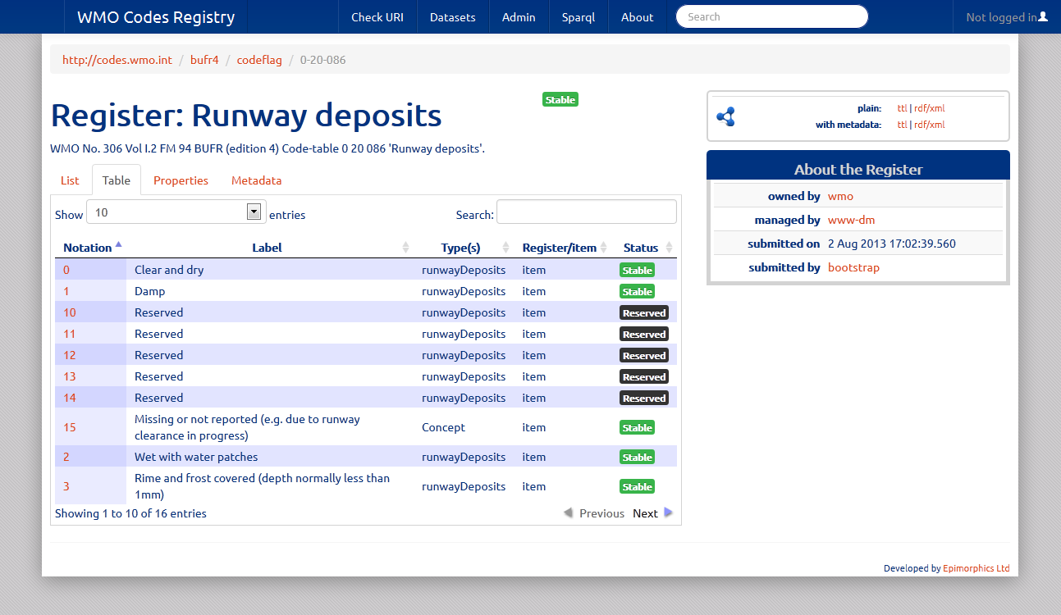

Figure : 'Table' tab for Registers

The ‘Table’ tab provides a paginated list of Sub-registers or Members in tabular form.

*Note: The information provided within the ‘Table’ tab includes resources of all status. shows a number of items with ‘Reserved’ status.*

#### Properties tab

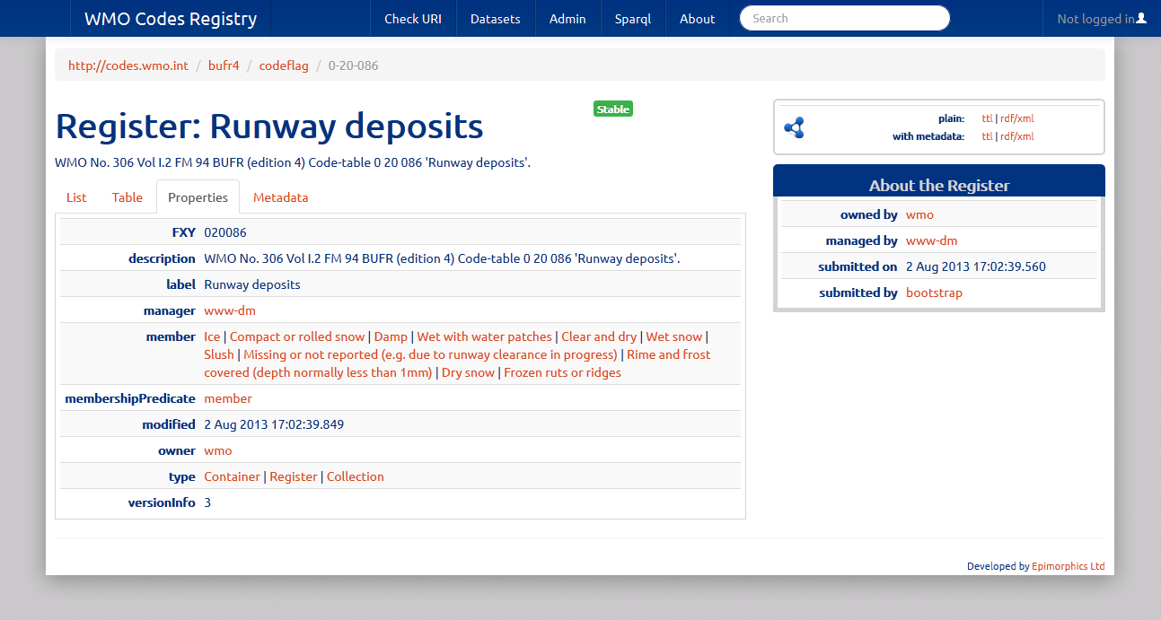

Figure : 'Properties' tab for Registers

The ‘Properties’ tab provides a tabular view of the properties of the Register. These will include:

* description
* label
* register manager
* register owner
* modification date
* member(s)
* version information

For more information about the Register data model please refer [here](http://www.epimorphics.com/public/vocabulary/Registry.html).

Figure 13 also illustrates the inclusion of domain specific properties – in this case “FXY”. This is the BUFR table B element number associated with this code-table. The FXY property is defined in the FM 94 BUFR ‘schema’ Sub-register:

http://codes.wmo.int/bufr4/schema/core/FXY

#### Metadata tab

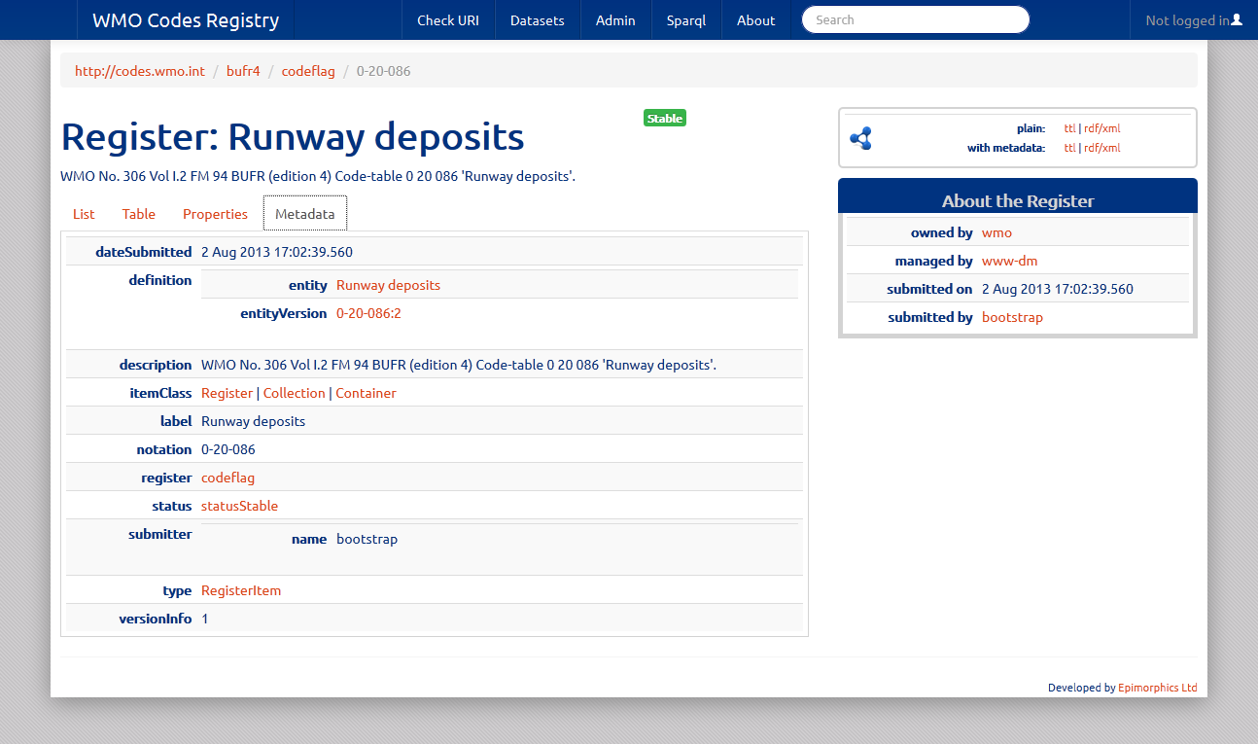

Figure : 'Metadata' tab for Registers

The ‘Metadata’ tab provides a tabular view of the properties of the Register Item associated with the target Register. These will include:

* date submitted
* definition
* description
* item class
* label
* notation
* parent register (e.g. [codeflag](http://codes.wmo.int/bufr4/codeflag)); this is a hyperlink to the parent Register itself
* status
* submitter
* type; this will always be [RegisterItem](http://purl.org/linked-data/registry#RegisterItem)
* version information

*Note: where the Register Item was submitted to the Registry during the initial start-up phase (e.g. direct from configuration files), the submitter name is specified as “bootstrap”.*

For more information about the Register Item data model please refer [here](http://www.epimorphics.com/public/vocabulary/Registry.html).

### Entity page

The Entity page provides information about the current Entity via the following tabs:

* Properties
* Metadata
* History

More information about the content of these tabs is provided below.

*Note: Where the Entity is one of the types identified in the system register “typed templates” (e.g.* [*SKOS Concept*](http://www.w3.org/2004/02/skos/core#Concept)*,* [*SKOS Concept Scheme*](http://www.w3.org/2004/02/skos/core#ConceptScheme)*), an additional “View” tab is provided with type-specific formatting.*

#### Overview

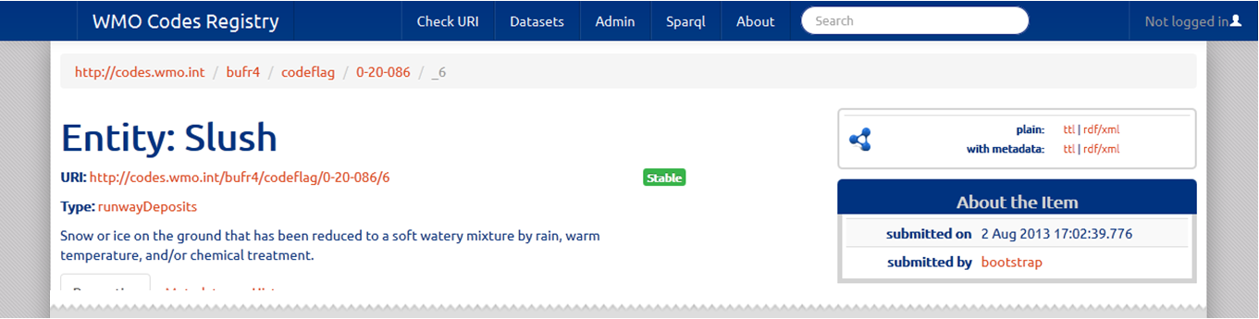

Figure : Entity overview

Figure 15 illustrates additional information provided for an Entity irrespective of the selected tab:

* URI; the HTTP URI for the Entity
* type
* description
* status

*Note: The breadcrumb for an Entity always refers to the Register Item – this is indicated by use of the underscore “_” syntax.*

#### Properties tab

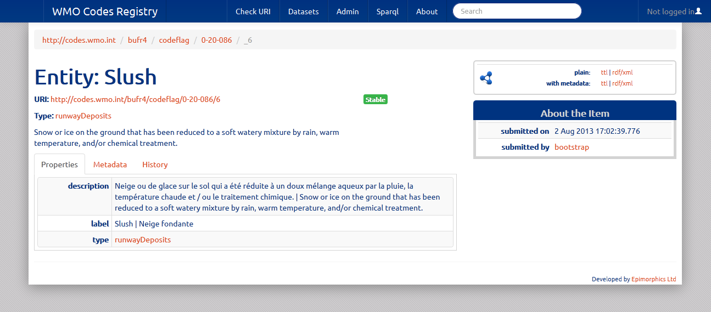

Figure : 'Properties' tab for Entities

The ‘Properties’ tab provides a tabular view of the properties of the Entity known within the Registry (e.g. captured at time of registration or subsequent amendment).

The set of properties used to describe an Entity must include label and type as a minimum. However, Entities may have an arbitrarily complex set of associated properties.

*Note: illustrates how multi-lingual properties are displayed.*

#### Metadata tab

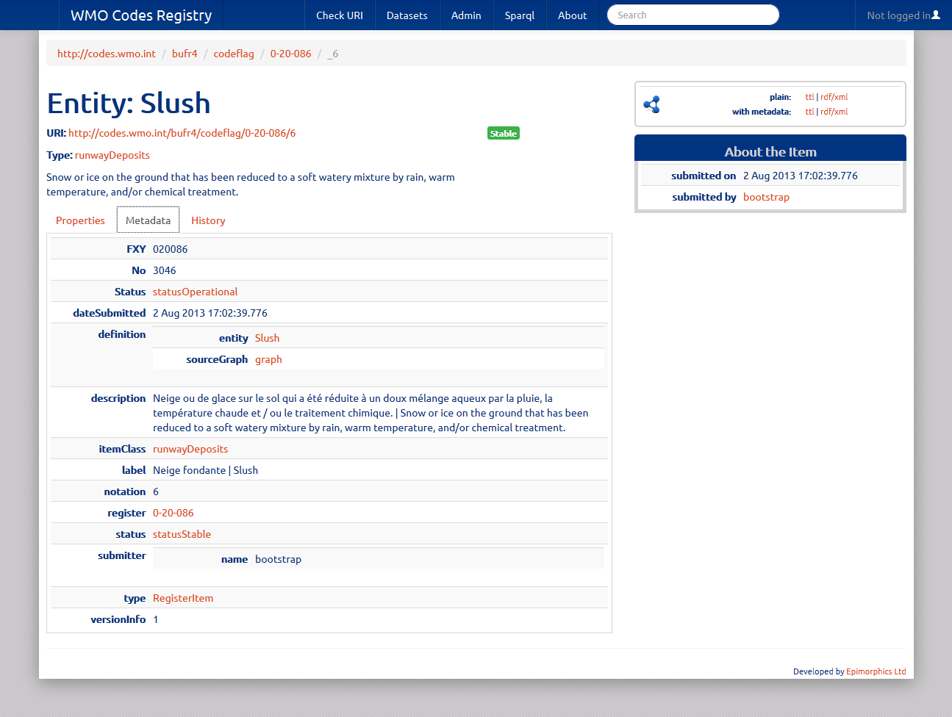

Figure : 'Metadata' tab for Entities

The ‘Metadata’ tab provides a tabular view of the properties of the Register Item associated with the target Entity. These will include:

* date submitted
* definition
* description
* item class
* label
* notation
* containing register (e.g. [0-20-086](http://codes.wmo.int/bufr4/codeflag/0-20-086)); this is a hyperlink to the containing Register itself
* status
* submitter
* type; this will always be [RegisterItem](http://purl.org/linked-data/registry#RegisterItem)
* version information

*Note: where the Register Item was submitted to the Registry during the initial start-up phase (e.g. direct from configuration files), the submitter name is specified as “bootstrap”.*

For more information about the Register Item data model please refer [here](http://www.epimorphics.com/public/vocabulary/Registry.html).

Figure 17 also illustrates the inclusion of domain specific properties – in this case “FXY”, “No” and “Status”. These are BUFR-specific metadata properties and are defined in the FM 94 BUFR ‘schema’ Sub-register:

http://codes.wmo.int/bufr4/schema/core/FXY

http://codes.wmo.int/bufr4/schema/core/No

http://codes.wmo.int/bufr4/schema/core/Status

#### History tab

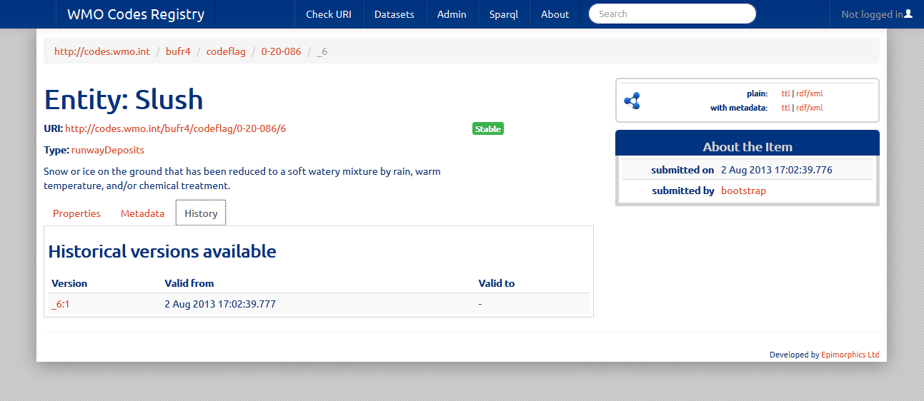

Figure : 'History' tab for Entities

The ‘History’ tab provides a list of available historical versions for the Register Item associated with the current Entity.

Each version is listed with the date / time period for which it is valid. A blank “valid to” property indicates that that version is still current.

Given that a new version of the Register Item is created at each change of status or amendment of information stored about the Entity, the ‘History’ tab enables users to determine what was previously known about the current Entity.

*Note: At time of writing, the vast majority of content in the WMO Codes Registry has been loaded during initial configuration (“bootstrap”) without subsequent amendment. As such, most Register Items are at version 1 and provide no meaningful history.*

### User authentication

Authentication is required in order to modify the contents of the WMO Codes Registry. Furthermore, an authenticated user must be in possession of the necessary permissions to modify content. Such permissions may granted by Registry administrators or delegated by other Users with the necessary permissions.

*Note: The contents of the WMO Codes Registry will be maintained by nominated members of the WMO Expert Teams and the WMO Secretariat. To request the provision of additional content from WMO Technical Regulation to be published via this Service please post to the* [*WMO Codes List Registry group*](http://www.google.com/url?q=https%3A%2F%2Fgroups.google.com%2Fa%2Fwmo.int%2Fforum%2F%3Fhl%3Den-GB%23!forum%2Fcbs-codes-registry)*.*

*Guidance on modification of content is beyond the scope of this User Guide.*

The WMO Codes Registry relies on an external Identity Provider to authenticate using the [OpenID protocol](http://openid.net/). At time of writing, only Google is validated as a working Identity Provider, but other OpenID providers *may* also work.

During the authentication process (e.g. Login) the WMO Codes Registry requests a human-readable name from the Identity Provider (e.g. the public name from the Google account) in order to use as a label against any modifications undertaken by that User.

Prior to Login, a User must first Register with the WMO Codes Registry.

Anyone is permitted to register with the service – although the value of such registration is low as only WMO experts will be granted permissions to modify content.

Figure 19 illustrates the Login / Registration page.

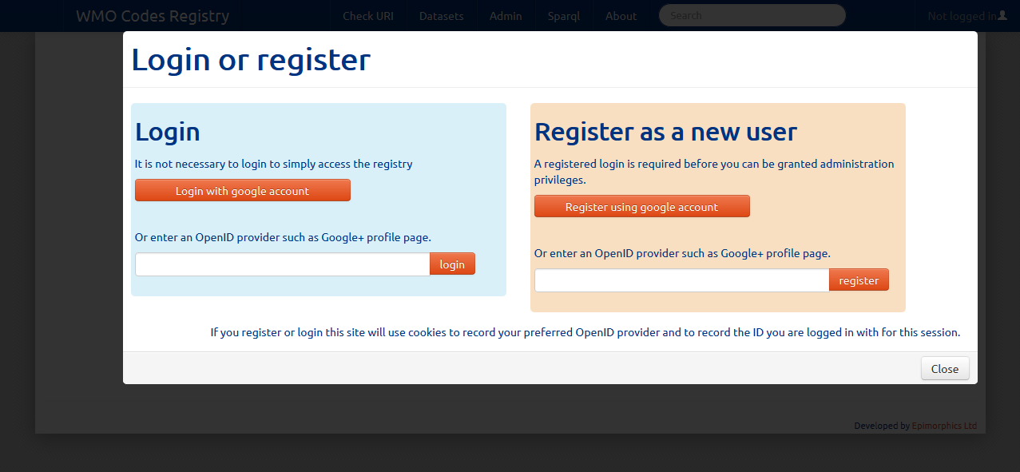

Figure : User Login and Registration

*Note: For more information on User authentication and the security model within the Registry please refer to the technical documentation* [*here*](https://github.com/der/ukl-registry-poc/wiki/Security-model)*.*

## Programmatic read access to WMO Codes Registry

Programmatic access to the WMO Codes Registry is provided via HTTP. Examples are provided based on use of the [cURL](http://en.wikipedia.org/wiki/CURL) utility, but any software application capable of executing HTTP would suffice.

Unless specified otherwise, all examples use the HTTP GET operation.

*Note: This section describes only those elements of the API providing read-access to the Registry content; more details of the programmatic API can be found* [*here*](https://github.com/der/ukl-registry-poc/wiki/Api), including a [summary of the API operations](https://github.com/der/ukl-registry-poc/wiki/Api#summary-of-api)*.*

### Content negotiation

The Registry software supports content negotiation via HTTP. The supported formats are [HTML](http://www.w3.org/TR/html-markup/), [Turtle](http://www.w3.org/TR/turtle/), [RDF/XML](http://www.w3.org/TR/REC-rdf-syntax/) and [JSON-LD](http://www.w3.org/TR/json-ld/).

The registered mime-types for these formats are:

* HTML: text/html
* Turtle: text/turtle
* RDF/XML: application/rdf+xml
* JSON-LD: application/ld+json

The default response of the Registry is the provision of HTML content. This may be overridden either by use of the “Accept” HTTP request header.

Alternatively, one may append the _format={format} query parameter to the HTTP request:

* Turtle: ?_format=ttl
* RDF/XML: ?_format=rdf
* JSON-LD: ?_format=jsonld

For consistency, all examples below will request content in turtle format.

### Register retrieval

This section describes the API operations pertaining to retrieval of information about Registers.

* To request details of a Register and those members with status category “accepted”.

GET http://registry/{register}

Example:

curl –i –H “Accept:text/turtle” http://codes.wmo.int/bufr4/codeflag/0-20-086

* To request details of a Register, excluding members.

GET http://registry/{register}?non-member-properties

Example:

curl –i –H “Accept:text/turtle” http://codes.wmo.int/bufr4/codeflag/0-20-086?non-member-properties

* To request details of a Register and a page of those members with status category “accepted”.

GET http://registry/{register}?firstPage

GET http://registry/{register}?_page={n}

Example:

curl –i –H “Accept:text/turtle” http://codes.wmo.int/306/4678?_page=2

* To request details of a Register and those members with specified status.

GET http://registry/{register}?status={status}

{status} must be one of:

* notAccepted
* submitted
* reserved
* invalid
* accepted
* valid
* experimental
* stable
* deprecated
* retired

Example:

curl –i –H “Accept:text/turtle” http://codes.wmo.int/bufr4/codeflag/0-20-086?status=reserved

* To request details of a Register and members – including associated Register Item resources.

GET http://registry/{register}?_view=with_metadata

Example:

curl –i –H “Accept:text/turtle” http://codes.wmo.int/49-2/AerodromeRecentWeather?_view=with_metadata

* To request details of a specific version of a Register and those members valid for that version.

GET http://registry/{register}:{version}

Example:

curl –i –H “Accept:text/turtle” http://codes.wmo.int/common/c-15:3

* To request details of a Register, its members, the Register Item associated with the Register and a list of versions of that Register Item.

GET http://registry/_{register}?_view=version_list

Example:

curl –i –H “Accept:text/turtle” http://codes.wmo.int/_common?_view=version_list

* To request details of a Register and its members at a specific date-time.

GET http://registry/{register}?_versionAt={dateTime}

Example:

curl –i –H “Accept:text/turtle” http://codes.wmo.int/common/c-6?_versionAt=2013-08-05T12:00:00Z

### Entity and Register Item retrieval

This section describes the API operations pertaining to retrieval of information about Entities and Register Items. Where Entities are referenced from outside the scope of the Registry, no guarantees can be made as to the behaviour of those resources. As a result, this section describes the operations pertaining to retrieval of information about those Entities managed within the scope of the Registry system.

* To request information about an Entity.

GET http://registry/{register}/{entity}

Example:

curl –i –H “Accept:text/turtle” http://codes.wmo.int/bufr4/codeflag/0-20-086/6

* To request information about an Entity and the associated Register Item.

GET http://registry/{register}/{entity}?_view=with_metadata

Example:

curl –i –H “Accept:text/turtle” http://codes.wmo.int/306/4678/FZDZ?_view=with_metadata

* To request information about a Register Item and the associated Entity.

GET http://registry/{register}/_{item}

Example:

curl –i –H “Accept:text/turtle” http://codes.wmo.int/49-2/AerodromeRecentWeather/_REFZDZ

* To request information about a specific version of a Register Item and the associated information known about the associated Entity for that version.

GET http://registry/{register}/_{item}:{version}

Example:

curl –i –H “Accept:text/turtle” http://codes.wmo.int/49-2/AerodromeRecentWeather/_REFZDZ:1

* To request information about a Register Item, the associated Entity and the list of each version of the Register Item – including the interval over which it was valid, which version (if any) it replaced and whether it is the current version of the item..

GET http://registry/{register}/_{item}?_view=version_list

Example:

curl –i –H “Accept:text/turtle” http://codes.wmo.int/49-2/AerodromeRecentWeather/_REFZDZ?_view=version_list

* To determine whether the Entity specified with the given URI is known within the Register sub-tree and has status category “accepted”; if found, details of the Entity are provided else a HTTP 404 “Not found” response is given.

GET http://registry/{register}?entity={uri}

Example:

curl –i –H “Accept:text/turtle” http://codes.wmo.int/ bufr4/b/12?entity=http://codes.wmo.int/common/c-15/me/dewPointTemperature

## Annex 1: WMO Codes Registry structure

* [/](http://codes.wmo.int/) - Root register
  + [/306](http://codes.wmo.int/306) - WMO No. 306 Manual on Codes.
    - [/306/4678](http://codes.wmo.int/306/4678) - Significant weather (w'w'); enumerating the set of meteorologically valid options defined in WMO No. 306 Vol 1 code-table 4678.
  + [/49-2](http://codes.wmo.int/49-2) - WMO No. 49 Technical Regulations Volume II - Meteorological Services for Air Navigation.
    - [/49-2/AerodromeForecastWeather](http://codes.wmo.int/49-2/AerodromeForecastWeather) - Significant weather permissible for specifying forecast weather at an aerodrome.
    - [/49-2/AerodromePresentWeather](http://codes.wmo.int/49-2/AerodromePresentWeather) - Significant weather permissible for specifying present weather at an aerodrome.
    - [/49-2/AerodromeRecentWeather](http://codes.wmo.int/49-2/AerodromeRecentWeather) - Significant weather permissible for specifying recent weather at an aerodrome.
    - [/49-2/CloudAmountReportedAtAerodrome](http://codes.wmo.int/49-2/CloudAmountReportedAtAerodrome) - Nominal value terms for describing cloud amount reported at an aerodrome.
    - [/49-2/SigConvectiveCloudType](http://codes.wmo.int/49-2/SigConvectiveCloudType) - Subset of cloud types that are of significance to aeronautical operations.
    - [/49-2/SigWxPhenomena](http://codes.wmo.int/49-2/SigWxPhenomena) - Weather phenomena of significance to aeronautical operations.
    - [/49-2/observable-property](http://codes.wmo.int/49-2/observable-property) - Composite observable property definitions that aggregate the set of physical properties evaluated as a result of regulated procedures such as aerodrome observation and forecast reports.
    - [/49-2/observation-type](http://codes.wmo.int/49-2/observation-type) - Observation and measurement types pertinent to meteorological services for air navigation.
      * [/49-2/observation-type/IWXXM](http://codes.wmo.int/49-2/observation-type/IWXXM) - ICAO IWXXM observation types.
  + [/bufr4](http://codes.wmo.int/bufr4) - WMO No. 306 Vol I.2 FM 94 BUFR (edition 4).
    - [/bufr4/b](http://codes.wmo.int/bufr4/b) - WMO No. 306 Vol I.2 FM 94 BUFR (edition 4) Table B.
      * [/bufr4/b/12](http://codes.wmo.int/bufr4/b/12) - WMO No. 306 Vol I.2 FM 94 BUFR (edition 4) Class 12 'Temperature'.
      * [/bufr4/b/20](http://codes.wmo.int/bufr4/b/20) - WMO No. 306 Vol I.2 FM 94 BUFR (edition 4) Class 20 'Observed phenomena'; defines present/past weather, special phenomena, etc..
    - [/bufr4/codeflag](http://codes.wmo.int/bufr4/codeflag) - WMO No. 306 Vol I.2 FM 94 BUFR (edition 4) Code- and Flag-tables.
      * [/bufr4/codeflag/0-08-023](http://codes.wmo.int/bufr4/codeflag/0-08-023) - WMO No. 306 Vol I.2 FM 94 BUFR (edition 4) Code-table 0 08 023 'First order statistics'.
      * [/bufr4/codeflag/0-10-063](http://codes.wmo.int/bufr4/codeflag/0-10-063) - WMO No. 306 Vol I.2 FM 94 BUFR (edition 4) Code-table 0 10 063 'Characteric of pressure tendency'.
      * [/bufr4/codeflag/0-20-008](http://codes.wmo.int/bufr4/codeflag/0-20-008) - WMO No. 306 Vol I.2 FM 94 BUFR (edition 4) Code-table 0 20 008 'Cloud distribution for aviation'.
      * [/bufr4/codeflag/0-20-012](http://codes.wmo.int/bufr4/codeflag/0-20-012) - WMO No. 306 Vol I.2 FM 94 BUFR (edition 4) Code-table 0 20 012 'Cloud type'.
      * [/bufr4/codeflag/0-20-086](http://codes.wmo.int/bufr4/codeflag/0-20-086) - WMO No. 306 Vol I.2 FM 94 BUFR (edition 4) Code-table 0 20 086 'Runway deposits'.
      * [/bufr4/codeflag/0-22-061](http://codes.wmo.int/bufr4/codeflag/0-22-061) - WMO No. 306 Vol I.2 FM 94 BUFR (edition 4) Code-table 0 22 061 'State of the sea'.
    - [/bufr4/schema](http://codes.wmo.int/bufr4/schema) - Schemata and definitions required to support WMO No. 306 Vol I.2 FM 94 BUFR (edition 4) code-table definitions in RDF.
  + [/common](http://codes.wmo.int/common) - WMO No. 306 Vol I.2 Common Features.
    - [/common/c-15](http://codes.wmo.int/common/c-15) - WMO No. 306 Vol I.2 Common Code-table C-15 'Physical quantities'. Note that this is a proposed new Common table and is marked with 'experimental' status.
      * [/common/c-15/ae](http://codes.wmo.int/common/c-15/ae) - WMO No. 306 Vol I.2 Common Code-table C-15 'Physical quantities - aeronautical meteorology discipline'.
      * [/common/c-15/me](http://codes.wmo.int/common/c-15/me) - WMO No. 306 Vol I.2 Common Code-table C-15 'Physical quantities - meteorology discipline'.
      * [/common/c-15/oc](http://codes.wmo.int/common/c-15/oc) - WMO No. 306 Vol I.2 Common Code-table C-15 'Physical quantities - oceanography discipline'.
    - [/common/c-6](http://codes.wmo.int/common/c-6) - WMO No. 306 Vol I.2 Common Code-table C-6 List of units for TDCFs.
    - [/common/nil](http://codes.wmo.int/common/nil) - Set of 'nil-reason' terms that are used to provide an explanation for recording a missing (or void) value within a data product.
    - [/common/observation-type](http://codes.wmo.int/common/observation-type) - Observation and measurement types pertinent to generic meteorological services and products.
      * [/common/observation-type/METCE](http://codes.wmo.int/common/observation-type/METCE) - WMO METCE observation types.
      * [/common/observation-type/OGC-OM](http://codes.wmo.int/common/observation-type/OGC-OM) - O&M observation types (OGC, ISO/TC211).
    - [/common/schema](http://codes.wmo.int/common/schema) - Schemata and definitions required to support WMO No. 306 Vol I.2 Common code-table definitions in RDF.
  + [/grib2](http://codes.wmo.int/grib2) - WMO No. 306 Vol I.2 FM 92 GRIB (edition 2).
    - [/grib2/codeflag](http://codes.wmo.int/grib2/codeflag) - WMO No. 306 Vol I.2 FM 92 GRIB (edition 2) Code- and Flag-tables.
      * [/grib2/codeflag/0.0](http://codes.wmo.int/grib2/codeflag/0.0) - Code-table 0.0 - Discipline of data.
      * [/grib2/codeflag/4.1](http://codes.wmo.int/grib2/codeflag/4.1) - Code-table 4.1 - Parameter category by product discipline.
      * [/grib2/codeflag/4.2](http://codes.wmo.int/grib2/codeflag/4.2) - Code-table 4.2 - Parameter number by product discipline and parameter category.
      * [/grib2/codeflag/4.5](http://codes.wmo.int/grib2/codeflag/4.5) - Code-table 4.5 - Fixed surface types and units.
      * [/grib2/codeflag/4.10](http://codes.wmo.int/grib2/codeflag/4.10) - Code-table 4.10 - Type of statistical processing.
    - [/grib2/schema](http://codes.wmo.int/grib2/schema) - Schemata and definitions required to support WMO No. 306 Vol I.2 FM 92 GRIB (edition 2) code-table definitions in RDF.
  + [/system](http://codes.wmo.int/system) - Registers which control registry system operation. Please refer to Registry implementation documentation for more information.

This page is intentionally left blank.

1. It is anticipate that the SPARQL query facility will be unavailable within the WMO Codes Registry.