How to Install WISPR3 on Seaglider
Last Updated 7/9/2026

Hardware Integration
- First, identify where you want to place the hydrophone. The placement of WISPR will affect the lengths of your cables, so determining the placement is important.
  - For SG, the backside of the plastic electronics plate is recommended (Fig 1).
  - For SGX, our group had a new plastic electronics plate machined for extra mounting space (Fig. 2). This is recommended for additional mounting space.
- Drill four 7/64” holes through the plastic electronics plate making sure to line up the holes with the mounting standoffs on WISPR.
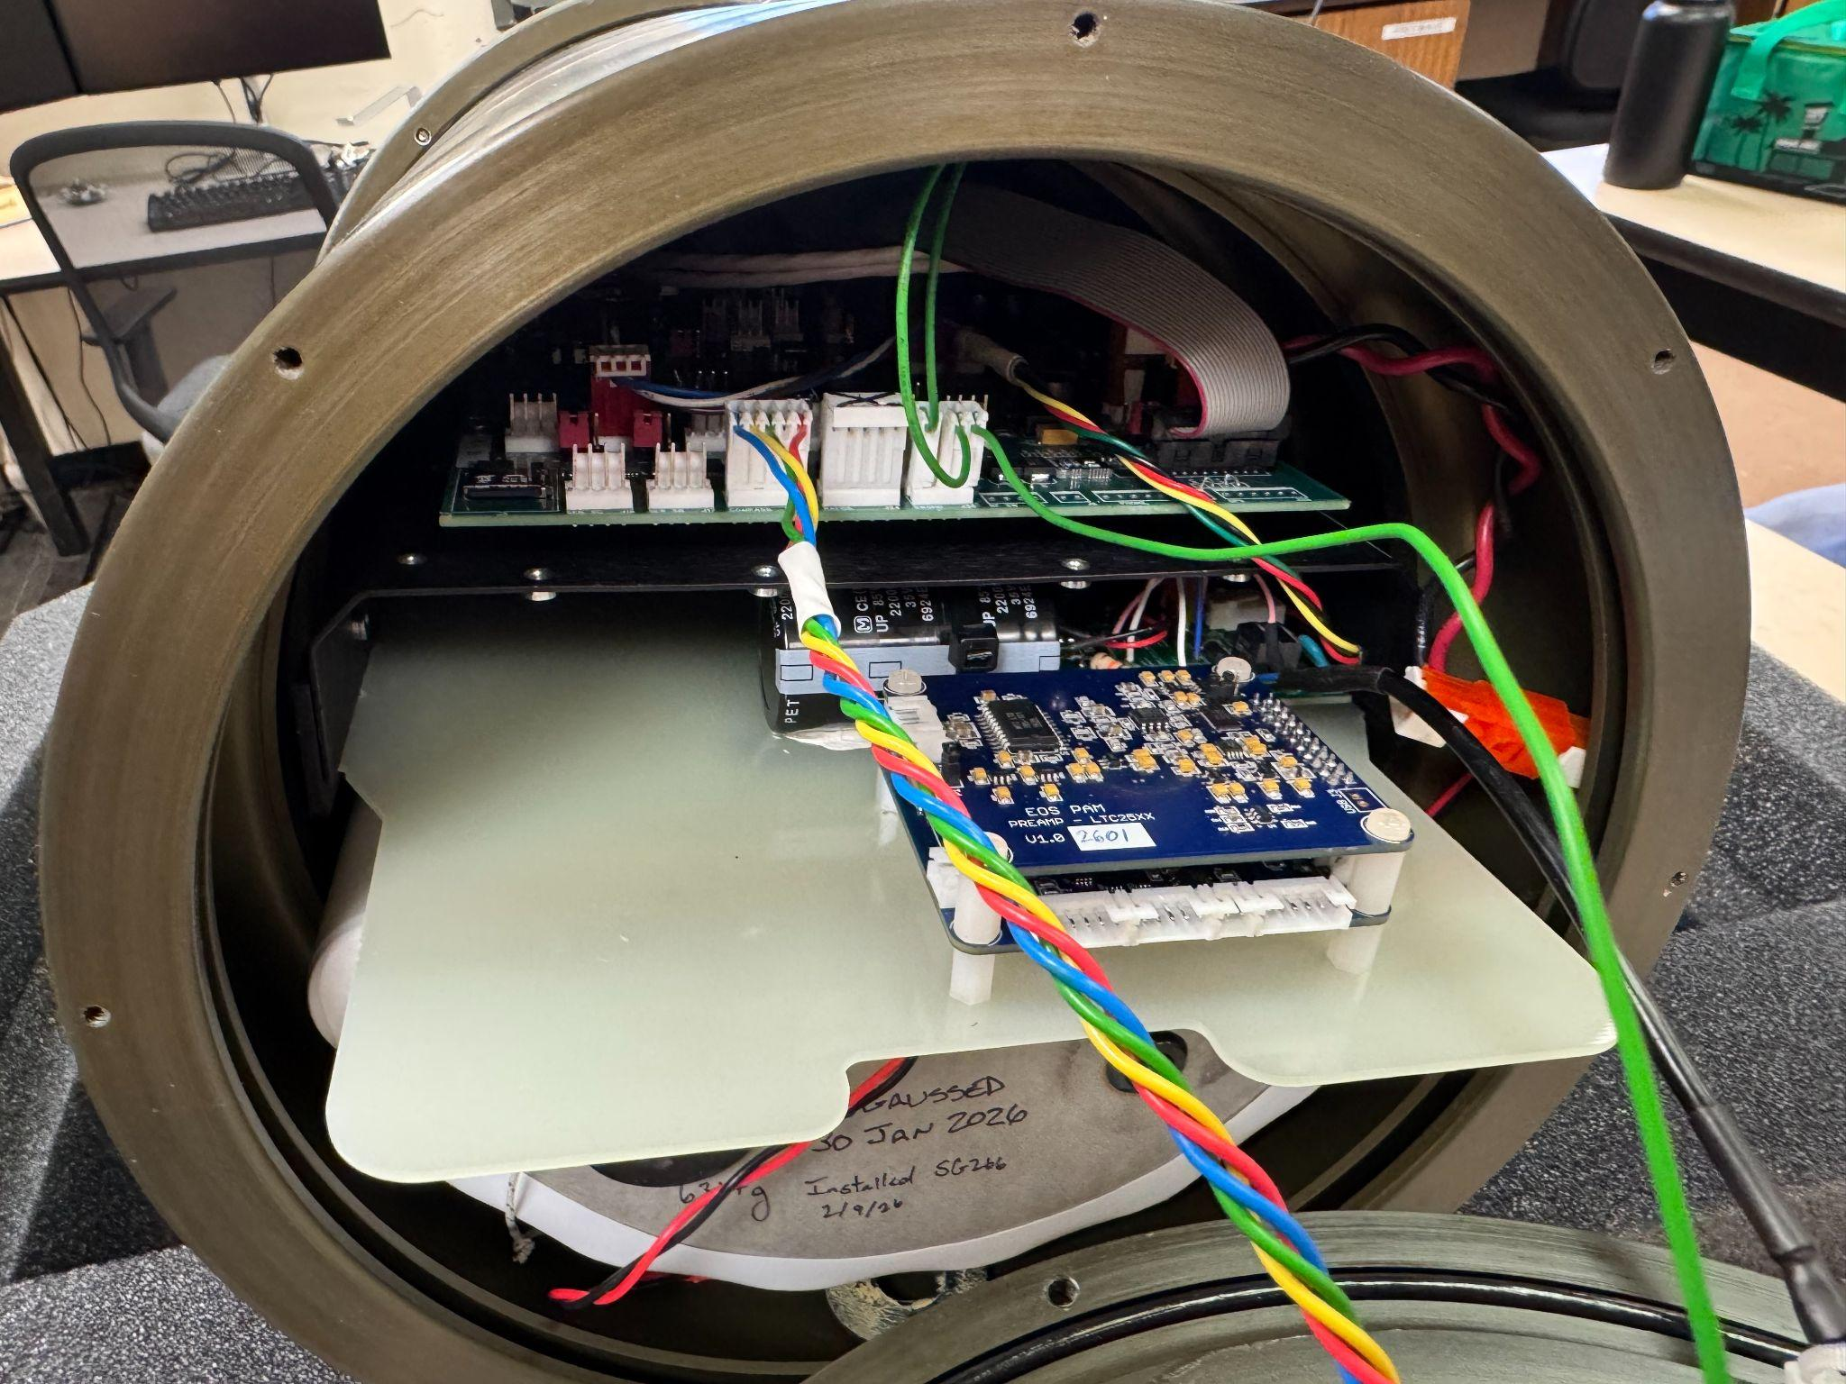Fig. 2: Mounted WISPR3 on a modified plastic electronics plate on an SGX.
- Mount the WISPR with the (FILL IN DETAILS LATER) standoffs.
- Once WISPR is mounted, build the wiring harness that connects the Seaglider motherboard serial to the WISPR micro-controller (Fig. 1,2,3).
  - Use serial ports 5A or 6 on Seaglider motherboard to communicate with WISPR using Logic (Fig. 4). WISPR only uses Logic communication.
  - Splice PWR from Seaglider serial port to WISPR PWR J1 Enable pin. This turns WISPR on every time it has power.
  - Splice GND from Seaglider serial port to WISPR PWR J1 and UART J5.
  - Connectors:
    - Seaglider serial port: FILL IN DETAILS LATER
    - WISPR PWR J1: FILL IN DETAILS LATER
    - WISPR UART J5: FILL IN DETAILS LATER
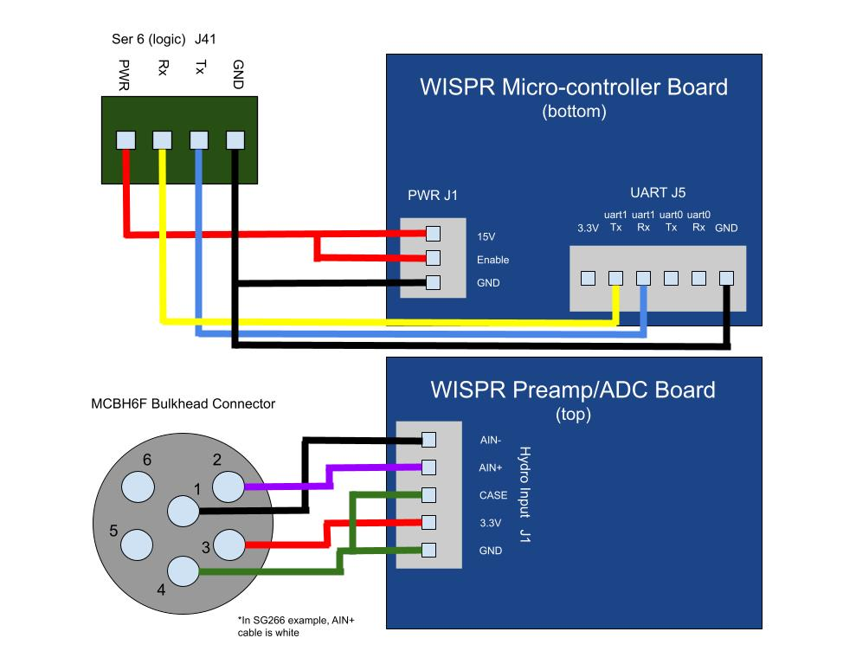
Fig. 3: Seaglider-WISPR wiring harness diagram. Use serial ports 5A or 6 on Seaglider mainboard for Logic communications.

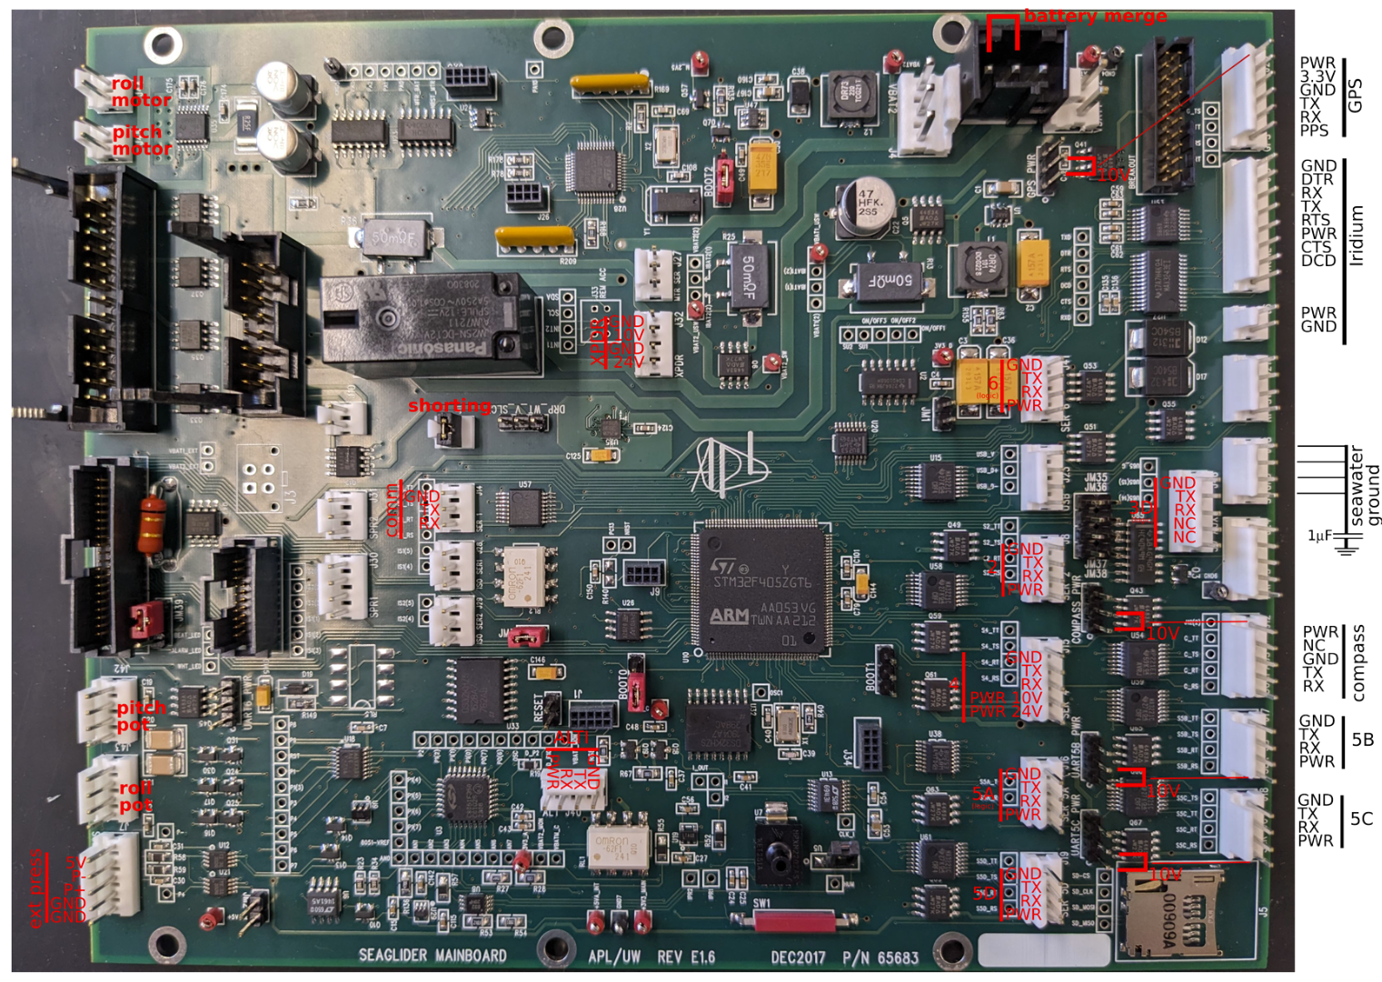Fig. 4: Seaglider motherboard diagram. Use serial ports 5A or 6 for logic communication to the WISPR micro-controller.
- The next step is to build the hydrophone cable. Use a 22 AWG 2 pair foil shielded cable. Measure the distance you need from the endcap to WISPR Hydro Input J1 can cut the cable length.
  - For SGX, you have the option of using either an aft endcap bulkhead connector or a forward endcap bulkhead connector. The forward endcap has slots for both IE55 or MCBH connectors depending on your hydrophone connector type. If comfortable, you can swap a bulkhead connector from aft to forward and replace the aft slot with one of the plugs from the forward endcap (Fig. 5). Make sure to use loc-tite on the bulkhead connector threads and tef-gel on the face.
- Splice the hydrophone cable to a bulkhead connector pigtail. Make sure to note the connected wires if there are color changes due to the splice.
- Run the spliced hydrophone cable through the glider if necessary, making sure there are no snagging points on any of the moving internal parts of the glider.
- Using a FILL IN DETAILS LATER connector, terminate the end of the hydrophone cable and connect it to the WISPR Hydro Input J1 on the Preamp board (Fig. 6 & 7).

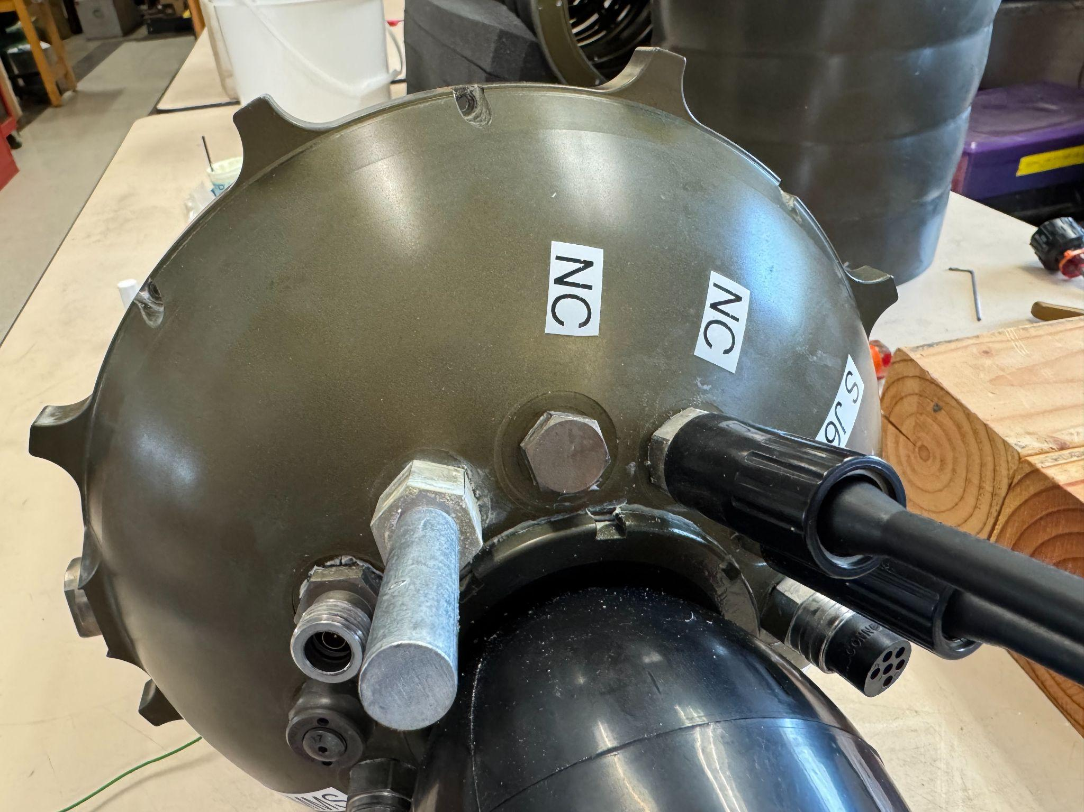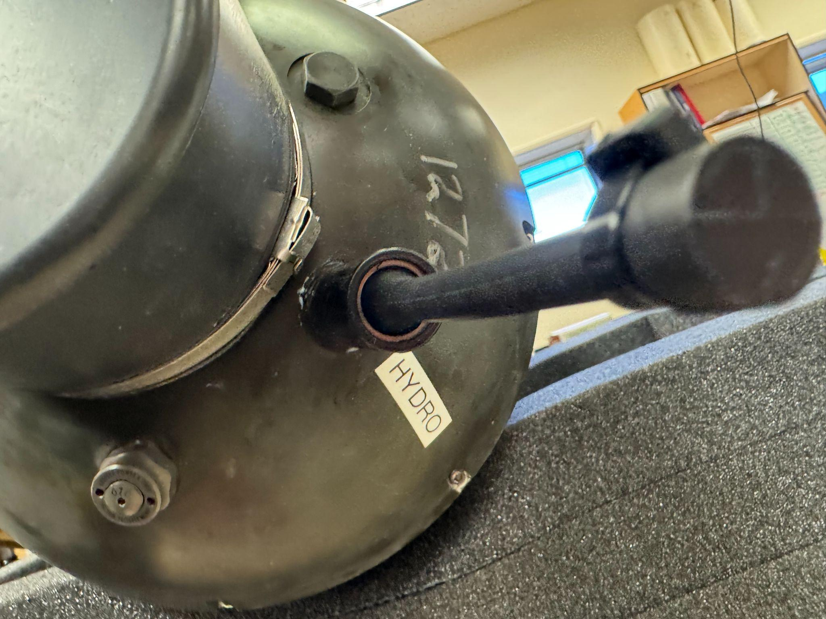
Fig. 5: SGX aft endcap with MCBH plug (left). SGX forward endcap with MCBH6F connector installed and dummy plug connected (right).

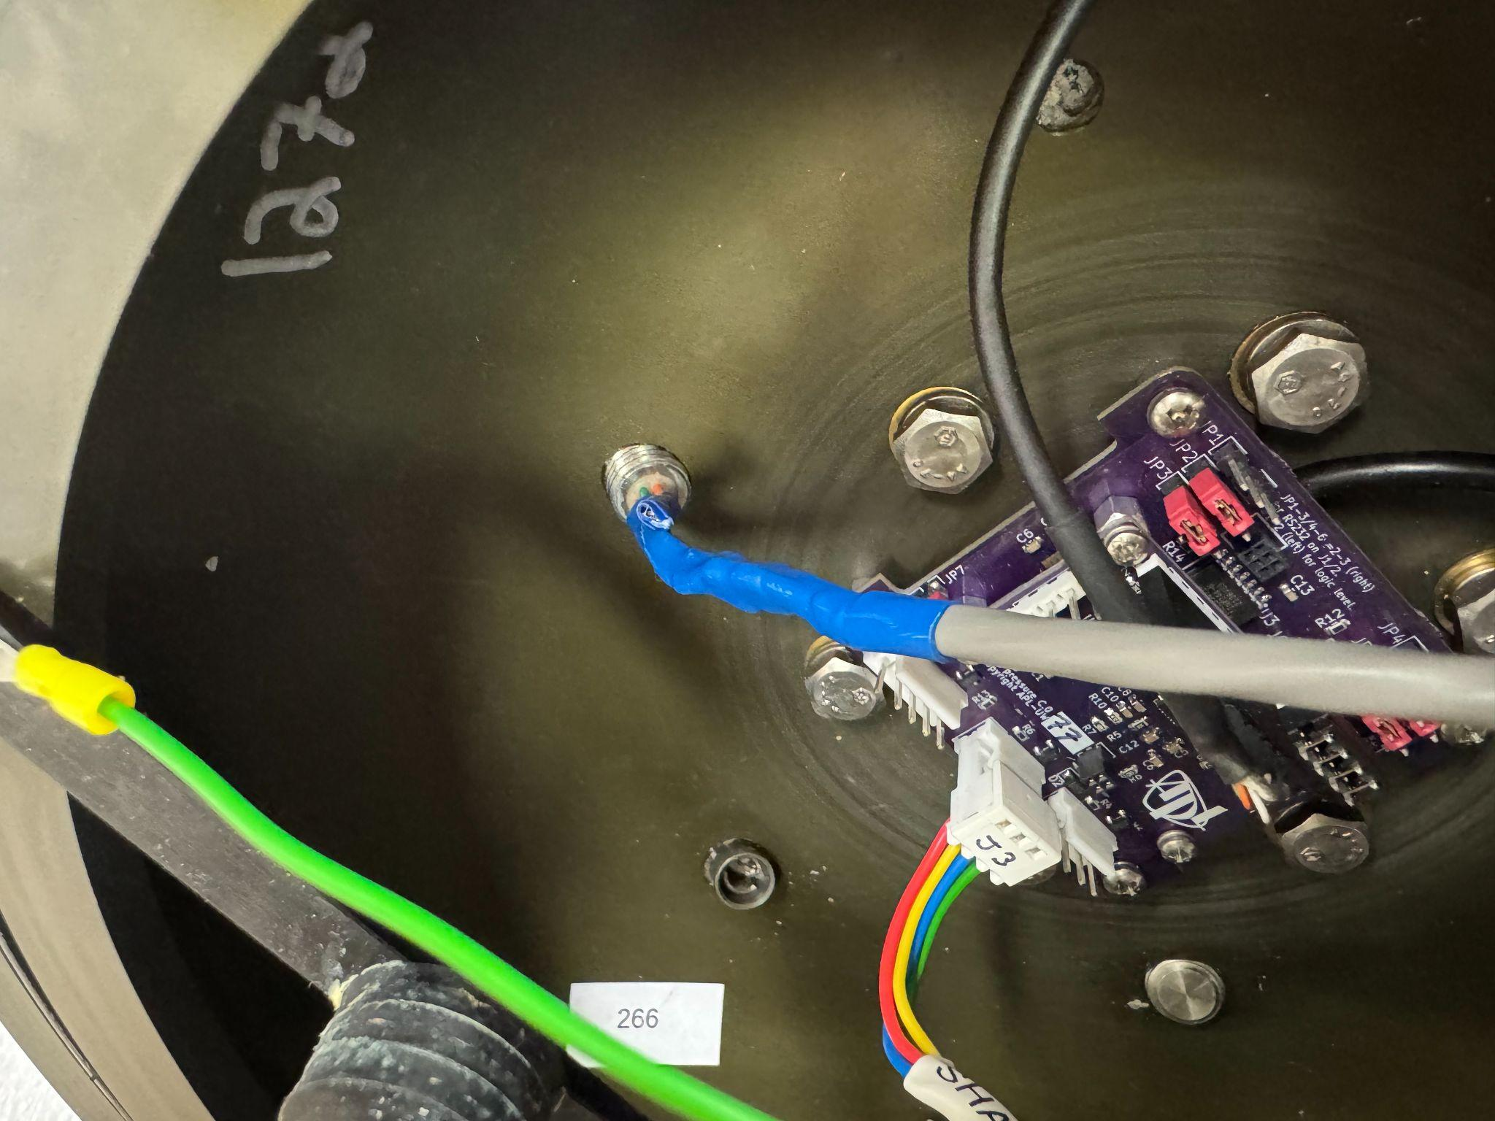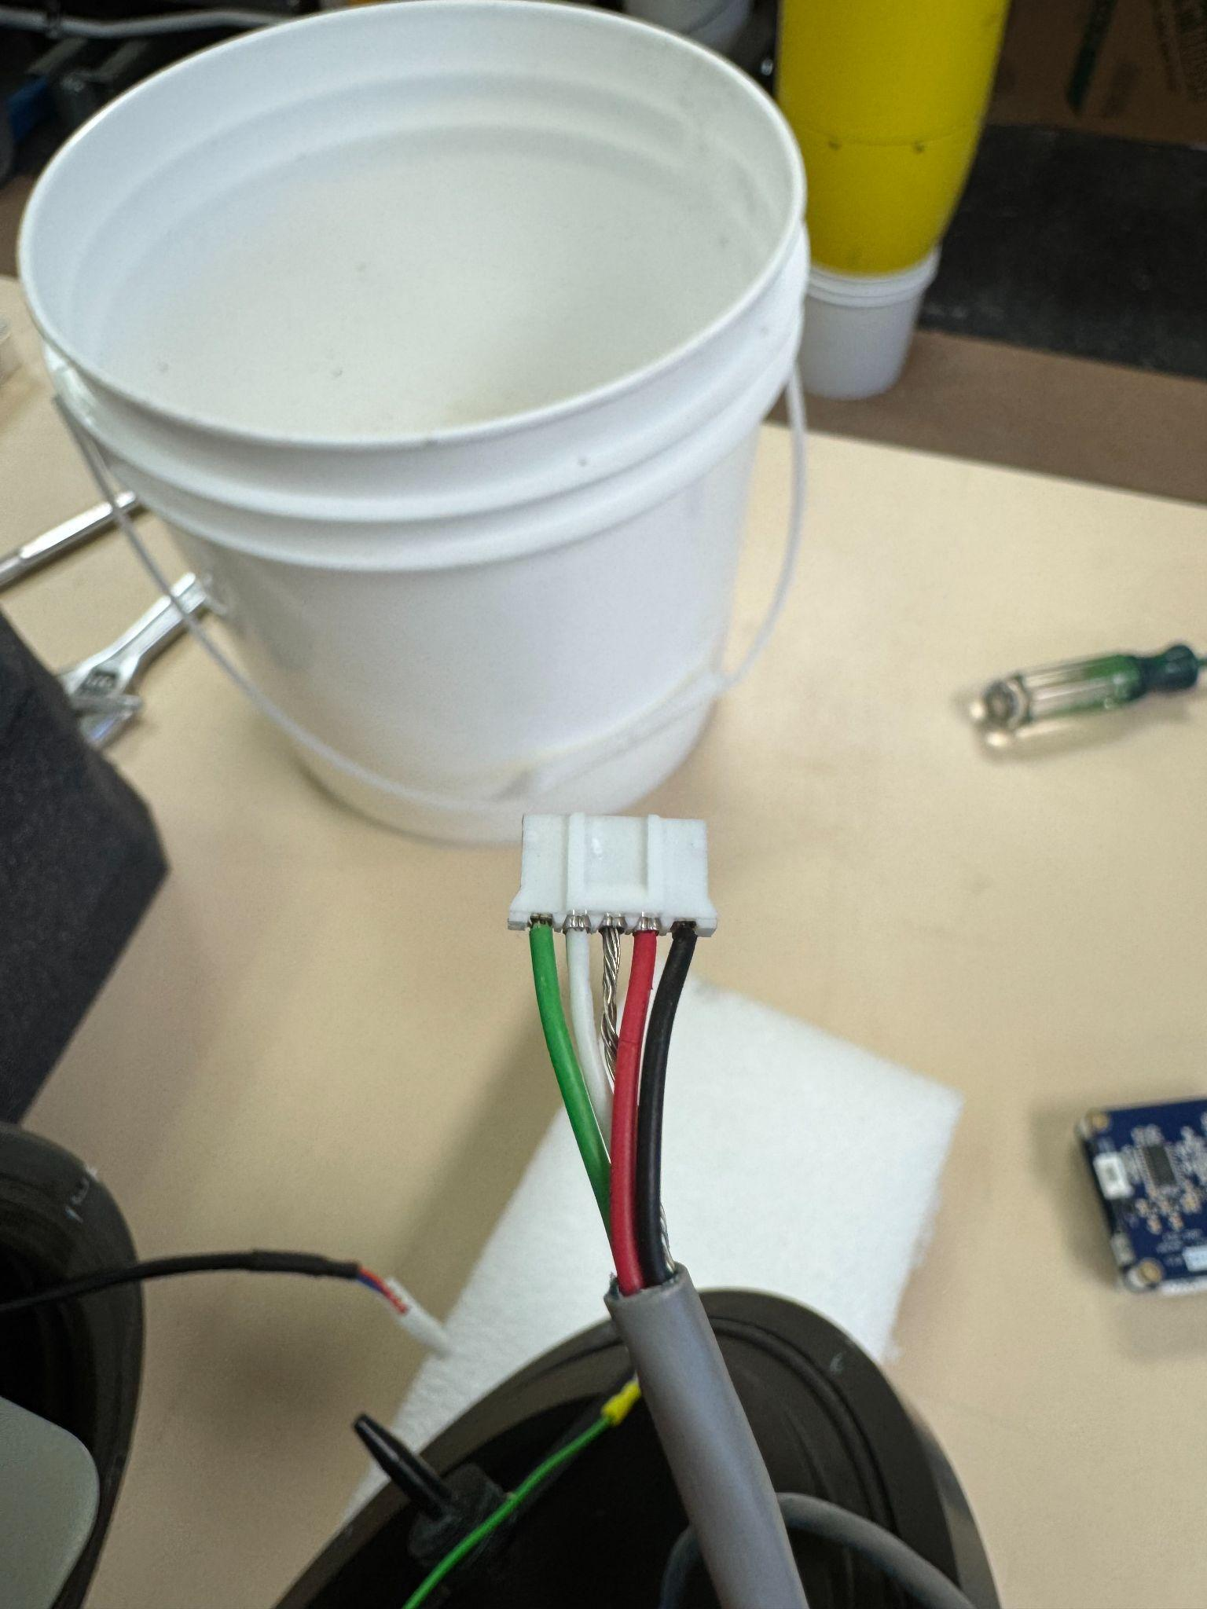
Fig. 6: SGX forward endcap with hydrophone cable spliced to bulkhead connector pigtail (left). FILL IN DETAILS LATER connector from the hydrophone to WISPR Hydro Input J1 (right).

Fig. 7: Hydrophone cable wiring diagram. In this example, the hydrophone connector was a MCIL6M, so the bulkhead connector was an MCBH6F. Colors in the diagram are different from the SG266 example.

At this point, you should have a fully integrated WISPR (Fig. 8). Now on to software integration….
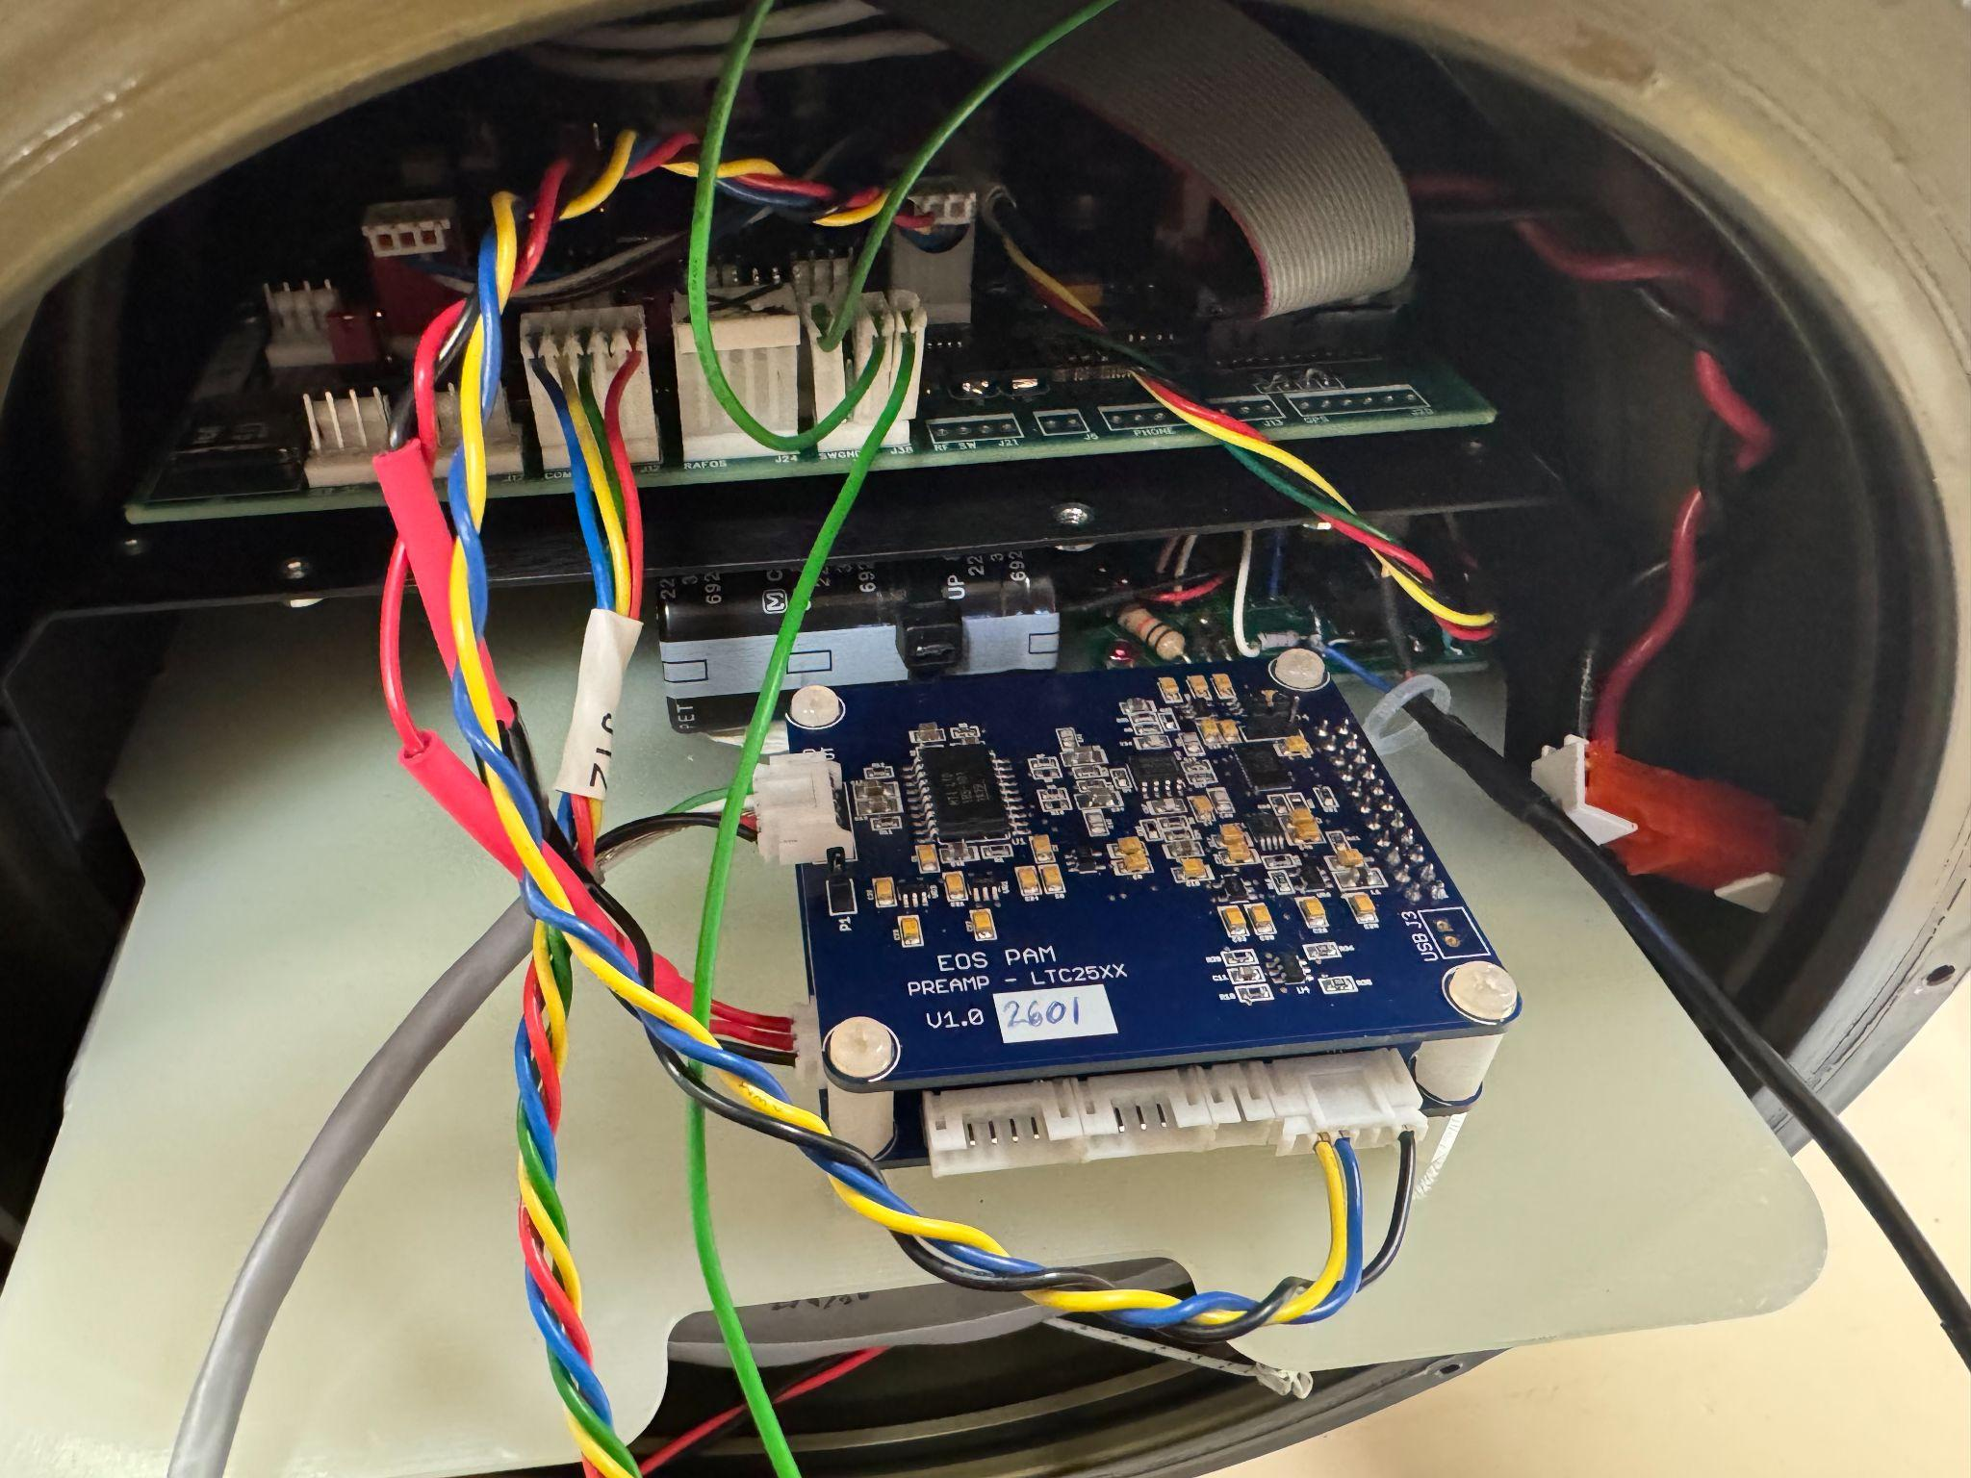
Fig. 8: Complete WISPR3 integration on SGX.

Software Integration
- Turn on the glider and use a terminal emulator (e.g. Tera Term) using 115200 baud N-8-1. If using a Rev. B glider, use 9600 baud.
- Select 4 [pdos] to upload a new configuration file using picoDOS.
  - Upload the new .cnf file from your computer: zs wispr.cnf
  - Cat the file to verify successful transfer.
  - Type quit to leave picoDOS.
- Now, we want to configure WISPR as a logger on the glider. To do this, once in the Main Menu select the following to go to the Hardware Configuration Menu:
  - 1 [param]
  - 12 [config]
- Next, add wispr.cnf to the hardware library:
  - 21 [logadd]
  - Choose an empty slot
  - Type wispr.cnf and hit Enter
  - Select 23 [loglib] to verify the cnf file was added
- Now that the cnf file is added to the hardware library, we can configure WISPR as a logger.
  - Select 1 [show] to see what logger slots are currently available.
  - Select 15 [logger]
  - Choose an empty logger slot
  - Select WISPR
  - Select which serial port you used for integrating WISPR
- Hit Enter to exit the Hardware Configuration Menu.
- Select ‘Y’ when asked to re-initialize hardware configuration.
- Go back to the Hardware Configuration Menu and view the current configuration.
  - 12 [config]
  - 1 [show]
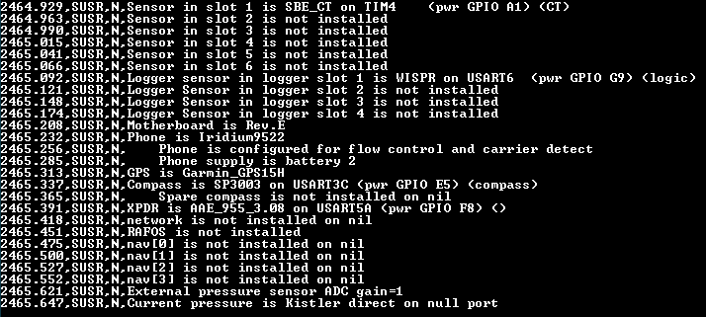
- Verify the settings are correct. A correct example should look like Fig. 8:
Fig. 8: Proper configuration of WISPR using USART6.

Initial Testing
- Build a testing cable harness like the following image in order to monitor WISPR output through uart0. It is identical to the wiring harness in Fig. 2 with pigtails in the UART0 Tx/Rx pins, as well as a spliced common ground (Fig. 9).
**When deploying, make sure there are no cables in the UART0 pins otherwise Seaglider-WISPR comms will not work.
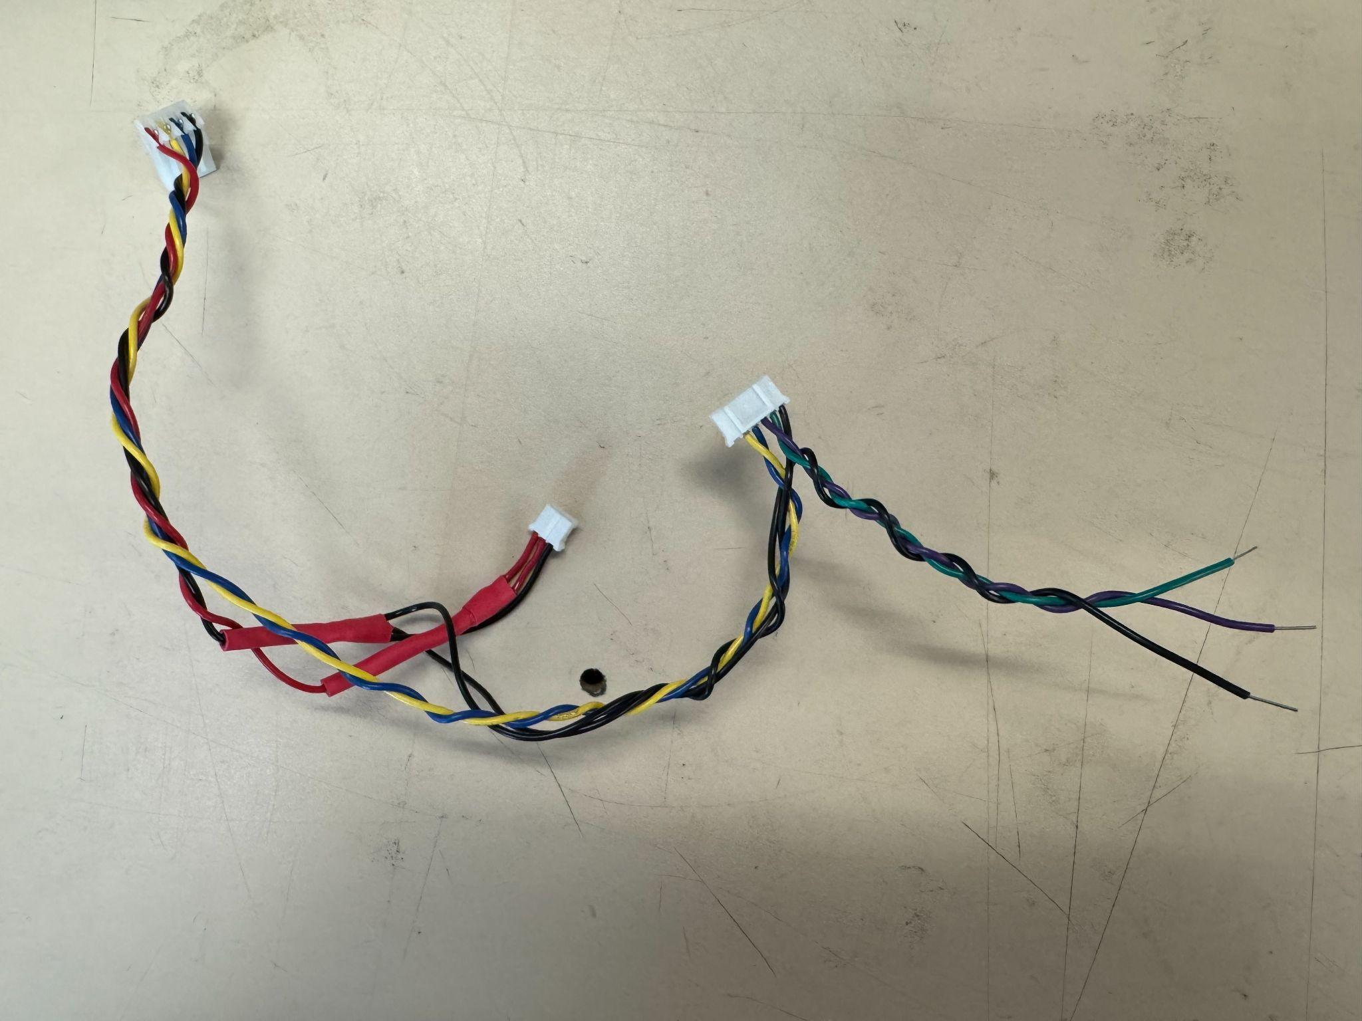
Fig. 9: WISPR testing cable harness. Note the additional pigtails in the WISPR UART J5 connector in addition to the spliced common ground. These will connect to a computer to monitor WISPR actions.
- Install one or two microSD cards in WISPR. WISPR will detect these cards on bootup and create a wispr.txt file where you can adjust settings.
- Use a terminal emulator (e.g. Tera Term) using 9600 baud N-8-1.
- Turn on the glider and open another terminal emulator window using 115200 baud N-8-1. If using a Rev. B glider, use 9600 baud.
- Go to the WISPR logger menu:
  - 2 [hw]
  - 14 [loggers]
  - 2 [ws] (WISPR should be the second logger if scicon is installed)
- Power on the WISPR by selecting 1 [on]. You should see the WISPR boot up on your 9600 baud terminal window.
  - Wait until you see: Idle: 00/01/01 00:00:03
- Sync the WISPR clock with the glider’s clock.
  - Type: command string="%{$TME,%s*ff}%r"
  - You should see the following output:
151.974,HWISPR,D,opening
152.037,HWISPR,D,%%{$TME,%%s*ff}%%r
fmt into strftime = [$TME,%s*ff]
152.110,HWISPR,N,sending [$TME,1771436099*ff]sleeping 2885 ticks, sync will be 0x0d
155.000,HWISPR,D,closing
155.062,HWISPR,N,@
- Start sampling:
  - Type: command string=$RUN*ee
  - You should see the following output:
[2026-02-18 17:34:06.146] 102.037,HWISPR,D,opening
[2026-02-18 17:34:06.205] 102.098,HWISPR,D,$RUN*ee
[2026-02-18 17:34:06.289] 102.166,HWISPR,D,closing
[2026-02-18 17:34:06.352] 102.229,HWISPR,N,@
  - Wait at least two minutes.
- Turn the sampling off:
  - 2 [off]
- Remove the microSD card in slot 1 and view the contents on a computer. You should see new files being created.
- For a full list of commands you can send to WISPR, see the WISPR3 Serial Command Interface document.

Simulated Dives
Now that we have integrated the hardware, installed the device as a logger on the glider, and tested its functionality, let’s move on to simulated dives.
- If using battery power, connect an RS-232 to IE55 serial comms cable from the glider to your computer.
- Turn on the glider and use a terminal emulator (e.g. Tera Term) using 115200 baud N-8-1. If using a Rev. B glider, use 9600 baud.
- Open a second terminal window connected to seaglider.pub (or wherever your basestation is hosted).
- Edit the command file and edit the following parameters (example values):
$WS_RECORDABOVE,-10.0
$WS_PROFILE,3.0
$WS_XMITPROFILE,3.0
$WS_UPLOADMAX,100.0
$WS_STARTS,720.0
$WS_NDIVE,1.0
  - See logdev.txt for a full list of parameters and their possible values.

