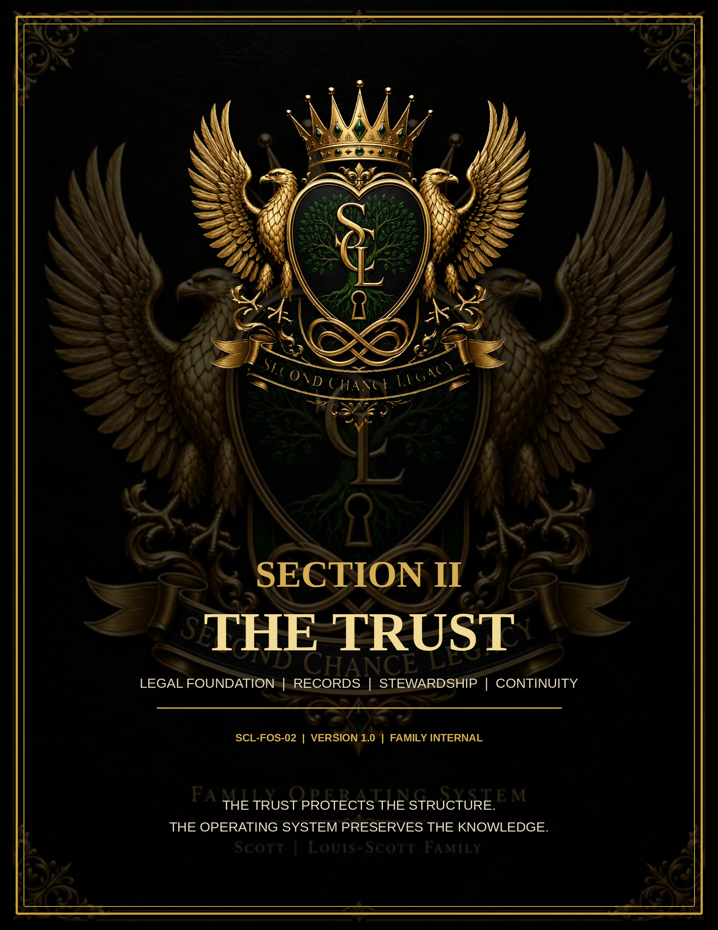

SECOND CHANCE LEGACY TRUST  FAMILY OPERATING SYSTEM | BUILDING A LEGACY. PROTECTING OUR FUTURE. | SECTION II  TRUST OVERVIEW  PAGE 2

THE LEGAL FOUNDATION
Second Chance Legacy Trust at a Glance
This section is the operating guide and records index for the Second Chance Legacy Trust. It explains how the family organizes Trust information, documents authority, maintains records, and reviews changes. It does not replace, amend, summarize away, or override the signed Trust instrument.
TRUST NAME | Second Chance Legacy Trust | DOCUMENT ID | SCL-FOS-02
GRANTORS / TRUSTORS | Marquise D. Scott and Caprice B. Louis-Scott | INITIAL TRUSTEE | Marquise D. Scott
TRUST CHARACTER | Revocable - exact rights governed by signed Trust | VERSION | 1.0 - Review Draft
FAMILY BUSINESS INTEREST | 100% sole legal Member of Second Chance Property Solutions, LLC | ACCESS | Restricted Family / Legal
PURPOSE OF THIS SECTION
PROTECT THE STRUCTURE  Keep the Trust, amendments, ownership records, and authority documents organized and traceable. | PRESERVE CONTINUITY  Give authorized family leaders a clear map for incapacity, death, succession, or emergency administration.
SEPARATE LAW FROM OPERATIONS  Keep signed legal instruments distinct from Family OS summaries, checklists, and education materials. | SUPPORT STEWARDSHIP  Create repeatable review, recordkeeping, funding, and change-control routines.
CONTROL RULE: The signed Trust, signed amendments, valid assignments, LLC governing documents, beneficiary designations, and applicable law control whenever they conflict with this Family OS.

SECOND CHANCE LEGACY TRUST  FAMILY OPERATING SYSTEM | BUILDING A LEGACY. PROTECTING OUR FUTURE. | SECTION II  ROLES & AUTHORITY  PAGE 3

WHO HOLDS WHICH RESPONSIBILITY
Trust Roles and Authority Map
1  GRANTORS  Create and fund the Trust; hold amendment or revocation rights only as provided in the signed Trust. | 2  TRUSTEE  Administers Trust property, records, and decisions within granted authority. | 3  LLC MANAGER  Operates Second Chance Property Solutions under the Operating Agreement and Manager authority. | 4  BENEFICIARIES  Receive benefits and protections according to the signed Trust, not informal expectations.
CURRENT APPROVED FAMILY STRUCTURE
MARQUISE D. SCOTT  Joint Grantor / Trustor; initial sole Trustee; initial sole Manager of Second Chance Property Solutions, LLC; final business decision-maker unless later signed documents change those roles. | CAPRICE B. LOUIS-SCOTT  Joint Grantor / Trustor; joint family legacy founder and intended joint beneficial/economic owner through the Trust structure, subject to the executed Trust language and later signed amendments.
TRUSTEE DECISIONS  Trust administration decisions must be documented when they affect title, distributions, appointments, ownership, banking, taxes, business control, or successor authority. | NO INFORMAL CHANGES  Texts, verbal statements, casual notes, and website edits do not change the Trust. Legal changes require the method stated in the signed Trust and applicable law.
VERIFY BEFORE ACTIVATION: The exact amendment, revocation, incapacity, successor-trustee, and beneficiary provisions must be cross-checked against the executed Trust and every signed amendment.

SECOND CHANCE LEGACY TRUST  FAMILY OPERATING SYSTEM | BUILDING A LEGACY. PROTECTING OUR FUTURE. | SECTION II  BUSINESS OWNERSHIP  PAGE 4

TRUST-OWNED ENTERPRISE
Trust-to-Business Ownership Map
SECOND CHANCE LEGACY TRUST
100% sole legal Member of Second Chance Property Solutions, LLC.
↓
MARQUISE D. SCOTT - INITIAL SOLE TRUSTEE
Exercises Trust authority only within the signed Trust and applicable law.
↓
SECOND CHANCE PROPERTY SOLUTIONS, LLC
Manager-managed LLC. Marquise D. Scott is the initial sole Manager and final business decision-maker unless governing documents are changed.
REQUIRED ALIGNMENT RECORDS
LLC OPERATING AGREEMENT  Must identify the Trust as sole Member and preserve manager-managed authority. | MEMBER / TRUSTEE RESOLUTIONS  Document major ownership, banking, tax, management, and succession actions.
BUSINESS RECORDS  Articles, EIN confirmation, licenses, insurance, tax registrations, and annual reports remain in Section IV, with reference links here. | CONFLICT CHECK  Any inconsistency between Trust, Articles, Operating Agreement, or resolutions must be logged and professionally reviewed.
The Family OS may display ownership and authority, but it cannot create legal ownership by itself. Transfers and appointments require the proper signed documents.

SECOND CHANCE LEGACY TRUST  FAMILY OPERATING SYSTEM | BUILDING A LEGACY. PROTECTING OUR FUTURE. | SECTION II  RECORDS INDEX  PAGE 5

ONE CLEAR HOME FOR EVERY TRUST RECORD
Controlled Trust Records Index
ID | RECORD | ACCESS | CONTROL STANDARD
02.01 | Executed Trust instrument | Restricted Legal | Original / certified copy location recorded; never upload unredacted public copy.
02.02 | Signed amendments and restatements | Restricted Legal | Chronological; never overwrite prior executed versions.
02.03 | Certification of Trust | Restricted Legal | Current version for institutions; verify accuracy after every amendment.
02.04 | Trustee acceptance / appointment records | Restricted Legal | Initial and successor trustee records.
02.05 | Trust asset schedule and funding ledger | Restricted Financial | Tracks what is actually titled or assigned to the Trust.
02.06 | LLC ownership records and assignments | Restricted Business | Links to Section IV originals and approved resolutions.
02.07 | Beneficiary structure and distribution notes | Highly Restricted | Use summary sheets; avoid exposing sensitive personal details.
02.08 | Legal, tax, and financial review notes | Restricted Advisory | Date, advisor, question, answer, and follow-up action.
02.09 | Annual Trust review packets | Restricted Family | Checklist, findings, decisions, signatures, and next review date.
02.10 | Superseded / archived records | Restricted Archive | Read-only history with superseded date and replacement reference.
Public GitHub pages must contain only non-sensitive summaries. Executed Trust documents, account data, identity records, and private beneficiary information belong in access-controlled storage.

SECOND CHANCE LEGACY TRUST  FAMILY OPERATING SYSTEM | BUILDING A LEGACY. PROTECTING OUR FUTURE. | SECTION II  TRUST FUNDING  PAGE 6

ASSETS ARE NOT PROTECTED MERELY BECAUSE THEY APPEAR ON A LIST
Trust Funding and Transfer Workflow
This workflow is an administrative control, not a transfer instrument. Each asset type may require a deed, assignment, beneficiary designation, institution form, title change, operating agreement update, or professional approval.
1  IDENTIFY  Describe the asset, owner, value, account/title details, and intended Trust treatment. | 2  REVIEW  Check legal, tax, insurance, lender, contract, and beneficiary consequences. | 3  EXECUTE  Complete the correct signed transfer, assignment, deed, designation, or institutional form. | 4  VERIFY  Obtain proof the receiving institution or public record reflects the intended ownership. | 5  RECORD  Update the Trust asset schedule, digital index, binder reference, and review date.
FUNDING CHECKLIST
[ ] Confirm the asset is eligible and appropriate for Trust ownership.
[ ] Confirm whether spouse consent, lender approval, insurer notice, or counterparty consent is required.
[ ] Use the exact legal name of the Trust and Trustee capacity shown in the executed documents.
[ ] Retain signed originals or certified copies in the controlled legal vault.
[ ] Record effective date, transfer document, confirmation source, and responsible person.
[ ] Update insurance, tax, business, estate, and emergency records as needed.
[ ] Do not mark an asset “funded” until ownership or beneficiary status is independently verified.
STATUS LABELS: Planned → Under Review → Documents Signed → Institution / Public Record Confirmed → Fully Recorded.

SECOND CHANCE LEGACY TRUST  FAMILY OPERATING SYSTEM | BUILDING A LEGACY. PROTECTING OUR FUTURE. | SECTION II  CHANGE CONTROL  PAGE 7

NO SILENT OR INFORMAL AMENDMENTS
Trust Amendment and Change-Control Protocol
Every proposed legal change follows a documented review path. This protocol controls records and approvals; the signed Trust controls who may amend or revoke, how consent must be given, and what formalities are required.
1  REQUEST  State the proposed change, reason, affected people/assets, and desired effective date. | 2  IMPACT REVIEW  Check Trust terms, community property, tax, beneficiary, business, insurance, and succession effects. | 3  PROFESSIONAL REVIEW  Obtain legal, tax, or financial review when the change can alter rights, title, liability, or taxation. | 4  EXECUTION  Use the exact signing, acknowledgment, witness, notarization, and delivery method required. | 5  SYNCHRONIZE  Update the certification, asset schedule, LLC records, Family OS, binder, access list, and version log.
MANDATORY CHANGE LOG FIELDS
CHANGE IDENTIFICATION  Request number, date, requestor, affected article/record, and summary. | AUTHORITY CONFIRMATION  Who approved, legal basis, required signatures, and any capacity determination.
EXECUTION PROOF  Signed document name, notarization/witness status, effective date, and original location. | DOWNSTREAM UPDATES  Bank, LLC, beneficiary, insurance, asset schedule, certification, website summary, binder, and archive.
Washington reference points for counsel review include RCW 11.103 (revocable trusts), RCW 11.98.075 (certification of trust), and RCW 11.98.078 / 11.97.010 (trustee duties and good-faith limits).

SECOND CHANCE LEGACY TRUST  FAMILY OPERATING SYSTEM | BUILDING A LEGACY. PROTECTING OUR FUTURE. | SECTION II  TRUSTEE ADMINISTRATION  PAGE 8

STEWARDSHIP THROUGH DOCUMENTATION
Trustee Administration Standard
LOYALTY AND GOOD FAITH  Act within the Trust, avoid undisclosed conflicts, and document transactions involving the Trustee or related parties. | ASSET PROTECTION  Maintain title evidence, insurance, taxes, registrations, valuations, and secure records.
SEPARATE RECORDS  Keep Trust activity distinct from personal and LLC activity unless a documented, authorized transaction connects them. | DECISION TRAIL  Record major decisions, supporting facts, professional advice, approvals, and follow-up actions.
INFORMATION SECURITY  Limit private records by role; use references rather than passwords or full account numbers in the binder. | CONTINUITY  Maintain current successor contacts, incapacity procedures, emergency locations, and handoff instructions.
ROUTINE TRUSTEE CHECKLIST
[ ] Review Trust-owned assets and confirm title / beneficiary records remain accurate.
[ ] Review LLC membership, Manager authority, annual reports, insurance, and major resolutions.
[ ] Review bank and investment statements for unusual activity, fees, or ownership discrepancies.
[ ] Confirm tax filings, estimated payments, information returns, and advisor follow-ups are complete.
[ ] Log material distributions, reimbursements, loans, transfers, or related-party transactions.
[ ] Update the Trust contact list, professional advisors, and secure-record locations.
[ ] Document unresolved issues and assign a responsible person and target date.
This Family OS does not authorize a transaction. Authority must come from the Trust, applicable law, a valid resolution, or another governing document.

SECOND CHANCE LEGACY TRUST  FAMILY OPERATING SYSTEM | BUILDING A LEGACY. PROTECTING OUR FUTURE. | SECTION II  REVIEW & CONTINUITY  PAGE 9

ANNUAL AND EVENT-DRIVEN REVIEW
Trust Review and Emergency Continuity
The Trust section is reviewed at least annually and whenever a major family, legal, asset, tax, business, health, or residency change occurs.
ANNUAL REVIEW CHECKLIST
[ ] Confirm executed Trust and amendment inventory is complete and readable.
[ ] Confirm Grantor, Trustee, successor, beneficiary, and advisor contact information.
[ ] Confirm Trust asset schedule matches actual title, assignments, and beneficiary designations.
[ ] Confirm Second Chance Property Solutions ownership and Manager authority remain aligned.
[ ] Review new assets, debts, insurance, businesses, marriages, births, deaths, separations, relocations, or incapacity concerns.
[ ] Review tax status, EIN use, filings, account titling, and advisor recommendations.
[ ] Test secure access: authorized people can reach required records without exposing secrets publicly.
[ ] Approve version update, archive superseded copies, and set the next review date.
EMERGENCY QUICK-REFERENCE SEQUENCE
1  STABILIZE  Protect people, property, accounts, businesses, and critical records. | 2  CONFIRM AUTHORITY  Locate signed Trust and incapacity / successor provisions before acting. | 3  CONTACT ADVISORS  Attorney, CPA/tax professional, insurance, financial institutions, and LLC leadership as needed. | 4  DOCUMENT  Maintain a dated action log, copies of notices, confirmations, expenses, and decisions.
The public website should show the process only. Names, phone numbers, passwords, original legal documents, account details, and emergency access instructions belong in the restricted vault and physical emergency packet.

SECOND CHANCE LEGACY TRUST  FAMILY OPERATING SYSTEM | BUILDING A LEGACY. PROTECTING OUR FUTURE. | SECTION II  DOCUMENT CONTROL  PAGE 10

SYSTEM MANAGEMENT
Section II Version and Approval Record
SYSTEM ID | SCL-FOS | DOCUMENT ID | SCL-FOS-02
DOCUMENT TITLE | The Trust | VERSION | 1.0
STATUS | REVIEW DRAFT | EFFECTIVE DATE | Upon written family approval
COMPILED | July 28, 2026 | OWNER | Scott | Louis-Scott Family
CLASSIFICATION | Restricted Family / Legal | PRIMARY CUSTODIANS | Marquise D. Scott and Caprice B. Louis-Scott
REVIEW CYCLE | Annual and after major changes | NEXT REVIEW | July 2027 or sooner
ACTIVATION REQUIREMENTS
[ ] Cross-check every role, authority, beneficiary, amendment, and succession statement against the executed Trust and all signed amendments.
[ ] Confirm the Trust is correctly shown as 100% sole legal Member in the LLC Operating Agreement and related ownership records.
[ ] Confirm the Trust asset schedule and funding ledger reflect actual completed transfers.
[ ] Resolve any legal, tax, community-property, insurance, or governance conflict before activation.
[ ] Approve the online module and binder section together; assign the same version and effective date.
APPROVAL
MARQUISE D. SCOTT  GRANTOR / FOUNDER / INITIAL TRUSTEE | CAPRICE B. LOUIS-SCOTT  GRANTOR / CO-FOUNDER
APPROVAL OF THIS SECTION APPROVES THE FAMILY OS SUMMARY AND CONTROL PROCESS ONLY. IT DOES NOT AMEND THE TRUST.

