HSE309

HPE307 – Ed
HPL262 - Lu

HSE0309_08Mar04.sip
contains
HED309a.cal
Hse309a.cal
Properties.txt – a small text file that specifles the baud rate of the sensor HSE0309

HPE0307_08Mar04.sip
contains
HPE307a.cal – Ed ShutterLight cal. file
HPL262a.cal - Lu ShutterLight cal. file
PED307a.cal - Ed ShutterDark cal. file
PLD262a.cal – Lu ShutterDark cal. file
Properties.txt – a small text file that specifles the baud rate of the sensor HPE0307

in satlantic data files
SATHPD does not occur but SATPED does

Prosoft 7.7.11 RC 5

Action:
Process Ed and Lu HOCR data into level 2S shutter dark corrected , time interpolated data files with Prosoft from test file“archive_24_SATLANTICINSTIME_L2s.002”.

Install and run Prosoft 7.7.11 RC 5.

Rename archive file extension to *.raw from *.002.

Create new configuration file with appropriate sensor calibration files.

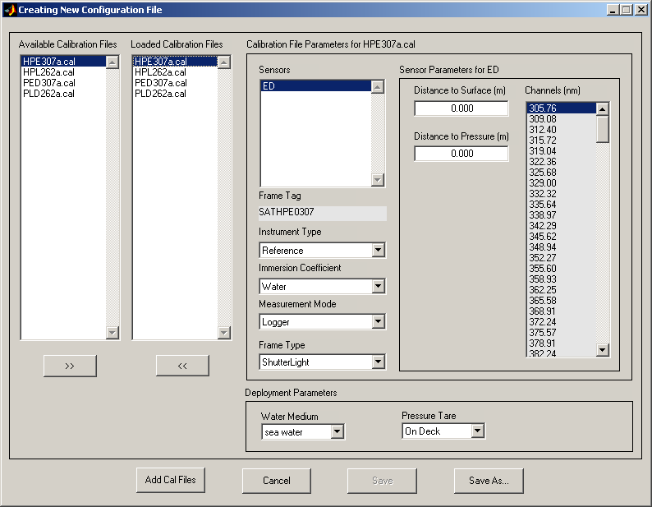

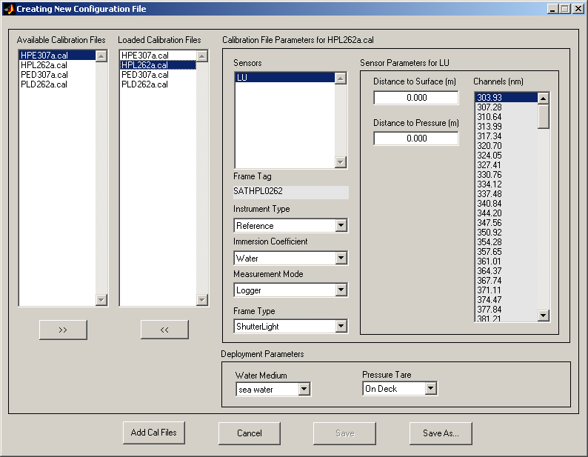

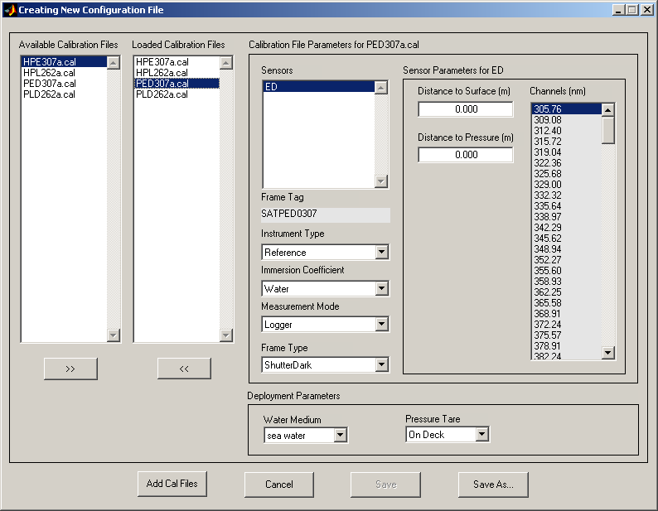

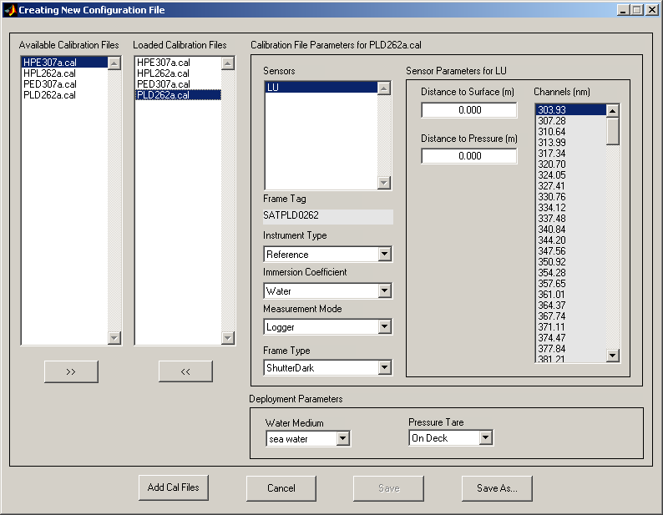

Create new current parameters file. Note that shutter dark correction must be implemented.

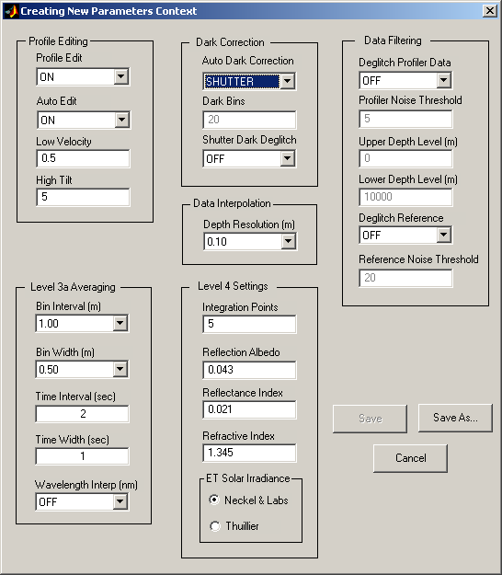

Process file to level 2s. Once processed go to main gui/ASCII/General Data Products to extract processed file to ASCII format.

