FSF ProSoft Quick Start Guide (v. 1.1 beta)

This document is a minimal description of how to set up the Satlantic ProSoft software for processing raw HyperOCR data files to level 2s, specifically for the NERC Field Spectroscopy Facility (FSF) aquatic profiling instrumentation. This document accompanies another document, the “FSF WLTool Quick Start Guide”, which describes the full process for extracting time-merged data files from the logger archive files, for all the sensors on the profiling frame. This document assumes a Microsoft Windows computer which has not previously had ProSoft installed on it. The steps in Part 1 describe installing ProSoft and setting up the calibration files for the underwater radiance (Lu) and irradiance (Ed) sensors, and for the above-water air irradiance (Es) sensor. This procedure only needs to be done once as the settings are recalled each time ProSoft is run.

PART 1 : SETTING UP PROSOFT
1. Install ProSoft.
These instructions are based on the files listed below that are available (or their equivalents) from the FSF. ProSoft is version 7.7.15 and there are two calibration file packages - the “.sip” files. These are just ZIP files and can be renamed to “.zip” to see their contents. The larger file numbered “0307” contains four calibration files for the light and dark reference of the underwater Ed and Lu sensors respectively. The smaller “0309” file contains the light and dark calibrations for the above-water irradiance sensor. For Prosoft they probably need to have the “.sip” extension, so don’t leave them renamed as “.zip”.
Install Prosoft by clicking on the “xxxx_Setup.exe” file. Click OK to every question.

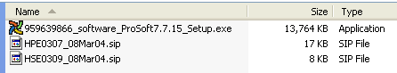

2. Run ProSoft from the Start menu. A message box will come up saying that you need to define the instruments (or words to that effect). Click OK, possibly twice, until you get to the application window.

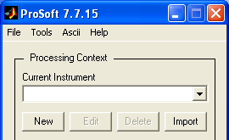 | 3. Click the New button under “Current Instrument”. Then navigate to the directory that holds the “.sip” files. Click OK.  Select the file starting “HPE0307” click Add. Select the other file, starting “HSE0309”, click Add. Then click OK.  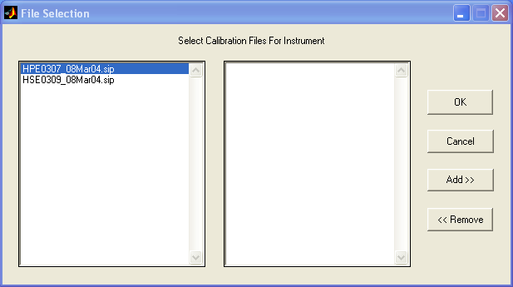
4. This window will appear. You need to tell ProSoft about each of the calibration files. On the left you can see the six calibration files, four that that are inside the underwater sensors HPE0307 “.sip” and two from the air sensor HSE0309 “.sip” file Load the calibration files one by one, by clicking on them and then on the “>>” button below, so that they appear listed on the right under “Loaded Calibration Files”. Then click on each one there and set up as below (for details p.t.o.).

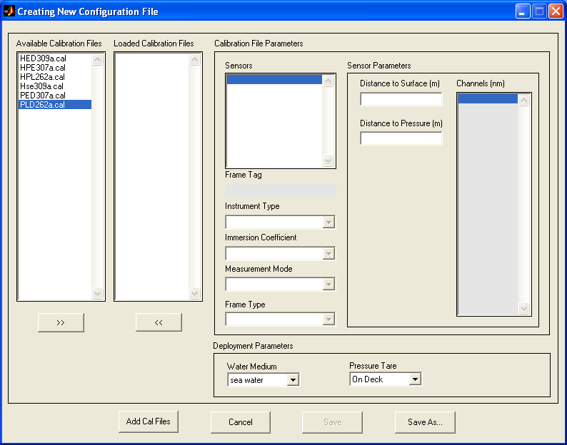
files
appear
here

HPE0307a.cal (Ed Light)  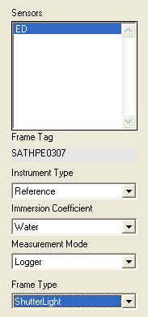 | HPL262a.cal (Lu Light)  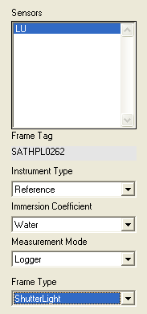 | PED307a.cal (Ed Dark)  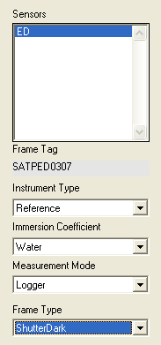 | PLD262a.cal (Lu Dark)  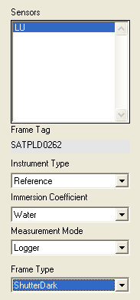
The first four are the underwater calibration files and need to be set as “Reference”, “Water”, “Logger”. The first two, beginning with “H”, are “ShutterLight” and the second two, with names of the form “PxD”, are “ShutterDark”. “Water Medium” and “Pressure Tare” can be set as desired (not sure what effect this has). “Distance to Surface” and “Distance to Pressure” will not have any effect in the context of processing the full FSF suite with WLTool because depth (pressure) is taken from the CTD. Any corrections for depth offsets for the instrument positions in the frame must be handled manually as a post-processing step.
The last two calibration files are for the air sensor and should be set as on the right – the main difference from the others being that “Immersion Coefficient” should be “Air”.  HED0309” is ShutterDark and “Hse0309” is ShutterLight. The naming of the calibration files is cryptic, but it seems a “D” in the name means “ShutterDark”.  Important Note: The information for the setting of the air sensors given here has been ascertained by trail and error, it is not based on any documentation from Satlantic (as the underwater sensors were). Perhaps “Measurement Mode” should be “Surface”, however it does not seem to make any difference to the output values. | HED0309a.cal (Es Dark)  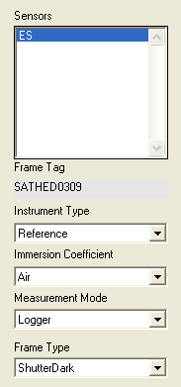 | Hse0309a.cal (Es Light)  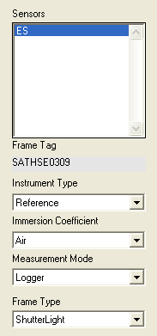

Then select Save As, and give suitable file name such as “fsf_inst_context”.

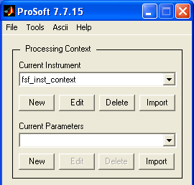 | 5. Now the parameters need to be set up. Click on the New button under “Current Parameters”. Only one thing needs to be changed on the window that opens – change “Auto Dark Correction” to “SHUTTER”.  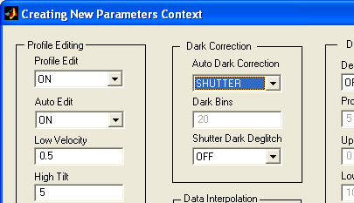

Then select Save As, and give suitable file name such as “fsf_params_context”.
ProSoft is now set up for processing the HyperOCR data. ProSoft will recall these settings every time it is run so the preceding steps will not need to be done again.

PART 2 : PROCESSING HYPEROCR DATA TO LEVEL 2s
1. Click on the button marked Level 1 → 2s. | 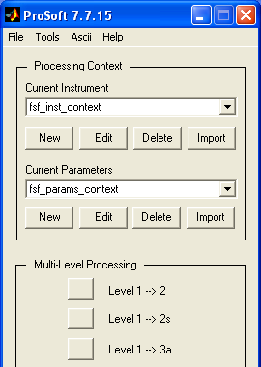

2. Navigate to the directory that contains the raw HyperOCR data file. This file must have the extension “.raw”. See the FSF WLTool Quick Start Guide for how to extract the raw HyperOCR data files from the logger archive files. The WLTool installation comes with a set of example files which includes a HyperOCR raw data file called “stithians008_chan4_HOCR.raw” for the underwater sensor, and an above-water sensor file called ‘stithians-air.raw”. The former file will be used in this example.  Find the directory that contains the file and click OK. | 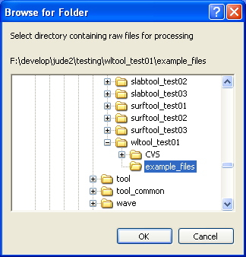

3. Select the “.raw” file on the left, click on the button Add >>, so that it appears on the right. Then click on the OK button.
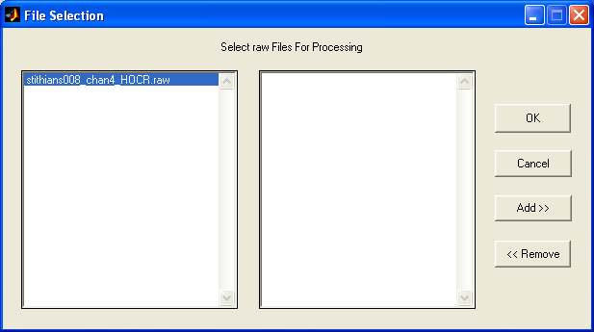

4. ProSoft will start to process the file. A progress bar will appear and you can also observe the progress in the terminal window that ProSoft has opened. When completed the terminal window should look as below. In particular the processing must successfully complete to Level 2s. Any errors here are likely due to the configuration of ProSoft, so review Part 1 of this document and ensure the settings are as described.

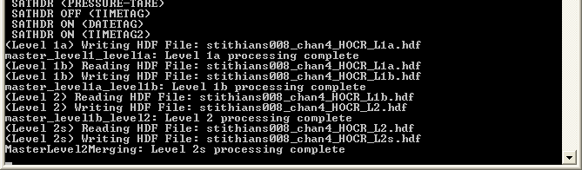
5. The processing has created a level 2s processed file called “stithians008_chan4_HOCR_L2s.hdf” (in this example) and placed it in the same directory as the source file. To be generally useful, and to merge the data with the other aquatic sensors using the WLTool software, this data file must be processed into a text (ASCII) file.

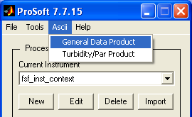 | Select Ascii > General Data Product from the ProSoft menu.  Then navigate to the directory containing the “.hdf” file. This will be the same directory as contained the “.raw” file and should already be selected. Click OK.

6. File selection works as before. Select the file with “L2s” in its name and click Add >>, and then OK. | 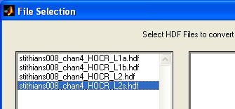

7. ProSoft will now appear to have crashed. A progress bar will appear but probably it will stay on zero, and nothing will happen for what seems a long time. Do not worry, this is normal. Eventually ProSoft will complete the conversion, as can be seen from an additional line that appears in the terminal window.

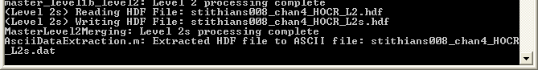
The file that has been produced has a “.dat” extension. It is a text file that can easily be imported to any spreadsheet software, such as Microsoft Excel. It is also the file that must be read back into WLTool for merging with the other aquatic sensor data. The file is located in a directory that ProSoft has created called “Ascii Files” in the original data source directory (“example_files” in this example).

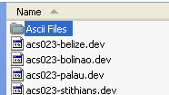 | 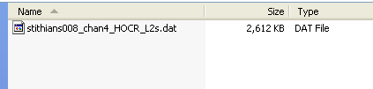

8. To process above-water air sensor files, such as “stithians-air.raw”, exactly the same process should be followed from Step 1 to obtain the ASCII file “stithians_air.dat”. This file can then be read into WLTool to provide synchronous air irradiance data. If Prosoft is set up with calibration files from both sensors as described in Part 1 it can process both the air and underwater files automatically using the correct calibration files in each case.

When using the full FSF aquatic profiling suite and WLTool for data merging, for best results the air sensor should be logging concurrently with the aquatic profiler. I.e. start the air irradiance sensor logging before profiling and stop it afterwards. Also very importantly ensure the DH4 and Satlantic sensors are logging comparable synchronised time stamp data. This will be immediately apparent when using WLTool (see the “FSF WLTool Quick Start Guide”) and is for example not what was done with the example Stithians data files, where the aquatic profiler was time stamping at around 02:00 hours, and the air sensor at around 11:00 hours. However if this type of error occurs the data is still usable, and can be manually adjusted providing the offset between the sensor time stamps can be deduced.

