FSF WLTool Quick Start Guide (v. 1.0 beta)

This document is a minimal description of how to process archive files downloaded from the NERC Field Spectroscopy Facility (FSF) aquatic profiling rig into a single time-merged file containing simultaneous data from all instruments. This document assumes the FSF standard configuration of WETLabs ACS, Seabird CTD, ECOBB3 and Satlantic HyperOCR irradiance and radiance sensors. For more details and other options see the full WLTool manual.
Processing requires first extracting the Satlantic data alone so that it can be passed through Satlantic software, ProSoft, then reloaded into WLTool for final merging of all sensor data. The final output is a tab-delimited text file that contains fully corrected Satlantic data, and data from the other instruments corrected to the same level as a from a basic application of WETLabs WAP software. Hence further processing of the ACS and ECOBB3 data will most likely be required.
The basic processing steps for using WLTool are:
1. Set up or check the sensor configuration.
2. Load the archive file.
3. Save the raw data file for the Satlantic HyperOCR sensors.
4. Separately, process the Satlantic data file to level 2s using the Satlantic software Prosoft.
5. Load the level 2s processed Satlantic data back into WLTool.
6. Save complete merged data file for all sensors.
The below description uses the file “archive-stithians.008”, which is supplied in the “example_files” directory of the WLTool executable distribution. It is recommended to follow the example with the supplied file in order to understand how processing works.

1 Run WLTool by double clicking on the icon. The program will open looking something like this.
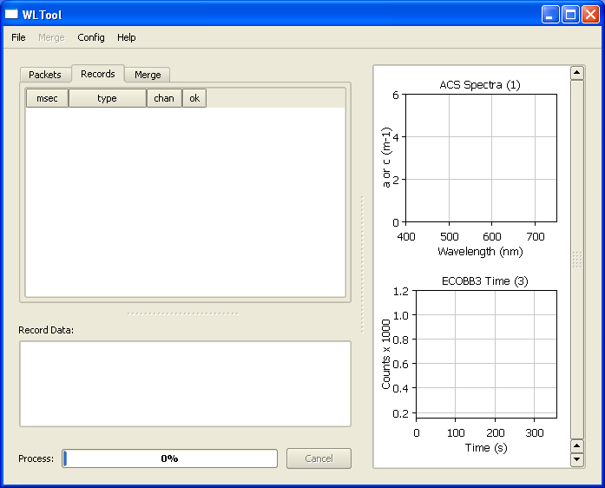

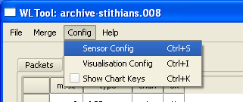 | 2. First confirm that the sensor configuration is the set to “FSF Standard” and that correct ACS device file has been specified. The correct ACS device file is the one that corresponds to the ACS calibration at the time the archive file was collected. Select Config → Sensor Config.

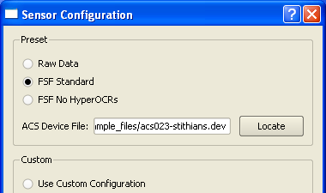 | 3. The ACS device file is the only device file that must be specified. Click on Locate and select the file. To follow the example, the file required is “acs023-stithians.dev” and is found in the “example_files” directory.  WLTool remembers these settings between separate runs, so there is no need to set them each time. However, be sure to verify the correct ACS device file is specified, otherwise the data may be processed incorrectly with no warning message.

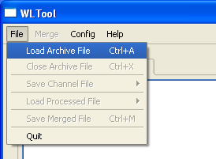 | 4. Load the archive file by selecting File → Load Archive File. Then locate the file in dialogue box that appears.  Select “archive-stithians.008”, click Open.  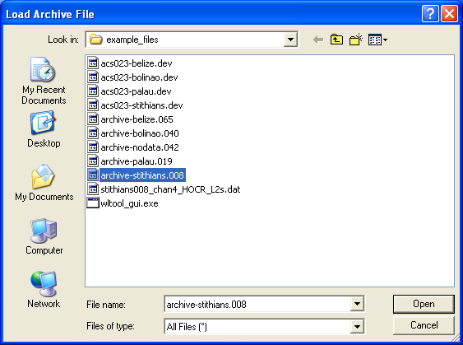

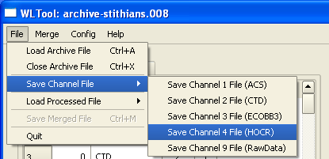 | 5. Save the raw Satlantic HyperOCR (HOCR) data file. Select File → Save Channel File → Save Channel 4 File (HOCR).  A file name will be suggested in the dialogue box that opens. It can be changed but ProSoft requires the “.raw” extension.

6. Process the raw HOCR data file to level 2s using the Satlantic software ProSoft. You can do this while WLTool is open. Or, WLTool can be closed, in which case simply reload the archive file when WLTool is re-run (Step 4 above).
Using ProSoft to process the raw HOCR data to level 2s is described in a separate document “FSF ProSoft Quickstart Guide”. The file “stithians008_chan4_HOCR_L2s.dat”, which can be found in the “example_files” directory, is the resulting output. So this file can be used to continue following the WLTool usage example presented here.

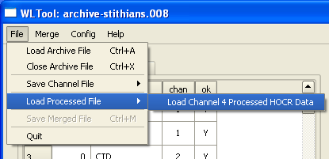 | 7. Load the level 2s processed HOCR data into WLTool by selecting File → Load Processed File → Load Channel 4 Processed HOCR Data. To follow the example here select the file “stithians008_chan4_HOCR_L2s.dat”.  * If you closed WLTool to run ProSoft you have to reload the archive file first (Step 4).

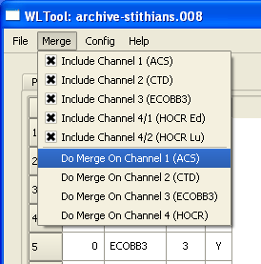 | 8. Do the merge by selecting Merge → Do Merge On Channel 1 (ACS). This will generate a table of data where each row contains approximately simultaneous data from all the sensors. The table is produced instantly and can be viewed under the Merge tab. The ACS is the sensor with the fastest data rate so it is most appropriate to merge against this sensor as a time reference. Time averaging of the data is recommended as a post-processing step. The check boxes can be used to include or exclude data from specific sensors. This can be useful, since many spreadsheet programs cannot open a file with as many columns as a full merge will produce. You can repeatedly merge different sensors against the ACS and each time save the output (see below) resulting a set of files each with the same number of rows, each row being one time point.

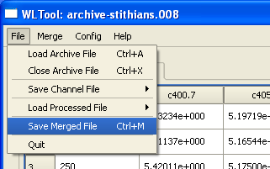 | 9. Save the merged output by selecting File → Save Merged File. You can preview the merged output under the Merge tab in the main window. Things to look out for are a column called “UNPROCESSED_ACS” which means you forgot to specify the ACS device file, or “UNPROCESSED_HOCR” which means you forgot to load in the level 2s processed HOCR data. In either case you can save the merged output anyway, but you won’t have any data from those sensors.

