FSF WLTool Quick Start Guide (v. 1.1 beta)

This document is a minimal description of how to process archive files downloaded from the NERC Field Spectroscopy Facility (FSF) aquatic profiling rig into a single time-merged file containing simultaneous data from all instruments. This document assumes the FSF standard configuration of WETLabs ACS, Seabird CTD, ECOBB3 and Satlantic HyperOCR irradiance and radiance sensors. In addition concurrent data from the FSF’s Satlantic above-water air irradiance sensor can also be integrated into the output time-merged data file.
Processing requires first extracting the Satlantic underwater sensor data from the archive file so that it can be passed through Satlantic software, ProSoft, then reloaded into WLTool for final merging of all sensor data. The final output is a tab-delimited text file that contains fully corrected Satlantic data, and data from the other instruments corrected to the same level as a from a basic application of WETLabs WAP software. Hence further processing of the ACS and ECOBB3 data will most likely be required.
The basic processing steps for using WLTool are:
1. Set up or check the sensor configuration.
2. Load the archive file.
3. Save the raw data file for the Satlantic HyperOCR sensors.
4. Separately, process the Satlantic data file to level 2s using the Satlantic software Prosoft.
5. Load the level 2s processed Satlantic underwater sensor data back into WLTool.
6. Optionally, load the level 2s processed Satlantic air irradiance sensor data into WLTool.
7. Save complete merged data file for all sensors.
The below description uses the files “archive-stithians.008” and “stithians-air.raw”, which are supplied in the “example_files” directory of the WLTool executable distribution. It is recommended to follow the example with the supplied files in order to understand how processing works.

1 Run WLTool by double clicking on the icon. The program will open looking something like this.
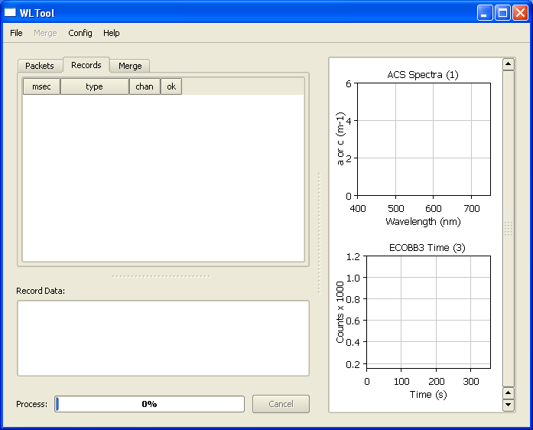

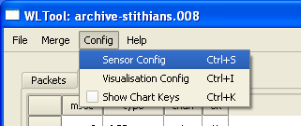 | 2. First confirm that the sensor configuration is the set to “FSF Standard” and that correct ACS device file has been specified. The correct ACS device file is the one that corresponds to the ACS calibration at the time the archive file was collected. Select Config → Sensor Config.

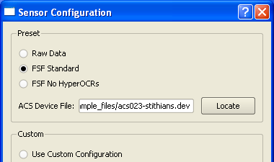 | 3. The ACS device file is the only device file that must be specified. Click on Locate and select the file. To follow the example, the file required is “acs023-stithians.dev” and is found in the “example_files” directory.  WLTool remembers these settings between separate runs, so there is no need to set them each time. However, be sure to verify the correct ACS device file is specified, otherwise the data may be processed incorrectly with no warning message.

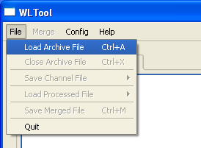 | 4. Load the archive file by selecting File → Load Archive File. Then locate the file in dialogue box that appears.  Select “archive-stithians.008”, click Open.  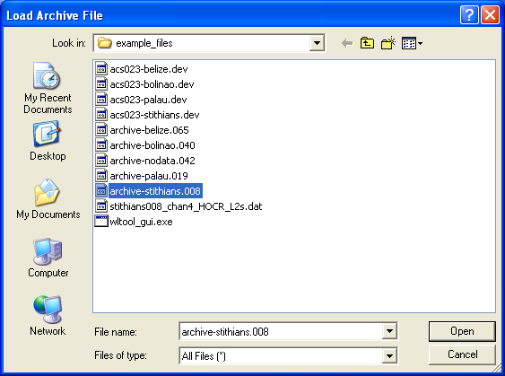

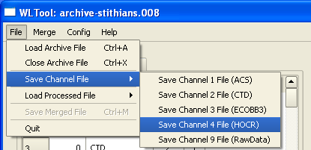 | 5. Save the raw Satlantic HyperOCR (HOCR) data file. Select File → Save Channel File → Save Channel 4 File (HOCR).  A file name will be suggested in the dialogue box that opens. It can be changed but ProSoft requires the “.raw” extension.

6. Process the raw HOCR data file to level 2s using the Satlantic software ProSoft. You can do this while WLTool is open. Or, WLTool can be closed, in which case simply reload the archive file when WLTool is re-run (Step 4 above).
Using ProSoft to process the raw HOCR data to level 2s is described in a separate document “FSF ProSoft Quickstart Guide”. The file “stithians008_chan4_HOCR_L2s.dat”, which can be found in the “example_files” directory, is the resulting output. So this file can be used to continue following the WLTool usage example presented here.

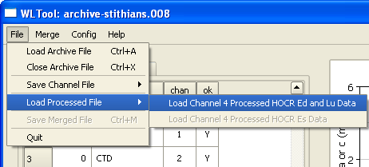 | 7. Load the level 2s processed HOCR underwater data into WLTool by selecting File → Load Processed File → Load Channel 4 Processed HOCR Ed And Lu Data. To follow the example here select “stithians008_chan4_HOCR_L2s.dat”.  * If you closed WLTool to run ProSoft you have to reload the archive file first (Step 4).

8. If concurrent data has been taken with the Satlantic HOCR air irradiance sensor then the level 2s processed data from that sensor can now be loaded. Select File → Load Processed File → Load Channel 4 Processed HOCR Es Data. To follow the example here select “stithians-air_L2s.dat”.
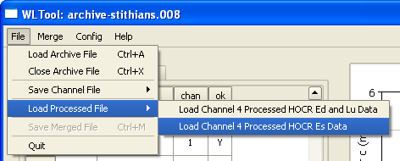
It is useful to know how the air irradiance data is processed. It must be loaded after the underwater HOCR data because the Prosoft generated time points of the underwater data records are used to locate the synchronous air irradiance data points. These are the time stamps in the form “HH:MM:SS” that appear in the “Timetag2” column of the “.dat” ASCII text files produced by Prosoft. For each of the underwater records the closest timed air data point is found, so clearly the accuracy here is at best one second, probably less in practice. Also this requires that the time sources for the underwater sensors and the air irradiance sensor are exactly synchronised. That probably means clocks in the DH4 and the laptop or data logger that the air irradiance HOCR is connected to (this document is being written without access to the hardware). The supplied example files “stithians008_chan4_HOCR_L2s.dat” and “stithians-air.dat” are a good example of a failure in this respect. The air data was taken slightly after the underwater data, but regardless the time sources were completely unsynchronized, the DH4 most likely being on American time, the air irradiance sensor has the correct UK times. For disjoint timings WLTool will still find the closest time point in the air irradiance data, but this will either always be the first or last record in the air data. To fix this kind of problem the “.dat” file can be manually edited in the Timetag2 column, with the desired times being put in the format “HH:MM:SS” in 24-hour clock, and without any AM or PM as Microsoft Excel seems to add.
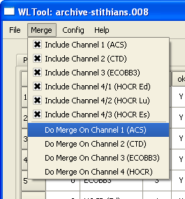 | 8. Do the merge by selecting Merge → Do Merge On Channel 1 (ACS). This will generate a table of data where each row contains approximately simultaneous data from all the sensors. The table is produced instantly and can be viewed under the Merge tab. The ACS is the sensor with the fastest data rate so it is most appropriate to merge against this sensor as a time reference. Time averaging of the data is recommended as a post-processing step. The check boxes can be used to include or exclude data from specific sensors. This can be useful, since many spreadsheet programs cannot open a file with as many columns as a full merge will produce. You can repeatedly merge different sensors against the ACS and each time save the output (see below) resulting a set of files each with the same number of rows, each row being one time point.

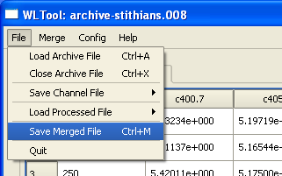 | 9. Save the merged output by selecting File → Save Merged File. You can preview the merged output under the Merge tab in the main window. Things to look out for are a column called “UNPROCESSED_ACS” which means you forgot to specify the ACS device file, or “UNPROCESSED_HOCR” which means you forgot to load in the level 2s processed HOCR data. In either case you can save the merged output anyway, but you won’t have any data from those sensors.

Notes on the output file
In the merged data file the last column for each sensor is called “msec_offset” and is the time point of the data record for that sensor with the merge reference record time point subtracted. These msec time stamps are set in the records by the WETLabs DH4 data logger. So for example, when merging against the ACS, all the msec offsets for the ACS will be zero, because that is the reference. A msec offset of 250 for the CTD means the data point for the CTD was time stamped as 250 msec later than the corresponding ACS data record. When merging, the closest timed record to the reference either forward or backward in time is taken, so the msec offsets can also be negative.
All three HOCR data types are treated as a single sensor record by WLTool. In fact, as can be seen under the “Record” tab, data from the underwater irradiance and radiance sensors comes in at different rates. However the level 2s processing in Prosoft does its own kind of time merging and the result is an irradiance (Ed) and radiance (Lu) data point for each DH4 record. The msec offsets reported for the HOCR data are therefore not especially meaningful.
Each of the three HOCR Ed, Lu and Es data column sets in the merged data file are preceded by the Prosoft generated “Timetag2” time stamp for that component. This can be used to check that the air-irradiance data was correctly time synchronised with the underwater HOCR data.

