

**Epidemics and Vaccination**

**MATH 112 Project Report**

**Dr. Mohamed Ibrahim Wafa**

**By**

**Reem Tarek Shaban**

**Maram Jamal Alfarmawy**

**Maha Abd Elwareth**

**Hanya Mostafa Mahmoud**

**Date**

# ABSTRACT

# With the constant outburst of new infectious diseases, a strong need for designing a credible mathematical model emerged in hope of creating a method that aids in generating an insightful look into the dynamics of a disease spread within a given populace, along with analyzing the best approach methods to be followed to restrain the disease’s course of action. With such heavy decisions falling on the shoulders of such models, creating a strong reliable model is crucial. Thus in this paper, we introduce one of the most commonly used epidemic models, which is the basic SIR model along with some of its variations and their uses, which is a great dependable method of realistically illustrating the changing behaviors of a population during the period of an epidemic. In addition to this, we implement some of the SIR model assumptions by referencing real disease outbreak data, in order to review the role of these models in characterizing the growth patterns of some real-life epidemics such as yellow fever and plague. Lastly, we test some simulation data to study how changing the values of certain parameters and introducing new ones such as vaccination can completely change the fate of disease outbreak eventually concurring it. . TABLE OF CONTENTS

Chapter Page

ABSTRACT 2

TABLE OF CONTENTS 3

LIST OF TABLES 4

LIST OF FIGURES 5

Section I: Introduction 6

SECTION II: Background and Literature Review 7

2.1.History of modelling infectious diseases 7

SECTION III: METHODOLOGY 9

3.1.The SIR model 9

1.The maximum value of infected 11

2. The Reproduction number (Ratio) 12

3.2.The SIRS model with temporary immunity 13

1.The SIRS Model steady states 13

2.Phase diagrams of SIRS 14

3.3.Modelling changing populations 15

3.4.The SEIR Model with a Latency period 17

3.5.Vaccination 17

1.Herd Immunity 18

3.6.Modelling Yellow Fever 18

1.Yellow fever Background 18

2. Epidemiology 19

3. Vaccination 20

4.Applying SIR model on yellow fever 20

3.7.Modelling plague 21

SECTION IV: RESULTS 24

4.1. Results of the SIR model 24

4.2. The effects of different infectious rates on the population 26

4.3. Yellow fever simulation 28

SECTION V: CONCLUSION 29

REFERENCES 30

Appendix A 32

# LIST OF TABLES

Table Page

Table 1: Summary of parameters 21

Table 2: The number of each compartment when infectious rate is 0.65 26

Table 3: The number of each compartment when infectious rate is 0.85 26

# LIST OF FIGURES

Figure Page

Fig.1. The compartments of the SIR model 7

Fig.2. A graph to show the relation between time and the SIR compartments 9

Fig.3. Left: model the infected group during a non-epidemic disease. Right: shows the fluctuation in the infected class during an epidemic. 10

Fig.4. The trajectories for an epidemic 11

Fig.5. Compartmental diagram of the SIRS model 13

Fig.6. Endemic equilibrium 15

Fig.7. Disease free equilibrium 15

Fig.8. Compartmental diagram of the SIR model with demography 16

Fig.9. Compartmental diagram of the SEIR model with a latent period 17

Fig.10. Transmission Cycles of Yellow Fever Virus 19

Fig.11. A continuous function (line) to actual incidence of weekly reported new infections of yellow fever in Angola, 2016 19

Fig.12.Bombay plague data . 23

Fig.13. SIR model without vaccination, when β= 1.98 24

Fig.14. SIR model without vaccination, when β= 3.5 25

Fig.15. SIR model with vaccination 25

Fig.16. How the susceptible group is affected by different infectious rates 27

Fig.17.How the recovered group is affected by different infectious rates 27

Fig.18.How the infected group is affected by different infectious rates 27

Fig.19.Graph representing the simulation 28

# SECTION I: Introduction

# In 2014, the Ebola virus became an epidemic taking more than 11 thousand souls even though it existed 38 years earlier. Later on, the Malaria epidemic erupted taking another 445 thousand souls despite its existence since 1902. With the constant media coverage of diseases such as Ebola and Malaria viruses, we keep hearing about the threat of epidemics. In 1911, Ross proposed a model for the transmission of malaria. Later a couple of fundamental works set up the premise of mathematical disease transmission. Among them, Kermack and McKendrick made the main progressively broad and thorough examination.

# The study of disease occurrence is called epidemiology. An epidemic is a drastic increase in the number of infected people with a certain disease in the same community in a short time span, even if it existed many years ago before its outbreak. A more lethal stage of an epidemic is the pandemic, which refers to a disease that has widespread to other countries or continents infecting a larger amount of people. One of the most striking features in the study of epidemics is the trouble of finding a causal factor, which gives off an impression of being sufficient to explain the frequent epidemics of disease that affect almost every populace. The epidemics problem can be summarized as follows: an infected person (or more) enters a society of individuals that are more or less susceptible to disease. The disease is transmitted by contact from affected to unaffected persons.

# The conditions which govern the causes of an outbreak of an epidemic include infected food supplies and contaminated water. Thus, some infectious diseases can be passed from person to person. Some are transmitted by bites from insects or animals. Take malaria for example and how it spread through Mosquitoes. Each disease spreads in its own way as transmission methods vary according to each disease. Some diseases are transmitted through the air; others are spread through insect bites and much more which will be discussed later on during this study.

# While there are many epidemics, only about 121 epidemics were reported to have erupted. However, in this paper, we will be using the SIR model for the mathematical modeling of diseases. We will examine the mathematics behind the model and different tools for making a decision about the viability of arrangements and control methods. We will examine our model using the infectious diseases the Yellow Fever and the Plague.

# 

# SECTION II: Background and Literature Review

## 2.1. History of modelling infectious diseases

Epidemiological models have been used to examine biological and epidemiological phenomena. The purpose of the modeling of infectious diseases is to uncover the roots of a given disease, identifying its origin and studying the characteristics of its spread in order to predict its outbreak course, and develop different strategies of controlling it. In his book “Natural and Political Observations made upon the Bills of Mortality”, John Graunt was the first scientist to study infectious disease data using the Bills of Mortality which were weekly records of numbers and causes of death in London. Graunt, then, analyzed the various causes of death and developed a method of estimation of the risks of death from different diseases, which was then considered to be the birth of the “theory of competing risks”. The first mathematical model of epidemics, however, was done by physician Daniel Bernoulli in 1766 on inoculation against Smallpox. During that time smallpox had widely spread across several parts of the world and was regarded as an endemic; therefore, Bernoulli designed this model to study the effects of using variolation, which is a method used before vaccination, used to immunize an individual against smallpox by taking material from smallpox sores and putting them into healthy people, as a way of immunization against the disease. According to his calculations, it was revealed that by receiving this immunity and eliminating Smallpox as a cause of death, life expectancy has increased by almost three years. Many years later in the 19th century, the basic compartmental model first made an appearance. This type of model divided the population into different classes each having similar characteristics, which made it much easier to make predictions about the course of the disease outbreak, detect its duration and see how the epidemic outcome can be affected by changing certain variables. And this was the basis for the Kermack-McKendrick epidemic model created in 1927, which divided the population into three compartments: S, which stands for the number of susceptible, I which stands for the number of infectious and R which stands for the number recovered. This is known as the SIR model, which we are going to study more in this paper. [1]

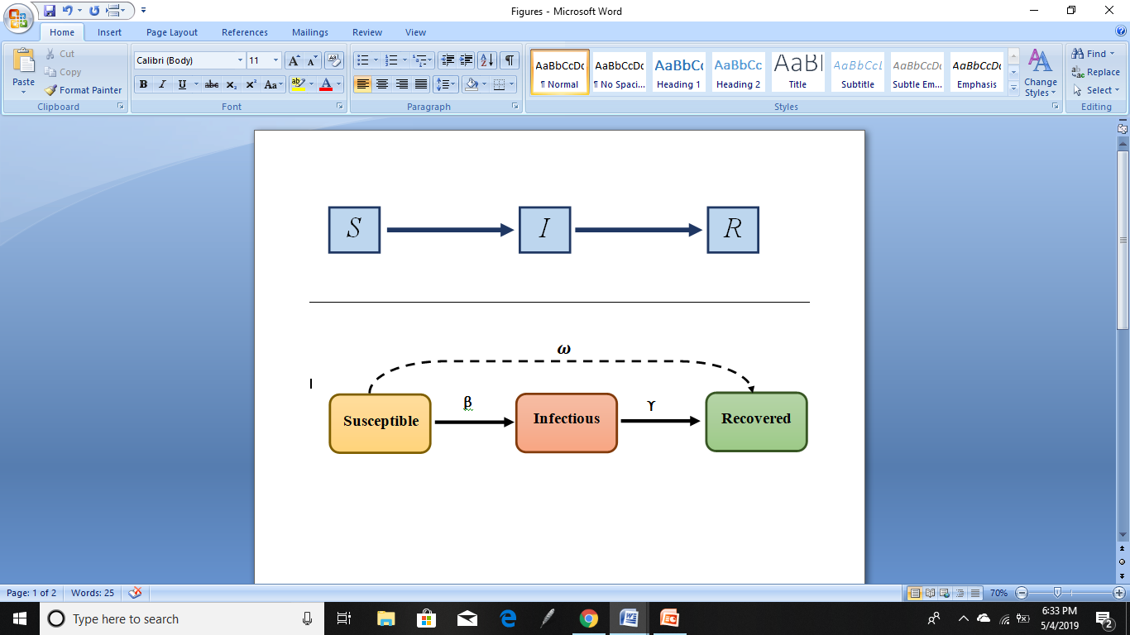

Fig.1. The compartments of the SIR model.

In this model:

S(t) $⇒$ is the number of susceptible individuals at time t (Still prone to catching the disease).

I(t) $⇒$ is the number of infected individuals at time t (Caught the disease and can infect others).

R(t) $⇒$ is the number of recovered individuals at time t (Recovered and immune from the disease).

This model, however, is based on several assumptions. One assumption is that the population is constant since the numbers of birth and immigration are ignored and not taken into consideration. Moreover, the only way out of the susceptible group is for the person to become infected, which applies to the infectious group as well. Furthermore, factors such as age, gender and ethnicity do not have a hand in changing the probability of becoming infected with the disease. In addition to this, once a person is recovered, he receives immunity and is not subject to catching the disease again. Finally, the interaction between members of the community is similar.[3][5]

Thus, further modifications such as adding additional compartments including the latent period of the disease, temporary immunity, and others have been incorporated in the model in order to achieve more realistic results. Now thanks to the model and its variations, we are able to derive the Reproduction number which represents the number of people infected on average by an infected individual, which allows us to determine if the disease is going to turn into an epidemic or not.

2.2.The SIR model:

The SIR model is a method used to calculate the hypothetical number of individuals who caught an infectious disease over the course of its outbreak. The model is designed to suit epidemics that make a sudden appearance infecting a significant amount of people before vanishing after a short time span. Since in the previous section we discussed how the population is divided into three compartments, we now need a system of differential equations that compute the changes witnessed by these compartments over time. Hence, the model is now defined as [10]

$\frac{dS}{dt}= -βsI$ (1)

$\frac{dI}{dt}= βsI- νI$ (2)

$\frac{dR}{dt}= νI$ (3)

With initial conditions S(0) > 0, I(0) ≥ 0 and R(0) ≥ 0. Where β is the average number of transmissions from an infected person in a time period and is dependent on the contact between the susceptible and infected group and ν is the recovery rate. And from the stated equations, we deduce that the number of susceptibles decreases as time goes on since dS/dt is negative, while the number of infectious fluctuates as it first increases by the susceptibles who get infected but then decreases by those who are now recovered from the infection and therefore, the number of recovered is always on the rise. This can be seen more clearly in figure 2.

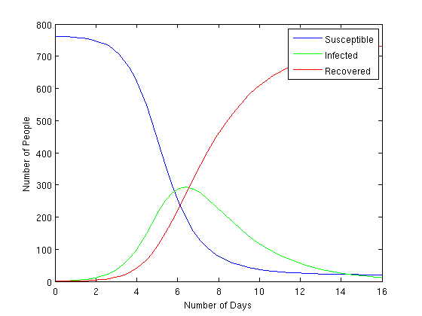

Fig. 2. A graph to show the relation between time and the SIR compartments.

And due to the model’s division of the population into three compartments, we can derive that the formula for the total population is given by

$N=S+I+R$ (4)

However, during the addition of the three derivatives of S, I and R an observation can be made that

$N’=S’+I’+R’ =-βsI+βsI-νI+νI =0$ (5)

Which concludes that the population is constant throughout the course of the epidemic. However, this can be justified by our earlier assumption that the epidemics occur over a short period of time, meaning that new births and deaths are non-significant and can be easily neglected.

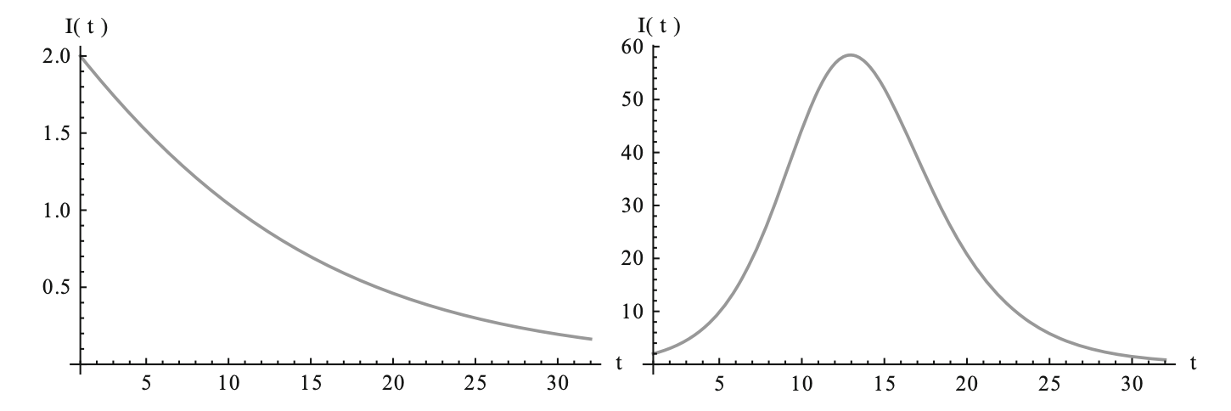

Fig. 3. Left: model the infected group during a non-epidemic disease. Right: shows the fluctuation in the infected class during an epidemic.

Unlike the susceptible and recovered group, predicting the behavior of the infected group has more complications, as it can follow two completely different routes as seen in figure 3. The first route represents an infectious disease that was wiped out without being an epidemiological threat since the people being infected witness a monotone decrease until reaching zero. While the second scenario shows that the number of individuals increasing to a maximum value before diminishing to zero [4]. And this last case is an illustration of the course of an outbreak of an epidemic. Hence, we can deduce that in order for an epidemic to occur, the value of $\frac{dI}{dt}$ must first exceed zero as follows.

$$βsI-νI>0$$

$$βsI>νI$$

$$βs>ν$$

### $s>\frac{ν}{β}$ (6)

### Thus we reach that s>ν/β is a threshold condition for an occurrence of an epidemic. This threshold value can be visualized by applying a phase-plane analysis to equations of S and I [6].We start by setting them both to zero as follows

### $S’ = -βSI = 0$ (7)

### $I’ = (βS - ν)I = 0$ (8)

### Reaching that the S-nullclines are

### $S = 0$ (9)

### $I = 0$ (10)

### and the I-nullclines are

### $S = ν/β$ (11)

### $I = 0$ (12)

### Now on the S-I phase plane, a triangle with vertices (0, 0), (N, 0) and (0, N) can be formed using the previous nullclines. And since we derived that R(0)=0, therefore the trajectory always starts from the line $S+I=N$. The figure below shows a typical trajectory of an epidemic.

### 

### 

### Fig.4. The trajectories for an epidemic.

### By viewing the shape of the curve, an observation can be made that a certain Threshold value exists at $S=\frac{ν}{β}$, which is the curve’s maximum value. Therefore, the number of individuals who are contagious will keep on going up until the susceptible group is minimized to $\frac{v}{β}$ and will reduce to 0. Thus, a conclusion can be made that when $S<\frac{v}{β}$, the susceptible and infected groups will both diminish converging to a point on the S-axis and thus the disease dies out with no outbreak. On the other hand, for an outbreak to occur, S should satisfy the following relation: $>\frac{v}{β}$, where the infected class showcases an exponential growth before hitting its maximum value at $S=\frac{v}{β}$. From these statements, we sum up that there is, in fact, a threshold value at $\frac{ν }{β}$ that must be satisfied for an epidemic to occur.[6][7]

### 2.2.1.The maximum value of infected:

### One important value that should be calculated to assess that fatality of an infectious disease is the maximum number of people that are going to fall victim to the pathogens before the disease dies out [7]. This could be achieved by dividing the derivatives of I and S as follows

### $\frac{dI}{dS}= (\frac{ν}{βS} - 1)$ (13)

### And then using integration to get

### $I=\int{(\frac{ν}{βS} - 1) }dS$ (14)

### $I=\frac{v}{β}\log\left(S\right)-S+C, where C≈N-\frac{v}{β}log⁡(N)$ (15)

### Hence,

### ${ I}_{max} = N(1 - \frac{1 + log R_{0}}{R_{0}})$ (16)

### Where, $R_{o}$ is the reproduction number.

### And by determining this number, we can now evaluate the seriousness of spreading disease, along with estimating the time when the epidemic reaches its climax, which helps us discover the duration of the outbreak.

### 2.2.2. The Reproduction number (Ratio) :

### The best aspect of using the SIR model is that we can calculate the basic reproduction number, which is denoted by $R_{o}$. This number represents an estimate of the number of people an infectious person can pass the disease to over his course of infection, and thus is used as a method of measuring how infectious a new disease is. Using the value of this reproduction number, we can predict the course of action of the disease, determining whether the disease will prosper or be wiped out. In the basic SIR, $R_{o}$ is calculated by multiplying the disease’s infection period $\frac{1}{v}$ and the rate by which individuals catch the disease due to having contact with an infected person, represented by $β\left[8\right]$.

### Therefore,

$R_{o}=\frac{βN}{v}$ (17)

This formula, however, is modified a bit when calculating the reproduction number for the variations of the SIR model, where extra factors such as births/deaths and latency periods are taken into account. However, despite these little changes, the following statements apply for every variant. These statements conclude that when,

${ R}_{o}<1$ (18)

this means that each individual in the infected class infects less than one person on average, therefore, the disease will die out without turning into an epidemic. On the other hand, when

$R_{o}>1$ (19)

then in this case, the disease will grow exponentially and be classified as an epidemic, since now each person infects more than one person on average. However, when

${ R}_{o}=1$ (20)

then the disease spread remains constant and restricted within the original location of the disease outbreak, as each individual infects only one person. This phenomenon is also known as an endemic state, which we are going to discuss more later on in the paper. And in addition to determining the course of outbreak of a disease, the reproduction number can also help us determine the number of susceptibles left unaffected after the end of an epidemic. This can be given by the equation constructed by Kermack and McKendrick which states that when t→ ∞

${S }_{∞}=exp\left(\left(1-{S }_{∞}\right)R_{0}\right)$ (21)

This value of s(∞) can help us determine the number of the recovered at infinity as well, using the formula :

$r(∞) = N -s(∞)$ (22)

### 2.3. The SIRS model with temporary immunity:

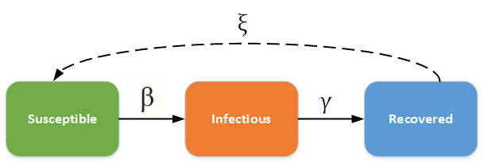When wanting to model diseases where the recovered individuals are not granted a permanent immunity like what was assumed before, but a temporary one, meaning that they are prone to catching the disease again, some slight modifications have to be added to the basic SIR model to suit these new requirements. This modified version is called the SIRS model, with the additional S at the end representing the susceptibility of becoming infected again after recovering. The propagation cycle of the disease can be seen in the diagram below.

### Fig.5. Compartmental diagram of the SIRS model

### In order to represent this modification through the equations, an extra parameter α representing the rate of losing immunity is added. Thus, the model is now defined by:

### $\frac{dS }{dt}=-βsI+αR$ (23)

### $\frac{dI}{dt}$ = $βsI-νI$ (24)

### $\frac{dR}{dt}$ = $υI$- $αR$ (25)

2.3.1.The SIRS Model steady states:

When the variables defining the behavior of the SIR model are unchanging in time, this means that the system is in a steady or equilibrium state. This can be achieved in two scenarios that both occur when the differential equations are set to zero. The first steady state is the disease-free equilibrium, which occurs when

$S=N, I=0, R=0$ (26)

While the second state is the endemic equilibrium, and this where the disease persists in a population, with the disease spread being constant as the reproduction number equals one. Now, in order to calculate the threshold value at which this equilibrium state occurs, we should first Suppose that I≠0, then R. Using that we can derive the following:

$\frac{dR}{dt}$ = $υI$- $αR$ =0 (27)

$⇒$ R= $\frac{νI}{α} ≠0$ (28)

Similarly,

$\frac{dI}{dt}$ = $βsI-νI$ = $(βS-ν)I$ =0 (29)

$⇒(βS-ν)$ =0 (30)

$⇒$ S= $\frac{ν}{β}$ (31)

And since, S+I+R=N, therefore

N= $\frac{ν}{β}$ +I+ $\frac{νI}{α}$ (32)

$⇒$ I= $\frac{N-\frac{ν}{β}}{1+\frac{ν}{α}}$ (33)

And since the endemic equilibrium does not exist for negative values, then a condition that S,I and R are greater than zero must apply for this to be considered a steady state. Thus,

$\frac{N-\frac{ν}{β}}{1+\frac{ν}{α}}$ >0

$N-\frac{ν}{β}$ >0

$N$ > $\frac{ν}{β}$ (34)

We can conclude that $\frac{ν}{β}$ is threshold value, which the population must exceed for the disease to be an epidemic, which is the same condition that must be satisfied in the SIR for an epidemic to occur as well.

2.3.2. Phase diagrams of SIRS:

In order to have a graphical representation of the state of the SIR model under different conditions, we first start out by rewriting the recovered term R, in terms of I and S as follows: R=N-S-I so that it can be eliminated completely from the equation. In this way, we end up with a two-dimensional system. Using that we can describe the possible states of outbreak using phase plane diagrams. Figure 6 represents the first state, where the reproduction number is less than one and thus the disease dies out. While figure 7, represents the model when $R_{0}$ >1 and thus an outbreak occurs. [11].

### 

### 

### Fig.6. Endemic equilibrium

### 

### Fig.7. Disease free equilibrium

### 2.4. Modelling changing populations:

### In the basic SIR model, the number of newborns, immigration and death are all ignored, since the model is built under the assumption that the epidemic lasts over a short duration. However, there are various cases where this hypothesis is not true, and the disease persists in the population over the course of several years such as HIV and hepatitis C. Thus, the basic model can no longer work as the population is no longer constant over this long period. Hence, the growth of the population must be incorporated in the model to include births and deaths. In this case, both are denoted by the parameter μ as they are both considered to acquire similar rates. Hence the model is now represented by:

$\frac{dS}{dt}$ = µ − βSI − µS (35)

$\frac{dI}{dt}$ = βSI − $ν$ I − µI (36)

$\frac{dR}{dt}$ = $ν$ I − µR. (37)

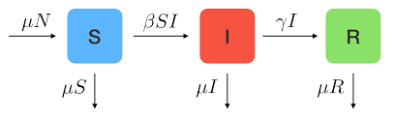

Fig.8. Compartmental diagram of the SIR model with demography

Since it is essential to study the behavior of the system at an equilibrium state, we will, therefore, explore the disease-free equilibrium and the endemic equilibrium which both satisfy the following assignments [8]:

$\frac{dS}{dt}$ =0

$\frac{dI}{dt}$ =0

$\frac{dR}{dt}$ =0

When the number of susceptibles remains almost unchanged due to the infectious component being zero, then this is considered the Disease Free equilibrium, as the disease almost instantly died out without spreading.

S=N, I=0, R=0 (38)

### However, when the infectious component is of a value greater than zero, the condition for disease-free equilibrium is no longer satisfied and we end up with the second steady state: Endemic Equilibrium which, happens when:

S = $\frac{ν+μ}{β}$ (39)

### In this case, when S< $\frac{ν+μ}{β}$, then there is no threat but when the value of $S_{0}$ exceeds $\frac{ν+μ}{β}$, which is the threshold value, then an epidemic is bound to occur as the number of the infected will increase until reaching its maximum value. And since, β is a representation of the disease transmission rate and from the above equations we can conclude that a susceptible spends an average time of $\frac{1}{ν+μ}$ before moving to the infected class, therefore, the reproduction number can be defined as

$R_{0}=\frac{β}{ν+μ}$ (40)

2.5. The SEIR Model with a Latency period

In the basic SIR model, it is assumed that an infected person is capable of infecting others right after catching the disease. However, this is not true for all diseases, since some have a latent period where the infected individuals still do not have the capability of transmitting the disease to others. Thus, a modified model was constructed to include an additional compartment that represents the Exposed individuals during that latency period, which is denoted by E.

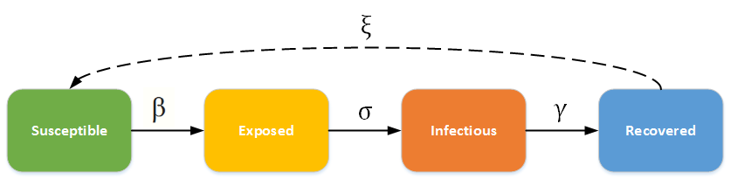

Fig.9. Compartmental diagram of the SEIR model with a latent period

And similar to the SIRS model, a new parameter was added to the differential equations to illustrate the rate of exposure and shifting into the infected class after becoming in contact with an infectious individual. The model equations are:

S’ = $μ$ − $μS$ − $βIS$ (41)

E’ = $βIS$ − $(μ+α)E$ (42)

I’ = $αE$- $(μ+ν)I$ (43)

R’ = $νI$ − $μR$ (44)

And by applying the phase-plane analysis to the equations of S and I as we did with some of the previous models , we come to a conclusion that there is a threshold value at the point

$\frac{(µ + ν)(µ + α)}{βα}$ (45)

### Therefore, the reproduction number can be computed as

$R_{0}=\frac{βα}{(μ+ν)(μ+α)}$ (46)

### So, now in order for an infectious disease to be classified as an epidemic , the following condition must apply

${ S}_{0}>\frac{(µ + ν)(µ + α)}{βα}⇔R_{0}>1$ (47)

2.6.Vaccination:

Since the number of people born immune to the disease is fairly low and can be ignored, therefore another method should be used in order to grant people this immunity and prevent the disease from spreading exponentially and infecting countless souls[11]. This method can be achieved by using vaccination, which helps in protecting susceptibles from the risk of falling into an infectious state. The equations for the model are now represented as follows.

v’ = $η$ (t) (48)

S’ = $(μ-η)N$ − $βIS$ − $μS$ (49)

I’= $βIS$ − $νI$ − $μI$ (50)

R’= $νI$ − $μR$ (51)

Similar to the SIRS model, vaccination has two possible scenarios for the equilibrium points. The disease-free equilibrium occurs at the initial time and assumes that there are no cases of infection yet ( or too little to be neglected). This is set at

$S=\left(1-\frac{η}{μ}\right)N=\left(1-p\right)N And I=0 (52)$

### Where p is the proportion of the population that is immune due to vaccination. While the second case scenario which is the endemic equilibrium is set at

### $S=\frac{ν+μ}{β}$ (53)

2.6.1. Herd Immunity:

Using the SIR model, certain calculations can help us determine the number of people required to be vaccinated in order to eradicate a certain disease. When enough people are immune, then the population has achieved herd immunity, which is a shield that protects against epidemics as it hinders disease spreading. Therefore, to eliminate the risk of an outbreak, enough individuals must get vaccinated. This threshold value of herd immunity representing the minimum number of individuals that need to be immunized for a disease to die out is given by the formula

$p=(1-\frac{1}{R_{o}})$ (54)

### Hence, if the mass vaccinations exceed this herd immunity value, we will successfully be able to eliminate the disease and prevent it from spreading just like what happened in 1980 when the World Health Organization (WHO) certified the global eradication of smallpox.

# SECTION V: CONCLUSION

The study of the outbreak of an infectious disease is a long-standing tradition which came to light at the beginning of the 19th century due to the absence of a proper method that predicts the evolution of a disease, determining its fatality and the duration for which it persists as a threat within a certain community. Thus, after a period filled with several trials and errors in hope for achieving the most suitable model for this representation, came to light the basic SIR model, which helped immensely in outlining the necessary courses of action for limiting the disease spread, such as knowing the percentage of the population in need for vaccination in order for the disease to die out. The SIR model studies the dynamics of an infection by calculating the number of people in a population who are susceptible, infected, or recovered at a given period of time. However, the model has various flaws as for instance it assumes that the population is fixed and that the recovered gain permanent immunity, therefore many modifications of the model such as SIRS and SEIR where created accounting for factors such as latency period, births and age, in order to accommodate the changing dynamics of the different diseases and the changing populations. And to dive deeper into the uses of the SIR model, we discussed real-life applications on two infectious diseases which are yellow fever and plague, along with different numerical examples to simulate how the different models behave in different scenarios. To sum up, even though the SIR models might seem simple at first glance, they are in fact a great help when a sudden crisis emerges as they are an essential tool that can quickly define the necessary steps to be taken to wisely respond to an emergency.

# REFERENCES

[1] Brauer, F. (2017). Mathematical epidemiology: Past, present, and future. [Online] Research Gate. Available at: https://www.researchgate.net/publication/313352700_Mathematical_epidemiology_Past_present_and_future

[2] Smith, D. and Moore, L. (2004). The SIR Model for Spread of Disease - The Differential Equation Model | Mathematical Association of America. [Online] Maa.org. Available at: https://www.maa.org/press/periodicals/loci/joma/the-sir-model-for-spread-of-disease-the-differential-equation-model

[3] Johnson, T. (2009). Mathematical Modeling of Diseases: Susceptible-Infected-Recovered (SIR) Model. [Online] Available at: http://op12no2.me/stuff/tjsir.pdf.

[4] Martcheva, M. (n.d.). An Introduction to Mathematical Epidemiology. Springer US.

[5] Chauhan, S., Misra, O. and Dhar, J. (2019). Stability Analysis of SIR Model with Vaccination. [Online] Article.sapub.org. Available at: http://article.sapub.org/10.5923.j.ajcam.20140401.03.html

s

[6] Zhang, L., Li, T. and Xue, Z. (2014). Mathematical Modeling of Influenza Viruses. [Online] web.wpi.edu. Available at: https://web.wpi.edu/Pubs/E-project/Available/E-project-031414-150750/unrestricted/all.pdf.

[7] Bastin, G. (2018). Lectures on Mathematical Modeling of Biological Systems. [Online] Perso.uclouvain.be. Available at: https://perso.uclouvain.be/georges.bastin/lectures-bio.pdf [Accessed 2019].

[8] Sofia, H. (2016). Application of SIR epidemiological model: new trends. [Online] Naun.org. Available at: http://www.naun.org/main/UPress/ami/2016/a262013-075.pdf.

[9] Moesta, M. (2017). A Mathematical Model for the Epidemiology of Yellow Fever. [Online] Cs.xu.edu. Available at: http://www.cs.xu.edu/~david.gerberry/Student/MoestaYellowFever.pdf.

[10] Gallina, R. (2011). Dynamic models for the analysis of epidemic spreads. [Online] Tesi.cab.unipd.it. Available at: http://tesi.cab.unipd.it/40389/1/tesi.pdf

[11] Hethcote H.W. (1989) Three Basic Epidemiological Models. In: Levin S.A., Hallam T.G., Gross L.J. (eds) Applied Mathematical Ecology. Biomathematics, vol 18. Springer, Berlin, Heidelberg

[12] WHO (2014). Smallpox. [online] World Health Organization. Available at: https://www.who.int/csr/disease/smallpox/en/

[13] Wilder-Smith, A. and Massad, E. (2019). Estimating the number of unvaccinated Chinese workers against yellow fever in Angola.

[14] Lopez, L., Amaku, M., Coutinho, F., Quam, M., Burattini, M., Struchiner, C., Wilder-Smith, A. and Massad, E. (2019). Modeling Importations and Exportations of Infectious Diseases via Travelers.

[15] Massad E, Coutinho FAB, Yang HM, De Carvalho HB, Mesquita F, Burattini MN (1994) The basic reproduction ratio of HIV among intravenous-drug-users.

[16] Smith. A & Massad, E (2018). Estimating the number of unvaccinated Chinese workers against yellow fever in Angola.

[17] Goutelle S, e., Maurin, M., Rougier, F., Barbaut, X., Maire, P., Bourguignon, L. and Ducher, M. (2019). The Hill equation: a review of its capabilities in pharmacological modelling. - PubMed - NCBI. [online] Ncbi.nlm.nih.gov. Available at: https://www.ncbi.nlm.nih.gov/pubmed/19049668

[18] Who.int. (2019). WHO | Plague manual: epidemiology, distribution, surveillance and control. [online] Available at: https://www.who.int/csr/resources/publications/plague/WHO_CDS_CSR_EDC_99_2_EN/en/

[19]Mayo Clinic. (2019). Plague - Symptoms and causes. [online] Available at: <https://www.mayoclinic.org/diseases-conditions/plague/symptoms-causes/syc-20351291>

[20]World Health Organization. (2019). Plague vaccines workshop April 23 2018. [online] Available at: https://www.who.int/blueprint/what/norms-standards/Plague_vaccines_workshop-23-april-2018/en/

[21] D., S. (2012). Using Real Data in an SIR Model. [online] Math.unm.edu. Available at: https://math.unm.edu/~sulsky/mathcamp/ApplyData.pdf [Accessed 30 Apr. 2019].

[22] Nóbrega Litvoc, M., Terra Gallafrio Novaes, C. and Igor Banks Ferreira Lopes, M. (2017). Yellow fever. [eBook] Available at: https://www.researchgate.net/publication/324441108_Yellow_fever [Accessed 29 Apr. 2019].

# 

# Appendix A