Sched-U Design Document

Nick Huebner and Mark Redden

Table of Contents

Overview 3

Purpose 3

Target Audience 3

Business Requirements 4

Classes 4

Instructors 4

Notes 4

Assignments 4

Calendar 5

Class Details View 5

Reminders 5

Preferences 5

Technology 6

Overall 6

Target Devices 6

Required Permissions 6

Other 6

Use Cases 7

User Interface 8

First Screen 8

Calendar Day and Week Views 9

Calendar Month View 10

Add/Edit Class 11

Add/Edit Instructor 12

Add Time Block 13

Class View 13

Class Assignments and Exams 14

Add Assignment 14

Add Exam 15

Class Notes 16

All Notes and Assignments 16

Text Note 17

Sketch Note 18

Preferences 19

UI Flowchart 20

ERD 21

# Overview

## Purpose

College students lead hectic lives. A vast majority now carries smart phones. Sched-U is designed to be an assistant to help college students manage getting to their classes on time, notes and assignments, and final exams.

## Target Audience

College student who need or want help juggling their class schedule, prioritizing assignments, organizing note materials, and preparing for final exams.

# Business Requirements

## Classes

1. Get school term start and end
2. Add class
   1. Set course code (required)
   2. Set class schedule (required)
   3. Set course name (optional)
   4. Set instructor, building name, room name (optional)
   5. Set transportation information: walk, bike, or bus to class (optional)
3. Edit class information
4. Delete classes
5. Get class location at start of first class

## Instructors

1. Add instructor
   1. Set name (required)
   2. Set contact information (optional)
   3. Set office hours and office location (optional)
2. Edit instructor information
3. Provide easy mechanism to email or call instructor based on the provided information

## Notes

1. Add and save different types of notes
   1. Text notes
   2. Photos
   3. Sketches
   4. Voice memos
2. Set a title or caption for each note (required)
3. Set a specific class for each note (required)
4. Show a list of all notes organized by date
5. View and delete notes
6. Edit text notes and sketches

## Assignments

1. Add assignment
   1. Set due date (required)
   2. Set assignment title (required)
   3. Set class (required)
   4. Set number of points (optional)
2. Show a list of all assignments, sorted by due date
   1. Colored by priority: due today, due tomorrow, due later (red, yellow, green)*
3. Edit and delete assignments

## Calendar

1. Show calendar, which can be switched between day, week and month view
   1. Classes, assignments, and tests shown in a chronological list
2. Show class details when touched in the calendar

## Class Details View

1. Show countdown until the start of class (if before) or the end of class (if during)
2. Show option to silence/unsilence phone during the class (default on)
3. Allow the class location to be shown on a map
4. Allow notes to be viewed, added, and edited
5. Allow assignments and exams to be viewed, added, and edited
6. Show instructor information

## Reminders

1. If the time to get to class is greater than the time until class plus a buffer amount*, show a notification*
   1. Use the Google API to calculate time to class
2. Show notifications* before an assignment is due or before a test occurs*
3. Silence phone automatically during class*

## Preferences

1. Turn off all reminders
2. Turn off auto-silence in class
3. Set buffer time to add to class distance
4. Set the number and times of notifications to show before an assignment is due or before a test occurs
5. Set the time period associated with each priority (shown as a color) when displaying assignments and exams
   1. Ex: Assignments and exams shown in red could be set to 12 hours, 1 day, or 2 days

* Can be adjusted in the preferences

# Technology

## Overall

Coding language: Java

IDE: Eclipse with ADT

## Target Devices

Devices running Android OS, version 2.2 and above (API 8+)

## Required Permissions

1. ACCESS_COURSE_LOCATION and/or ACCESS_FINE_LOCATION
2. CAMERA
3. MODIFY_AUDIO_SETTINGS
4. RECORD_AUDIO

## Other

1. Third-party API: Google Maps API

# Use Cases

College student needs to be reminded ahead of time, accounting for travel time from their current location, in order to make it to class on time.

College student takes notes in various forms on their device and needs to call up these materials and also send them to non-mobile systems or to fellow students.

College student has access to information about all the classes in their schedule regarding class and lab times and locations, instructor office hours and contact information, and current assignments and upcoming exams.

# User Interface

## First Screen

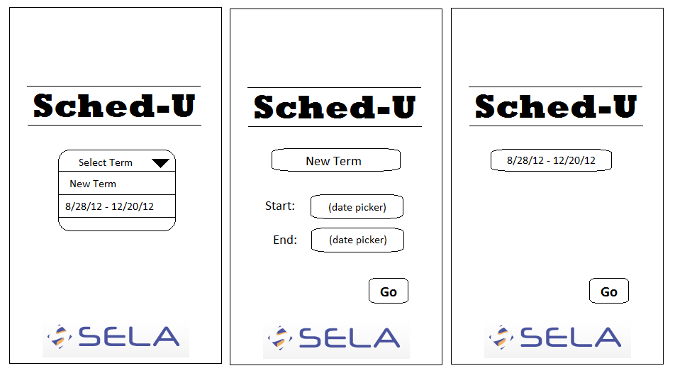

## Calendar Day and Week Views

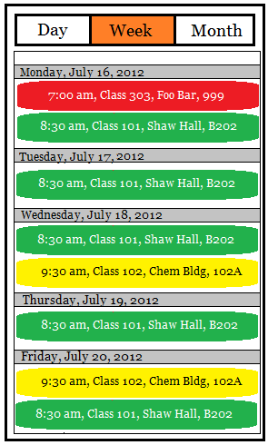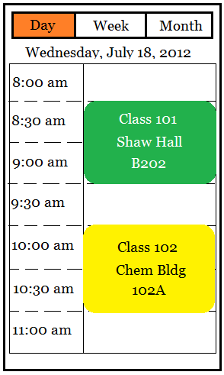

## Calendar Month View

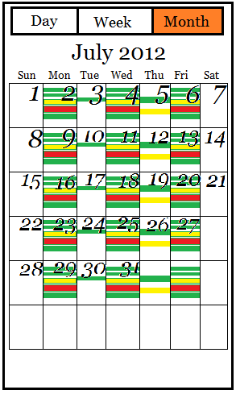

## Add/Edit Class

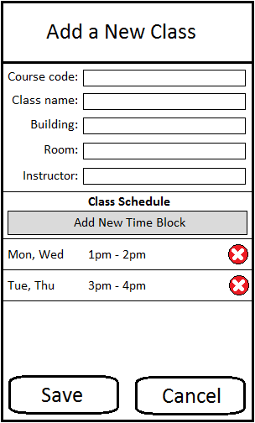

## Add/Edit Instructor

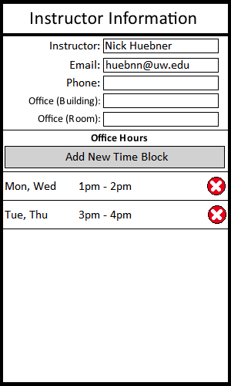

## Add Time Block

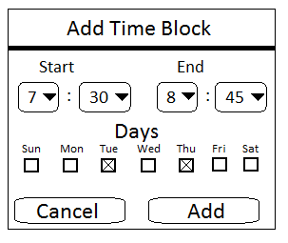

## Class View

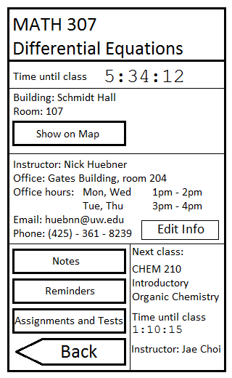

## Class Assignments and Exams

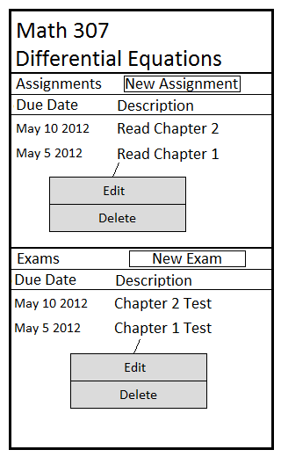

## Add Assignment

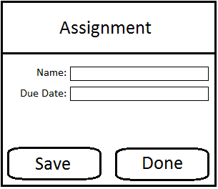

## Add Exam

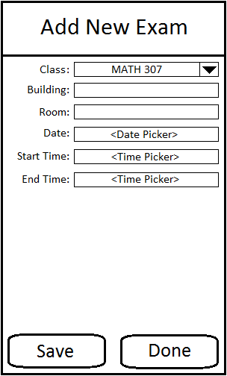

## Class Notes

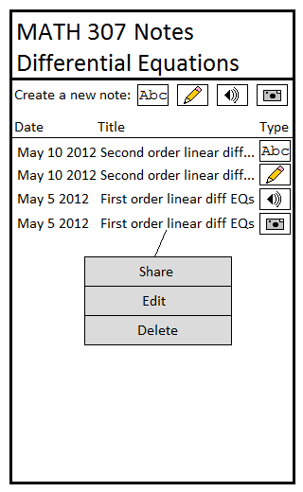

## All Notes and Assignments

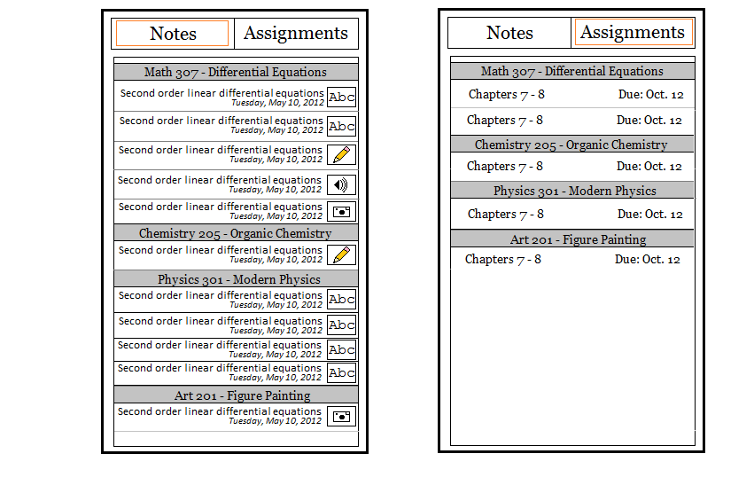

## Text Note

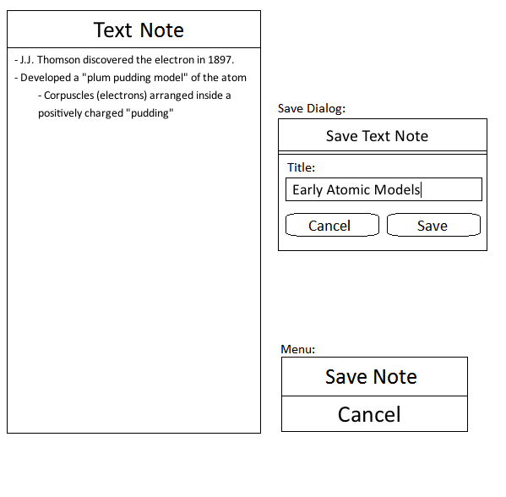

## Sketch Note

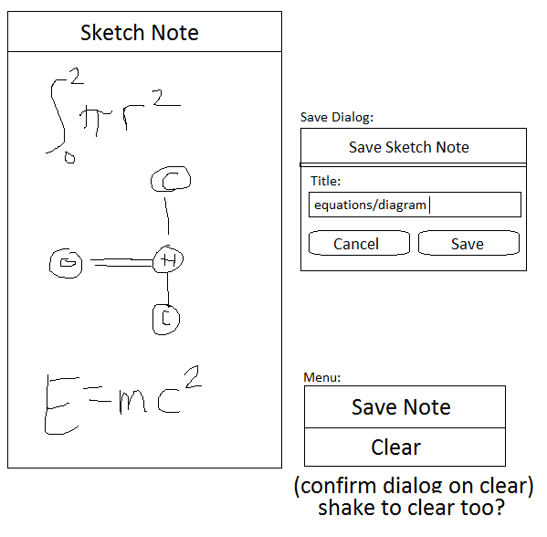

## Preferences

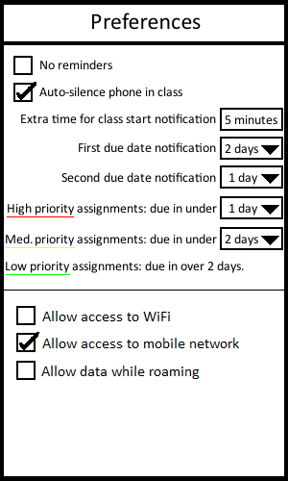

# UI Flowchart

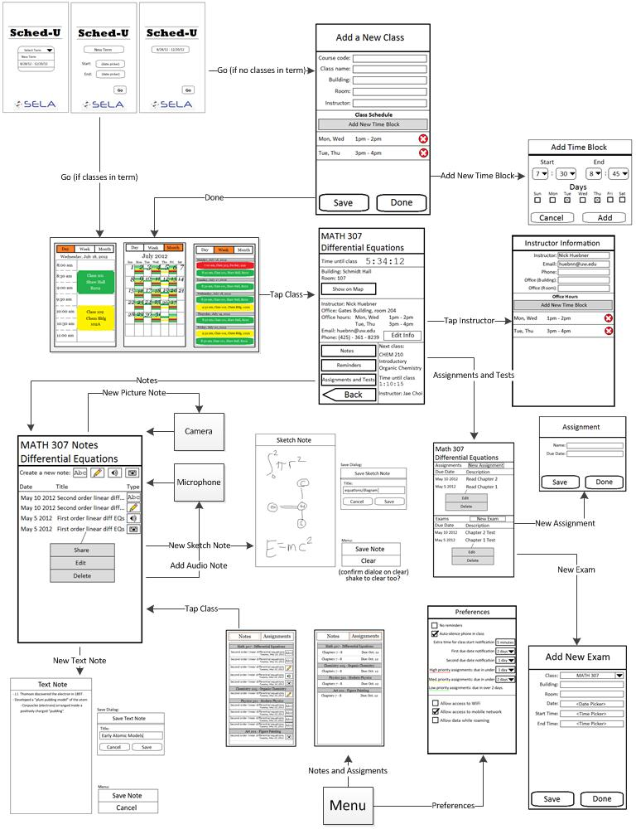

# ERD

