Our application is aimed at college students to organize their class schedule and note taking for their courses.

We need a logo for our app, called Sched-U

Splash screen.

Launcher icon.

Note icons: (for buttons and listview)

1. Text
2. Sketch
3. Audio
4. Picture

UI Flow:

From most, if not all screens, we will be providing Menu options to get back to the Main Term Select screen and the course select screen.

Once the user has entered a term, and the current date (today) is within those dates, we won’t display the initial screens (select term and course select). Instead, when the app starts they will be put at the calendar day view, or if they are within a course time, that course screen will be displayed.

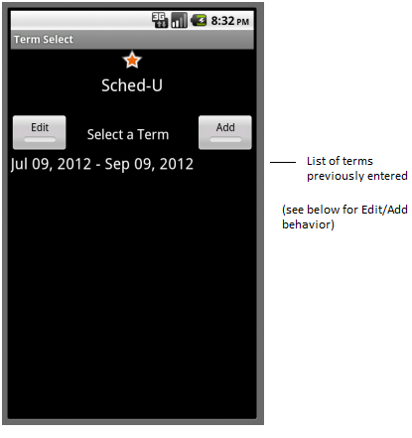

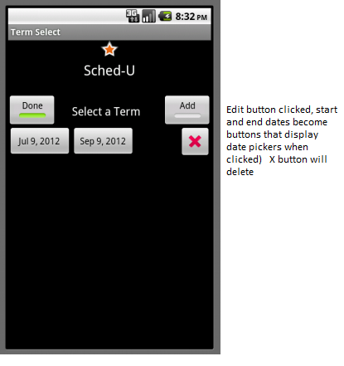

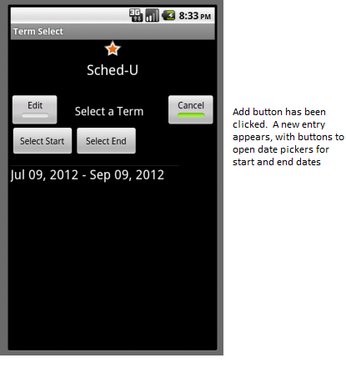

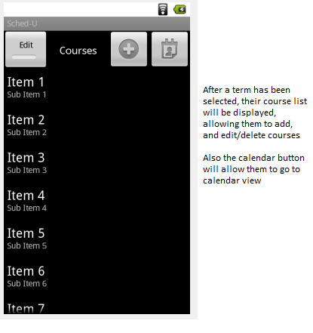

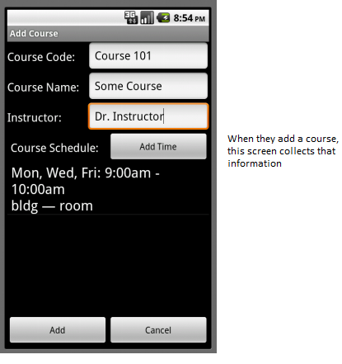

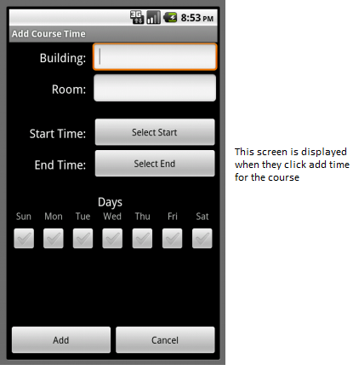

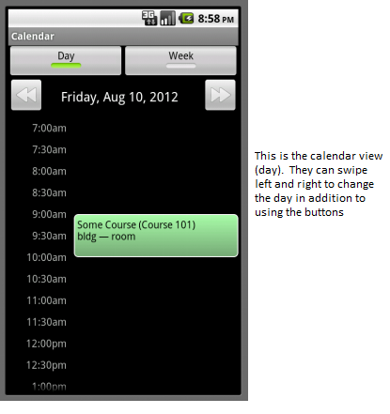

(the above will be displayed when the application is launched, if today is in the term)

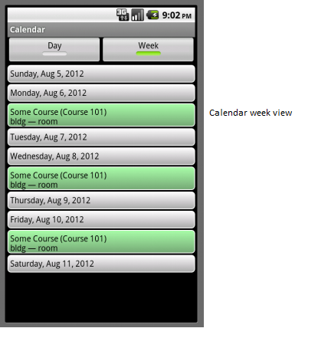

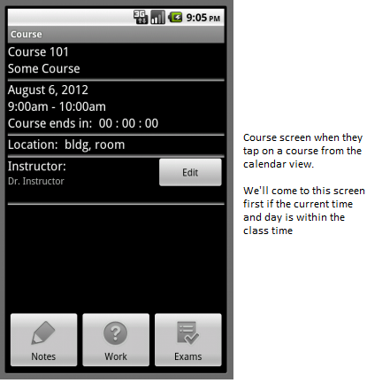

Below is displayed when they click on Edit button for the instructor: (adding time for instructor is similar to adding time for a course)

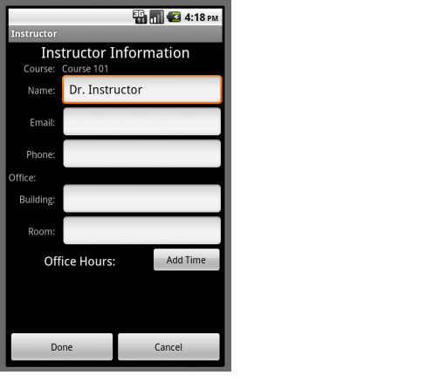

Below is displayed when they click on the Notes button from the Course screen.

