**Introduction:**

Investing can be complex and time-consuming. Choosing the right investment plan can depend on various variables. Investing can also be very risky. In 1929, on the New York Stock Exchange, investors exchanged 16 million shares in a single day, dubbed "Black Tuesday." Thousands of investors were wiped out as a result of the loss of billions of dollars. Following Black Tuesday, the United States and the rest of the industrialized world plunged into the Great Depression. People started to not trust banks and hide their money in a mattress or in a vault somewhere in their house for safekeeping but by doing so there is no increase in equity.

Banks started introducing personal equity plans back in the late 1980s. A personal equity plan (PEP) was a British investment platform that enabled people over the age of 18 to invest in shares of British companies.[1] It was accomplished by the use of a pre-approved plan, a qualified unit trust, or an investment trust. Both wages and capital gains are tax-free for investors. PEP is advantageous to both the bank and the investor because it allows the client to invest passively in a low-risk, high-reward asset. Additionally, this is extra global fiduciary capital for banks to invest. Money making money.

Some questions that should be asked before investing in PEP are the following: what are the benefits of PEP? What are the risks? What happens if more than one withdrawal happens in a year? Are there any fees? Just one business could be invested in every tax year under a single-company PEP. Individuals had a range of investment opportunities for general self-select plans, including shares, open-ended investment firms, corporate bonds, and investment trusts. The investments made under self-select plans were directed by the investor, though a manager or firm was still required to facilitate the plan, leaving the plan owner in charge of determining how their money should be spent. Individuals without market knowledge may invest in PEPs using such prepared plans.In 1999, PEP was discontinued and replaced with savings accounts.

**Analysis:**

About the data

First, the libraries for Association Rule Mining (ARM) were added to the script. Then, the data was read in from the csv file provided and examined using the structure function. Initially, the data looked like Figure 1 below. Before any cleaning or processing, the data consisted of a unique id, age (numeric), sex (“male” or “female”), region (“inner_city”, “rural”, “suburban”, “town”), income (numeric), married (“yes” or “no”), children (0-4), car (“yes” or “no”), saving account (“yes” or “no”), current account (“yes” or “no”), mortgage (“yes” or “no”), and PEP (“yes” or “no”).

Figure 1: Original structure of the dataframe

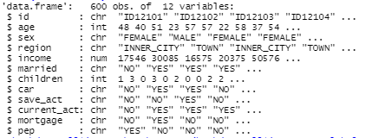

Once the bank dataset is loaded some pre-processing steps are used to clean the data. To start, since the customers’ income and age are both continuous variables, the numeric data type was converted to a categorical variable with fixed sub-levels. Secondly, id, age, and income was removed from the original dataset because it is no longer required for future analysis. Lastly, characters data types were converted into factors. Since each specific character value is only stored once and the data is stored as a vector of integers, factors are a very efficient way to store character values as shown in Figure 2.

Figure 2: Cleaned Structure

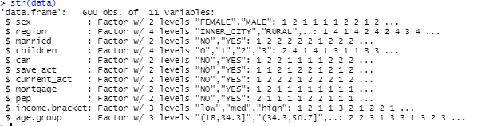

Figure 3: Cleaned Data

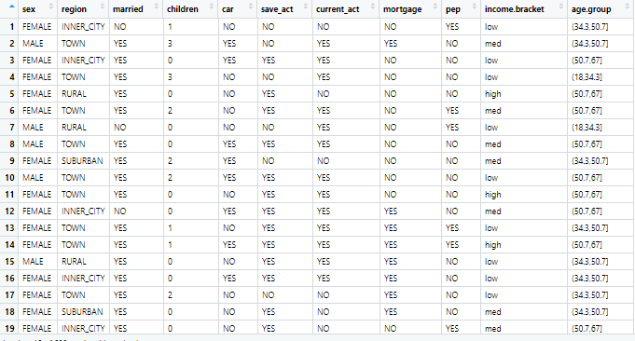

Association Rule Mining

This analysis was created using Association Rule Mining. Support, confidence, and lift are three main components used by Association Rule Mining to decide whether anything is important enough to be called a "rule." The frequency with which something appears in the dataset is known as support. The frequency in which item X appears in transactions containing Y is referred to as confidence. Using the ‘arules’ package in R, the Apriori Algorithm on the dataset was created.

Figure 4: Apriori Algorithm for NewRule1 (Code)- newrule1 <- apriori(data = data, parameter = list(minlen=2, maxlen=100, supp = 0.05, conf=0.8), appearance = list(default="lhs", rhs=c("pep=NO", "pep=YES")))



Figure 5: Inspect of NewRule1

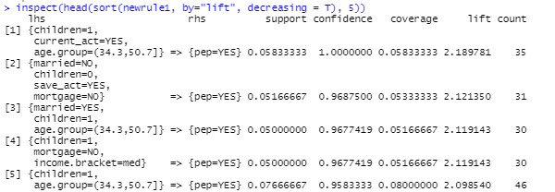

Figure 6: Apriori Algorithm for NewRule2 (Code) newrule2 <- apriori(data = data, parameter = list(minlen=1, maxlen=100, supp = 0.1, conf=0.9), appearance = list(default="lhs", rhs=c("pep=NO", "pep=YES")))

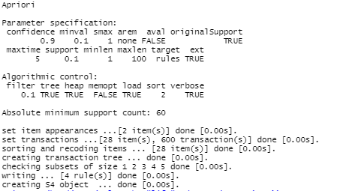

Figure 7: Inspect NewRule 2

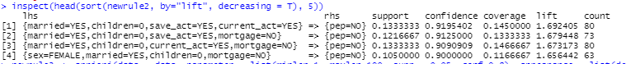

Figure 8: Apriori Algorithm for NewRule3 (Code) newrule3 <- apriori(data = data, parameter = list(minlen=1, maxlen=100, supp = 0.05, conf=0.8), appearance = list(default="lhs", rhs=c("pep=NO", "pep=YES")))



Figure 9: Inspect NewRule3

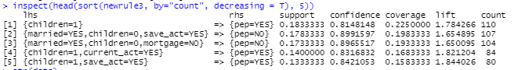

**Results:**

**Findings from NewRule1-**

If an investor is between the ages of 34 and 50, has a kid, and has a current account, they are far more likely than chance to buy the PEP product.

Values:

Support=0.0583 Confidence=1.000 Lift=2.1897

The rule with the highest lift is {children=1,current_act=YES,age.group=(34.3,50.7]}. This pattern does not occur very often (as support = 0.05), but has a strong relationship (as confidence = 1.00) and the rule has the highest predictive power (lift =2.189).

**Findings from NewRule2:**

Customers who are married, have no children, and have both a savings and a current account are less likely to buy PEP.

Values: Support = 0.1333333 Confidence = 0.9195402 Lift = 1.692405

When analyzing the populations in this pattern, there is clearly a very strong association (92%) and a good chance of occurrence (13%) when the pattern is reviewed.

Customers who are married but do not have children follow the same law as those who are single. They are more likely to not buy the PEP product if they have a savings account and no mortgage.

Values: Support = 0.1216667 Confidence = 0.9125000 Lift = 1.679448

When considering the demographics in this trend, there is a very strong association (91%) and a chance of occurance (12%).

A married ‘Female' customer with no children and no mortgage would almost certainly not buy the PEP product indicated by the following values:

Values: Support=0.1050000 Confidence=0.9000000 Lift=1.656442

This pattern has a strong relationship (90%) and a relatively good chance of occurrence (10%), as well as a reasonable predictive capacity (i.e. 1.6 when compared to highest predictive power of 2.18).

**Findings from NewRule3:**

When a customer has a child and a current or savings account, they are more likely to buy the PEP product indicated by the following values:

Support= 0.1400000 Confidence=0.83 Lift=1.821204

Both of the above trends have a close relationship. As a result, the attributes have a strong relationship (84%) and a decent likelihood of occurrence (14%) with a predictive power of about 1.8.

**Conclusion:**

If a customer is between the ages of 34 and 50, has a kid, and has a current account, they are far more likely than to buy the PEP product. These results indicate that customers between the ages of 34 and 50 who have a child and a current account are more likely to have a secure employment. They would be enticed to invest in new equity because of their employment and profits. Customers will also look for a successful Equity plan to earn profits and income so that they can help their children. As a result, there is a good chance of purchasing the PEP product. A recommendation would be to concentrate on this demographic. The target market would be other companies with the same age group employees.

Customers who are married, have no children, and have both a savings and a current account are less likely to buy PEP. The explanation for this may be that the customers are newlyweds or have recently married but are not yet ready to make large investments. It is often important to focus on customers who are interested in ‘purchasing’ the product, but it is also important to collect demographic data from customers that are not interested in purchasing the product. As a result, a deduction can be made from this pattern. To increase product sales, an increase to advertisement or recognition among this group of customers would be beneficial.

Customers who are married but do not have children follow the same pattern as those who are single. They are more likely to not buy the PEP product if they have a savings account and no mortgage.The explanation for this may be that the customers are newlyweds or have recently married but are not yet ready to make large investments. In this case, the additional argument is that they do not have a mortgage. The need for the equity plan is low. An increased number of customer awareness is needed to inform the customers the importance of investing in equities, as well as the profits and benefits for the future. This approach will reach the entire demographic of customers who have not yet purchased the PEP but will do so in the near future. A married ‘Female' customer with no children and no mortgage would almost certainly not buy the PEP product. It may be that, in general, men in households are more likely to spend and prepare for equities. Women, on the other hand, would be less interested in this commodity. A recommendation would be to increase the product's ease of comprehension and appeal to people of all genders. Since the female buyer in this category is married, it is also important to advertise or persuade her partner to buy the product. When a customer has a child and a current or savings account, they are more likely to buy the PEP product. A recommendation would be to increase the market sales and promote the product for customers with bank accounts.

1. "personal equity plan." Collins Dictionary of Economics, 4th ed.. 2005. C. Pass, B. Lowes, L. Davies 27 Apr. 2021 <https://financial-dictionary.thefreedictionary.com/personal+equity+plan>