I. LITERATURE REVIEW

One of the earlier works in fine-grained classification was an attempt at identifying plant species by Belhumeur et. al. This approach involved segmenting a leaf and then using shape to determine the species. Along similar lines, a paper by Farrell et. al attempted to identify a birds species by finding key points along the beak, eyes, wings, feet, and tail, and building features around them. [8] More relevantly, however, a 2012 paper by Liu et. al attempted dog breed identification using a similar approach. [2] They first use an SVM regressor using greyscale SIFT descriptors as features to isolate the face of the dog. To handler rotation and scale, the window is also rotated and scaled; by using non-maximum suppression and picking the detection with the highest score, they isolate a single best window. The primary focus of the paper is to find the facial keypoints of the dog. Liu et. al leverages a part localization algorithm, in which a sliding window SVM detector using SIFT greyscale descriptors is used over each eye and nose. After the eyes and nose have been detected, greyscale SIFT descriptors around the keypoints are used as features by an SVM classifier. With this approach, Liu et. al is able to classify their test dataset with an accuracy of about 90

II. Existing System

There is site where we can search dog and its details , we can get to known from veterinary consultant

III. Existing System disadvantages

There is site where we can search dog and its details ,but we cannot upload and get the breed of a dog through its image, yes we get breed detail by passing through allots of data were we have spent hours in front of the system to get a particular breed we like to know

VI. Proposed System

The web app that predict the dog breed by inputting the image through the upload

The pet lover love this system because it not the details of the dog user search but also

They can shop the pet item through this web, no need to jump to another site for pet or pet

Product.

Training mage

Data processing

features

classification

input image

image processing

Prediction

model

V. Proposed System advantage

The advantage is that this web app using CNN deep learning its show high accuracy in image classification so site can predict the breed of a dog that uploaded by the user , the site also proved a ecommerce facilities to purchase pet and pet items

VI. Module

1. Admin Module
2. User Module
3. Shop owner Module

**Frontend : django**

**Backend : python and sqlite3**

User

perdiction

image input

modle

Product view

login

View

Admin

User Verification

Shop Verification

product

VII. Architecture

Input image

predicted

**Table Design:**

**Admin module**

**Admin_tbl**

|  |  |  |
| --- | --- | --- |
| **Name** | **Type** | **Description** |
| **Id** | **Int** | **Id number** |
| **Username** | **Varchar** | **Username** |
| **Password** | **Varchar** | **password** |

**userModule:**

**user_reg**

|  |  |  |
| --- | --- | --- |
| **Name** | **Type** | **Description** |
| **Id** | **Int** | **Id number** |
| **Username** | **Varchar** | **Username** |
| **Password** | **Varchar** | **Password** |
| **Name** | **Varchar** | **Name** |
| **Email** | **Varchar** | **Email id** |
| **Contact** | **Varchar** | **Contact number** |
| **Upload** | **Varchar** | **Photo upload** |
| **Ver_id** | **Varchar** | **Verification id** |

**Shop_owner**

|  |  |  |
| --- | --- | --- |
| **Name** | **Type** | **Description** |
| **Id** | **Int** | **Id number** |
| **Username** | **Varchar** | **Username** |
| **Password** | **Varchar** | **Password** |
| **Name** | **Varchar** | **Name** |
| **Email** | **Varchar** | **Email id** |
| **Contact** | **Varchar** | **Contact number** |
| **Upload** | **Varchar** | **Photo upload** |
| **Ver_id** | **Varchar** | **Verification id** |

**product**

|  |  |  |
| --- | --- | --- |
| **Name** | **Type** | **Description** |
| **Id** | **Int** | **Id number** |
| **Type** | **Varchar** | **Product type** |
| **Name** | **Varchar** | **Product Name** |
| **price** | **Varchar** | **price** |

**Breed_expensive**

|  |  |  |
| --- | --- | --- |
| **Name** | **Type** | **Description** |
| **Id** | **Int** | **Id number** |
| **Breed** | **Varchar** | **BreedName** |
| **exp** | **Varchar** | **expens** |

**prediction**

|  |  |  |
| --- | --- | --- |
| **Name** | **Type** | **Description** |
| **Id** | **Int** | **Id number** |
| **User id** | **Varchar** | **User id** |
| **Prediction** | **Varchar** | **prediction** |

**Form Design:**

**Level0:**

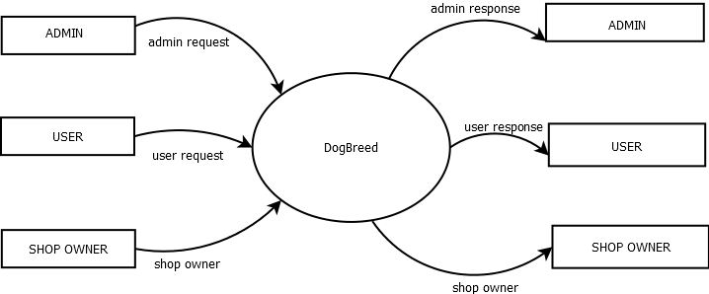

Level1:

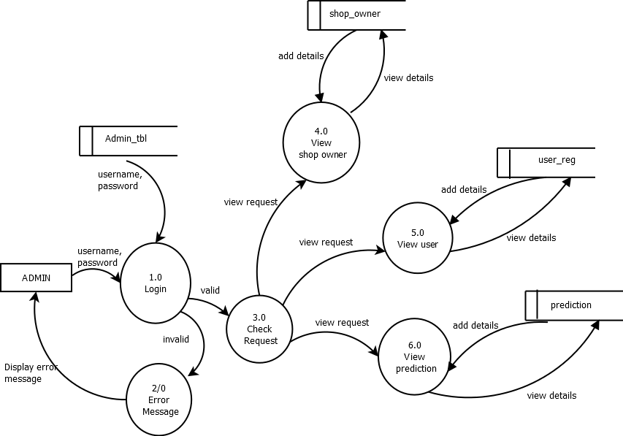

Level2:

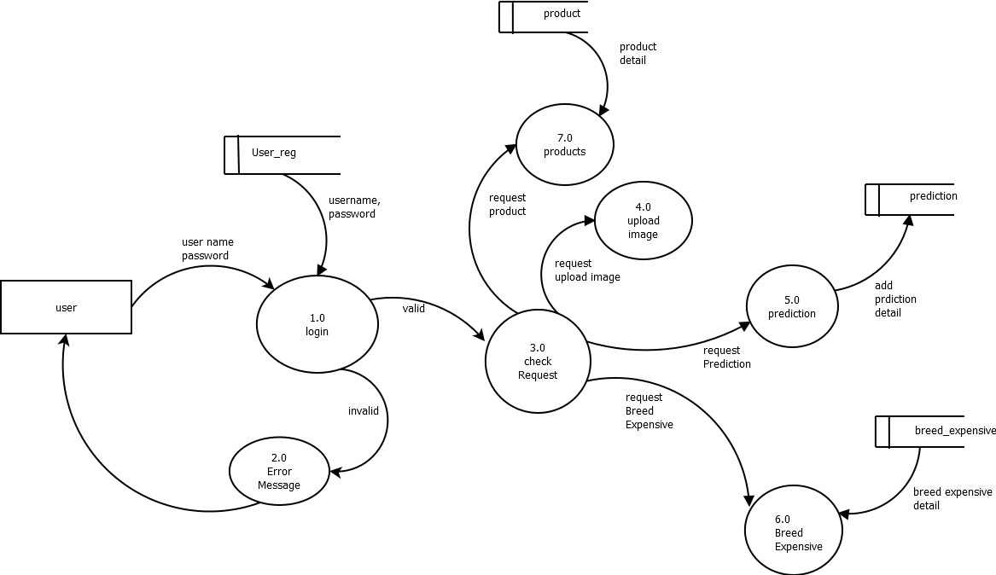

Level3:

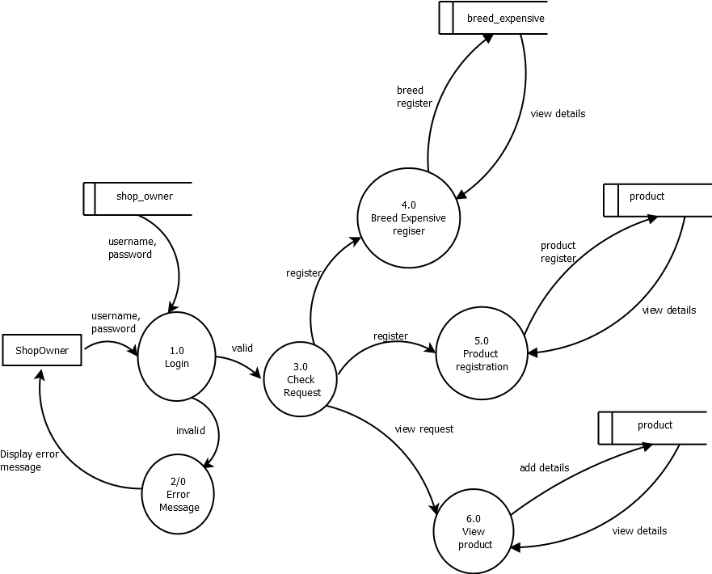

Module description:

1. Admin Module
   1. View user and update delete them
   2. view prediction by user
   3. Register Medicine and view Register
2. User Module
   1. View prediction
   2. Upload image
   3. product
3. Shop owner
   1. Product Registration
   2. Breed Expensive Registration
   3. View Product

Data flow :

Input train image

Image processing

Model saving

Classification image

prediction

Model load

Image featuring

Test image input