American University of Sharjah  College of Engineering  Dept of Computer Science & Engg  P. O. Box 26666  Sharjah, UAE |  | Lab Instructor: Salsabeel Shapsough  Office: ESB-1010A  Phone: 971-6-5154948  E-mail: sshapsough@aus.edu  Semester: Fall 2024

Lab #3 Simplification of Boolean Functions using Boolean Algebra and Universal gates

Objectives
- Use of switches as inputs and LEDs as outputs.
- Understand and test operations of basic logic gates.
- Convert logic designs to universal gates designs (all NAND or all NOR).
- Study the representation of functions using truth tables, logic diagrams and Boolean algebra.
- Simplify and modify Boolean logic functions using postulates and theorems of Boolean algebra including De Morgan laws.
- Implement SOPs using standard logic gates.

Lab Equipment and Circuit Components
  - Equipment
    - Breadboard
  - Circuit Components
    - 7400 NAND
    - 7402 NOR
    - 7404 inverter
    - 7408 AND
    - 7432 OR

Boolean Theorems

The following table describes the various postulates and theorems that can be applied on complex Boolean expressions to simplify them so that we use the most minimum amount of gates for our final output.

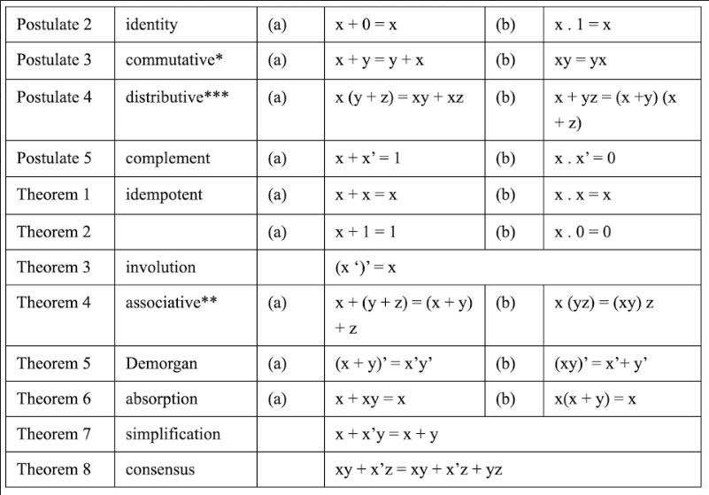
Lab Activities:

- Simplify the expression and demonstrate the following:
$$B+A.\left[D+ C.\left(\overline{A.}B+ \overline{C}\right)\right]$$

- Build the Truth Table.
- Simulate the simplified equation circuit (show the IC pins numbers on your drawing).
- Implement the circuit and verify your implementation from the truth table.
- Compare the number of gates used to implement the expression before the simplification and the number of gates used in this lab after the simplification.
- Compare the number of ICs used to implement the expression before the simplification (in lab 1) and the number of ICs used in this lab after the simplification.

- Design a logic circuit to produce HIGH output only if the input, represented by a 3-bit binary number, is greater than one and less than six.
- Build the Truth Table.
- Using theorems of Boolean algebra, simplify the equation.
- Simulate the simplified equation circuit (show the IC pins numbers on your drawing).
- Implement the circuit and verify your implementation.

- Given the following Boolean expression:
$$F=\left(A+B\right).\left(\overline{A}+\overline{B}\right)$$
- Simulate the circuit using LogiSim, verify its operation by building the truth table.
- Convert F to all NOR design, show your design, simulate it, and implement it on the Breadboard.
- Convert F to all NAND design, show your design, simulate it, and implement it on the Breadboard.

