# **Travel Advisor Website**

# **System Design Document**

**Revision History**

|  |  |  |  |
| --- | --- | --- | --- |
| **Version** | **Date** | **Reason For Changes** | **Owner** |
| Version 1 | 24/4 | Initial fill | Sahar Hamdy |
| Version 2 | 27/4 | Update wireframe after customer feedback | Esraa Mostafa |
|  |  |  |  |
|  |  |  |  |
|  |  |  |  |

**Table of Contents**

**1.**  **Introduction**

1.1 Purpose of the SDD

1.2 Terms and Definitions

**2.** **High-Level Design**

2.1 Use Case Diagram

2.2 High-Level Decomposition

2.3 Entity Relation Diagram

**3.** **Low Level Diagram**

3.1 Wireframe

3.2 Class Diagrams

3.3 Flowcharts

3.4 Sequence Diagrams

## **1.** **Introduction**

This application provides a window for the different places and tours a visitor can view before travelling to a specific country. This site guides him/her through from the start to the end of the journey.

### **1.1** **Purpose of the SDD**

The System Design Document (SDD) tracks the necessary information required to effectively define the architecture and system design to give the development team guidance on the system's architecture. Design documents are incrementally and iteratively produced during the system development life cycle, based on the particular circumstances of the information technology (IT) project and the system development methodology used for developing the system. Its intended audience is the project manager, project team, and development team. Some portions of this document, such as the user interface (UI), may be shared with the client/user, and other stakeholders whose input/approval into the UI is needed.

## **1.2 Terms and Definitions**

|  |  |
| --- | --- |
| SD_HL | High-Level Design |
| SD_HL_USD | Use Case Diagram |
| SD_HL_HLD | High-Level Decomposition |
| SD_HL_ERD | Entity Relation Diagram |
| SD_LL | Low-Level Design |
| SD_LL_WF | Wireframes |
| SD_LL_CD | Class Diagram |
| SD_LL_FC | Flowchart |
| SD_LL_SEQD | Sequence Diagram |

## **2.** **High-Level Design**

This section describes the high-level design diagrams for the system.

**2.1 Use Case Diagram**

* A use case diagram provides a high-level view of how different actors interact with the Travel Advisor Web Application,it illustrates the system’s functionality from the user’s perspective.
* Three actors interact with the system (Registered user, Unregistered user, Admin).
* The use case represents the system's specific functionalities or actions (Register, Login, Booking flight, Rating the system) for users and (Add user, Delete user) for Admin.
* Arrows connecting actors to use cases show the interactions.

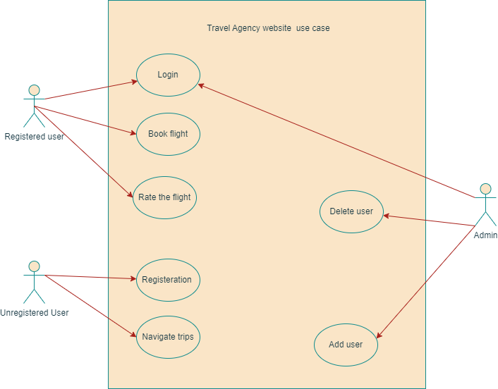

SD_HL_USD_01

**2.2 High-Level Decomposition**

The system is broken down into smaller parts (modules) that are easier to understand, program, and maintain.

The system comprises five modules( Registration, Login, Home, Booking a Flight, and Rating).

The Login and the registration modules are on the same level, after that the user can be redirected to the home page then book a flight and finally the user can rate that flight.

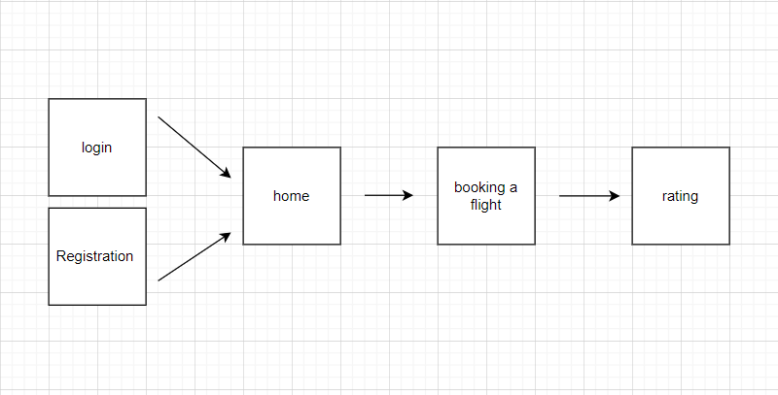

SD_HL_HLD_01

**2.3 Entity Relation Diagram**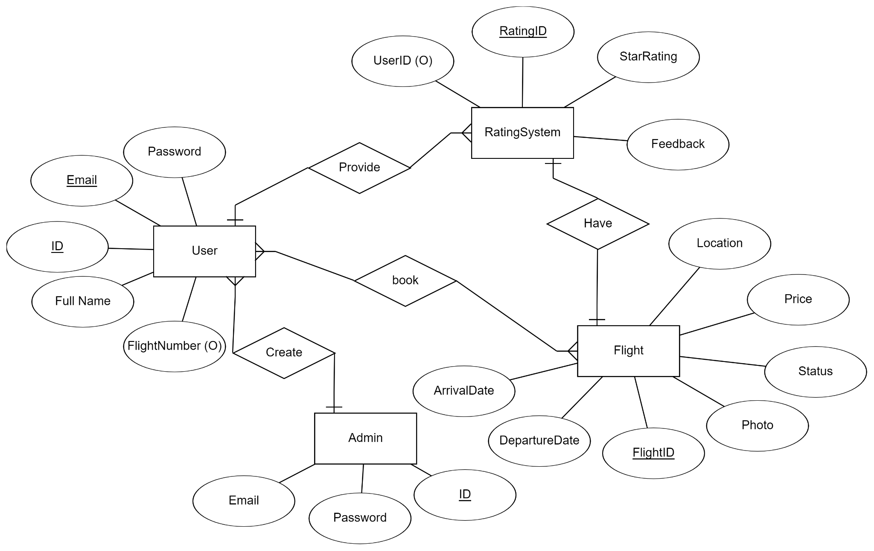

SD_HL_ERD

**3.** **Low Level Diagram**

3.1 Wireframe

SD_LL_WF_01

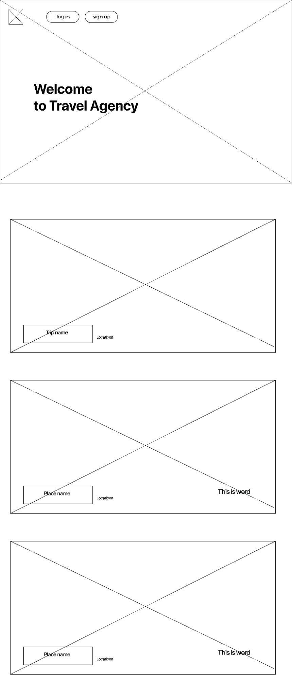

SD_LL_WF_02

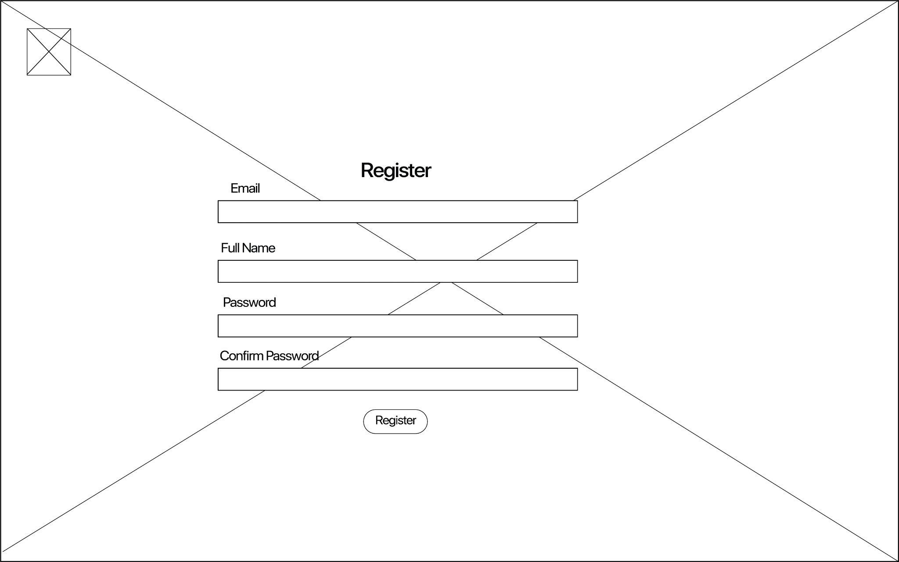

SD_LL_WF_03

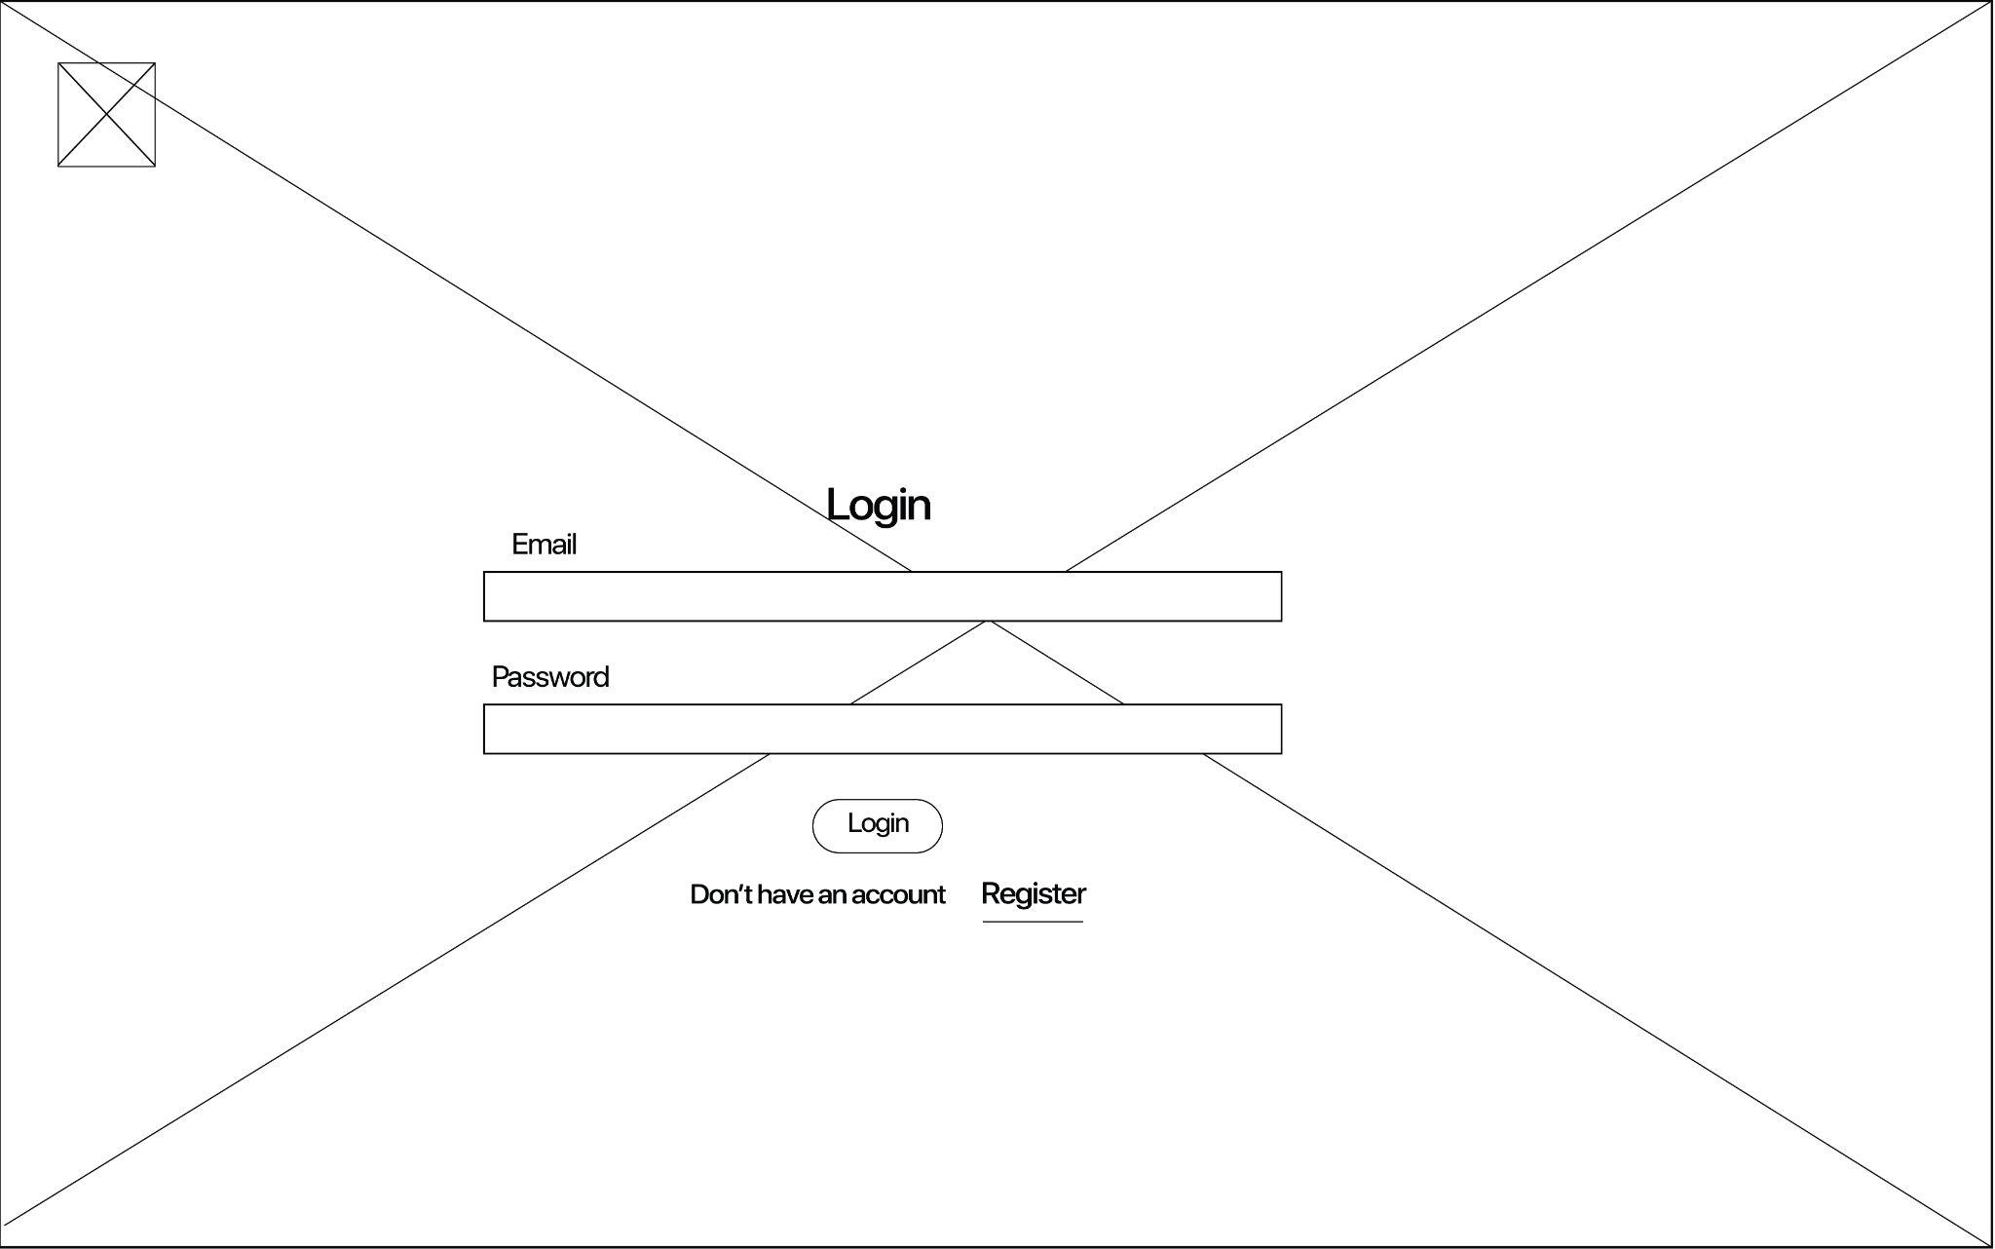

SD_LL_WF_04

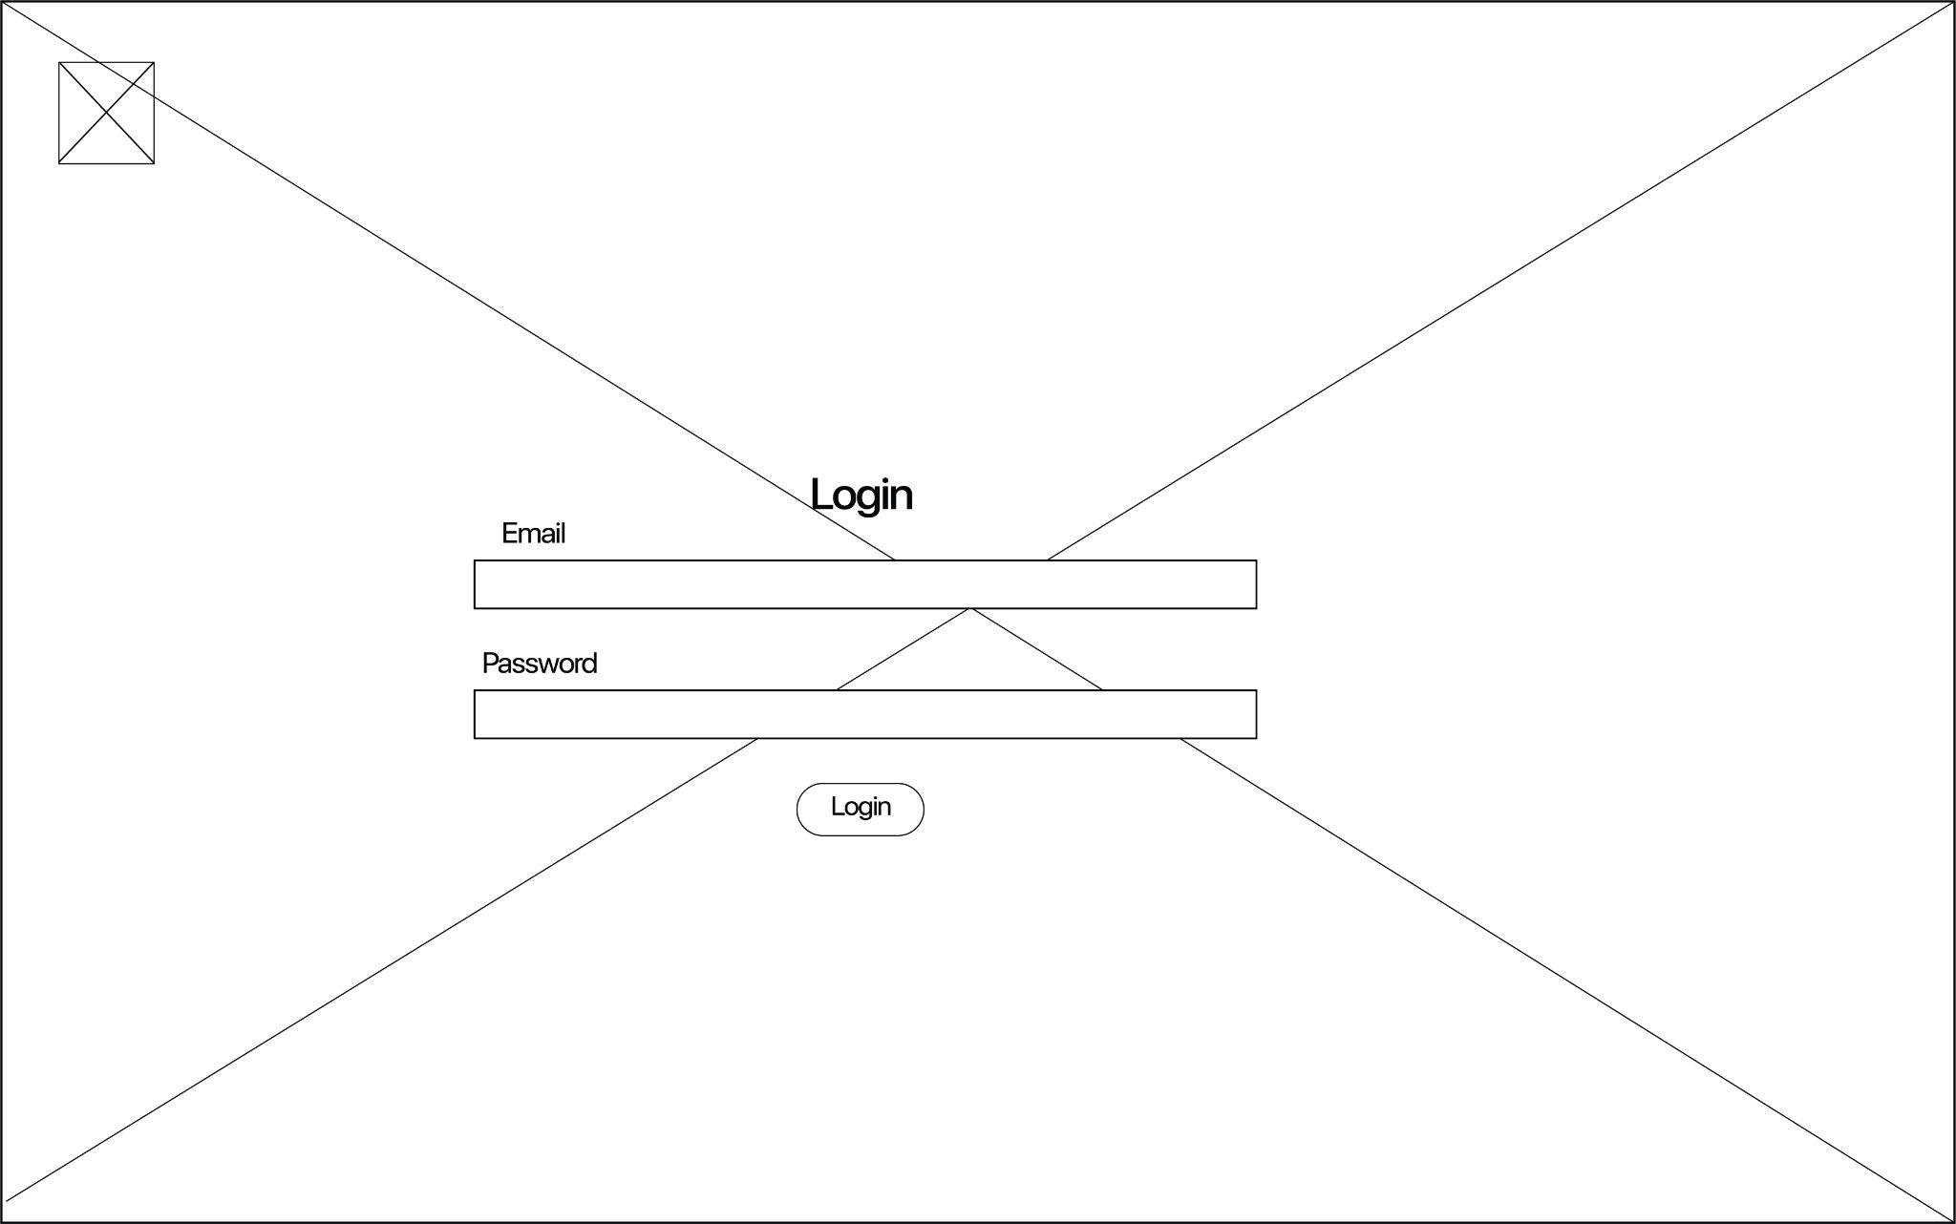

SD_LL_WF_05

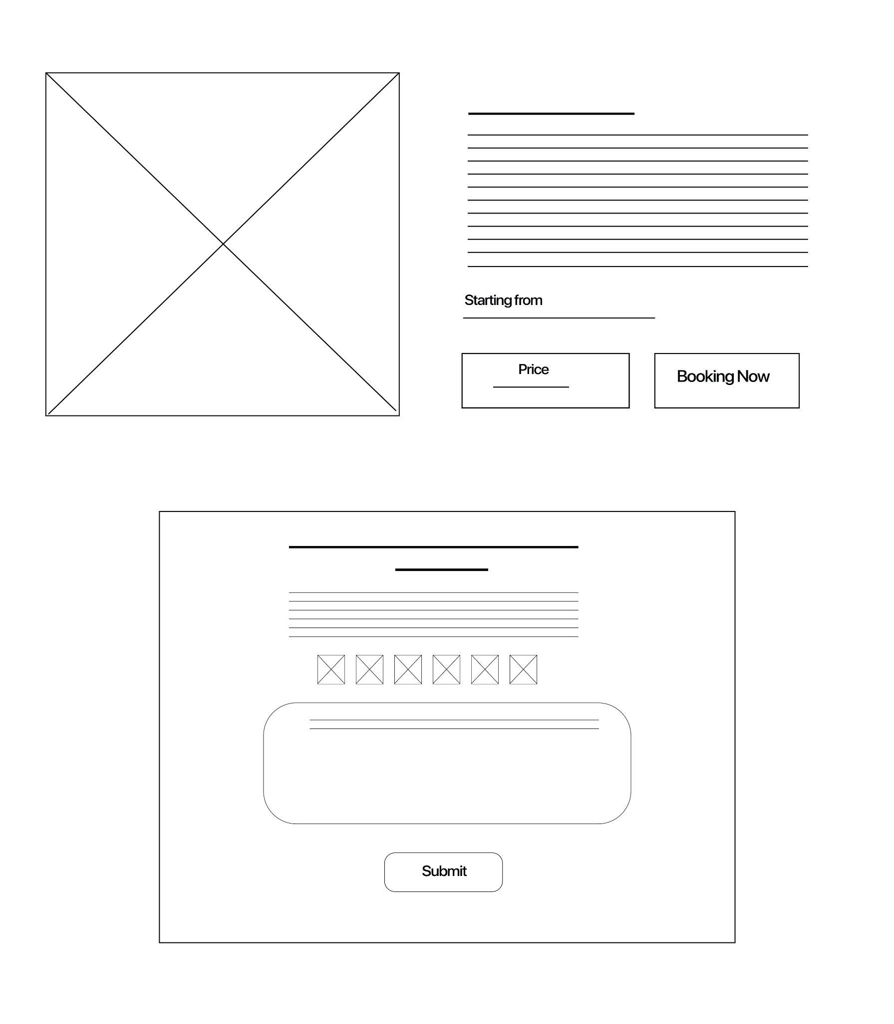

SD_LL_WF_06

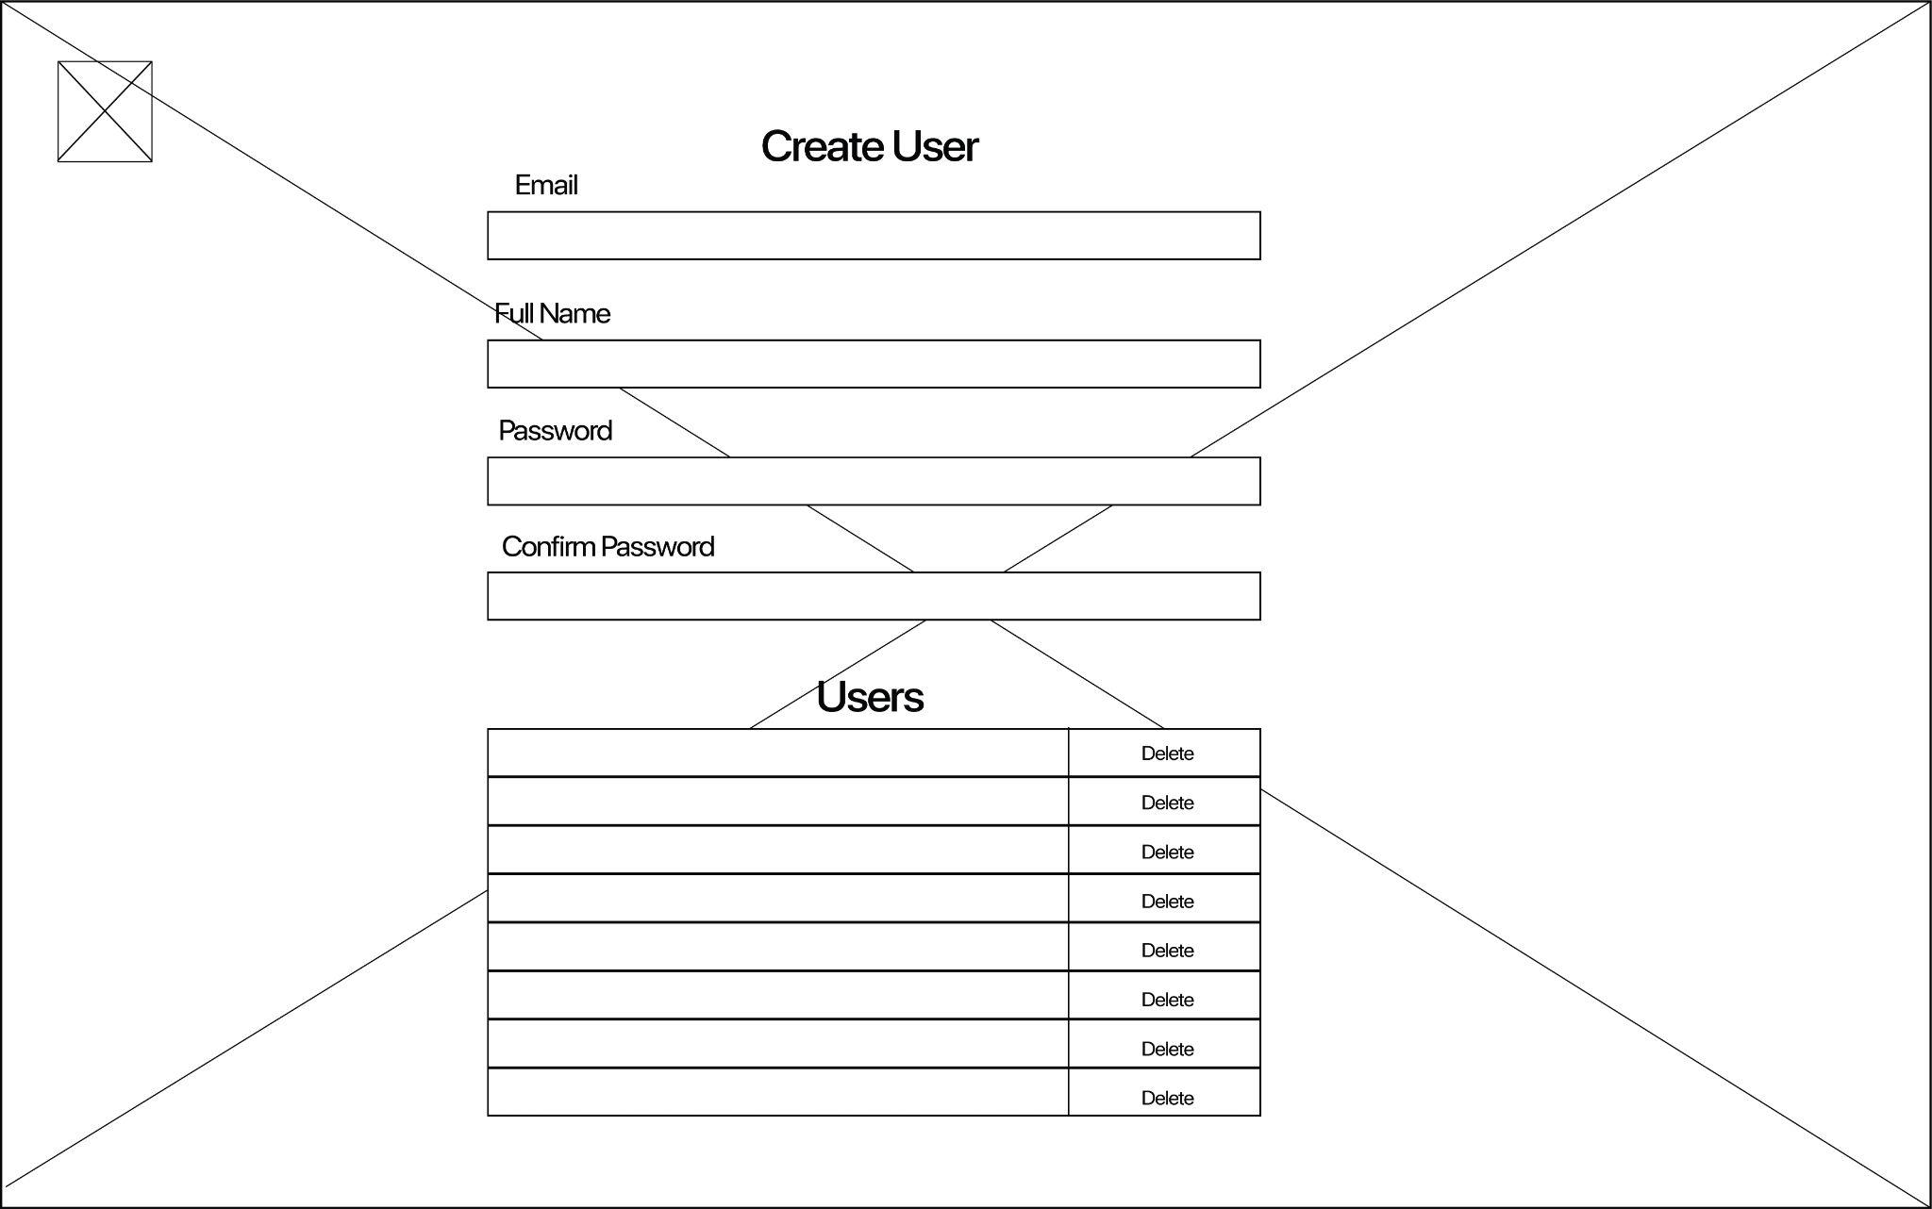

3.2 Class Diagrams

SD_LL_CD_01

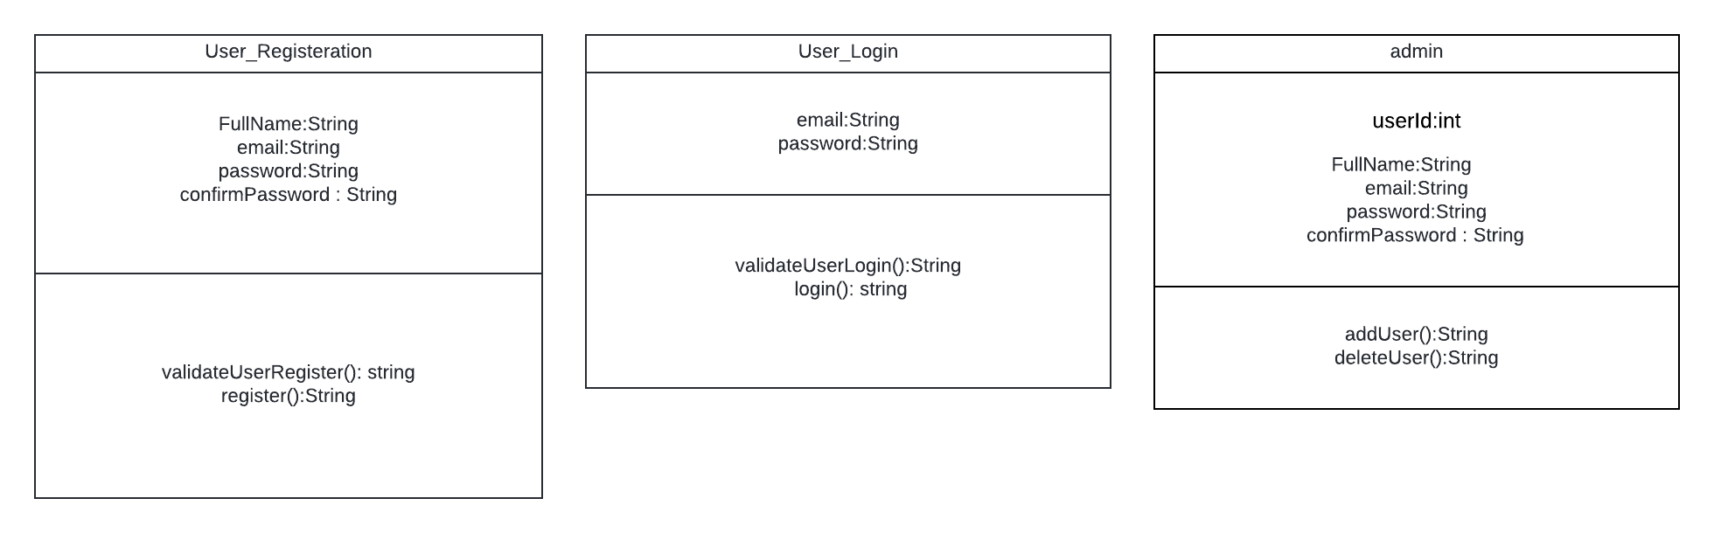

SD_LL_CD_02



SD_LL_CD_03



SD_LL_CD_04

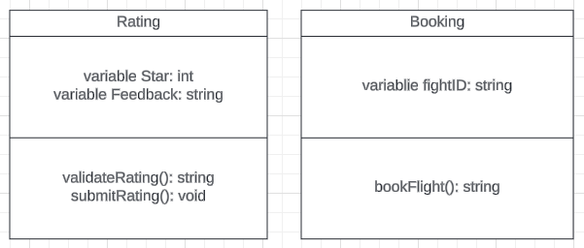

SD_LL_CD_05



3.3 Flow Charts

3.3.1 User_Registration

3.3.1.1 validateUserRegister

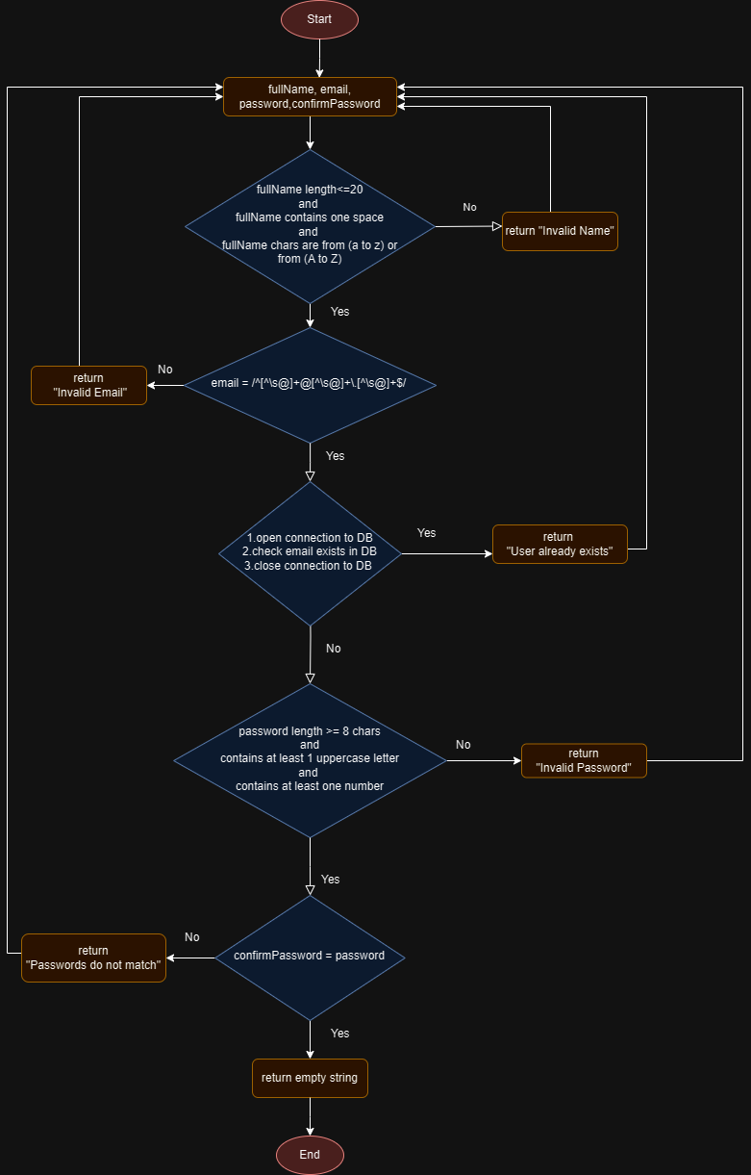 SD_LL_FC_01

3.3.2 User_Login

3.3.2.1 validateUserLogin

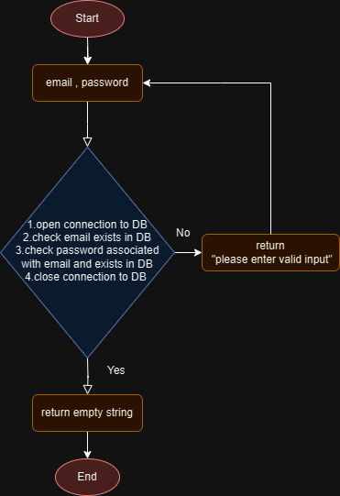

SD_LL_FC_02

3.3.3 Admin

3.3.3.1 addUser

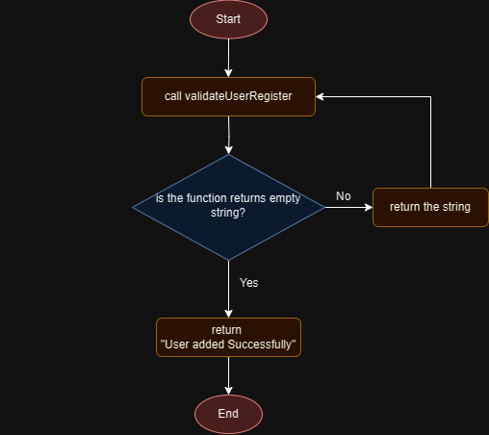

SD_LL_FC_03

3.3.3.2 deleteUser

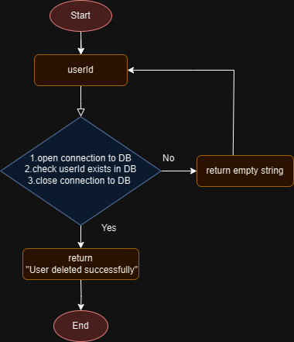

SD_LL_FC_04

3.3.4 Rating

3.3.4.1 validateRating

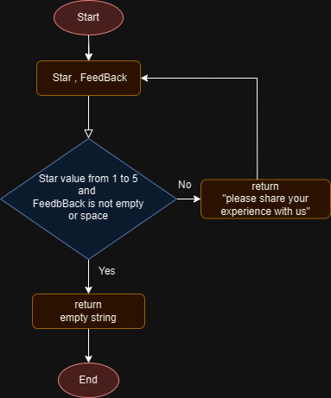

SD_LL_FC_05

3.3.4.2 submitRating

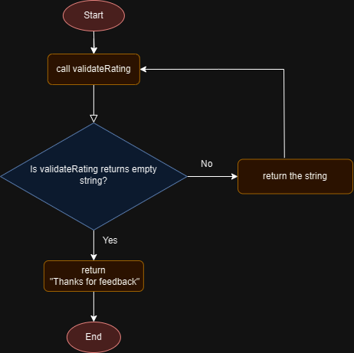

SD_LL_FC_06

3.3.5 Booking

3.3.5.1 bookingFlight

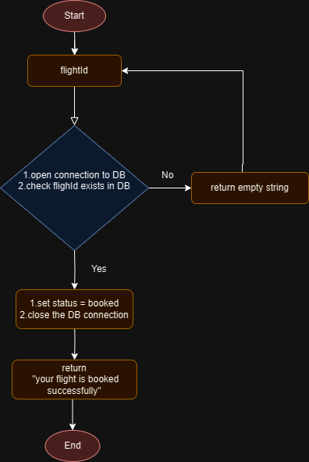

SD_LL_FC_07

3.4 Sequence Diagrams

3.4.1 User_Registration

3.4.1.1 register

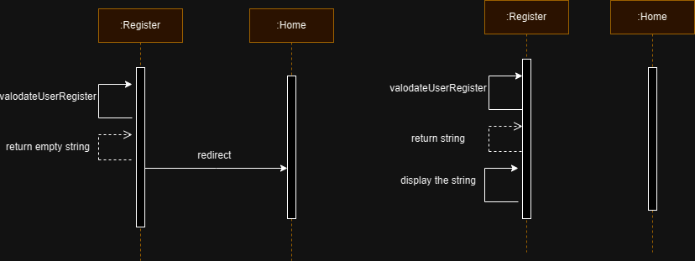

SD_LL_SEQD_01

3.4.2 User_Login

3.4.2.1 login

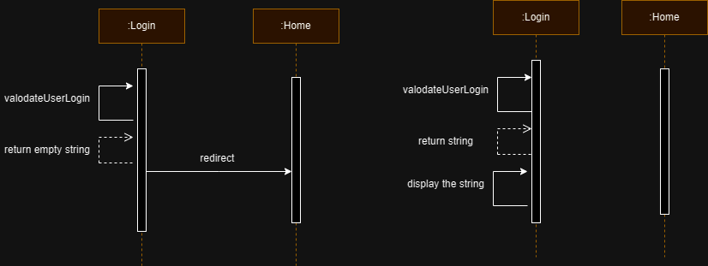

SD_LL_SEQD_02

3.4.3 Home

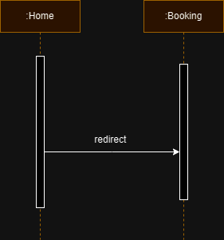

SD_LL_FC_03