

Botany Downs Secondary College
Internal Assessment
Level 3-2026
91906- Use Complex Techniques to Develop a Computer Program-6 credits
91907- Use complex processes to develop a digital technologies outcome -6 credits
Achieved | Merit | Excellence
· Use complex programming techniques to develop a computer program. | · Use complex programming techniques to develop an informed computer program. | · Use complex programming techniques to develop a refined computer program.  Student Declaration:  I hereby declare that I have completed the assessment for 91906-907, independently and to the best of my abilities. This assessment represents my own work and is based on my own research, practice and understanding of the subject matter.  I confirm that all sources used in this assessment, including but not limited to books, articles, online resources, and any other references, have been appropriately cited and acknowledged according to the prescribed referencing style.  I further affirm that I have not engaged in any form of academic dishonesty, such as plagiarism or unauthorized collaboration, in the completion of this assessment. The ideas, arguments and content presented in this assessment are my own and have not been copied or reproduced from any other source.  I understand that any act of academic misconduct or violation of the academic integrity may result in disciplinary actions, which could include penalties such as grade reduction, course failure or other consequences as determined by the institution.  I take full responsibility for the authenticity and originality of the assessment and acknowledge that my work will be subject to scrutiny and evaluation by my instructors or assessors.  Signed : ……………………………. Date: …………………………………..  Signed:  Date:

Answer the following questions before you start the assessment:
- Describe the purpose of your digital outcome.
- Who is the intended user?
- What problem does it solve?
- Why is this problem worth solving?
Personalised skincare checker
The purpose of my digital outcome is to assist users with identifying their skin type and skin concerns, then recommend suitable skincare solutions and ingredients. The digital outcome aims to help users build an effective skincare routine and make informed decisions when purchasing skincare products. The intended users are young adults and teenagers, specifically those who are new to skincare and are struggling to find products or ingredients that are suitable for their skin type and concerns. My digital outcome solves a problem that many people face when choosing skincare products. Most people find it difficult to choose skincare products as they are unsure of their skin type, skin concerns, and which ingredients are suitable. This can often lead to buying ineffective or damaging products. This problem is worth solving because choosing the incorrect products can negatively affect skin health. A personalised skincare checker can help users understand their skin’s needs, select appropriate products, and develop an effective skincare routine while lowering the risk of potential damage or irritation.
- Explain why you selected this programming language, software and development tools.
Instead of simply naming them, explain why they were appropriate.
Example prompts:
- Why Python?:
Python was chosen as the programming language for this assessment because it is easy to read, write, and understand, making it suitable for developing the personalised skincare checker. Python has built in libraries such as Tkinter which will allow me to create a suitable graphical user interface without needing additional software. Python’s syntax is simple, allowing me to easily identify and solve problems which may occur.
- Why Tkinter?:
Tkinter was chosen because it is built directly into Python as part of its GUI library. It will allow me to create windows, buttons, labels, text boxes, and other interface components. These elements improve the program’s usability and accessibility, making it easier for users to interact with. Overall, Tkinter is the most appropriate GUI library because it provides all the necessary features needed for my digital outcome’s interface while remaining simple to learn and implement.

- Why VS Code? :
VS Code will be used as it is a lightweight source code editor which supports python. VS code is equipped with a range of excellent features such as error detection, debugging tools, syntax highlighting, autocompletion, and many more. These tools will significantly contribute to the development of the digital outcome.
- Why GitHub?:
GitHub will be used for version control and project management. This development tool will allow me to back up my code online, track changes, and restore previous versions. GitHub will allow me to easily organise and manage the project as well as clearly demonstrating the development process over time. This reduces the risk of losing work and provides clear evidence of the project’s changes, therefore making it an appropriate tool for the development of my personalised skincare checker.

Introduction to chosen task: (your task should explain the following items. Background Information:
- Objectives
- Significance
)
While working at a skincare and cosmetics store, I often assisted customers with selecting skincare product. I noticed that many customers were unsure about their skin type, skin concerns, and which products would benefit them the most. With the wide range of products available, customers often felt overwhelmed and lacked confidence in choosing the right skincare products. Through these reoccurring experiences, I identified the need for a simple, personalised tool that can guide users towards suitable skincare products based on their individual skin type and skin concerns.
This motivated me to develop a personalised skincare checker, a digital solution with the objective of helping users identify their skin type and skin concerns through a quiz before providing personalised skincare recommendations tailored specifically to each individual. The digital solution aims to make skincare decisions easier, reduce the risk of negative effects, and improve confidence in building an effective skincare routine.
The personalised skincare checker is significant because it addresses the challenge of people struggling to find suitable skincare products for their individual needs. This digital solution provides a more accessible and personalised approach by helping users make appropriate skincare choices. It can save users time and money, reduce the likelihood of irritation, and encourage healthier skincare habits. Furthermore, the digital solution demonstrates how technology can be used to solve real-world problems by providing solutions in an efficient and user-friendly way.

Methodology: (Describe the methodology or approach used to tackle the problem. Explain briefly the algorithms, techniques or tools you will employ in the project. This section should provide a clear understanding of how the project will be implemented.)
In order to develop the personalised skincare checker, an iterative development approach will be applied. An iterative development process is a method where software is built, tested, and improved in repeated, concise cycles rather than all at once. The project will begin with researching skin types, skin concerns, skincare needs, and suitable ingredients to ensure the recommendations provided by the digital outcome are accurate and useful. A questionnaire system will be implemented to identify the user’s skin type, concerns, skincare goals, and preferences.
The program will mainly use conditional algorithms (if/elif/else statements) to analyse user response and link them with the appropriate skincare recommendations. A database of skincare information will be used to store details about ingredients, benefits, and suitable skin conditions. The Graphical User Interface of the program will be developed using Python and Tkinter to create an interactive and user-friendly digital outcome. Testing will be conducted throughout all stages of the development to identify and solve error, ensuring that the recommendations are relevant and personalised for different users.

Software Requirements(List down the system requirements and dependencies necessary to run the project, include the version of python used and any external libraries or specific hardware requirements.)
The following software requirements are needed to develop the personalised skincare checker

System requirements:
Operating system: Windows 11 or macOS
Python version: Python 3.12
Source-code editor: Visual Studio Code (VS Code)
Version control: GitHub
Dependencies:
Tkinter: tkinter will be used to create the graphical user interface of the digital outcome.
PIL: pillow (PIL) displays and resizes images used in the program.
Json: Json will be used to store and retrieve skincare product and ingredient data.
Os: Allows program to interact directly with the computer’s operating system, allowing the application to access files and directories.
Hardware requirements:
- Laptop/computer
- Available storage
- Minimum of 4GB RAM
List of Complex Techniques being used:
1 | Conditional algorithms:  (if/elif/else statements) used to analyse a user’s skin type and concerns to provide appropriate recommendations. | 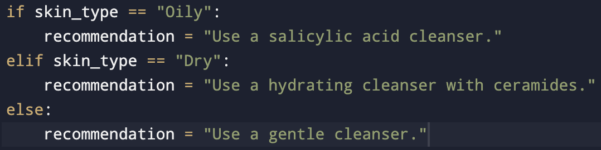
2 | Functions:  Used to organise complex logic and automate specific tasks, making the code easier to maintain. | 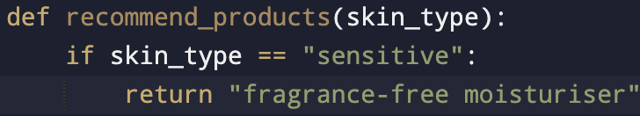
3 | Dictionaries:  Used to store skincare ingredients, recommendations, and products. | 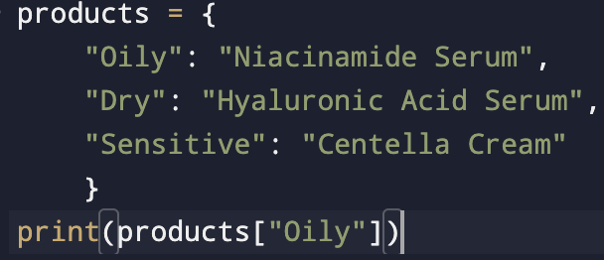
4 | Input validation:  Ensures information entered by user is valid before the program continues. | 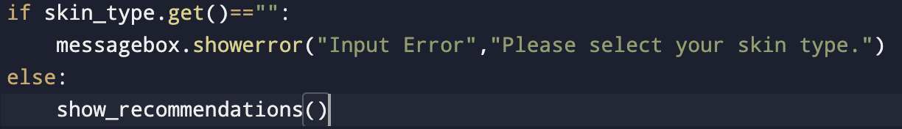
5 | Graphical User Interface (GUI):  Developed using Tkinter to provide an interactive and intuitive experience for users.
6 | Object oriented programming (OOP):  Classes will serve as a reuseable blueprint for creating objects that group related data and functions together, making the program more organised. | 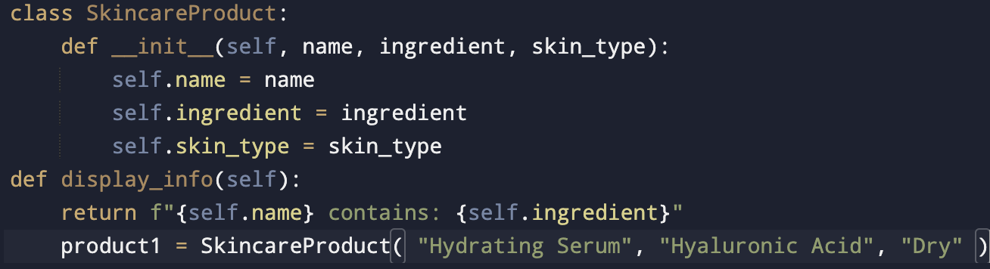
7 | Error handling:  Used to prevent the program from crashing when errors occur. | 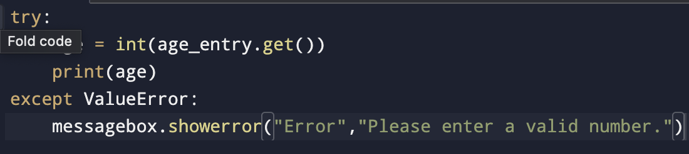
8 | Searching and filtering algorithms:  Used to search through skincare product and ingredient data to filter and extract products that match the user’s skin type and concerns. | 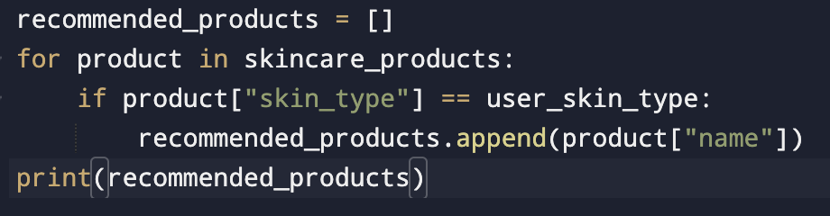

List of Complex Processes being used:
1 | User input collection:  The program collects information from the user through the questionnaire system in the GUI about the user’s skin type and concerns. This process ensures the application gathers the information required to generate personalised recommendations that are relevant to each individual. | 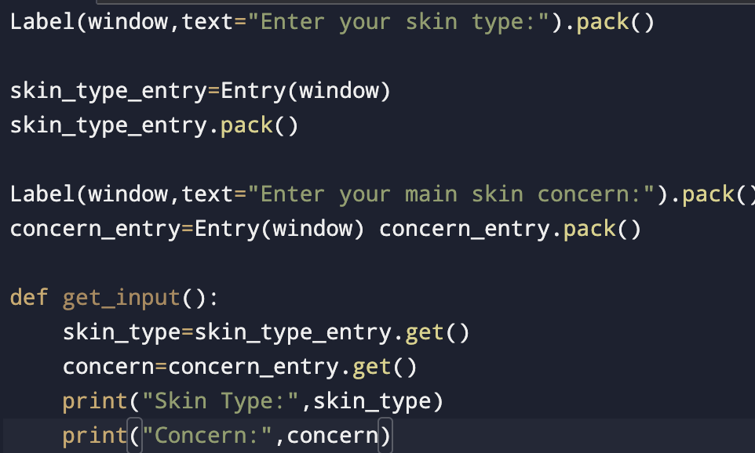
2 | Data retrieval:  The program will retrieve skincare product and ingredient information from a JSON file. Storing the data separately allows us to transfer information in a plain-text format, making the application easier to maintain and expand. | 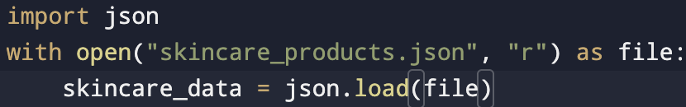
3 | Data storage:  The program will save user results in a JSON file. This allows information to be reused later on without requiring the user to re-enter their details again. This will make it easier to adjust or expand over time. | 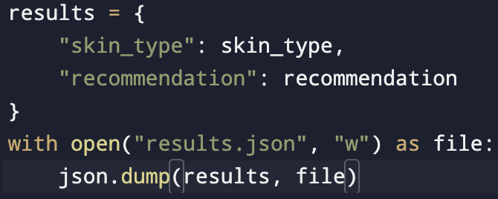
4 | GUI design:  The interface is designed to be intuitive and user-friendly. Colours, fonts, layout, and button placement will be refined to improve usability and accessibility for users. | 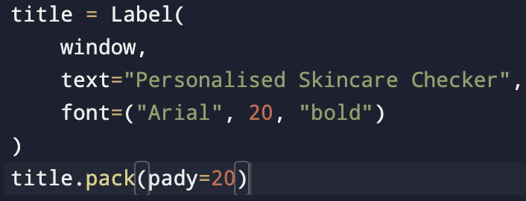
5 | Decision making:  The program follows a series of decisions to determine the more suitable recommendations. The user’s responses are analysed collectively rather than independently to provide more accurate and personalised results. | 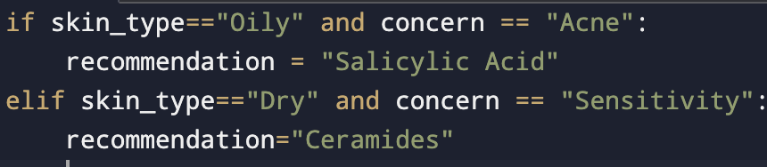

Planning Requirements: (How will you plan your application design. This should include a pseudocode, flowchart, project management tools, saving tools and drawing tools.)
The development of the personalised skincare checker will be planned before and during implementation to ensure that the project is organised and meets the needs of the users. A range of different planning, design, and project management tools will be used all throughout the development process.
- Flowchart:
Flowcharts will be created using draw.io to visually represent the program’s method and decision-making process. It will visually illustrate how the users will move through the program and how their responses are processed, as well as how recommendations are generated. This will make it easier to identify potential issues before development.
- Project management tool
GitHub, GitHub projects, and Trello will be used to organise tasks and track progress throughout the development process. Large tasks will be divided into smaller, more manageable stages. GitHub will also be used for version control, allowing previous versions of the project to be restored if necessary.
- Design tool
Figma and Adobe XD will be used to design wireframes and mock-ups of the program’s user interface before coding begins. These designs will be used to plan the layout of buttons, images, labels, and navigation to ensure the interface is straightforward and user-friendly.
- Version control
GitHub will be used to save the project’s source code throughout all stages of development. Regularly commiting changes will make it easier to track progress, recover previous versions, and record improvements.

Relevant Implications: (list the implications that are only relevant to your program development. Note: How these has been applied in developing your outcome should be written at the end.)
Relevant Implication | Describe | Explain
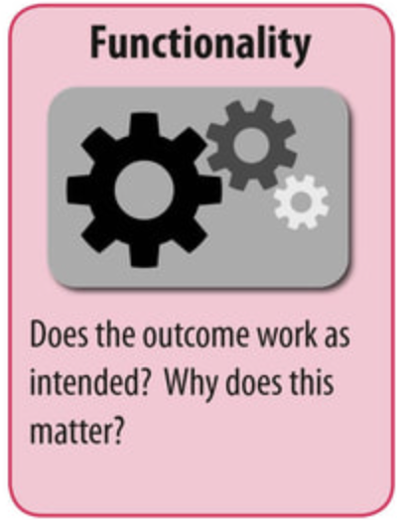 | The functionality of the program refers to how well the outcome performs its intended purpose. | The personalised skincare checker must be able to correctly collect user information, process responses, and generate suitable skincare recommendations. All buttons, recommendation features, and navigation should function without errors. If the program does not work as intended, it could result in users receiving incorrect recommendations.
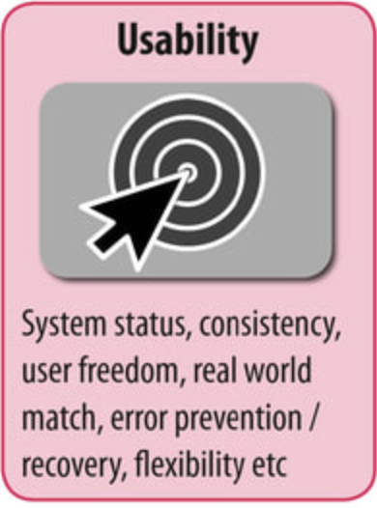 | Usability refers to the ease with which users can learn, understand, navigate, and interact with the program. | The personalised skincare checker is targeted towards people with different levels of skincare knowledge and computer experience. It should include a simple user interface, simple instructions, clear fonts, and labelled buttons so users can efficiently and confidently complete the questionnaire. A user-friendly design reduces confusion and improves user experience.
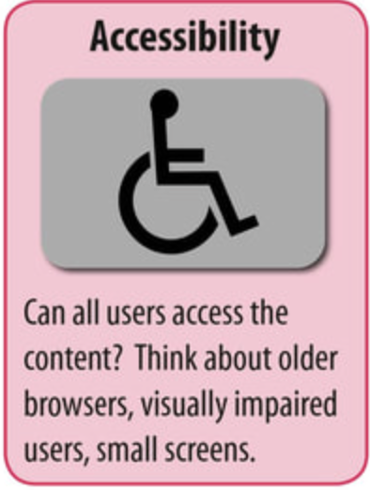 | Accessibility ensures that the application can be used by as many people as possible regardless of their abilities or level of technical expertise. | The program should use clear and readable fonts, font sizes, simple navigation, and clearly labelled buttons. These design choices in the user interface help ensure users can easily read information and navigate the application without any issues.
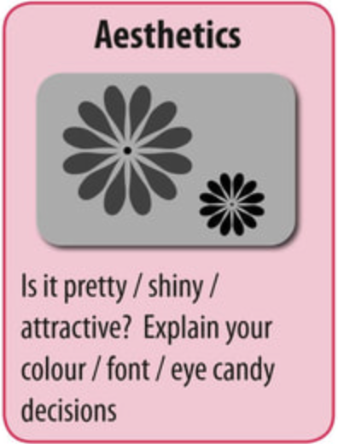 | Aesthetics refers to the visual appeal of the application, including its layout, colour scheme, fonts, images, and design. | The personalised skincare checker should incorporate a well-designed interface, making the application more engaging, professional, and visually appealing. An attractive design helps engage users, encouraging users to interact with the application and improves the overall user experience.
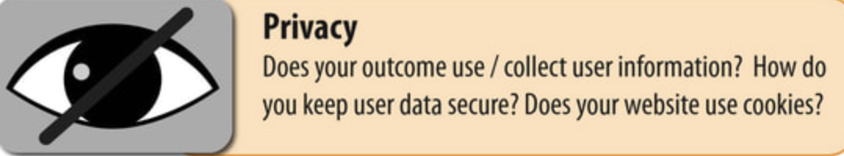 | Privacy refers to protecting the information entered by users and ensuring it is used responsibly. | The program will only request information that is required to generate the appropriate skincare recommendations, such as skin type and skin concerns. The personalised skincare checker does not require sensitive personal information, helping to protect privacy.

Links to Project Management:
Project Management Tool | Link
Trello | https://trello.com/invite/b/6a669e8b2b0895ae0a836cfb/ATTIb70630e9006a888a587ef6df54cace68B72F83F0/marrisapheng-91906
Github | https://github.com/marrisapheng/MarrisaPheng-91906
Draw.IO | https://drive.google.com/file/d/1kmkiB7r9Op4vNCS6ukcyJEd7NnPnD2zf/view?usp=sharing

(Screenshot of Task Decomposition from Trello)
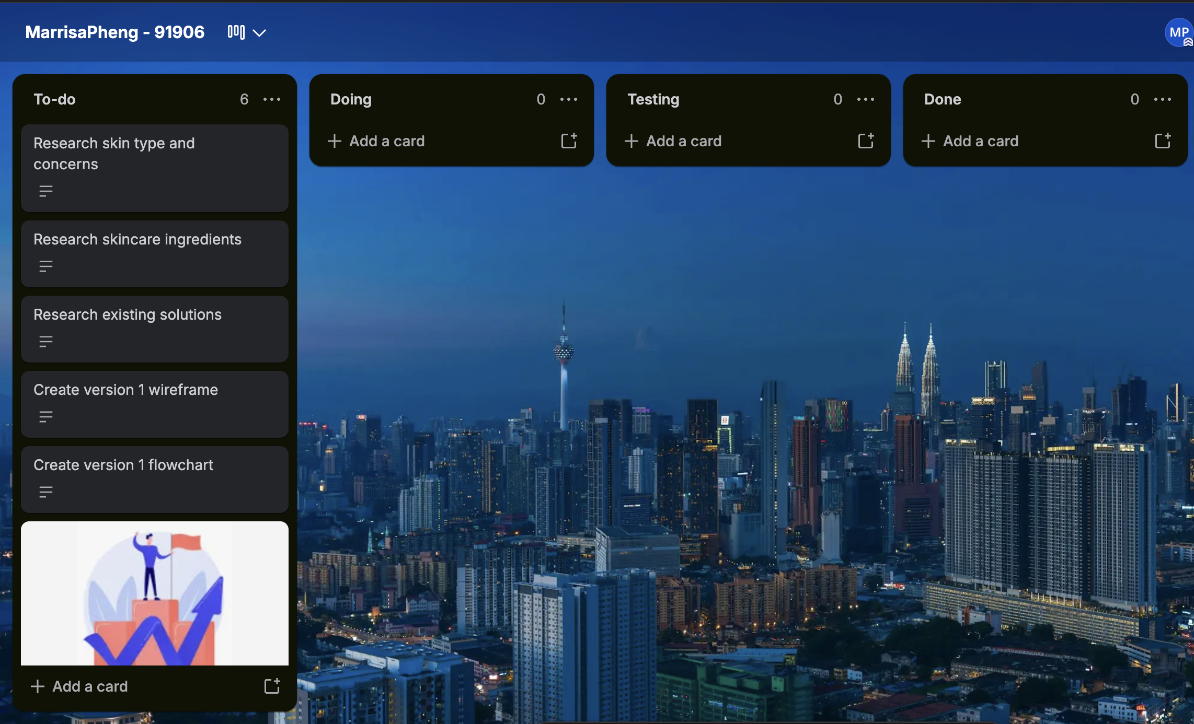

Iteration1: Explain what actions will happen in your first iteration.
(This should include the UML diagram with classes and inheritance if any, wireframe of your GUI, code structure, classes used, functions used. Highlight the key sections of the code that are of significance.)
The aim of the first iteration is to develop a basic working model of the personalised skincare checker. This version will focus on creating a simple graphical user interface, collecting user input, and displaying suitable skincare recommendations. The aim is to ensure the functionality of the program works before incorporating more advanced features into the application.
UML diagram:

Version 1 wireframe:
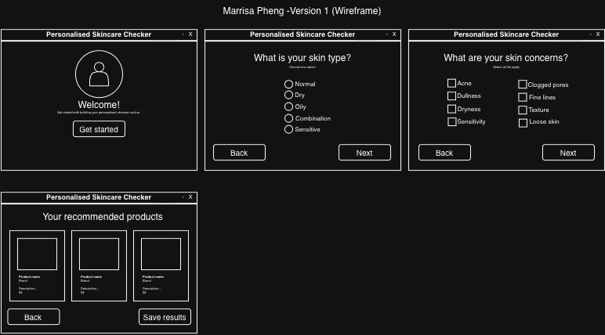
Code structure:
Table of objects required in the program (Add more rows if required.)
Objects/Variables/Storage structures such as lists/dictionaries/CSV/JSON | Datatype | Purpose and its relevance to the outcome development
Screenshot of Version 1 Flowchart:

Iteration 1: Component Testing Table: Include Screenshots and give reason which component is selected and why?
Valid Boundary Testing: (This is an example) Copy this table as you require below. Also create a table in this style with Invalid Boundary Testing.
Test Case Information | I will be testing the password input
Test Type | Invalid
Component Being Tested | Password Input
Test Data Entered | abc
Why This Data Was Used | It’s too short (only 3 characters)
Expected Result | Show error message with screenshot
Actual Result | Accepted the password
Pass/Fail | ❌ Fail
How the Error Was Fixed | Added a minimum length check (>=8 characters)
Screenshot | (Paste here)

Feedback on Version 1: include a testing video here.
Stakeholder | Feedback
SH1
SH2
Teacher’s Feedback
Updated Trello Screenshot after Version1

Summary of Feedback and intended changes to make in Version 2:

Iteration2: Explain what actions will happen in your second iteration.
(This should include the GUI Wireframe,code structure, classes used, functions used. Highlight the key sections of the code that are of significance. Include the Task screenshot from Trello)

Screenshot of V2 Flowchart:

Iteration 2: Component Testing Table: Include Screenshots: Include Screenshots and give reason which component is selected and why? Add more tables for other cases such as invalid cases.

Test Case Information
Test Type
Component Being Tested
Test Data Entered
Why This Data Was Used
Expected Result
Actual Result
Pass/Fail
How the Error Was Fixed
Screenshot

Feedback on Version 2: include a testing video here.
Stakeholder | Feedback
SH1
SH2
Teacher’s Feedback

Update the Trello and place a screenshot showing completion of above task.

Summary of Feedback and intended changes to make in Version 3:

Iteration3: Explain what actions will happen in your 3rd iteration.
(This should include the GUI Wireframe, code structure, classes used, functions used. Highlight the key sections of the code that are of significance.)

Screenshot of V3 Flowchart:

Iteration 3: Component Testing Table: Include Screenshots : Include Screenshots and give reason which component is selected and why? Add more tables for other cases such as invalid cases.

Test Case Information
Test Type
Component Being Tested
Test Data Entered
Why This Data Was Used
Expected Result
Actual Result
Pass/Fail
How the Error Was Fixed
Screenshot

Feedback on Version 3: include a testing video here.
Stakeholder | Feedback
SH1
SH2
Teacher’s Feedback

Summary of Feedback and intended changes to make in Version 4:

Iteration4: Explain what actions will happen in your fourth iteration.
(This should include the code structure, classes used, functions used. Highlight the key sections of the code that are of significance.)

Screenshot of V4 Flowchart:

Iteration 4: Component Testing Table: Include Screenshots : Include Screenshots and give reason which component is selected and why? Add more tables for other cases such as invalid cases.
Test Case Information
Test Type
Component Being Tested
Test Data Entered
Why This Data Was Used
Expected Result
Actual Result
Pass/Fail
How the Error Was Fixed
Screenshot

Feedback on Version4: include a testing video here.
Stakeholder | Feedback
SH1
SH2
Teacher’s Feedback
Summary of Feedback and intended changes to make in Version 5:

Iteration5: Explain what actions will happen in your fifth iteration.
(This should include the GUI wire frame, code structure, classes used, functions used. Highlight the key sections of the code that are of significance.)

Screenshot of V5 Flowchart:

Iteration 5: Component Testing Table: Include Screenshots: Include Screenshots and give reason which component is selected and why?
Test Case | Expected

Feedback on Version 5: include a testing video here.
Stakeholder | Feedback
SH1
SH2
Teacher’s Feedback

A comparative chart of Version GUI showing iterative improvement
Version1 Description | GUI Design
Version2 Description and Feedback | Gui Design
Version 3 Description and Feedback | GUI Design
Version4 Description and Feedback | GUI Design
Version 5 Description and Feedback | GUI Design

Discuss how you addressed the Relevant Implications you described and explained earlier. Please provide screenshots where you applied the implication.
Relevant Implication | How I applied this in the development of my outcome.

Final Trello Board showing all the Tasks Done :

Fitness for Purpose:
(Discusses how the information from planning, testing and trialling of components assisted in the development of a high-quality outcome. Include how this can be further developed and implemented in the future.)

Describe two alternative approaches you considered.
Explain why you rejected them.

Describe one major programming challenge you encountered.
Explain
- what caused it
- how you investigated it
- how you solved it
- what you learnt

Choose one important function or algorithm from your program.
Explain
- why it was designed this way
- why this solution is efficient
- what would happen if it were written differently

Explain how decomposition helped you during development.
Possible discussion
- functions
- modules
- classes
- reusable code
- readability

Identify one programming convention you followed.
Examples
- naming conventions
- comments
- indentation
- modular programming
- constants
- validation
Explain why following the convention improved the program.

Describe your testing process.
Include
- unit testing
- integration testing
- user testing
- boundary testing
- invalid data
Choose one bug that was difficult to fix.
Explain
- symptoms
- possible causes
- investigation
- final solution
Describe a situation where testing changed your original design.

What evidence convinced you to make the change?

Describe one piece of stakeholder feedback.
Explain
- why the stakeholder suggested it
- whether you agreed
- what changes you made
- how those changes improved the outcome
Describe one stakeholder suggestion that you did NOT implement.
- Explain why.

- This demonstrates critical judgement rather than blindly accepting all feedback.

Evaluate the strengths of your completed program.
Don't simply list features.
Explain
- how each feature benefits the user
- why it improves fitness for purpose

What evidence shows that your program is fit for purpose?
Support your answer using
- testing
- stakeholder feedback
- final functionality

Make sure you tick all the boxes here.
Requirement | Status  √
Introduction to the project
End users
Project Management Tools such as Trello, Github, Draw.IO used and updated from version to version.
Relevant implications- Described and Explained
Software requirements listed
Program design requirements such as selection, sequence and iteration control structures
Flowcharts
Defined Classes and created obje
GUI wireframes for all versions including annotations
Coding conventions followed
Reads from or writes to files or other persistent storage used
Defined classes and created objects
Defined and used custom data types
Used complex data structures such as Queues
Trello updated frequently.
Links for Trello, Github and Draw.IO given
Comments written to describe the code
Annotated screenshots or screencast videos showing the testing procedures
Annotated screenshots or screencast videos demonstrating the program is functioning
Documented all the testing procedures using tables provided for each version.
Feedback from end users/stakeholders documented correctly.
Addressed relevant Implications with screenshots
Summary of fitness for purpose
Final Update of Trello board with all tasks done.

