Machine Learning and End-to-end Deep Learning for the Detection of Chronic Heart Failure from Heart Sounds

Due to chronic heart failure many peoples are losing their lives worldwide and to reduce this lives lost we need to have expert physicians and sometime if such experts not available then it’s difficult to save life and to overcome from such issue author of this paper is combining different algorithms such as Classic Random Forest and End-End Deep Learning model and then extracting features from both algorithms and then retraining with Random forest by taking AVERAGE Aggregate Recording features from Classic ML and end - end deep learning models. Average Aggregate Recording model giving better accuracy compare to other algorithms.

In propose paper author is using heart sound dataset from PHYSIONET website and this dataset contains PCG signals data and we are extracting systolic and diastolic features from this PCG signals and training with Classic ML algorithms and then PCG recording voice data will get trained with deep learning algorithm.

ML cannot train on RAW features so we are extracting systolic and diastolic features from PCG RAW data and training with Classic ML and then Raw features get trained with Deep learning. From both models we will extract average recordings and then retrain with 3rd classifier which will give more accuracy.

To implement this project we have designed following modules

1. Upload Physionet Dataset: using this module we will upload dataset to application
2. Dataset Preprocessing: using this module we will extract audio recording features and systolic and diastolic features from dataset and then normalize values
3. Run ML Segmented Model with FE & FS: using this module we will extract and select systolic and diastolic features from dataset and then train with Random Forest Classic ML model and then apply test data to calculate its prediction accuracy
4. Run DL Model on Raw Features: using this module we will extract RAW features from recording and then train with deep learning model and then this model will be applied on test data to calculate its accuracy
5. Run Recording ML Model: using this module we will extract features from Classic ML model and deep learning model and then retrain with 3rd classifier to get its prediction accuracy
6. Predict CHF from Test Sound: using this module we will upload Test Heart Sound file and then classifier model will predict weather given recording file is Normal or Abnormal

Below is the dataset screen used in this project

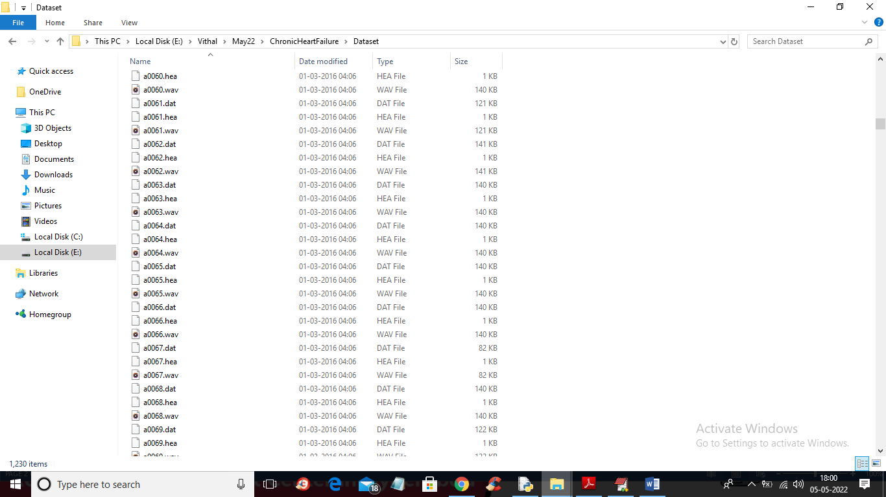

In above screen we have 3 files where .hea file contains class label as Normal or Abnormal and .dat file contains PCG signals and .wav file contains heart sound recording and by using all files we will train all algorithms

SCREEN SHOTS

To run project double click on ‘run.bat’ file to get below screen

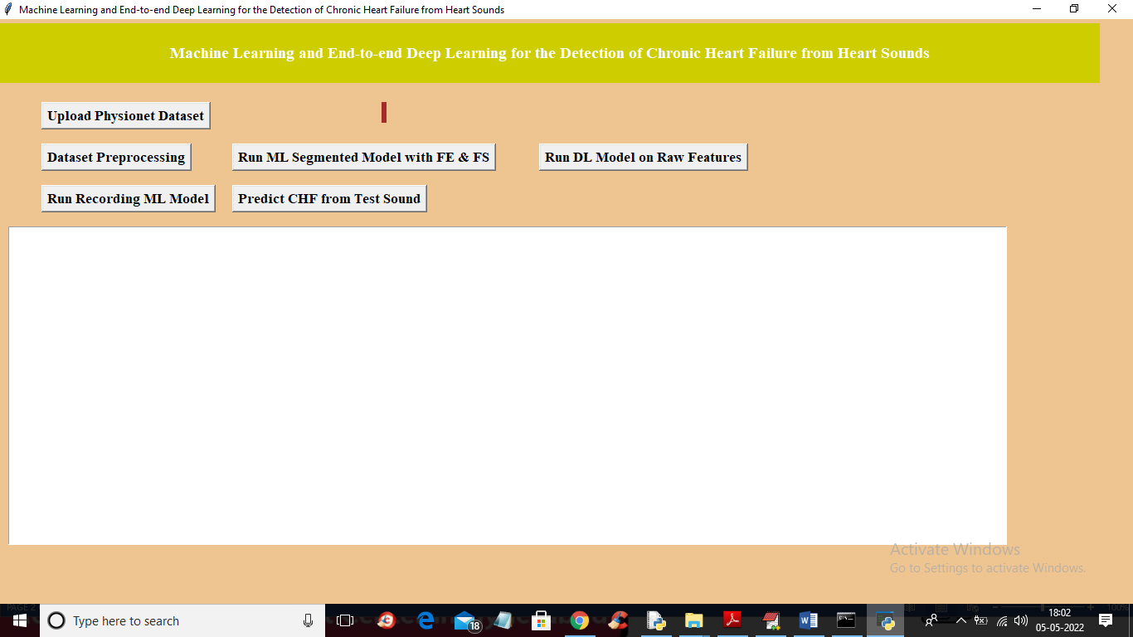

In above screen click on ‘Upload Physionet Dataset’ button to upload dataset

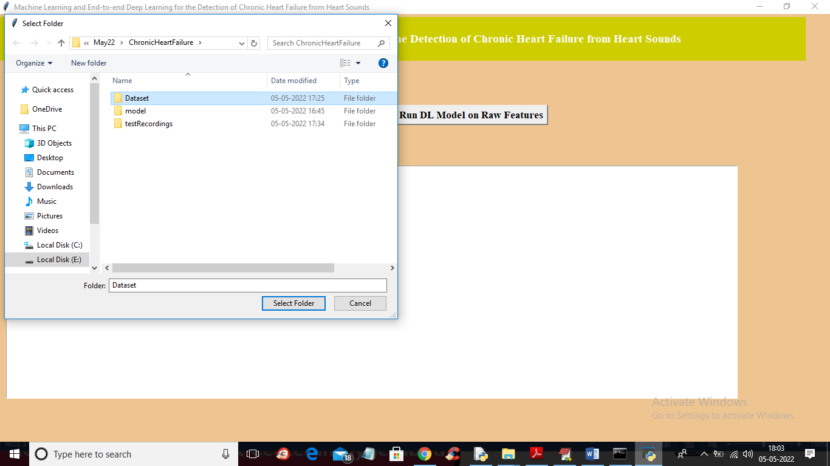

In above screen selecting and uploading ‘Dataset’ folder and then click on ‘Select Folder’ button to load dataset and to get below output

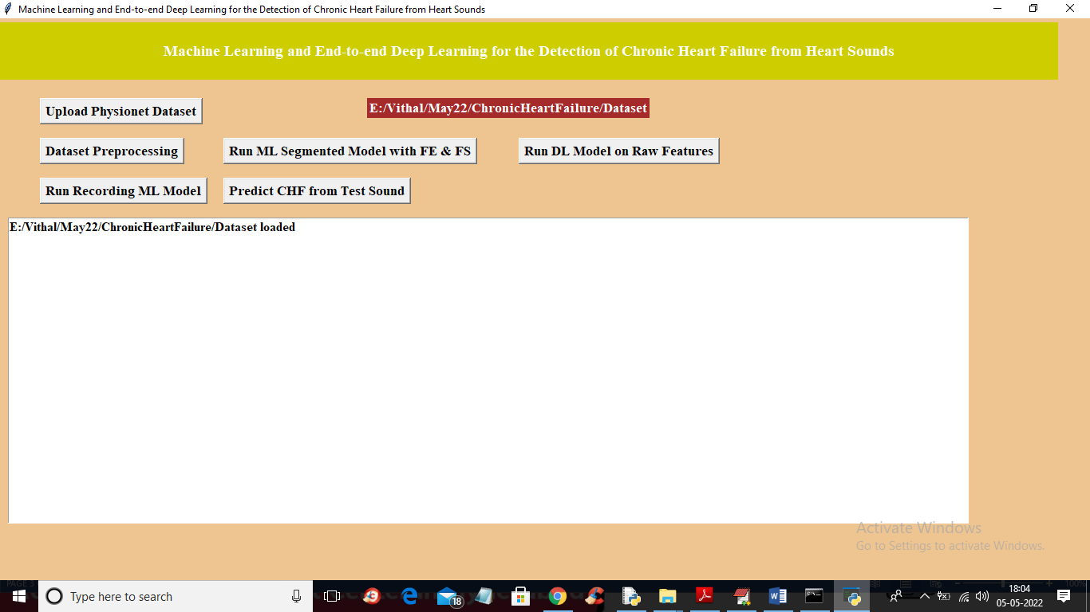

In above screen dataset loaded and now click on ‘Dataset Preprocessing’ button to read all dataset file and then extract features from it

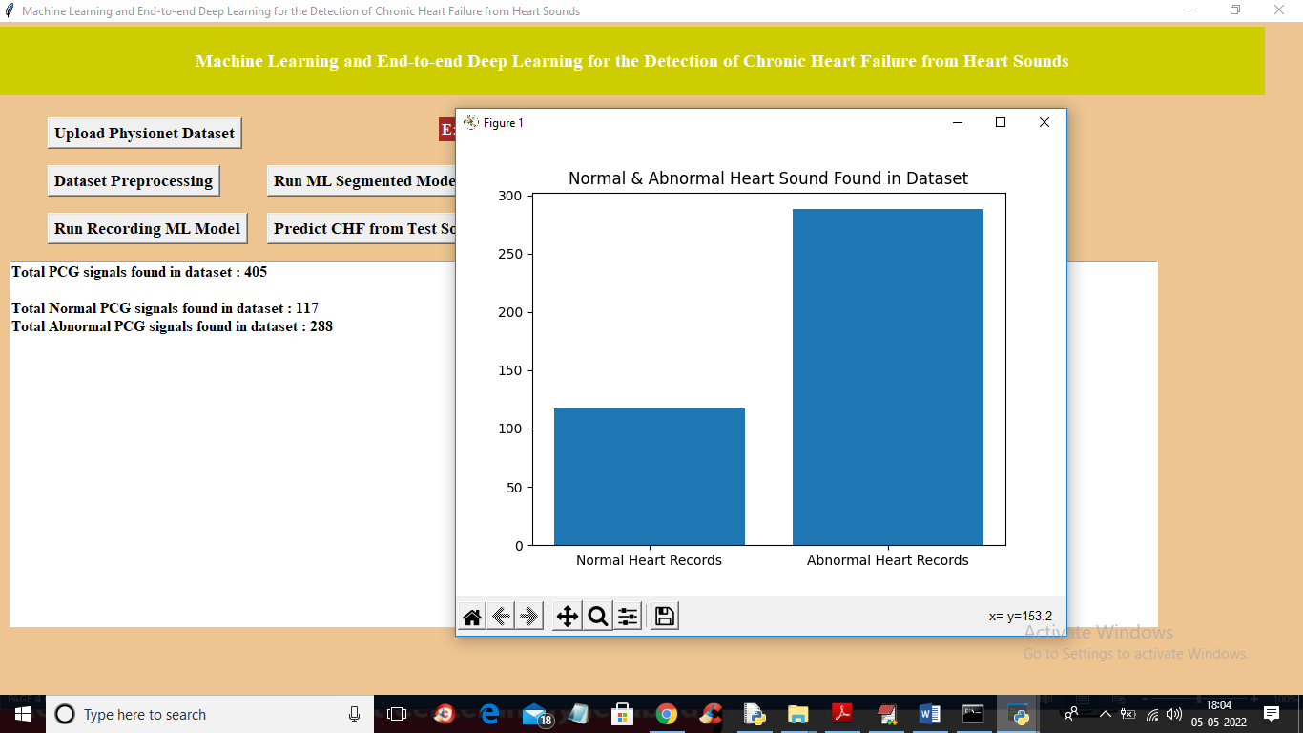

In above screen we can see dataset contains 405 heart sound files from 405 different person and 117 are the Normal sound and 288 are abnormal and in graph x-axis represents normal or abnormal and y-axis represents number of persons for normal or abnormal. Now close above graph and then click on ‘Run ML Segmented Model with FE & FS’ button to train Classic ML segmented model on above dataset and get below output

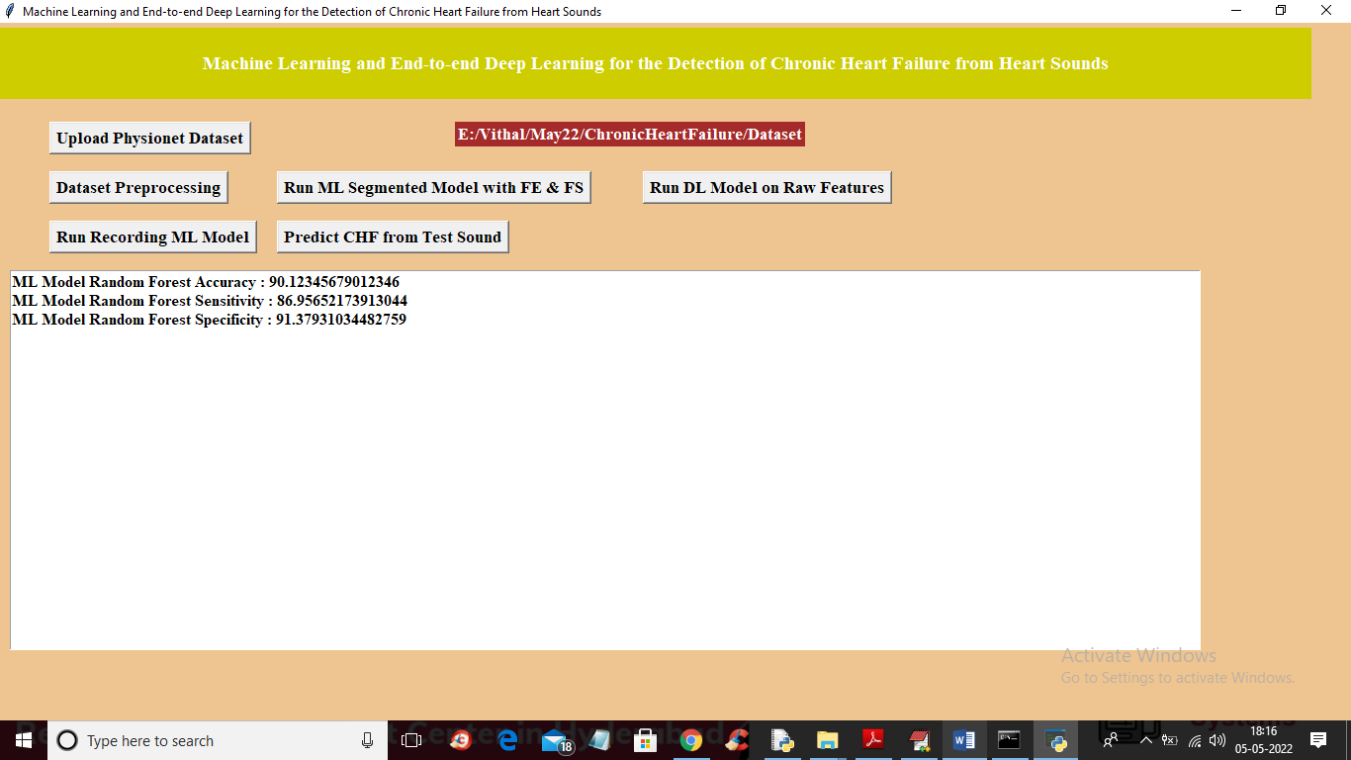

In above screen with Classic ML we got 90% accuracy and now click on ‘Run DL Model on Raw Features’ to get below output

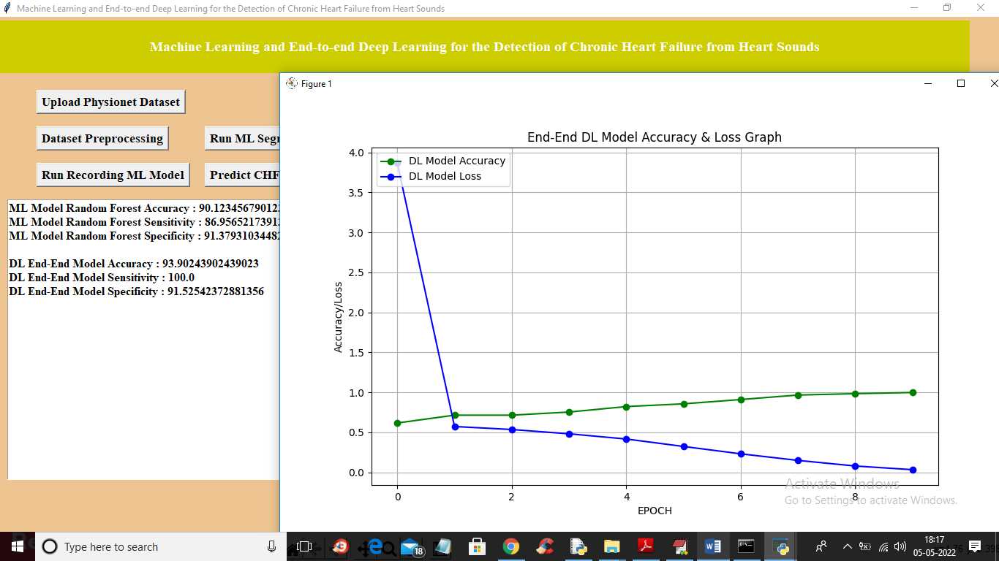

In above screen with DL model we got 93% accuracy and in graph x-axis represents epoch or iterations and y-axis represents accuracy or loss values and green line represents accuracy and blue line represents LOSS and we can see with each increasing epoch accuracy got increase and loss got decrease and now close above graph and then click on ‘Run Recording Model’ button to get below output

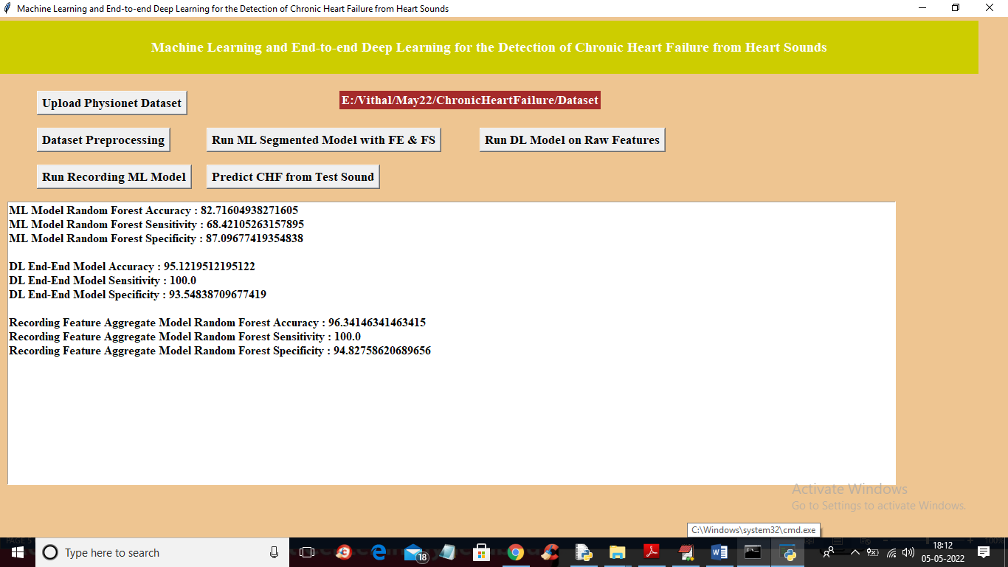

In above screen with recording model we got 96% accuracy and we can see all algorithms performance graph in below screen

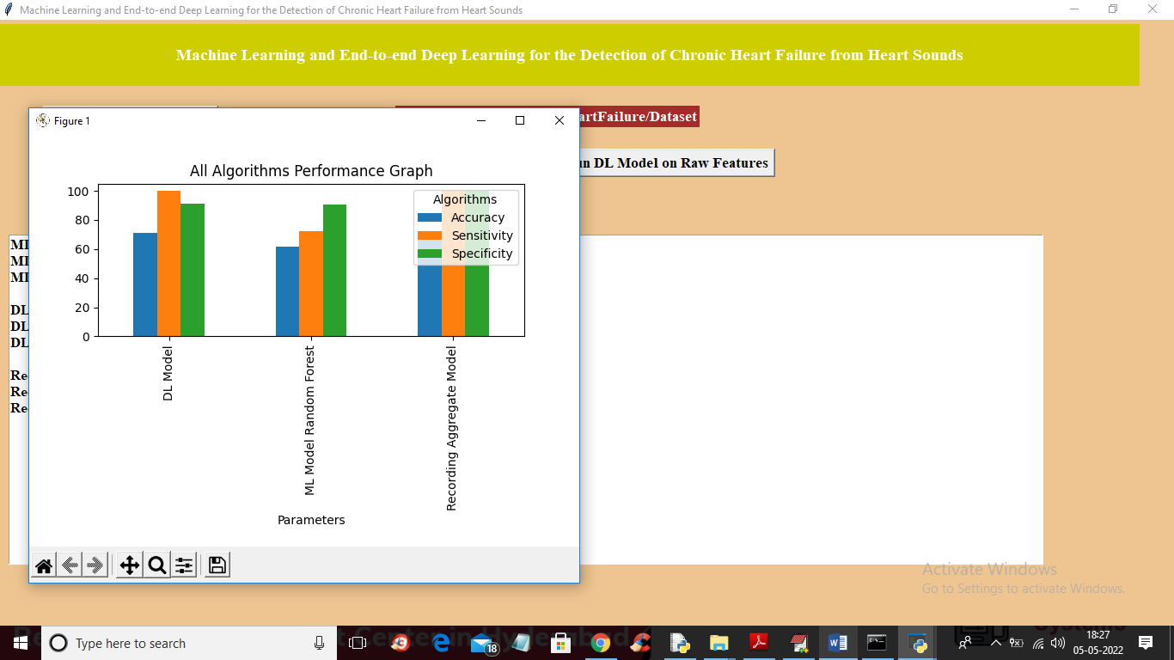

In above graph x-axis represents algorithm names and y-axis represents accuracy, sensitivity and specificity and in all algorithms Recording model has got high accuracy. Now close above graph and then click on ‘Predict CHF from Test Sound’ button to upload test sound file and get predicted output as Normal or Abnormal

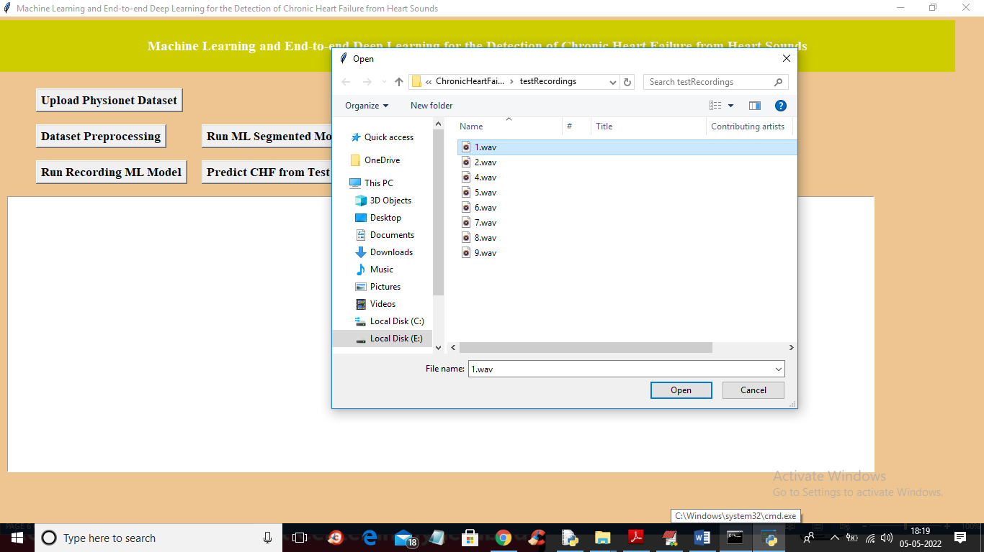

In above screen selecting and uploading ‘1.wav’ file and then click on ‘Open’ button to get below output

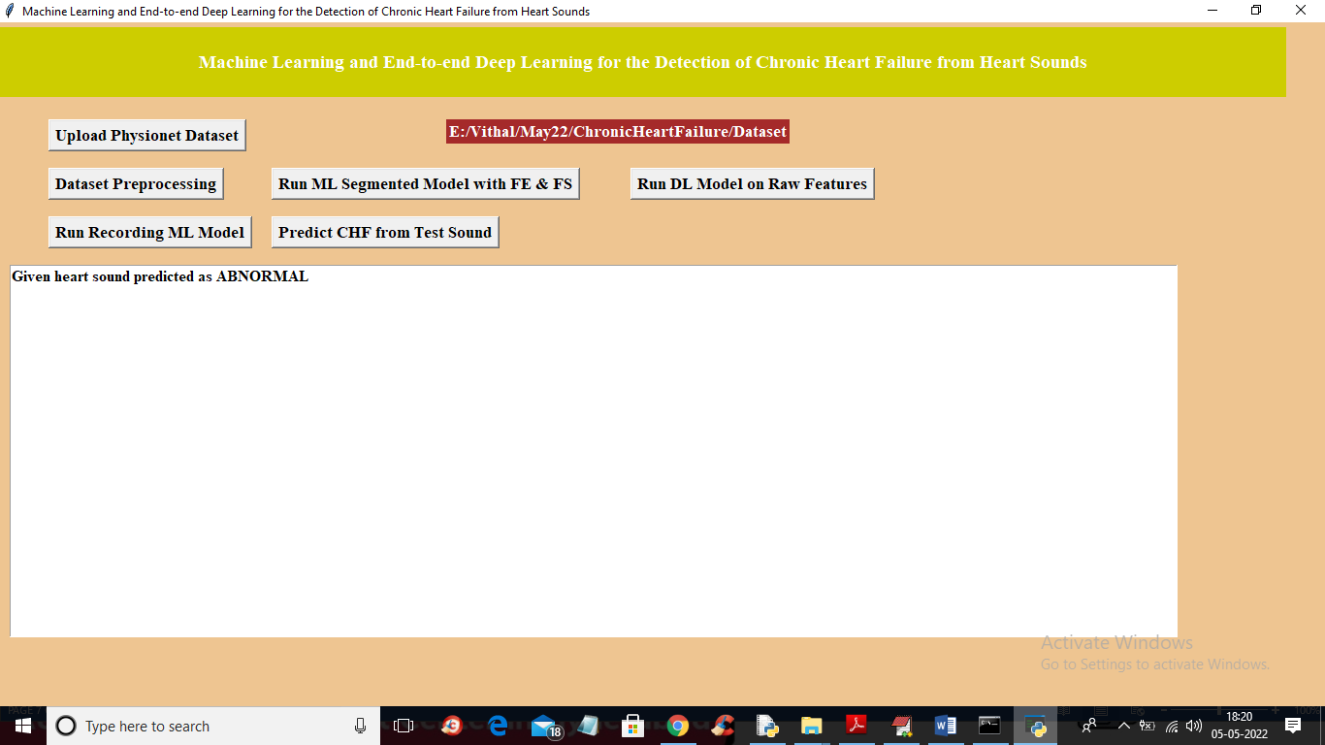

In above screen uploaded heart sound file predicted as ABNORMAL and similarly you can upload other files and test

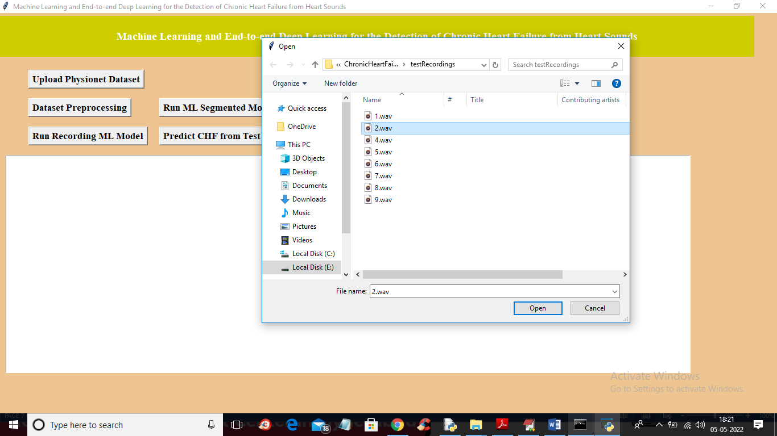

For 2.wav’ file below is the output

