Author : Mark Roberts
IBM Rational Software
markroberts@uk.ibm.com
March, 2013

Rational License Reporting Tool
Issue 1.0

This software is supplied without warranty or support. Enhancement requests and defects may be reported to the author but there is no guarantee that the request will be acted upon. I will do what I can to assist with the use and further development of this reporting tool, but it cannot be considered to be a part of the Rational product set which is covered by a purchased maintenance contract.

Introduction

This tool uses the FlexLM command line utilities supplied with Rational products (other than ClearCase and ClearCase MultiSite) to report on license use. The commands used are :

lutil lmstat –f <Rational Product Name>

For ClearCase and ClearCase MultiSite the command shown below is used :

clearlicense –product <Rational Product Name>

Required Script Modifications

In order to use the tool the following site specific modifications are required :

Name of the license server :

Change the text within the quotes to set the variable $LIC_SERVER to the name of the required license server.

Name of the summary information file :

Change the text “summary.txt” to whatever the summary document should be called.

Name of the log file :

Change the text “log.txt” to whatever the log file should be called.

Products to report on :

To report on Rational products it is first necessary to find the right name with the right capitalisation to put into the report. Execute the command :

lmutil lmstat –a

This will show lines such as :

Users of RationalSuiteEnterprise: (Total of xx licenses available)

The required text is RationalSuiteEnterprise without the trailing quote character.

Put a space separated list of the required products inside the brackets in the line of the script that sets the variable @FlexLicenses.

Abbreviated names of products to report on :

For each product on which licenses are to be reported a shorter abbreviated name is required. For example Rational Suite Enterprise could be abbreviated to RSE or SE, and Rational Suite Test Studio could be abbreviated to TS etc. The space separated list of abbreviations should go inside the brackets in the line of the script that sets the variable @LicenseAbreviations. Note that if ClearCase and ClearQuest are to be reported on then their abbreviations must also be included at the end of the list. The sample script supplied includes reporting on Rational Suite Enterprise, ClearCase and ClearCase MultiSite.

If reporting of license use on ClearCase or ClearCase MultiSite is not required then the sections indicated by comments can be removed.

Script execution :

The script has been tested using ActiveState PERL version 5.6.1. There are no special libraries used and so any PERL implementation should work fine. There are no required command line arguments to the script and so it may be executed simply by using :

perl get_license_information.pl

Output files :

For each named product on which to report (listed in the @FlexLicenses variable) a file is produced. This file has the same name as that which is put into @FlexLicenses, except that it has .txt appended to the name.

An example of the content of the file is show below :

,clare,emma,joe,mark,mike,mroberts,sarah
2/5/2003,2,2,1,0,1,0,2
2/6/2003,24,55,86,55,0,0,0
4/9/2003,0,0,0,0,0,14,0
Totals,26,57,87,55,1,14,2

The comma separated data can be imported into Excel where it will appear as :

 | clare | emma | joe | mark | mike | mroberts | sarah
2/5/2003 | 2 | 2 | 1 | 0 | 1 | 0 | 2
2/6/2003 | 24 | 55 | 86 | 55 | 0 | 0 | 0
4/9/2003 | 0 | 0 | 0 | 0 | 0 | 14 | 0
Totals | 26 | 57 | 87 | 55 | 1 | 14 | 2

The information shows that during each day the specified number of ‘reporting units’ were consumed by each person. If the report is executed every 10 minutes then it can be assumed that on 2/6/2003 Clare used Rational Suite Enterprise for 4 hours. In total during the period that the reporting tool has been in use Joe has used 87 ‘reporting units’ which represents 14.5 hours of use.

When the data is opened in Excel it is possible to produce charts that show the relative use of the tools such as that shown below :

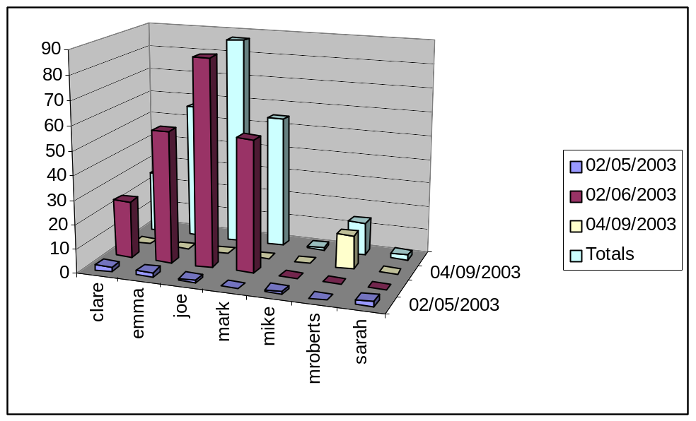

A chart of the relative total license use is as shown below :

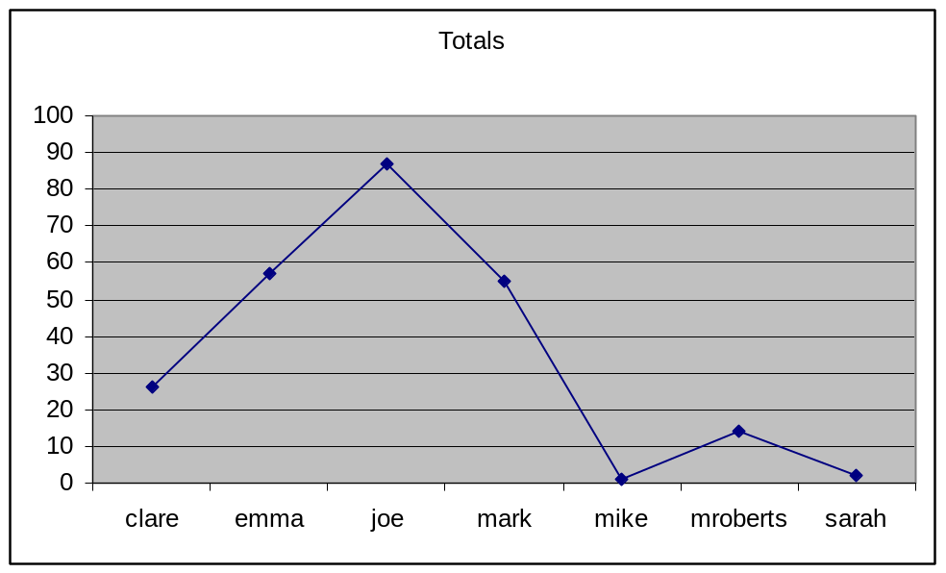

A single summary document is also produced. This shows the maximum license count available and the current license usage. This report differs from the daily cumulative report shown above since it also includes the time that the reports was executed. This will allow peaks and trends throughout the day to be tracked. The data is as shown below :

Date & Time,SE-Max,SE-Cur,CC-Max,CC-Cur,CCMS-Max,CCMS-Cur
04/09/2003 09:00,10,2,10,3,10,0
04/09/2003 09:30,10,2,10,5,10,1
04/09/2003 10:00,10,4,10,8,10,2
04/09/2003 10:30,10,6,10,10,10,4
04/09/2003 11:00,10,8,10,10,10,5
04/09/2003 11:30,10,10,10,9,10,6
04/09/2003 12:00,10,10,10,9,10,6
04/09/2003 12:30,10,10,10,10,10,7
04/09/2003 13:00,10,10,10,10,10,8
04/09/2003 13:30,10,10,10,10,10,8
04/09/2003 14:00,10,10,10,9,10,8
04/09/2003 14:30,10,10,10,8,10,6
04/09/2003 15:00,10,10,10,7,10,4
04/09/2003 15:30,10,8,10,8,10,6
04/09/2003 16:00,10,7,10,8,10,5
04/09/2003 16:30,10,5,10,5,10,2
04/09/2003 17:00,10,4,10,2,10,1
04/09/2003 17:30,10,1,10,3,10,0

When opened in Excel the data appears as :

Date & Time | SE-Max | SE-Cur | CC-Max | CC-Cur | CCMS-Max | CCMS-Cur
04/09/2003 09:00 | 10 | 2 | 10 | 3 | 10 | 0
04/09/2003 09:30 | 10 | 2 | 10 | 5 | 10 | 1
04/09/2003 10:00 | 10 | 4 | 10 | 8 | 10 | 2
04/09/2003 10:30 | 10 | 6 | 10 | 10 | 10 | 4
04/09/2003 11:00 | 10 | 8 | 10 | 10 | 10 | 5
04/09/2003 11:30 | 10 | 10 | 10 | 9 | 10 | 6
04/09/2003 12:00 | 10 | 10 | 10 | 9 | 10 | 6
04/09/2003 12:30 | 10 | 10 | 10 | 10 | 10 | 7
04/09/2003 13:00 | 10 | 10 | 10 | 10 | 10 | 8
04/09/2003 13:30 | 10 | 10 | 10 | 10 | 10 | 8
04/09/2003 14:00 | 10 | 10 | 10 | 9 | 10 | 8
04/09/2003 14:30 | 10 | 10 | 10 | 8 | 10 | 6
04/09/2003 15:00 | 10 | 10 | 10 | 7 | 10 | 4
04/09/2003 15:30 | 10 | 8 | 10 | 8 | 10 | 6
04/09/2003 16:00 | 10 | 7 | 10 | 8 | 10 | 5
04/09/2003 16:30 | 10 | 5 | 10 | 5 | 10 | 2
04/09/2003 17:00 | 10 | 4 | 10 | 2 | 10 | 1
04/09/2003 17:30 | 10 | 1 | 10 | 3 | 10 | 0

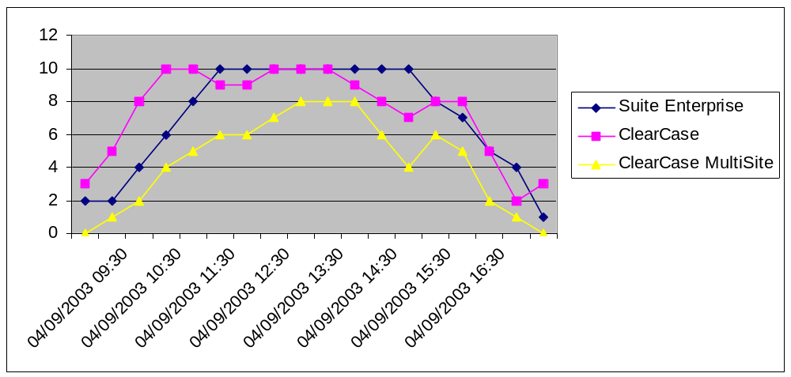Graphs can then be plotted to show the usage patters such as :

The final output file is a log of all captured information.
This shows the following information :

28/2/2003 20:47,RationalSuiteEnterprise.txt,sarah,192.168.218.155,w2k-sroberts
28/2/2003 20:47,RationalSuiteEnterprise.txt,julie,192.168.218.154,w2k-jsharman
4/9/2003 11:45,ClearCase.txt,emma
4/9/2003 11:45,ClearCase.txt,Adrian
The first line shows that at 20:47 on 28/2/2003 a user who was logged in as ‘Sarah’ from a workstation called w2k-sroberts, with an ip address of 192.168.218.155 and used Rational Suite Enterprise.
The third and fourth lines show ClearCase use by users logged in as Emma and Adrian. ClearCase and ClearCase MultiSite reports do not show workstation names and ip addresses.

Scheduling the execution :

It is possible to schedule the execution of the reporting tool using the windows ‘at’ scheduler, or other suitable software.

Script

# Put the appropriate license server name here.
$LIC_SERVER="IBMGB-MROBER01";

# The name of the file to hold summary information.
$Summary = "summary.txt";

# The name of the log file.
$LogFileName = "log.txt";

my @TimeArray = localtime(time);
$CurrentDate = @TimeArray[3]."/".(@TimeArray[4] + 1)."/".(@TimeArray[5] + 1900);

if (@TimeArray[2] <= 9) { $Time = "0".@TimeArray[2]; }
else { $Time = @TimeArray[2]; }
if (@TimeArray[1] <= 9) { $Time .= ":0".@TimeArray[1]; }
else { $Time .= ":".@TimeArray[1]; }

$CurrentDateTime = $CurrentDate." ".$Time;

# Add unquoted list of products for which licenses are to be recorded. Use the actual word reported by the
# FlexLM license tools. Use the command 'lmutil lmstat -a' to show the appropriate keywords to use for the
# products that you have.

@FlexLicenses = qw(RationalSuiteEnterprise ClearQuestMultiSite ClearQuest);

# Add an unquoted list of suitable license key abreviations. In the summary document these abreviations will
# have -Max and -Cur appended to them to indicate maximum available licenses and current license use.
@LicenseAbreviations = qw(SE CQMS CQ);

$SummaryData = $CurrentDateTime;

foreach $Flex (@FlexLicenses)
{
print "=========================================================\n";
GetSuiteLicenseUse($Flex);
UpdateUseStats($Flex, $LogFileName);
ClearDataStructures();
$SummaryData .= ",".$MaxLicenses.",".$UseCount;
}
$SummaryData .= "\n";

# ClearCase block - remove if ClearCase is not used.
# print "=========================================================\n";
ClearDataStructures();
GetClearCaseLicenseUse("ClearCase");
UpdateUseStats("ClearCase", $LogFileName);
$SummaryData .= ",".$MaxLicenses.",".$UseCount;
# End of ClearCase block

# ClearCase MultiSite block - remove is ClearCase is not used.
# print "=========================================================\n";
ClearDataStructures();
GetClearCaseLicenseUse("MultiSite");
UpdateUseStats("MultiSite", $LogFileName);
$SummaryData .= ",".$MaxLicenses.",".$UseCount."\n";
# End of ClearCase MultiSite block

if (-e $Summary)
{
$Summary = ">>".$Summary;
open SUMMARY, $Summary;
print SUMMARY $SummaryData;
close SUMMARY;
}
else
{
$Summary = ">".$Summary;
open SUMMARY, $Summary;

print SUMMARY "Date & Time";
foreach $LicAbr (@LicenseAbreviations)
{
print SUMMARY ",".$LicAbr."-Max,".$LicAbr."-Cur";
}
print SUMMARY "\n".$SummaryData;
close SUMMARY;
}

exit(0);

sub GetSuiteLicenseUse{
my ($LicType) = @_;
print $LicType."\n";

$GetLicenseDataCmd = "lmutil lmstat -f ".$LicType;
$LicenseData = `$GetLicenseDataCmd`;

# Split the license report data into an array and process it.
#

@LicenseArray = split("\n", $LicenseData);
$LineCounter = 1;
$UseCount = 0;
foreach $_ (@LicenseArray)
{
# Get the total number of licenses available.
#
if (((m/\(Total of/) && (m/licenses available/)) || ((m/\(Total of/) && (m/licenses issued/)))
{
$MaxLicensesTmp = substr($_, index($_, "Total of ") + length("Total of "));
$MaxLicenses = substr($MaxLicensesTmp, 0, index($MaxLicensesTmp, " "));
}
# Get the date that the command was run.
#
if (m/Flexible License Manager status on/)
{
$DateSampled = substr($_, index($_, "Flexible License Manager status on ") + length("Flexible License Manager status on ") + 4);
@DateTime = split(" ", $DateSampled);
@DateParts = split("/", @DateTime[0]);
$DateSampled = @DateParts[1]."/".@DateParts[0]."/".@DateParts[2];
$DateTimeSampled = $DateSampled." ".@DateTime[1];
}

# Get the total number of lines that start at the specific column.
# These are the names of the users.
#

if ($LineCounter > 9)
{
if (m/^ ([A-Z]|[a-z]|[0-9])/)
{
$UserInformation = substr($_, 4);
@UserInformationArray = split(" ", $UserInformation);
$UserName = @UserInformationArray[0];
$ClientIPAddress = @UserInformationArray[1];
$ClientMachineName = @UserInformationArray[2];

# push the username, IP address and the client PC name into an array for processing later.
#

push @UseArray, $UserName.",".$ClientIPAddress.",".$ClientMachineName."\n";
$UseCount++;
}
}
$LineCounter++;
}

$ResultString = $DateSampled.",".$MaxLicenses.",".$UseCount;
print "Max Licenses : ".$MaxLicenses." ";
print "Use count : ".$UseCount."\n";
}

sub GetClearCaseLicenseUse{
my ($LicType) = @_;
print $LicType."\n";
$GetLicenseDataCmd = "clearlicense -product ".$LicType;
$LicenseData = `$GetLicenseDataCmd`;
print $LicenseData."\n";

$DateSampled = $CurrentDate;
$DateTimeSampled = $CurrentDateTime;

# Split the license report data into an array and process it.
#

@LicenseArray = split("\n", $LicenseData);
$LineCounter = 1;
$UseCount = 0;
foreach $_ (@LicenseArray)
{
# Get the total number of licenses available.
#
if (m/\Maximum active users allowed:/)
{
$MaxLicenses = substr($_, index($_, ": ") + length(": "));
}

# Get the total number of lines that start at the specific column.
# These are the names of the users.
#

if (m/Current active users:/)
{
$UseCount = substr($_, index($_, ": ") + length(": "));
}
if (m/License Usage Statistics/)
{
$ActiveUsersRegion = 0;
}
if ((!m/Time-out in/) && ($ActiveUsersRegion == "1") && (m/$\\)/))
{
for ($Counter = 0;$Counter < 20; $Counter++)
{
$_ =~ s/ / /g;
}
$_ =~ s/^ //g;
@UseData = split(" ", $_);
push @UseArray, @UseData[0]."\n";
}
if (m/ACTIVE users:/)
{
$ActiveUsersRegion = 1;
}
}

$ResultString = $DateSampled.",".$MaxLicenses.",".$UseCount;
print "Max Licenses : ".$MaxLicenses." ";
print "Use count : ".$UseCount."\n";
}

sub UpdateUseStats
{
my ($StatsFileName, $LogFile) = @_;
$StatsFileName = $StatsFileName."\.txt";
# Get the current usage information from the file.
#

if (-e $StatsFileName)
{
# The file exists.

$FileData = "";

open STATS_FILE, $StatsFileName;
while (!eof(STATS_FILE)) { read STATS_FILE, $Buffer, 25; $FileData .= $Buffer; }
close STATS_FILE;

# Populate the hash data.
#

@FileDataArray = split("\n", $FileData);

pop(@FileDataArray);

@NamesList = split("\,", @FileDataArray[0]);

@NamesList = reverse(@NamesList);
pop(@NamesList);

@NamesList = reverse(@NamesList);

for ($DataCounter = 1; $DataCounter <= $#FileDataArray; $DataCounter++)
{
@LineContent = split("\,", @FileDataArray[$DataCounter]);
for ($RowCounter = 1; $RowCounter <= $#LineContent; $RowCounter++)
{
$Data{$LineContent[0]}{@NamesList[$RowCounter - 1]} = @LineContent[$RowCounter];
}
}

# Print the file data to screen.
#
print "-------------------------------------------------------------------\n";
print "Old statistics .....\n";
for $Date (sort SortDates keys %Data)
{
print $Date.".... ";
for $Person (sort keys %{$Data{$Date}}) { print $Person." = ".$Data{$Date}{$Person}." "; }
print "\n";
}
}

$DateFound = 0;

for $Date (sort keys %Data)
{
$_ = $Date;
if (m/$DateSampled/) { $DateFound = 1; }
}
if ($DateFound == "0")
{
print "Date to be added.\n";
foreach $Name (@NamesList)
{
$Data{$DateSampled}{$Name} = 0;
print "placeholder for : ".$Name."\n";
}
}
# Add new names to the hash if necessary.
#

foreach $Use (@UseArray)
{
if (index($Use, ",") > 0)
{
@UseData = split("\,", $Use);
$_ = @UseData[0];
}
else
{
if (index($Use, "\n") > 0)
{
$_ = $Use;
$_ =~ s/\n//g;
}
}

$NameFound = 0;

foreach $CurrentName (@NamesList)
{
if (m/$CurrentName/) { $NameFound = 1; }
}
if ($NameFound == "0")
{
# Add the new name to the hash.
for $Date (sort keys %Data) { $Data{$Date}{$_} = 0; }
}
}

# Add current usage stats.
#

foreach $Use (@UseArray)
{
if (index($Use, ",") > 0)
{
@UseData = split("\,", $Use);
$_ = @UseData[0];
}
else
{
if (index($Use, "\n") > 0)
{
$_ = $Use;
$_ =~ s/\n//g;
}
}

if ($Data{$DateSampled}{$_} == "") { $Data{$DateSampled}{$_} = "1"; }
else { $Data{$DateSampled}{$_}++; }
}

print "-------------------------------------------------------------------\n";
print "New statistics .....\n";

for $Date (sort SortDates keys %Data)
{
print $Date.".... ";
for $Person (sort keys %{$Data{$Date}}) { print $Person." = ".$Data{$Date}{$Person}." "; }
print "\n";
$LastDate = $Date;
}

# Totals
#

foreach $Person (keys %{$Data{$DateSampled}})
{
$Total = 0;
for $Date (sort keys %Data) { $Total += $Data{$Date}{$Person}; }
$Totals{$Person} = $Total;
}

# Store the new data in the file.
#

print "-------------------------------------------------------------------\n";

# Save the old stats to a .bak file.

$CopyCmd = "copy ". $StatsFileName." ". $StatsFileName.".bak";
`$CopyCmd`;

$FileName = ">".$StatsFileName;

open FILEHANDLE, $FileName;

for $Person (sort keys %{$Data{$LastDate}}) { print FILEHANDLE ",".$Person; }
print FILEHANDLE "\n";
for $Date (sort SortDates (keys %Data))
{
print FILEHANDLE $Date;
for $Person (sort keys %{$Data{$Date}}) { print FILEHANDLE ",".$Data{$Date}{$Person}; }
print FILEHANDLE "\n";
}
print FILEHANDLE "Totals";
for $Person (sort keys %{Totals}) { print FILEHANDLE ",".$Totals{$Person}; }
print FILEHANDLE "\n";

close FILEHANDLE;

$LogFile = ">>".$LogFile;

open FILEHANDLE, $LogFile;

foreach $Use (@UseArray)
{
print FILEHANDLE $DateTimeSampled.",".$StatsFileName.",".$Use;
}

close FILEHANDLE;
}

sub SortDates
{
@AParts = split("\/", $a);
@BParts = split("\/", $b);

if (@BParts[2] < @AParts[2]) { return (1); }
elsif (@BParts[2] > @AParts[2]) { return (-1); }
if (@BParts[1] < @AParts[1]) { return(1); }
elsif (@BParts[1] > @AParts[1]) { return(-1); }
if (@BParts[0] < @AParts[0]) { return(1); }
elsif (@BParts[0] > @AParts[0]) { return(-1); }
else { return(0); }
}

sub ClearDataStructures
{
undef @UseArray;
undef %Data;
undef %Totals;
undef @NamesList;

}

