ImmForm User Registration Service

UCD Discovery Pack - User Journeys
ImmForm Technical Services | UKHSA
Version 1.0 | May 2026
Author: Tim Rickeard, Head of ImmForm Technical Services

About This Pack
This pack contains the discovery artefacts for the ImmForm User Registration Service alpha. It is intended for the UCD team to review the problem statement, scenario context, and all documented user journeys before design and prototyping work begins.
The journeys cover all user groups and key flow variations including the happy path, Authorised Person approval, expiry and resend, rejection, and exception handling. All journeys are derived from the ImmForm User Registration Service Requirements Specification v0.7.

Contents
- Scenario Overview and Problem Statement
- Journey 1 - NHS New Starter: Successful Registration (Happy Path)
- Journey 2 - Authorised Person: Decision and Time-Bound Approval
- Journey 3 - Approval Link Expiry and Resend Workflow
- Journey 4 - Application Rejected by Authorised Person
- Journey 5 - Duplicate Email Detected and Blocked
- Journey 6 - Account Validation Failure (Invalid Account/Org Code Pair)
- Journey 7 - Session Timeout and Abandonment
- Journey 8 - Field Validation Error Correction
- Journey 9 - GBMSM Sexual Health Service Registration
- Journey 10 - Occupational Health and Private Setting Registration
- Journey 11 - COVID-19 Programme Registration
- Journey 12 - Mpox Programme Mobile Registration
- Journey 13 - Non-NHS Wholesaler Registration
- Journey 14 - Immunoglobulin Holding Centre Critical Supply Registration
- Journey 15 - Fallback Case Resolution (Helpdesk Escalation)
- Journey 16 - Admin Qualification Review
- Journey 17 - Account Creation API Execution
- Journey 18 - Audit Evidence Retrieval

ImmForm New User Registration (Existing Account) - Discovery Scenario

Scenario Overview
ImmForm is a nationally critical digital service used by UKHSA, NHS England, and local health organisations to manage vaccine ordering and related immunisation operations. The users most directly affected by onboarding delays are people newly taking on an ordering role at an existing ImmForm account - for example, GP practice staff, sexual health services, occupational health providers, COVID-19 and Mpox programme teams, immunoglobulin holding centres, and authorised wholesaler staff. These individuals need reliable, timely access to an existing ImmForm ordering account so they can perform programme-critical activity without avoidable disruption to vaccine supply operations.
Today, onboarding is handled through a manual PDF-and-email process. Applicants complete the ImmForm Account Change/Revalidation Form and submit it to the helpdesk, where staff manually validate details, re-key submitted data into ImmForm, and chase the Authorised Person for approval by email. This creates repeated handoffs, variable lead times, and preventable error loops - for example, invalid account and organisation code pairs, incomplete data, and non-compliant email addresses. Applications routinely take up to five working days to complete.
This registration step sits within a wider, regulated medicinal product supply chain context where traceability, timeliness, and data integrity are not optional - they are compliance requirements under MHRA GDP expectations. The current journey does not produce a consistent, machine-readable record of approval and lifecycle decisions, creating both operational risk and a fragmented audit picture. The end-to-end workflow stages are: applicant starts journey; submits personal and account details; account and organisation code pair is validated; application is submitted with declaration; Authorised Person approves or rejects within a defined time window; approved requests proceed to account creation and applicant notification.

Problem Statement
How might we enable people who need access to an existing ImmForm Organisation Ordering account to complete registration quickly and safely, without relying on manual helpdesk processing and ad hoc email-based approval?
People need a way to submit a new user registration that validates key account details early in the journey, routes approval to the correct Authorised Person with a clear and enforced time boundary, and produces a complete auditable lifecycle record from submission through to activation. This matters because delays in onboarding slow vaccine ordering operations, increase pressure on helpdesk teams, and introduce avoidable risk into a system that underpins national immunisation and medicinal product distribution.
The current cost of the problem is measurable in both operational effort and service risk: repeated manual re-keying of applicant data, fragmented email trails in place of structured event records, variable approval turnaround with no enforcement mechanism, and a baseline activation time of up to five working days. These costs compound across a high volume of registration requests, particularly during programme mobilisation periods.
Success in alpha should be evidenced by measurable outcomes:
- Mean activation time reduced to two working days or fewer for standard NHS site registrations
- Manual helpdesk intervention removed from the standard registration pathway
- Every registration state transition captured in an immutable audit trail that meets UKHSA and MHRA GDP expectations
- Measurable reduction in error-loop rate driven by early account/organisation code validation
- The audit trail is independently retrievable and exportable by the UKHSA QA / WDA Responsible Person without helpdesk or product team involvement, producing records adequate for MHRA GDP inspection

Assumptions
The following assumptions must hold for the problem statement to remain valid. Each should be treated as a hypothesis to be tested rather than a given.
Assumption | Risk level
The ImmForm Organisation API can reliably validate the account number and organisation code pair and return a single Authorised Person for the target account at the point required in the journey | High - critical path dependency
Real-world approval behaviour conforms to a 72-hour expiry window with a maximum of two resend attempts, without generating unacceptable rejection or abandonment rates | High - directly affects completion and activation time
Users can provide valid ImmForm account numbers and organisation codes during registration without disproportionate drop-off or support demand | High - drives avoidable error loops and abandonment
GOV.UK Notify can support the required approval and applicant notification templates at the reliability level required for time-bound approvals | Medium
Shared mailbox detection based on agreed rules and heuristics is adequate for alpha to enforce individual accountability and traceability | Medium
Session expiry and abandonment behaviour in alpha provides sufficient signal for completion-rate analysis without introducing unacceptable friction | Medium
The mocked ImmForm Registration API used in alpha is representative enough to validate the target operational flow and key failure-handling paths | Medium
Both the ImmForm Organisation API and ImmForm Registration API will be mocked for alpha using ASP.NET Core minimal API projects within the same solution, implementing the expected request and response contracts including key failure states (API unavailability, no Authorised Person found, Registration API error) | Medium

Riskiest assumptions to test first: Organisation API accuracy and availability under expected demand; real-world approval behaviour against the 72-hour policy; and user ability to provide valid account and organisation identifiers first time.

Out of Scope
The following are explicitly excluded from this alpha to maintain focus. Each represents a separate problem space that may be addressed in subsequent phases.
- Authorised Person registration
- Account revalidation for existing users
- Existing account changes (for example delivery point address, organisation code merger updates, billing or invoice details)
- Creation of new delivery locations or new ImmForm accounts
- Account deactivation or offboarding
- Federated identity integration (for example CIS2, NHSmail, or other SSO) in alpha - architecture should remain adaptable
- Welsh language implementation in alpha - architecture should remain adaptable
- WDA(H) document upload and storage in alpha
- Multi-account registration within a single journey; users requiring access to multiple accounts complete separate registrations
- Updating the Authorised Person record held against an ImmForm account where the named individual has left or is incorrect - this is handled through the existing ImmForm account management process and is triggered by the helpdesk as a fallback when automated approval cannot proceed

Journey 1 - NHS New Starter Registration with Early Validation
Primary Actor: Priya Chandrasekaran
Duration: 1 to 2 working days
Preconditions: Applicant has an NHS mail address and can access ImmForm account number and organisation code
Success Criteria: Applicant account is activated within two working days with no helpdesk intervention

Overview
This journey covers a first-time NHS applicant joining an existing GP account and needing access before the next vaccine ordering cycle. It demonstrates the standard happy path for the alpha service, including early account and organisation validation and time-bound approval routing.
The journey is important because it replaces a manual PDF and email process that currently creates avoidable delay and error loops. It also demonstrates the service objective of reducing activation time while preserving traceability and named accountability.

Main Flow
Step | Actor | Action | System Response | Touchpoint | Notes
1 | Priya | Opens registration service | Shows required data checklist and journey start guidance | Web | Checklist includes account number and organisation code
2 | Priya | Enters name, role, individual email, account details | Validates mandatory fields and email format | Web | Shared mailbox rule shown before submit
3 | System | Validates account and organisation code pair | Returns AP identity for target account | API | Failure is handled before declaration submit
4 | Priya | Reviews declaration and submits | Creates registration record and immutable event log entry | Web | Submission timestamp stored
5 | System | Sends approval request to AP | Sends AP email with approve and reject links and expiry time | GOV.UK Notify | 72-hour approval window starts
6 | Linda | Approves request from email action link | Records AP decision and notifies applicant | Email | No portal login needed for AP
7 | System | Creates ImmForm user account | Sends activation confirmation to applicant | API and Email | End state is activated

Sequence Diagram: Actor Interactions
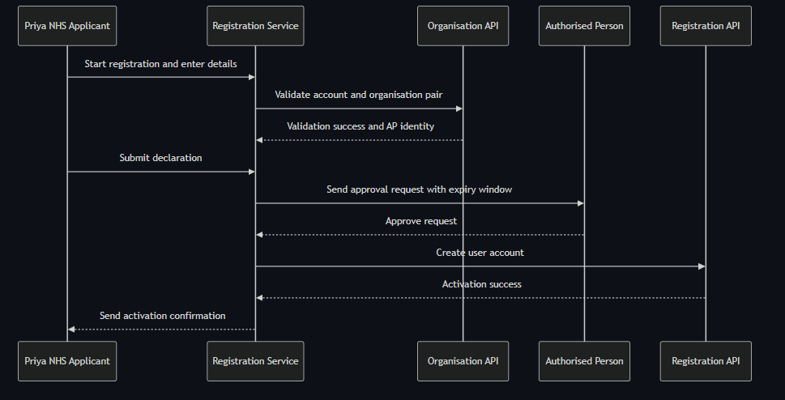

Decision Points & Variations

Decision Point 1: Account and organisation validation
Condition: When validation returns a mismatch
Path A: Valid pair
- Continue to declaration and submit
- Route approval to AP
Path B: Invalid pair
- Show inline correction guidance
- Prevent submit until corrected

Decision Point 2: AP response window
Condition: When AP has not responded before expiry
Path A: AP acts within window
- Record decision
- Continue to activation or rejection notification
Path B: AP does not act
- Send scheduled reminder resend
- Move case to fallback after resend limit

Process Flow: Decision Logic

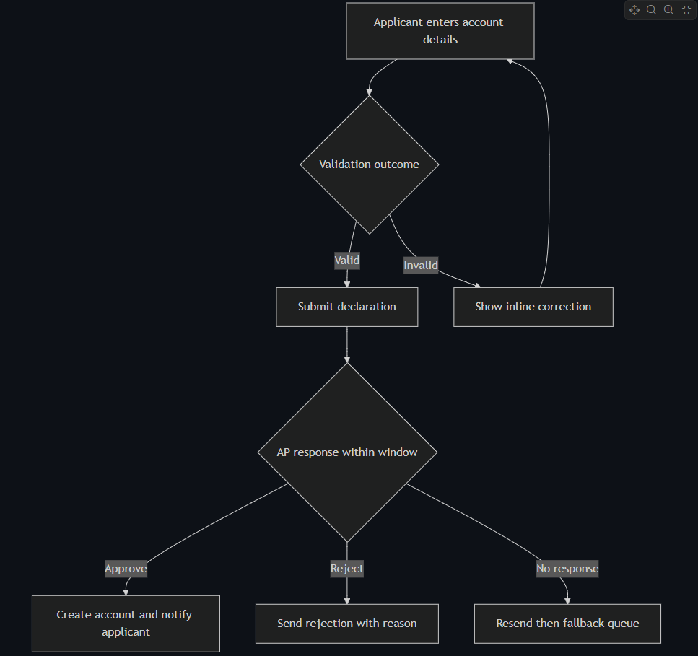

Touchpoints

Digital Touchpoints
- Registration web service: Data entry, validation, declaration, status updates
- GOV.UK Notify emails: AP request, applicant status, activation notice
- ImmForm APIs: Validation and account creation

Physical Touchpoints
- Local handover notes from outgoing staff: Source of account number

People Involved
- Applicant: Completes registration and declaration
- Authorised Person: Approves or rejects request
- Helpdesk case handler: Involved only for fallback

Pain Points & Opportunities

Current Pain Points
- Applicants often do not have account identifiers to hand
- Manual checking causes delayed error discovery

Opportunities for Improvement
- Add guided pre-check panel before form start
- Add self-serve status page for in-flight approvals

Accessibility Considerations
- Clear heading structure and field-level error messaging aligned to WCAG 2.1 AA
- Keyboard-first form navigation and logical focus movement after validation errors

Related Personas
- Linda Forsythe: Provides approval decision
- David Acheampong: Current state manual processor displaced from happy path

Related Journeys
- journey-authorised-person-approval.md: AP decision workflow details
- journey-fallback-case-resolution.md: Exception path after expiry or routing failure

Notes
This is the baseline alpha success path and should represent the majority of NHS registrations.

Data Elements
- Applicant name and role: Identity and accountability
- Individual email address: Notification and anti-shared-mailbox enforcement
- ImmForm account number: Target account for access
- Organisation code: Pair validation key
- AP decision and timestamp: Approval evidence

Service Level Expectations
- Standard case activation within two working days
- Validation failures resolved inline without helpdesk intervention

Journey 2 - Authorised Person Decision and Time Bound Approval
Primary Actor: Linda Forsythe
Duration: 2 to 10 minutes for AP action
Preconditions: Applicant has submitted a valid registration and AP routing has succeeded
Success Criteria: AP decision is captured with timestamp and identity, then applicant is notified

Overview
This journey isolates the AP experience, which is the most critical dependency between submission and activation. It demonstrates a low-friction email-based decision flow with explicit expiry handling.
The journey is important because AP responsiveness strongly influences activation lead time. Clear AP communications and decision capture reduce stalled requests and support compliance traceability.

Main Flow
Step | Actor | Action | System Response | Touchpoint | Notes
1 | System | Sends AP request email | Includes applicant details, account details, expiry time, decision links | Email | Actionable without login
2 | Linda | Reviews applicant details | Opens approve or reject link | Email and Web | Two minute target action
3 | Linda | Chooses approve | Captures AP identity, timestamp, and outcome | Web | Immutable event written
4 | System | Executes decision workflow | Activates account if approved or records rejection reason | API | Rejection reason persisted
5 | System | Sends applicant outcome notice | Provides next steps and contact route | Email | Case closed unless fallback needed

Sequence Diagram: Actor Interactions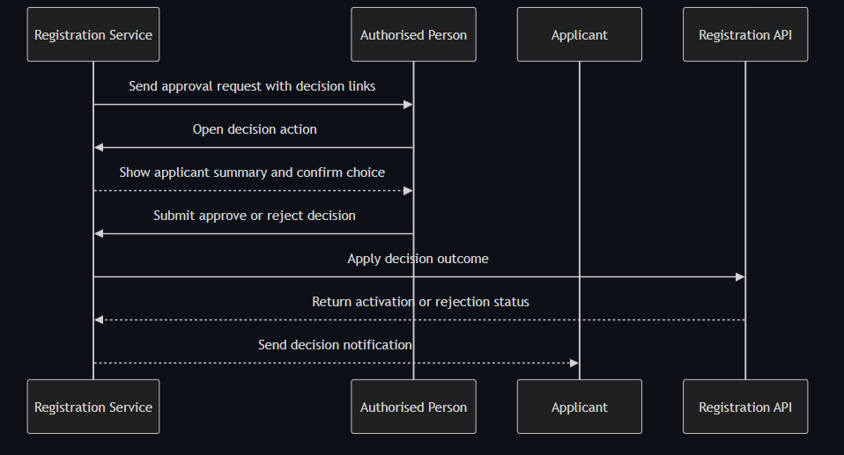

Decision Points & Variations

Decision Point 1: AP recognition of applicant
Condition: AP cannot confirm applicant identity
Path A: Applicant is recognised
- Approve request
- System continues to activation
Path B: Applicant not recognised
- Reject request with reason text
- Applicant receives actionable guidance

Decision Point 2: AP response timing
Condition: AP does not respond before expiry
Path A: AP responds before deadline
- Decision captured and workflow ends
- Applicant notified immediately
Path B: AP misses deadline
- Reminder and resend schedule executes
- Case moves to fallback queue after resend limit

Process Flow: Decision Logic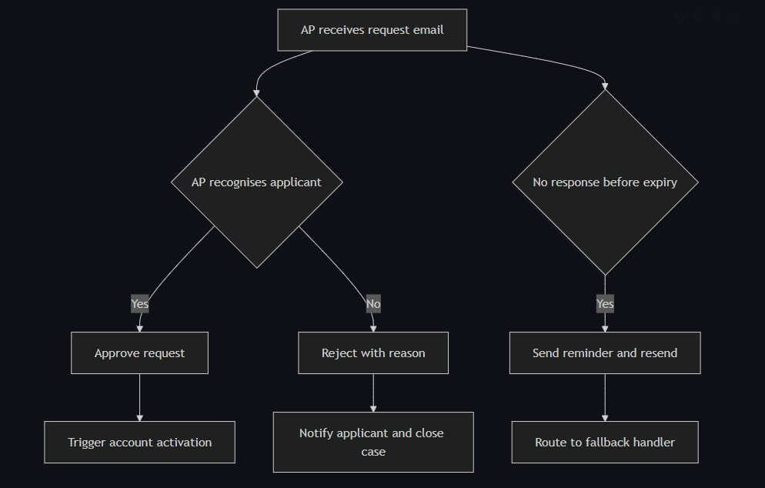

Touchpoints

Digital Touchpoints
- AP email template: Decision CTA and expiry context
- Decision confirmation page: Captures explicit AP action
- Applicant status email: Communicates final outcome

Physical Touchpoints
- None in the standard path

People Involved
- Authorised Person: Core decision maker
- Applicant: Receives outcome
- Fallback helpdesk handler: Manages expired cases

Pain Points & Opportunities

Current Pain Points
- AP inbox overload causes missed requests
- AP role accountability is not always clear to decision makers

Opportunities for Improvement
- Add calendar-friendly expiry marker in email template
- Add optional delegate policy for planned AP absence

Accessibility Considerations
- Email content readable in plain text and high zoom contexts
- Decision page supports keyboard and screen reader confirmation flows

Related Personas
- Priya Chandrasekaran: Applicant awaiting AP decision
- Fatima Osei: Handles non-response fallback path

Related Journeys
- journey-nhs-new-starter-registration.md: Standard applicant flow before AP action
- journey-fallback-case-resolution.md: AP non-response exception management

Notes
AP action latency is a primary determinant of the two-day activation target.

Data Elements
- AP identity: Decision attribution
- AP decision timestamp: SLA and compliance evidence
- Decision outcome and reason: Applicant communication and audit record
- Expiry timer events: Fallback trigger evidence

Service Level Expectations
- AP decision action should complete in under ten minutes
- Expired requests should enter fallback handling within one hour of timeout

Journey 3 - Approval Expiry and Resend Workflow
Primary Actor: Applicant
Duration: Up to multiple 72-hour windows
Preconditions: AP approval link expired without action
Success Criteria: Resend attempts are controlled, auditable, and capped with clear helpdesk fallback

Overview
This journey defines what happens after approval expiry. It includes resend attempt one, resend attempt two, and resend-limit reached behavior.
The journey ensures consistent policy enforcement and clear applicant expectations while maintaining an audit trail for each resend action.

Main Flow
Step | Actor | Action | System Response | Touchpoint | Notes
1 | System | Detects no AP action at 72 hours | Marks approval expired and notifies applicant | Workflow and Email | EVT-09
2 | Applicant | Requests resend first time | Sends new AP approval email | Web and Email | EVT-10
3 | System | Waits second 72-hour window | Tracks AP action status | Workflow | Can complete if AP responds
4 | Applicant | Requests resend second time | Sends second resend to AP | Web and Email | EVT-11
5 | Applicant | Attempts third resend | Blocks resend and directs to helpdesk | Web and Email | EVT-12

Sequence Diagram: Actor Interactions

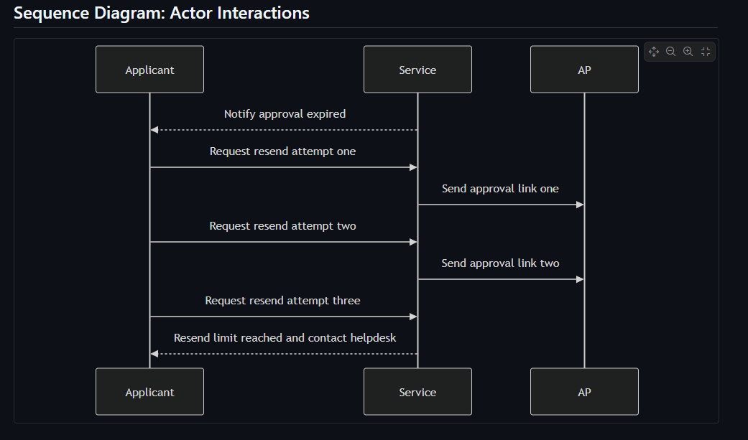Decision Points & Variations

Decision Point 1: AP action after resend
Condition: AP responds during resend window
Path A: AP approves or rejects
- Workflow continues to normal outcome
- No further resend required
Path B: AP no response
- Window expires
- Applicant can request next resend if limit not reached

Decision Point 2: Resend attempt count
Condition: Applicant requests resend after second attempt already used
Path A: Attempt count less than three
- Resend request accepted
- New AP email sent
Path B: Third request attempted
- Request blocked
- Helpdesk route required

Process Flow: Decision Logic

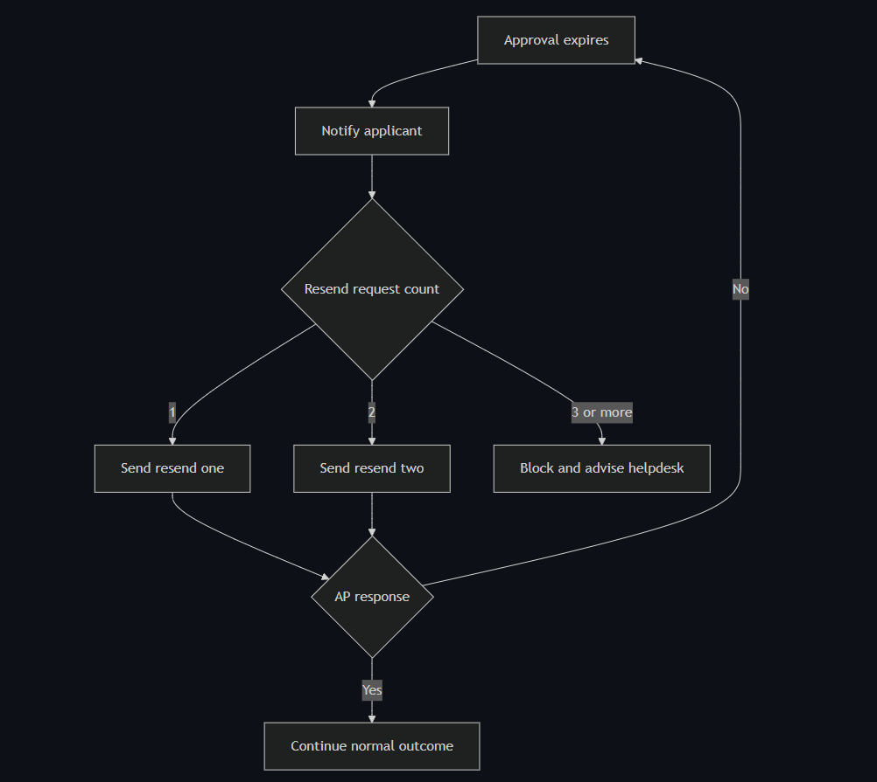Touchpoints

Digital Touchpoints
- Applicant expiry notification email
- Resend request action in service
- AP resend emails

Physical Touchpoints
- None

People Involved
- Applicant: Initiates resend actions
- Authorised Person: Receives repeated approval links
- Helpdesk: Manual re-entry point after resend limit

Pain Points & Opportunities

Current Pain Points
- Applicants may not understand resend limits
- Multiple expiry windows can feel slow

Opportunities for Improvement
- Show resend counter and remaining attempts clearly
- Add AP availability guidance before second resend

Accessibility Considerations
- Resend control and state labels are screen-reader clear
- Expiry and limit messages use plain language and explicit next step

Related Personas
- Linda Forsythe: AP workload affects response timeliness
- Fatima Osei: Handles cases that pass resend limit

Related Journeys
- journey-authorised-person-approval.md: Primary AP decision flow
- journey-fallback-case-resolution.md: Post-limit or route-failure handling

Notes
Requirement mapping: FR-15, EVT-10, EVT-11, EVT-12.

Data Elements
- Expiry timestamp and resend counters
- Applicant resend actions with timestamps
- Final limit reached reason code

Service Level Expectations
- Expiry state is communicated immediately
- Third resend attempt is blocked consistently and auditable

Journey 4 - Registration Rejection Outcome and Recovery
Primary Actor: Applicant
Duration: 5 to 30 minutes for review and recovery decision
Preconditions: Authorised Person has rejected registration with reason
Success Criteria: Applicant receives reasoned outcome and clear next action path

Overview
This journey focuses on the post-rejection experience for applicants. It ensures rejection reasons are communicated clearly and that users understand whether to restart, correct data, or contact helpdesk.
The journey separates rejection handling from approval happy path to improve clarity of outcomes and reduce repeated failed submissions.

Main Flow
Step | Actor | Action | System Response | Touchpoint | Notes
1 | AP | Rejects request and enters reason | Stores mandatory rejection reason | Web | EVT-08 generated
2 | System | Sends rejection notice to applicant | Includes rejection reason and next steps | Email | FR-14 communication
3 | Applicant | Reviews rejection message | Chooses restart or support route | Email and Web | No silent failure
4 | Applicant | Starts new registration where appropriate | Creates new session and flow | Web | Previous record retained
5 | System | Preserves rejected record in audit log | Makes record available to QA role | Audit | Compliance traceability

Sequence Diagram: Actor Interactions
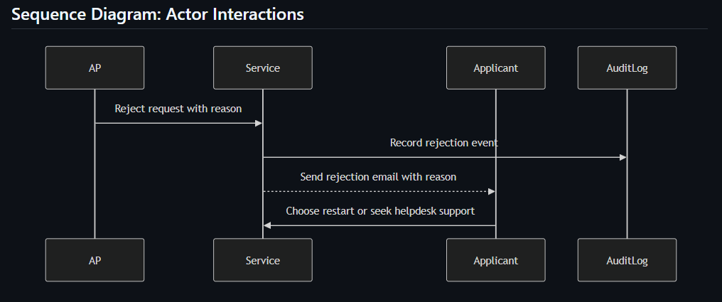 [Diagram: see markdown source for Mermaid diagram code]

Decision Points & Variations

Decision Point 1: Rejection reason category
Condition: Reason indicates correctable data issue versus account ownership issue
Path A: Correctable issue
- Applicant restarts with corrected details
- New registration proceeds through normal flow
Path B: Non-correctable issue
- Applicant contacts helpdesk
- Manual guidance resolves ownership or policy concern

Decision Point 2: Applicant action after notification
Condition: Applicant chooses immediate retry or delayed action
Path A: Immediate retry
- Starts new registration quickly
- Potentially meets operational deadline
Path B: Delayed action
- Waits for internal clarification
- May risk programme delay

Process Flow: Decision Logic

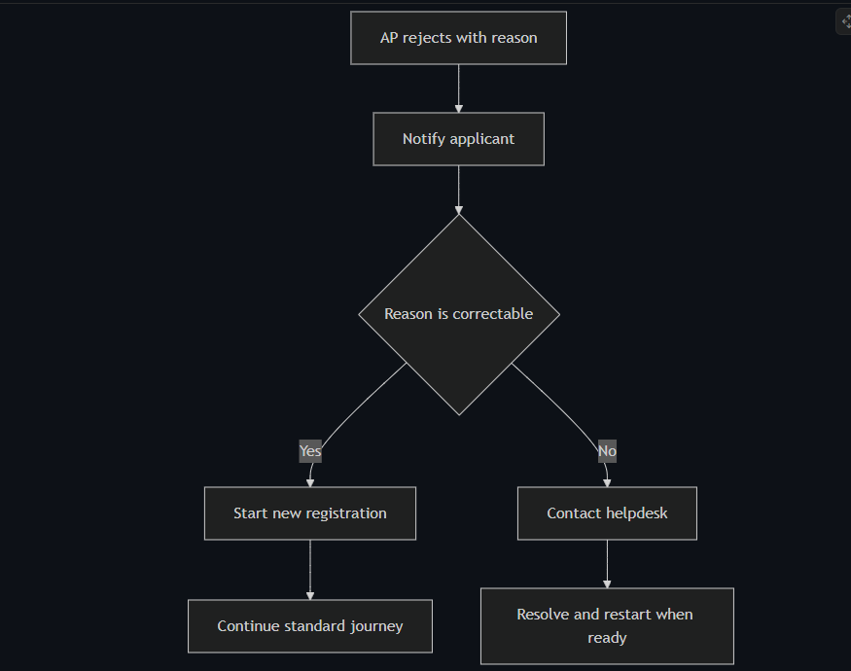

Touchpoints

Digital Touchpoints
- AP rejection form with mandatory reason
- Applicant rejection email and guidance
- Audit log record for rejected case

Physical Touchpoints
- None

People Involved
- Authorised Person: Provides rejection decision and reason
- Applicant: Receives outcome and takes next action
- Helpdesk: Supports unresolved ownership or policy issues

Pain Points & Opportunities

Current Pain Points
- Rejections can feel abrupt if reason is unclear
- Users may repeat same error without targeted guidance

Opportunities for Improvement
- Standardize reason categories with plain-language outcomes
- Provide direct restart link with checklist reminder

Accessibility Considerations
- Rejection email uses plain language and clear action statements
- Restart path is keyboard and screen-reader compatible

Related Personas
- Linda Forsythe: AP who may reject unknown applicants
- Priya Chandrasekaran: Applicant who needs fast recovery path

Related Journeys
- journey-authorised-person-approval.md: AP decision capture flow
- journey-nhs-new-starter-registration.md: Restart target journey

Notes
Requirement mapping: FR-14, EVT-08.

Data Elements
- Rejection reason text
- AP identity and timestamp
- Applicant notification timestamp

Service Level Expectations
- Rejection notice sent immediately after decision
- Rejected record remains queryable in audit trail

Journey 5 - Duplicate Detection Error Before Submission
Primary Actor: Applicant
Duration: 5 to 10 minutes
Preconditions: Applicant has entered personal and account details
Success Criteria: Duplicate conditions are blocked safely and user receives clear next action

Overview
This journey describes how the service handles duplicate registration checks before submission. It covers two requirement cases: an email already active in ImmForm and an email with a pending registration on the same account.
The journey prevents duplicate account creation and avoids wasted approval cycles. It also provides clear user guidance so applicants can resolve the issue without confusion.

Main Flow
Step | Actor | Action | System Response | Touchpoint | Notes
1 | Applicant | Completes declaration and attempts submit | Starts pre-submit duplicate checks | Web | Check runs before EVT-02 commit
2 | System | Checks active user account by email | If match found, blocks submission | API | Duplicate active account path
3 | System | Checks pending registration for same account | If match found, blocks submission | API | Duplicate pending path
4 | System | Shows error summary and inline message | Gives helpdesk route or wait guidance | Web | GDS style errors
5 | Applicant | Corrects details or exits journey | Resubmits only when no duplicate exists | Web | Prevents duplicate creation

Sequence Diagram: Actor Interactions

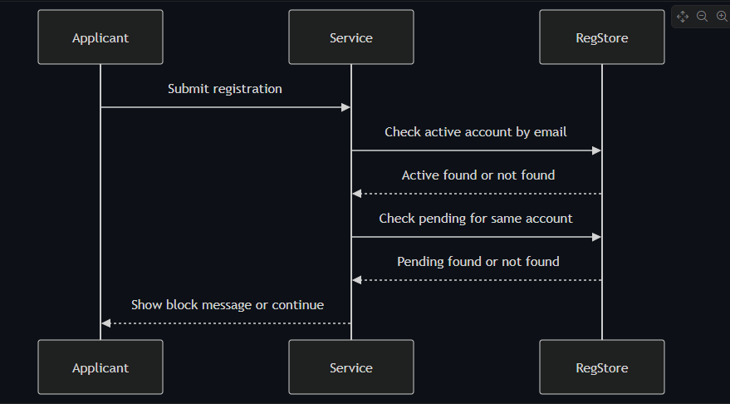Decision Points & Variations

Decision Point 1: Active account already exists
Condition: Email matches existing active ImmForm user
Path A: No active account
- Continue to second duplicate check
- Allow normal submission if pending check passes
Path B: Active account found
- Block submit
- Show contact helpdesk guidance

Decision Point 2: Pending registration exists on same account
Condition: Email has pending registration for same account number
Path A: No pending registration
- Continue submit flow
- Create submission event
Path B: Pending registration found
- Block submit
- Show already in progress message

Process Flow: Decision Logic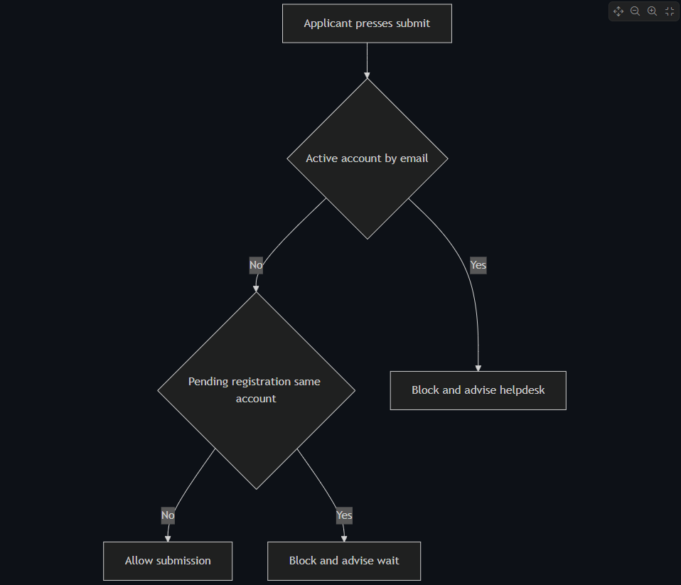
[Diagram: see markdown source for Mermaid diagram code]

Touchpoints

Digital Touchpoints
- Registration web form: Submit and error display
- Registration data store: Active and pending checks

Physical Touchpoints
- None

People Involved
- Applicant: Attempts submit and receives outcome
- Helpdesk: Escalation route for active duplicate issue

Pain Points & Opportunities

Current Pain Points
- Users can repeatedly attempt submit without clear reason if duplicate handling is unclear
- Duplicate failures late in journey feel frustrating

Opportunities for Improvement
- Add concise pre-submit duplicate hint text
- Include clear retry or correction guidance in error state

Accessibility Considerations
- Error summary appears at top and links to offending fields
- Page title includes Error prefix in error state

Related Personas
- Priya Chandrasekaran: Standard NHS applicant
- Marcus Obi: Non-NHS applicant with compliance sensitivity

Related Journeys
- journey-nhs-new-starter-registration.md: Happy path without duplicates
- journey-field-validation-error-correction.md: Other input validation outcomes

Notes
Requirement mapping: FR-16, EVT-03.

Data Elements
- Applicant email: Duplicate key
- Account number: Same-account pending check scope
- Duplicate reason code: Active or pending

Service Level Expectations
- Duplicate checks complete before final submit commit
- Block message shown immediately with clear next action

Journey 6 - Account and Organisation Validation Failure
Primary Actor: Applicant
Duration: 5 to 15 minutes
Preconditions: Applicant is on organisation and account step
Success Criteria: Invalid account or organisation entries are corrected before progression

Overview
This journey captures fail-fast validation when the ImmForm account number and organisation code pair is invalid or not active. It ensures error handling occurs on the organisation step, near the data entry point.
The journey supports data quality and reduces avoidable downstream failures. It also aligns with GDS error patterns for clear, actionable correction.

Main Flow
Step | Actor | Action | System Response | Touchpoint | Notes
1 | Applicant | Enters account number and organisation code | Performs format checks | Web | 10-digit account rule enforced
2 | System | Calls Organisation API for pair validation | Returns match or failure | API | Active pair required
3 | System | Displays error summary and inline errors | Explains exact issue type | Web | Invalid format or pair not found
4 | Applicant | Corrects one or both fields | Validation reruns | Web | Loop until valid
5 | System | Confirms valid pair and AP presence | Allows forward progression | API and Web | Continue to check answers

Sequence Diagram: Actor Interactions
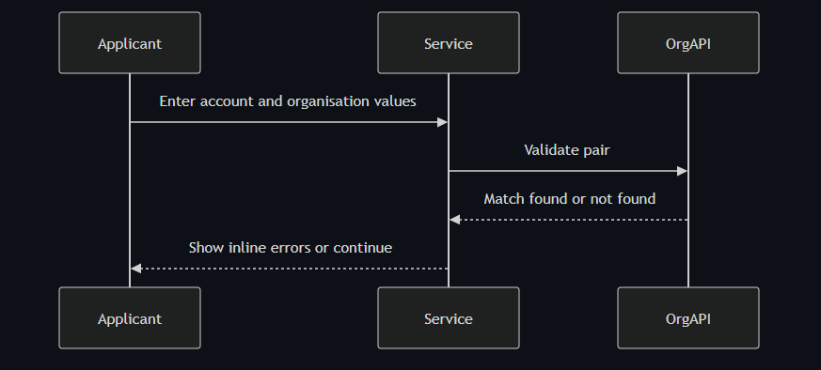 [Diagram: see markdown source for Mermaid diagram code]

Decision Points & Variations

Decision Point 1: Format validation
Condition: Account number or organisation code format invalid
Path A: Formats valid
- Proceed to API pair validation
- Continue based on API result
Path B: Formats invalid
- Show field-specific errors
- Prevent API call until corrected

Decision Point 2: Pair validation outcome
Condition: Organisation API cannot find active pair
Path A: Active pair found
- Store organisation name from API
- Continue to next step
Path B: Pair not found
- Show not found guidance and helpdesk route
- Keep user on organisation step

Process Flow: Decision Logic
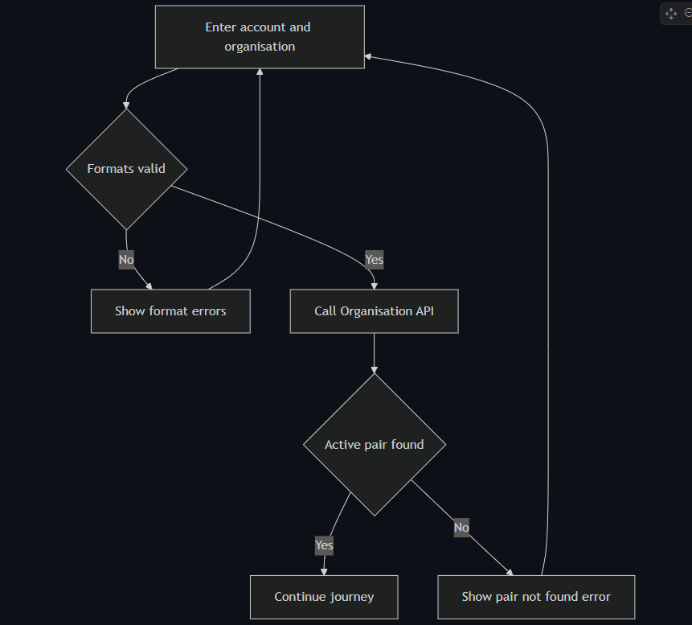 [Diagram: see markdown source for Mermaid diagram code]

Touchpoints

Digital Touchpoints
- Organisation step form
- Organisation API validation endpoint

Physical Touchpoints
- None

People Involved
- Applicant: Provides and corrects identifiers
- Helpdesk: Assisted route when user cannot resolve identifiers

Pain Points & Opportunities

Current Pain Points
- Users often lack confidence in account identifiers
- Late validation failures increase abandonment risk

Opportunities for Improvement
- Add inline examples for valid formats
- Include short explainers for where to find account number

Accessibility Considerations
- Error summary with focus move and field links
- Clear language that states what to fix

Related Personas
- Keisha Mensah: Commissioning context can cause code confusion
- Donna Eze: Limited time for repeated correction loops

Related Journeys
- journey-nhs-new-starter-registration.md: Standard path once validation passes
- journey-duplicate-detection-error.md: Pre-submit duplicate block path

Notes
Requirement mapping: FR-04, EVT-04.

Data Elements
- ImmForm account number
- ImmForm organisation code
- Validation outcome code and timestamp

Service Level Expectations
- Validation feedback shown immediately on submit of step
- No progression until active pair is confirmed

Journey 7 - Session Timeout and Abandonment Handling
Primary Actor: System
Duration: 60 minutes inactivity plus restart time
Preconditions: Applicant started registration session and then became inactive
Success Criteria: Session expires securely, abandonment event is logged, and restart path is clear

Overview
This journey covers inactivity timeout handling for in-progress registrations. It ensures secure session expiry and captures abandonment telemetry for service performance analysis.
The journey prevents stale sessions and unintended data exposure while keeping re-entry simple for users.

Main Flow
Step | Actor | Action | System Response | Touchpoint | Notes
1 | Applicant | Starts journey and enters data | Session is created | Web | Session cookie is server-backed
2 | Applicant | Leaves session inactive | Inactivity timer continues | Web | No input events observed
3 | System | Reaches 60-minute inactivity threshold | Expires and purges session state | Backend | Security control
4 | System | Writes abandonment event | Logs EVT-05 with timestamp | Audit log | No notify email
5 | Applicant | Returns after timeout | Sees session expired message and restart action | Web | Must start new session

Sequence Diagram: Actor Interactions
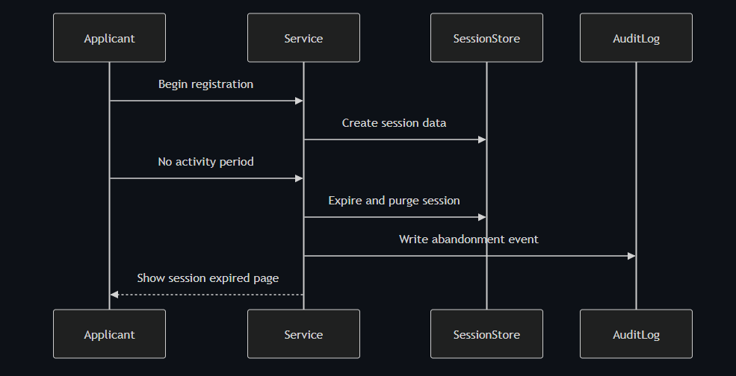 [Diagram: see markdown source for Mermaid diagram code]

Decision Points & Variations

Decision Point 1: User returns before timeout
Condition: Activity resumes before 60 minutes
Path A: Activity resumes
- Session remains valid
- User continues journey
Path B: No activity until threshold
- Session expires and state purged
- User must restart

Decision Point 2: Resume expectation
Condition: User expects previous data to persist after timeout
Path A: User restarts successfully
- New session starts
- User re-enters data
Path B: User cannot restart
- Directed to helpdesk assisted path
- Journey exits

Process Flow: Decision Logic
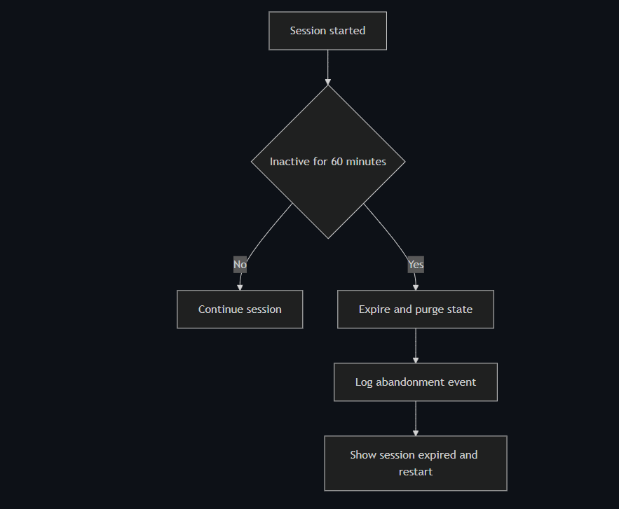 [Diagram: see markdown source for Mermaid diagram code]

Touchpoints

Digital Touchpoints
- Session middleware and store
- Session expired page
- Audit logging pipeline

Physical Touchpoints
- None

People Involved
- Applicant: Re-enters after timeout
- Helpdesk: Optional assisted fallback

Pain Points & Opportunities

Current Pain Points
- Timeout can feel sudden without user awareness
- Restart effort can be high if many fields were entered

Opportunities for Improvement
- Add inactivity warning before hard timeout
- Add save-for-later only if policy allows in future phase

Accessibility Considerations
- Expired session page has clear heading and single primary action
- Message explains timeout in plain language

Related Personas
- Priya Chandrasekaran: Likely interrupted by operational tasks
- Donna Eze: Clinical context increases interruption risk

Related Journeys
- journey-nhs-new-starter-registration.md: Normal completion path
- journey-field-validation-error-correction.md: Restarted journey may encounter validation path

Notes
Requirement mapping: EVT-05, NFR-09.

Data Elements
- Session id and expiry timestamp
- Abandonment event record
- Correlation id where applicable

Service Level Expectations
- Session expires at 60 minutes of inactivity
- Abandonment event is logged immediately on expiry

Journey 8 - Field Validation Error Correction
Primary Actor: Applicant
Duration: 5 to 15 minutes
Preconditions: Applicant enters one or more invalid field values
Success Criteria: Validation errors are shown clearly and corrected without support dependency

Overview
This journey covers server-side validation outcomes for common field rules such as email format, phone number format, name, and job title constraints.
It ensures users receive clear, plain-language feedback through GDS error summary and inline messages and can correct data efficiently.

Main Flow
Step | Actor | Action | System Response | Touchpoint | Notes
1 | Applicant | Enters details on step page | Submits step form | Web | One thing per page pattern
2 | System | Runs server-side validation | Detects rule failures by field | Backend | NFR-06 controls
3 | System | Renders error summary and inline text | Focuses error summary and keeps data where safe | Web | GDS pattern
4 | Applicant | Corrects invalid fields | Resubmits step | Web | Loop until valid
5 | System | Accepts valid values | Progresses to next step | Web | Validation success

Sequence Diagram: Actor Interactions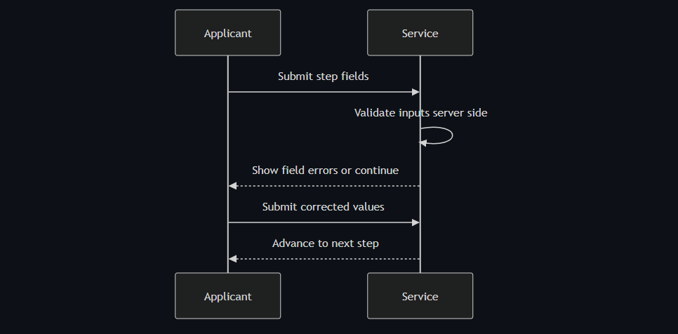
[Diagram: see markdown source for Mermaid diagram code]

Decision Points & Variations

Decision Point 1: Email validation
Condition: Email is invalid format or shared mailbox
Path A: Valid individual email
- Accept email
- Continue step progression
Path B: Invalid email condition
- Show targeted email error
- Require corrected individual email

Decision Point 2: Phone and text fields
Condition: Phone or text length rule fails
Path A: Values within rules
- Save step values
- Move forward
Path B: Rule failure
- Show specific correction text
- Keep user on same step

Process Flow: Decision Logic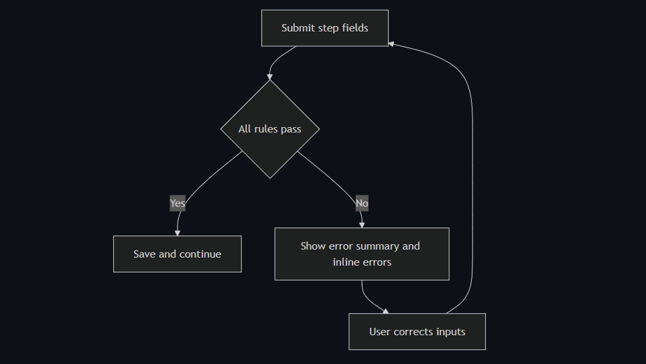
[Diagram: see markdown source for Mermaid diagram code]

Touchpoints

Digital Touchpoints
- Step form pages
- Server-side validators
- Error summary and inline components

Physical Touchpoints
- None

People Involved
- Applicant: Corrects invalid entries
- Helpdesk: Not needed for normal correction loop

Pain Points & Opportunities

Current Pain Points
- Generic error text can cause repeated failures
- Multiple field failures can overwhelm users

Opportunities for Improvement
- Use specific examples in each error message
- Preserve non-sensitive values to reduce re-entry burden

Accessibility Considerations
- Error summary appears at top and is announced by assistive tools
- Inline messages are tied to field labels and ids

Related Personas
- Priya Chandrasekaran: First-time user needs plain language cues
- Colin Rafferty: Time-sensitive seasonal user needs fast correction

Related Journeys
- journey-account-validation-failure.md: Pair-specific validation path
- journey-nhs-new-starter-registration.md: Normal path after correction

Notes
Requirement mapping: NFR-06.

Data Elements
- Field validation codes
- Error message ids and field mapping
- Correction submission timestamps

Service Level Expectations
- Validation runs server-side on every step submit
- Error feedback is immediate and actionable

Journey 9 - GBSM Sexual Health Registration Context
Primary Actor: Keisha Mensah
Duration: 1 to 2 working days
Preconditions: Applicant has access to sexual health service account identifiers
Success Criteria: Registration completes with correct account ownership and AP routing in a commissioned service context

Overview
This journey provides programme-context coverage for GBSM sexual health orderers operating in dual organisational settings such as local authority commissioning and NHS trust delivery.
The underlying registration flow remains the same as standard track, but this variant stresses account ownership clarity and AP route confidence.

Main Flow
Step | Actor | Action | System Response | Touchpoint | Notes
1 | Keisha | Starts registration with service context in mind | Shows standard checklist and account requirements | Web | Shared flow baseline
2 | Keisha | Enters applicant and account details | Validates formats and account pair | Web and API | Ownership ambiguity risk
3 | System | Resolves AP from account pair | Returns AP route or error | API | Fail-fast if no AP
4 | Keisha | Submits declaration | Creates auditable submission event | Web | Same standard declarations
5 | AP | Approves request | Triggers account creation flow | Email | Standard AP process

Sequence Diagram: Actor Interactions
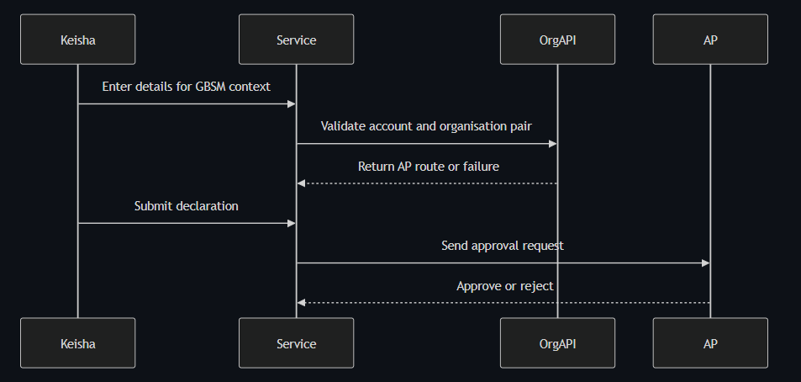 [Diagram: see markdown source for Mermaid diagram code]

Decision Points & Variations

Decision Point 1: Account ownership clarity
Condition: Applicant is unsure whether trust or commissioner account applies
Path A: Correct account used
- Validation succeeds
- Continue normal workflow
Path B: Wrong account used
- Validation fails or AP mismatch occurs
- Applicant corrects details or seeks helpdesk support

Decision Point 2: AP route validity
Condition: AP on record is outdated
Path A: AP valid
- Approval completes
- Account activation proceeds
Path B: AP outdated
- Expiry and resend path may trigger
- Fallback handling required

Process Flow: Decision Logic

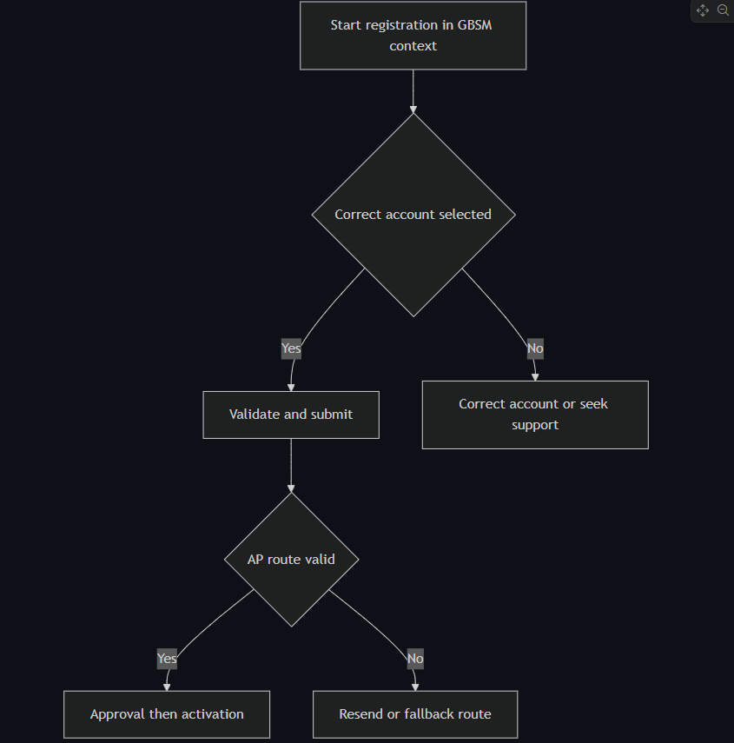
[Diagram: see markdown source for Mermaid diagram code]

Touchpoints

Digital Touchpoints
- Registration web journey
- Organisation API validation
- AP email approval flow

Physical Touchpoints
- Internal service handover notes for account ownership

People Involved
- Applicant in sexual health service role
- Authorised Person for account
- Helpdesk for ownership ambiguity resolution

Pain Points & Opportunities

Current Pain Points
- Commissioning versus provider boundaries create account uncertainty
- AP records can lag organisational change

Opportunities for Improvement
- Add guidance examples for commissioned services
- Add account ownership hint before organisation step

Accessibility Considerations
- Guidance content uses plain language and short sentences
- Validation errors remain field-linked and screen-reader clear

Related Personas
- Donna Eze: Similar sexual health programme pressure
- Linda Forsythe: AP decision role

Related Journeys
- journey-nhs-new-starter-registration.md: Shared baseline registration flow
- journey-account-validation-failure.md: Correction path for account mismatch

Notes
Requirement mapping: Section 3.3 user group coverage for GBSM programme orderers.

Data Elements
- Account type and organisation identifiers
- AP route result
- Submission and approval timestamps

Service Level Expectations
- Context complexity should not increase baseline activation target
- Ownership ambiguity should be resolved early in journey

Journey 10 - Occupational Health and Private Registration Context
Primary Actor: Colin Rafferty
Duration: 1 to 3 working days
Preconditions: Applicant has private or occupational account identifiers for BCG and TB PPD scope
Success Criteria: Registration completes with correct account scope and attributable user access

Overview
This journey provides context coverage for occupational health and private settings where account scope can be narrower and policy-sensitive.
The core registration steps are unchanged, but the variant highlights account scope correctness and role continuity for seasonal programmes.

Main Flow
Step | Actor | Action | System Response | Touchpoint | Notes
1 | Colin | Starts registration for current role credentials | Shows standard requirements list | Web | Same start pattern
2 | Colin | Enters personal details and account pair | Validates account and organisation data | Web and API | Existing access history may differ
3 | System | Resolves AP and eligibility path | Returns route and status | API | Must align with account record
4 | Colin | Submits declaration | Creates auditable submission event | Web | Standard declaration step
5 | AP | Approves request | System proceeds to account creation | Email and API | Activation follows approval

Sequence Diagram: Actor Interactions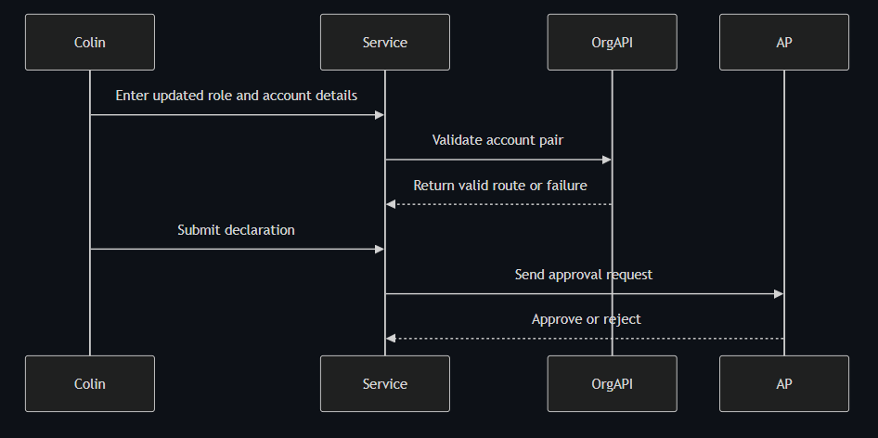
[Diagram: see markdown source for Mermaid diagram code]

Decision Points & Variations

Decision Point 1: Role and email transition
Condition: Applicant changed role or email since prior access
Path A: New details accepted
- Continue standard registration
- Create new attributable record
Path B: Details conflict with pending state
- Trigger duplicate or validation checks
- Correct and resubmit

Decision Point 2: Account scope confidence
Condition: Applicant uncertain account is correct for occupational or private context
Path A: Correct account scope
- AP route resolves and approval proceeds
- Activation completes
Path B: Incorrect scope account
- Validation or AP route fails
- Helpdesk guidance used for correction

Process Flow: Decision Logic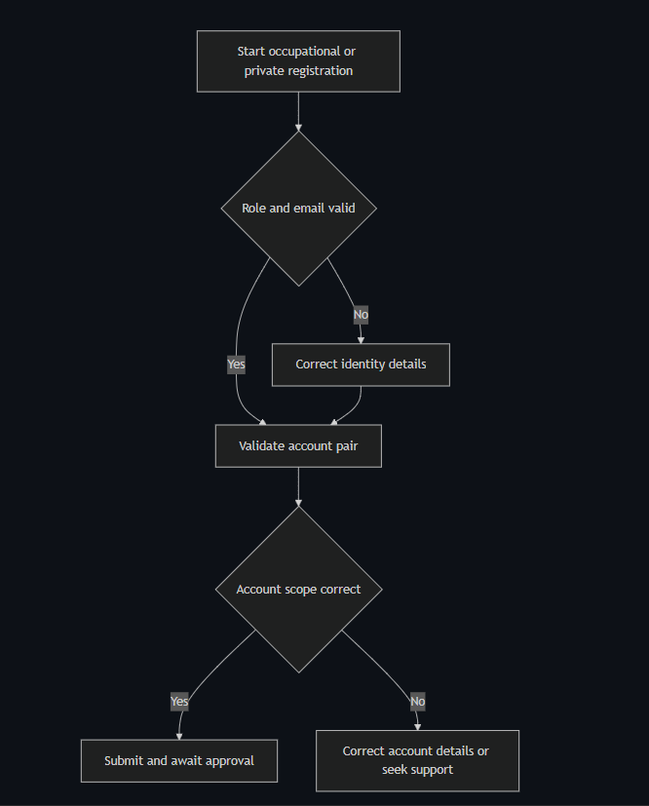
[Diagram: see markdown source for Mermaid diagram code]

Touchpoints

Digital Touchpoints
- Registration service pages
- Organisation API validation
- AP decision email flow

Physical Touchpoints
- Internal team handover and programme planning notes

People Involved
- Occupational health applicant
- Authorised Person
- Helpdesk support for account scope ambiguity

Pain Points & Opportunities

Current Pain Points
- Role changes can create uncertainty about correct registration route
- Seasonal deadlines make delays costly

Opportunities for Improvement
- Add role-change guidance in pre-start content
- Provide account scope examples for private and occupational contexts

Accessibility Considerations
- Error summaries remain plain-language and field-linked
- Change links and correction loops are keyboard-friendly

Related Personas
- Priya Chandrasekaran: Similar timeline pressure in routine programmes
- Marcus Obi: Comparable compliance sensitivity in non-NHS contexts

Related Journeys
- journey-account-validation-failure.md: Invalid pair correction loop
- journey-duplicate-detection-error.md: Duplicate prevention path

Notes
Requirement mapping: Section 3.3 user group coverage for occupational health and private orderers.

Data Elements
- Applicant identity and role fields
- Account and organisation identifiers
- AP route and final outcome state

Service Level Expectations
- Context-specific ambiguity should be resolved before submission
- Activation target should remain within standard service expectations

Journey 11 - COVID-19 Programme Registration Context
Primary Actor: Amir Siddiqui
Duration: 1 to 2 working days
Preconditions: Applicant has valid account pair for programme ordering account
Success Criteria: Individual access replaces shared access without service disruption

Overview
This journey covers COVID-19 programme orderers transitioning from shared or informal access to attributable individual access.
The registration flow is the same standard journey, but this variant focuses on continuity during programme timelines and governance transition.

Main Flow
Step | Actor | Action | System Response | Touchpoint | Notes
1 | Amir | Starts registration ahead of ordering cycle | Shows standard start guidance | Web | Same FR-02 pattern
2 | Amir | Enters individual details and account pair | Applies validation and shared mailbox policy | Web and API | Individual accountability enforced
3 | System | Resolves AP and sends approval request | Starts time-bound approval window | API and Email | Standard FR-13 behavior
4 | AP | Approves request | Triggers automated account creation | Email and API | No manual helpdesk in standard case
5 | System | Sends activation message with reference | Confirms individual access active | Email | Programme continuity maintained

Sequence Diagram: Actor Interactions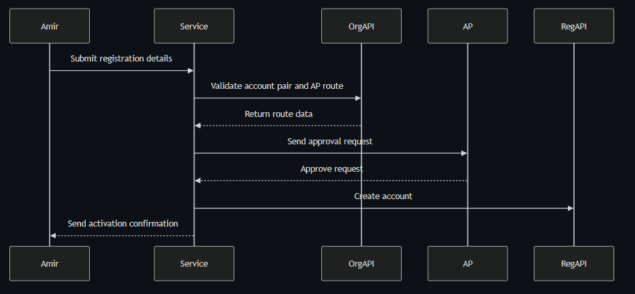
[Diagram: see markdown source for Mermaid diagram code]

Decision Points & Variations

Decision Point 1: Shared to individual transition
Condition: Applicant initially enters shared mailbox
Path A: Individual email entered
- Continue normal flow
- Preserve attributable access model
Path B: Shared mailbox entered
- Block and request individual email
- Continue after correction

Decision Point 2: Programme deadline risk
Condition: AP decision delayed near ordering window
Path A: Decision in time
- Activation before critical ordering task
- No continuity gap
Path B: Decision delayed
- Resend and fallback mechanisms may trigger
- Operational risk increases

Process Flow: Decision Logic

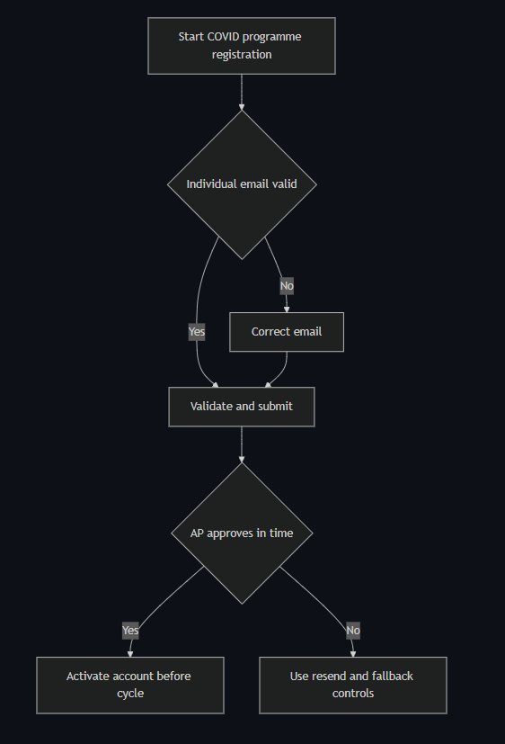
[Diagram: see markdown source for Mermaid diagram code]

Touchpoints

Digital Touchpoints
- Registration web forms
- AP email decision flow
- Registration API account creation

Physical Touchpoints
- Programme coordination planning documents

People Involved
- Applicant coordinator
- Authorised Person
- Helpdesk for delayed exception path

Pain Points & Opportunities

Current Pain Points
- Legacy shared access patterns conflict with new controls
- Tight programme windows magnify approval delay impact

Opportunities for Improvement
- Add transition guidance for shared-to-individual scenarios
- Add status transparency for pending AP decisions

Accessibility Considerations
- Error messaging remains concise under time pressure
- Confirmation and status messages use clear headings and action text

Related Personas
- Priya Chandrasekaran: Similar operational urgency for immunisation cycles
- Fatima Osei: Exception handling when approvals stall

Related Journeys
- journey-nhs-new-starter-registration.md: Baseline path
- journey-approval-resend-workflow.md: Delay and resend controls

Notes
Requirement mapping: Section 3.3 user group coverage for COVID-19 programme orderers.

Data Elements
- Applicant identity and individual email
- Approval timing relative to ordering cycle
- Activation confirmation reference

Service Level Expectations
- Standard target remains two working days
- Delayed approvals trigger resend policy without hidden state

Journey 12 - Mobile First Registration for Mpox Programme Continuity
Primary Actor: Donna Eze
Duration: 20 to 40 minutes plus AP response time
Preconditions: Applicant has mobile access, account identifiers, and individual NHS email
Success Criteria: Applicant completes registration in one mobile session and receives activation before next ordering window

Overview
This journey captures a clinically busy programme user completing registration from a mobile device. It tests whether the service supports constrained time windows and high-urgency programme continuity.
The journey is important because Mpox delivery teams cannot tolerate avoidable ordering disruption. Mobile-ready completion and clear fallback guidance are key to preventing stock cycle delays.

Main Flow
Step | Actor | Action | System Response | Touchpoint | Notes
1 | Donna | Opens service on mobile | Presents concise mobile checklist and progress indicator | Mobile web | One-screen checklist
2 | Donna | Enters applicant details and account pair | Applies mobile-friendly validation and correction prompts | Mobile web | Inline errors avoid page jumps
3 | System | Validates account pair and AP route | Confirms AP found and submission ready | API | Supports programme account type
4 | Donna | Accepts declaration and submits | Creates registration event and sends AP request | Mobile web and Email | Submission complete in one session
5 | System | Sends status updates to Donna | Sends submit confirmation and decision outcome | Email | No repeated login needed
6 | Linda or AP | Approves request | Decision triggers account activation | Email | AP journey unchanged

Sequence Diagram: Actor Interactions

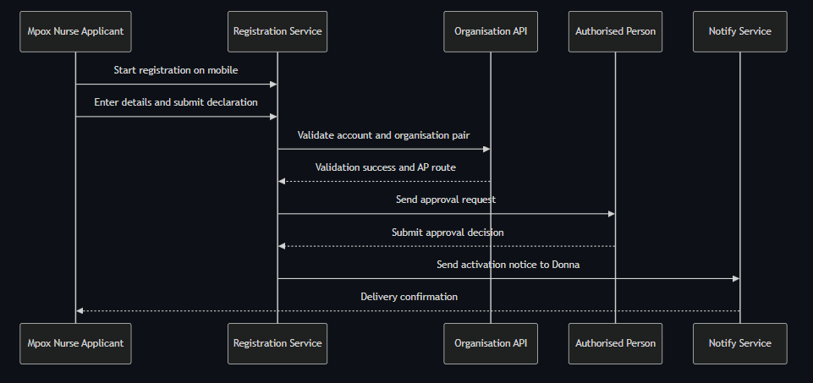
[Diagram: see markdown source for Mermaid diagram code]

Decision Points & Variations

Decision Point 1: Missing account number at point of entry
Condition: Applicant does not have account number ready
Path A: Account number available
- Continue in same mobile session
- Submit normally
Path B: Account number unavailable
- Save partial progress token
- Resume later without re-entering all fields

Decision Point 2: AP route appears outdated
Condition: Applicant suspects AP no longer in post
Path A: AP is current
- Approval completes within standard window
- Account activated
Path B: AP outdated
- Request expires after resend policy
- Case moves to fallback and applicant is informed

Process Flow: Decision Logic

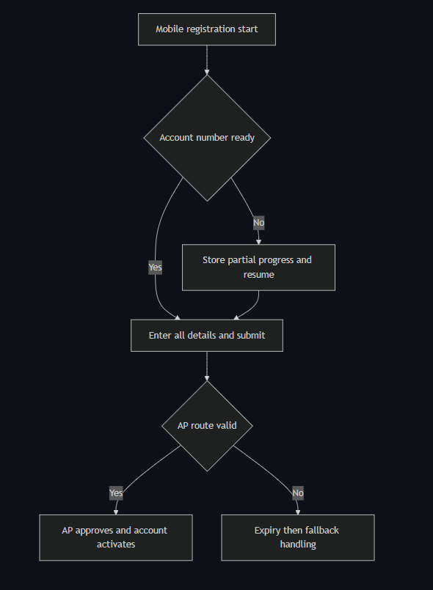
[Diagram: see markdown source for Mermaid diagram code]

Touchpoints

Digital Touchpoints
- Mobile registration web pages: Form completion and validation
- Email notifications: Submission and outcome updates
- Organisation API validation: Account pair and AP route checks

Physical Touchpoints
- Handover conversation with departing colleague for account identifiers

People Involved
- Applicant: Completes mobile submission
- Authorised Person: Provides decision
- Fallback case handler: Resolves AP route failures

Pain Points & Opportunities

Current Pain Points
- Clinical workload competes with admin tasks
- Account identifier retrieval depends on informal handover

Opportunities for Improvement
- Add optional quick capture mode with deferred non-critical fields
- Add explicit programme context badges for Mpox users

Accessibility Considerations
- Responsive layout at mobile zoom with no horizontal scroll
- Touch target size and error messaging optimised for handheld use

Related Personas
- Keisha Mensah: Similar commissioned service ambiguity in account ownership
- Fatima Osei: Handles stalled cases caused by AP data issues

Related Journeys
- journey-nhs-new-starter-registration.md: Baseline registration behaviour
- journey-fallback-case-resolution.md: Stalled request intervention flow

Notes
This journey pressure-tests one-session completion and continuity risk before colleague handover closes.

Data Elements
- Device context: Mobile experience quality signal
- Partial save token: Resume capability state
- AP route confidence flag: Signals likely fallback risk
- Outcome notification timestamp: Programme planning evidence

Service Level Expectations
- Mobile form completion in under forty minutes for prepared users
- Stalled AP routes surfaced to fallback team within one expiry cycle

Journey 13 - Non NHS Wholesaler Registration with Compliance Evidence
Primary Actor: Marcus Obi
Duration: 1 to 3 working days
Preconditions: Applicant has licensed wholesaler context and valid account identifiers
Success Criteria: Access is granted with an auditable record usable in GDP documentation

Overview
This journey represents non-NHS registration where compliance context is stronger and users need confidence that records are inspection-ready. It demonstrates that the service can support licensed wholesaler workflows without forcing return to manual PDF processing.
The journey focuses on policy clarity for individual email use, accurate AP routing, and structured outcome evidence suitable for internal compliance retention.

Main Flow
Step | Actor | Action | System Response | Touchpoint | Notes
1 | Marcus | Reviews registration guidance | Shows non-NHS eligibility and individual email policy | Web | Shared mailbox policy made explicit
2 | Marcus | Enters applicant and account details | Performs schema checks and identity format checks | Web | Role and organisation metadata captured
3 | System | Validates account and organisation code | Returns AP and account type metadata | API | Flags unsupported account types
4 | Marcus | Submits declaration | Creates auditable registration event | Web | Includes declarative statements
5 | System | Requests AP decision | Sends time-bound approval request | Email | Reminder schedule applied
6 | AP | Approves request | Decision and identity are recorded | Email | Decision history retained
7 | System | Activates account and sends outcome | Sends confirmation with reference details | API and Email | Confirmation retained in compliance folder

Sequence Diagram: Actor Interactions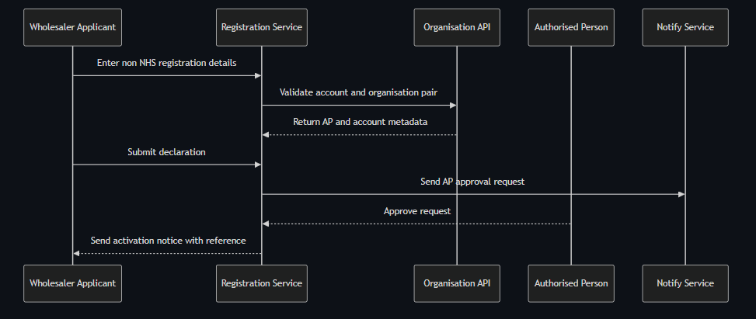
[Diagram: see markdown source for Mermaid diagram code]

Decision Points & Variations

Decision Point 1: Shared mailbox detection
Condition: When entered email appears to be a shared inbox
Path A: Individual mailbox confirmed
- Continue to declaration submit
- Proceed with AP routing
Path B: Shared mailbox suspected
- Show policy and require individual mailbox change
- Block submit until updated

Decision Point 2: AP lookup quality
Condition: When AP returned by Organisation API is outdated
Path A: Correct AP
- Approval decision captured within standard window
- Continue to activation
Path B: Incorrect AP
- Request expires after resend limit
- Send case to fallback handler

Process Flow: Decision Logic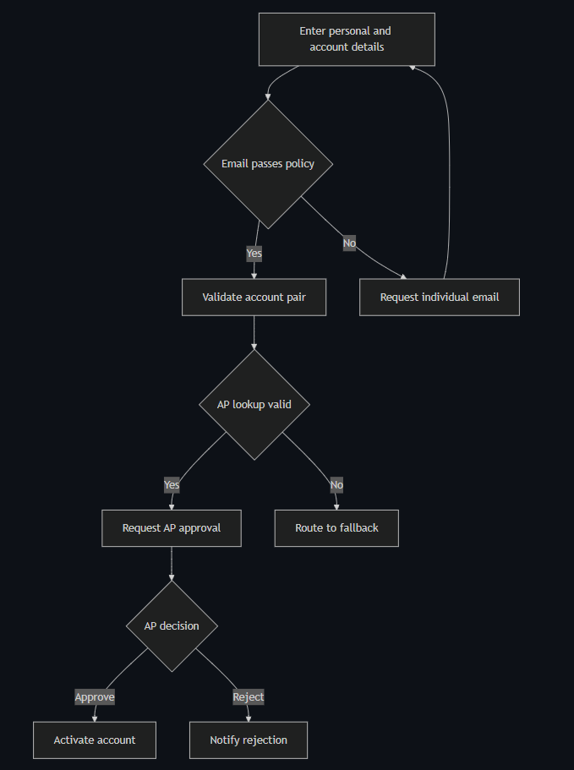
[Diagram: see markdown source for Mermaid diagram code]

Touchpoints

Digital Touchpoints
- Registration web service: Form completion and declaration
- Notify email templates: AP decision requests and applicant outcome
- Organisation API: AP discovery and account validation

Physical Touchpoints
- Internal compliance pack: Evidence archive for inspections

People Involved
- Applicant: Provides attributable identity and registration details
- Authorised Person: Provides approval decision
- Helpdesk fallback handler: Intervenes on AP routing failures

Pain Points & Opportunities

Current Pain Points
- Non-NHS users have low trust that pathways support regulated contexts
- AP data quality for some accounts is inconsistent

Opportunities for Improvement
- Add account-type-aware guidance panel before submit
- Add structured confirmation export link in completion notice

Accessibility Considerations
- Plain language guidance for policy constraints without legal jargon overload
- Error summaries linked to form fields and readable by assistive technology

Related Personas
- Sanjay Patel: Similar compliance depth in holding centre context
- Rachel Thornton: Consumes lifecycle records as compliance evidence

Related Journeys
- journey-holding-centre-critical-supply-registration.md: Higher-risk non-NHS supply continuity case
- journey-audit-evidence-retrieval.md: Audit retrieval and export workflow

Notes
This journey validates non-NHS viability and reduces manual fallback due to policy ambiguity.

Data Elements
- Organisation type marker: Distinguishes non-NHS context
- Email policy result: Captures enforcement outcome
- AP identity and decision metadata: Compliance attribution
- Activation reference: Record retrieval key

Service Level Expectations
- Non-NHS standard cases complete within three working days
- Any AP routing issue escalated to fallback within one expiry cycle

Journey 14 - Immunoglobulin Holding Centre Registration with No Supply Gap
Primary Actor: Sanjay Patel
Duration: 1 to 2 working days with priority handling for continuity risk
Preconditions: Applicant has holding centre account details and compliant individual identity information
Success Criteria: Registration activates without ordering gap and produces inspection-ready lifecycle evidence

Overview
This journey represents a high-consequence non-NHS context where ordering continuity has direct patient safety implications. It demonstrates stricter expectations for audit quality while still using the same digital registration architecture.
The journey validates that the service can support designated holding centre accounts with robust AP routing, traceability, and rapid exception escalation where supply continuity is at risk.

Main Flow
Step | Actor | Action | System Response | Touchpoint | Notes
1 | Sanjay | Starts registration and reviews compliance statement | Shows record retention and audit scope summary | Web | Compliance context visible before data entry
2 | Sanjay | Enters identity and account details | Performs strict field validation and policy checks | Web | Individual accountability enforced
3 | System | Validates account pair and AP route | Returns AP data and continuity risk marker | API | High-risk profile flagged
4 | Sanjay | Submits declaration | Stores immutable submission event | Web | Includes context of holding centre role
5 | System | Sends AP request and priority tracking | Applies standard expiry with high-risk monitoring | Email and Workflow | Priority queue for fallback
6 | AP | Approves request | Decision metadata persisted | Email | Approval identity retained
7 | System | Activates account and issues evidence reference | Sends activation and record reference to applicant | API and Email | Reference supports audit retrieval

Sequence Diagram: Actor Interactions

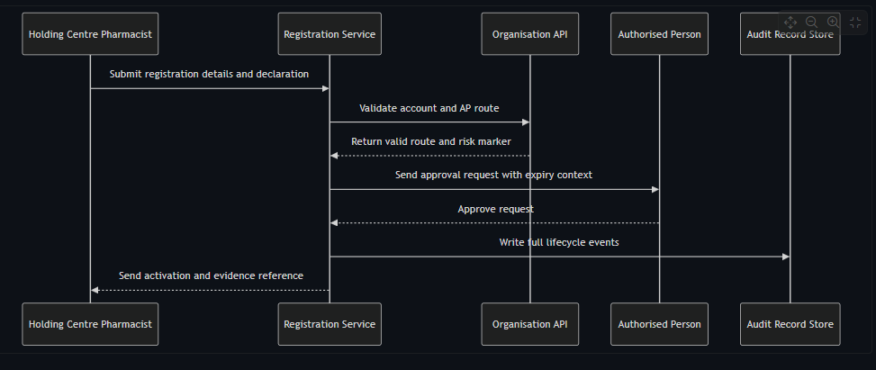
[Diagram: see markdown source for Mermaid diagram code]

Decision Points & Variations

Decision Point 1: AP route confidence
Condition: AP appears outdated or unreachable
Path A: AP responds normally
- Activation completes in standard time
- No supply continuity risk event triggered
Path B: AP route failure
- Fallback raised with high-risk marker
- Same-day escalation policy applied

Decision Point 2: Audit adequacy check
Condition: Applicant reviews completion evidence quality
Path A: Evidence is complete
- Applicant files record in GDP dossier
- Journey closes as compliant
Path B: Evidence appears incomplete
- Applicant raises compliance query
- Service owner review is triggered

Process Flow: Decision Logic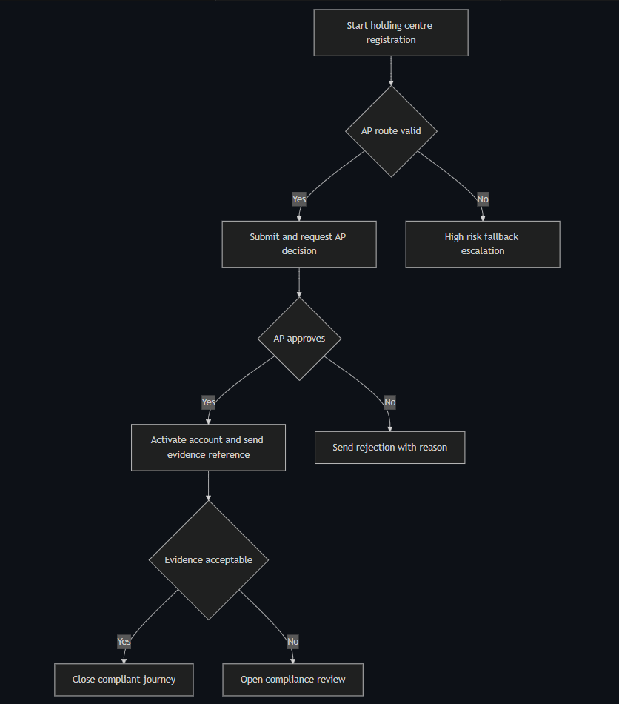
[Diagram: see markdown source for Mermaid diagram code]

Touchpoints

Digital Touchpoints
- Registration service: Data entry, declarations, status
- AP email flow: Decision action and expiry
- Audit record store: Lifecycle evidence capture and retrieval references

Physical Touchpoints
- Internal GDP compliance dossier where evidence is filed

People Involved
- Applicant pharmacist: Requires continuity and compliance confidence
- Authorised Person: Approves account access
- Fallback case handler and service owner: Handle high-risk exceptions

Pain Points & Opportunities

Current Pain Points
- Any access gap creates patient safety and compliance risk
- Confidence in AP data quality is variable for specialised accounts

Opportunities for Improvement
- Add proactive AP data quality checks for designated high-risk accounts
- Add explicit priority banner and fast-track fallback trigger for continuity risk

Accessibility Considerations
- Complex compliance guidance written in plain language with expandable detail
- Status indicators and timelines readable with assistive technology

Related Personas
- Marcus Obi: Similar non-NHS compliance needs in wholesaler context
- Rachel Thornton: Consumes records for MHRA evidence

Related Journeys
- journey-non-nhs-wholesaler-registration.md: Standard non-NHS pathway
- journey-fallback-case-resolution.md: High-risk fallback intervention route

Notes
This journey should be used to test policy for high-risk escalation and evidence completeness thresholds.

Data Elements
- Continuity risk marker: Determines escalation speed
- Evidence reference id: Retrieval handle for compliance review
- AP route status: Route confidence and fallback trigger
- Lifecycle event chain: End-to-end traceability record

Service Level Expectations
- High-risk fallback triaged same business day
- No unresolved high-risk case should exceed two working days without service owner action

Journey 15 - Fallback Case Resolution for Expired or Unroutable Requests
Primary Actor: Fatima Osei
Duration: Same day to 2 working days depending on case type
Preconditions: Case has entered fallback due to AP expiry, AP lookup failure, or unresolved validation exception
Success Criteria: Case reaches resolved state with documented intervention trail and applicant notified

Overview
This journey defines how digitally-assisted helpdesk handling works after the automated path cannot complete. It demonstrates controlled human intervention without reverting to unstructured email workflows.
The journey is critical because exception handling quality determines whether automation gains are preserved. It also provides the strongest test of audit trail completeness for non-standard cases.

Main Flow
Step | Actor | Action | System Response | Touchpoint | Notes
1 | System | Flags case for fallback | Creates fallback reason code and SLA timer | Admin case view | Trigger includes event history
2 | Fatima | Opens assigned case | Displays chronological event log and current state | Admin case view | No email reconstruction needed
3 | Fatima | Selects permitted intervention | Applies action such as extend window or update AP contact | Admin case view | Action authority enforced by role
4 | System | Executes intervention | Records operator identity and intervention reason | Workflow engine | Immutable entry appended
5 | Fatima | Monitors outcome | Confirms AP decision or closes unresolvable case | Admin case view | Closure reason required
6 | System | Notifies applicant | Sends status update with next steps | Email | Transparent status communication

Sequence Diagram: Actor Interactions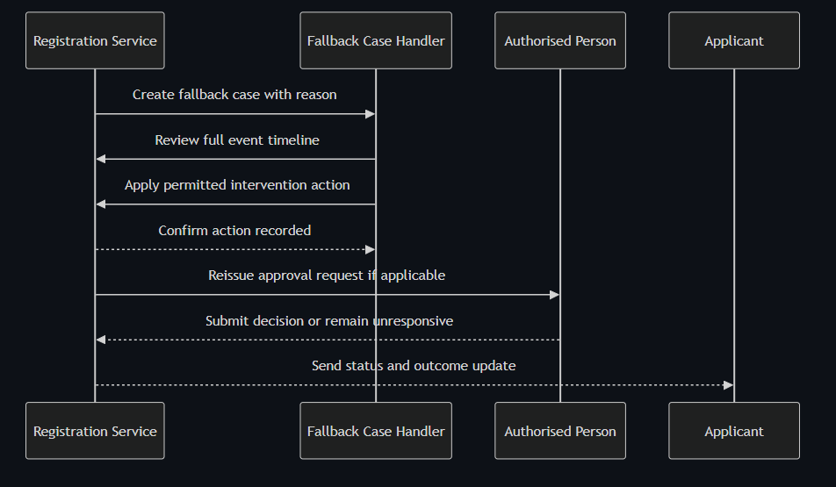
[Diagram: see markdown source for Mermaid diagram code]

Decision Points & Variations

Decision Point 1: Fallback reason category
Condition: Why case entered fallback
Path A: AP unresponsive
- Extend response window or reissue with updated AP contact
- Track additional expiry timeline
Path B: No valid AP found
- Request account owner correction path
- Close as unresolved if ownership cannot be verified

Decision Point 2: Intervention outcome
Condition: Whether intervention produces valid AP decision
Path A: Decision obtained
- Record decision and complete activation or rejection outcome
- Notify applicant and close case
Path B: No decision after intervention
- Escalate to service owner under policy
- Close with documented unresolved reason

Process Flow: Decision Logic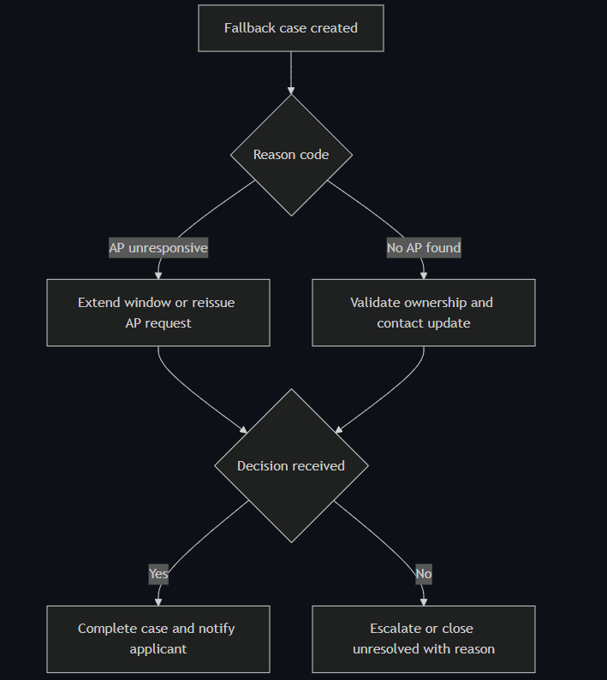
[Diagram: see markdown source for Mermaid diagram code]

Touchpoints

Digital Touchpoints
- Admin case view: Timeline, intervention actions, SLA ageing
- Notification service: Applicant status and closure notices
- Registration event store: Immutable intervention audit entries

Physical Touchpoints
- None required in standard fallback operation

People Involved
- Fallback case handler: Applies controlled interventions
- Authorised Person: May receive reissued request
- Service owner: Handles escalations beyond helpdesk authority

Pain Points & Opportunities

Current Pain Points
- Undefined authority causes either over-escalation or risky local decisions
- Incomplete case histories force manual reconstruction and delay

Opportunities for Improvement
- Add reason-code analytics dashboard for recurrent failure patterns
- Add guided intervention playbooks by case type

Accessibility Considerations
- Case timeline readable with keyboard navigation and clear status semantics
- Intervention actions include explicit confirmation to prevent accidental updates

Related Personas
- David Acheampong: Current-state helpdesk processor for manual model
- Rachel Thornton: Needs visibility of intervention records for compliance

Related Journeys
- journey-authorised-person-approval.md: Source of many fallback triggers
- journey-audit-evidence-retrieval.md: Consumption of fallback audit data

Notes
Fallback must remain exception-only or activation targets will regress toward current-state performance.

Data Elements
- Fallback reason code: Classifies automation failure mode
- Handler identity: Named intervention accountability
- Intervention action and rationale: Compliance and service improvement inputs
- Case closure status: Resolved, rejected, or unresolved outcome

Service Level Expectations
- Fallback case triage starts within four business hours
- High-risk supply cases escalated same day if unresolved after one intervention

Journey 16 - Admin Qualification Review and Decision
Primary Actor: ImmForm Administrator
Duration: 5 to 20 minutes per case
Preconditions: Registration has reached admin qualification stage
Success Criteria: Admin applies qualified decision, assigns pricelist where required, and records rationale

Overview
This journey describes the admin dashboard workflow for qualification checks, approval or rejection decisions, and pricelist assignment actions.
It covers operational controls not handled in the applicant journey and ensures auditable admin activity for regulated review.

Main Flow
Step | Actor | Action | System Response | Touchpoint | Notes
1 | Admin | Opens dashboard queue | Displays status, age, and full registration detail | Admin web | FR-19 view
2 | Admin | Reviews application detail | Confirms account qualification readiness | Admin web | Includes event history
3 | Admin | Approves or rejects qualification | Records decision and reason when needed | Admin web | EVT-13 or EVT-14
4 | Admin | Assigns pricelist access | Records assignment details | Admin web | EVT-15
5 | Admin | Applies manual override if exceptional | Records previous and new state with reason | Admin web | EVT-16

Sequence Diagram: Actor Interactions
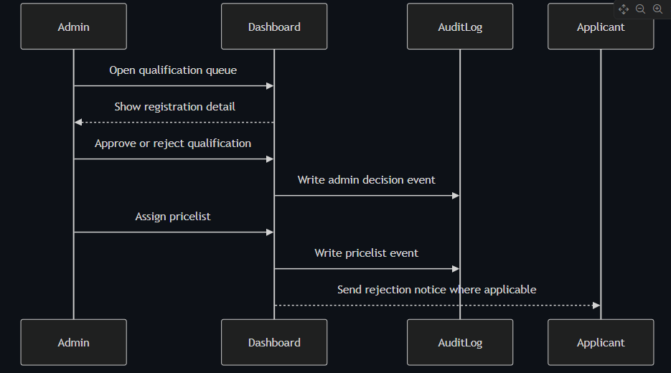 [Diagram: see markdown source for Mermaid diagram code]

Decision Points & Variations

Decision Point 1: Qualification decision
Condition: Registration satisfies qualification checks
Path A: Qualified
- Record admin approval event
- Continue to next operational step
Path B: Not qualified
- Record rejection with reason
- Notify applicant with action guidance

Decision Point 2: Exceptional handling
Condition: Standard path cannot proceed due to edge condition
Path A: No override needed
- Keep normal progression
- Maintain standard state sequence
Path B: Manual override required
- Record previous and new state
- Capture mandatory reason text

Process Flow: Decision Logic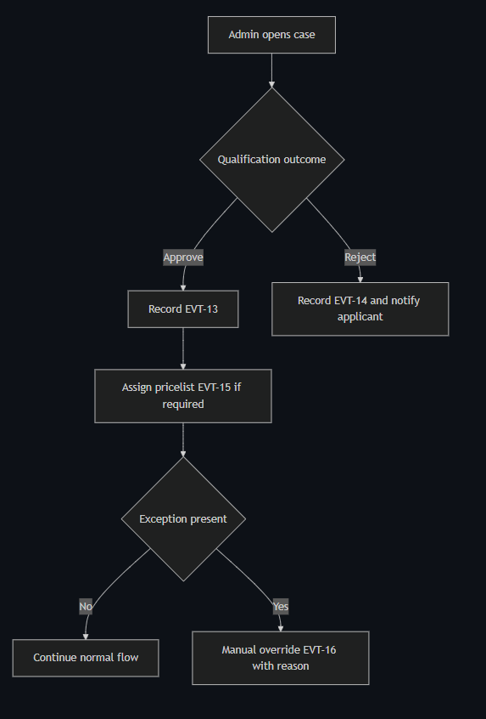
[Diagram: see markdown source for Mermaid diagram code]

Touchpoints

Digital Touchpoints
- Admin dashboard list and detail views
- Audit log writer for admin events
- Notification flow for rejection communications

Physical Touchpoints
- None

People Involved
- ImmForm administrator: Qualification decision maker
- Applicant: Receives rejection outcome when applicable
- QA or WDA role: Reviews override evidence later

Pain Points & Opportunities

Current Pain Points
- High queue volume can delay qualification decisions
- Missing reason capture weakens audit evidence

Opportunities for Improvement
- Add queue SLA indicators and filters
- Enforce structured reason templates for consistency

Accessibility Considerations
- Dashboard tables and controls are keyboard-operable
- Decision forms include clear labels and error feedback

Related Personas
- Fatima Osei: Related operational handling role
- Rachel Thornton: Consumes admin event records for compliance checks

Related Journeys
- journey-fallback-case-resolution.md: Exception handling after stalls
- journey-audit-evidence-retrieval.md: Review of admin actions in audit views

Notes
Requirement mapping: FR-19, FR-21, EVT-13, EVT-14, EVT-15, EVT-16.

Data Elements
- Admin identity and timestamp
- Qualification decision and reason
- Pricelist assignment details
- Previous and new state for overrides

Service Level Expectations
- Admin decisions are logged at action time
- Override actions always require explicit reason

Journey 17 - Account Creation API Execution and Outcome
Primary Actor: System
Duration: Seconds to minutes depending on retries
Preconditions: Authorised Person approval is complete
Success Criteria: Account creation API attempt and outcome are fully traceable, with failure alerts and success notification

Overview
This journey defines the automated account creation phase after approval. It includes request attempt logging, failure handling after resilience retries, and confirmed activation.
The journey is central to removing manual helpdesk steps and proving end-to-end automation under FR-17.

Main Flow
Step | Actor | Action | System Response | Touchpoint | Notes
1 | System | Receives approved registration state | Builds Registration API payload | Backend | Ready for EVT-17
2 | System | Sends account creation request | Logs API call attempt | API and Audit | EVT-17
3 | System | Handles API response | Success path or failure path chosen | Backend | Retry and timeout policy
4 | System | On retry exhaustion or timeout | Logs failure and sends operational alert | Audit and Monitoring | EVT-18
5 | System | On success | Logs account created and notifies applicant | Audit and Email | EVT-19

Sequence Diagram: Actor Interactions

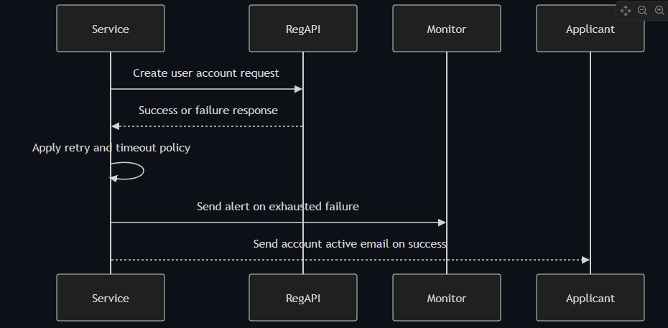
[Diagram: see markdown source for Mermaid diagram code]

Decision Points & Variations

Decision Point 1: API call outcome
Condition: Registration API returns success or error
Path A: Success
- Record account creation confirmed event
- Send activation confirmation to applicant
Path B: Error or timeout
- Retry using resilience policy
- Log failure if retries exhausted

Decision Point 2: Post-failure handling
Condition: Failure persists after retries
Path A: Recoverable later
- Operational team investigates and retriggers safely
- Audit trail keeps full attempt history
Path B: Immediate resolution not possible
- Applicant remains pending with clear status
- Manual operational response follows alert

Process Flow: Decision Logic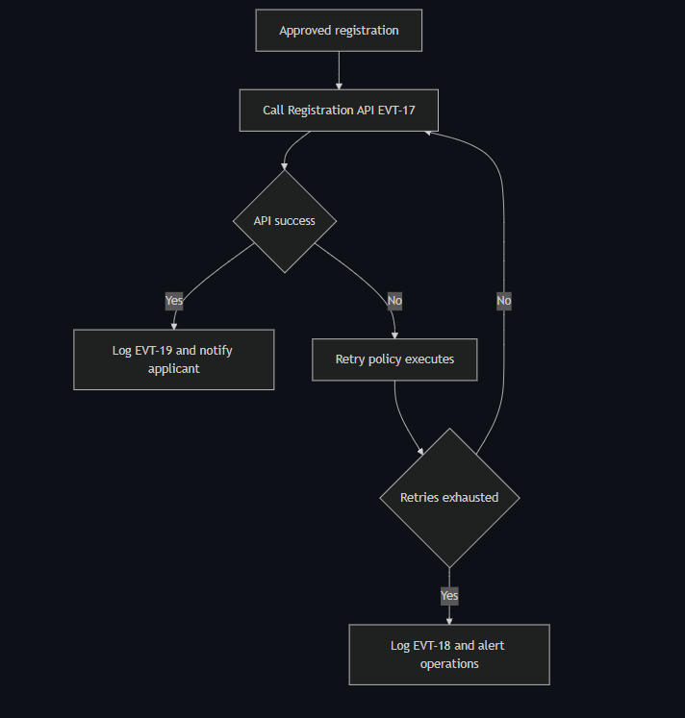
[Diagram: see markdown source for Mermaid diagram code]

Touchpoints

Digital Touchpoints
- Registration API endpoint
- Resilience middleware and logs
- Monitoring alerts channel
- Applicant activation email

Physical Touchpoints
- None

People Involved
- System runtime: Executes API automation
- Operations team: Receives failure alerts
- Applicant: Receives activation confirmation

Pain Points & Opportunities

Current Pain Points
- External API instability can stall activation
- Missing attempt history complicates incident response

Opportunities for Improvement
- Add idempotency key visibility in ops dashboard
- Add applicant pending status updates during prolonged failures

Accessibility Considerations
- Applicant outcome notifications are clear and concise
- Status pages avoid ambiguous technical language

Related Personas
- David Acheampong: Benefits from reduced manual creation load
- Rachel Thornton: Needs full event trace for inspection evidence

Related Journeys
- journey-authorised-person-approval.md: Upstream approval trigger
- journey-audit-evidence-retrieval.md: Downstream evidence consumption

Notes
Requirement mapping: FR-17, EVT-17, EVT-18, EVT-19.

Data Elements
- API request id and correlation id
- Attempt count and failure reason
- Final outcome state and notification timestamp

Service Level Expectations
- Every API attempt and outcome is auditable
- Failure alerts fire immediately after retry exhaustion

Journey 18 - Compliance Audit Retrieval and Evidence Export
Primary Actor: Rachel Thornton
Duration: 10 to 30 minutes per evidence request
Preconditions: Registration event records exist for target applicants and roles
Success Criteria: QA lead retrieves and exports complete lifecycle evidence without helpdesk support

Overview
This journey focuses on compliance and audit operations rather than frontline registration. It demonstrates independent retrieval and export of records needed for MHRA inspection and internal quality assurance.
The journey is essential because successful registration outcomes alone are insufficient if evidence cannot be reliably produced under audit conditions. It validates the service objective of independently retrievable lifecycle records.

Main Flow
Step | Actor | Action | System Response | Touchpoint | Notes
1 | Rachel | Opens audit interface | Shows search filters and recent retrieval history | Web admin | Access controlled by role
2 | Rachel | Searches by applicant or account keys | Returns matching registration lifecycle records | Audit store query | Filters include date and state
3 | Rachel | Opens target record | Displays immutable timeline with actor attribution | Web admin | Includes AP and fallback actions
4 | Rachel | Exports evidence package | Generates structured export with metadata | Export service | Suitable for inspection pack
5 | Rachel | Files evidence for inspection | Confirms package completeness | Internal QA process | No helpdesk dependency

Sequence Diagram: Actor Interactions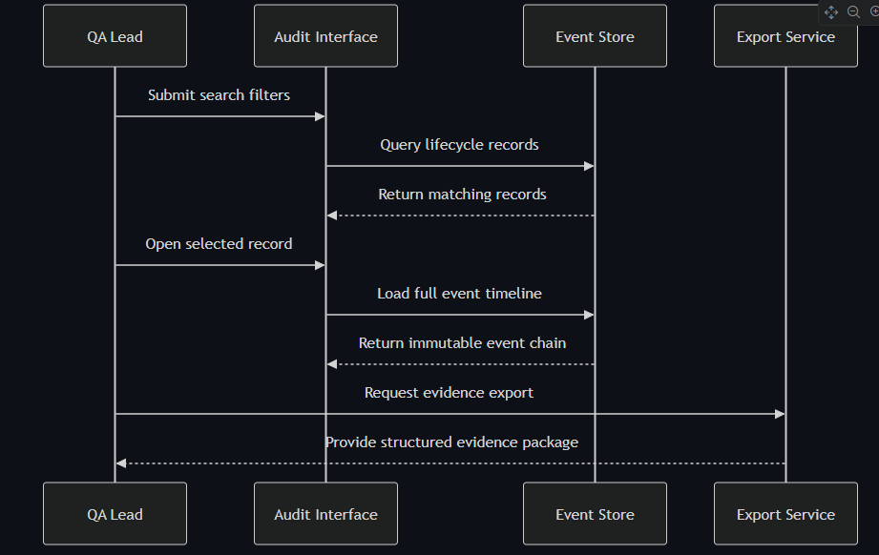
[Diagram: see markdown source for Mermaid diagram code]

Decision Points & Variations

Decision Point 1: Record completeness check
Condition: Timeline appears to have missing events
Path A: Complete chain found
- Export evidence package
- Mark request complete
Path B: Missing event detected
- Raise compliance issue to service owner
- Track remediation ticket before close

Decision Point 2: Evidence request urgency
Condition: Request is inspection-critical
Path A: Standard request
- Complete within normal business day
- Attach to monthly QA review archive
Path B: Inspection request
- Prioritise immediate retrieval and export
- Produce pack within defined urgent SLA

Process Flow: Decision Logic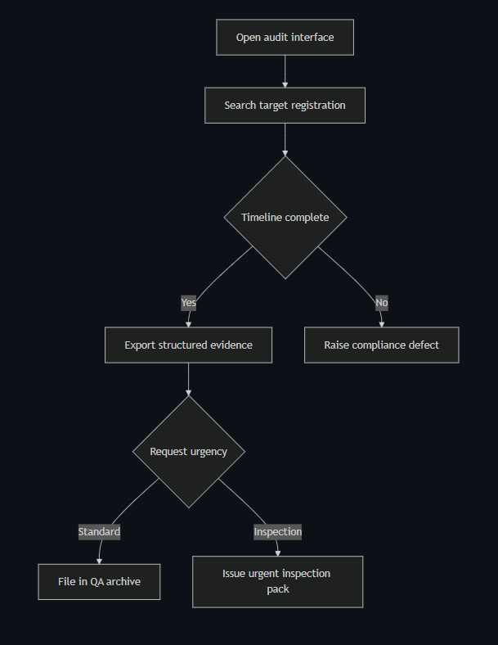
[Diagram: see markdown source for Mermaid diagram code]

Touchpoints

Digital Touchpoints
- Audit interface: Search, inspection, and export actions
- Event store: Immutable lifecycle records
- Export generator: Structured package for external review

Physical Touchpoints
- MHRA inspection pack and internal QA evidence file sets

People Involved
- QA lead and WDA RP: Retrieves and validates evidence
- Service owner: Receives and resolves record completeness issues

Pain Points & Opportunities

Current Pain Points
- Fragmented evidence retrieval creates dependence on operational teams
- Manual collation risks inconsistency during inspections

Opportunities for Improvement
- Add one-click inspection pack profiles with pre-set filters
- Add proactive alerting for incomplete lifecycle chains

Accessibility Considerations
- Search and filter controls operable by keyboard with clear status announcements
- Export format includes machine-readable structure and human-readable summary

Related Personas
- Fatima Osei: Produces intervention records used in evidence chain
- Sanjay Patel: Consumer of compliance-grade evidence in regulated operations

Related Journeys
- journey-fallback-case-resolution.md: Source of exception-handling events
- journey-holding-centre-critical-supply-registration.md: High-risk registration evidence use case

Notes
This journey is the primary test of whether the service meets independent evidence retrieval requirements.

Data Elements
- Search keys: Applicant name, account number, organisation code, state, date
- Event chain hash or integrity marker: Confirms immutability
- Export metadata: Generated time, requesting role, record scope
- Compliance defect reference: Tracks evidence gap remediation

Service Level Expectations
- Standard evidence retrieval completed same working day
- Inspection-critical retrieval and export completed within two hours

