D02 – Devising a WIS

# Identification data

__4__ __3__ __https://github.com/rodddella/Acme-Planner/______________________________  
Group Level GitHub repository

__Seville (Spain), 29/04/2021__________________________________________________________  
Place, date

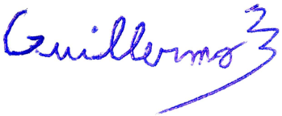__Guillermo Diz Gil (Manager, developer, tester)________________________________   
Student #1: Full name, roles, and signature

__Francisco Rodríguez Pérez (Developer, tester)________________________________  
Student #3: Full name, roles, and signature



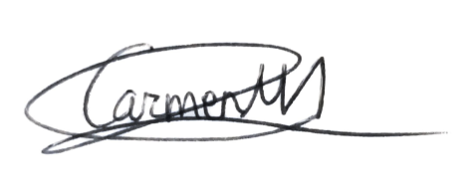__Carmen María Muñoz Pérez (Developer, tester)________________________________  
Student #2: Full name, roles, and signature

__George Laurentiu Bogdan (Developer, tester)________________________________  
Student #4: Full name, roles, and signature

# Responsibility statements

[X] I am an author of this deliverable. I have not cheated in any way.

[X] I have collaborated with my partners on producing this deliverable; in other words, neither have I ridden their coattails nor gobbled them up.

[X] I have learnt from working on this deliverable, so that I can pass my control check.

[X] I understand that my deliverable will be considered failed if I fail to meet any of its requirements or if I fail to submit it by the deadline.

[X] I understand that I must have a contingency plan and that submitting my deliverable very close to the deadline is likely to result in disaster.

[X] I have taken into account the guidelines provided in the lectures and document “On your deliverables.pdf”, which are available at the USE’s e-learning platform.

# Deliverable and requirements

### Item 1: reports

* Produce a report in which you describe your work plan. It must report on the tasks performed to produce this deliverable. For each task, you must provide a title, a short description, worker name(s), start and end-dates, and total number of hours.
* Produce a budget. It must take the amortisation of your computers and the personnel costs into account. To compute the amortisation, assume that it is linearly distributed along three years. To compute the personnel costs, assume that a manager’s work hour or an analyst’s work hour costs approximately 25€ and a worker’s work hour costs approximately 15€.
* Produce a progress report in which you describe how the work in your workgroup has gone on. Please, do not write on your subjective impressions; make a point of writing a concise and objective progress report.

### Item 2: project

* Produce a project that implements the requirements in the Acme Planner project at the desired level. The project must include a “CONTRIBUTORS.txt” file with the names and corporate e-mail accounts of your workgroup members, a “README.txt” file that describes it and provides a link to your GitHub repository and your GitHub release, and an empty “CHANGELOG.txt” file.