D03 – Functional testing

# Identification data

__4__ __B__ __https://github.com/rodddella/Acme-Planner/______________________________  
Group Level GitHub repository

__Seville (Spain), 24/05/2021__________________________________________________________  
Place, date

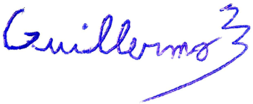__Guillermo Diz Gil (Manager, developer, tester)________________________________   
Student #1: Full name, roles, and signature

__Francisco Rodríguez Pérez (Developer, tester)________________________________  
Student #3: Full name, roles, and signature

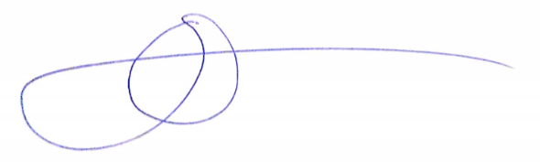

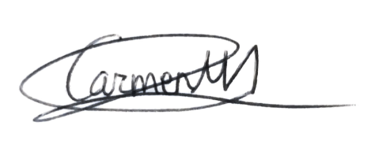__Carmen María Muñoz Pérez (Developer, tester)________________________________  
Student #2: Full name, roles, and signature

__George Laurentiu Bogdan (Developer, tester)________________________________  
Student #4: Full name, roles, and signature

# Responsibility statements

[X] I am an author of this deliverable. I have not cheated in any way.

[X] I have collaborated with my partners on producing this deliverable; in other words, neither have I ridden their coattails nor gobbled them up.

[X] I have learnt from working on this deliverable, so that I can pass my control check.

[X] I understand that my deliverable will be considered failed if I fail to meet any of its requirements or if I fail to submit it by the deadline.

[X] I understand that I must have a contingency plan and that submitting my deliverable very close to the deadline is likely to result in disaster.

[X] I have taken into account the guidelines provided in the lectures and document “On your deliverables.pdf”, which are available at the USE’s e-learning platform.

# Deliverable and requirements

### Item 1: reports

* Team members: produce a report in which you introduce your workgroup members, including their full names, recent picture, corporate email, roles played, and a global assessment of their performance.
* Work plan: produce a report in which you report on the tasks performed to produce this deliverable. For each task, you must provide a title, a short description, worker name(s), start and end dates, and total number of hours spent. (Note that the report is not about estimated number of hours, but the actual number of hours spent on each task.)
* Budget: produce a report with your budget, which must take the amortisation of your computers and the personnel costs into account. To compute the amortisation, assume that it is linearly distributed along three years. To compute the personnel costs, assume that a manager’s work hour or an analyst’s work hour costs approximately 25€ and a worker’s work hour costs approximately 15€.
* Progress report: produce a report in which you describe how the work in your workgroup has gone on. Please, do not write on your subjective impressions; make a point of writing a concise and objective progress report.
* Lint report: produce a report in which you explain the bad smells found by Sonar Lint and why they are not problematic. Note that, ideally, this report must be empty because Sonar Lint should not be able to find any bad smells in your code. In the cases in which Sonar Lint finds a bad smell, you must analyse it; it may be the case that Sonar Lint is right, which means that you have to correct the problem; in the exceptional case in which Sonar Lint is not right, you must clearly justify the reason why.
* Change-log report: produce a report in which you describe the mistakes that you’ve found in your previous delivery and how you have corrected them.
* Credentials: produce a file in which you provide a link to your GitHub repository, a link to your Clever Cloud application, and the credentials to start your project up at Clever Cloud.
* Data model report: produce a report with a model for the data managed in project Acme Planner at the desired level. Please, make sure that the model includes all of the constraints in the requirements and the ones that result from analysing it.
* Features model report: produce a report with the features models of project Acme Planner at the desired level. Please, make sure that the model includes all of the features, actions, and constraints in the requirements and the ones that result from analysing it.

### Item 2: project

* Produce a project that implements the requirements in the Acme Planner project at the desired level. You are strongly encouraged to correct the mistakes found in the previous deliverable and to take your lecturer’s advice into account. Ideally, Sonar Lint should not report any bad smells; if it does, please, justify why Sonar Lint is wrong in the corresponding report.
* Produce a test suite to perform formal functional testing on your project. Your test suite must fulfil the following requirements so that it can be accepted for evaluation:
  + The instruction coverage reported by the Coverage Runner plugin must be at least 60% in every feature.
  + Every feature must have at least a positive test case per action.
  + Every feature must have at least a negative test case per action.
  + Every test case must include a header comment in which you make it clear the feature that is going to be tested (including the constraints that are violated) and the expected results.