**REWARDS ADMINISTRATOR**

1. **Add Country**

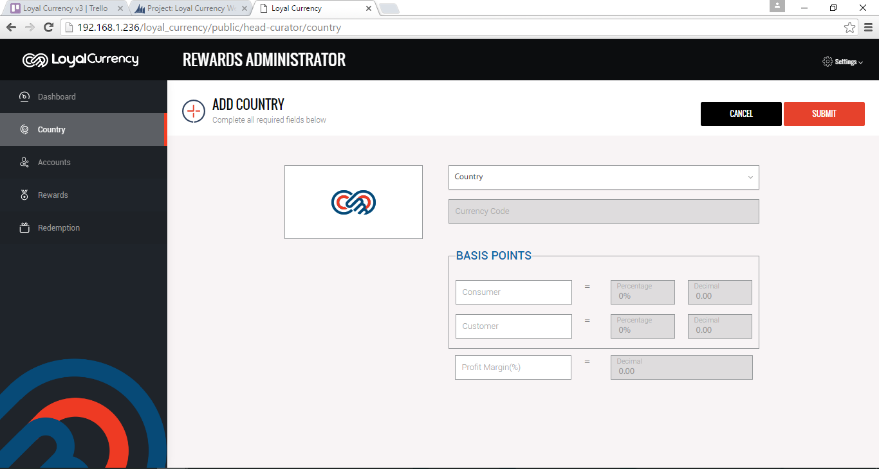

1. **Add Country with Error message (Without Entering Value)**

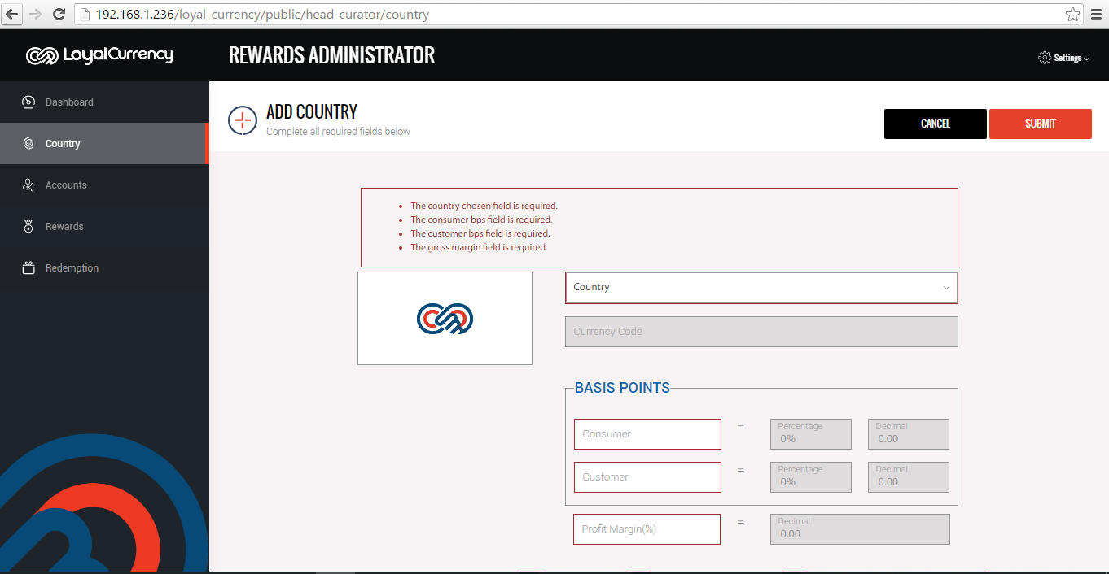

1. **Add Country with error message (Some Fields has value)**

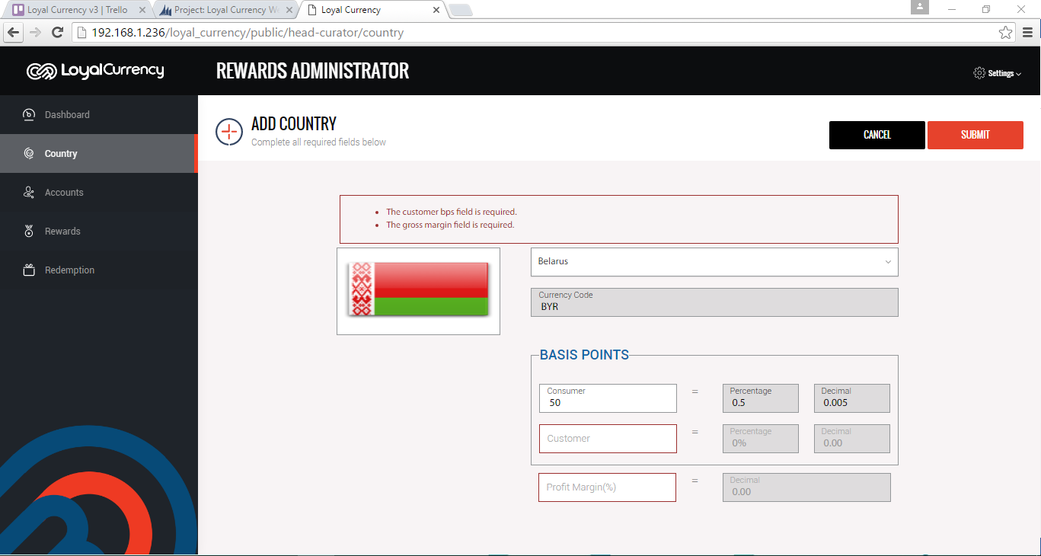

1. **Edit Country with error message (Remove all data in required/enabled field)**

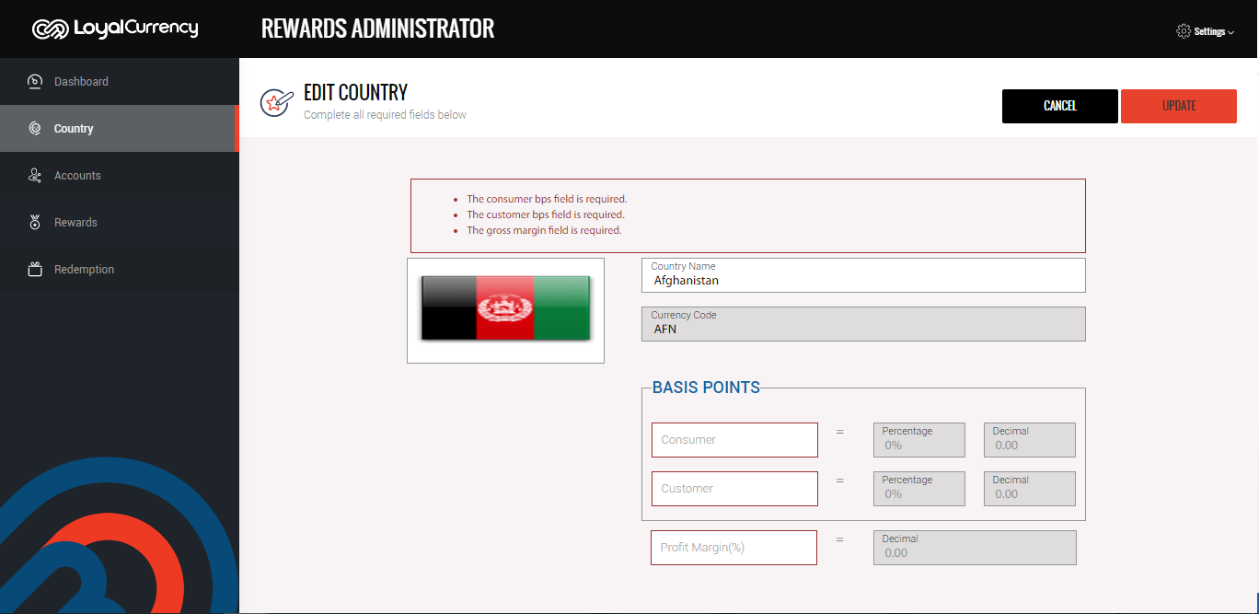

1. **Add account**

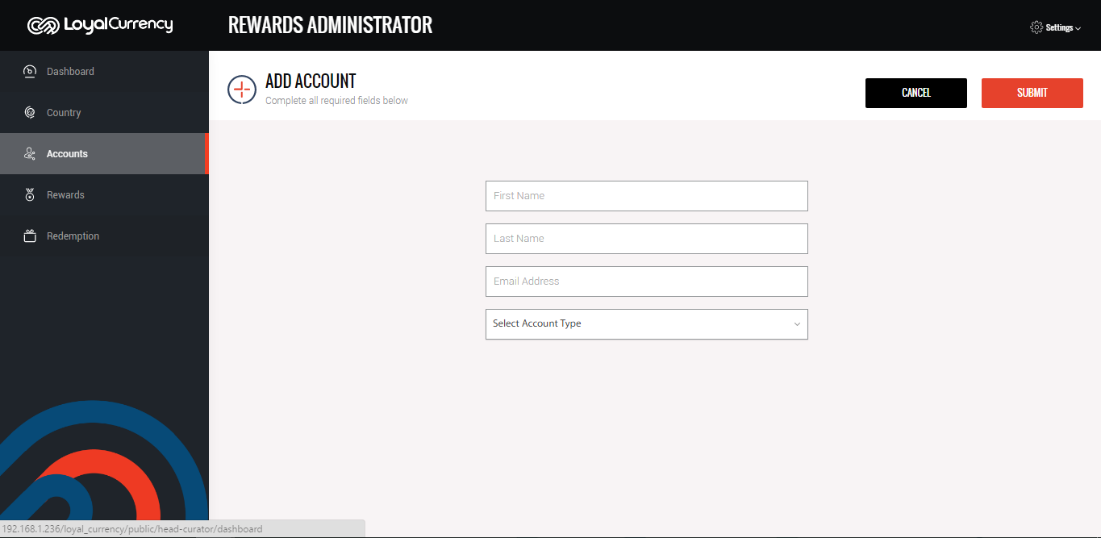

1. **Add account with error message (Without entering values)**

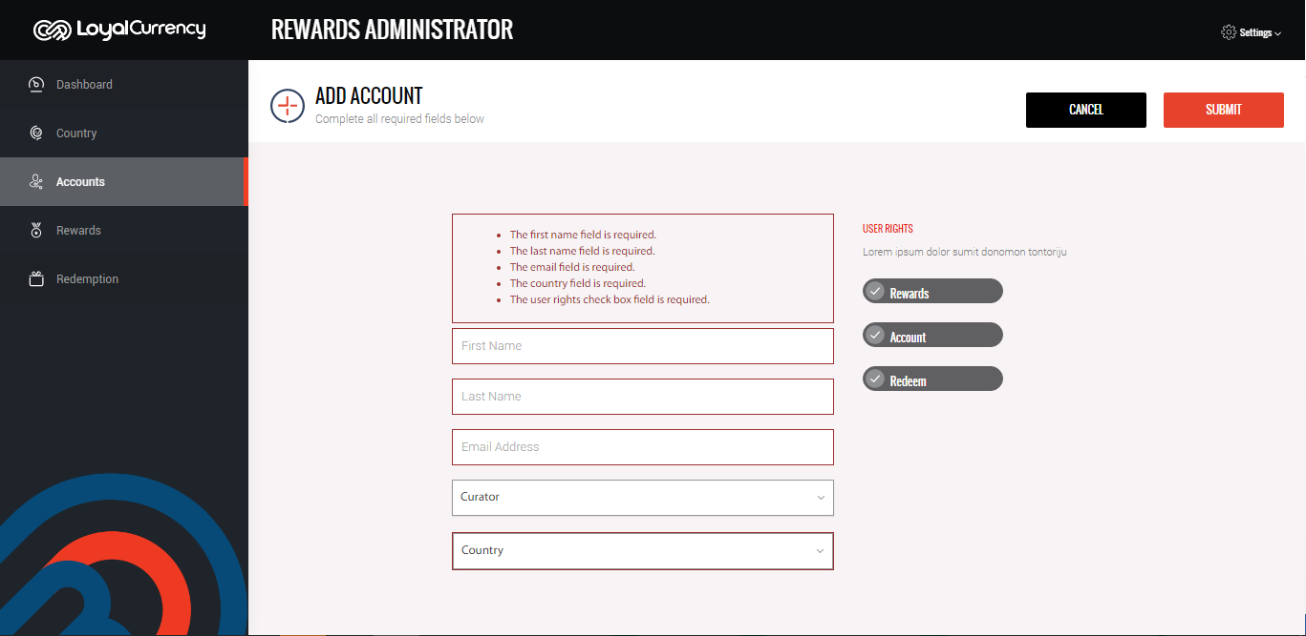

1. **Add account wrong email**

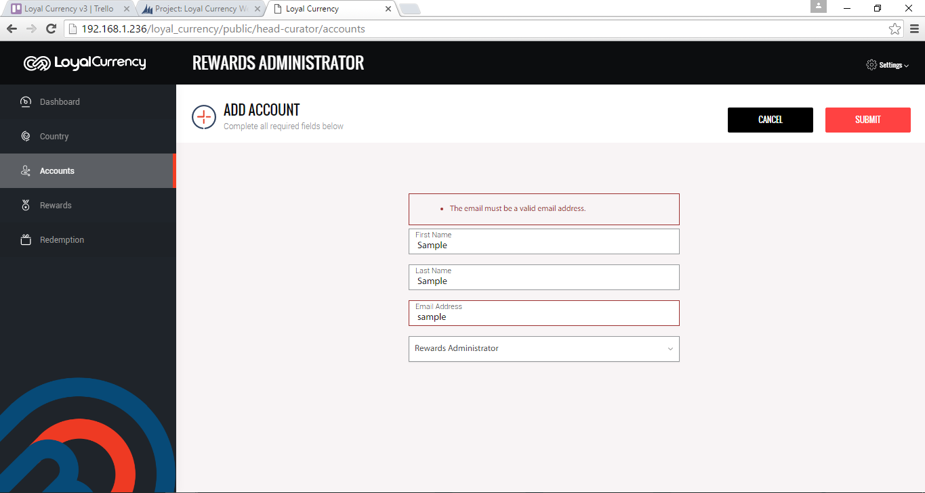

1. **Edit account remove required/editable fields**

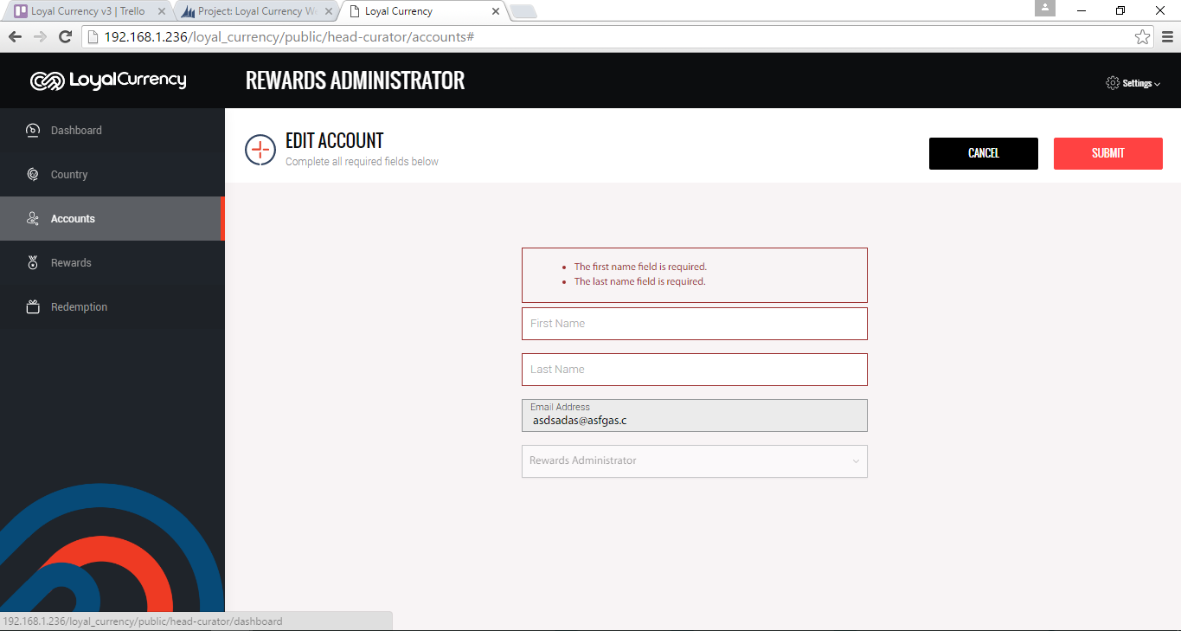

1. **Adding of rewards**

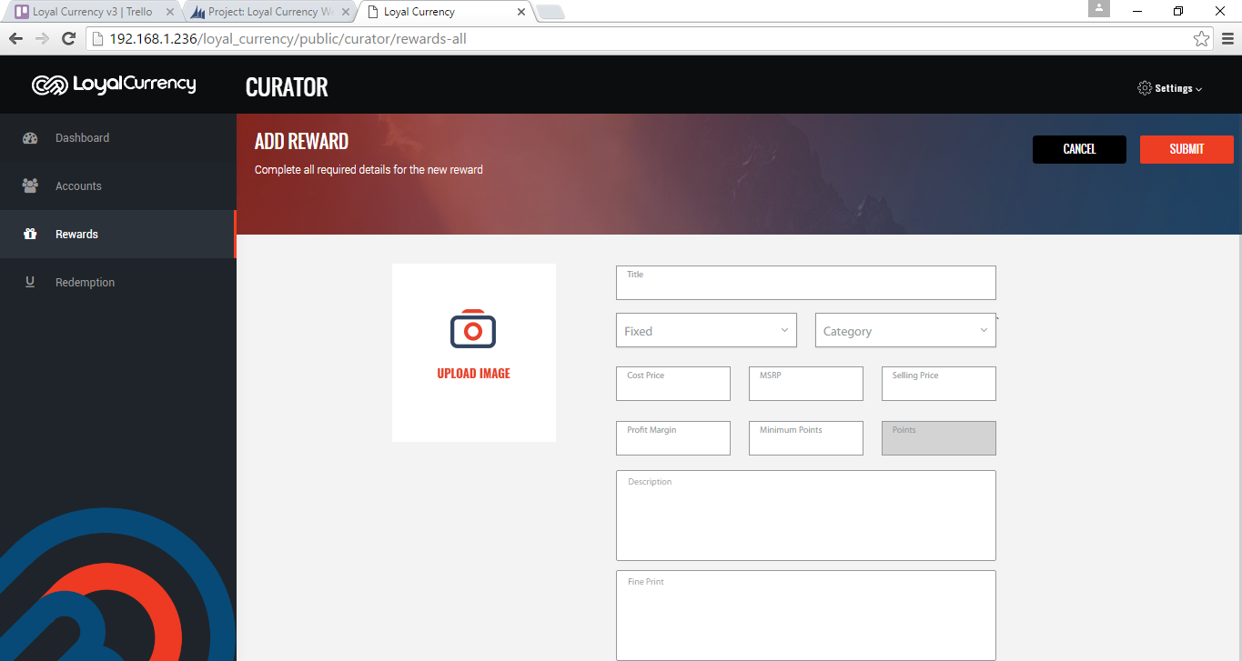

1. **Adding of rewards without entering data on fields**

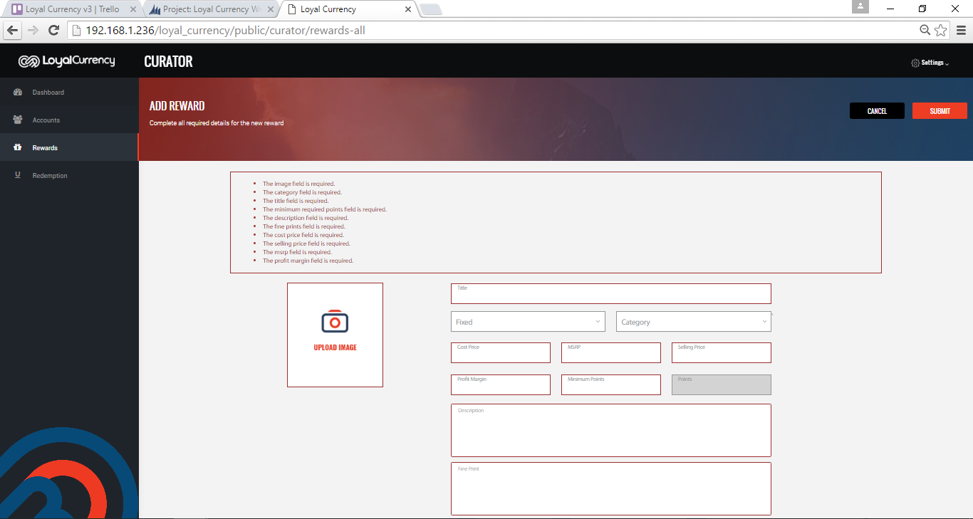

1. **Adding of rewards validation on Dates**

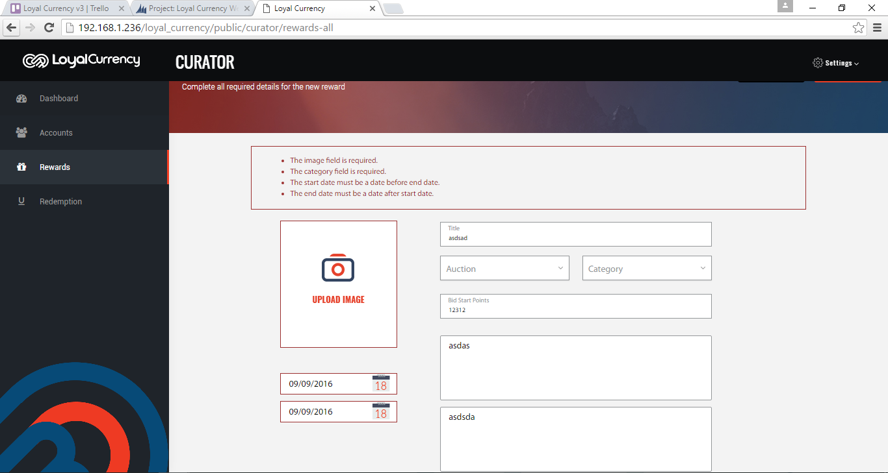

1. **Add behavior**

