TP 3

Exercice 1 :
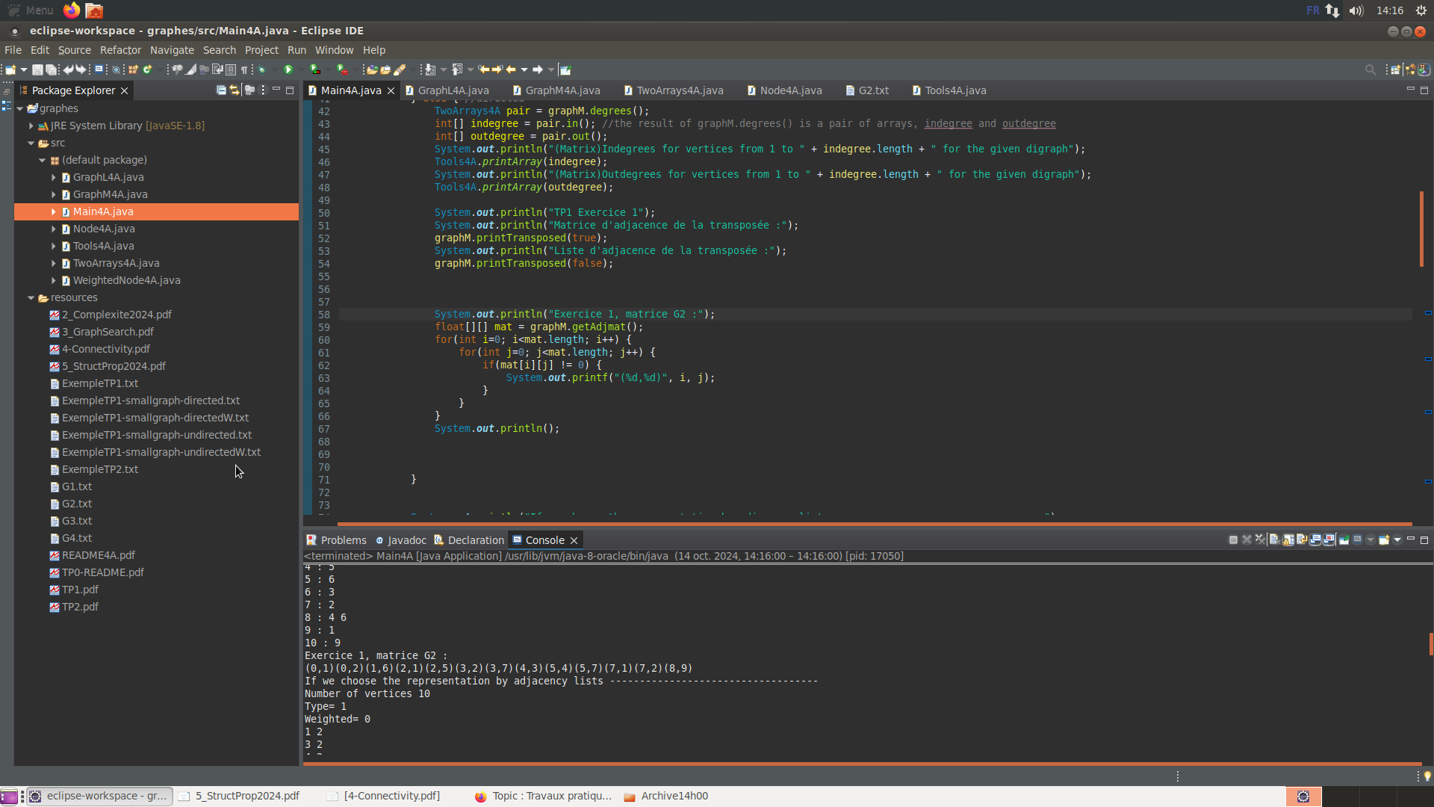
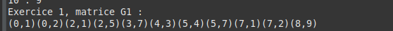

Exercice 2 :

/**
* @param outMatrix display the result as an adjacency matrix (or as an adjacency list)
*/
public void printTransposed(boolean outMatrix) {
if (outMatrix)
Tools4A.printMatrix(transposedMM());
else
Tools4A.printAdjList(transposedML(), transposedMLW());
}

/**
* Compute the transposed graph, represented by an unweighted adjacency list
*/
private Node4A[] transposedML() {
if (this.weighted == 1) return null;

Node4A[] adjlist = new Node4A[this.n];
//liste des successeurs du noeud j
for (int j = 0; j < this.n; j++) {
int[] successeurs = new int[this.n];
int k = 0;
for (int i = 0; i < this.n; i++) {
if (this.adjmat[i][j] != 0) {
successeurs[k] = i;
k++;
}
}
//ajout du noeud j et de ses successeurs dans adjlist
Node4A n = new Node4A(successeurs[0], null); //n.val = premier successeur de n
adjlist[j] = n;
k = 1;
while (successeurs[k] != 0) { //n.next = autre successeur de n
Node4A s = new Node4A(successeurs[k], null);
n.setNext(s);
n = s;
k++;
}
}
return adjlist;
}

Complexité : Θ(n²)

Exercice 3 :

/**
* TP2
* Perform a graph search using the DFSnum algorithm
*/
public void search() {
this.debut = new int[this.n];
this.fin = new int[this.n];
this.arcType = new int[this.n][this.n];
this.cycle = new LinkedList<Integer>();
for (int i=0; i<this.n; i++) { //parcours de tous les noeuds (juste les noeuds, pas leurs successeurs)
if (this.debut[i] == 0) {
this.nb += 1;
this.debut[i] = this.nb;
this.cycle.add(i);
System.out.print(i+1 + " ");
if (this.weighted == 0)
DFS_Num(adjlist[i], i);
else
DFS_NumW(adjlistW[i], i);
}
}
System.out.println();

/**
* TP2
* @param s the vertex root of the tree provided by the DFSnum algorithm
* @param sval the value of the node s (on n'y a pas vraiment accès si on le garde pas)
*/
private void DFS_Num(Node4A s, int sval) {
//récursivité sur chaque successeur de s
for (Node4A next = s; next != null; next = next.getNext()){
if (this.debut[next.getVal()] == 0) {
//tree arc
this.nb += 1;
this.debut[next.getVal()] = this.nb;
this.arcType[sval][next.getVal()] = 1;
this.cycle.add(next.getVal());
System.out.print(next.getVal()+1 + « »);

DFS_Num(adjlist[next.getVal()], next.getVal());

}
else {
//not tree arc
if (this.fin[next.getVal()] == 0) {
if (this.debut[sval] < this.debut[next.getVal()])
this.arcType[sval][next.getVal()] = 2; //forward (d[s]<d[n]) arc
else {
this.arcType[sval][next.getVal()] = 3; //backward (d[s]>d[n]) arc (=cycle)
//tous les noeuds entre s et n dans this.cycle sont dans le cycle
//System.out.println("Présence d'un cycle :");
//for(int i=this.cycle.indexOf(next.getVal()); i<this.cycle.indexOf(sval)+1; i++)
// System.out.print(this.cycle.get(i) + 1 + " ");
//System.out.println();
}
}
else
this.arcType[sval][next.getVal()] = 4; //cross arc
}
}
this.nb += 1;
this.fin[sval] = this.nb;
this.cycle.remove((Integer) sval);
}

main :

System.out.println("Exercice 3 : ");
float[][] mat = graphM.getAdjmat();
for(int i=0; i<mat.length; i++) {
for(int j=0; j<mat.length; j++) {
if(mat[i][j] == 1) {
System.out.printf("(%d,%d) de type tree arc\n", i, j);
}
if(mat[i][j] == 2) {
System.out.printf("(%d,%d) de type forward arc\n", i, j);
}
if(mat[i][j] == 3) {
System.out.printf("(%d,%d) de type backward arc\n", i, j);
}
if(mat[i][j] == 4) {
System.out.printf("(%d,%d) de type cross arc\n", i, j);
}
}
}
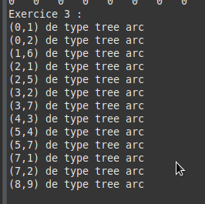
System.out.println();

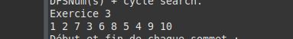

Exercice 4 :
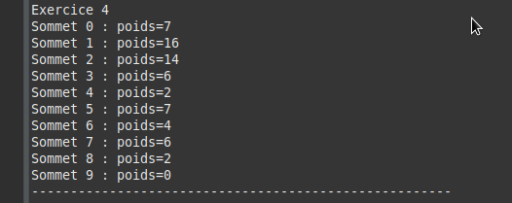

Main :

System.out.println("Exercice 4");
graphL.SommePoidsSommets();

GraphL4A :

private int[] somme;

public void SommePoidsSommets() {
this.somme = new int[this.n];

for (int i=0; i<this.n; i++) {
for (WeightedNode4A next = adjlistW[i]; next != null; next = next.getNext()) {
somme[i] += next.getWeight();
}
System.out.printf("Sommet %d : poids=%d\n", i, this.somme[i]);
}

}

