Rocket.Chat Technical Support Analyst – Challenge – Bruna Martins
- Server set up and environment creation:
http://d1358dfb9e29.ngrok.io – URL to my server
Username: brunera
Password: Gremio182@

- For the server set up I created a Virtual Box machine running Ubuntu 18.04, as I did not have any other operational system besides Windows on my personal computer.
- I did the server configuration following the steps bellow, I used the documentation from Rocket Docs for Ubuntu(https://docs.rocket.chat/installation/manual-installation/ubuntu), and also, I did some research on the internet, because it did not work as expected for Mongo installation, the service did not ran as expected,which came to what i found online – the replication on Mongo.conf. file.

- Another point I would like to share, because it really intrigued me, was the ‘One Click Deploy’ for Heroku. I’m not sure if I should have done any other steps , but it did not work. I will attach thescreenshot I took, it worked fine until it asked for npm update into the log, hit the compilation step, then finished unsuccessfully and just closed. I would like to know if there are other steps besides the web app to create the environment.
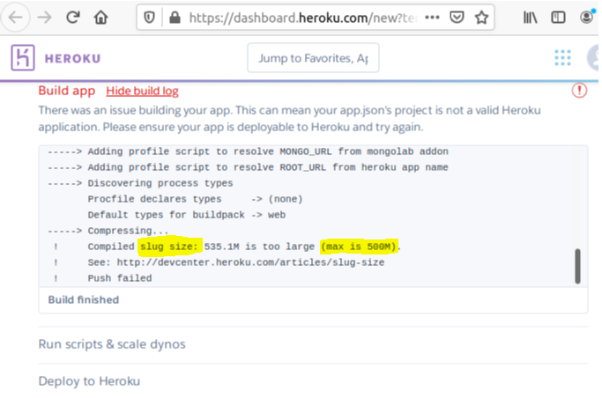

2.Command lines used:
- Ubuntu 18.04 (desktop version), I opened the terminal and ran the following:

apt-get -y update && apt-get install -y sudo

sudo apt-get install -y dirmngr && sudo apt-key adv --keyserver hkp://keyserver.ubuntu.com:80 --recv 9DA31620334BD75D9DCB49F368818C72E52529D4

echo "deb http://repo.mongodb.org/apt/debian stretch/mongodb-org/4.0 main" | sudo tee /etc/apt/sources.list.d/mongodb-org-4.0.list

sudo apt-get -y update && sudo apt-get install -y curl && curl -sL https://deb.nodesource.com/setup_8.x | sudo bash -

sudo apt-get install -y build-essential mongodb-org nodejs graphicsmagick

sudo npm install -g inherits n && sudo n 8.11.4

nano /etc/mongod.conf -- this is the point where I added :
replication:
replSetName: "001-rs"

curl -L https://releases.rocket.chat/latest/download -o /tmp/rocket.chat.tgz

tar -xzf /tmp/rocket.chat.tgz -C /tmp

cd /tmp/bundle/programs/server && npm install --unsafe-perm

sudo mv /tmp/bundle /opt/Rocket.Chat

cd /opt/Rocket.Chat

sudo useradd -M rocketchat && sudo usermod -L rocketchat && sudo chown -R rocketchat:rocketchat /opt/Rocket.Chat

sudo chown -R rocketchat:rocketchat /opt/Rocket.Chat

cd ../../

export MONGO_OPLOG_URL=mongodb://localhost:27017/local?replicaSet=001-rs
export ROOT_URL=https://localhost:3000/
export MONGO_URL=mongodb://localhost:27017/rocketchat
export PORT=3000
node main.js

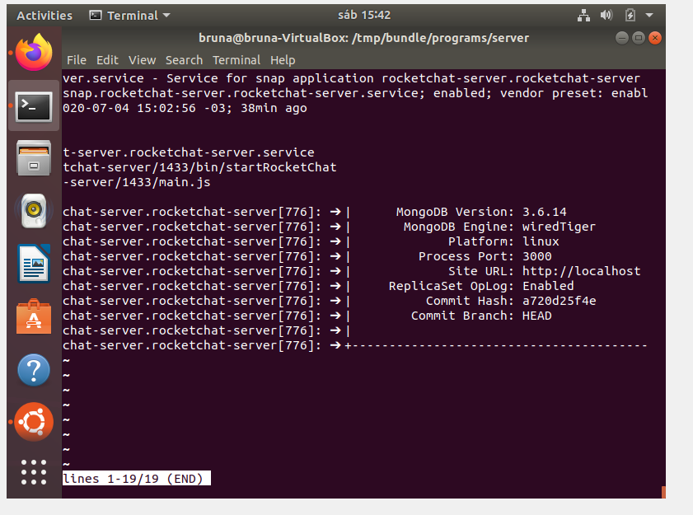
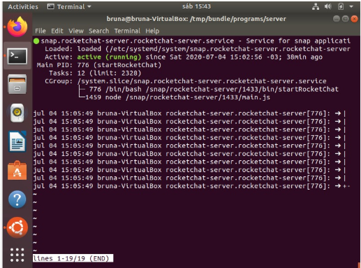Rocket.Chat service running

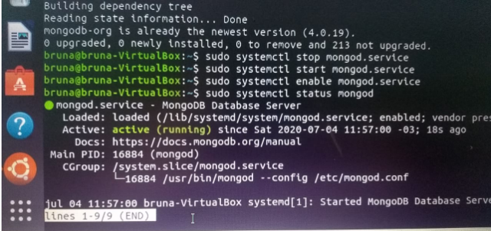MongoD service running

After I completed the steps above, I checked my localhost to the 3000 port and got the RocketChat page to finish my account:

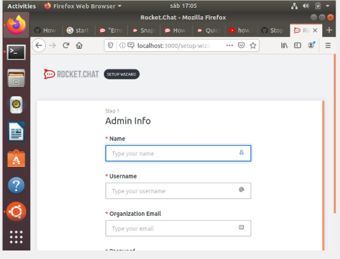

I created the user ‘brunera’ and set up my account according to the required information.
As it was pointing to my machine, I also used Ngrok to create a tunnel connection so I could send you the link to my server.
I tested it on my Windows computer, through the URL on RocketChat application and also on the web browser.
For general testing, I sent an invite to my friend setting the URL of the server into the ‘General’ menu , and I also tried it out on my mobile as if I was a guest.

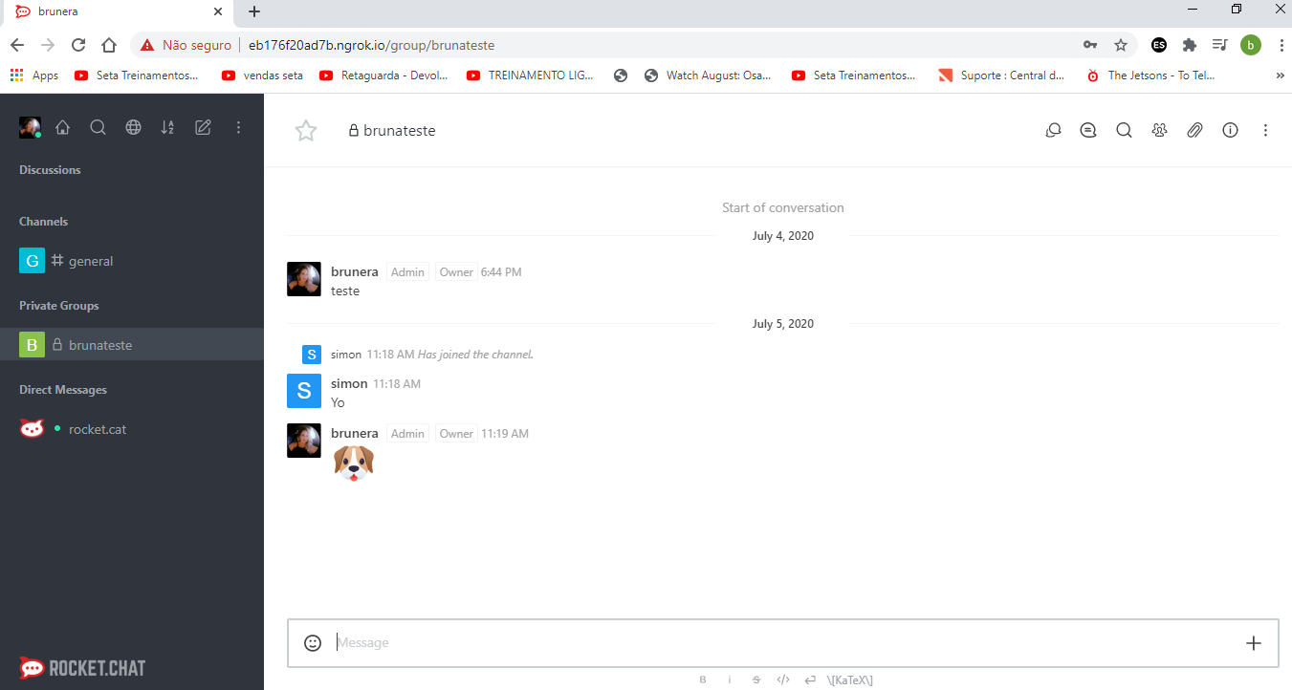
Web browser test – channel created and person invited

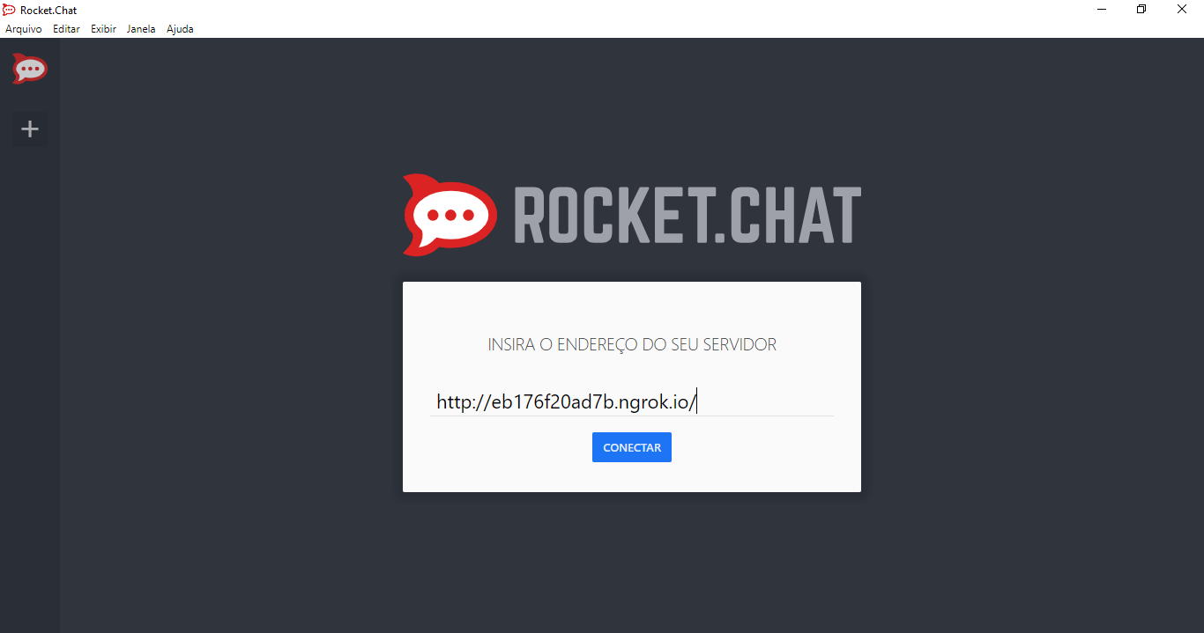
Windows app on my personal computer
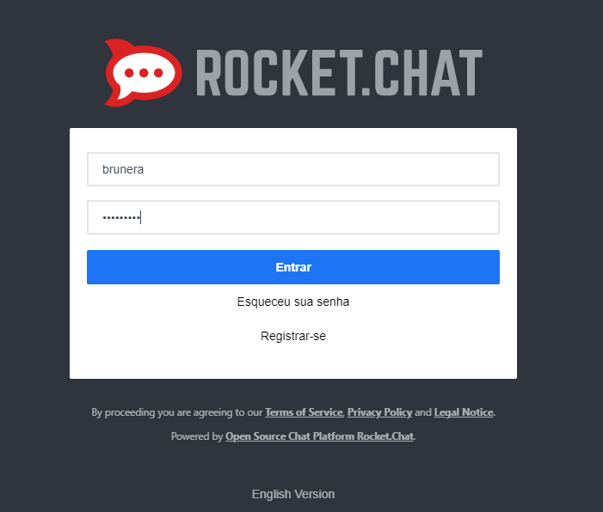
Login info

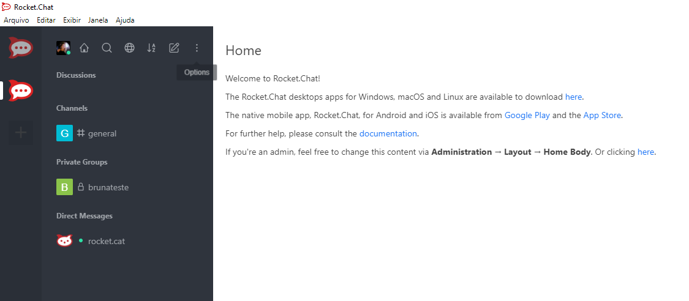
Windows app logged in
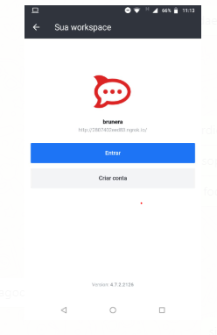mobile testing

3.API’s:
I’ll attach the screenshots , I used Postman, exept for the login , which I did on Ubuntu Terminal. All the tests were OK,status 200.

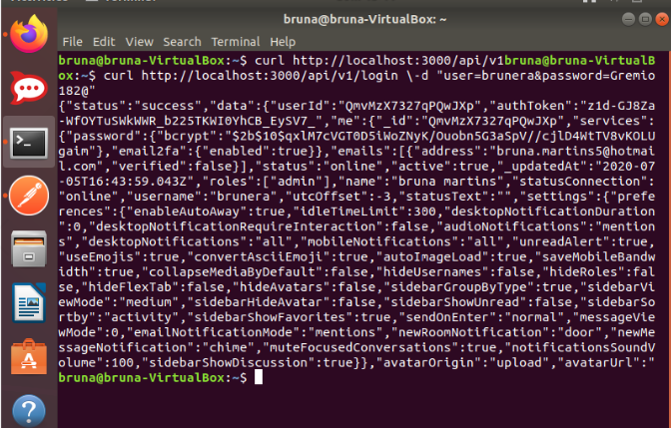
Login, where I got the userId and authToken.

User creation : Bruno
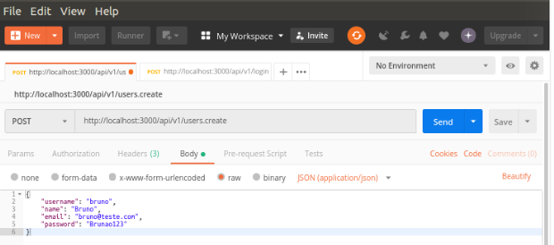
Post users.create

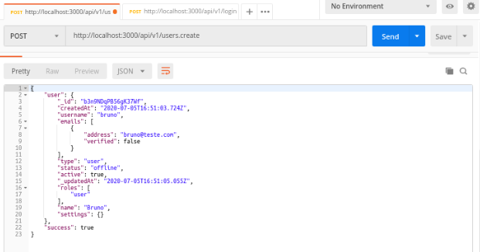
User created response

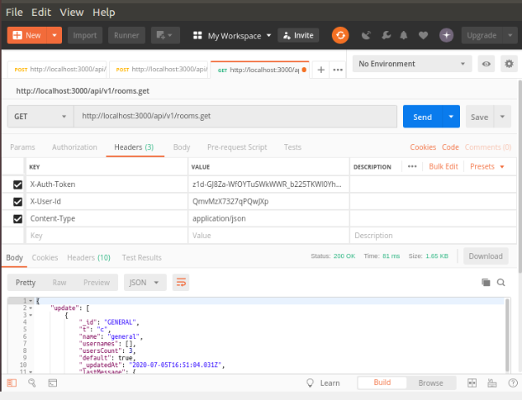
Rooms.get

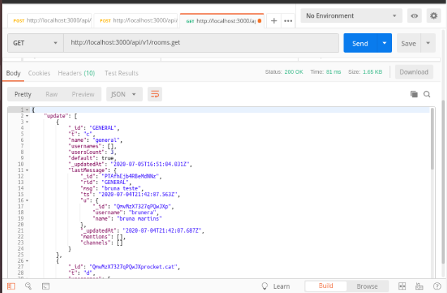
Rooms response

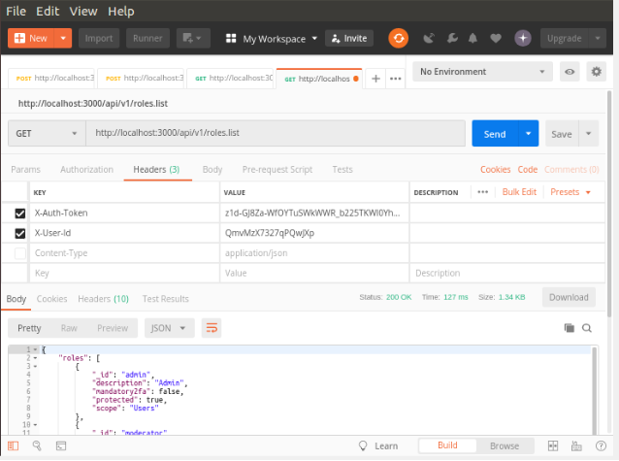
Roles list

