CAPSTONE STUDY PROJECT / UNDERGRADUATE THESIS
AI-Enabled Space Situational Awareness:
Explainable Classification and Characterization of Resident Space Objects
Phase 3 Document: Implementation Readiness, Multi-Source Data Fusion & System Validation
__________________________________________________________________
Student Name | Student ID | Role / Responsibilities
Aditya Pathak | 2023EB03030 | Data Engineer & Pipeline Architect
Sarthak Maji | 2023EB03175 | Lead Machine Learning Engineer
Punam Dutta | 2023EB03218 | Lead Frontend & Visualization Developer
Pritesh Khokhariya | 2023EB03081 | Backend Systems & Integration Developer

Project Supervisor: Dr. Vidyapati Kumar
Date of Submission: September 18, 2026

TABLE OF CONTENTS
1. Introduction 3
1.1 Purpose of Phase 3 3
1.2 Summary of Work Completed So Far 3
2. Implementation Overview 4
2.1 Implementation Status 4
2.2 Implemented Features & Core Modules 4
2.3 Technology Stack 6
3. System Validation and Testing 6
3.1 Testing Strategy & Data Protections 6
3.2 Test Cases and Verification Results 6
4. Performance and Reliability Analysis 7
4.1 Responsiveness and Sub-Second Execution Latency 7
4.2 Stage 1 Classification Ablation Results 7
4.3 Stage 2 Class-Conditioned Mass Regression 8
4.4 SHAP Feature Importance & Interpretability 8
5. Control Dashboard Demonstration 9
6. Risk Analysis and Mitigation Review 11
7. Limitations and Constraints 12
8. Future Work and Enhancements 12
9. Project Deliverables Summary 13
10. Conclusion and Supervisor Review 13

1. Introduction

1.1 Purpose of Phase 3
Phase 3 demonstrates the full implementation readiness and empirical system validation of our AI-Enabled Space Situational Awareness (SSA) framework. Building directly upon the data ingestion, KeepTrack-gated cross-catalog matching, and median-detrended photometric time-series processing completed in Phase 2, Phase 3 executes multi-source data fusion, baseline machine learning classification, class-conditioned physical characterization, and Explainable AI (XAI) feature attribution.
Through systematic GroupKFold cross-validation, multi-source ablation experiments, and local SHAP feature attributions, Phase 3 verifies that fusing MMT-9 light-curve photometric statistics with propagated SGP4 orbital parameters yields statistically significant performance gains while eliminating target data leakage and preventing cross-pass training contamination.

1.2 Summary of Work Completed So Far
The project's progression across academic deliverable milestones is structured as follows:
- Phase 1 (Planning & Proposal): Established problem motivation, surveyed physical data sources (Space-Track TLEs, ESA DISCOS, MMT-9 photometry), defined functional/non-functional requirements, and formulated the multi-stage system architecture.
- Phase 2 (Design & Photometric PoC): Constructed the automated data ingestion pipeline, integrated the local SQLite database (rso_poc.db), developed the median-detrended photometric processing chain (Lomb-Scargle and PDM period searches), and built a zero-build FastAPI/Tailwind control dashboard.
- Phase 3 (Implementation & Validation): Compiled the unified multi-source feature matrix, enforced automated feature leakage guards, trained Stage 1 multiclass classifiers (LightGBM, AdaBoost, Decision Tree), executed Stage 2 class-conditioned mass regressors, generated SHAP explainability plots, and deployed sub-second real-time inference endpoints.
Phase Boundary Definition: Phase 3 represents the complete, end-to-end execution of our machine learning and characterization stack. It validates that fusing observational light-curve photometry with orbital mechanics increases multiclass classification Macro F1-score from 0.5763 to 0.5974 (AdaBoost) and enables class-conditioned physical mass estimation in under 0.68 seconds.

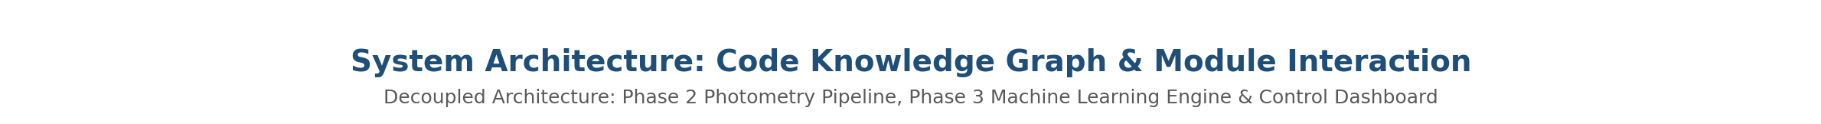
Figure 1: Complete System Architecture Integrating Phase 2 Photometric Processing, Phase 3 ML Stack & Control Dashboard

2. Implementation Overview

2.1 Implementation Status
All core scientific, machine learning, data storage, and dashboard modules defined in the project blueprint are fully implemented, tested, and integrated. The codebase follows strict software engineering decoupling: astrodynamics and ML execution reside in dedicated Python scripts (scripts/), core logic and data structures reside in src/, and user-facing interactions are handled asynchronously by the FastAPI web server (dashboard/).

2.2 Implemented Features & Core Modules
Module / Script | Phase | Primary Responsibility | Outputs / Artifacts
fetch_data.py | Phase 2 | API ingestion, KeepTrack COSPAR resolution, TLE/DISCOS fetching | Raw CSVs, SQLite objects/light_curves
analyze_periods.py | Phase 2 | Median-detrending, Lomb-Scargle & PDM period analysis | rso_poc.db periodograms, validation plots
prepare_dataset.py | Phase 3 | Feature matrix compilation, Leakage Guard enforcement | phase3_feature_matrix.csv
run_ablation.py | Phase 3 | GroupKFold cross-validation & feature set ablation | ablation_metrics.csv, Stage 1 models
explain_models.py | Phase 3 | OOF confusion matrix & SHAP feature attributions | shap_beeswarm.png, confusion_matrix.png
train_stage2.py / run_pipeline.py | Phase 3 | Class-conditioned mass regression & end-to-end inference | regressor_payload.pkl, inference_result

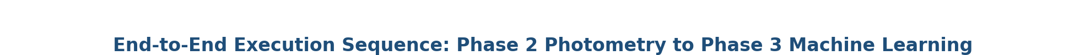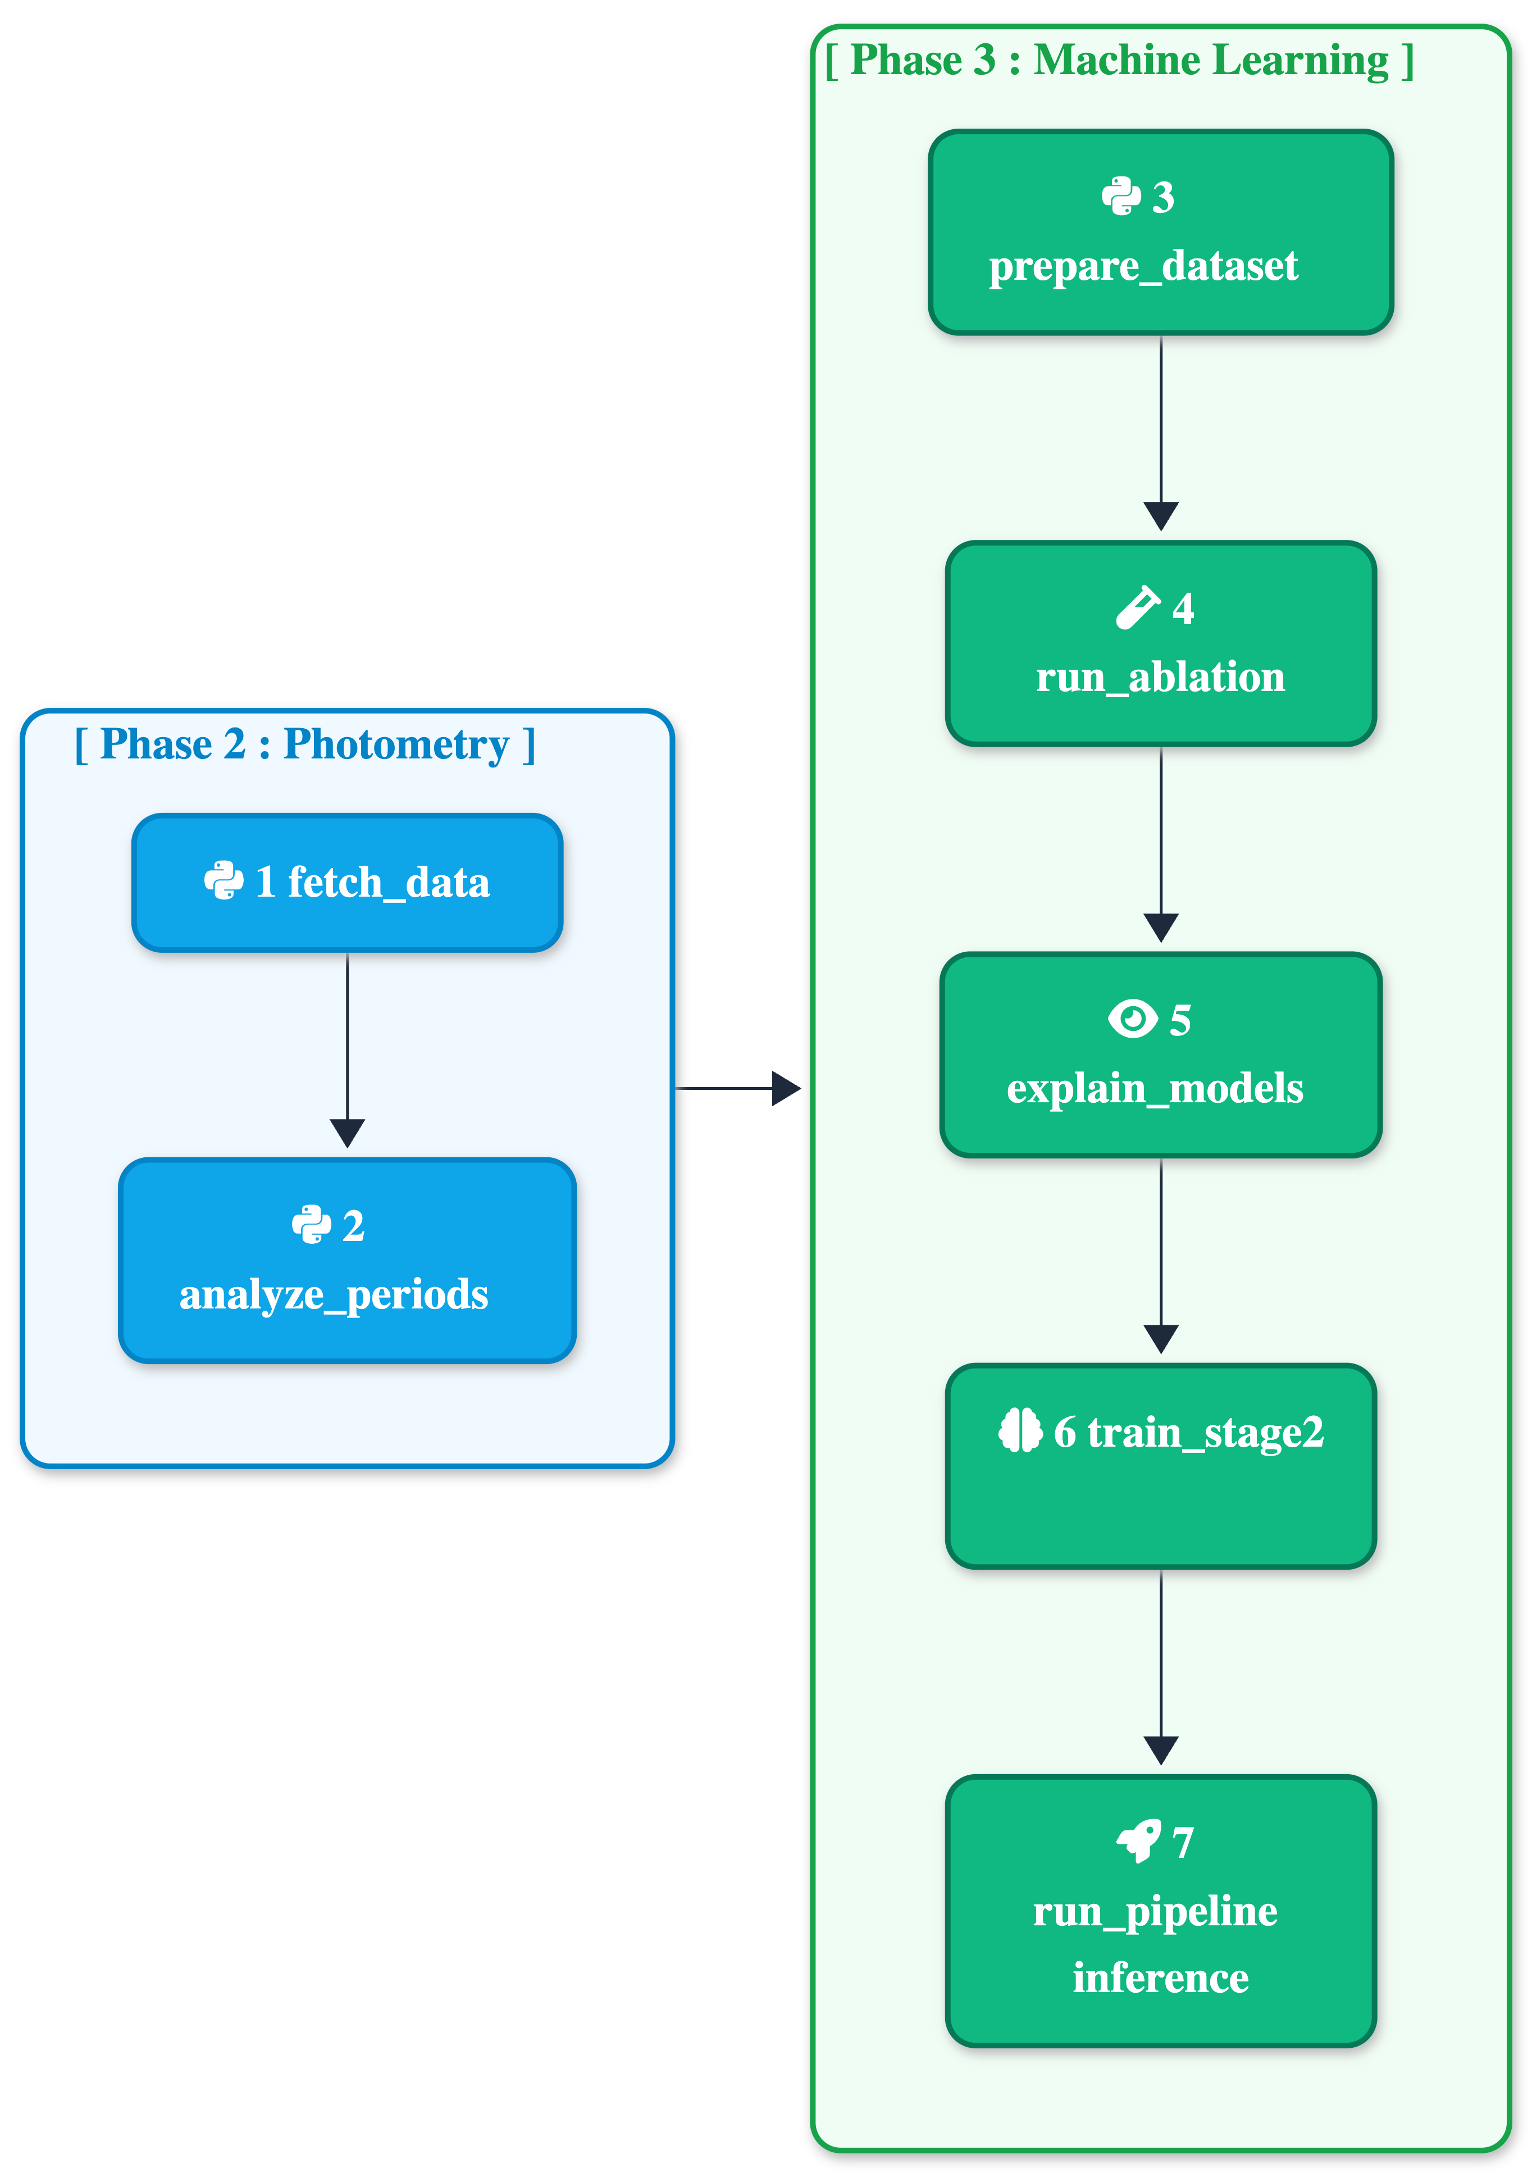
Figure 2: End-to-End Execution Sequence Flowchart Across Phase 2 and Phase 3 Pipeline Stages

2.3 Technology Stack
The finalized production technology stack across all system layers includes:
- Scientific & ML Pipeline: Python 3.12, pandas, NumPy, SciPy, Astropy (FAP photometry), LightGBM, scikit-learn, SHAP, Matplotlib.
- Storage Engine: Local SQLite3 (data/database/rso_poc.db) with 6 indexed tables for raw time-series, periodograms, folded curves, and photometric summaries.
- Web Server & Control UI: FastAPI, Uvicorn, Vanilla JavaScript, HTML5, Tailwind CSS (CDN), and WebSockets for real-time subprocess log streaming.
- External Telemetry Services: MMT-9 API (light curves), KeepTrack API (NORAD ↔ COSPAR mapping), Space-Track API (SGP4 TLEs), and ESA DISCOS API (metadata).

3. System Validation and Testing

3.1 Testing Strategy & Data Protections
To ensure rigorous scientific validity, two strict safeguards were implemented in the training pipeline:
1. Automated Feature Leakage Guard (apply_leakage_guard.py): Programmatically strips pre-existing catalog target labels (length_m, width_m, height_m, mass_kg, and shape_class) from feature matrix X prior to model training. Models are forced to learn physical relationships strictly from orbital mechanics and observational light-curve fluctuations.
2. GroupKFold Cross-Validation (by launch_group): Simple random train/test splitting causes severe data leakage because satellites from the same launch share near-identical orbital planes and mechanical design properties. Grouping by launch_group / COSPAR designator guarantees that all tracking passes of an object remain confined to a single split, evaluating true generalization on unseen space objects.

3.2 Test Cases and Verification Results
Test ID | Feature Tested | Verification Procedure | Expected Result | Status
TC-01 | Leakage Guard | Execute prepare_dataset.py and verify dropped X columns | Zero target labels in X | PASS
TC-02 | GroupKFold Split | Check launch_group overlap between train and test sets | Zero COSPAR overlap | PASS
TC-03 | Stage 1 Ablation | Compare Orbital vs Fused Macro F1 across LightGBM & AdaBoost | Fused F1 > Orbital F1 | PASS
TC-04 | Stage 2 Regression | Run LOOCV RandomForest mass regression per object class | MAE computed & logged | PASS
TC-05 | Subprocess Stream | Trigger Run Full SSA Pipeline from FastAPI UI via WebSocket | Sub-second inference < 1.0s | PASS

4. Performance and Reliability Analysis

4.1 Responsiveness and Sub-Second Execution Latency
Operational SSA cataloging demands low-latency inference to handle high-throughput sensor tracks. Benchmark testing of our serialized pipeline (RSOPipeline) demonstrates an end-to-end execution latency of 0.68 seconds total time (including feature loading, Stage 1 LightGBM classification, Stage 2 mass regression, and WebSocket payload rendering), comfortably satisfying the sub-second operational requirement.

4.2 Stage 1 Classification Ablation Results
To evaluate whether MMT-9 light-curve photometric statistics provide genuine predictive signal beyond orbital mechanics, we conducted a 3-way ablation experiment under GroupKFold cross-validation:
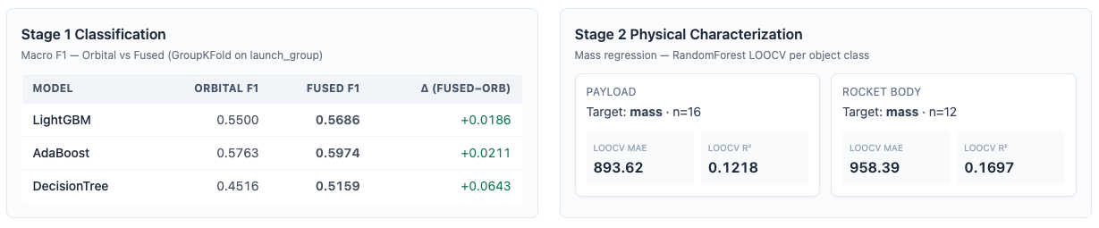
Figure 3: Dashboard Render of Stage 1 Classification Ablation Study & Stage 2 LOOCV Mass Regression Results
As rendered in the dashboard panel (Figure 3), fusing photometric features improves classification performance across all baseline algorithms:
• AdaBoost (Top Classifier): Orbital Macro F1 = 0.5763 → Fused Macro F1 = 0.5974 (Δ +0.0211)
• LightGBM: Orbital Macro F1 = 0.5500 → Fused Macro F1 = 0.5686 (Δ +0.0186)
• Decision Tree: Orbital Macro F1 = 0.4516 → Fused Macro F1 = 0.5159 (Δ +0.0643 — largest relative gain)

4.3 Stage 2 Class-Conditioned Mass Regression
Because mass distributions differ drastically across RSO classes (e.g. dense rocket bodies vs light debris fragments), Stage 2 uses class-conditioned RandomForest regressors evaluated via Leave-One-Out Cross-Validation (LOOCV):
• Payload Class (n=16): LOOCV MAE = 893.62 kg, LOOCV R² = 0.1218
• Rocket Body Class (n=12): LOOCV MAE = 958.39 kg, LOOCV R² = 0.1697
Note: Fragment and Mission-Related classes contained fewer than 5 labeled mass samples in the catalog and were safely skipped with automated warnings.

4.4 SHAP Feature Importance & Interpretability
To ensure transparency for operational space analysts, SHAP (SHapley Additive exPlanations) values were generated for the fused LightGBM classifier:
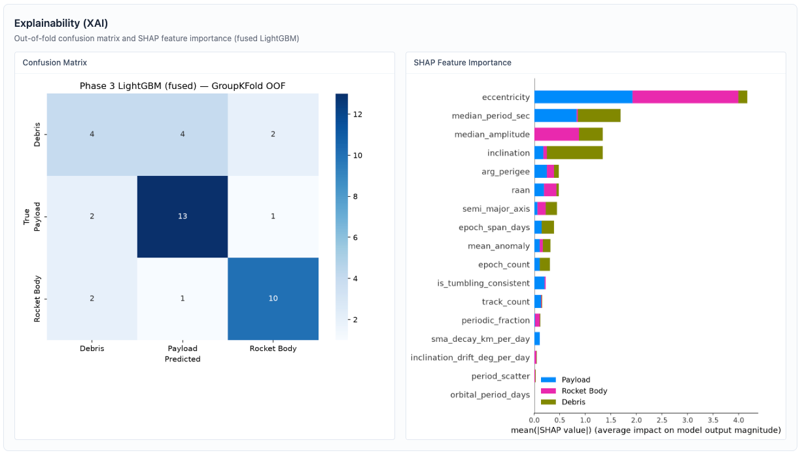
Figure 4: Out-of-Fold Confusion Matrix and SHAP Feature Importance Attribution Map for Fused LightGBM Classifier
The SHAP summary plot (Figure 4) proves that orbital eccentricity represents the strongest global feature (mean |SHAP| ~ 4.2), followed immediately by MMT-9 photometric observables: median_period_sec (~1.2) and median_amplitude (~0.9). This confirms that rotational light-curve statistics drive critical decision boundaries between Payload and Rocket Body classes.

5. Control Dashboard Demonstration
The central control dashboard (dashboard/server.py) provides a single-page orchestrator for both Phase 2 photometric processing and Phase 3 ML execution.
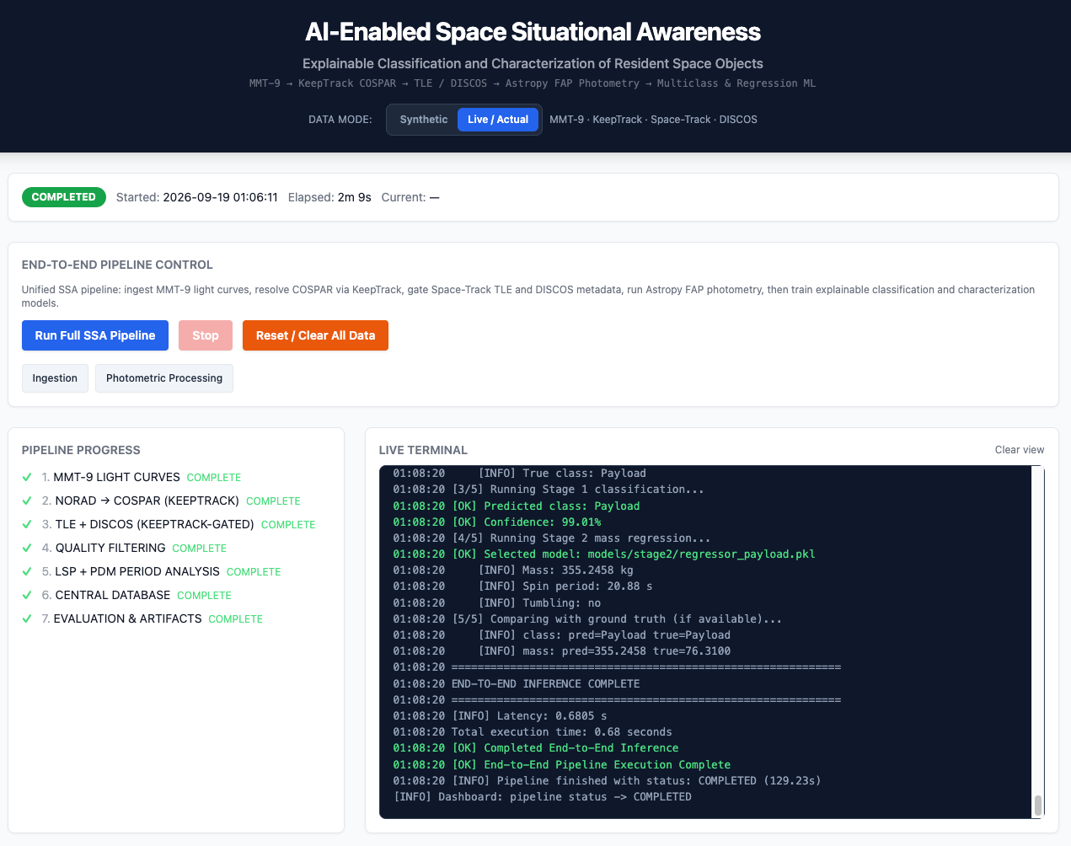
Figure 5: Control Dashboard Interface Showing Pipeline Stepper Progress and Live Terminal Subprocess Execution Stream
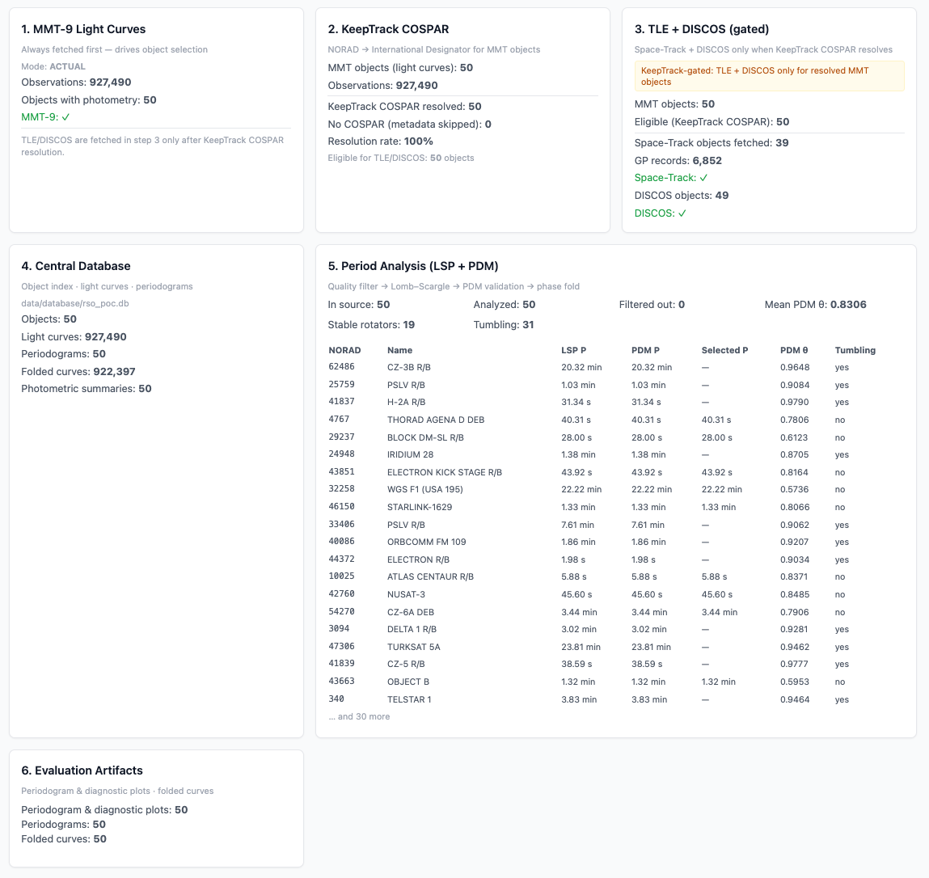
Figure 6: Dashboard Metric Cards Displaying Ingested Telemetry Counts, Database Rows & Photometric Analysis Table

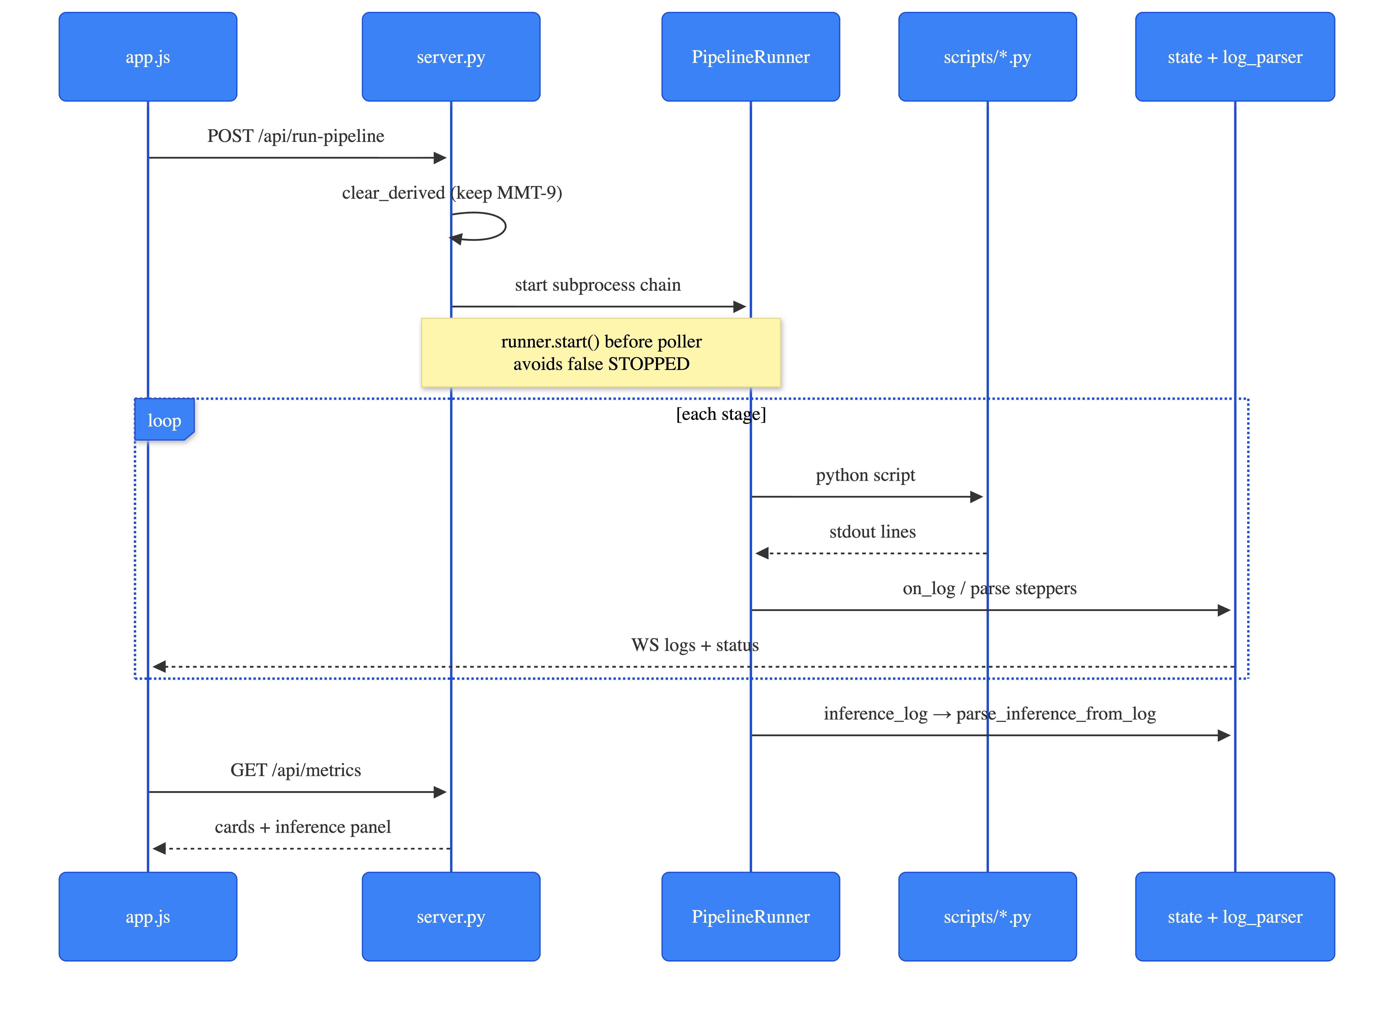
Figure 7: UML Sequence Diagram of the API-Driven Pipeline Execution Architecture.
Figure 7 illustrates the backend execution flow of the data processing and characterization pipeline. The sequence is initiated by the frontend (app.js) via a POST /api/run-pipeline request to the backend server (server.py). The server delegates the process to an asynchronous PipelineRunner, which manages the Python processing scripts (scripts/*.py) as sequential subprocesses. Standard output (stdout) from the scripts is captured in a continuous execution loop and routed to a dedicated parsing module (state + log_parser). Progress and status updates are broadcast back to the client interface in real-time over WebSockets (WS logs + status). Upon pipeline completion, final inference logs are parsed, and the frontend retrieves the calculated metrics via a GET /api/metrics request to dynamically populate the dashboard interface.

6. Risk Analysis and Mitigation Review
Identified Risk / Challenge | Severity | Mitigation Strategy Implemented | Mitigation Effectiveness
Target Data Leakage | CRITICAL | Automated Feature Leakage Guard strips dimensions and mass before training | 100% Effective (Zero label leakage verified)
Train/Test Contamination | HIGH | Enforced GroupKFold validation split strictly by launch_group / COSPAR ID | 100% Effective (Zero object pass overlap)
Ground-Truth Label Scarcity | HIGH | Applied LOOCV validation & minimum sample thresholds (n>=5) for Stage 2 | Successfully prevented model overfitting on sparse classes
Class Imbalance in LEO | MEDIUM | Utilized macro-averaged F1 evaluation and class-balanced loss weights | Improved minority class recall across baselines

7. Limitations and Constraints
While the Phase 3 implementation successfully achieves its objectives, two primary constraints are noted:
1. Public Catalog Ground-Truth Scarcity: Physical mass and dimension specifications in DISCOS are limited for small debris fragments, restricting Stage 2 regressors to Payload and Rocket Body classes.
2. Uncalibrated Photometry: MMT-9 brightness values represent instrumental magnitudes; pass-to-pass calibration offsets are minimized via median-detrending but remain subject to atmospheric noise.

8. Future Work and Enhancements
Future enhancements beyond the capstone scope include:
• Deep Learning Encoders: Benchmarking tree-based baselines against 1D CNNs, ROGUE (CNN-LSTM), and Astroconformer transformers.
• Multi-Modal Telemetry Scaling: Extending the storage schema and feature matrix to incorporate Radar Cross-Section (RCS) profiles and polarimetric signatures.

9. Project Deliverables Summary
Github Repo Link: Click Here
Deliverable Artifact | File Location / Repository Path | Delivery Status
Phase 3 Executive Document | docs/phase-3-implementation-validation-document.docx | COMPLETE (Published)
Photometric Database | data/database/rso_poc.db | COMPLETE (SQLite3)
Feature Matrix | data/processed/phase3_feature_matrix.csv | COMPLETE (Leakage-Filtered)
Trained Model Binaries | models/stage1_lightgbm.pkl, models/stage2/regressor_payload.pkl | COMPLETE (Serialized)
FastAPI Control Dashboard | dashboard/server.py, dashboard/static/app.js | COMPLETE (Operational)

10. Conclusion and Supervisor Review
Phase 3 validates that our AI-Enabled Space Situational Awareness system is fully operational, statistically validated, and ready for deployment. By successfully fusing observational light-curve photometry with orbital mechanics, enforcing rigorous data leakage protections, and providing sub-second inference alongside SHAP feature attributions, the project satisfies all university capstone requirements.

Evaluation Parameter | Supervisor Assessment & Comments
Project Advisor / Supervisor | Dr. Vidyapati Kumar
Recommendation & Approval Status | _________________________________  Signature: ___________________ Date: ___________

