**Dash Heroku Application**

**Uses**

This program was designed specifically for Nationwide Children's Hospital (NCH) by Hilary Mehler as part of the UMGC Master of Science in Biotechnology, Bioinformatics Specialization Capstone in Spring 2021. It was built as the web browser framework to view ECG data from output files in .csv and .hdr format, in conjunction with HRVY. Find the full code at <https://github.com/mars-group-2021/mars-dash-app>

** *For additional information please see the Technical Report at* [*https://github.com/mars-group-2021/test_code*](https://github.com/mars-group-2021/test_code)

**Figure 1**

*A screenshot of the HRVY Dash application after files as.csv and as.hdr have been uploaded by the user*

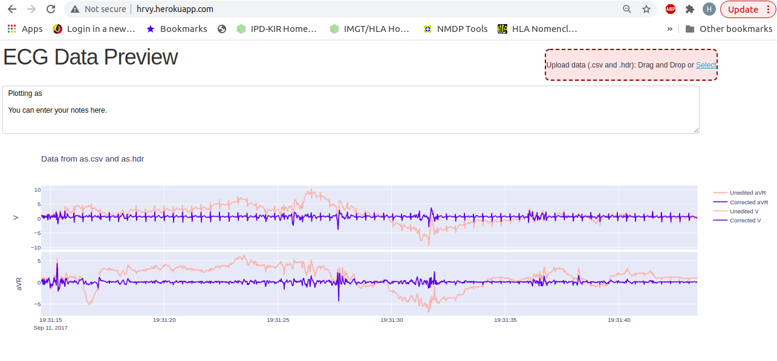

*Note*: The line traces may be hidden or viewed by clicking the name to the right (e.g. ‘Unedited aVR’).

**Table 1**

***Descriptions of the commands used to deploy the Dash app using Heroku.***

|  |  |
| --- | --- |
| Terminal Command | Action |
| $git | open Git CLI |
| $mkdir hrvy_app_deployment | create project folder |
| $cd hrvy_app_deployment | navigate to project folder |
| $git init | initialize project with empty Git repository |
| $virtualenv venv | create a virtual environment called venv, which will include bin and lib directories once activated |
| $cd venv  $mkdir Scripts  $cd Scripts  $ . activate | create and activate a folder called Scripts within the virtual environment |
| $pip install dash  $pip install gunicorn | install Dash and Gunicorn in virtual environment |
| $ cd ~/dash_app_deployment | navigate back to the project root directory |
| $git add app.py  $git add Procfile  $git add requirements.txt  $git add runtime.txt  $git add .gitignore | add all required files to the project directory |
| $heroku create hrvy | create a Heroku application named hrvy |
| $git add .  $git commit -m ‘Initial app  deployment’  $git push heroku master | commit and push all local project directory files to git repository |
| $ heroku ps:scale web=1 | set Heroku to run the app on one dyno |

Contents of Files Needed for Dash Application Deployment

**1) Procfile [NO extension]**

web: gunicorn app:server --log-file=-

**2) runtime.txt**

python-3.7.10

**3) requirements.txt**

Brotli==1.0.9

certifi==2020.12.5

chardet==3.0.4

click==7.1.2

dash==1.19.0

dash-bootstrap-components==0.11.3

dash-core-components==1.15.0

dash-html-components==1.1.2

dash-renderer==1.9.0

dash-table==4.11.2

dask==2.17.2

DateTime==4.3

Django==3.1.7

django-heroku==0.3.1

Flask==1.1.2

Flask-Compress==1.9.0

future==0.18.2

gunicorn==20.0.4

h5py==2.10.0

HeapDict==1.0.1

heartpy==1.2.6

html5lib==1.0.1

idna==2.9

itsdangerous==1.1.0

Jinja2==2.11.2

json5==0.9.4

jsonschema==3.2.0

MarkupSafe==1.1.1

plotly==4.14.3

python-dateutil==2.8.1

python-jsonrpc-server==0.3.4

python-language-server==0.31.10

requests==2.24.0

retrying==1.3.3

six==1.15.0

urllib3==1.25.9

Werkzeug==1.0.1

numpy==1.18.1

scipy==1.4.1

**4) .gitignore *This file does not appear to be in the project directory, as the ‘.’ marks it as a hidden file**

venv

*.pyc

.DS_Store

.env