Swag Labs Test Project:

Pre-requisites for running this project

1. Install software

a) Java Development Kit (JDK)

b) IDE

Eclipse: A widely-used Java IDE.

IntelliJ IDEA: Known for its excellent support for Java development.

1. Dependencies and plugins (Automatically included)
2. Selenium
3. TestNG
4. Cucumber
5. Gherkin
6. Allure

The project has 5 test cases currently

* Verifying login with valid credentials
* Verifying unsuccessful login with invalid credentials (with 3 examples)
* Successful place of order

There are five classes for five different pages as it is based on POM

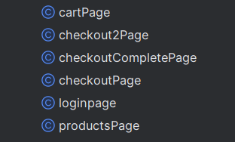

There are two test classes and 2 feature files

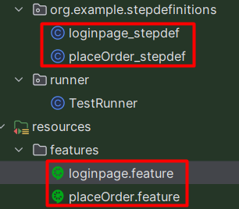

Open project on your downloaded IDE

Right Click on project name and open it on terminal

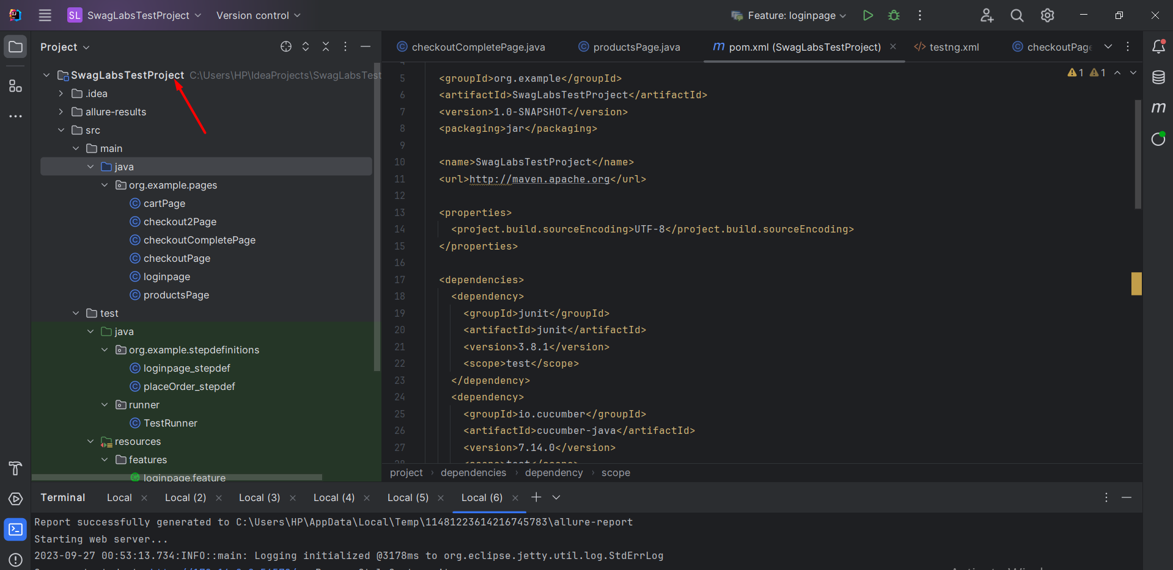

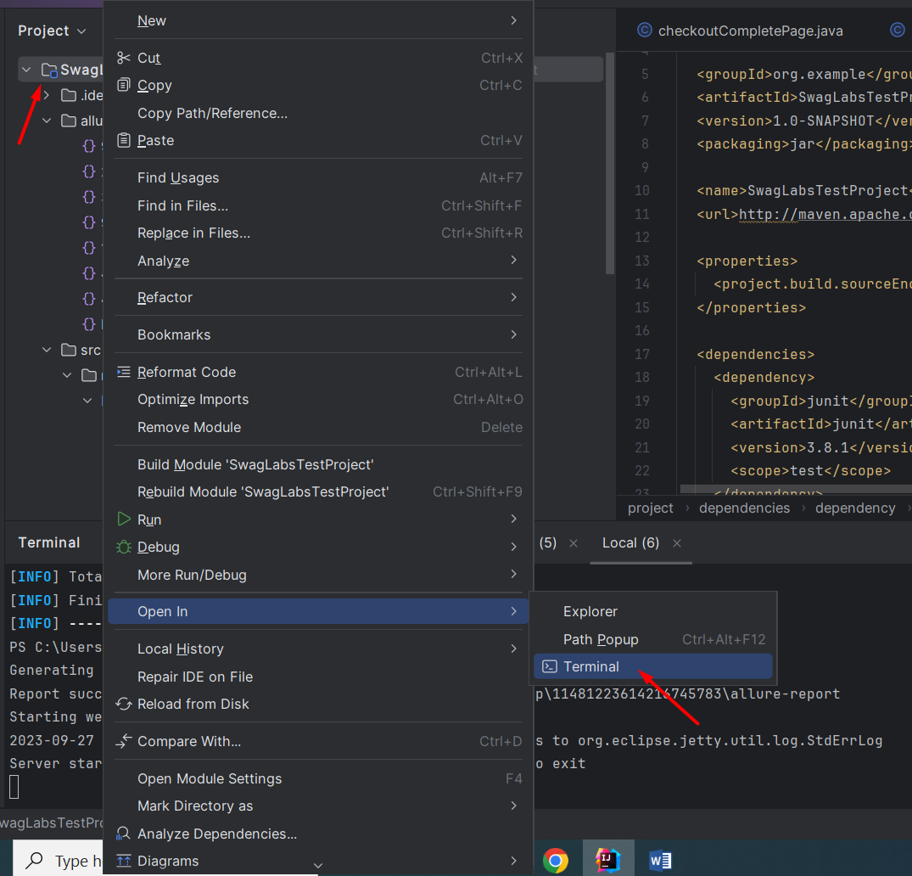

Run command “maven clean package”, it will read pom.xml and read all dependencies then after it you can run it with “mvn test”

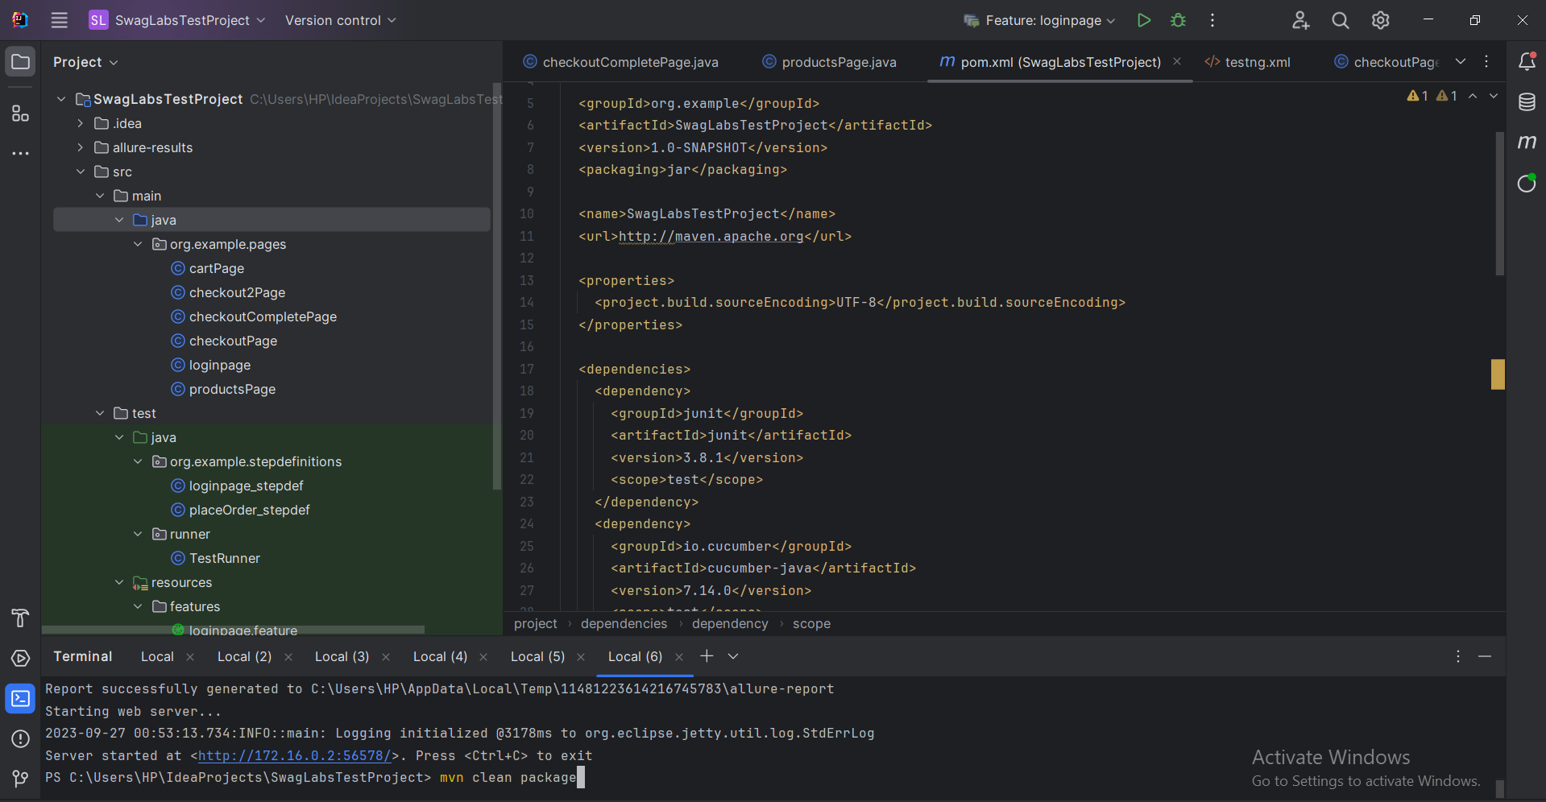

**For Allure reports**

Run this command “npm install -g allure-commandline” (Node should be installed in order to run it)

Then Run this command to open allure report “allure serve allure-results”

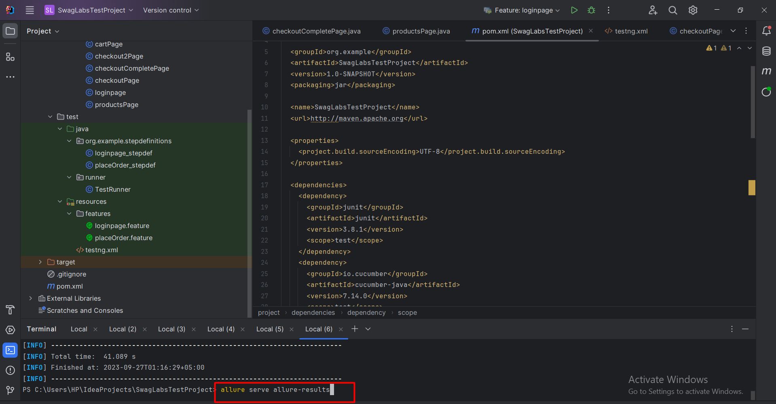

Allure Report will show up

